 | crop estimates committee | 
 | oesskattingskomitee
From/Van: Rodney D. Dredge
Tel: 012 319 6507  Fax/Faks: 012 319 6211  E-mail/E-pos: RodneyD@daff.gov.za
Web page/Webblad: www.daff.gov.za/statistics and economic reports or www.sagis.org.za/CEC: Crop Estimates
EMBARGO: 15:30

The first production forecast for summer crops for 2015 is hereby released. /
Hiermee word die eerste produksieskatting vir somergewasse vir 2015 vrygestel.

SUMMER CROPS – AREA PLANTED AND FIRST PRODUCTION FORECAST: 2015
SOMERGEWASSE – OPPERVLAKTE EN EERSTE PRODUKSIESKATTING: 2015
CROP/GEWAS  The Crop Estimates Committee comprises officials of the following institutions:  Department of Agriculture, Forestry and Fisheries; Provincial Departments of Agriculture; various ARC-Institutes (Soil, Climate and Water; Small Grains Institute;  and Grain Crops Institute); and Statistics SA. | Area planted/  Opp beplant  2015 | 1st forecast/  1ste skatting  2015 | Area planted/  Opp beplant  2014 | Finale oes/  Final crop  2014 | Change/  Verandering/
 | Ha | Tons | Ha | Tons | %
 | (A) | (B) | (C) | (D) | (B) ÷ (D)
Commercial/Kommersieel:
White maize/Witmielies | 1 460 000 | 4 696 390 | 1 551 200 | 7 710 000 | -39,09
Yellow maize/Geelmielies | 1 204 800 | 4 968 900 | 1 137 000 | 6 540 000 | -24,02
Maize/Mielies | 2 664 800 | 9 665 290 | 2 688 200 | 14 250 000 | -32,17
Sunflower seed/Sonneblomsaad | 568 000 | 574 300 | 598 950 | 832 000 | -30,97
Soybeans/Sojabone | 687 300 | 938 350 | 502 900 | 948 000 | -1,02
Groundnuts/Grondbone | 58 000 | 67 845 | 52 125 | 74 500 | -8,93
Sorghum | 70 500 | 178 700 | 78 850 | 265 000 | -32,57
Dry beans/Droëbone | 64 000 | 79 940 | 55 820 | 82 130 | -2,67
TOTAL/TOTAAL | 4 112 600 | 11 504 425 | 3 976 845 | 16 451 630 | -30,07
Note: Estimate is for calendar year, e.g. production season 2014/15 = 2015
Nota: Skatting is vir kalenderjaar, bv. produksie-seisoen 2014/15 = 2015

26 February / Februarie 2015
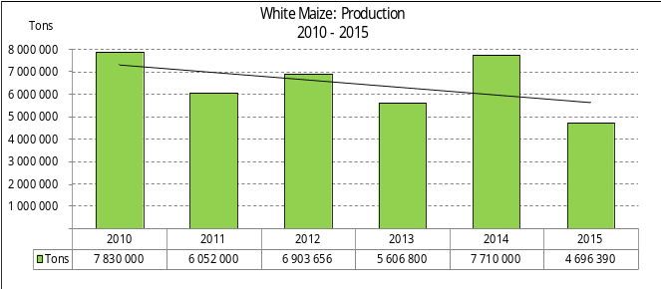

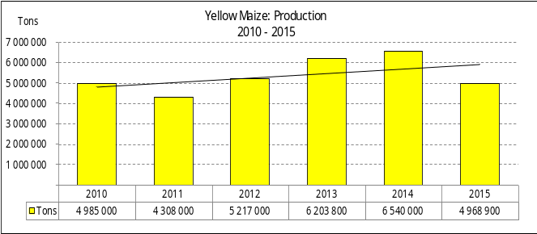
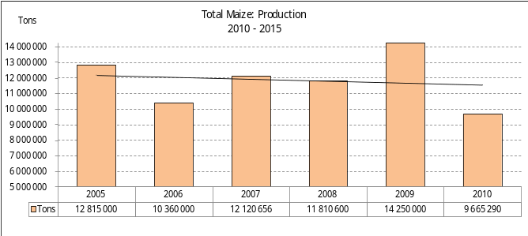

WHITE AND YELLOW MAIZE – AREA PLANTED AND FIRST PRODUCTION FORECAST: 2015
WIT- EN GEELMIELIES – OPPERVLAKTE EN EERSTE PRODUKSIESKATTING: 2015

Provinsie/  Province | Area planted/  Oppervlakte beplant  2015 |  |  | 1st forecast/  1ste skatting  2015 |  |  | Area planted/  Oppervlakte beplant  2014 |  |  | Final crop/  Finale oes  2014
Provinsie/  Province | White/  Wit  Ha | Yellow/  Geel  Ha | Total/  Totaal  Ha | White/  Wit  Tons | Yellow/  Geel  Tons | Total/  Totaal  Tons | White/  Wit  Ha | Yellow/  Geel  Ha | Total/  Totaal  Ha | White/  Wit  Tons | Yellow/  Geel  Tons | Total/  Totaal  Tons
Western Cape/Wes-Kaap | 450 | 3 800 | 4 250 | 4 050 | 34 200 | 38 250 | 500 | 3 000 | 3 500 | 4 500 | 28 500 | 33 000
Northern Cape/Noord-Kaap | 2 450 | 46 000 | 48 450 | 27 440 | 598 000 | 625 440 | 2 200 | 48 000 | 50 200 | 25 300 | 638 400 | 663 700
Free State/Vrystaat | 710 000 | 510 000 | 1 220 000 | 2 201 000 | 1 708 500 | 3 909 500 | 730 000 | 465 000 | 1 195 000 | 3 759 500 | 2 487 750 | 6 247 250
Eastern Cape/Oos-Kaap | 2 600 | 14 000 | 16 600 | 15 600 | 84 000 | 99 600 | 2 500 | 16 000 | 18 500 | 13 750 | 97 600 | 111 350
KwaZulu-Natal | 40 000 | 45 000 | 85 000 | 220 000 | 261 000 | 481 000 | 43 000 | 45 000 | 88 000 | 266 600 | 292 500 | 559 100
Mpumalanga | 154 000 | 315 000 | 469 000 | 739 200 | 1 417 500 | 2 156 700 | 168 000 | 332 000 | 500 000 | 907 200 | 1 875 000 | 2 782 200
Limpopo | 28 500 | 21 000 | 49 500 | 171 000 | 130 200 | 301 200 | 30 000 | 20 000 | 50 000 | 183 000 | 124 000 | 307 000
Gauteng | 47 000 | 65 000 | 112 000 | 225 600 | 273 000 | 498 600 | 65 000 | 53 000 | 118 000 | 357 150 | 291 250 | 648 400
North West/Noordwes | 475 000 | 185 000 | 660 000 | 1 092 500 | 462 500 | 1 555 000 | 510 000 | 155 000 | 665 000 | 2 193 000 | 705 000 | 2 898 000
Total/Totaal | 1 460 000 | 1 204 800 | 2 664 800 | 4 696 390 | 4 968 900 | 9 665 290 | 1 551 200 | 1 137 000 | 2 688 200 | 7 710 000 | 6 540 000 | 14 250 000

SUNFLOWER SEED – AREA PLANTED AND FIRST PRODUCTION FORECAST: 2015
SONNEBLOMSAAD – OPPERVLAKTE EN EERSTE PRODUKSIESKATTING: 2015

Province/  Provinsie | Area planted/  Opp beplant  Ha | 1st forecast/  1ste skatting  Tons | Area planted/  Opp beplant  Ha | Final crop/  Finale oes  Tons
Province/  Provinsie | 2015 | 2015 | 2014 | 2014
Western Cape/Wes-Kaap | - | - | - | -
Northern Cape/Noord-Kaap | - | - | 900 | 450
Free State/Vrystaat | 280 000 | 308 000 | 280 000 | 448 000
Eastern Cape/Oos-Kaap | - | - | 550 | 825
KwaZulu-Natal | - | - | - | -
Mpumalanga | 3 000 | 3 600 | 3 500 | 4 550
Limpopo | 82 000 | 69 700 | 90 000 | 76 275
Gauteng | 3 000 | 3 000 | 3 000 | 3 900
North West/Noordwes | 200 000 | 190 000 | 221 000 | 298 000
Total/Totaal | 568 000 | 574 300 | 598 950 | 832 000

SOYBEANS – AREA PLANTED AND FIRST PRODUCTION FORECAST: 2015
SOJABONE – OPPERVLAKTE EN EERSTE PRODUKSIESKATTING: 2015

Province/  Provinsie | Area planted/  Opp beplant  Ha | 1st forecast/  1ste skatting  Tons | Area planted/  Opp beplant  Ha | Final crop/  Finale oes  Tons
Province/  Provinsie | 2015 | 2015 | 2014 | 2014
Western Cape/Wes-Kaap | 800 | 1 600 | - | -
Northern Cape/Noord-Kaap | 4 000 | 14 000 | 3 900 | 14 040
Free State/Vrystaat | 310 000 | 310 000 | 201 000 | 352 000
Eastern Cape/Oos-Kaap | 1 500 | 2 250 | 2 000 | 3 600
KwaZulu-Natal | 42 000 | 84 000 | 35 000 | 98 000
Mpumalanga | 240 000 | 348 000 | 203 000 | 335 000
Limpopo | 24 000 | 72 000 | 22 000 | 66 000
Gauteng | 30 000 | 54 000 | 20 000 | 47 360
North West/Noordwes | 35 000 | 52 500 | 16 000 | 32 000
Total/Totaal | 687 300 | 938 350 | 502 900 | 948 000

GROUNDNUTS – AREA PLANTED AND FIRST PRODUCTION FORECAST: 2015
GRONDBONE – OPPERVLAKTE EN EERSTE PRODUKSIESKATTING: 2015

Province/  Provinsie | Area planted/  Opp beplant  Ha | 1st forecast/  1ste skatting  Tons | Area planted/  Opp beplant  Ha | Final crop/  Finale oes  Tons
Province/  Provinsie | 2015 | 2015 | 2014 | 2014
Western Cape/Wes-Kaap | - | - | - | -
Northern Cape/Noord-Kaap | 7 100 | 19 525 | 7 000 | 18 200
Free State/Vrystaat | 22 500 | 22 500 | 20 000 | 23 500
Eastern Cape/Oos-Kaap | - | - | - | -
KwaZulu-Natal | 100 | 100 | 75 | 90
Mpumalanga | - | - | 50 | 100
Limpopo | 2 500 | 2 500 | 3 000 | 4 110
Gauteng | - | - | - | -
North West/Noordwes | 25 800 | 23 220 | 22 000 | 28 500
Total/Totaal | 58 000 | 67 845 | 52 125 | 74 500

SORGHUM – AREA PLANTED AND FIRST PRODUCTION FORECAST: 2015
SORGHUM – OPPERVLAKTE EN EERSTE PRODUKSIESKATTING: 2015

Province/  Provinsie | Area planted/  Opp beplant  Ha | 1st forecast/  1ste skatting  Tons | Area planted/  Opp beplant  Ha | Final crop/  Finale oes  Tons
Province/  Provinsie | 2015 | 2015 | 2014 | 2014
Western Cape/Wes-Kaap | - | - | - | -
Northern Cape/Noord-Kaap | - | - | - | -
Free State/Vrystaat | 36 000 | 82 800 | 42 000 | 139 200
Eastern Cape/Oos-Kaap | - | - | - | -
KwaZulu-Natal | 500 | 2 100 | 850 | 4 400
Mpumalanga | 11 000 | 44 000 | 11 000 | 54 000
Limpopo | 16 000 | 36 800 | 14 000 | 32 200
Gauteng | 1 000 | 2 800 | 1 500 | 4 800
North West/Noordwes | 6 000 | 10 200 | 9 500 | 30 400
Total/Totaal | 70 500 | 178 700 | 78 850 | 265 000

DRY BEANS – AREA PLANTED AND FIRST PRODUCTION FORECAST: 2015
DROëBONE – OPPERVLAKTE EN EERSTE PRODUKSIESKATTING: 2015

Province/  Provinsie | Area planted/  Opp beplant  Ha | 1st forecast/  1ste skatting  Tons | Area planted/  Opp beplant  Ha | Final crop/  Finale oes  Tons
Province/  Provinsie | 2015 | 2015 | 2014 | 2014
Western Cape/Wes-Kaap | 300 | 390 | 300 | 450
Northern Cape/Noord-Kaap | 900 | 2 160 | 1 000 | 2 000
Free State/Vrystaat | 28 000 | 29 400 | 26 000 | 37 700
Eastern Cape/Oos-Kaap | 800 | 1 040 | 770 | 1 155
KwaZulu-Natal | 6 500 | 7 800 | 5 000 | 6 500
Mpumalanga | 9 000 | 10 800 | 8 750 | 12 250
Limpopo | 7 000 | 16 800 | 5 500 | 9 625
Gauteng | 4 000 | 4 800 | 3 000 | 4 200
North West/Noordwes | 7 500 | 6 750 | 5 500 | 8 250
Total/Totaal | 64 000 | 79 940 | 55 820 | 82 130

CONFIDENTIALITY ISSUES that CEC members are committed to adhere to on the day of the meeting
- Personal items such as laptops, handbags, cell phones, etc. are not allowed in the venue during the meeting
- No member is allowed to leave the meeting before 12:00 in order to prevent disclosure of the information
- The embargo time for the release of crop estimates information is 15:30
- No member is allowed to discuss crop estimates information with anyone other than a member of the Committee before the embargo time
- Only the Chairperson, or a member appointed by the Chairperson, may release the figures to the media
- Members must regard the detail of any information that was collected for and/or discussed during the meeting, as confidential
- Individual information received for crop estimate purposes is treated strictly confidential, and is not divulged for any other purposes

REVISED AREA AND FIRST PRODUCTION FORECAST OF SUMMER CROPS (2015)/
HERSIENE OPPERVLAKTE- EN EERSTE PRODUKSIESKATTING VIR SOMERGEWASSE (2015)
26 FEBRUARY / FEBRUARIE 2015

Summer field crops – 2015  Commercial maize: The revised area estimate for maize is 2,665 mill. ha, which is 0,87% or 23 400 ha less than the 2,688 mill. ha planted for the previous season and also 0,31% more than the preliminary area estimate of 2,656 mill. ha released in January 2015.  The expected commercial maize crop is 9,665 mill. tons, which is 32,17% less than the 14,250 mill. tons of the previous season, with an expected yield of 3,63 t/ha.  The area planted figures are mainly based on information obtained from the Producer Independent Crop Estimation System (PICES), conducted by the National Crop Statistics Consortium (NCSC) for Northern Cape, Free State, KwaZulu-Natal, Mpumalanga, Limpopo, Gauteng and North West provinces.  Please note that information from the objective yield survey by the NCSC for the Mpumalanga province will be available in April 2015; and for the Free State and North West provinces in May 2015. The current yield figures are mainly obtained from producers in the different provinces.  The area estimate for white maize is 1,460 mill. ha, which represents a decrease of 5,88% or 91 200 ha compared to the 1,551 mill. ha planted last season and also 1,86% less than the preliminary area estimate of 1,488 mill. ha. In the case of yellow maize the area estimate is 1,205 mill. ha, which is 5,96% or 67 800 ha more than the 1,137 mill. ha planted last season and also 3,08% more than the preliminary area estimate of 1,169 mill. ha.  The production forecast of white maize is 4,696 mill. tons, which is 39,09% less than the 7,710 mill. tons of last season. The yield for white maize is 3,22 t/ha. In the case of yellow maize the production forecast is 4,969 mill. tons, which is 24,02% less than the 6,540 mill. tons of last season. The yield for yellow maize is 4,12 t/ha.  Sunflower seed: The revised area estimate for sunflower seed is 568 000 ha, which is 5,17% less than the 598 950 ha planted the previous season, but 1,25% more than the preliminary area estimate of 561 000 ha. The production forecast for sunflower seed is 574 300 tons, which is 30,97% less than the 832 000 tons of the previous season. The expected yield is 1,01 t/ha.  Other crops: It is estimated that 687 300 ha have been planted to soybeans, which represents an increase of 36,67% compared to the 502 900 ha planted last season. It is also 10,80% more than the preliminary area estimate of 620 300 ha. The production forecast for soybeans is 938 350 tons, which is 1,02% less than the 948 000 tons of the previous season. The expected yield is 1,37 t/ha.  For groundnuts, the area estimate is 58 000 ha, which is 11,27% more than the 52 125 ha planted for the previous season and also 5,07% higher than the preliminary area estimate of 55 200 ha. The expected groundnut crop is 67 845 tons – which is 8,93% less than the 74 500 tons of last season. The expected yield is 1,17 t/ha.  The area estimate for sorghum decreased by 10,59%, from 78 850 ha to 70 500 ha against the previous season. The production forecast for sorghum is 178 700 tons, which is 32,57% less than the 265 000 tons of the previous season. The expected yield is 2,53 t/ha.  For dry beans, the area estimate is 64 000 ha, which is 14,65% more than the 55 820 ha planted for the previous season. In the case of dry beans the production forecast is 79 940 tons, which is 2,67% less than the 82 130 tons of the previous season. The expected yield is 1,25 t/ha.  Please note that the second production forecast for summer field crops for 2015 will be released on 25 March 2015. |  | Somergewasse – 2015  Kommersiële mielies: Die hersiene skatting van die oppervlakte onder mielies beloop 2,665 milj. ha, wat 0,87% of 23 400 ha minder is as die 2,688 milj. ha wat verlede seisoen aangeplant is, maar ook 0,31% meer as die voorlopige oppervlakteskatting van 2,656 milj. ha soos vrygestel in Januarie 2015.  Die verwagte kommersiële mielie-oes is 9,665 milj. ton wat 32,17% minder is as die 14,250 milj. ton van die vorige seisoen, met ‘n verwagte opbrengs van 3,63 t/ha.  Die oppervlakte beplant syfers is hoofsaaklik verkry vanaf die Produsente Onafhanklike Oesskattingstelsel (PICES), soos deur die Nasionale Oesskattingskonsortium gerapporteer vir Noord-Kaap, Vrystaat, KwaZulu-Natal, Mpumalanga, Limpopo, Gauteng en Noordwes provinsies.  Neem kennis dat inligting van die objektiewe opbrengs-opname van die Konsortium vir die Mpumalanga provinsie, in April 2015 gerapporteer word en vir die Vrystaat en Noordwes provinsies in Mei 2015. Die huidige opbrengs syfers is hoofsaaklik verkry vanaf produsente in die verskillende provinsies.  Die oppervlak onder witmielies is 1,460 milj. ha, wat ’n afname van 5,88% of 91 200 ha verteenwoordig vergeleke met die 1,551 milj. ha die vorige seisoen en ook 1,86% minder as die voorlopige oppervlakteskatting van 1,488 milj. ha. In die geval van geelmielies is die oppervlakteskatting 1,205 milj. ha, wat 5,96% of 67 800 ha meer is as die 1,137 milj. ha geplant die vorige seisoen en ook 3,08% meer as die voorlopige oppervlakteskatting van 1,169 milj. ha.  Die produksieskatting van witmielies is 4,696 miljoen ton, 39,09% minder is as die 7,710 milj. ton van die vorige seisoen. Die opbrengs van witmielies is 3,22 t/ha. In die geval van geelmielies is die produksieskatting 4,969 miljoen ton, wat 24,02% minder is as die 6,540 milj. ton van die vorige seisoen. Die opbrengs van geelmielies is 4,12 t/ha.  Sonneblomsaad: Die hersiene oppervlakteskatting vir sonneblomsaad is 568 000 ha, wat 5,17% minder is as die 598 950 ha aangeplant die vorige seisoen, maar 1,25% meer as die voorlopige oppervlakteskatting van 561 000 ha. Die produksieskatting vir sonneblomsaad is 574 300 ton, wat 30,97% minder is as die 832 000 ton van die vorige seisoen. Die verwagte opbrengs is 1,01 t/ha.  Ander gewasse: Die geskatte oppervlakte beplant met sojabone is 687 300 ha, wat ’n toename van 36,67% verteenwoordig vergeleke met die 502 900 ha geplant die vorige seisoen. Dit is ook 10,80% meer as die voorlopige oppervlakteskatting van 620 300 ha. Die produksieskatting van sojabone is 938 350 ton, wat 1,02% minder is as die 948 000 ton van die vorige seisoen. Die verwagte opbrengs is 1,37 t/ha.  Vir grondbone is die oppervlakteskatting 58 000 ha, wat 11,27% meer is as die 52 125 ha geplant vir die vorige seisoen en ook 5,07% hoër as die voorlopige oppervlakteskatting van 55 200 ha. Die verwagte grondbone-oes is 67 845 ton – 8,93% minder as die 74 500 ton van die vorige seisoen. Die verwagte opbrengs is 1,17 t/ha.  Die oppervlakteskatting vir sorghum het afgeneem met 10,59%, van 78 850 ha tot 70 500 ha teenoor die vorige seisoen. Die produksieskatting van sorghum is 178 700 ton – 32,57% minder as die 265 000 ton van die vorige seisoen. Die verwagte opbrengs is 2,53 t/ha.  Vir droëbone is die geskatte oppervlakte beplant 64 000 ha, wat 14,65% meer is as die 55 820 ha geplant vir die vorige seisoen. In die geval van droëbone is die produksieskatting 79 940 ton, wat 2,67% minder is as die 82 130 ton van die vorige seisoen. Die verwagte opbrengs is 1,25 t/ha.  Neem asseblief kennis dat die tweede produksieskatting vir somergewasse vir 2015, op 25 Maart 2015 vrygestel sal word.

The area estimate and final production estimate for winter cereals for the 2014 is hereby released. /
Hiermee word die oppervlakteskatting en finale produksieskatting vir wintergewasse vir 2014 vrygestel.
WINTER CEREALS – AREA PLANTED ESTIMATE AND FINAL PRODUCTION ESTIMATE: 2014
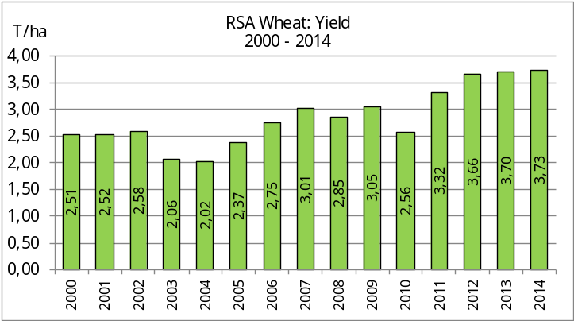
WINTERGEWASSE – OPPERVLAKTE- EN FINALE PRODUKSIESKATTING: 2014
CROP/GEWAS | Area planted/  Opp beplant  2014 | Final estimate/  Finale skatting  2014 | 6th forecast/  6de skatting  2014 | Area planted/  Opp beplant  2013 | Final crop/  Finale oes  2013 | Change/  Verandering
CROP/GEWAS | Ha | Tons | Tons | Ha | Tons | %
CROP/GEWAS | (A) | (B) | (C) | (D) | (E) | (B) ÷ (C)
Commercial/Kommersieel:
Wheat/Koring | 476 570 | 1 775 534 | 1 775 534 | 505 500 | 1 870 000 | -
Malting barley/Moutgars | 85 125 | 306 786 | 310 361 | 81 320 | 267 500 | -1,15
Canola/Kanola | 95 000 | 123 500 | 123 500 | 72 165 | 112 000 | -
Total/Totaal | 656 695 | 2 205 820 | 2 209 395 | 658 985 | 2 249 500 | +0,16
Note: Estimate is for calendar year, e.g. production season 2014/15 = 2014
Nota: Skatting is vir kalenderjaar, bv. produksie-seisoen 2014/15 = 2014

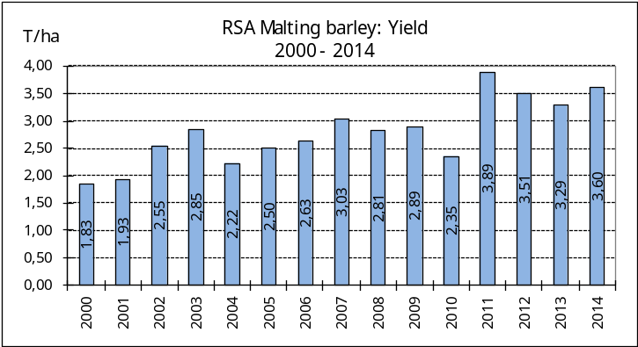
WHEAT – AREA PLANTED ESTIMATE AND FINAL PRODUCTION ESTIMATE: 2014
KORING – OPPERVLAKTE- EN FINALE PRODUKSIESKATTING: 2014
Province/  Provinsie | Area planted/  Opp beplant  Ha | Final estimate/  Finale skatting  Tons | Area planted/  Opp beplant  Ha | Final crop/  Finale oes  Tons
Province/  Provinsie | 2014 | 2014 | 2013 | 2013
Western Cape/Wes-Kaap | 310 000 | 899 000 | 310 000 | 928 000
Northern Cape/Noord-Kaap | 38 000 | 285 000 | 42 000 | 320 000
Free State/Vrystaat | 69 500 | 271 050 | 90 000 | 270 000
Eastern Cape/Oos-Kaap | 3 000 | 12 000 | 4 500 | 19 800
KwaZulu-Natal | 6 500 | 39 000 | 7 000 | 42 000
Mpumalanga | 3 500 | 21 350 | 4 500 | 28 000
Limpopo | 27 500 | 137 500 | 28 000 | 146 000
Gauteng | 570 | 3 534 | 1 000 | 6 200
North West/Noordwes | 18 000 | 107 100 | 18 500 | 110 000
Total/Totaal | 476 570 | 1 775 534 | 505 500 | 1 870 000

AREA PLANTED AND FINAL PRODUCTION ESTIMATE OF WINTER CEREALS (2014 PRODUCTION SEASON) /
OPPERVLAK - EN FINALE PRODUKSIESKATTING VIR WINTERGEWASSE (2014 PRODUKSIE-SEISOEN)
26 FEBRUARY/ FEBRUARIE 2015

Winter cereal crops - 2014 production season  Wheat: The final commercial production estimate of wheat remained unchanged at 1,776 mill. tons, whilst the expected yield is 3,73 t/ha.  The expected production in the Western Cape is 899 000 tons (51%), in the Northern Cape 285 000 tons (16%) and in the Free State 271 050 tons (15%).  The area estimate for wheat remained unchanged at 476 570 ha.  Other crops: The production forecast for malting barley decreased slightly by 3 575 tons to 306 786 tons. The area planted is estimated at 85 125 ha, while the expected yield is 3,60 t/ha.  The expected canola crop remained unchanged at 123 500 tons. The area estimate for canola is 95 000 ha, with an expected yield of 1,30 t/ha.  Please note that the intentions to plant winter cereals for 2015 will be released on 29 April 2015. |  | Wintergewasse - 2014 produksie-seisoen  Koring: Die finale kommersiële produksieskatting vir koring is onveranderd gelaat op 1,776 milj. ton, terwyl die verwagte opbrengs 3,73 t/ha is.  Die verwagte produksie in die Wes-Kaap is 899 000 ton (51%), in die Noord-Kaap 285 000 ton (16%) en in die Vrystaat 271 050 ton (15%).  Die oppervlakteskatting vir koring is onveranderd gelaat op 476 570 ha.  Ander gewasse: Die produksieskatting vir moutgars het effens afgeneem met 3 575 ton tot 306 786 ton. Die oppervlakte beplant is beraam op 85 125 ha, terwyl die verwagte opbrengs 3,60 t/ha beloop.  Die verwagte kanola-oes is onverander gelaat op 123 500 ton. Die oppervlakteskatting vir kanola is 95 000 ha, met ŉ verwagte opbrengs van 1,30 t/ha.  Neem asseblief kennis dat die voorneme om wintergewasse te plant vir 2015 op 29 April 2015 vrygestel sal word.

Information is available on the internet at http://www.daff.gov.za/crop estimates or http://www.sagis.org.za, as from 15:30 on the date of the relevant meeting of the Crop Estimates Committee. |  | Inligting is beskikbaar op die internet by http://www.daff.gov.za/crop estimates of by http://www.sagis.org.za, vanaf 15:30 op die dag van die toepaslike vergadering van die Oesskattingskomitee.
CONFIDENTIALITY ISSUES that CEC members are committed to adhere to on the day of the meeting
- Personal items such as laptops, handbags, cell phones, etc. are not allowed in the venue during the meeting
- No member is allowed to leave the meeting before 12:00 in order to prevent disclosure of the information
- The embargo time for the release of crop estimates information is 15:30
- No member is allowed to discuss crop estimates information with anyone other than a member of the Committee before the embargo time
- Only the Chairperson, or a member appointed by the Chairperson, may release the figures to the media
- Members must regard the detail of any information that was collected for and/or discussed during the meeting, as confidential
- Individual information received for crop estimate purposes is treated strictly confidential, and is not divulged for any other purposes

