 | crop estimates committee | 
 | oesskattingskomitee
From/Van: Rodney D. Dredge
Tel: 012 319 6507  Fax/Faks: 012 319 6211  E-mail/E-pos: RodneyD@daff.gov.za
Web page/Webblad: www.daff.gov.za/crop estimates or www.sagis.org.za/CEC: Crop Estimates
EMBARGO: 15:30

The final production estimate for summer crops for 2013 is hereby released. /
Hiermee word die finale produksieskatting vir somergewasse vir 2013 vrygestel.

SUMMER CROPS – AREA PLANTED AND FINAL PRODUCTION ESTIMATE: 2013
SOMERGEWASSE – OPPERVLAKTE EN FINALE PRODUKSIESKATTING: 2013
CROP/GEWAS | Area planted/  Opp beplant  2013 | Final estimate/  Finale skatting  2013 | 7th forecast/  7de skatting  2013 | Area planted/  Opp beplant  2012 | Finale oes/  Final crop  2012 | Change/  Verandering/
CROP/GEWAS | Ha | Tons | Tons | Ha | Tons | %
CROP/GEWAS | (A) | (B) | (C) | (D) | (E) | (B) ÷ (C)
Commercial/Kommersieel:
White maize/Witmielies | 1 617 200 | 5 580 300 | 5 580 300 | 1 636 200 | 6 903 656 | -
Yellow maize/Geelmielies | 1 164 000 | 6 142 250 | 5 933 100 | 1 063 000 | 5 217 000 | +3,53
Maize/Mielies | 2 781 200 | 11 722 550 | 11 513 400 | 2 699 200 | 12 120 656 | +1,82
Sunflower seed/Sonneblomsaad | 504 700 | 566 600 | 566 600 | 453 350 | 522 000 | -
Soya-beans/Sojabone | 516 500 | 787 100 | 787 100 | 472 000 | 650 000 | -
Groundnuts/Grondbone | 46 900 | 42 300 | 42 300 | 45 450 | 59 000 | -
Sorghum | 62 620 | 151 064 | 154 494 | 48 550 | 135 500 | -2,22
Dry beans/Droëbone | 43 550 | 60 200 | 60 200 | 39 750 | 47 695 | -
TOTAL/TOTAAL | 3 955 470 | 13 329 814 | 13 124 094 | 3 758 300 | 13 534 851 | +1,57

The Crop Estimates Committee comprises of the following officials:
Department of Agriculture, Forestry and Fisheries; Provincial Departments of Agriculture; various ARC-Institutes (Soil, Climate and Water; Small Grains Institute; and Grain Crops Institute),
Statistics SA
Note: Estimate is for calendar year, e.g. production season 2012/13 = 2013
Nota: Skatting is vir kalenderjaar, bv. produksie-seisoen 2012/13 = 2013

26 September 2013

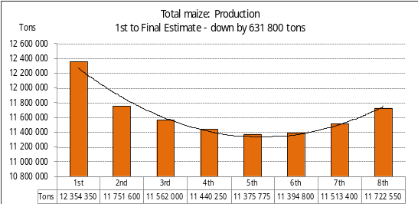

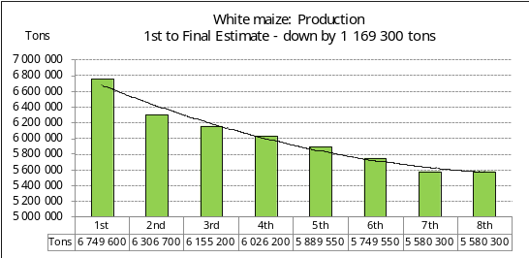

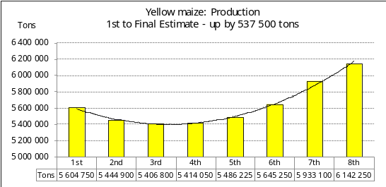

WHITE AND YELLOW MAIZE – AREA PLANTED AND FINAL PRODUCTION ESTIMATE: 2013
WIT- EN GEELMIELIES – OPPERVLAKTE EN FINALE PRODUKSIESKATTING: 2013

Provinsie/  Province | Area planted/  Oppervlakte beplant  2013 |  |  | Final estimate/  Finale skatting  2013 |  |  | Area planted/  Oppervlakte beplant  2012 |  |  | Final crop/  Finale oes  2012
Provinsie/  Province | White/  Wit  Ha | Yellow/  Geel  Ha | Total/  Totaal  Ha | White/  Wit  Tons | Yellow/  Geel  Tons | Total/  Totaal  Tons | White/  Wit  Ha | Yellow/  Geel  Ha | Total/  Totaal  Ha | White/  Wit  Tons | Yellow/  Geel  Tons | Total/  Totaal  Tons
Western Cape/Wes-Kaap | 300 | 3 000 | 3 300 | 3 000 | 30 000 | 33 000 | 500 | 2 500 | 3 000 | 5 000 | 25 000 | 30 000
Northern Cape/Noord-Kaap | 2 200 | 51 000 | 53 200 | 25 300 | 647 700 | 673 000 | 2 200 | 47 000 | 49 200 | 25 400 | 592 000 | 617 400
Free State/Vrystaat | 725 000 | 505 000 | 1 230 000 | 2 573 750 | 2 272 500 | 4 846 250 | 710 000 | 450 000 | 1 160 000 | 3 050 000 | 1 773 000 | 4 823 000
Eastern Cape/Oos-Kaap | 3 700 | 15 000 | 18 700 | 18 500 | 87 000 | 105 500 | 3 500 | 13 500 | 17 000 | 17 756 | 75 000 | 92 756
KwaZulu-Natal | 47 000 | 48 000 | 95 000 | 258 500 | 312 000 | 570 500 | 44 000 | 45 000 | 89 000 | 242 000 | 270 000 | 512 000
Mpumalanga | 170 000 | 300 000 | 470 000 | 1 020 000 | 1 980 000 | 3 000 000 | 160 000 | 290 000 | 450 000 | 904 000 | 1 625 000 | 2 529 000
Limpopo | 30 000 | 23 500 | 53 500 | 153 000 | 136 300 | 289 300 | 32 000 | 18 000 | 50 000 | 174 500 | 99 000 | 273 500
Gauteng | 74 000 | 43 500 | 117 500 | 370 000 | 239 250 | 609 250 | 74 000 | 42 000 | 116 000 | 378 500 | 200 000 | 578 500
North West/Noordwes | 565 000 | 175 000 | 740 000 | 1 158 250 | 437 500 | 1 595 750 | 610 000 | 155 000 | 765 000 | 2 106 500 | 558 000 | 2 664 500
Total/Totaal | 1 617 200 | 1 164 000 | 2 781 200 | 5 580 300 | 6 142 250 | 11 722 550 | 1 636 200 | 1 063 000 | 2 699 200 | 6 903 656 | 5 217 000 | 12 120 656

SUNFLOWER SEED – AREA PLANTED AND FINAL PRODUCTION ESTIMATE: 2013
SONNEBLOMSAAD – OPPERVLAKTE EN FINALE PRODUKSIESKATTING: 2013

Province/  Provinsie | Area planted/  Opp beplant  Ha | Final forecast/  Finale skatting  Tons | Area planted/  Opp beplant  Ha | Final crop/  Finale oes  Tons
Province/  Provinsie | 2013 | 2013 | 2012 | 2012
Western Cape/Wes-Kaap | - | - | - | -
Northern Cape/Noord-Kaap | 200 | 100 | 350 | 100
Free State/Vrystaat | 220 000 | 297 000 | 190 000 | 247 000
Eastern Cape/Oos-Kaap | - | - | - | -
KwaZulu-Natal | - | - | - | -
Mpumalanga | 6 600 | 10 230 | 10 000 | 13 500
Limpopo | 99 000 | 79 200 | 100 000 | 85 000
Gauteng | 3 900 | 5 070 | 3 000 | 3 900
North West/Noordwes | 175 000 | 175 000 | 150 000 | 172 500
Total/Totaal | 504 700 | 566 600 | 453 350 | 522 000

SOYA-BEANS – AREA PLANTED AND FINAL PRODUCTION ESTIMATE: 2013
SOJABONE – OPPERVLAKTE EN FINALE PRODUKSIESKATTING: 2013

Province/  Provinsie | Area planted/  Opp beplant  Ha | Final forecast/  Finale skatting Tons | Area planted/  Opp beplant  Ha | Final crop/  Finale oes  Tons
Province/  Provinsie | 2013 | 2013 | 2012 | 2012
Western Cape/Wes-Kaap | - | - | - | -
Northern Cape/Noord-Kaap | 2 000 | 7 000 | 500 | 1 500
Free State/Vrystaat | 215 000 | 225 750 | 175 000 | 192 500
Eastern Cape/Oos-Kaap | 500 | 750 | 500 | 750
KwaZulu-Natal | 32 000 | 80 000 | 34 000 | 81 600
Mpumalanga | 205 000 | 369 000 | 200 000 | 263 050
Limpopo | 20 000 | 55 000 | 22 000 | 50 600
Gauteng | 20 000 | 32 000 | 19 000 | 28 500
North West/Noordwes | 22 000 | 17 600 | 21 000 | 31 500
Total/Totaal | 516 500 | 787 100 | 472 000 | 650 000

GROUNDNUTS – AREA PLANTED AND FINAL PRODUCTION ESTIMATE: 2013
GRONDBONE – OPPERVLAKTE EN FINALE PRODUKSIESKATTING: 2013

Province/  Provinsie | Area planted/  Opp beplant  Ha | Final estimate/  Finale skatting Tons | Area planted/  Opp beplant  Ha | Final crop/  Finale oes  Tons
Province/  Provinsie | 2013 | 2013 | 2012 | 2012
Western Cape/Wes-Kaap | - | - | - | -
Northern Cape/Noord-Kaap | 7 000 | 14 000 | 6 500 | 16 900
Free State/Vrystaat | 18 000 | 16 200 | 20 000 | 21 800
Eastern Cape/Oos-Kaap | - | - | - | -
KwaZulu-Natal | 150 | 150 | 150 | 150
Mpumalanga | 750 | 750 | - | -
Limpopo | 1 000 | 1 200 | 2 800 | 3 350
Gauteng | - | - | - | -
North West/Noordwes | 20 000 | 10 000 | 16 000 | 16 800
Total/Totaal | 46 900 | 42 300 | 45 450 | 59 000

SORGHUM – AREA PLANTED AND FINAL PRODUCTION ESTIMATE: 2013
SORGHUM – OPPERVLAKTE EN FINALE PRODUKSIESKATTING: 2013

Province/  Provinsie | Area planted/  Opp beplant  Ha | Final estimate/  Finale skatting  Tons | Area planted/  Opp beplant  Ha | Final crop/  Finale oes  Tons
Province/  Provinsie | 2013 | 2013 | 2012 | 2012
Western Cape/Wes-Kaap | - | - | - | -
Northern Cape/Noord-Kaap | - | - | - | -
Free State/Vrystaat | 32 000 | 70 400 | 22 000 | 60 500
Eastern Cape/Oos-Kaap | - | - | - | -
KwaZulu-Natal | 320 | 1 344 | 200 | 800
Mpumalanga | 11 500 | 44 850 | 11 500 | 49 450
Limpopo | 12 000 | 21 000 | 10 000 | 13 700
Gauteng | 500 | 1 500 | 350 | 1 050
North West/Noordwes | 6 300 | 11 970 | 4 500 | 10 000
Total/Totaal | 62 620 | 151 064 | 48 550 | 135 500

DRY BEANS – AREA PLANTED AND FINAL PRODUCTION ESTIMATE: 2013
DROëBONE – OPPERVLAKTE EN FINALE PRODUKSIESKATTING: 2013

Province/  Provinsie | Area planted/  Opp beplant  Ha | Final estimate/  Finale skatting  Tons | Area planted/  Opp beplant  Ha | Final crop/  Finale oes  Tons
Province/  Provinsie | 2013 | 2013 | 2012 | 2012
Western Cape/Wes-Kaap | 200 | 400 | 500 | 1 000
Northern Cape/Noord-Kaap | 850 | 1 700 | 750 | 1 500
Free State/Vrystaat | 16 000 | 19 200 | 16 000 | 17 600
Eastern Cape/Oos-Kaap | 100 | 200 | 200 | 240
KwaZulu-Natal | 6 000 | 7 800 | 4 000 | 5 200
Mpumalanga | 7 000 | 11 900 | 6 300 | 8 505
Limpopo | 5 400 | 10 800 | 5 000 | 6 250
Gauteng | 2 000 | 3 400 | 2 000 | 2 400
North West/Noordwes | 6 000 | 4 800 | 5 000 | 5 000
Total/Totaal | 43 550 | 60 200 | 39 750 | 47 695

CONFIDENTIALITY ISSUES that CEC members are committed to adhere to on the day of the meeting
- Personal items such as laptops, handbags, cell phones, etc. are not allowed in the venue during the meeting
- No member is allowed to leave the meeting before 12:00 in order to prevent disclosure of the information
- The embargo time for the release of crop estimates information is 15:30
- No member is allowed to discuss crop estimates information with anyone other than a member of the Committee before the embargo time
- Only the Chairperson, or a member appointed by the Chairperson, may release the figures to the media
- Members must regard the detail of any information that was collected for and/or discussed during the meeting, as confidential
- Individual information received for crop estimate purposes is treated strictly confidential, and is not divulged for any other purposes

AREA AND FINAL PRODUCTION ESTIMATE OF SUMMER CROPS (2013)/
OPPERVLAKTE- EN FINALE PRODUKSIESKATTING VIR SOMERGEWASSE (2013)
26 SEPTEMBER 2013

Summer field crops – 2013  Commercial maize: The potential size of the maize crop was increased by 209 150 tons or 1,82% to 11,723 mill. tons, mainly based on actual producer deliveries, as reported by SAGIS.  The area estimate for maize remained unchanged at 2,781 mill. ha, while the expected yield is 4,21 t/ha.  The area estimate for white maize is 1,617 mill. ha and for yellow maize it is 1,164 mill. ha.  The production estimate of white maize remained unchanged at 5,580 mill. tons and the expected yield is 3,45 t/ha. In the case of yellow maize the production estimate is 6,142 mill. tons, which is 209 150 tons or 3,53% more than the 5,933 mill. tons of the previous forecast. The yield for yellow maize is 5,28 t/ha as against the previous 5,10 t/ha.  Sunflower seed: The production estimate for sunflower seed remained unchanged at 566 600 tons. The area estimate for sunflower seed is 504 700 ha, with an expected yield of 1,12 t/ha.  Other crops: The production estimate for soya-beans remained unchanged at 787 100 tons. For soya-beans the area estimate is 516 500 ha, with an expected yield of 1,52 t/ha.  The expected groundnut crop also remained unchanged at 42 300 tons. The area estimate is 46 900 ha, and the expected yield is 0,90 t/ha.  The production estimate for sorghum was decreased by 3 430 tons or 2,22% to 151 064 tons, as against the previous forecast. The area estimate for sorghum is 62 620 ha, and the expected yield is 2,41 t/ha.  In the case of dry beans the production estimate remained unchanged at 60 200 tons, with an area estimate of 43 550 ha. The expected yield is 1,38 t/ha.  Please note that the ‘intentions of farmers’ to plant summer grain crops for 2014 will be released on 24 October 2013 at 15:30. |  | Somergewasse – 2013  Kommersiële mielies: Die potensiële grootte van die mielie-oes is verhoog met 209 150 ton of 1,82% tot 11,723 milj. ton, hoofsaaklik gebaseer op werklike produsentelewerings, soos gemonitor deur SAGIS.  Die skatting van die oppervlakte onder mielies is onveranderd gelaat op 2,781 milj. ha, terwyl die verwagte opbrengs 4,21 t/ha is.  Die oppervlak onder witmielies is 1,617 milj. ha en vir geelmielies is dit 1,164 milj. ha.  Die produksieskatting van witmielies is onveranderd gelaat op 5,580 miljoen ton, en die verwagte opbrengs is 3,45 t/ha. In die geval van geelmielies is die produksieskatting 6,142 miljoen ton, wat 209 150 ton of 3,53% meer is as die 5,933 milj. ton van die vorige skatting. Die opbrengs van geelmielies is 5,28 t/ha teenoor die vorige 5,10 t/ha.  Sonneblomsaad: Die produksieskatting vir sonneblomsaad is onveranderd gelaat op 566 600 ton. Die oppervlakteskatting vir sonneblomsaad is 504 700 ha, terwyl die verwagte opbrengs 1,12 t/ha is.  Ander gewasse: Die produksieskatting van sojabone is onveranderd gelaat op 787 100 ton. Die oppervlakte beplant met sojabone is 516 500 ha, met ‘n verwagte opbrengs van 1,52 t/ha.  Die verwagte grondbone-oes is ook onveranderd gelaat op 42 300 ton. Die oppervlakteskatting is 46 900 ha, terwyl die verwagte opbrengs 0,90 t/ha is.  Die produksieskatting van sorghum is verminder met 3 430 ton of 2,22% tot 151 064 ton teenoor die vorige skatting. Die oppervlakteskatting vir sorghum is 62 620 ha en die verwagte opbrengs is 2,41 t/ha.  In die geval van droëbone is die produksieskatting onveranderd gelaat op 60 200 ton, met ’n oppervlakteskatting van 43 550 ha. Die verwagte opbrengs is 1,38 t/ha.  Neem asseblief kennis dat die ‘voorneme van produsente om somergraangewasse te plant’ vir 2014, op 24 Oktober 2013 om 15:30 vrygestel sal word.

Information is available on the internet at http://www.daff.gov.za/crop estimates or http://www.sagis.org.za, as from 15:30 on the date of the relevant meeting of the Crop Estimates Committee. |  | Inligting is beskikbaar op die internet by http://www.daff.gov.za/crop estimates of by http://www.sagis.org.za, vanaf 15:30 op die dag van die toepaslike vergadering van die Oesskattingskomitee.

The non-commercial agricultural sectors’ production estimate for maize for 2013 is hereby released. /
Hiermee word die nie-kommersiële landbou-sektor se produksieskatting vir mielies vir 2013 vrygestel.

NON-COMMERCIAL MAIZE – AREA PLANTED AND PRODUCTION ESTIMATE: 2013
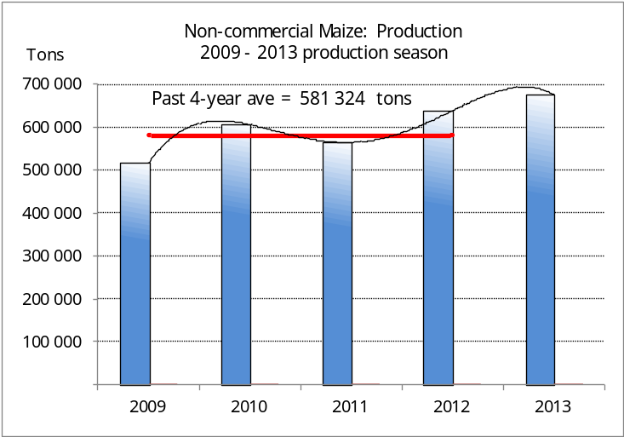
NIE-KOMMERSIëLE MIELIES – OPPERVLAKTE- EN PRODUKSIESKATTING: 2013
CROP/GEWAS | Area planted/  Opp beplant  2013 | Production/  Produksie  2013 | Area planted/  Opp beplant  2012 | Final crop/  Finale oes  2012 | Change/  Verandering
CROP/GEWAS | Ha | Tons | Ha | Tons | %
CROP/GEWAS | (A) | (B) | (C) | (D) | (B) ÷ (D)
Non-commercial agriculture/Nie-kommersiële landbou:
White maize/Witmielies | 320 105 | 459 995 | 302 316 | 429 329 | +7,14
Yellow maize/Geelmielies | 136 795 | 215 095 | 139 798 | 209 134 | +2,85
Maize/Mielies | 456 900 | 675 090 | 442 114 | 638 463 | +5,74
The area planted to maize in the non-commercial agricultural sector is estimated at 456 900 ha, which represents an increase of 3,34% compared to the 442 114 ha of the previous season. The expected maize crop for this sector is 675 090 tons, which is 5,74 % higher than the 638 463 tons of last season. It is important to note that about 58% of the maize produced in the non-commercial sector, is planted in the Eastern Cape.
Die oppervlakte beplant met mielies in die nie-kommersiële landbou-sektor word geskat op 456 900 ha, wat ‘n toename van 3,34 % verteenwoordig in vergelyking met die 442 114 ha van die vorige seisoen. Die verwagte mielie-oes van dié sektor is 675 090 ton, wat 5,74 % hoër is as die 638 463 ton van die vorige seisoen. Dit is belangrik om daarop te let dat ongeveer 58% van die mielies wat geproduseer word in die nie-kommersiële sektor, in die Oos-Kaap geplant word.

The revised area estimate and second production forecast for winter cereals for the 2013 is hereby released. /
Hiermee word die hersiene oppervlakteskatting en tweede produksieskatting vir wintergewasse vir 2013 vrygestel.

WINTER CEREALS – REVISED AREA PLANTED ESTIMATE AND SECOND PRODUCTION FORECAST: 2013
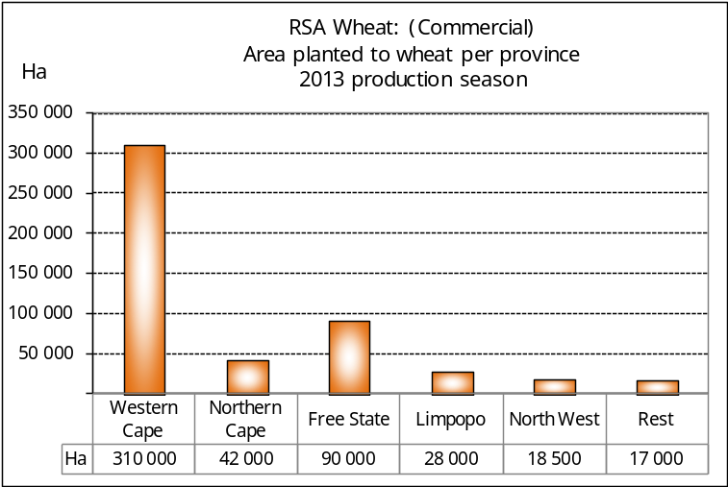
WINTERGEWASSE – HERSIENE OPPERVLAKTE- EN TWEEDE PRODUKSIESKATTING: 2013
CROP/GEWAS | Area planted/  Opp beplant  2013 | 2nd forecast/  2de skatting  2013 | 1st forecast/  1ste skatting  2013 | Area planted/  Opp beplant  2012 | Final crop/  Finale oes  2012 | Change/  Verandering
CROP/GEWAS | Ha | Tons | Tons | Ha | Tons | %
CROP/GEWAS | (A) | (B) | (C) | (D) | (E) | (B) ÷ (C)
Commercial/Kommersieel:
Wheat/Koring | 505 500 | 1 758 500 | 1 784 950 | 511 200 | 1 870 000 | -1,48
Malting barley/Moutgars | 81 320 | 280 961 | 280 961 | 84 940 | 298 000 | -
Canola/Kanola | 75 165 | 113 001 | 113 001 | 44 100 | 79 000 | -
Total/Totaal | 661 985 | 2 152 462 | 2 178 912 | 640 240 | 2 247 000 | -1,21
Note: Estimate is for calendar year, e.g. production season 2013/14 = 2013
Nota: Skatting is vir kalenderjaar, bv. produksie-seisoen 2013/14 = 2013

WHEAT – REVISED AREA PLANTED ESTIMATE AND SECOND PRODUCTION FORECAST: 2013
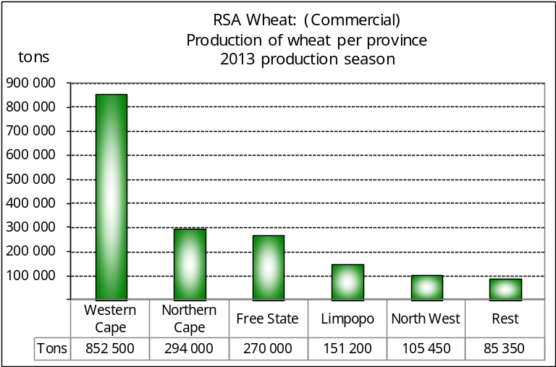
KORING – HERSIENE OPPERVLAKTE- EN TWEEDE PRODUKSIESKATTING: 2013
Province/  Provinsie | Area planted/  Opp beplant  Ha | 2nd forecast/  2de skatting  Tons | Area planted/  Opp beplant  Ha | Final crop/  Finale oes  Tons
Province/  Provinsie | 2013 | 2013 | 2012 | 2012
Western Cape/Wes-Kaap | 310 000 | 852 500 | 272 000 | 897 600
Northern Cape/Noord-Kaap | 42 000 | 294 000 | 42 000 | 272 600
Free State/Vrystaat | 90 000 | 270 000 | 130 000 | 360 000
Eastern Cape/Oos-Kaap | 4 500 | 18 900 | 4 500 | 18 500
KwaZulu-Natal | 7 000 | 35 700 | 6 500 | 32 500
Mpumalanga | 4 500 | 24 750 | 4 700 | 25 380
Limpopo | 28 000 | 151 200 | 30 000 | 141 000
Gauteng | 1 000 | 6 000 | 1 500 | 8 420
North West/Noordwes | 18 500 | 105 450 | 20 000 | 114 000
Total/Totaal | 505 500 | 1 758 500 | 511 200 | 1 870 000

REVISED AREA ESTIMATE AND SECOND PRODUCTION FORECAST OF WINTER CROPS (2013) /
HERSIENE OPPERVLAKTEKSKATTING EN TWEEDE PRODUKSIESKATTING VAN WINTERGEWASSE (2013)
26 SEPTEMBER 2013

Winter cereal crops - 2013 production season  Wheat: The expected commercial production of wheat is 1,758 mill. tons, which is 1,48% less than the previous forecast of 1,785 mill. tons, whilst the expected yield is 3,48 t/ha.  The expected production in the Western Cape is 852 500 tons (48%), in the Northern Cape 294 000 tons (17%) and in the Free State 270 000 tons (15%).  The area estimate for wheat was revised to 505 500 ha, which is 20 000 ha less than the 525 500 ha of the previous estimate. The main reason for the decrease in the area was because of a downward revision in the area planted for the Free State, from 110 000 ha to 90 000 ha.  The revised area estimate for the Free State is based on information obtained from the Producer Independent Crop Estimation System (PICES) as conducted by the National Crop Statistics Consortium (NCSC), which is led by the ARC.  Other crops: The production forecast for malting barley remained unchanged at 280 961 tons. The area planted is estimated at 81 320 ha, while the expected yield is 3,46 t/ha.  The expected canola crop is 113 001 tons. The area estimate for canola is 75 165 ha, with an expected yield of 1,50 t/ha.  Please note that the third production forecast for winter cereals for 2013 will be released on 24 October 2013. |  | Wintergewasse - 2013 produksie-seisoen  Koring: Die verwagte kommersiële produksie vir koring is 1,758 milj. ton, wat 1,48% minder is as die vorige skatting van 1,785 milj. ton, terwyl die verwagte opbrengs 3,48 t/ha is.  Die verwagte produksie in die Wes-Kaap is 852 500 ton (48%), in die Noord-Kaap 294 000 ton (17%) en in die Vrystaat 270 000 ton (15%).  Die oppervlakteskatting vir koring is hersien na 505 500 ha, wat 20 000 ha minder is as die 525 500 ha teenoor die vorige skatting. Die vernaamste rede vir die afname in die oppervlakte beplant was as gevolg van ’n afwaartse afname in die oppervlakte vir die Vrystaat, vanaf 110 000 ha tot 90 000 ha.  Die hersiene oppervlakteskatting vir die Vrystaat is gebaseer op inligting soos verkry vanaf die Produsente Onafhanklike Oesskattingstelsel (“PICES”) , soos deur die LNR-geleide Konsortium gerapporteer.  Ander gewasse: Die produksieskatting vir moutgars is onveranderd gelaat op 280 961 ton. Die oppervlakte beplant is beraam op 81 320 ha, terwyl die verwagte opbrengs 3,46 t/ha beloop.  Die verwagte kanola-oes is 113 001 ton. Die oppervlakteskatting vir kanola is 75 165 ha, met ŉ verwagte opbrengs van 1,50 t/ha.  Neem asseblief kennis dat die derde produksieskatting vir wintergewasse vir 2013 op 24 Oktober 2013 vrygestel sal word.

Information is available on the internet at http://www.daff.gov.za/links/crop estimates or http://www.sagis.org.za, as from 15:30 on the date of the relevant meeting of the Crop Estimates Committee. |  | Inligting is beskikbaar op die internet by http://www.daff.gov.za/links/crop estimates of by http://www.sagis.org.za, vanaf 15:30 op die dag van die toepaslike vergadering van die Oesskattingskomitee.

