 | crop estimates committee | 
 | oesskattingskomitee
From/Van: Rodney D. Dredge
Tel: 012 319 6507  Fax/Faks: 012 319 6211  E-mail/E-pos: RodneyD@daff.gov.za
Web page/Webblad: www.daff.gov.za/statistics and economic reports or www.sagis.org.za/CEC: Crop Estimates
EMBARGO: 15:30

The area planted estimate and fourth production forecast for summer crops for 2016 is hereby released.
Hiermee word die oppervlakte- en vierde produksieskatting vir somergewasse vir 2016 vrygestel.

SUMMER CROPS – AREA PLANTED AND FOURTH PRODUCTION FORECAST: 2016
SOMERGEWASSE – OPPERVLAKTE- EN VIERDE PRODUKSIESKATTING: 2016
CROP/GEWAS  The Crop Estimates Committee comprises officials of the following institutions:  Department of Agriculture, Forestry and Fisheries; Provincial Departments of Agriculture; various ARC-Institutes (Soil, Climate and Water; Small Grains Institute;  and Grain Crops Institute); and Statistics SA. | Area planted/  Opp beplant  2016 | 4th forecast/  4de skatting  2016 | 3rd forecast/  3de skatting  2016 | Area planted/  Opp beplant  2015 | Final crop/  Finale oes  2015 | Change/  Verandering/
 | Ha | Tons | Tons | Ha | Tons | %
 | (A) | (B) | (C) | (D) | (E) | (B) ÷ (C)
Commercial/Kommersieel:
White maize/Witmielies | 1 014 750 | 3 067 475 | 3 070 675 | 1 448 050 | 4 735 000 | -0,10
Yellow maize/Geelmielies | 932 000 | 3 986 900 | 3 994 600 | 1 204 800 | 5 220 000 | -0,19
Total Maize/Totale Mielies | 1 946 750 | 7 054 375 | 7 065 275 | 2 652 850 | 9 955 000 | -0,15
Sunflower seed/Sonneblomsaad | 718 500 | 730 500 | 710 500 | 576 000 | 663 000 | +2,81
Soybeans/Sojabone | 502 800 | 694 550 | 691 750 | 687 300 | 1 070 000 | +0,40
Groundnuts/Grondbone | 22 600 | 32 550 | 33 550 | 58 000 | 62 300 | -2,98
Sorghum | 48 500 | 88 500 | 92 700 | 70 500 | 120 500 | -4,53
Dry beans/Droëbone | 34 400 | 38 095 | 38 195 | 64 000 | 73 390 | -0,26
TOTAL/TOTAAL | 3 273 550 | 8 638 570 | 8 631 970 | 4 108 650 | 11 944 190 | +0,08
Note: Estimate is for calendar year, e.g. production season 2015/16 = 2016
Nota: Skatting is vir kalenderjaar, bv. produksie-seisoen 2015/16 = 2016

26 April 2016

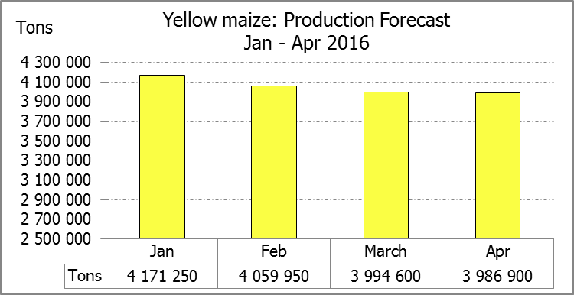
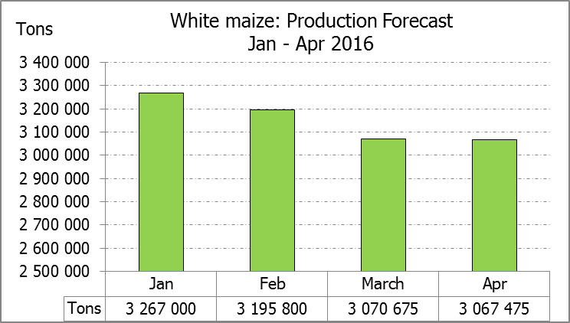

WHITE AND YELLOW MAIZE – AREA PLANTED AND FOURTH PRODUCTION FORECAST: 2016
WIT- EN GEELMIELIES – OPPERVLAKTE EN VIERDE PRODUKSIESKATTING: 2016

Provinsie/  Province | Area planted/  Oppervlakte beplant  2016 |  |  | 4th forecast/  4de skatting  2016 |  |  | Area planted/  Oppervlakte beplant  2015 |  |  | Final crop/  Finale oes  2015
Provinsie/  Province | White/  Wit  Ha | Yellow/  Geel  Ha | Total/  Totaal  Ha | White/  Wit  Tons | Yellow/  Geel  Tons | Total/  Totaal  Tons | White/  Wit  Ha | Yellow/  Geel  Ha | Total/  Totaal  Ha | White/  Wit  Tons | Yellow/  Geel  Tons | Total/  Totaal  Tons
Western Cape/Wes-Kaap | 500 | 4 000 | 4 500 | 5 000 | 40 000 | 45 000 | 450 | 3 800 | 4 250 | 4 050 | 34 200 | 38 250
Northern Cape/Noord-Kaap | 3 750 | 50 000 | 53 750 | 35 625 | 665 000 | 700 625 | 3 500 | 46 000 | 49 500 | 35 000 | 644 000 | 679 000
Free State/Vrystaat | 390 000 | 310 000 | 700 000 | 1 092 000 | 945 500 | 2 037 500 | 710 000 | 510 000 | 1 220 000 | 2 236 000 | 1 708 500 | 3 944 500
Eastern Cape/Oos-Kaap | 2 000 | 12 000 | 14 000 | 10 000 | 60 000 | 70 000 | 2 600 | 14 000 | 16 600 | 15 600 | 84 000 | 99 600
KwaZulu-Natal | 38 000 | 48 000 | 86 000 | 193 800 | 278 400 | 472 200 | 40 000 | 45 000 | 85 000 | 224 000 | 283 500 | 507 500
Mpumalanga | 160 000 | 330 000 | 490 000 | 672 000 | 1 452 000 | 2 124 000 | 154 000 | 315 000 | 469 000 | 824 000 | 1 605 300 | 2 429 300
Limpopo | 31 500 | 22 000 | 53 500 | 173 250 | 127 600 | 300 850 | 28 500 | 21 000 | 49 500 | 156 750 | 124 000 | 280 750
Gauteng | 49 000 | 56 000 | 105 000 | 205 800 | 218 400 | 424 200 | 44 000 | 65 000 | 109 000 | 193 600 | 292 500 | 486 100
North West/Noordwes | 340 000 | 100 000 | 440 000 | 680 000 | 200 000 | 880 000 | 465 000 | 185 000 | 650 000 | 1 046 000 | 444 000 | 1 490 000
Total/Totaal | 1 014 750 | 932 000 | 1 946 750 | 3 067 475 | 3 986 900 | 7 054 375 | 1 448 050 | 1 204 800 | 2 652 850 | 4 735 000 | 5 220 000 | 9 955 000

SUNFLOWER SEED – AREA PLANTED AND FOURTH PRODUCTION FORECAST: 2016
SONNEBLOMSAAD – OPPERVLAKTE EN VIERDE PRODUKSIESKATTING: 2016

Province/  Provinsie | Area planted/  Opp beplant  Ha | 4th forecast/  4de skatting  Tons | Area planted/  Opp beplant  Ha | Final crop/  Finale oes  Tons
Province/  Provinsie | 2016 | 2016 | 2015 | 2015
Western Cape/Wes-Kaap | - | - | - | -
Northern Cape/Noord-Kaap | 500 | 600 | 500 | 500
Free State/Vrystaat | 400 000 | 440 000 | 285 000 | 370 500
Eastern Cape/Oos-Kaap | - | - | - | -
KwaZulu-Natal | - | - | - | -
Mpumalanga | 4 000 | 4 400 | 2 500 | 3 300
Limpopo | 65 000 | 48 750 | 82 000 | 61 500
Gauteng | 4 000 | 4 000 | 6 000 | 7 200
North West/Noordwes | 245 000 | 232 750 | 200 000 | 220 000
Total/Totaal | 718 500 | 730 500 | 576 000 | 663 000

SOYBEANS – AREA PLANTED AND FOURTH PRODUCTION FORECAST: 2016
SOJABONE – OPPERVLAKTE EN VIERDE PRODUKSIESKATTING: 2016

Province/  Provinsie | Area planted/  Opp beplant  Ha | 4th forecast/  4de skatting  Tons | Area planted/  Opp beplant  Ha | Final crop/  Finale oes  Tons
Province/  Provinsie | 2016 | 2016 | 2015 | 2015
Western Cape/Wes-Kaap | 800 | 1 200 | 800 | 1 600
Northern Cape/Noord-Kaap | 4 000 | 12 400 | 4 000 | 14 000
Free State/Vrystaat | 174 000 | 156 600 | 305 000 | 366 000
Eastern Cape/Oos-Kaap | 1 500 | 2 100 | 1 500 | 2 100
KwaZulu-Natal | 28 000 | 61 600 | 42 000 | 102 900
Mpumalanga | 240 000 | 360 000 | 245 000 | 389 900
Limpopo | 16 000 | 38 400 | 24 000 | 72 000
Gauteng | 23 000 | 48 300 | 30 000 | 69 000
North West/Noordwes | 15 500 | 13 950 | 35 000 | 52 500
Total/Totaal | 502 800 | 694 550 | 687 300 | 1 070 000

GROUNDNUTS – AREA PLANTED AND FOURTH PRODUCTION FORECAST: 2016
GRONDBONE – OPPERVLAKTE EN VIERDE PRODUKSIESKATTING: 2016

Province/  Provinsie | Area planted/  Opp beplant  Ha | 4th forecast/  4de skatting Tons | Area planted/  Opp beplant  Ha | Final crop/  Finale oes  Tons
Province/  Provinsie | 2016 | 2016 | 2015 | 2015
Western Cape/Wes-Kaap | - | - | - | -
Northern Cape/Noord-Kaap | 5 000 | 15 500 | 7 100 | 22 700
Free State/Vrystaat | 6 500 | 6 500 | 22 500 | 21 800
Eastern Cape/Oos-Kaap | - | - | - | -
KwaZulu-Natal | - | - | 100 | 100
Mpumalanga | - | - | - | -
Limpopo | 1 600 | 2 000 | 2 500 | 3 250
Gauteng | - | - | - | -
North West/Noordwes | 9 500 | 8 550 | 25 800 | 14 450
Total/Totaal | 22 600 | 32 550 | 58 000 | 62 300

SORGHUM – AREA PLANTED AND FOURTH PRODUCTION FORECAST: 2016
SORGHUM – OPPERVLAKTE EN VIERDE PRODUKSIESKATTING: 2016

Province/  Provinsie | Area planted/  Opp beplant  Ha | 4th forecast/  4de skatting  Tons | Area planted/  Opp beplant  Ha | Final crop/  Finale oes  Tons
Province/  Provinsie | 2016 | 2016 | 2015 | 2015
Western Cape/Wes-Kaap | - | - | - | -
Northern Cape/Noord-Kaap | - | - | - | -
Free State/Vrystaat | 28 000 | 37 800 | 36 000 | 45 000
Eastern Cape/Oos-Kaap | - | - | - | -
KwaZulu-Natal | 500 | 2 000 | 500 | 2 200
Mpumalanga | 10 000 | 35 000 | 11 000 | 48 000
Limpopo | 7 000 | 9 800 | 16 000 | 17 600
Gauteng | - | - | 1 000 | 2 600
North West/Noordwes | 3 000 | 3 900 | 6 000 | 5 100
Total/Totaal | 48 500 | 88 500 | 70 500 | 120 500

DRY BEANS – AREA PLANTED AND FOURTH PRODUCTION FORECAST: 2016
DROëBONE – OPPERVLAKTE EN VIERDE PRODUKSIESKATTING: 2016

Province/  Provinsie | Area planted/  Opp beplant  Ha | 4th forecast/  4de skatting  Tons | Area planted/  Opp beplant  Ha | Final crop/  Finale oes  Tons
Province/  Provinsie | 2016 | 2016 | 2015 | 2015
Western Cape/Wes-Kaap | 100 | 150 | 300 | 390
Northern Cape/Noord-Kaap | 350 | 630 | 900 | 2 160
Free State/Vrystaat | 17 000 | 17 000 | 28 000 | 22 400
Eastern Cape/Oos-Kaap | 250 | 375 | 800 | 1 040
KwaZulu-Natal | 2 200 | 2 640 | 6 500 | 7 800
Mpumalanga | 6 000 | 6 000 | 9 000 | 11 250
Limpopo | 3 000 | 4 500 | 7 000 | 16 800
Gauteng | 2 500 | 3 500 | 4 000 | 4 800
North West/Noordwes | 3 000 | 3 300 | 7 500 | 6 750
Total/Totaal | 34 400 | 38 095 | 64 000 | 73 390

CONFIDENTIALITY ISSUES that CEC members are committed to adhere to on the day of the meeting
- Personal items such as laptops, handbags, cell phones, etc. are not allowed in the venue during the meeting
- No member is allowed to leave the meeting before 12:00 in order to prevent disclosure of the information
- The embargo time for the release of crop estimates information is 15:30
- No member is allowed to discuss crop estimates information with anyone other than a member of the Committee before the embargo time
- Only the Chairperson, or a member appointed by the Chairperson, may release the figures to the media
- Members must regard the detail of any information that was collected for and/or discussed during the meeting, as confidential
- Individual information received for crop estimate purposes is treated strictly confidential, and is not divulged for any other purposes

AREA ESTIMATE AND FOURTH PRODUCTION FORECAST OF SUMMER CROPS (2016 PRODUCTION SEASON)/
OPPERVLAKTE- EN VIERDE PRODUKSIESKATTING VIR SOMERGEWASSE (2016 PRODUKSIE-SEISOEN)
26 APRIL 2016

Summer field crops – 2016  Commercial maize: The size of the expected commercial maize crop has been set at 7,054 million tons, which is 0,15% or 10 900 tons less than the previous forecast of 7,065 million tons. The area estimate for maize remained unchanged at 1,947 million ha, while the expected yield is 3,62 t/ha.  The production forecast of white maize is 3,067 million tons, which is 0,10% or 3 200 tons less than the 3,071 million tons of the previous forecast. The yield for white maize is 3,02 t/ha. In the case of yellow maize the production forecast is 3,987 million tons, which is 0,19% or 7 700 tons less than the 3,995 million tons of the previous forecast. The yield for yellow maize is 4,28 t/ha.  The yield per ha for the Mpumalanga province was based on scientific and objective results provided by the National Crop Statistics Consortium (NCSC), which is led by the ARC. Please note that the objective results for the Free State and North West provinces will be available in May 2016.  Other summer crops:  Sunflower seed: The production forecast for sunflower seed is 730 500 tons, which is 2,81% or 20 000 tons more than the 710 500 tons of the previous forecast. The area estimate for sunflower seed is 718 500 ha, while the expected yield is 1,02 t/ha.  Other crops: The production forecast for soybeans is 694 550 tons, which is 0,40% or 2 800 tons more than the 691 750 tons of the previous forecast. The estimated area planted to soybeans is 502 800 ha, with an expected yield of 1,38 t/ha.  The expected groundnut crop is 32 550 tons, which is 2,98% or 1 000 tons less than the 33 550 tons of the last forecast. For groundnuts, the area estimate is 22 600 ha, with an expected yield of 1,44 t/ha.  The production forecast for sorghum is 88 500 tons, which is 4,53% or 4 200 tons less than the 92 700 tons of the previous forecast. The area estimate for sorghum is 48 500 ha and the expected yield is 1,82 t/ha.  In the case of dry beans, the production forecast is 38 095 tons, which is 0,26% or 100 tons less than the 38 195 tons of the previous forecast. The area estimate of dry beans is 34 400 ha, with an expected yield of 1,11 t/ha.  Please note that the fifth production forecast for summer field crops for 2016 will be released on 26 May 2016. |  | Somergewasse – 2016  Kommersiële mielies: Die grootte van die verwagte kommersiële mielie-oes is op 7,054 miljoen ton gestel, wat 0,15% of 10 900 ton minder is as die vorige skatting van 7,065 miljoen ton. Die skatting van die oppervlakte onder mielies is onveranderd gelaat op 1,947 miljoen ha, terwyl die verwagte opbrengs 3,62 t/ha is.  Die produksieskatting van witmielies is 3,067 miljoen ton, wat 0,10% of 3 200 ton minder is as die 3,071 miljoen ton van die vorige skatting. Die opbrengs van witmielies is 3,02 t/ha. In die geval van geelmielies is die produksieskatting 3,987 miljoen ton, wat 0,19% of 7 700 ton minder is as die 3,995 miljoen ton van die vorige skatting. Die opbrengs van geelmielies is 4,28 t/ha.  Die opbrengs-bepaling per ha vir die Mpumalanga provinsie is gebaseer op wetenskaplike en objektiewe resultate verstrek deur die Nasionale Oesskattingskonsortium, gelei deur die LNR. Neem kennis dat die objektiewe resultate vir die Vrystaat en Noordwes provinsies, in Mei 2016 gerapporteer sal word.  Ander somergewasse:  Sonneblomsaad: Die produksieskatting vir sonneblomsaad is 730 500 ton, wat 2,81% of 20 000 ton meer is as die 710 500 ton van die vorige skatting. Die oppervlakteskatting vir sonneblomsaad is 718 500 ha, terwyl die verwagte opbrengs 1,02 t/ha is.  Ander gewasse: Die produksieskatting van sojabone is 694 550 ton, wat 0,40% of 2 800 ton meer is as die 691 750 ton van die vorige skatting. Die geskatte oppervlakte beplant met sojabone is 502 800 ha, met ‘n verwagte opbrengs van 1,38 t/ha.  Die verwagte grondbone-oes is 32 550 ton, wat 2,98% of 1 000 ton minder is as die 33 550 ton van die vorige skatting. Vir grondbone is die oppervlakteskatting 22 600 ha, terwyl die verwagte opbrengs 1,44 t/ha is.  Die produksieskatting van sorghum is 88 500 ton, wat 4,53% of 4 200 ton laer is as die 92 700 ton van die vorige skatting. Die oppervlakteskatting vir sorghum is onveranderd gelaat op 48 500 ha, en die verwagte opbrengs is 1,82 t/ha.  In die geval van droëbone is die produksieskatting 38 095 ton, wat 0,26% of 100 ton minder is as die 38 195 ton van die vorige skatting. Die oppervlakte beplant met droëbone is 34 400 ha, en die verwagte opbrengs is 1,11 t/ha.  Neem asseblief kennis dat die vyfde produksieskatting vir somergewasse vir 2016, op 26 May 2016 vrygestel sal word.

The non-commercial agricultural sectors’ production estimate for maize for 2016 is hereby released. /
Hiermee word die nie-kommersiële landbou-sektor se produksieskatting vir mielies vir 2016 vrygestel.

NON-COMMERCIAL MAIZE – AREA PLANTED AND PRODUCTION ESTIMATE: 2016
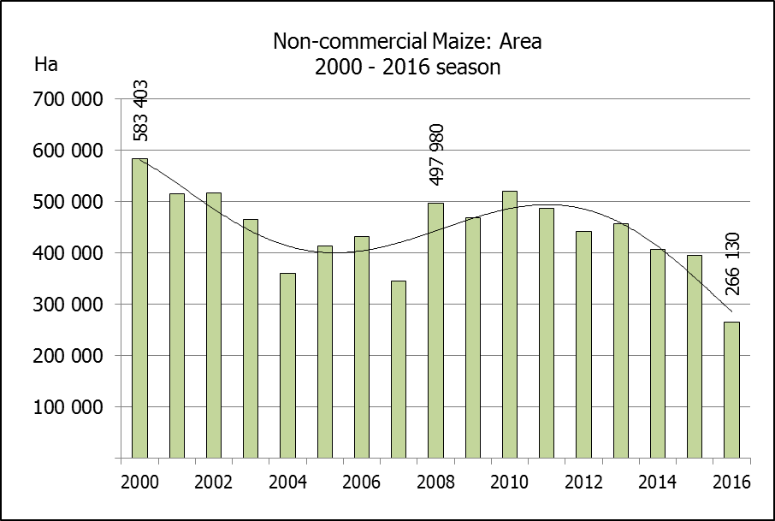
NIE-KOMMERSIëLE MIELIES – OPPERVLAKTE- EN PRODUKSIESKATTING: 2016
CROP/GEWAS | Area planted/  Opp beplant  2016 | Production/  Produksie  2016 | Area planted/  Opp beplant  2015 | Final crop/  Finale oes  2015 | Change/  Verandering
CROP/GEWAS | Ha | Tons | Ha | Tons | %
CROP/GEWAS | (A) | (B) | (C) | (D) | (B) ÷ (D)
Non-commercial agriculture/Nie-kommersiële landbou:
White maize/Witmielies | 191 225 | 286 175 | 278 000 | 442 200 | -35,28
Yellow maize/Geelmielies | 74 905 | 149 565 | 117 200 | 231 600 | -35,42
Maize/Mielies | 266 130 | 435 740 | 395 200 | 673 800 | -35,33
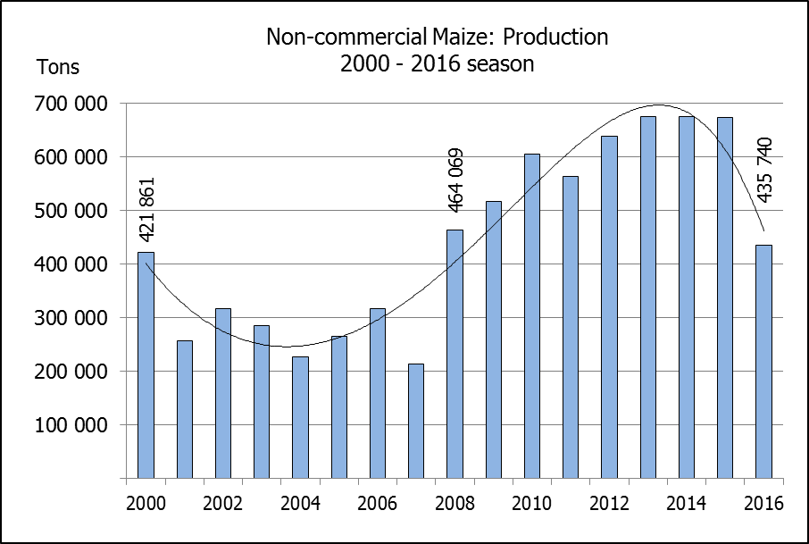
The area planted to maize in the non-commercial agricultural sector is estimated at 266 130 ha, which represents a decrease of 32,7% compared to the 395 200 ha of the previous season. The expected maize crop for this sector is 435 740 tons, which is 35,3% less than the 673 800 tons of last season. It is important to note that about 60% of the maize produced in the non-commercial sector, is planted in the Eastern Cape.
Die oppervlakte beplant met mielies in die nie-kommersiële landbou-sektor word geskat op 266 130 ha, wat ‘n afname van 32,7 % verteenwoordig in vergelyking met die 395 200 ha van die vorige seisoen. Die verwagte mielie-oes van dié sektor is 435 740 ton, wat 35,3% minder is as die 673 800 ton van die vorige seisoen. Dit is belangrik om daarop te let dat ongeveer 60% van die mielies wat geproduseer word in die nie-kommersiële sektor, in die Oos-Kaap geplant word.

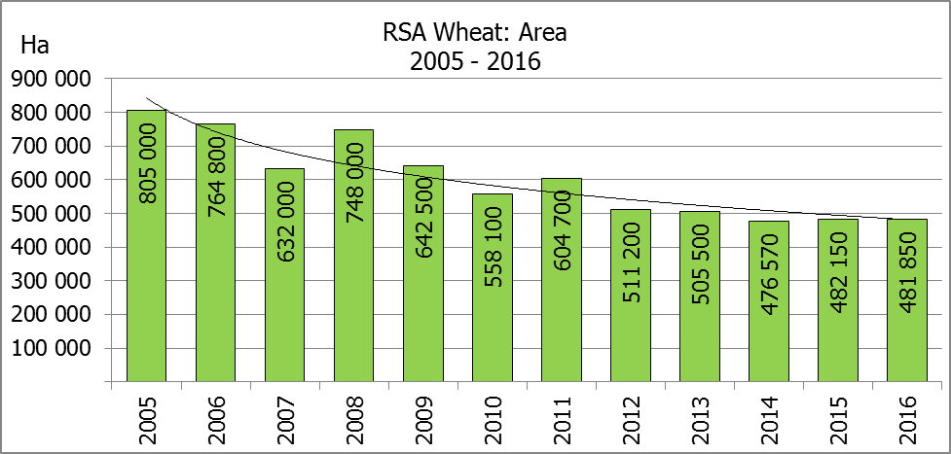
The intentions to plant winter cereals for the 2016 production season is hereby released. /
Hiermee word die voorneme om wintergewasse te plant vir die 2016 produksie-seisoen vrygestel.
WINTERGEWASSE – VOORNEME OM TE PLANT: 2016
WINTER CEREALS –INTENTIONS TO PLANT: 2016
GEWAS/CROP | Voorneme/  Intentions*  2016 | Opp beplant/  Area planted  2015 | Finale skatting/  Final estimate  2015 | Verandering/  Change
GEWAS/CROP | Ha | Ha | Tons | %
GEWAS/CROP | (A) | (B) | (C) | (A) ÷ (B)
Koring/Wheat | 481 850 | 482 150 | 1 457 015 | 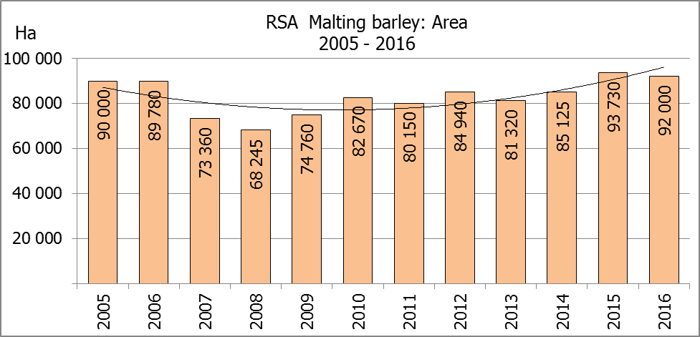  -0,06
Moutgars/Malting barley | 92 000 | 93 730 | 333 373 | -1,84
Kanola/Canola | 71 050 | 78 050 | 97 600 | -8,97
Totaal/Total | 644 900 | 653 930 | 1 887 988 | -1,38

* Based on conditions at the middle of April 2016 / Gebaseer op toestande soos teen middel April 2016.
KORING – VOORNEME OM TE PLANT: 2016
WHEAT – INTENTIONS TO PLANT: 2016

Provinsie/  Province | Voorneme/  Intentions  Ha | Opp beplant/  Area planted  Ha | Finale skatting/  Final estimate  Tons
Provinsie/  Province | 2016 | 2015 | 2015
Wes-Kaap/Western Cape | 320 000 | 310 000 | 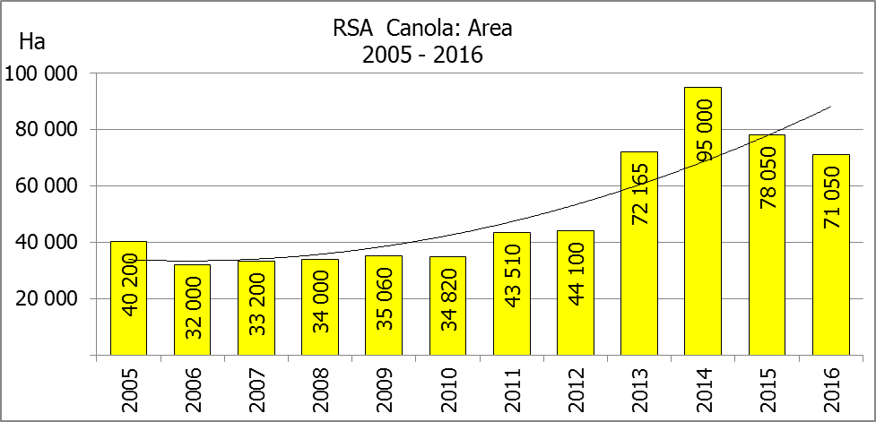  697 500
Noord-Kaap/Northern Cape | 34 000 | 36 000 | 259 200
Vrystaat/Free State | 80 000 | 80 000 | 184 000
Oos-Kaap/Eastern Cape | 2 600 | 3 100 | 14 880
KwaZulu-Natal | 7 000 | 7 300 | 41 610
Mpumalanga | 3 000 | 3 500 | 20 125
Limpopo | 22 000 | 27 000 | 151 200
Gauteng | 250 | 250 | 1 500
Noordwes/North West | 13 000 | 15 000 | 87 000
Totaal/Total | 481 850 | 482 150 | 1 457 015

* Based on conditions at the middle of April 2016 / Gebaseer op toestande soos teen middel April 2016.

INTENTIONS TO PLANT WINTER CROPS FOR 2016 / VOORNEME OM WINTERGEWASSE AAN TE PLANT VIR 2016

Winter cereal crops – 2016  Producers’ intentions to plant winter cereals are based on the results of a non-probability survey conducted by the Directorate: Statistics and Economic Analysis of the Department of Agriculture, Forestry and Fisheries and reflects the position as at the middle of April 2016.  The figures for wheat represent the total number of hectares that are intended to be planted for grain, excluding any hectares that will be planted for fodder and grazing.  Early indications are that producers intend to plant 481 850 ha of wheat for the 2016 season. This is 0,1% or 300 ha less than 482 150 ha planted to wheat in 2015. The main producing areas are within the Western Cape with 320 000 ha (66%), followed by the Free State with 80 000 ha (17%) and the Northern Cape with 34 000 ha (7%).  The expected area planted to malting barley is 92 000 ha, which is 1,8% or 1 730 ha less than the 93 730 ha of the previous year. The expected area planted to canola is 71 050 ha, which is 9,0% or 7 000 ha less than the 78 050 ha planted in 2015.  Please note that the preliminary area estimate of winter crops for 2016 will be released on 27 July 2016. |  | Wintergewasse – 2016  Produsente se voorneme om wintergewasse te plant is gebaseer op die resultate van ’n nie-ewekansige opname onderneem deur die Direktoraat: Statistiek en Ekonomiese Analise van die Departement van Landbou, Bosbou en Visserye en weerspieël die situasie teen die middel van April 2016.  Die syfers vir koring verteenwoordig die totale aantal hektare wat werklik beplant gaan word vir graan, uitgesluit alle hektare wat beplant gaan word vir groenvoer en weiding.  Vroeë aanduidings is dat produsente van voorneme is om 481 850 ha koring te plant vir die 2016-produksie-seisoen. Dit is 0,1% of 300 ha minder koring aangeplant as in 2015. Die grootste produserende gebiede is in die Wes-Kaap, met 320 000 ha (66%), gevolg deur die Vrystaat met 80 000 ha (17%) en die Noord-Kaap met 34 000 ha (7%).  Die verwagte aanplantings van moutgars is 92 000 ha – 1,8% of 1 730 ha minder as die 93 730 ha van die vorige jaar. Die verwagte aanplantings van kanola is 71 050 ha, wat 9,0% of 7 000 ha minder is as die 78 050 ha wat aangeplant was in 2015.  Neem asseblief kennis dat die voorlopige oppervlakteskatting vir wintergewasse vir 2016 op 27 Julie 2016 vrygestel sal word.
Information is available on the internet at http://www.daff.gov.za/links/crop estimates or http://www.sagis.org.za, as from 15:30 on the date of the relevant meeting of the Crop Estimates Committee. |  | Inligting is beskikbaar op die internet by http://www.daff.gov.za/links/crop estimates of by http://www.sagis.org.za, vanaf 15:30 op die dag van die toepaslike vergadering van die Oesskattingskomitee.

