 | crop estimates committee | 
 | oesskattingskomitee
From/Van: Rodney D. Dredge
Tel: 012 319 6507  Fax/Faks: 012 319 6211  E-mail/E-pos: RodneyD@daff.gov.za
Web page/Webblad: www.daff.gov.za/statistics and economic reports or www.sagis.org.za/CEC: Crop Estimates
EMBARGO: 15:30

The preliminary area planted estimate and preliminary production forecast for summer crops for 2016 is hereby released.
Hiermee word die voorlopige oppervlakte- en voorlopige produksieskatting vir somergewasse vir 2016 vrygestel.

SUMMER CROPS – PRELIMINARY AREA PLANTED AND PRELIMINARY PRODUCTION FORECAST: 2016
SOMERGEWASSE – VOORLOPIGE OPPERVLAKTE- EN VOORLOPIGE PRODUKSIESKATTING: 2016
CROP/GEWAS  The Crop Estimates Committee comprises officials of the following institutions:  Department of Agriculture, Forestry and Fisheries; Provincial Departments of Agriculture; various ARC-Institutes (Soil, Climate and Water; Small Grains Institute;  and Grain Crops Institute); and Statistics SA. | Area planted/  Opp beplant  2016 | Production forecast/  Produksieskatting  2016 | Area planted/  Opp beplant  2015 | Final estimate/  Finale skatting  2015 | Change/  Verandering/
 | Ha | Tons | Ha | Tons | %
 | (A) | (B) | (C) | (D) | (B) ÷ (D)
Commercial/Kommersieel:
White maize/Witmielies | 1 032 650 | 3 267 000 | 1 448 050 | 4 702 700 | -30,53
Yellow maize/Geelmielies | 962 500 | 4 171 250 | 1 204 800 | 5 238 950 | -20,38
Total Maize/Totale Mielies | 1 995 150 | 7 438 250 | 2 652 850 | 9 941 650 | -25,18
Sunflower seed/Sonneblomsaad | 617 000 | 622 000 | 576 000 | 660 900 | -5,89
Soybeans/Sojabone | 535 000 | 768 560 | 687 300 | 1 059 850 | -27,48
Groundnuts/Grondbone | 24 000 | 29 600 | 58 000 | 56 675 | -47,77
Sorghum | 62 500 | 119 400 | 70 500 | 116 500 | +2,49
Dry beans/Droëbone | 25 500 | 35 150 | 64 000 | 73 390 | -52,11
TOTAL/TOTAAL | 3 259 150 | 9 012 960 | 4 108 650 | 11 908 965 | -24,32
Note: Estimate is for calendar year, e.g. production season 2015/16 = 2016
Nota: Skatting is vir kalenderjaar, bv. produksie-seisoen 2015/16 = 2016

27 January 2016 / 27 Januarie 2016

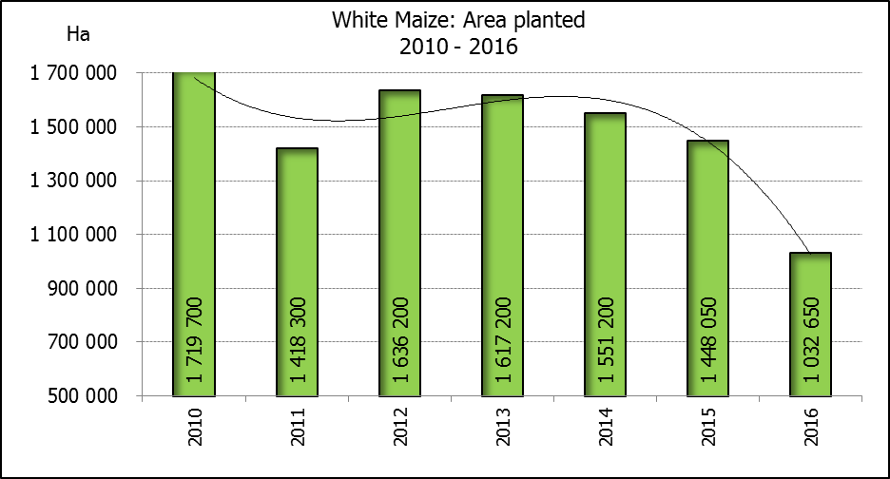

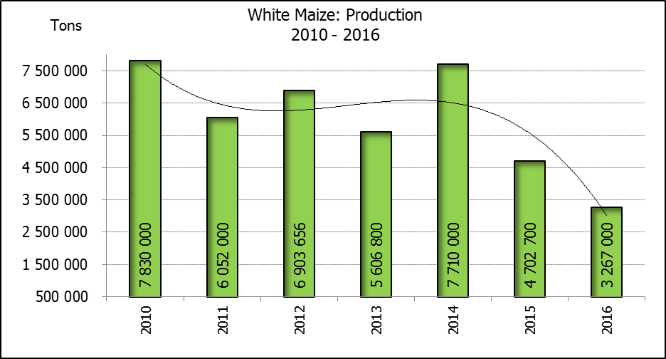

WHITE AND YELLOW MAIZE – PRELIMINARY AREA PLANTED ESTIMATE AND PRELIMINARY PRODUCTION FORECAST: 2016
WIT- EN GEELMIELIES – VOORLOPIGE OPPERVLAKTE- EN VOORLOPIGE PRODUKSIESKATTING: 2016
Province/  Provinsie | Preliminary area planted  Voorlopige oppervlakte beplant  2016 |  |  | Preliminary production forecast/  Voorlopige produksieskatting  2016 |  |  | Area planted/  Oppervlakte beplant  2015 |  |  | Final estimate¹⁾/  Finale skatting¹⁾  2015
Province/  Provinsie | White/  Wit  Ha | Yellow/  Geel  Ha | Totaal/  Total  Ha | White/  Wit  Tons | Geel/  Yellow  Tons | Totaal/  Total  Tons | White/  Wit  Ha | Yellow/  Geel  Ha | Totaal/  Total  Ha | White/  Wit  Tons | Geel/  Yellow  Tons | Totaal/  Total  Tons
Western Cape/Wes-Kaap | 400 | 3 500 | 3 900 | 4 000 | 35 000 | 39 000 | 450 | 3 800 | 4 250 | 4 050 | 34 200 | 38 250
Northern Cape/Noord-Kaap | 3 750 | 50 000 | 53 750 | 37 500 | 675 000 | 712 500 | 3 500 | 46 000 | 49 500 | 35 000 | 644 000 | 679 000
Free State/Vrystaat | 435 000 | 350 000 | 785 000 | 1 392 000 | 1 155 000 | 2 547 000 | 710 000 | 510 000 | 1 220 000 | 2 236 500 | 1 708 500 | 3 945 000
Eastern Cape/Oos-Kaap | 2 000 | 12 000 | 14 000 | 10 000 | 60 000 | 70 000 | 2 600 | 14 000 | 16 600 | 15 600 | 84 000 | 99 600
KwaZulu-Natal | 36 000 | 42 000 | 78 000 | 162 000 | 231 000 | 393 000 | 40 000 | 45 000 | 85 000 | 222 000 | 283 500 | 505 500
Mpumalanga | 155 000 | 315 000 | 470 000 | 682 000 | 1 433 250 | 2 115 250 | 154 000 | 315 000 | 469 000 | 816 200 | 1 622 250 | 2 438 450
Limpopo | 27 500 | 20 000 | 47 500 | 137 500 | 110 000 | 247 500 | 28 500 | 21 000 | 49 500 | 156 750 | 126 000 | 282 750
Gauteng | 48 000 | 60 000 | 108 000 | 192 000 | 252 000 | 444 000 | 44 000 | 65 000 | 109 000 | 193 600 | 292 500 | 486 100
North West/Noordwes | 325 000 | 110 000 | 435 000 | 650 000 | 220 000 | 870 000 | 465 000 | 185 000 | 650 000 | 1 023 000 | 444 000 | 1 467 000
Total/Totaal | 1 032 650 | 962 500 | 1 995 150 | 3 267 000 | 4 171 250 | 7 438 250 | 1 448 050 | 1 204 800 | 2 652 850 | 4 702 700 | 5 238 950 | 9 941 650
- 29 September 2015

CONFIDENTIALITY ISSUES that CEC members are committed to adhere to on the day of the meeting
- Personal items such as laptops, handbags, cell phones, etc. are not allowed in the venue during the meeting
- No member is allowed to leave the meeting before 12:00 in order to prevent disclosure of the information
- The embargo time for the release of crop estimates information is 15:30
- No member is allowed to discuss crop estimates information with anyone other than a member of the Committee before the embargo time
- Only the Chairperson, or a member appointed by the Chairperson, may release the figures to the media
- Members must regard the detail of any information that was collected for and/or discussed during the meeting, as confidential
- Individual information received for crop estimate purposes is treated strictly confidential, and is not divulged for any other purposes

PRELIMINARY AREA ESTIMATE AND PRELIMINARY PRODUCTION FORECAST OF SUMMER CROPS (2016 PRODUCTION SEASON)/
VOORLOPIGE OPPERVLAKTE- EN VOORLOPIGE PRODUKSIESKATTING VIR SOMERGEWASSE (2016 PRODUKSIE-SEISOEN)
27 JANUARY 2016 / 27 JANUARIE 2016

Summer field crops – 2016  The preliminary area estimate and preliminary production forecast of today is mainly based on the results of a non-probability survey conducted by the Directorate: Statistics and Economic Analysis of the Department of Agriculture, Forestry and Fisheries and reflects the position during the 3rd week of January 2016.  The revised area planted and production figures, which will be released by the Crop Estimates Committee on 25 February 2016, will mainly be based on information obtained from the Producer Independent Crop Estimation System (PICES) survey for the Northern Cape, Free State, KwaZulu-Natal, Mpumalanga, Limpopo, Gauteng and North West provinces, and should therefore be more accurate and comprehensive.  Commercial maize: The preliminary area estimate for maize is 1,995 mill. ha, which is 24,79% or 657 700 ha less than the 2,653 mill. ha planted for the previous season, and also 21,78% or 555 650 ha less than the intentions to plant figure of 2,551 mill. ha released in October 2015.  The preliminary size of the commercial maize crop is 7,438 mill. tons, which is 25,18% or 2,503 mill. tons less than the 9,942 mill. tons of the previous season, with an expected yield of 3,73 t/ha.  The preliminary area estimate for white maize is 1,033 mill. ha, which represents a decrease of 28,69% or 415 400 ha compared to the 1,448 mill. ha planted last season. In the case of yellow maize the area estimate is 962 500 ha, which is also 20,11% or 242 300 ha less than the 1,205 mill. ha planted last season.  The preliminary production forecast of white maize is 3,267 mill. tons, which is 30,53% or 1,436 mill. tons less than the 4,703 mill. tons of last season. The yield for white maize is 3,16 t/ha. In the case of yellow maize the production forecast is 4,171 mill. tons, which is 20,38% or 1,068 mill. tons less than the 5,239 mill. tons of last season. The yield for yellow maize is 4,33 t/ha.  Other summer crops:  Sunflower seed: The preliminary area estimate for sunflower seed is 617 000 ha, which is about 7,12% or 41 000 ha more than the 576 000 ha planted the previous season. The preliminary production forecast for sunflower seed is 622 000 tons, which is 5,89% or 38 900 tons less than the 660 900 tons of the previous season. The expected yield is 1,01 t/ha.  Other crops: It is estimated that 535 000 ha have been planted to soybeans, which represents a decrease of 22,16% or 152 300 ha compared to the 687 300 ha planted last season. The production forecast is 768 560 tons, which is 27,48% or 291 290 tons less than the 1,060 mill. tons of the previous season. The expected yield is 1,44 t/ha.  For groundnuts, the area estimate is 24 000 ha, which is 58,62% or 34 000 ha less than the 58 000 ha planted for the previous season. The expected crop is 29 600 tons – which is 47,77% or 27 075 tons less than the 56 675 tons of last season. The expected yield is 1,23 t/ha.  The area estimate for sorghum decreased by 11,35%, from 70 500 ha to 62 500 ha against the previous season. The production forecast for sorghum is 119 400 tons, which is 2,49% or 2 900 tons more than the 116 500 tons of the previous season. The expected yield is 1,91 t/ha.  For dry beans, the area estimate is 25 500 ha, which is 60,16% or 38 500 ha less than the 64 000 ha planted for the previous season. The production forecast is 35 150 tons, which is 52,11% or 38 240 tons less than the 73 390 tons of the previous season. The expected yield is 1,38 t/ha. |  | Somergewasse – 2016  Die voorlopige oppervlakte- en voorlopige produksieskatting van vandag is hoofsaaklik gebaseer op die resultate van ’n nie-ewekansige opname onderneem deur die Direktoraat: Statistiek en Ekonomiese Analise van die Departement van Landbou, Bosbou en Visserye en weerspieël die situasie soos gedurende die 3de week van Januarie 2016.  Die hersiene aangeplante oppervlakte en produksiesyfers sal deur die Oesskattingskomitee op 25 Februarie 2016 vrygestel word en sal hoofsaaklik gebaseer wees op inligting verkry vanaf die “PICES”-opname vir die Noord-Kaap, Vrystaat, KwaZulu-Natal, Mpumalanga, Limpopo, Gauteng en Noordwes provinsies, en behoort gevolglik akkurater en omvattender te wees.  Kommersiële mielies: Die voorlopige skatting van die oppervlakte onder mielies beloop 1,995 milj. ha, wat 24,79% of 657 700 ha minder is as die 2,653 milj. ha wat verlede seisoen aangeplant is, en ook 21,78% of 555 650 ha minder as die voornemens om te plant syfer van 2,551 milj. ha soos vrygestel in Oktober 2015.  Die voorlopige grootte van die kommersiële mielie-oes is 7,438 milj. ton wat 25,18% of 2,503 milj. ton minder is as die 9,942 milj. ton van die vorige seisoen, met ‘n verwagte opbrengs van 3,73 t/ha.  Die voorlopige oppervlak onder witmielies is 1,033 milj. ha, wat ’n afname van 28,69% of 415 400 ha verteenwoordig vergeleke met die 1,448 milj. ha die vorige seisoen. In die geval van geelmielies is die oppervlakteskatting 962 500 ha, wat ook 20,11% of 242 300 ha minder is as die 1,205 milj. ha geplant die vorige seisoen.  Die voorlopige produksieskatting van witmielies is 3,267 milj. ton, 30,53% of 1,436 milj. ton minder is as die 4,703 milj. ton van die vorige seisoen. Die opbrengs van witmielies is 3,16 t/ha. In die geval van geelmielies is die produksieskatting 4,171 miljoen ton, wat 20,38% of 1,068 milj. ton minder is as die 5,239 milj. ton van die vorige seisoen. Die opbrengs van geelmielies is 4,33 t/ha.  Ander somergewasse:  Sonneblomsaad: Die voorlopige oppervlakteskatting vir sonneblomsaad is 617 000 ha, wat omtrent 7,12% of 41 000 ha meer is as die 576 000 ha aangeplant die vorige seisoen. Die preliminary produksieskatting vir sonneblomsaad is 622 000 ton, wat 5,89% of 38 900 ton minder is as die 660 900 ton van die vorige seisoen. Die verwagte opbrengs is 1,01 t/ha.  Ander gewasse: Die geskatte oppervlakte beplant met sojabone is 535 000 ha, wat ’n afname van 22,16% of 152 300 ton verteenwoordig vergeleke met die 687 300 ha geplant die vorige seisoen. Die produksieskatting is 768 560 ton, wat 27,48% of 291 290 ton minder is as die 1,060 milj. ton van die vorige seisoen. Die verwagte opbrengs is 1,44 t/ha.  Vir grondbone is die oppervlakteskatting 24 000 ha, wat 58,62% of 34 000 ha minder is as die 58 000 ha geplant vir die vorige seisoen. Die verwagte grondbone-oes is 29 600 ton – 47,77% of 27 075 ton minder as die 56 675 ton van die vorige seisoen. Die verwagte opbrengs is 1,23 t/ha.  Die oppervlakteskatting vir sorghum het afgeneem met 11,35%, van 70 500 ha tot 62 500 ha teenoor die vorige seisoen. Die produksieskatting van sorghum is 119 400 ton – 2,49% of 2 900 ton meer as die 116 500 ton van die vorige seisoen. Die verwagte opbrengs is 1,91 t/ha.  Vir droëbone is die geskatte oppervlakte beplant 25 500 ha, wat 60,16% of 38 500 ha minder is as die 64 000 ha geplant vir die vorige seisoen. Die produksieskatting is 35 150 ton, wat 52,11% of 38 240 ton minder is as die 73 390 ton van die vorige seisoen. Die verwagte opbrengs is 1,38 t/ha.

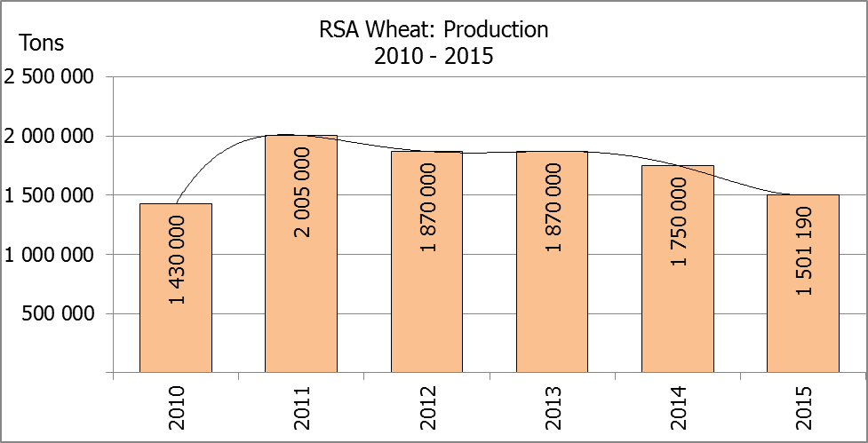
The area estimate and sixth production forecast for winter cereals for the 2015 is hereby released. /
Hiermee word die oppervlakteskatting en sesde produksieskatting vir wintergewasse vir 2015 vrygestel.
WINTER CEREALS – AREA PLANTED ESTIMATE AND SIXTH PRODUCTION FORECAST: 2015
WINTERGEWASSE – OPPERVLAKTE- EN SESDE PRODUKSIESKATTING: 2015
CROP/GEWAS | Area planted/  Opp beplant  2015 | 6th forecast/  6de skatting  2015 | 5th forecast/  5de skatting  2015 | Area planted/  Opp beplant  2014 | Final crop/  Finale oes  2014 | Change/  Verandering
CROP/GEWAS | Ha | Tons | Tons | Ha | Tons | %
CROP/GEWAS | (A) | (B) | (C) | (D) | (E) | (B) ÷ (C)
Commercial/Kommersieel:
Wheat/Koring | 482 150 | 1 501 190 | 1 501 190 | 476 570 | 1 750 000 | -
Malting barley/Moutgars | 93 730 | 341 373 | 357 487 | 85 125 | 302 000 | 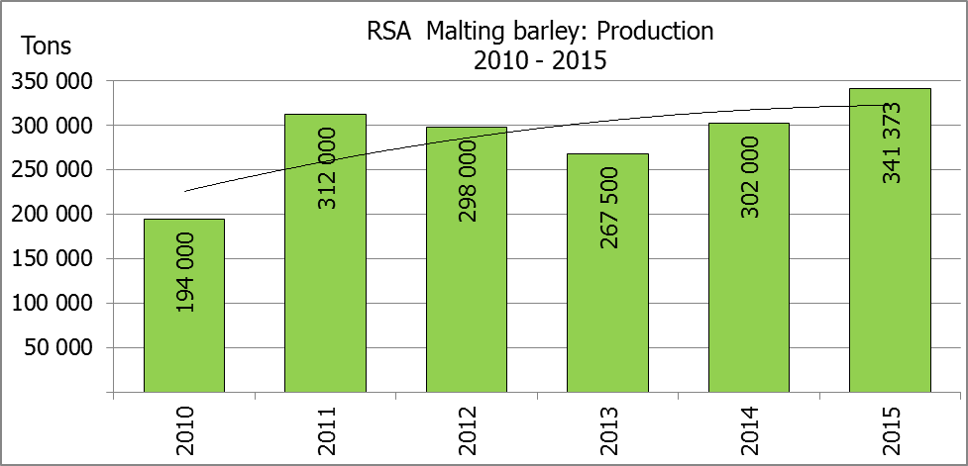  -4,51
Canola/Kanola | 78 050 | 97 600 | 101 500 | 95 000 | 121 000 | -3,84
Total/Totaal | 653 930 | 1 940 163 | 1 960 177 | 656 695 | 2 173 000 | -1,02
Note: Estimate is for calendar year, e.g. production season 2015/16 = 2015
Nota: Skatting is vir kalenderjaar, bv. produksie-seisoen 2015/16 = 2015
WHEAT – AREA PLANTED ESTIMATE AND SIXTH PRODUCTION FORECAST: 2015
KORING – OPPERVLAKTE- EN SESDE PRODUKSIESKATTING: 2015
Province/  Provinsie | Area planted/  Opp beplant  Ha | 6th forecast/  6de skatting  Tons | Area planted/  Opp beplant  Ha | Final crop/  Finale oes  Tons
Province/  Provinsie | 2015 | 2015 | 2014 | 2014
Western Cape/Wes-Kaap | 310 000 | 713 000 | 310 000 | 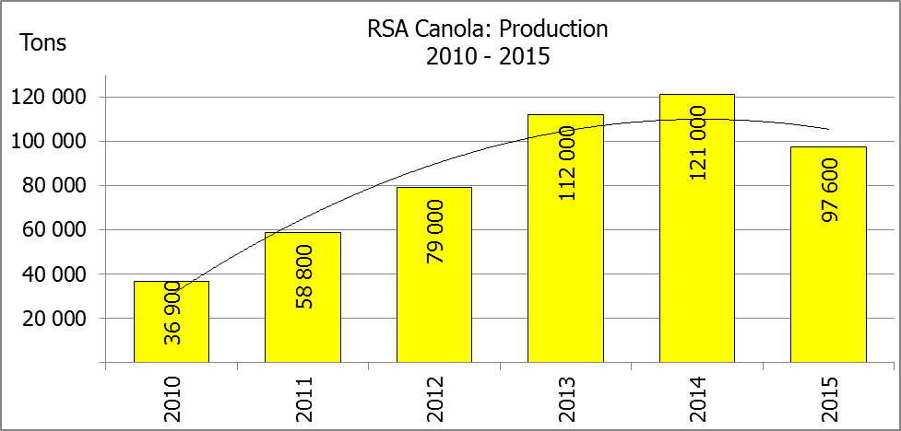  899 000
Northern Cape/Noord-Kaap | 36 000 | 259 200 | 38 000 | 285 000
Free State/Vrystaat | 80 000 | 208 000 | 69 500 | 245 500
Eastern Cape/Oos-Kaap | 3 100 | 14 880 | 3 000 | 12 000
KwaZulu-Natal | 7 300 | 41 610 | 6 500 | 39 000
Mpumalanga | 3 500 | 20 300 | 3 500 | 21 350
Limpopo | 27 000 | 151 200 | 27 500 | 137 500
Gauteng | 250 | 1 500 | 570 | 3 550
North West/Noordwes | 15 000 | 91 500 | 18 000 | 107 100
Total/Totaal | 482 150 | 1 501 190 | 476 570 | 1 750 000

AREA ESTIMATE AND SIXTH PRODUCTION FORECAST OF WINTER CROPS (2015) /
OPPERVLAKTESKATTING EN SESDE PRODUKSIESKATTING VAN WINTERGEWASSE (2015)
27 JANUARY 2016 / 27 JANUARIE 2016

Winter cereal crops - 2015 production season  Wheat: The expected commercial production of wheat remained unchanged at 1,501 mill. tons, with an expected yield of 3,11 t/ha.  During the current (2015) production season, most of the country’s wheat crop was produced in the Western Cape (713 000 tons or 47 %), followed by the Northern Cape (259 200 tons or 17 %) and Free State (208 000 tons or 14 %) provinces.  The area estimate for wheat is 482 150 ha.  Other crops: The production forecast for malting barley is 341 373 tons, which is 4,51 % or 16 114 tons less than the previous forecast of 357 487 tons. The area planted is estimated at 93 730 ha, while the expected yield is 3,64 t/ha.  The expected canola crop decreased by 3,84 % or 3 900 tons, to 97 600 tons. The area estimate for canola is 78 050 ha, with an expected yield of 1,25 t/ha.  Please note that the final production estimate for winter cereals for 2015 will be released on 25 February 2016. |  | Wintergewasse - 2015 produksie-seisoen  Koring: Die verwagte kommersiële produksie vir koring is onveranderd gelaat op 1,501 milj. ton, met ‘n verwagte opbrengs van 3,11 t/ha.  Gedurende die huidige (2015) produksie seisoen, is die grootste gedeelte van die land se koring-oes in die Wes-Kaap (713 000 ton of 47 %) geproduseer, gevolg deur die Noord-Kaap (259 200 ton of 17 %) en die Vrystaat (208 000 ton of 14 %) provinsies.  Die oppervlakteskatting vir koring is 482 150 ha.  Ander gewasse: Die produksieskatting vir moutgars is 341 373 ton, wat 4,51 % of 16 114 ton minder is as die vorige skatting van 357 487 ton. Die oppervlakte beplant is beraam op 93 730 ha, terwyl die verwagte opbrengs 3,64 t/ha beloop.  Die verwagte kanola-oes het met 3,84% of 3 900 ton afgeneem, tot 97 600 ton. Die oppervlakteskatting vir kanola is 78 050 ha, met ŉ verwagte opbrengs van 1,25 t/ha.  Neem asseblief kennis dat die finale produksieskatting vir wintergewasse vir 2015 op 25 Februarie 2016 vrygestel sal word.

Information is available on the internet at http://www.daff.gov.za/statistics and economic reports or http://www.sagis.org.za, as from 15:30 on the date of the relevant meeting of the Crop Estimates Committee. |  | Inligting is beskikbaar op die internet by http://www.daff.gov.za/statistics and economic reports of by http://www.sagis.org.za, vanaf 15:30 op die dag van die toepaslike vergadering van die Oesskattingskomitee.

