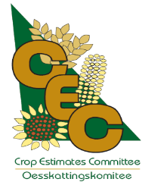 | crop estimates committee | 
 | oesskattingskomitee
From/Van: Rodney D. Dredge
Tel: 012 319 6507  Fax/Faks: 012 319 6211  E-mail/E-pos: RodneyD@daff.gov.za
Web page/Webblad: www.daff.gov.za/crop estimates or www.sagis.org.za/CEC: Crop Estimates
EMBARGO: 15:30

The final production estimate for summer crops for 2014 is hereby released. /
Hiermee word die finale produksieskatting vir somergewasse vir 2014 vrygestel.

SUMMER CROPS – AREA PLANTED AND FINAL PRODUCTION ESTIMATE: 2014
SOMERGEWASSE – OPPERVLAKTE EN FINALE PRODUKSIESKATTING: 2014
CROP/GEWAS  The Crop Estimates Committee comprises officials of the following institutions:  Department of Agriculture, Forestry and Fisheries; Provincial Departments of Agriculture; various ARC-Institutes (Soil, Climate and Water; Small Grains Institute;  and Grain Crops Institute); and Statistics SA. | Area planted/  Opp beplant  2014 | Final estimate/  Finale skatting  2014 | 7th forecast/  7de skatting  2014 | Area planted/  Opp beplant  2013 | Finale oes/  Final crop  2013 | Change/  Verandering/
 | Ha | Tons | Tons | Ha | Tons | %
 | (A) | (B) | (C) | (D) | (E) | (B) ÷ (C)
Commercial/Kommersieel:
White maize/Witmielies | 1 551 200 | 7 697 350 | 7 697 350 | 1 617 200 | 5 606 800 | -
Yellow maize/Geelmielies | 1 137 000 | 6 609 700 | 6 609 700 | 1 164 000 | 6 203 800 | -
Maize/Mielies | 2 688 200 | 14 307 050 | 14 307 050 | 2 781 200 | 11 810 600 | -
Sunflower seed/Sonneblomsaad | 598 950 | 853 325 | 853 325 | 504 700 | 557 000 | -
Soya-beans/Sojabone | 502 900 | 944 340 | 944 340 | 516 500 | 784 500 | -
Groundnuts/Grondbone | 52 125 | 78 090 | 78 090 | 46 900 | 41 500 | -
Sorghum | 78 850 | 268 920 | 268 920 | 62 620 | 147 200 | -
Dry beans/Droëbone | 55 820 | 82 130 | 82 130 | 43 550 | 60 200 | -
TOTAL/TOTAAL | 3 976 845 | 16 533 855 | 16 533 855 | 3 955 470 | 13 401 000 | -
Note: Estimate is for calendar year, e.g. production season 2013/14 = 2014
Nota: Skatting is vir kalenderjaar, bv. produksie-seisoen 2013/14 = 2014
30 September 2014

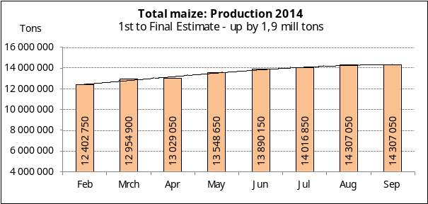

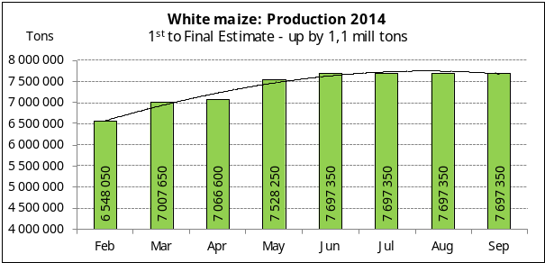

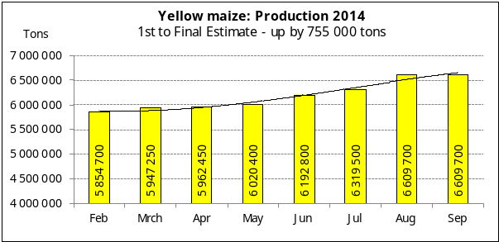

WHITE AND YELLOW MAIZE – AREA PLANTED AND FINAL PRODUCTION ESTIMATE: 2014
WIT- EN GEELMIELIES – OPPERVLAKTE EN FINALE PRODUKSIESKATTING: 2014

Provinsie/  Province | Area planted/  Oppervlakte beplant  2014 |  |  | Final estimate/  Finale skatting  2014 |  |  | Area planted/  Oppervlakte beplant  2013 |  |  | Final crop/  Finale oes  2013
Provinsie/  Province | White/  Wit  Ha | Yellow/  Geel  Ha | Total/  Totaal  Ha | White/  Wit  Tons | Yellow/  Geel  Tons | Total/  Totaal  Tons | White/  Wit  Ha | Yellow/  Geel  Ha | Total/  Totaal  Ha | White/  Wit  Tons | Yellow/  Geel  Tons | Total/  Totaal  Tons
Western Cape/Wes-Kaap | 500 | 3 000 | 3 500 | 4 500 | 28 500 | 33 000 | 300 | 3 000 | 3 300 | 3 000 | 30 000 | 33 000
Northern Cape/Noord-Kaap | 2 200 | 48 000 | 50 200 | 25 300 | 638 400 | 663 700 | 2 200 | 51 000 | 53 200 | 25 300 | 650 000 | 675 300
Free State/Vrystaat | 730 000 | 465 000 | 1 195 000 | 3 759 500 | 2 511 000 | 6 270 500 | 725 000 | 505 000 | 1 230 000 | 2 574 000 | 2 310 800 | 4 884 800
Eastern Cape/Oos-Kaap | 2 500 | 16 000 | 18 500 | 13 750 | 97 600 | 111 350 | 3 700 | 15 000 | 18 700 | 18 500 | 90 000 | 108 500
KwaZulu-Natal | 43 000 | 45 000 | 88 000 | 266 600 | 294 750 | 561 350 | 47 000 | 48 000 | 95 000 | 284 000 | 315 000 | 599 000
Mpumalanga | 168 000 | 332 000 | 500 000 | 907 200 | 1 892 400 | 2 799 600 | 170 000 | 300 000 | 470 000 | 1 020 000 | 1 985 000 | 3 005 000
Limpopo | 30 000 | 20 000 | 50 000 | 183 000 | 124 000 | 307 000 | 30 000 | 23 500 | 53 500 | 154 000 | 138 000 | 292 000
Gauteng | 65 000 | 53 000 | 118 000 | 344 500 | 310 050 | 654 550 | 74 000 | 43 500 | 117 500 | 370 000 | 230 000 | 600 000
North West/Noordwes | 510 000 | 155 000 | 665 000 | 2 193 000 | 713 000 | 2 906 000 | 565 000 | 175 000 | 740 000 | 1 158 000 | 455 000 | 1 613 000
Total/Totaal | 1 551 200 | 1 137 000 | 2 688 200 | 7 697 350 | 6 609 700 | 14 307 050 | 1 617 200 | 1 164 000 | 2 781 200 | 5 606 800 | 6 203 800 | 11 810 600

SUNFLOWER SEED – AREA PLANTED AND FINAL PRODUCTION ESTIMATE: 2014
SONNEBLOMSAAD – OPPERVLAKTE EN FINALE PRODUKSIESKATTING: 2014

Province/  Provinsie | Area planted/  Opp beplant  Ha | Final estimate/  Finale skatting  Tons | Area planted/  Opp beplant  Ha | Final crop/  Finale oes  Tons
Province/  Provinsie | 2014 | 2014 | 2013 | 2013
Western Cape/Wes-Kaap | - | - | - | -
Northern Cape/Noord-Kaap | 900 | 450 | 200 | 100
Free State/Vrystaat | 280 000 | 448 000 | 220 000 | 297 000
Eastern Cape/Oos-Kaap | 550 | 825 | - | -
KwaZulu-Natal | - | - | - | -
Mpumalanga | 3 500 | 5 250 | 6 600 | 9 900
Limpopo | 90 000 | 85 500 | 99 000 | 85 000
Gauteng | 3 000 | 3 900 | 3 900 | 4 000
North West/Noordwes | 221 000 | 309 400 | 175 000 | 161 000
Total/Totaal | 598 950 | 853 325 | 504 700 | 557 000

SOYA-BEANS – AREA PLANTED AND FINAL PRODUCTION ESTIMATE: 2014
SOJABONE – OPPERVLAKTE EN FINALE PRODUKSIESKATTING: 2014

Province/  Provinsie | Area planted/  Opp beplant  Ha | Final estimate/  Finale skatting  Tons | Area planted/  Opp beplant  Ha | Final crop/  Finale oes  Tons
Province/  Provinsie | 2014 | 2014 | 2013 | 2013
Western Cape/Wes-Kaap | - | - | - | -
Northern Cape/Noord-Kaap | 3 900 | 14 040 | 2 000 | 7 000
Free State/Vrystaat | 201 000 | 351 750 | 215 000 | 249 500
Eastern Cape/Oos-Kaap | 2 000 | 3 600 | 500 | 750
KwaZulu-Natal | 35 000 | 98 000 | 32 000 | 82 000
Mpumalanga | 203 000 | 334 950 | 205 000 | 335 000
Limpopo | 22 000 | 66 000 | 20 000 | 53 500
Gauteng | 20 000 | 44 000 | 20 000 | 34 000
North West/Noordwes | 16 000 | 32 000 | 22 000 | 22 750
Total/Totaal | 502 900 | 944 340 | 516 500 | 784 500

GROUNDNUTS – AREA PLANTED AND FINAL PRODUCTION ESTIMATE: 2014
GRONDBONE – OPPERVLAKTE EN FINALE PRODUKSIESKATTING: 2014

Province/  Provinsie | Area planted/  Opp beplant  Ha | Final estimate/  Finale skatting  Tons | Area planted/  Opp beplant  Ha | Final crop/  Finale oes  Tons
Province/  Provinsie | 2014 | 2014 | 2013 | 2013
Western Cape/Wes-Kaap | - | - | - | -
Northern Cape/Noord-Kaap | 7 000 | 18 900 | 7 000 | 14 000
Free State/Vrystaat | 20 000 | 24 000 | 18 000 | 15 100
Eastern Cape/Oos-Kaap | - | - | - | -
KwaZulu-Natal | 75 | 90 | 150 | 150
Mpumalanga | 50 | 100 | 750 | 750
Limpopo | 3 000 | 4 200 | 1 000 | 1 500
Gauteng | - | - | - | -
North West/Noordwes | 22 000 | 30 800 | 20 000 | 10 000
Total/Totaal | 52 125 | 78 090 | 46 900 | 41 500

SORGHUM – AREA PLANTED AND FINAL PRODUCTION ESTIMATE: 2014
SORGHUM – OPPERVLAKTE EN FINALE PRODUKSIESKATTING: 2014

Province/  Provinsie | Area planted/  Opp beplant  Ha | Final estimate/  Finale skatting  Tons | Area planted/  Opp beplant  Ha | Final crop/  Finale oes  Tons
Province/  Provinsie | 2014 | 2014 | 2013 | 2013
Western Cape/Wes-Kaap | - | - | - | -
Northern Cape/Noord-Kaap | - | - | - | -
Free State/Vrystaat | 42 000 | 140 700 | 32 000 | 68 800
Eastern Cape/Oos-Kaap | - | - | - | -
KwaZulu-Natal | 850 | 4 420 | 320 | 1 280
Mpumalanga | 11 000 | 55 000 | 11 500 | 42 620
Limpopo | 14 000 | 33 600 | 12 000 | 21 000
Gauteng | 1 500 | 4 800 | 500 | 1 500
North West/Noordwes | 9 500 | 30 400 | 6 300 | 12 000
Total/Totaal | 78 850 | 268 920 | 62 620 | 147 200

DRY BEANS – AREA PLANTED AND FINAL PRODUCTION ESTIMATE: 2014
DROëBONE – OPPERVLAKTE EN FINALE PRODUKSIESKATTING: 2014

Province/  Provinsie | Area planted/  Opp beplant  Ha | Final estimate/  Finale skatting  Tons | Final crop/  Finale oes  Tons | Final crop/  Finale oes  Tons
Province/  Provinsie | 2014 | 2014 | 2013 | 2013
Western Cape/Wes-Kaap | 300 | 450 | 200 | 400
Northern Cape/Noord-Kaap | 1 000 | 2 000 | 850 | 1 700
Free State/Vrystaat | 26 000 | 37 700 | 16 000 | 19 200
Eastern Cape/Oos-Kaap | 770 | 1 155 | 100 | 200
KwaZulu-Natal | 5 000 | 6 500 | 6 000 | 7 800
Mpumalanga | 8 750 | 12 250 | 7 000 | 11 900
Limpopo | 5 500 | 9 625 | 5 400 | 10 800
Gauteng | 3 000 | 4 200 | 2 000 | 3 400
North West/Noordwes | 5 500 | 8 250 | 6 000 | 4 800
Total/Totaal | 55 820 | 82 130 | 43 550 | 60 200

CONFIDENTIALITY ISSUES that CEC members are committed to adhere to on the day of the meeting
- Personal items such as laptops, handbags, cell phones, etc. are not allowed in the venue during the meeting
- No member is allowed to leave the meeting before 12:00 in order to prevent disclosure of the information
- The embargo time for the release of crop estimates information is 15:30
- No member is allowed to discuss crop estimates information with anyone other than a member of the Committee before the embargo time
- Only the Chairperson, or a member appointed by the Chairperson, may release the figures to the media
- Members must regard the detail of any information that was collected for and/or discussed during the meeting, as confidential
- Individual information received for crop estimate purposes is treated strictly confidential, and is not divulged for any other purposes

AREA AND FINAL PRODUCTION ESTIMATE OF SUMMER CROPS (2014)/
OPPERVLAKTE- EN FINALE PRODUKSIESKATTING VIR SOMERGEWASSE (2014)
30 SEPTEMBER 2014

Summer field crops – 2014  Commercial maize: The potential size of the maize crop remained unchanged at 14,3 mill. tons.  The area estimate for maize also remained unchanged at 2,688 mill. ha, while the expected yield is 5,32 t/ha.  The area estimate for white maize is 1,551 mill. ha and for yellow maize the area estimate is 1,137 mill. ha.  The production estimate of white maize is 7,697 mill. tons with an expected yield of 4,96 t/ha. In the case of yellow maize the production estimate is 6,610 mill. tons and the expected yield is 5,81 t/ha.  Sunflower seed: The production estimate for sunflower seed is 853 325 tons. The area estimate for sunflower seed is 598 950 ha, and the yield is 1,42 t/ha.  Other crops: The production estimate for soya-beans is 944 340 tons. The area estimate is 502 900 ha, and the yield is 1,88 t/ha.  The production estimate of groundnuts is 78 090 tons, with an area estimate of 52 125 ha, and a yield of1,50 t/ha.  The production estimate for sorghum is 268 920 tons. The area estimate for sorghum is 78 850 ha, and the yield is 3,41 t/ha.  In the case of dry beans, the production estimate is 82 130 tons. The area estimate of dry beans is 55 820 ha, and the yield is 1,47 t/ha.  Please note that the ‘intentions of farmers’ to plant summer grain crops for 2015 will be released on 28 October 2014. |  | Somergewasse – 2014  Kommersiële mielies: Die potensiële grootte van die mielie-oes is onveranderd gelaat op 14,3 milj. ton.  Die skatting van die oppervlakte onder mielies is ook onveranderd gelaat op 2,688 milj. ha, terwyl die verwagte opbrengs 5,32 t/ha is.  Die oppervlak onder witmielies is 1,551 milj. ha en vir geelmielies is die oppervlak 1,137 milj. ha.  Die produksieskatting van witmielies is 7,697 milj. ton met ‘nverwagte opbrengs van 4,96 t/ha. In die geval van geelmielies is die produksieskatting 6,610 milj. ton en die verwagte opbrengs is 5,81 t/ha.  Sonneblomsaad: Die produksieskatting vir sonneblomsaad is 853 325 ton. Die oppervlakteskatting vir sonneblomsaad is 598 950 ha, terwyl die opbrengs 1,42 t/ha is.  Ander gewasse: Die produksieskatting van sojabone is 944 340 ton. Die geskatte oppervlakte beplant met sojabone is 502 900 ha, met ‘n opbrengs van 1,88 t/ha.  Die produskieskatting van grondbone is 78 090 ton, met ‘n oppervlakteskatting van 52 125 ha en ‘n opbrengs van 1,50 t/ha.  Die produksieskatting van sorghum is 268 920 ton. Die oppervlakte beplant met sorghum is 78 850 ha, en die opbrengs is 3,41 t/ha.  In die geval van droëbone is die produksieskatting 82 130 ton. Die oppervlakte beplant met droëbone is 55 820 ha, en die opbrengs is 1,47 t/ha.  Neem asseblief kennis dat die ‘voorneme van produsente om somergraangewasse te plant’ vir 2015, op 28 Oktober 2014 vrygestel sal word.

Information is available on the internet at http://www.daff.gov.za/crop estimates or http://www.sagis.org.za, as from 15:30 on the date of the relevant meeting of the Crop Estimates Committee. |  | Inligting is beskikbaar op die internet by http://www.daff.gov.za/crop estimates of by http://www.sagis.org.za, vanaf 15:30 op die dag van die toepaslike vergadering van die Oesskattingskomitee.

The non-commercial agricultural sectors’ production estimate for maize for 2014 is hereby released. /
Hiermee word die nie-kommersiële landbou-sektor se produksieskatting vir mielies vir 2014 vrygestel.

NON-COMMERCIAL MAIZE – AREA PLANTED AND PRODUCTION ESTIMATE: 2014
NIE-KOMMERSIëLE MIELIES – OPPERVLAKTE- EN PRODUKSIESKATTING: 2014
CROP/GEWAS | Area planted/  Opp beplant  2014 | Production/  Produksie  2014 | Area planted/  Opp beplant  2013 | Final crop/  Finale oes  2013 | Change/  Verandering
CROP/GEWAS | Ha | Tons | Ha | Tons | %
CROP/GEWAS | (A) | (B) | (C) | (D) | (B) ÷ (D)
Non-commercial agriculture/Nie-kommersiële landbou:
White maize/Witmielies | 288 100 | 447 500 | 320 105 | 459 995 | -2,72
Yellow maize/Geelmielies | 119 900 | 227 500 | 136 795 | 215 095 | +5,77
Maize/Mielies | 408 000 | 675 000 | 456 900 | 675 090 | -0,01
The area planted to maize in the non-commercial agricultural sector is estimated at 408 000 ha, which represents a decrease of 10,70% compared to the 456 900 ha of the previous season. The expected maize crop for this sector is 675 000 tons, which is more or less the same than the 675 090 tons of last season. It is important to note that about 55% of the maize produced in the non-commercial sector, is planted in the Eastern Cape.
Die oppervlakte beplant met mielies in die nie-kommersiële landbou-sektor word geskat op 408 000 ha, wat ‘n afname van 10,70 % verteenwoordig in vergelyking met die 456 900 ha van die vorige seisoen. Die verwagte mielie-oes van dié sektor is 675 000 ton, wat min of meer dieselfde is as die 675 090 ton van die vorige seisoen. Dit is belangrik om daarop te let dat ongeveer 55% van die mielies wat geproduseer word in die nie-kommersiële sektor, in die Oos-Kaap geplant word.

The revised area estimate and second production forecast for winter cereals for the 2014 is hereby released. /
Hiermee word die hersiene oppervlakte- en tweede produksieskatting vir wintergewasse vir 2014 vrygestel.

WINTER CEREALS – REVISED AREA PLANTED AND SECOND PRODUCTION FORECAST: 2014 PRODUCTION SEASON
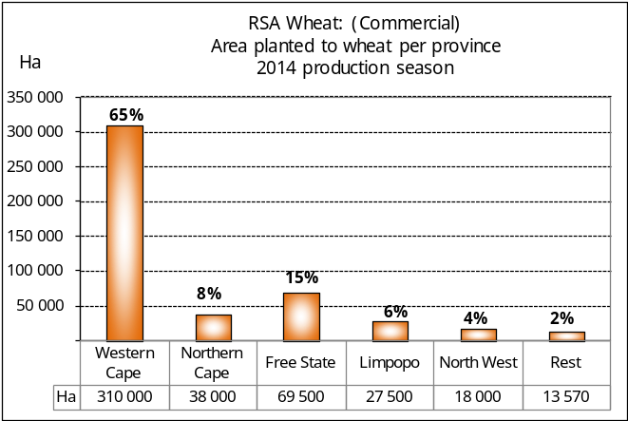
WINTERGEWASSE – HERSIENE OPPERVLAKTE- EN TWEEDE PRODUKSIESKATTING: 2014-PRODUKSIESEISOEN
CROP/GEWAS | Area planted/  Opp beplant  2014 | 2nd forecast/  2de skatting  Tons | 1st forecast/  1ste skatting  Tons | Area planted/  Opp beplant  2013 | Final crop/  Finale oes  2013 | Change/  Verandering
CROP/GEWAS | Ha | 2014 | 2014 | Ha | Tons | %
CROP/GEWAS | (A) | (B) | (C) | (D) | (E) | (B) ÷ (C)
Wheat/Koring | 476 570 | 1 790 909 | 1 779 950 | 505 500 | 1 870 000 | +0,62
Malting barley/Moutgars | 85 125 | 317 893 | 313 080 | 81 320 | 267 500 | +1,54
Canola/Kanola | 95 000 | 147 250 | 139 500 | 72 165 | 112 000 | +5,56
Total/Totaal | 656 695 | 2 256 052 | 2 232 530 | 658 985 | 2 249 500 | +1,05
Note: Estimate is for calendar year, e.g. production season 2014/15 = 2014
Nota: Skatting is vir kalenderjaar, bv. produksie-seisoen 2014/15 = 2014
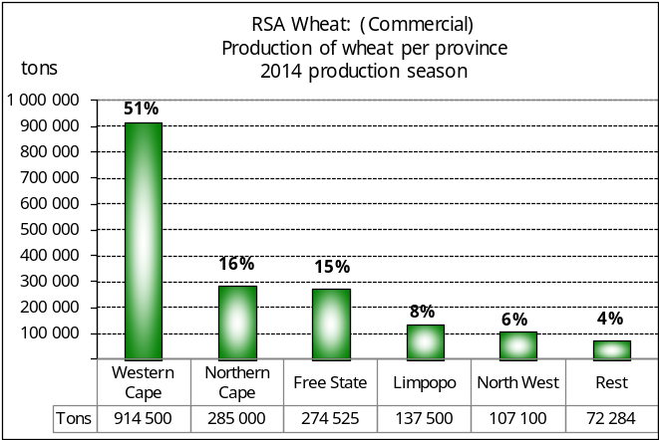
WHEAT – REVISED AREA PLANTED AND SECOND PRODUCTION FORECAST: 2014
KORING – HERSIENE OPPERVLAKTE- EN TWEEDE PRODUKSIESKATTING: 2014

Province/  Provinsie | Area planted/  Opp beplant  Ha | 2nd forecast/  2de skatting  Tons | Area planted/  Opp beplant  Ha | Final crop/  Finale oes  Tons
Province/  Provinsie | 2014 | 2014 | 2013 | 2013
Western Cape/Wes-Kaap | 310 000 | 914 500 | 310 000 | 928 000
Northern Cape/Noord-Kaap | 38 000 | 285 000 | 42 000 | 320 000
Free State/Vrystaat | 69 500 | 274 525 | 90 000 | 270 000
Eastern Cape/Oos-Kaap | 3 000 | 12 000 | 4 500 | 19 800
KwaZulu-Natal | 6 500 | 35 750 | 7 000 | 42 000
Mpumalanga | 3 500 | 21 000 | 4 500 | 28 000
Limpopo | 27 500 | 137 500 | 28 000 | 146 000
Gauteng | 570 | 3 534 | 1 000 | 6 200
North West/Noordwes | 18 000 | 107 100 | 18 500 | 110 000
Total/Totaal | 476 570 | 1 790 909 | 505 500 | 1 870 000

REVISED AREA ESTIMATE AND SECOND PRODUCTION FORECAST OF WINTER CROPS (2014) /
HERSIENE OPPERVLAKTEKSKATTING EN TWEEDE PRODUKSIESKATTING VAN WINTERGEWASSE (2014)
30 SEPTEMBER 2014

Winter cereal crops - 2014 production season  Wheat: The expected commercial production of wheat is 1,791 mill. tons, which is 0,62% more than the previous forecast of 1,780 mill. tons, whilst the expected yield is 3,76 t/ha.  The expected production in the Western Cape is 914 500 tons (51%), in the Northern Cape 285 000 tons (16%) and in the Free State 274 525 tons (15%).  The area estimate for wheat was revised to 476 570 ha, which is 8 570 ha more than the 468 000 ha of the previous estimate. The main reason for the increase in the area was because of an upward revision in the area planted for the Free State, from 60 000 ha to 69 500 ha. The area planted in the Eastern Cape was revised downwards by 1 000 ha to 3 000 ha and the area planted in Gauteng was adjusted upwards by 70 ha to 570 ha.  The revised area estimate for the Free State is based on information obtained from the Producer Independent Crop Estimation System (PICES) as conducted by the National Crop Statistics Consortium (NCSC), which is led by the ARC.  Other crops: The production forecast for malting barley is 317 893 tons, which is 1,54% more than the previous forecast of 313 080 tons. The area planted is estimated at 85 125 ha, while the expected yield is 3,73 t/ha.  The expected canola crop was adjusted upwards by 7 750 tons to 147 250 tons. The area estimate for canola was also adjusted upwards by 5 000 ha to 95 000 ha, with an expected yield of 1,55 t/ha.  Please note that the third production forecast for winter cereals for 2014 will be released on 28 October 2014. |  | Wintergewasse - 2014 produksie-seisoen  Koring: Die verwagte kommersiële produksie vir koring is 1,791 milj. ton, wat 0,62% meer is as die vorige skatting van 1,780 milj. ton, terwyl die verwagte opbrengs 3,76 t/ha is.  Die verwagte produksie in die Wes-Kaap is 914 500 ton (51%), in die Noord-Kaap 285 000 ton (16%) en in die Vrystaat 274 525 ton (15%).  Die oppervlakteskatting vir koring is hersien na 476 570 ha, wat 8 570 ha meer is as die 468 000 ha teenoor die vorige skatting. Die vernaamste rede vir die toename in die oppervlakte beplant was as gevolg van ’n opwaartse aanpassing in die oppervlakte vir die Vrystaat, vanaf 60 000 ha tot 69 500 ha. Die oppervlakte beplant in die Oos-Kaap is afwaarts aangepas met ‘n 1 000 ha na 3 000 ha en die oppervlakte beplant in Gauteng is opwaarts aangepas met 70 ha na 570 ha.  Die hersiene oppervlakteskatting vir die Vrystaat is gebaseer op inligting soos verkry vanaf die Produsente Onafhanklike Oesskattingstelsel (“PICES”) , soos deur die LNR-geleide Konsortium gerapporteer.  Ander gewasse: Die produksieskatting vir moutgars is 317 893 ton, wat 1,54% meer is as die vorige skatting van 313 080 ton. Die oppervlakte beplant is beraam op 85 125 ha, terwyl die verwagte opbrengs 3,73 t/ha beloop.  Die verwagte kanola-oes is opwaarts aangepas met 7 750 ton na 147 250 ton. Die oppervlakteskatting vir kanola is ook opwaarts aangepas met 5 000 ha na 95 000 ha, met ŉ verwagte opbrengs van 1,55 t/ha.  Neem asseblief kennis dat die derde produksieskatting vir wintergewasse vir 2014 op 28 Oktober 2014 vrygestel sal word.

Information is available on the internet at http://www.daff.gov.za/links/crop estimates or http://www.sagis.org.za, as from 15:30 on the date of the relevant meeting of the Crop Estimates Committee. |  | Inligting is beskikbaar op die internet by http://www.daff.gov.za/links/crop estimates of by http://www.sagis.org.za, vanaf 15:30 op die dag van die toepaslike vergadering van die Oesskattingskomitee.

