Project Report 

**A.ELANCHEZHIYAN**

**MAHENDRA ENGINEERING COLLEGE**

**NAMAKKAL.**

# Title: HandsMen Threads – Elevating the Art of Sophistication in Men's Fashion

Internship: Salesforce Developer with Agentblazer Champion Program

## Abstract

The HandsMen Threads project is a Salesforce-driven application designed to modernize the customer relationship and service experience for luxury men’s fashion brands. It focuses on building a seamless digital ecosystem for product cataloging, order management, personalized communication, and real-time customer interaction. With features like automated workflows, real-time dashboards, and interactive Lightning Web Components (LWC), the project aims to deliver a sophisticated yet efficient backend system for fashion enterprises.

## Objective

- Design a custom CRM tailored for premium fashion brands using Salesforce.  
- Automate customer engagement, order tracking, and feedback collection processes.  
- Utilize Apex, LWC, and Flows to build responsive, scalable modules for real-time use.  
- Provide detailed reports and dashboards for business insights and decision-making.  
- Enhance customer satisfaction through timely communication and personalization.

## Technology Stack

**Platform**: Salesforce Lightning  
**Languages**: Apex, JavaScript (LWC)  
**Tools & Services:**  
- Lightning Web Components (LWC)  
- Salesforce Flow Builder  
- Custom Objects, Record Types  
- Apex Triggers and Test Classes  
- Reports & Dashboards  
- Process Builder and Workflow Rules

## Detailed Project Explanation

1. **Custom Object Development**Created custom objects like 'Product', 'Customer Profile', 'Order', and 'Feedback'. Relationships were designed to represent real-world business scenarios. Master-detail and lookup relationships were used effectively to link customer records with their transactions and feedback.

2. **Lightning Web Components (LWC)**

Developed interactive UI components for displaying products, creating orders, collecting reviews, and navigating records. LWC allowed fast loading, reusable, and event-driven components tailored for user roles.

3. **Apex Development**

Wrote backend logic using Apex classes and triggers. These were responsible for inventory updates, real-time order validation, auto-generation of invoices, and email notification logic. Maintained high test coverage to ensure successful deployment and system reliability.

4. **Flow Automation**

Implemented screen flows and record-triggered flows to automate routine tasks such as welcome emails, order status updates, and feedback forms. This reduced manual effort and increased workflow efficiency.

5. **Reporting and Dashboards**

Built real-time dashboards showing key KPIs like daily sales, top products, repeat customers, and pending orders. Reports enabled data-driven decisions and weekly performance reviews.

## Flows

**Order Conformatiom Flow**

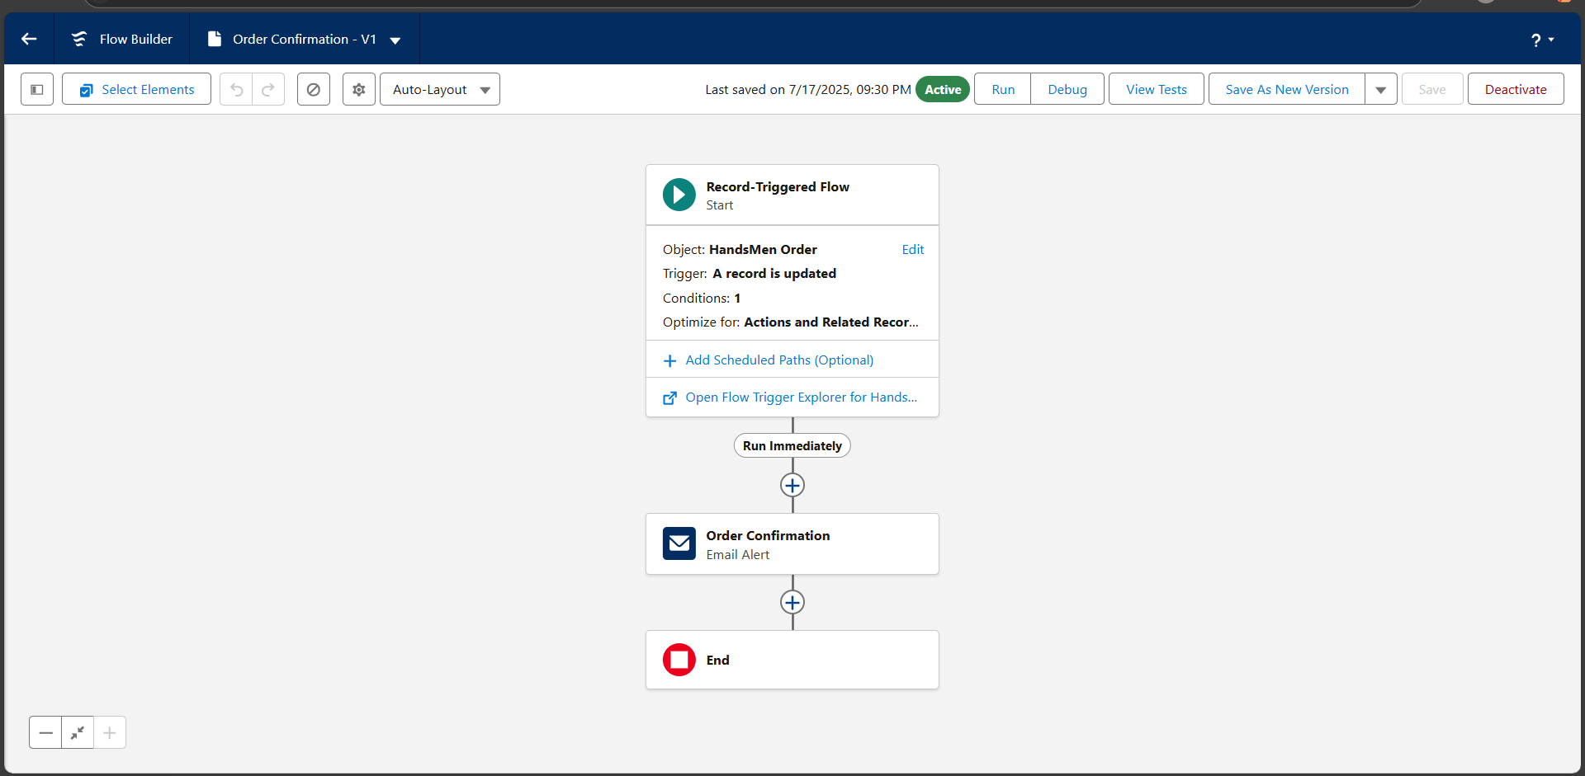

**Inventory Flow**

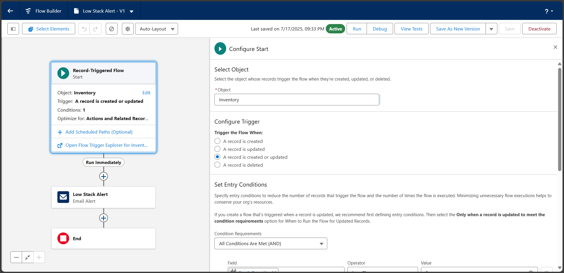

**Loyality Program Flow**

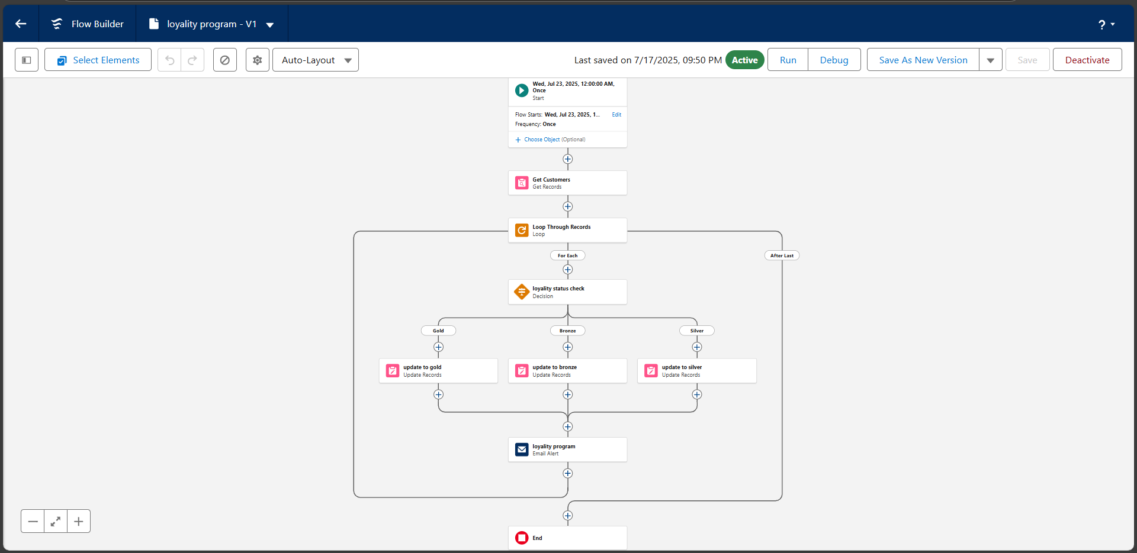

## Output Screenshots

**Project Index Page**

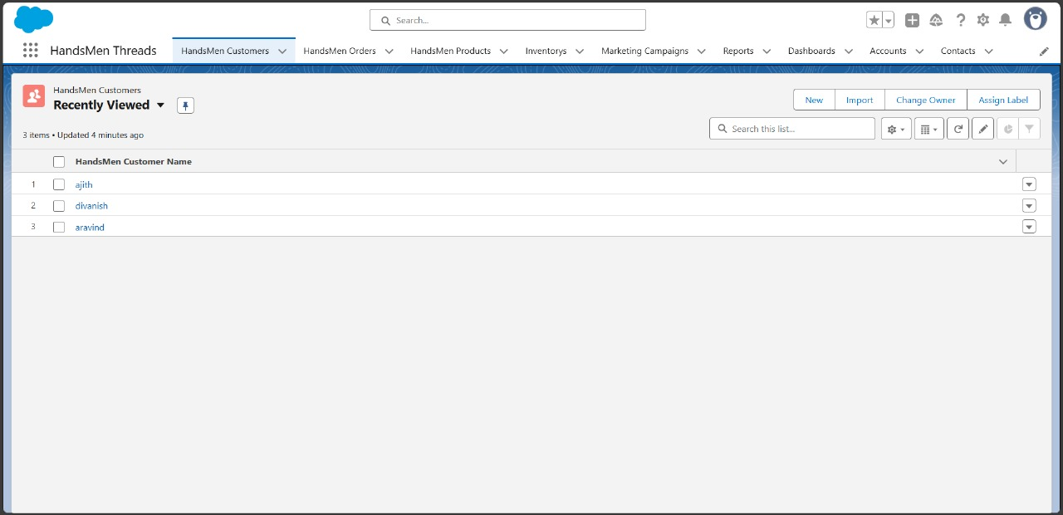

**Handsman Order Tab**

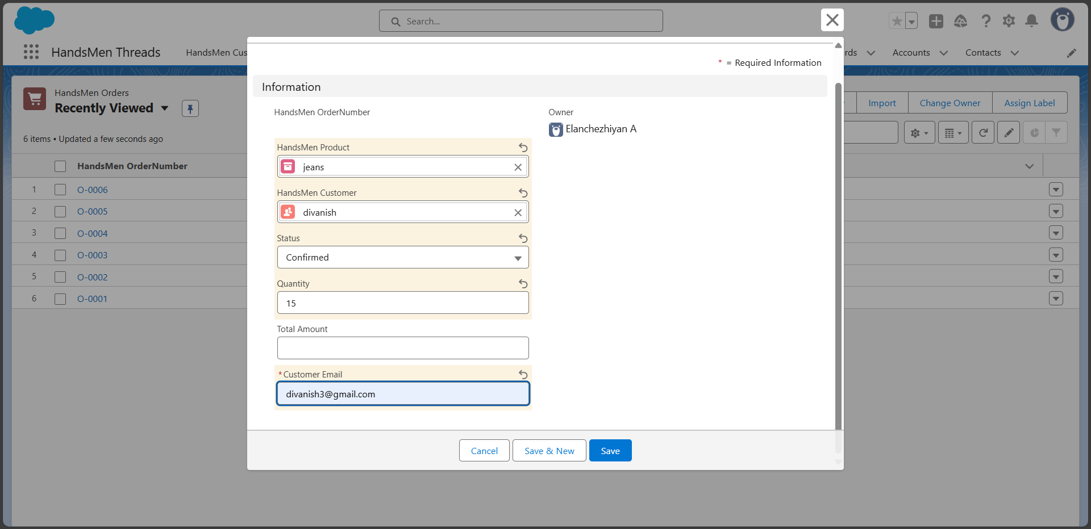

**Handsman Product Tab**

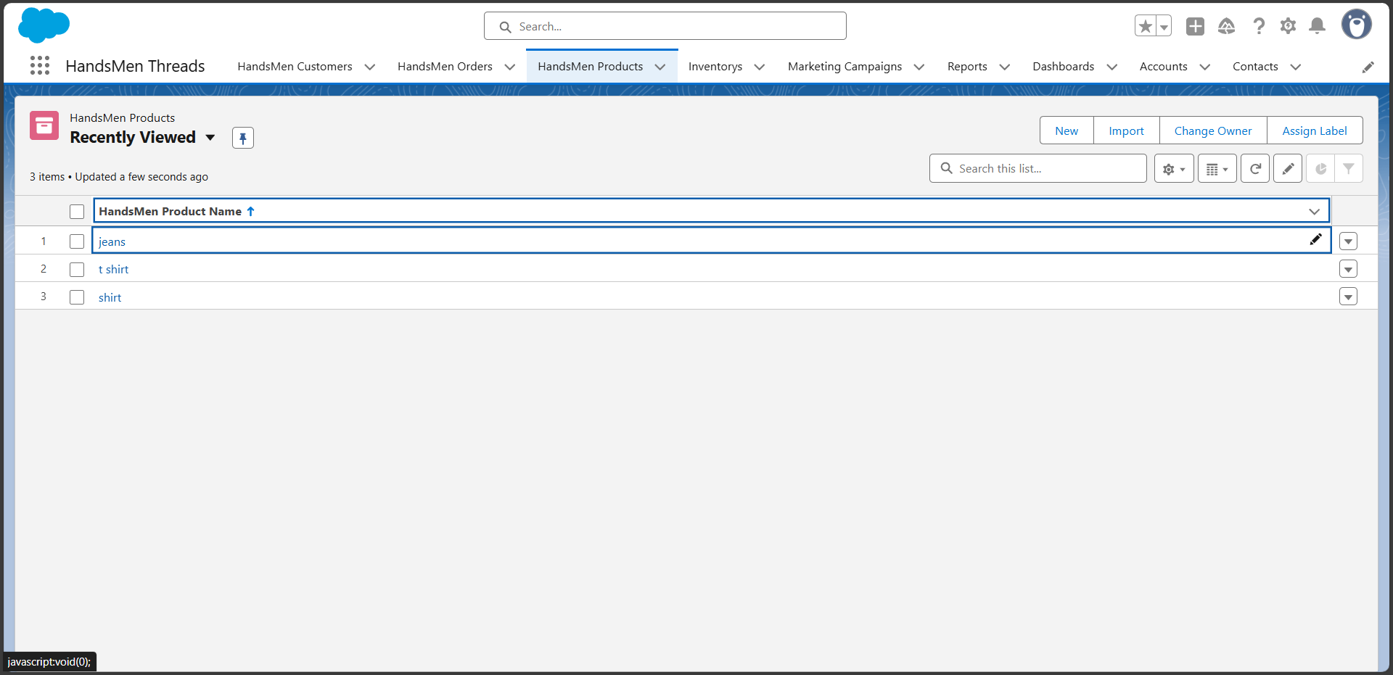

**Inventory Product Details**

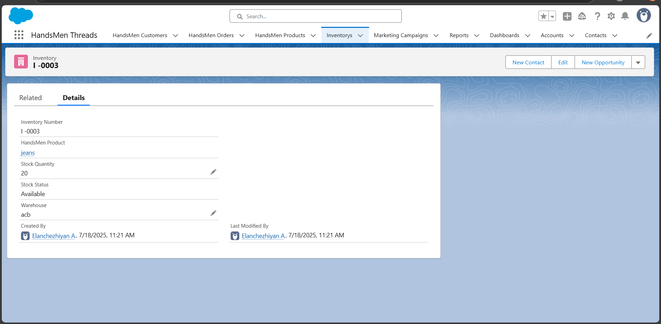

**Order Confirmed Email**

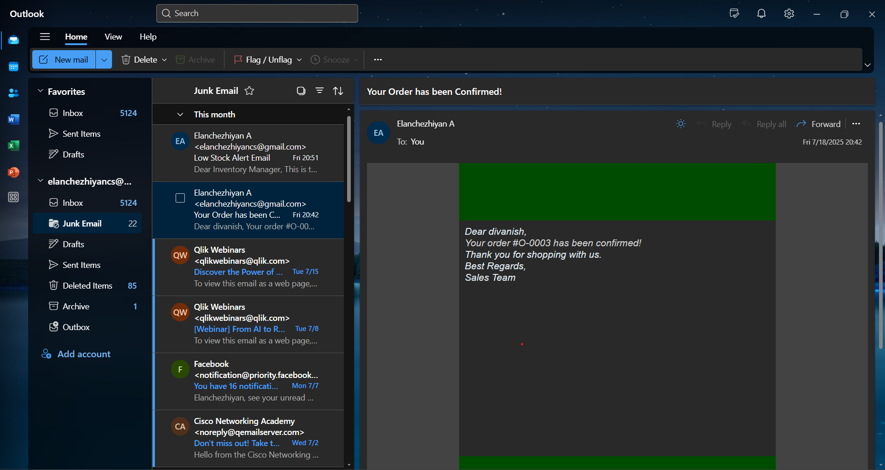

**Low Stock Alert Email**

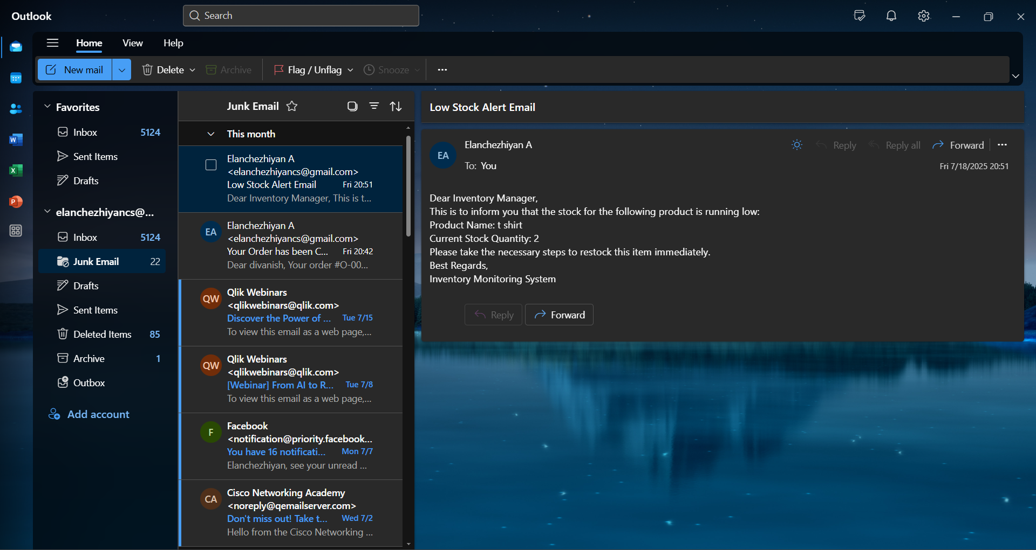

## Conclusion

The HandsMen Threads project proved that Salesforce can be customized beyond traditional CRM usage to manage fashion business workflows with elegance and precision. All key modules—product listing, order flow, automation, and performance analytics—were implemented successfully. This solution will help luxury fashion retailers stay competitive and offer a highly personalized customer experience.

## Future Scope

- Integration with external e-commerce platforms (Shopify, WooCommerce) using APIs.  
- Use Salesforce Einstein for AI-powered product recommendations.  
- Add multilingual and multi-currency support for global scalability.  
- Enable mobile accessibility via the Salesforce mobile app.  
- Build loyalty and referral programs using point systems and reward automation.  
- Expand reporting to include predictive analytics and trend analysis.