Report

Diagram/Pictures

As a case we used a modified guitar hero guitar (shown in figure 1). By modifying the stem and fitting a Raspberry Pi into the base we were able to change it into a Simon Game. We have wired up the buttons and LED's using a main board that is located in the stem (figure 2) and a jumper board located in the base on the guitar.

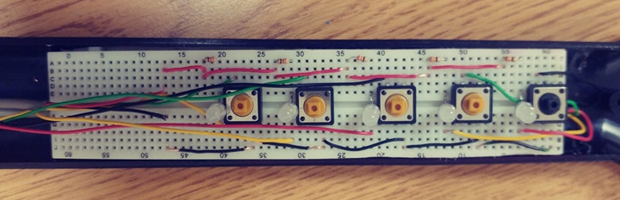
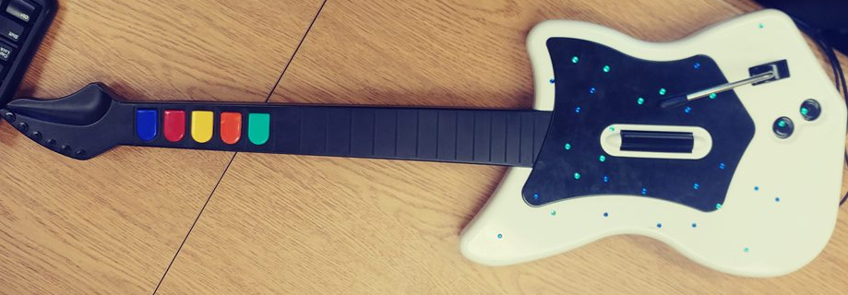
(Figure 1) (Figure 2)

To make everything fit correctly we had to cut down the size of the buttons remove many of the screw connection points. We also had to slim the bread board down so that it would fit inside of the stem of the guitar.
(Figure 3)
GPIO 5
GPIO
16
GPIO 21
GPIO 19
GND
GPIO 12
Blue Button

Red Button

Yellow Button

Orange Button

Green Button

3.3V
GPIO 20
GPIO 22
GPIO 13
GPIO 6
GPIO 4
Green LED

Orange LED

Yellow LED

Red LED

Blue LED

R5
430 OHM
R4
430 OHM
R3
430 OHM
R2
430 OHM
R1
430 OHM

For this project we use GPIO pins 5,12,16,19, and 21 for our buttons and GPIO pins 4,6,13,20, and 22 for our LEDWe s this can be seen in figure 3 above. Each LED's positive side is connect to the 3.3V power through a 430 OHM resistor and each negative side is connected to its designated GPIO pin. Where as the buttons are connected on one side to there set GPIO pin and the other side to the ground pin. Pins 19 and 20 run the blue LED button and LED, pins 21 and 22 run the red button and LED, pins 16 and 13 run the yellow button and LED, pins 12 and 6 run the orange button and LED, and pins 5 and 4 run the green button and LED.

Game modes:
For this project we have implemented 4 different game modes. We have implemented the classic game mode, a lights out version of the classic mode, learn a song, and record 20 nodes.
The classic game mode can be selected by pressing the blue button when prompt for which game mode you wish to play. It has 3 different difficulties easy, medium and hard. Easy uses only 4 buttons at a slower speed. Medium uses 4 buttons at a faster speed and hard uses all 5 buttons at the faster speed. This game mode creates a random number between 1 and 5 adding it to the sequence it has been making. Once it has played the new sequence in its entirety the user must input the same sequence back to the game. If they get it wrong the game will out put a booing noise and restart at the menu. If they get it right the game will generate a new number and repeat this sequence. If they at any point fill the array (currently set to 5 for demonstration purposes) it will output a cheering sound and restart at the menu.
The lights out game mode can be selected by pressing the red button when prompt for which game mode you wish to play. Upon choosing this game mode the game will go through the sequence of sounds that correlate with each button before the game starts. It will then start the game, outputting the first button noise then wait for the user to input what button they believe it to be. It will continue doing this generating a new random button number and adding it to the array each time the user gets it right. It will go until the array is full (currently set to 5 for demonstration purposes). If they get them all right it will output a cheering noise and return to menu, otherwise it will output a booing noise and return to menu.
The learn a song game mode can be selected by choosing the yellow button when prompt which game mode you wish to play. Upon choosing the game mode the game will play hot cross buns for the user, then wait for the user for the user to play the song back to it. If they get it wrong the booing noise will play and return back to menu, otherwise it will output cheering and return to menu.
The record 20 notes game mode can be selected by choosing the orange button when prompt which game mode you wish to play. This game mode allows the user to input any 20 notes they wish to hear (currently only allows 5 for demonstration purposes). The game then stores these notes into an array and when the user is done inputting it plays the sequence back to them. It then outputs a cheering noise and returns to the menu.
The last option of the game mode menu is to exit the game. This is chosen by pressing the green button when prompt for which game mode you wish to play.

Bare Metal:

To implement bare metal the first thing we had to do was write our own random function as we cant call srand(). To do this we set up a loop that counts up every iteration checking to see if any button has been pressed yet. Once a button has been pressed it drops out of the loop returning the count. It takes this count and divides it by the current size of array. It takes the quotient of that divide and divides that by 4. It then takes the remainder of this ,which would be a number between 0-3, and add 1 to it. We now have a seemingly random number between 1-4 which we can use flash a light.
We take this number and insert it into the next spot in the array. We then call our playback function to output the current array to each values corresponding light. Playback loads each value of the array, blinks that light, calls delay to pause the program for 0xD7000 clock cycles and then does it for the next value in the array. Next we wait for the user to input what they believe the sequence to be. If they get the current sequence correctly we loop back and create a new random number and does it all again. If they get any of them wrong it flashes all the lights 3 times and exits the program.

