GETTING STARTED WITH R

Cleo Falvey | Filip Stefanovic | 7.29.2020

## Below are links to install R and RStudio. Please try have BOTH R and RStudio installed on your computer before you come to the workshop!

Link to install R for Windows: <https://cran.r-project.org/bin/windows/base/>

Link to install R for Apple: <https://cran.r-project.org/bin/macosx/>

Link to install R for Linux: <https://cran.r-project.org/> (click on download R for Linux).

Link to install RStudio (integrated development environment) which helps you keep track of your code. While this is not mandatory to code in R, the course will be taught using RStudio; it’s easy to get started: <https://rstudio.com/products/rstudio/download/#download>

|  |  |
| --- | --- |
|  | Be sure to pick the right operating system to install R and RStudio! |

## If you get stuck, please watch the videos below to guide you through the process.

Video link to install R/RStudio for Windows: <https://www.youtube.com/watch?v=GAGUDL-4aVw>

Video link to install R/RStudio for Mac: <https://www.youtube.com/watch?v=Y20P3u3c_1c>

Video link to install R/RStudio for Linux: <https://www.youtube.com/watch?v=tMwaDXqv4W4>

## Now, it is time to download the course materials. Please go here to install a .zip file of the content. Go to the green button that says “Code” and then click “Download ZIP”

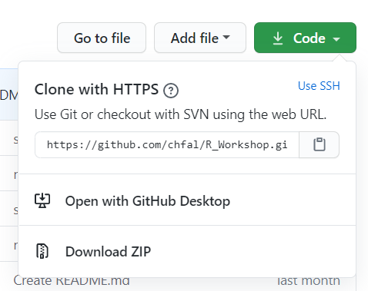

Once you have unzipped the file, open the file called **“Day_1.html.”** This is the first content for Day 1. You should see something that looks like this opened in a PDF viewer on your laptop:

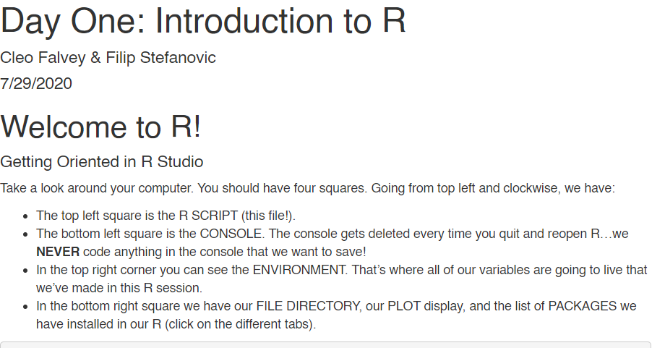

This is the first day’s content and what we will be covering in the workshop. Please read this through so you can have a good idea of what we will be trying to cover!

## Now, we are going to open up our first .Rmd document.

Please open the file called **“Day_1.Rmd”.** You can double-check that your installation has gone properly because the computer will either ask you what you want to open the file with (select RStudio), or it will automatically open up in RStudio for you. You should see four panes, but the top left one should look something like this:

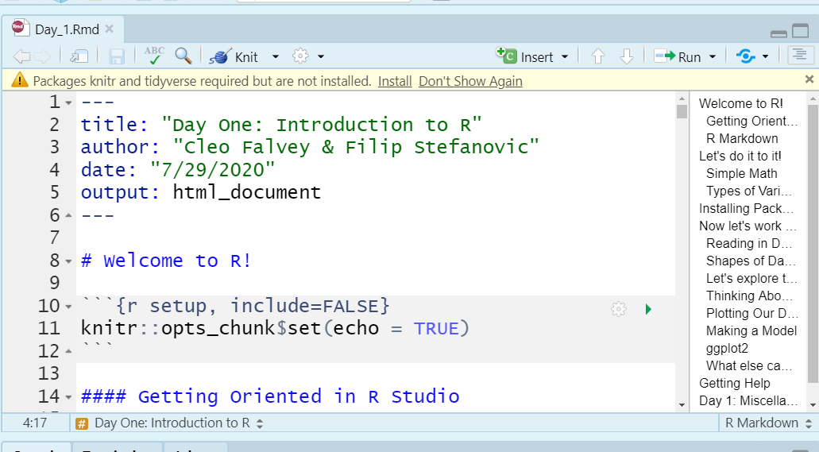

## Installing Your First Packages

In order to get started for the workshop, you should install several packages. RStudio will helpfully tell you which packages these are. If you look back up at the picture, RStudio is helpfully informing you that you need to install the packages called “knitr’” and “tidyverse.” It may also ask you to install ‘RMarkdown.”

Please click the button that says INSTALL the packages. This requires a WiFi connection and it may take some time depending on your WiFi speed. The packages will install, although it may take a moment.



## How will I know it worked?

You will know everything is set up and running correctly if you hit the “Knit” button on the Day_1 script. R will run the file and it will open two help pages and create a .HTML file which looks the same as the “Day_1.html” file.

## Changing the Colors in RStudio so that you can follow along

Lastly, during the workshop, I’ll be sharing my screen. I have changed the color setting in RStudio from the default white to a dark color because it is easier to see. If it would be helpful for my screen to match your screen, please change the color of your RStudio.

**On Windows**: At the top of RStudio, go to TOOLS > GLOBAL OPTIONS.

Once the Global Options open up, go to “Appearance” and fill out the window until it looks like mine below.

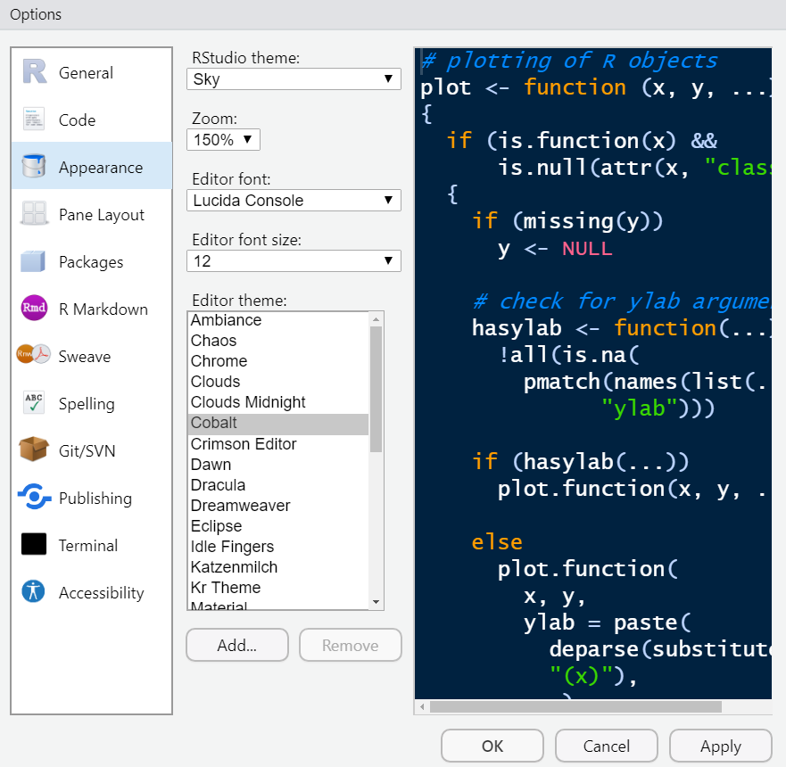

**On Mac**: Hit COMMAND+C (?)

## If you still need help on any of these steps, please come 15 minutes early to the first session and we will help you install the programs onto your computer.