Exploring ensemble applications for multi-sequence myocardial pathology segmentation
Markus J. Ankenbrand¹[0000-0002-6620-807X] David Lohr¹[0000-0002-6509-3776] and Laura M. Schreiber¹[0000-0002-8827-1838]
¹ Chair of Cellular and Molecular Imaging, Comprehensive Heart Failure Center, University Hospital Würzburg, Am Schwarzenberg 15, 97078 Würzburg, Germany
Ankenbrand_M@ukw.de
Abstract. We tested different loss functions and hyper-parameters using a 2D U-Net architecture (resnet34 backbone) with five-fold cross-validation on the training data. Pathology specific sequence data (e.g. LGE for scar and T₂ for edema) was used as a sole input for training and in combination with all sequences. We wanted to address the question whether for limited training data it is beneficial to incorporate prior knowledge by predicting classes with their appropriate sequence or if a neural network is able to infer these relationships from a multi-sequence dataset. In addition, we aimed to create a model zoo, combining predictions from models with high performance on individual classes. Images were cropped to the central 256x256 region as this contained the region of interest in all cases. To improve robustness and learn more general features extensive data augmentation was used, including both MR artifacts (motion, noise) and standard image transformations (zoom, rotation, brightness, contrast). Variations of training data, loss functions and hyper-parameters led to 21 models trained. The multi-sequence model was trained using all image sequences input via color channels producing pixel-level segmentation for all six classes (background, left ventricle, right ventricle, myocardium, edema, and scar). Cross-entropy as a loss function performed best (metric: dice) for non-pathologic tissue, while pathology weighted focal-loss (0.35 for both scar and edema) had best mean performance on scar and edema.
The mean Dice scores over all cross validation folds using the multi-sequence model were: Dice(LV)=0.853, Dice(RV)=0.787, Dice(myocardium)=0.695, Dice(scar)=0.438, Dice(edema)=0.227. The specific models reached dice scores of: Dice(scar)=0.479, Dice(edema)=0.276
These results indicate that the employed neural network is capable of learning multi-sequence segmentation end-to-end. Combining different outputs from a model zoo based on objective criteria proofed difficult.
Keywords: Deep Learning, U-Net, Ensemble, Segmentation, Cardiac MRI
- Introduction
A very short introduction to CMR incl. LGE and T2. General intro to automatic segmentation and neural networks. Challenges of automatic seg. Total ~half page.
- Material & Methods
  - (Hardware and) Software
Google colab GPU instance for parameter search. Our server for final training and prediction (Ubuntu…)
Python, pytorch, Fastai v2, MONAI focal loss, nibabel

  - Hyperparameter search
General hyperparameter choice (e.g. resnet34 based U-Net)
General multi-channel/multi-class networks (different focus), pathology specific single-channel/single-class networks.

Preliminary experiments

In preliminary experiments the effect of
Systematic experiments (21)
Targeted experiments (6) Long training and final training
  - Ensemble method
Combining predictions from different networks.
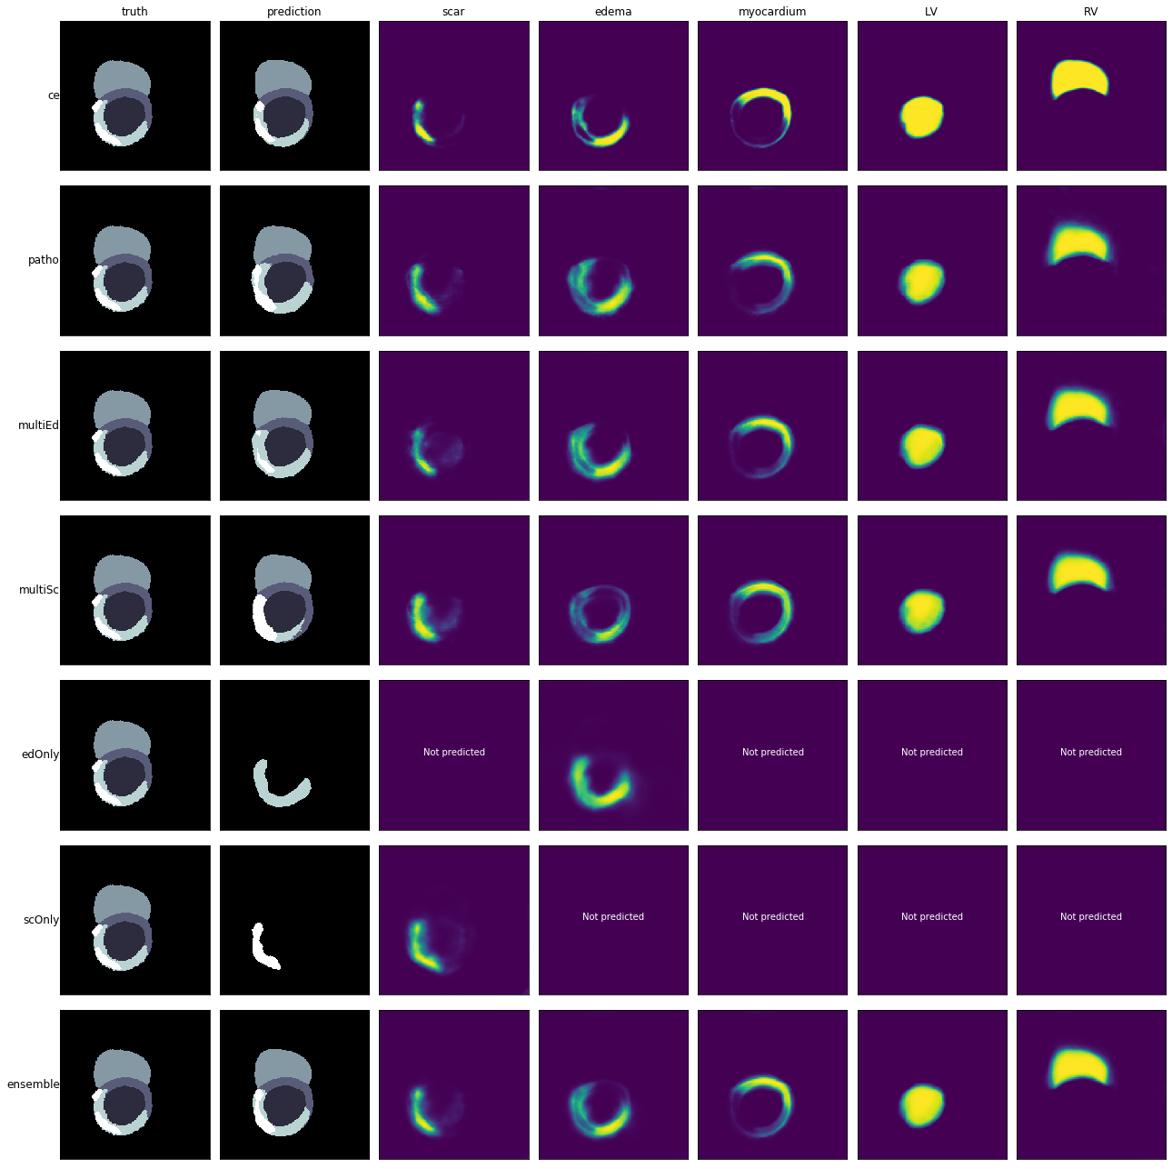Fig. 1. Probability maps for all classes and derived prediction (second column) for the six networks and the ensemble, compared to the ground truth (left most)
  - Availability of models and code
GitHub + zenodo
- Results
  - Cross-validation results on training set
  - Performance on test set
- Discussion

References
- Author, F.: Article title. Journal 2(5), 99–110 (2016).
- Author, F., Author, S.: Title of a proceedings paper. In: Editor, F., Editor, S. (eds.) CONFERENCE 2016, LNCS, vol. 9999, pp. 1–13. Springer, Heidelberg (2016).
- Author, F., Author, S., Author, T.: Book title. 2nd edn. Publisher, Location (1999).
- Author, F.: Contribution title. In: 9th International Proceedings on Proceedings, pp. 1–2. Publisher, Location (2010).
- LNCS Homepage, http://www.springer.com/lncs, last accessed 2016/11/21.

