**JobListingSampleApplication**

This demo application demonstrates how all jobs or jobs of a specific user are listed. According to the security rules, only Administrator users are allowed to get all jobs and normal users can only get their jobs. This security rules are also demonstrated in this demo application. The user table and the corresponding data should be created before executing this demo.

The Joblisting and Security Service Urls, Thumbprint and DnsEndpointId of the certificate must be specified in the app.config file.

Below are the output messages you should have after executing this demo. If your output is different than this, you should check the parameters in the app.config file.

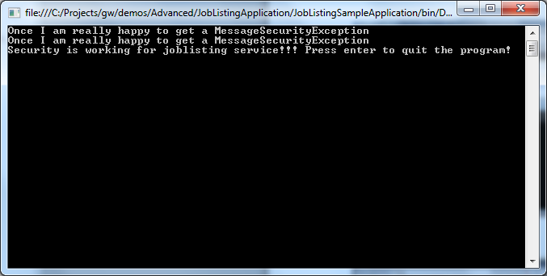

aliceJobListingClient.GetAllJobs();

The first line results a security exception because a normal user is trying to list with all jobs.

aliceJobListingClient.GetJobs("Bob");

The second line results a security exception because a normal user is trying to list jobs of another user.

adminJobListingClient.GetAllJobs();

aliceJobListingClient.GetJobs("Alice");

bobJobListingClient.GetJobs("Bob");

adminJobListingClient.GetJobs("Alice");

These are all valid requests, so they should not result a security exception.