**NotificationSampleApplication**

The NotificationSampleApplication demo shows how a notification subscription can be made to a submitted job. This is useful when the job takes a long time and the user wants to get notified about the outcome of the executed job.

Notification subscriptions are created for a certain jobs and for specified status. This means, a new entry will be inserted to the queue when the job status is one of the specified status. When notification subscriptions are created for a job, the job notifications are added to queues in a user specified Azure storage.

In the app.config file, the service urls, certificate thumbprint and DNS endpoint must be configured to the environment the demo will be run. Also, the connection string that the queues will be created must be specified in the configuration. For demonstration purposes, the queues defined in this demo application is as follows:

**allstatuses** For the first job in the list with all statuses

**runningstatus** For the first job in the list with Running status

**finishedstatus** For the first and second job in the list with Finished status

Before proceeding with running the NotificationSampleApplication, jobs must be created for notification subscription. This can be achieved by executing the Workflow.UBVBio application. The UPVBio application should be executed and when the below step is reached, the NotificationSampleApplication application should be executed to attach the subscriptions. Once the subscriptions are attached, the UPVBio can be continued and the splitter job can be submitted.

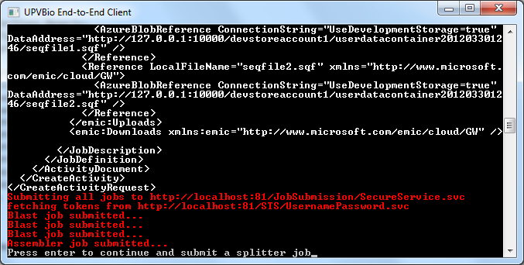

Below is the output window after all the jobs executed successfully. There are some security checks here to control whether admin can subscribe on jobs or a user can subscribe on another user’s jobs. The green messages in the output window show these checks.

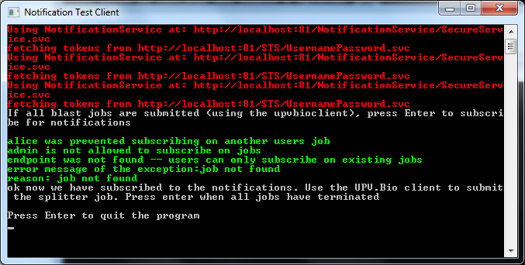

You should see the queues filled in the specified connection storage.

