**JobSubmissionSampleUI**

This is a sample application that executes a selected executable with the selected input and output files and the specified command line arguments.

In the screenshot below the input, output files, the executable and the command line parameters are seen as an example to run SimpleMathConsoleApp that can be found in the GW solution. A valid Generic Worker URL and Cloud Data Connection String must be supplied. The deployment in the cloud must be configured to allow insecure access, as this demo uses insecure access for demonstration purposes.

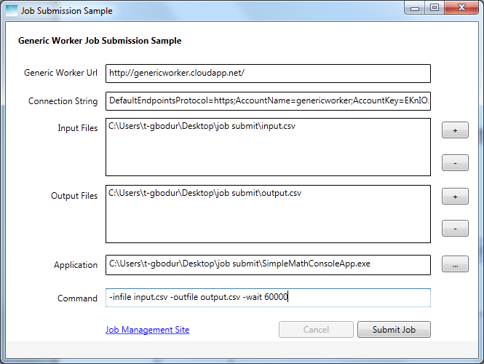

New input files can be added by pressing the + button and selecting the files, or already added input files can be deleted by the – button. Output files are also selected the same way, only difference is the output file selection dialog does not allow multiple selection and a non-existing file can also be selected (which will be created in this specified path after the job executes successfully). An executable file is selected and the command line arguments are entered in the command textbox.

When the Submit Job button is pressed, the application description and package is created and uploaded to the cloud storage along with the input files. Then the job description is created and executed, this will start the execution of the job in the cloud and lock the controls on the screen so that only cancelation of the running job is possible. The current status of the job is shown above the screen, which is continuously refreshed in the background. The status bar is also updated to show the latest step of the execution. While the job is running, the application waits for the job to finish and polls for the output files that will be created.

If for any reason, the job fails in the cloud, the link below can be used to check the job management site and see detailed information. If there is a problem with the Generic Worker URL or Connection String, the status bar also shows the reason and double-clicking on the status bar shows detailed information.

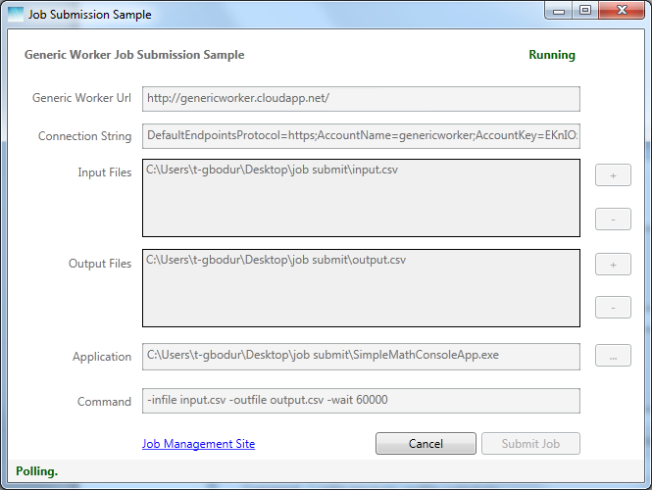

After the job execution completes, the output files are downloaded to the selected path and the controls on the screen are unlocked again, enabling the execution of a new job.

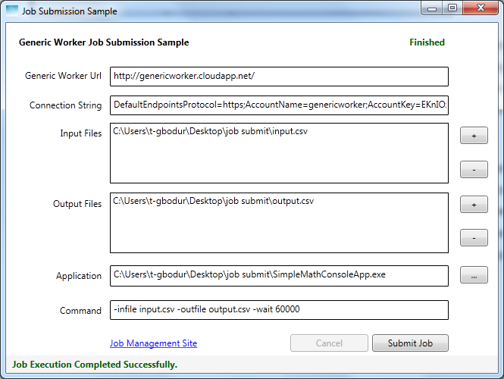

If cancel is pressed while the job is running, the application sends the terminate job command and waits until the job is actually cancelled in the cloud.

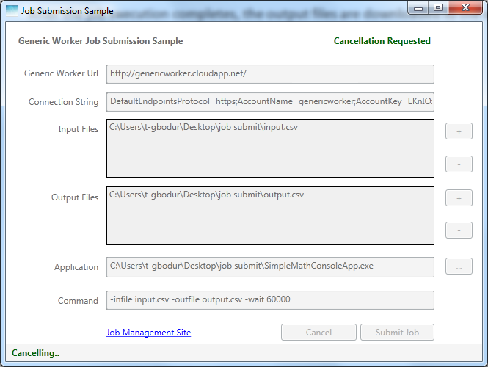

It takes a while until the job is cancelled in the cloud, the user interface is unlocked.

