**UPVBioClient**

UPVBioClient is an application that shows how jobs are prepared, created and executed. Three executables are executed in the cloud with this application. These executables must be uploaded first to the server by running the UPVBioInstaller application.

In the app.config file, the service urls, the management urls, the thumbprint and the DNS Endpoint of the certificate must be configured for the Azure environment.

For these executables to run, the defined input files must be ready. The first executable that must run is the splitter which creates the input data for the other jobs. The application prompts for user confirmation so that the jobs can start. This is useful if notification subscriptions will be made. For more information check the NotificationSampleApplication.

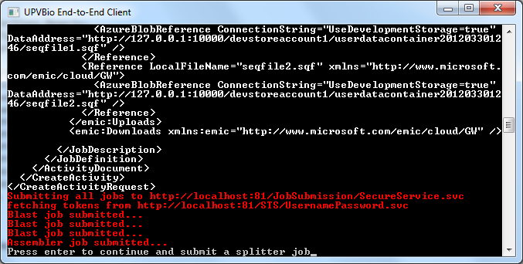

After submitting the splitter job, the execution of 5 jobs (Splitter, Assemble and 3 Blast jobs) should start. The execution of the jobs can be cancelled any time by typing “y”. These would send a cancellation request for the jobs.

After all the jobs are finished the output file is shown in the output window.

