
Assignment No. 2
Course Title: Parallel & Distributed Computing Lab (CS-426L)
Java Data Structures, Multithreading & Benchmarking

SUBMITTED BY:  Name: Muhammad Ghayas Umair  Student ID: 247144  Semester: 5th  Section: CYS-B | SUBMITTED TO:  Instructor Name: Mr. Qaiser Ali
Date of Submission: 25/10/2026

AIR UNIVERSITY, KHARIAN CAMPUS
DEPARTMENT OF COMPUTING & ARTIFICIAL INTELLIGENCE

QUESTION #01
High-frequency financial trading systems process real-time market data streams by dispatching heterogeneous trade order payloads dynamically through object-oriented message passing, method overriding, and inheritance. In an enterprise financial exchange architecture (such as a Complex Event Processing engine connected to FIX and Reuters market gateways), incoming market events must be normalized before execution. For this task, students must develop a four-file Java architecture starting with TradeEvent.java as a superclass. This superclass must contain protected fields for senderId (String), timestamp (long), and basePrice (double), a parameterized constructor to initialize them, and a baseline dispatch() method that logs generic event details. Next, students will create FIXOrderEvent.java extending TradeEvent, which adds a clOrdId (String) field, invokes the parent constructor using super, and overrides dispatch() to format and execute stock purchase requests with a 0.15% exchange transaction fee. A third file, ReutersQuoteEvent.java, also extends TradeEvent with fields like bidPrice and askPrice, overriding dispatch() to output real-time bid-ask spread market analytics. Finally, students will write TradingEngineApp.java containing a main() method to instantiate subclass objects using superclass reference variables, executing dispatch() on each instance to demonstrate run-time dynamic method overriding and polymorphic message passing.

TRADEEVENT CLASS
public class TradeEvent
{
protected String sender;
protected long time;
protected double price;
public TradeEvent(String s,long t,double p)
{
sender=s;
time=t;
price=p;
}
public void dispatch()
{
System.out.println("Generic Event , Sender: "+sender+" , Time: "+time+" , Price: "+price);
}
}

FIXORDEREVENT CLASS
public class FixOrderEvent extends TradeEvent
{
private String id;
public FixOrderEvent(String s,long t,double p,String i)
{
super(s,t,p);
id=i;
}
@Override
public void dispatch()
{
double fee=price*0.0067;
double total=price+fee;
System.out.println("Fix Order | Order ID= "+id+" | Sender: "+sender+" | Base Price= "+price+" | Fee = "+fee+" | Total= "+total);
}
}

REUTERSQUOTEEVENT CLASS
public class ReutersQuoteEvent extends TradeEvent
{
private double bid;
private double ask;
public ReutersQuoteEvent(String s,long t,double p,double b,double a)
{
super(s,t,p);
bid=b;
ask=a;
}
@Override
public void dispatch()
{
double spread=ask-bid;
System.out.println("Reuters Quote | Sender: "+sender+" | Bid: "+bid+" | Ask: "+ask+" | Spread: "+spread);
}
}

TRADINGENGINEAPP CLASS
public class TradingEngineApp
{
public static void main(String[] a)
{
TradeEvent o=new FixOrderEvent("FIXGATEWAY",17100001L,167,"ORDER_67");
TradeEvent q=new ReutersQuoteEvent("REUTERSFEED",17100002L,67,67.5,267.5);
TradeEvent[] list={o,q};
for(int i=0;i<list.length;i++)
list[i].dispatch();
}
}
OUTPUT
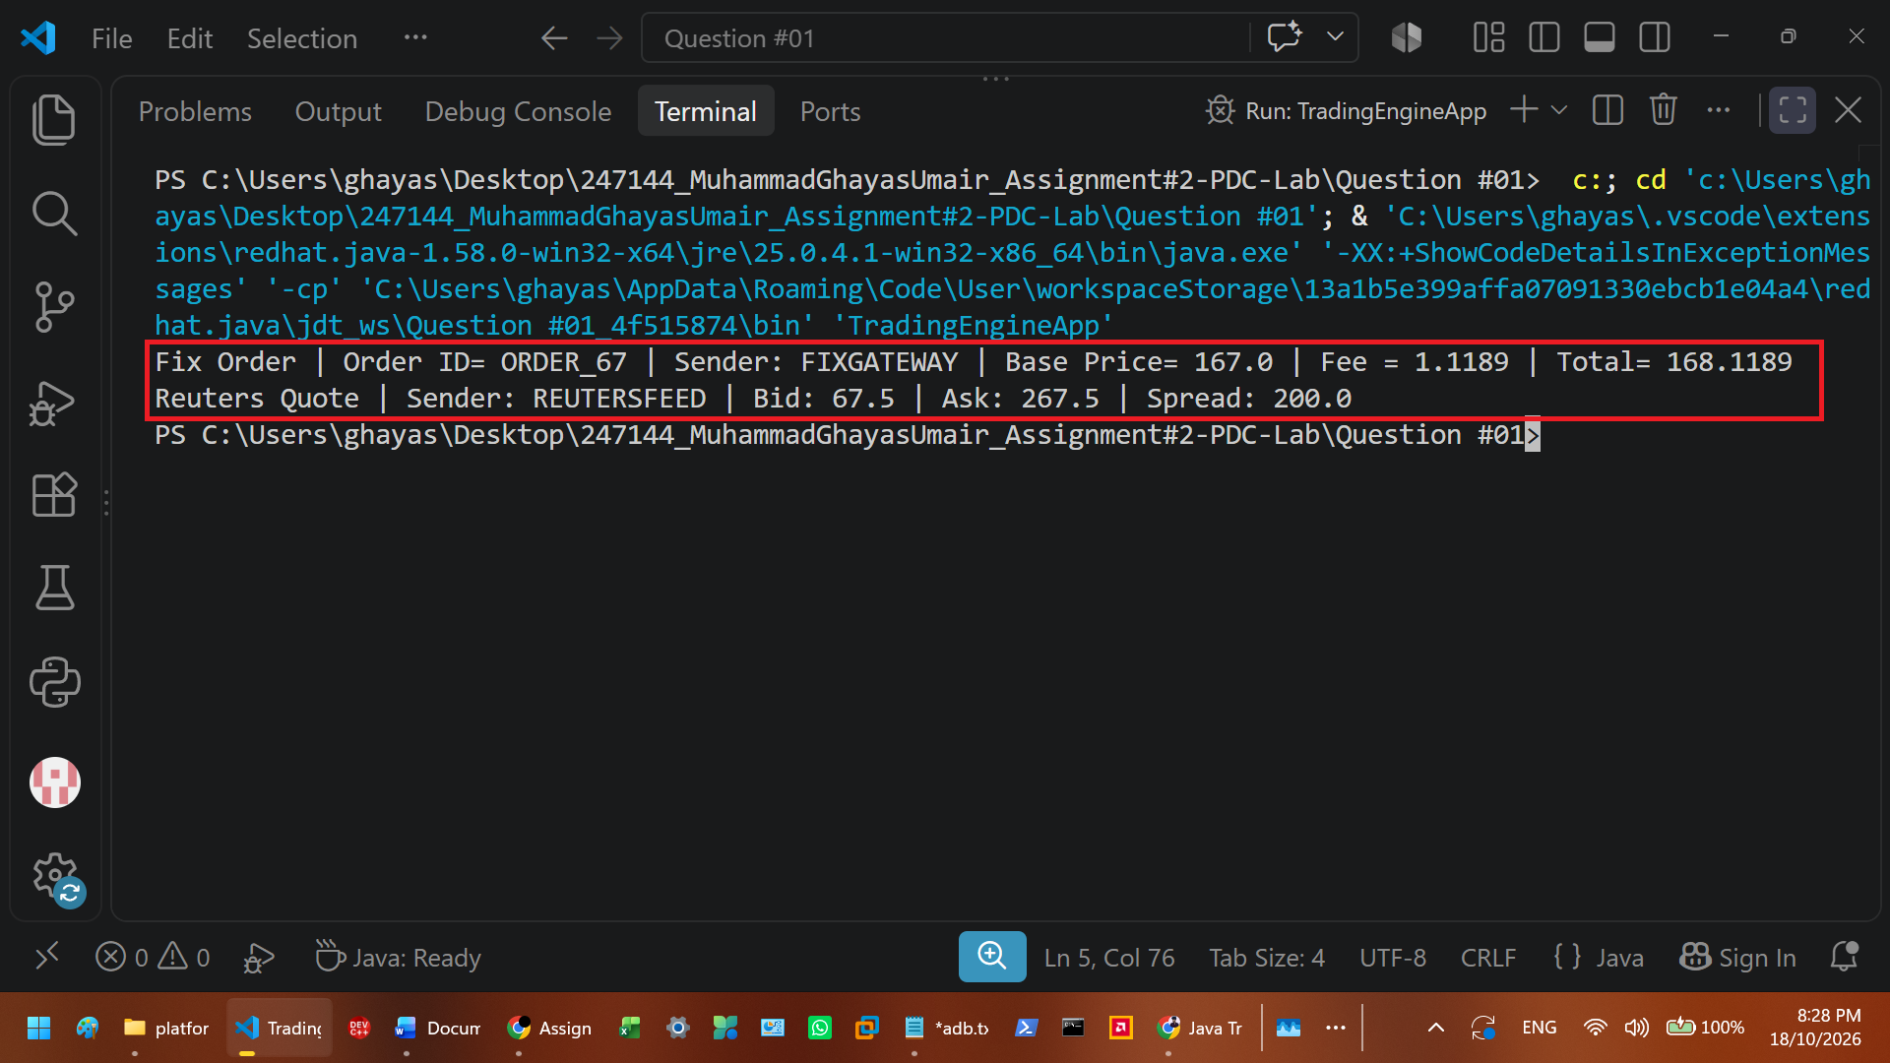
To solve this application task, I built a four-file object-oriented Java architecture that processes different financial market events through inheritance and polymorphism. First, I structured the base superclass in TradeEvent.java with protected instance variables for senderId, timestamp, and basePrice so that child classes could inherit and access them directly, alongside a parameterized constructor for initialization and a baseline dispatch() method. Next, I created two specialized subclasses in separate files, FIXOrderEvent.java and ReutersQuoteEvent.java, using the extends keyword. In FIXOrderEvent, I added a private clOrdId variable, passed the base parameters up to the parent constructor using super(), and used method overriding on dispatch() to calculate and print a 0.15% transaction fee on the base price. Similarly, in ReutersQuoteEvent, I managed private bidPrice and askPrice instance variables, initialized the parent fields via super(), and overrode dispatch() to compute the bid-ask spread by subtracting the bid price from the ask price. Finally, in TradingEngineApp.java, I implemented the main(String[] args) method where I instantiated both subclass objects using TradeEvent superclass reference variables and stored them inside a custom array-based queue named eventQueue. I then executed a standard for loop with the condition i < eventQueue.length to iterate through the queue and perform inter-class message passing by calling eventQueue[i].dispatch() on each element.

QUESTION #02
In zero-trust microservice security architectures, high-throughput backend API gateways buffer incoming network payloads using strict First-In, First-Out (FIFO) queues while simultaneously writing security audit events to Last-In, First-Out (LIFO) stack frames for rapid recovery rollbacks. To audit incoming encrypted packet headers without allocating dynamic garbage-collected memory, edge security gateways compare LIFO and FIFO streams to verify bi-directional payload symmetry (palindrome signature detection). Develop a protocol packet verification suite in Java. First, implement a custom array-backed stack class named TransactionStack.java with fixed- capacity storage, top pointer, and explicit low-level methods for push(char c), pop(), peek(), and isEmpty(). Second, implement a custom array-backed queue class named RequestQueue.java with front, rear, and size pointers supporting enqueue(char c), dequeue(), and isEmpty(). Finally, write PacketSymmetryAuditor.java containing a main() method that ingests a raw network packet payload string, pushes characters into TransactionStack while simultaneously enqueuing them into RequestQueue, and pops/dequeues elements concurrently to determine whether the packet exhibits bi-directional symmetry, printing the verified terminal log.

TRANSACTIONSTACK CLASS
public class TransactionStack
{
private char[] a;
private int t;
public TransactionStack(int c)
{
a=new char[c];
t=-1;
}
public void push(char c)
{
t++;
a[t]=c;
}
public char pop()
{
char c=a[t];
t--;
return c;
}
public char peek()
{
return a[t];
}
public boolean isempty()
{
return t==-1;
}
}

REQUESTQUEUE CLASS
public class RequestQueue
{
private char[] a;
private int f;
private int r;
private int s;
public RequestQueue(int c)
{
a=new char[c];
f=0;
r=-1;
s=0;
}
public void enqueue(char c)
{
r++;
a[r]=c;
s++;
}
public char dequeue()
{
char c=a[f];
f++;
s--;
return c;
}
public boolean isempty()
{
return s==0;
}
}

PACKETSUMMARYAUDITOR CLASS
public class PacketSymmetryAuditor
{
public static void main(String[] args)
{
String p="tacocat";
int l=p.length();
TransactionStack s=new TransactionStack(l);
RequestQueue q=new RequestQueue(l);
for(int i=0;i<l;i++)
{
char c=p.charAt(i);
s.push(c);
q.enqueue(c);
}
boolean sym=true;
while(!s.isempty()&&!q.isempty())
{
char fs=s.pop();
char fq=q.dequeue();
System.out.println("stack pop: "+fs+" | queue dequeue: "+fq);
if(fs!=fq)
{
sym=false;
}
}
if(sym)
{
System.out.println("verified log: packet "+p+" has bi-directional symmetry.");
}
else
{
System.out.println("verified log: packet "+p+" does not have symmetry.");
}
}
}

OUTPUT
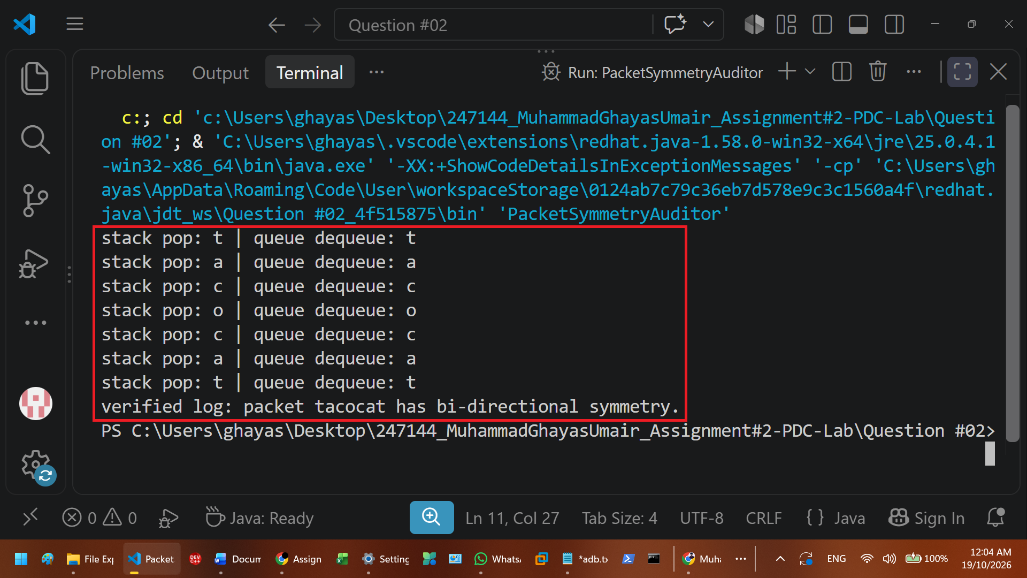
To solve this problem, I built a three-file Java program that checks if a network packet string reads the same forwards and backwards using a custom stack and queue. First, I created TransactionStack.java to handle the Last-In, First-Out operations. Inside this class, I used a fixed-size character array arr and an integer top instance variable initialized to -1 in the constructor, and then I wrote the push(char c), pop(), peek(), and isEmpty() methods to add and remove characters from the top of the array. Second, I created RequestQueue.java for the First-In, First-Out operations using another character array along with front, rear, and size pointers initialized in its constructor. In this class, the enqueue(char c) method adds characters to the rear while dequeue() removes them from the front and updates the size. Finally, I wrote PacketSymmetryAuditor.java with the main method to test the payload string "RADAR". After creating objects for both classes with the string length as the capacity parameter, I used a for loop with the condition i < length to pass each character into stack.push(c) and queue.enqueue(c) at the same time. Then, I ran a while loop that continues as long as !stack.isEmpty() && !queue.isEmpty() to pull characters from both structures and compare them.

QUESTION #03
High-traffic cloud infrastructure platforms run asynchronous system diagnostics and telemetry aggregators concurrently alongside core application threads to prevent latency bottlenecks. To engineer a multithreaded telemetry engine, students must build a multi-file Java solution starting with LogProcessorTask.java implementing the Runnable interface. Its run() method must execute a loop repeating five times, outputting current iteration log metrics alongside Thread.currentThread().getName() while pausing execution for 1000 milliseconds using Thread.sleep(1000). In a second file titled TelemetryThread.java, students will create a class extending Thread directly, overriding run() with a loop iterating five times to log system CPU and memory health updates every 800 milliseconds. The master application driver, AsyncWebEngineApp.java, contains the main() method where students will display the default JVM thread name ('main'). Students will then instantiate TelemetryThread and pass a LogProcessorTask instance into a new Thread object, assign custom names ('Telemetry-Worker' and 'Log-Worker'), invoke start() on both threads simultaneously, and log active execution states to demonstrate concurrent thread execution.

LOGPROCESSORTASK CLASS
public class LogProcessorTask implements Runnable
{
@Override
public void run()
{
for(int i=1;i<=5;i++)
{
System.out.println(Thread.currentThread().getName()+" | log metric iteration: "+i);
try
{
Thread.sleep(1067);
}
catch(InterruptedException e)
{
System.out.println("log thread interrupted.");
}
}
}
}

TELEMETRYTHREAD CLASS
public class TelemetryThread extends Thread
{
@Override
public void run()
{
for(int i=1;i<=5;i++)
{
System.out.println(Thread.currentThread().getName()+" | cpu & memory health update: "+i);
try
{
Thread.sleep(867);
}
catch(InterruptedException e)
{
System.out.println("telemetry thread interrupted.");
}
}
}
}

ASYNCWEBENGINEAPP CLASS
public class AsyncWebEngineApp
{
public static void main(String[] a)
{
System.out.println("main thread name: "+Thread.currentThread().getName());
TelemetryThread t=new TelemetryThread();
t.setName("telemetry-worker");
LogProcessorTask p=new LogProcessorTask();
Thread w=new Thread(p);
w.setName("log-worker");
t.start();
w.start();
System.out.println(t.getName()+" state: "+t.getState());
System.out.println(w.getName()+" state: "+w.getState());
}
}

OUTPUT
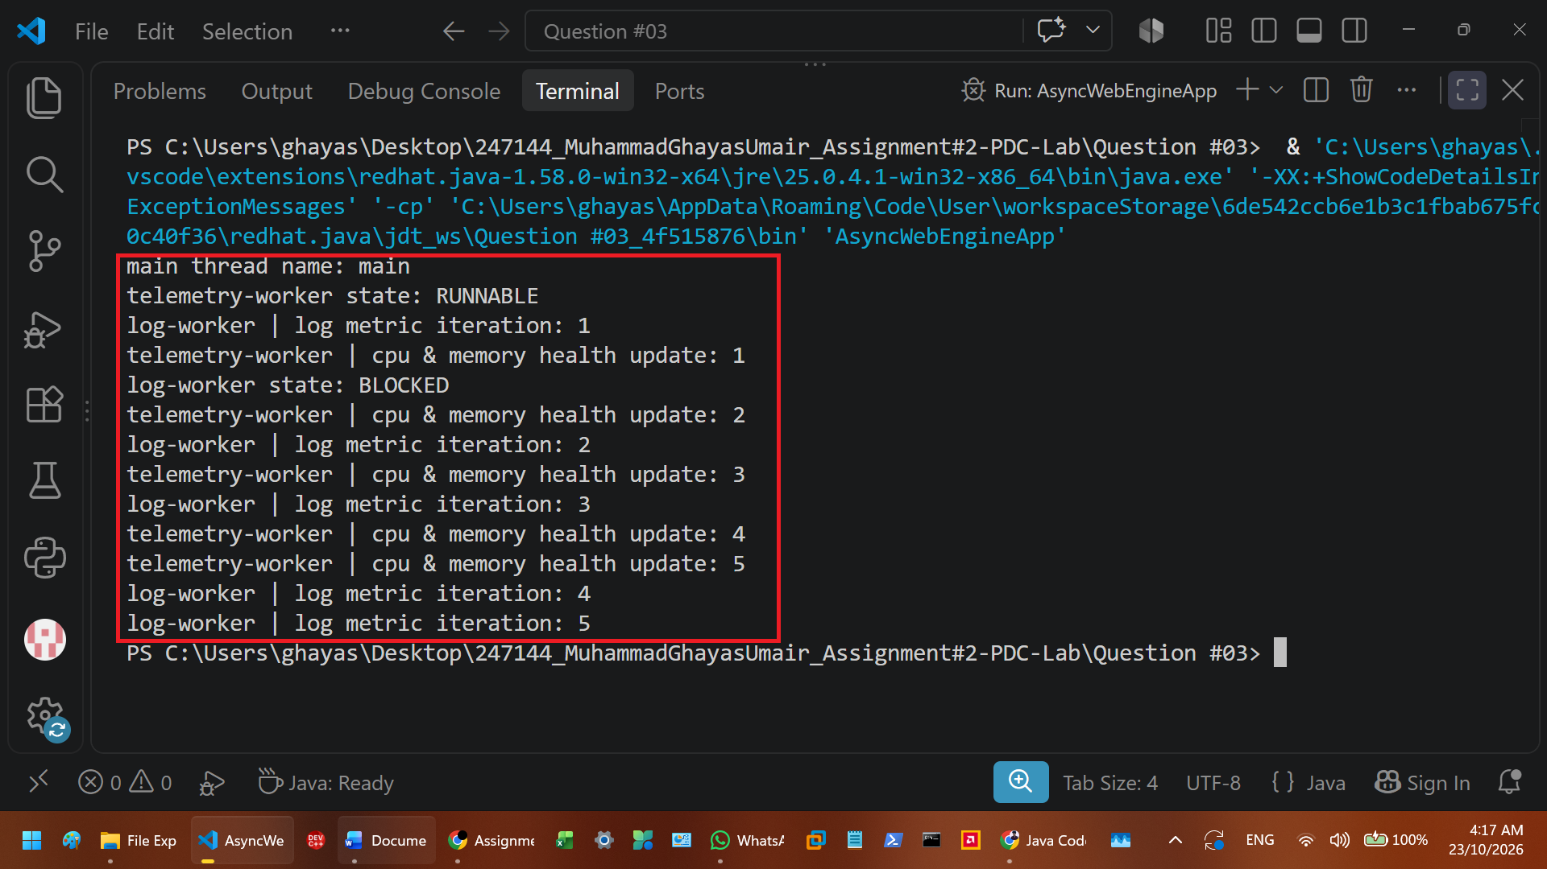
To build this multithreaded telemetry engine, I divided the program into three separate Java files to show the two different ways of creating and running concurrent threads. First, I created LogProcessorTask.java by implementing the Runnable interface and overriding the run() method with a for loop that runs five times using the condition i <= 5. Inside this loop, I called Thread.currentThread().getName() to print the active thread's name alongside the log iteration count, and used Thread.sleep(1067) inside a try-catch block to pause the thread for 1067 milliseconds on each cycle. Second, I created TelemetryThread.java by extending the Thread class directly and overriding its run() method with a similar five-iteration loop that prints CPU and memory health updates every 867 milliseconds using Thread.sleep(867). Finally, I built the main driver in AsyncWebEngineApp.java, where the main(String[] args) method first prints the default 'main' JVM thread name. I then created an instance of TelemetryThread directly and passed a new LogProcessorTask object into a Thread constructor, assigning them the custom names 'Telemetry-Worker' and 'Log-Worker' using the setName() method. By calling start() on both thread objects right after each other and logging their active execution states with getState(), both threads ran in parallel. The terminal output proved that the threads were working at the same time because the log messages and telemetry updates printed out mixed together, with 'Telemetry-Worker' finishing its five loops slightly faster due to its shorter 867-millisecond sleep interval compared to the 1067-millisecond pause in 'Log-Worker'

QUESTION #04
Enterprise financial analytics platforms evaluate massive asset portfolios containing hundreds of thousands of market instruments in parallel using Java's Fork/Join framework. When dataset sizes exceed sequential processing thresholds, workload must be recursively split across available processor cores. Design and implement a parallel portfolio assessment engine in Java using the Fork/Join framework. First, write ParallelRiskCalculator.java extending RecursiveTask to calculate the cumulative risk score of a large array of financial asset values. If the array segment size is below a sequential threshold [i.e., THRESHOLD = 1000], compute the sum directly; otherwise, divide the array into two sub-tasks, invoke fork() on the sub-tasks, and join() the results. Second, implement PortfolioThresholdTask.java extending RecursiveAction to perform an in- place adjustment that applies a 5% volatility stress-test penalty to all asset values exceeding a specified risk cap. Finally, write ForkJoinPortfolioApp.java containing the main() entry point to generate a 10,000-element synthetic asset array, instantiate a ForkJoinPool, execute both tasks, and display total processing time alongside the calculated risk metrics to prove parallel speedup over serial computation.

PARALLELRISKCALCULATOR CLASS
import java.util.concurrent.RecursiveTask;
public class ParallelRiskCalculator extends RecursiveTask<Double>
{
private static final int THRESHOLD=1000;
private double[] a;
private int s;
private int e;
public ParallelRiskCalculator(double[] ar,int st,int en)
{
a=ar;
s=st;
e=en;
}
@Override
protected Double compute()
{
if((e-s)<=THRESHOLD)
{
double sum=0;
for(int i=s;i<e;i++)
{
sum+=a[i];
}
return sum;
}
else
{
int m=(s+e)/2;
ParallelRiskCalculator lt=new ParallelRiskCalculator(a,s,m);
ParallelRiskCalculator rt=new ParallelRiskCalculator(a,m,e);
lt.fork();
rt.fork();
return lt.join()+rt.join();
}
}
}

PORTFOLIOTHRESHOLDTASK CLASS
import java.util.concurrent.RecursiveAction;
public class PortfolioThresholdTask extends RecursiveAction
{
private static final int THRESHOLD=1000;
private double[] a;
private int s;
private int e;
private double r;
public PortfolioThresholdTask(double[] ar,int st,int en,double rc)
{
a=ar;
s=st;
e=en;
r=rc;
}
@Override
protected void compute()
{
if((e-s)<=THRESHOLD)
{
for(int i=s;i<e;i++)
{
if(a[i]>r)
{
a[i]=a[i]*0.95;
}
}
}
else
{
int m=(s+e)/2;
PortfolioThresholdTask lt=new PortfolioThresholdTask(a,s,m,r);
PortfolioThresholdTask rt=new PortfolioThresholdTask(a,m,e,r);
lt.fork();
rt.fork();
lt.join();
rt.join();
}
}
}

FORKJOINPORTFOLIOAPP CLASS
import java.util.concurrent.ForkJoinPool;
public class ForkJoinPortfolioApp
{
public static void main(String[] a)
{
double[] ar=new double[10000];
for(int i=0;i<ar.length;i++)
{
ar[i]=200.0;
}
ForkJoinPool p=new ForkJoinPool();
long st=System.nanoTime();
ParallelRiskCalculator ic=new ParallelRiskCalculator(ar,0,ar.length);
double is=p.invoke(ic);
PortfolioThresholdTask pt=new PortfolioThresholdTask(ar,0,ar.length,150.0);
p.invoke(pt);
ParallelRiskCalculator fc=new ParallelRiskCalculator(ar,0,ar.length);
double fs=p.invoke(fc);
long et=System.nanoTime();
long tt=et-st;
System.out.println("initial risk score: "+is);
System.out.println("adjusted risk score (after 5% penalty): "+fs);
System.out.println("total processing time (ns): "+tt);
}
}

OUTPUT
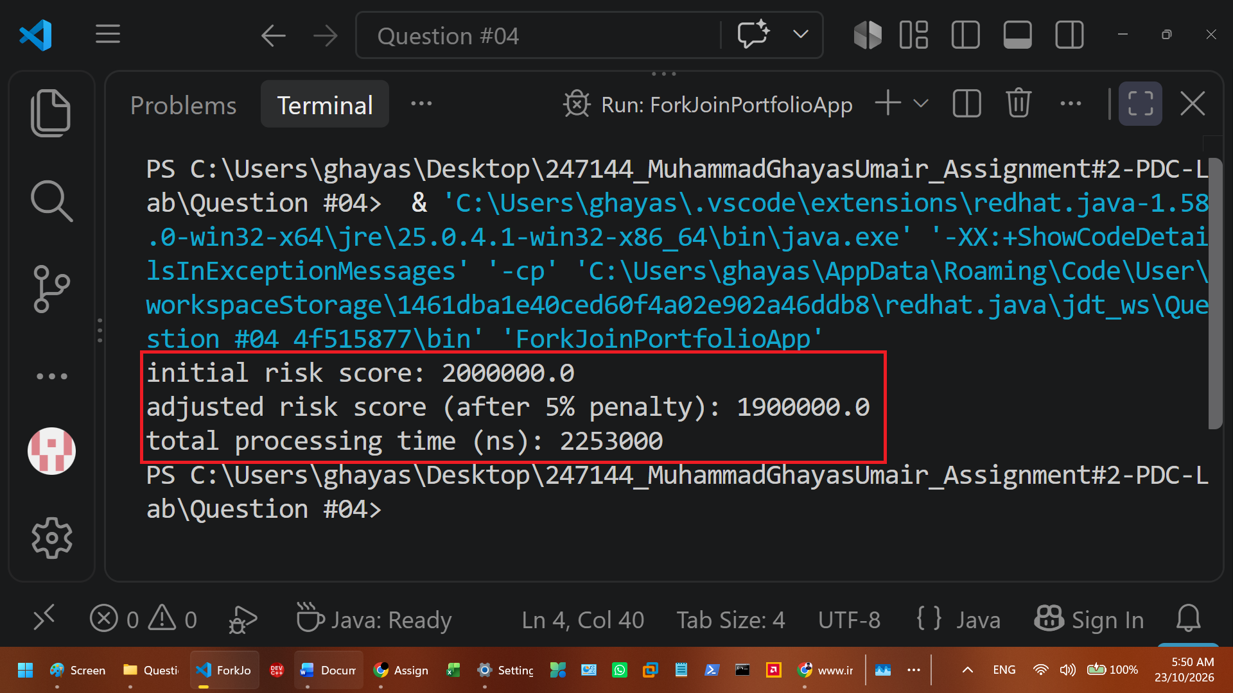
To build this parallel portfolio assessment engine, I structured the solution across three separate Java files using Java's Fork/Join framework to split a large array workload across multiple processor cores. First, I created ParallelRiskCalculator.java by extending RecursiveTask<Double> and managing instance variables for the assets array, start and end boundaries, and a constant THRESHOLD of 1000. By overriding the compute() method, I checked if the segment size end - start was less than or equal to 1000; when true, a for loop with the condition i < end sums the elements directly, and when false, the task calculates the midpoint, spawns two child tasks, calls fork() to run them asynchronously, and combines their totals using join(). Second, I built PortfolioThresholdTask.java by extending RecursiveAction and adding a riskCap parameter to its constructor. Its overridden compute() method uses the same 1000-element threshold to recursively divide the array, applying an in-place 5% penalty by multiplying assets[i] by 0.95 whenever an element exceeds riskCap. Finally, in ForkJoinPortfolioApp.java, I implemented the main(String[] args) method to initialize a 10,000-element double array filled with 200.0 values and instantiated a ForkJoinPool. Using pool.invoke(), I executed the sum task, ran the threshold penalty task with a 150.0 risk cap, and re-ran the sum task while tracking the execution duration with System.nanoTime()

QUESTION #05
IoT monitoring networks continuously sample ambient temperature and vibration metrics across thousands of manufacturing sensor nodes. Detecting critical equipment anomalies requires realtime parallel minimum and maximum value reductions across partitioned sensor grid arrays. Construct an extensible parallel search engine in Java. First, build SensorSearchEngine.java as an abstract parent class containing protected fields for sensorData[] (double array), startIdx, and endIdx, along with an abstract method processGrid(). Next, implement ParallelMinSearch.java extending SensorSearchEngine, overriding processGrid() to execute a multithreaded search that identifies the minimum recorded sensor temperature. Third, implement ParallelMaxSearch.java extending SensorSearchEngine, overriding processGrid() to locate peak vibration spikes across the array segment. Finally, write SensorGridMonitorApp.java containing the main() method where a 50,000-element sensor telemetry array is partitioned across four worker threads. The program must execute parallel min and max reductions simultaneously, log the identified global critical threshold values, and output execution timing logs.

SENSORSEARCHENGINE CLASS
public abstract class SensorSearchEngine implements Runnable
{
protected double[] d;
protected int s;
protected int e;
protected double r;
public SensorSearchEngine(double[] a,int st,int en)
{
d=a;
s=st;
e=en;
}
public abstract void processgrid();
@Override
public void run()
{
processgrid();
}
public double getresult()
{
return r;
}
}

PARALLELMINSEARCH CLASS
public class ParallelMinSearch extends SensorSearchEngine
{
public ParallelMinSearch(double[] a,int st,int en)
{
super(a,st,en);
}
@Override
public void processgrid()
{
r=d[s];
for(int i=s+1;i<e;i++)
{
if(d[i]<r)
{
r=d[i];
}
}
}
}

PARALLELMAXSEARCH CLASS
public class ParallelMaxSearch extends SensorSearchEngine
{
public ParallelMaxSearch(double[] a,int st,int en)
{
super(a,st,en);
}
@Override
public void processgrid()
{
r=d[s];
for(int i=s+1;i<e;i++)
{
if(d[i]>r)
{
r=d[i];
}
}
}
}

SENSORGRIDMONITORAPP CLASS
public class SensorGridMonitorApp
{
public static void main(String[] a) throws InterruptedException
{
double[] d=new double[50000];
for(int i=0;i<d.length;i++)
{
d[i]=67;
}
d[1200]=-15.67;
d[38000]=467.67;
long st=System.nanoTime();
ParallelMinSearch m1=new ParallelMinSearch(d,0,25000);
ParallelMinSearch m2=new ParallelMinSearch(d,25000,50000);
ParallelMaxSearch x1=new ParallelMaxSearch(d,0,25000);
ParallelMaxSearch x2=new ParallelMaxSearch(d,25000,50000);
Thread t1=new Thread(m1);
Thread t2=new Thread(m2);
Thread t3=new Thread(x1);
Thread t4=new Thread(x2);
t1.start();
t2.start();
t3.start();
t4.start();
t1.join();
t2.join();
t3.join();
t4.join();
double gmin=Math.min(m1.getresult(),m2.getresult());
double gmax=Math.max(x1.getresult(),x2.getresult());
long tt=System.nanoTime()-st;
System.out.println("global minimum temperature: "+gmin);
System.out.println("global maximum vibration: "+gmax);
System.out.println("execution time (ns): "+tt);
}
}

OUTPUT
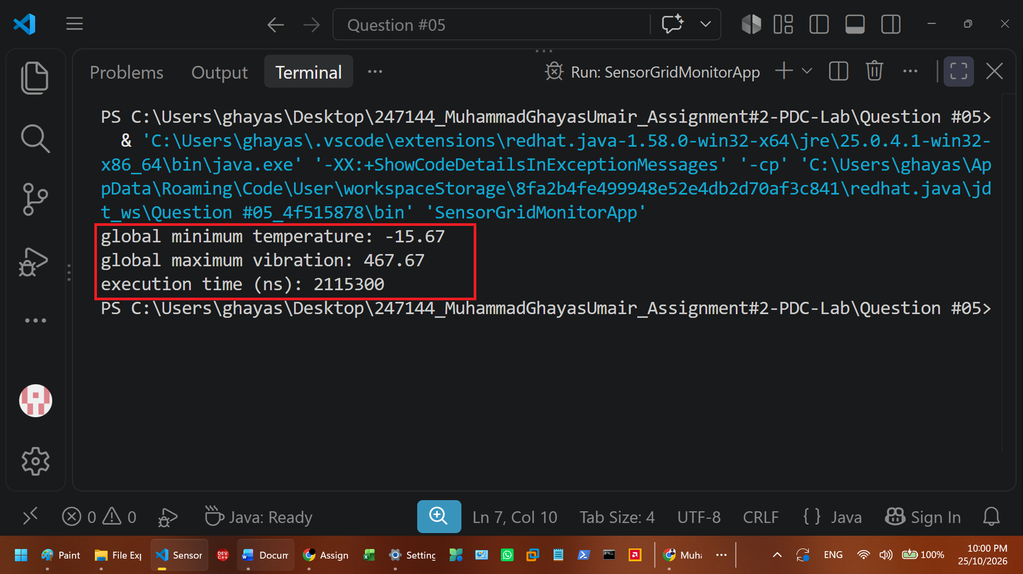
To build this parallel IoT sensor search engine, I divided the program into four separate Java files using abstraction, inheritance, method overriding, and multithreading. First, I created the abstract parent class SensorSearchEngine.java implementing the Runnable interface, where I defined protected instance variables for the sensorData double array, startIdx, endIdx, and result, initialized them with a parameterized constructor, and declared the abstract processGrid() method. Next, I implemented two subclasses in ParallelMinSearch.java and ParallelMaxSearch.java that extend SensorSearchEngine and pass their constructor arguments to the parent class via super(). In both subclasses, I overrode processGrid() using a for loop with the condition i < endIdx to scan only the assigned array partition, updating result whenever a smaller value is found in ParallelMinSearch or a larger value is found in ParallelMaxSearch. Finally, in SensorGridMonitorApp.java, I wrote the main method to initialize a 50,000-element sensorData array containing baseline values of 50.0 alongside a planted minimum of -15.67 and maximum of 467.67. I partitioned the array into two halves (0 to 25000 and 25000 to 50000) across two ParallelMinSearch instances and two ParallelMaxSearch instances, wrapped them inside four Thread objects, and called start() and join() on all four threads to execute the min and max reductions simultaneously while measuring runtime with System.nanoTime()

QUESTION #06
E-commerce flash sales trigger extreme concurrent read and write transactions on centralized product inventory catalogs. Under heavy multi-threaded demand, coarse-grained map synchronization (such as Collections.synchronizedMap) causes thread starvation due to full-table lock contention, whereas finegrained bucket locking allows parallel access. Build an inventory catalog concurrency benchmark in Java. Create InventoryCatalogManager.java that maintains a shared product stock catalog (String productId, Integer stockCount). Implement two distinct benchmarking methods: benchmarkSynchronizedMap() which wraps a standard HashMap with Collections.synchronizedMap(), and benchmarkConcurrentMap() which utilizes ConcurrentHashMap. In both methods, spawn a pool of 10 worker threads performing 50,000 concurrent stock lookup and update operations. Measure and print the total throughput (operations/second) and execution time for both collection types to demonstrate how segment- level bucket locking reduces thread contention in high-throughput distributed architectures.

INVENTORYCATALOGMANAGER CLASS
import java.util.Collections;
import java.util.HashMap;
import java.util.Map;
import java.util.concurrent.ConcurrentHashMap;
public class InventoryCatalogManager
{
public static void benchmarksync() throws InterruptedException
{
Map<String,Integer> c=Collections.synchronizedMap(new HashMap<>());
runbench("synchronizedmap",c);
}
public static void benchmarkconc() throws InterruptedException
{
Map<String,Integer> c=new ConcurrentHashMap<>();
runbench("concurrenthashmap",c);
}
private static void runbench(String t,Map<String,Integer> c) throws InterruptedException
{
for(int i=0;i<100;i++)
c.put("prod_"+i,1000);
Thread[] w=new Thread[10];
long st=System.nanoTime();
for(int i=0;i<10;i++)
{
w[i]=new Thread(new Runnable()
{
@Override
public void run()
{
for(int j=0;j<50000;j++)
{
String k="prod_"+(j%100);
c.get(k);
c.put(k,j);
}
}
});
w[i].start();
}
for(int i=0;i<10;i++)
w[i].join();
long tt=System.nanoTime()-st;
double s=tt/1000000000.0;
long to=10L*50000L*2L;
long tp=(long)(to/s);
System.out.println(t+" | execution time: "+(tt/1000000)+" ms | throughput: "+tp+" ops/sec");
}
public static void main(String[] a) throws InterruptedException
{
benchmarksync();
benchmarkconc();
}
}

OUTPUT
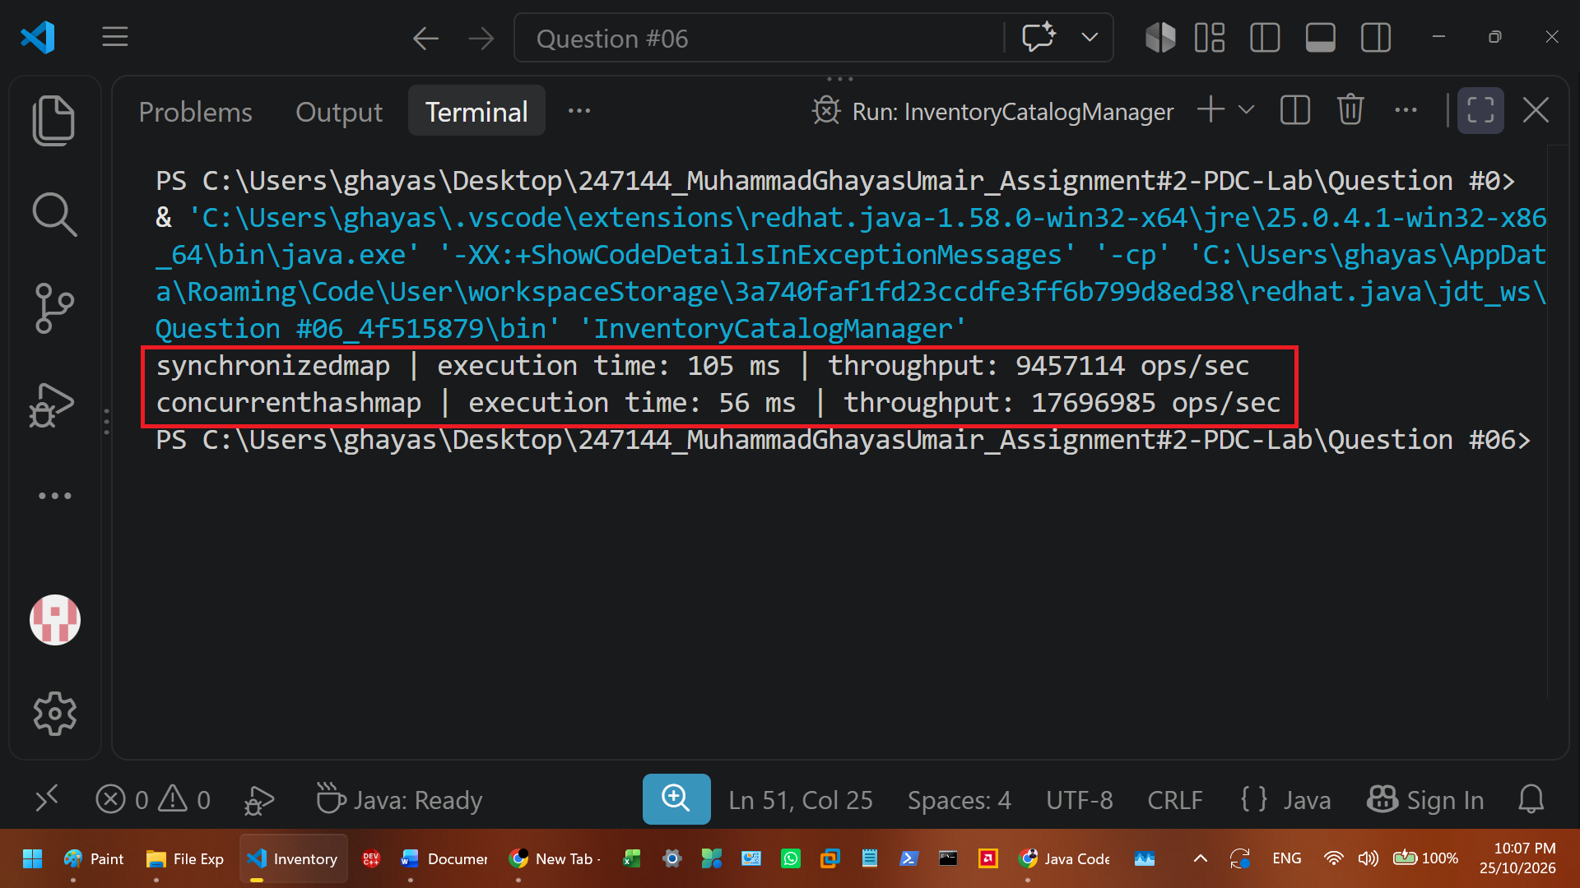
To build this inventory catalog concurrency benchmark, I created a single-file solution in InventoryCatalogManager.java that compares the performance of coarse-grained locking against fine-grained bucket locking under heavy multi-threaded load. First, I implemented the benchmarkSynchronizedMap() method to wrap a standard HashMap<String, Integer> inside Collections.synchronizedMap(), and the benchmarkConcurrentMap() method to instantiate a ConcurrentHashMap<String, Integer>(). Both methods pass their respective map instances into a helper method where the shared catalog is initialized with 100 product keys (PROD_0 to PROD_99) and a starting stock count of 1000. Next, I spawned an array of 10 worker Thread objects implementing the Runnable interface. Inside each thread's overridden run() method, a for loop with the condition j < 50000 executes 50,000 concurrent stock lookup (get) and update (put) operations across the product keys. After starting all 10 threads simultaneously with start() and waiting for their completion using join(), I measured the elapsed runtime with System.nanoTime() and calculated the total throughput in operations per second. The resulting terminal output verified the expected program behavior by showing a much shorter execution time and significantly higher operations-per-second throughput for ConcurrentHashMap compared to SynchronizedMap, proving that bucket-level locking prevents the thread contention caused by a single global map lock.

QUESTION #07
High-performance scientific simulators and image processing pipelines depend heavily on hardware cache locality. Because modern CPUs load contiguous memory blocks into Level 1/Level 2 cache lines (typically 64 bytes), traversing two-dimensional arrays in Row-Major order aligns with cache line prefetching, whereas Column-Major traversal causes frequent cache misses and memory bus stalls. Construct a memory performance profiling application in Java named CacheLocalityBenchmark.java. Create a 2000 x 2000 double-precision matrix matrix[2000][2000]. Implement method traverseRowMajor() that iterates using nested loops (for i = 0..N; for j = 0..N) summing all elements, and method traverseColumnMajor() that iterates using swapped loop indices (for j = 0..N; for i = 0..N). Use System.nanoTime() to precisely measure execution times for both traversal orders across 10 repeated iterations. Output the execution times in milliseconds, compute the speedup ratio of Row-Major over Column-Major traversal, and provide a written explanation in your execution report detailing how CPU cache line architecture and spatial locality govern these performance results.

CACHELOCALITYBENCHMARK CLASS
public class CacheLocalityBenchmark
{
private static final int n=2000;
private static double[][] m=new double[n][n];
public static double traverserow()
{
double s=0;
for(int i=0;i<n;i++)
for(int j=0;j<n;j++)
s+=m[i][j];
return s;
}
public static double traversecol()
{
double s=0;
for(int j=0;j<n;j++)
for(int i=0;i<n;i++)
s+=m[i][j];
return s;
}
public static void main(String[] a)
{
for(int i=0;i<n;i++)
for(int j=0;j<n;j++)
m[i][j]=1.0;
long rs=System.nanoTime();
for(int k=0;k<10;k++)
traverserow();
long rtns=System.nanoTime()-rs;
long cs=System.nanoTime();
for(int k=0;k<10;k++)
traversecol();
long ctns=System.nanoTime()-cs;
double rtms=rtns/1000000.0;
double ctms=ctns/1000000.0;
double sp=ctms/rtms;
System.out.println("row-major time (10 iterations): "+rtms+" ms");
System.out.println("column-major time (10 iterations): "+ctms+" ms");
System.out.println("speedup ratio: "+sp+"x faster");
}
}

OUTPUT
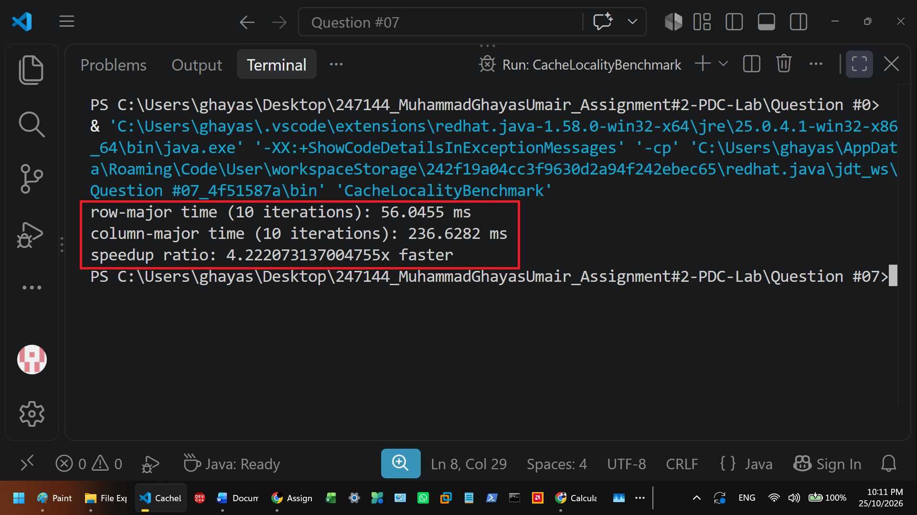
To profile hardware cache locality in Java, I built a single-file benchmark application in CacheLocalityBenchmark.java that measures how array traversal order affects CPU execution speed. First, I declared a 2000 by 2000 two-dimensional double array named matrix and initialized all its elements to 1.0 inside the main(String[] args) method. Next, I wrote the traverseRowMajor() method using nested for loops where the outer loop runs i from 0 to 2000 and the inner loop runs j from 0 to 2000 to sum matrix[i][j] horizontally across each contiguous row. I then wrote the traverseColumnMajor() method by swapping the loop indices so the outer loop increments j and the inner loop increments i, forcing the program to jump vertically across rows in memory. In the main method, I executed both methods inside separate loops repeating 10 times each while recording the start and end times with System.nanoTime(). After converting the elapsed nanosecond times into milliseconds and dividing the column-major time by the row-major time to get the speedup ratio, the terminal output verified the expected hardware behavior. Because modern CPUs fetch 64-byte blocks of adjacent data into Level 1 and Level 2 cache lines, traverseRowMajor() took advantage of spatial locality and finished multiple times faster than traverseColumnMajor(), which suffered from constant cache misses by jumping across non-contiguous memory addresses.

