PySpark Preparation Guide

This document contains categorized PySpark interview questions and detailed answers for preparation.

Contents
1. Spark Architecture & Core Concepts
2. Performance, Memory & Tuning
3. Data Handling (Duplicates, Nulls, Schema)
4. File Formats & Storage
5. Transformations & Joins
6. Deployment & Execution
7. Structured Streaming & Kafka

Spark Architecture & Core Concepts

1. Explain architecture of Spark Application
A Spark application consists of:
- Driver Program → builds logical/physical plan and coordinates execution
- Cluster Manager (YARN, Kubernetes, Standalone, Mesos) → allocates resources
- Executors → run tasks on worker nodes, handle caching and computation
Flow:
1. User submits spark-submit
2. Driver creates DAG and sends to cluster manager
3. Cluster manager allocates executors
4. Executors perform tasks in parallel
5. Results returned to driver or external storage
Detailed Explanation:
In Spark (including PySpark), a job is triggered when you perform an action (like collect(), count(), save(), etc.) on a DataFrame or RDD.
So when you submit a job in PySpark, here’s what happens under the hood:
⚙️ Execution Flow After Submitting a Job
- Action Trigger
  - You write some transformations (map, filter, select, etc.).
  - Nothing actually runs yet – Spark builds a logical DAG (Directed Acyclic Graph).
  - As soon as you call an action (show(), collect(), count(), write()), Spark triggers a job.
- DAG Creation & Logical Plan
  - Spark’s Catalyst Optimizer builds a logical plan of your transformations.
  - The logical plan is optimized (e.g., predicate pushdown, projection pruning).
  - Then Spark converts it to a physical plan (how tasks will actually run).
- Job Submission
  - Spark breaks the job into stages based on shuffle boundaries.
  - Each stage is further divided into tasks (one per data partition).
  - Example: If your RDD has 100 partitions, Spark will create 100 tasks for that stage.
- Job Scheduling
  - The Spark Driver (your PySpark program) sends tasks to the Cluster Manager (YARN, Kubernetes, Mesos, or Spark’s standalone scheduler).
  - The cluster manager allocates resources (executors + cores).
  - Executors are launched on worker nodes.
- Task Execution
  - Each executor runs the tasks it receives.
  - Executors process data in partitions (read from HDFS/S3/MapR/local).
  - Results are either:
    - Returned to the driver (e.g., collect()),
    - Or written to external storage (e.g., saveAsTextFile(), write.parquet()).
- Result Collection
  - If it’s a driver-returning action (like collect()), results are sent back to the driver.
  - If it’s a storage action (like write), results stay in external storage.
- Completion
  - Once all stages finish, the job is marked successful.
  - Spark releases resources (executors may shut down if dynamic allocation is enabled).

2. What is lazy evaluation? What are actions and transformations?
- Lazy evaluation: transformations build logical plan but don’t execute immediately. Spark starts executing the job, when an action is called.
- Transformations: map, filter, select (lazy)
- Actions: show, collect, count, save (trigger execution)
Example:
df.filter(df.age > 30) # transformation, no execution
df.count() # action, triggers execution

3. What is lineage and DAG? What is the difference among them?
- Lineage: metadata of how RDD/DataFrame is derived
- DAG: Directed Acyclic Graph representing execution plan
Difference:
- Lineage = logical history of transformations
- DAG = actual execution stages & tasks
Detailed Explanation:
Lineage in DataFrames
- Definition: In DataFrames, lineage is the logical history of transformations applied.
  - Spark records metadata about operations like select, filter, join, etc.
  - It does not execute immediately (lazy evaluation).
- Why useful?
  - For fault tolerance → if part of the data is lost, Spark can recompute from the lineage.
  - For optimization → Spark can rearrange operations in the lineage before execution.
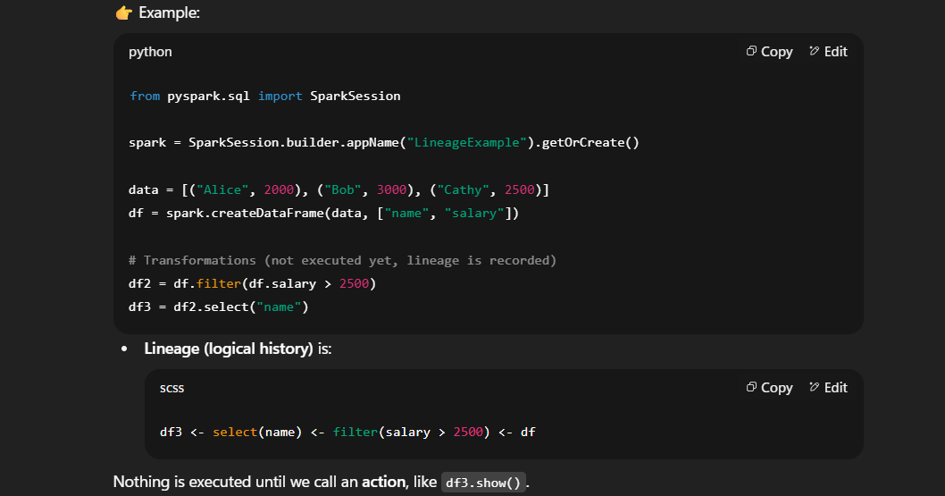
DAG (Directed Acyclic Graph):
DAG is the physical execution plan Spark creates when an action is called.
- Spark’s Catalyst Optimizer first builds a logical plan from the lineage.
- Then it creates an optimized physical plan.
- The DAG Scheduler breaks this into stages and tasks.
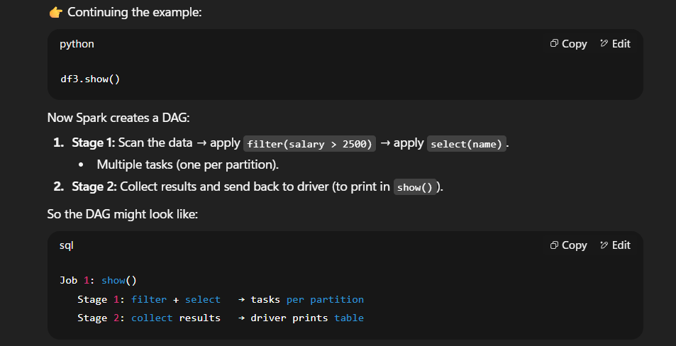
Differences in short:
Feature | Lineage | DAG
What it represents | Logical sequence of transformations on a DataFrame | Actual execution plan of a job (stages + tasks)
When created | During transformations (e.g., select, filter) | When an action is called (e.g., show, count, write)
Level | Per DataFrame | Per Job
Purpose | Records "what operations to do" | Decides "how to execute them"
Persistence | Stored with the DataFrame object | Rebuilt for every job/action

4. What is the job of Catalyst Optimizer?
The Catalyst Optimizer is Spark SQL’s query optimization framework.
- It takes the logical plan (built from DataFrame / SQL operations),
- Applies rule-based and cost-based optimizations,
  - Rule based: such as (1+1 considered as 2 in sql queries, keeps only necessary items)
  - Cost based: such as re-ordering joins and deciding join types.
- Produces an optimized logical plan,
- Then converts it into a physical plan (actual execution strategy).
Catalyst Optimizer improves query execution by applying below techniques:
4.1 Predicate pushdown (Loads relevant data from source based on the given condition)
Definition:
Pushes filtering conditions (e.g., WHERE age > 30) down to the data source level, so Spark reads only the relevant rows.
Benefits:
- Minimizes data read from disk
- Reduces memory and CPU usage
- Speeds up query execution

Example:
df = spark.read.parquet("s3://bucket/data/")
filtered_df = df.filter(df.age > 30)
If the Parquet file has column stats(in metadata), Spark will skip row groups where age <= 30 — before loading them into memory.
Supported Formats: Parquet, ORC, JDBC (e.g., PostgreSQL, MySQL)
Not Supported: CSV, JSON Files as they are row based.
4.2 Projection Pruning/ Column Pruning (Loads specified columns from data source)
Definition:
Only loads the columns you actually use in your query — avoids scanning unnecessary data.
Benefits:
- Reduces data transfer and memory usage
- Speeds up transformations and joins
Example:
df = spark.read.parquet("s3://bucket/data/")
selected_df = df.select("name", "age")
Spark will only read name and age columns from disk — skipping all others.
Combined Optimization (Predicate Pushdown & Projection Pruning)
df = spark.read.parquet("s3://bucket/data/")
optimized_df = df.filter("age > 30").select("name")
This triggers:
- Predicate pushdown: age > 30 applied at source
- Projection pruning: only name column loaded
Supported Formats: Parquet, ORC, JDBC (e.g., PostgreSQL, MySQL)
Not Supported: CSV, JSON Files as they are row based.

4.3 Constant folding (Evaluates constant expressions at compile time)
Definition:
- Constant folding is a logical optimization rule in Spark’s Catalyst engine that:
Evaluates constant expressions at compile time instead of runtime.
- This means Spark simplifies expressions like 3 + 5 or 2 > 1, before executing the query — so it doesn’t waste compute cycles doing obvious math during execution.
Example
from pyspark.sql.functions import lit
df = spark.range(1).select(lit(3) > lit(2))
df.explain(True)

Before Constant Folding: Project [(3 > 2) AS (3 > 2)]
After Constant Folding: Project [true AS (3 > 2)]
Spark replaces (3 > 2) with true — no need to evaluate this during execution.
Why It Matters
- Reduces computation overhead
- Simplifies query plans
- Speeds up execution, especially in large pipelines with many literals or static expressions

4.4 Join Re-ordering (Ability to rearrange the order of joins to minimize data shuffle)
Definition: Join reordering is Spark’s ability to rearrange the order of joins in a multi-table query to minimize data movement and optimize execution.
Why It Matters?
- Reduces shuffle cost
- Minimizes intermediate data size
- Improves parallelism and execution time
How It Works?
Spark uses statistics (row count, size estimates) to decide the most efficient join order.
It prefers:
- Smaller tables first
- Broadcast joins when possible
- Avoiding skewed joins
Example
df1 = spark.read.parquet("s3://bucket/large_table/")
df2 = spark.read.parquet("s3://bucket/small_lookup/")
df3 = spark.read.parquet("s3://bucket/medium_table/")
joined = df1.join(df2, "id").join(df3, "id")
Even if you wrote df1 → df2 → df3, Spark might internally reorder to df2 → df3 → df1 if that is more efficient.

5. What is checkpointing, why is it needed? Show me how we can do it
- Checkpointing saves RDD/DataFrame state to reliable storage (HDFS/S3).
- Needed to truncate lineage and recover from failures.
- It is one of the fault tolerant mechanisms.
Examples:
1. spark.sparkContext.setCheckpointDir("/tmp/checkpoints")
df.checkpoint()
2. query = windowed_df.writeStream \
.format("parquet") \
.option("path", "s3a://your-bucket/output-bonus-windowed/") \
.option("checkpointLocation", "s3a://your-bucket/checkpoints/bonus-job/") \
.outputMode("append") \
.start()

6. What are memory overflow errors? When can we see this? How to handle them?
- Occurs when data > executor memory (OutOfMemoryError)
- Seen during shuffle, caching large datasets, skewed data
Handling:
- Increase executor memory (--executor-memory)
- Use efficient formats (Parquet, ORC)
- Optimize partitions (repartition, coalesce)
- Avoid caching very large datasets
Detailed explanation:
When Can We See Memory Overflow Errors?
- During Shuffle Operations
  - Spark shuffles data for groupBy, reduceByKey, join, distinct, etc.
  - If the shuffle produces massive intermediate data, executors may run out of memory.
  - Especially problematic with data skew (when one key has much more data than others).
- When Caching/Persisting Large Datasets
  - If you cache() or persist() a DataFrame that is larger than executor memory, it may crash.
  - Spark tries to keep it in memory but spills to disk if configured. By default it is configured to: spark.shuffle.spill “true”.
- Skewed Data
  - Example: 90% of your data belongs to one key in a join.
  - One task gets almost all data, causing executor memory to blow up while others finish quickly.
- Collecting Large Data to Driver
  - Using collect() or toPandas() on huge datasets loads all data into the driver’s memory → driver OutOfMemoryError.
- Too Many Partitions or Bad Partition Sizes
  - Very few partitions → each task processes too much data.
  - Very many tiny partitions → overhead and memory pressure.
How to Handle Memory Overflow Errors?
1. Tune Spark Memory Settings in any of the following ways:
Memory Settings:
- Increase executor memory: --executor-memory 4G
- Increase driver memory (if problem is on driver): --driver-memory 4G
- Increase memory overhead: --memory-overhead 2G
- Configure memory fractions properly:
spark.memory.fraction # default 0.6 (fraction for execution + storage)
spark.memory.storageFraction # default 0.5 (fraction for cached data)
Where to change:
- At $SPARK_HOME/conf/spark-defaults.conf
spark.driver.memory 4g
spark.executor.memory 8g
spark.executor.memoryOverhead 2g

- At Job Submission (spark-submit CLI)
spark-submit --driver-memory 4G --executor-memory 8G
--conf spark.executor.memoryOverhead=2G \
my_app.py
--driver-memory → JVM heap size for the driver.
--executor-memory → JVM heap size for each executor.
--spark.executor.memoryOverhead → Extra off-heap memory for things like shuffle, Python worker processes, etc.
- At the creation of SparkSession
spark = SparkSession.builder.appName("MemoryExample") \
.config("spark.driver.memory", "4g") \
.config("spark.executor.memory", "8g") \
.config("spark.executor.memoryOverhead", "2g") \fg
.getOrCreate()
These settings overrides cluster defaults for your job.

2. Optimize Data Format
- Use columnar formats like Parquet or ORC instead of CSV/JSON (saves memory and speeds up).
- Enable compression (Snappy, ZSTD).

3. Optimize Partitioning
- Balance partitions so that no single executor is overloaded:
df = df.repartition(200) # increase partitions for parallelism
df = df.coalesce(50) # reduce partitions if too many
- Use partitioning wisely when writing (e.g., partitioned parquet tables).

4. Handle Skewed Data
- Use salting (add a random prefix to keys before shuffle).
- Use broadcast joins for small tables:
from pyspark.sql.functions import broadcast
df_large.join(broadcast(df_small), "id")
- Use spark.sql.adaptive.enabled=true (Adaptive Query Execution) to handle skew automatically at spark-defaults.conf file

5. Avoid Collecting Too Much Data
- Avoid collect() or toPandas() on large DataFrames.
- Use show(), limit(), or write results to storage (Parquet, S3, etc.) instead.

6. Checkpointing & Spill to Disk
- Use df.checkpoint() to truncate lineage
(So Spark doesn’t recompute massive chains).
- Allow Spark to spill intermediate data to disk:
spark.shuffle.spill # default true
If set to false, Spark may crash instead of spilling.

7. What is Spark dynamic and static allocation? How can we choose?
- Static allocation: fixed executors for entire job (set via --num-executors)
- Dynamic allocation: Spark adjusts executors based on workload
Detailed Explanation:
1. Static Allocation:
- Executors are fixed for the lifetime of the Spark application.
- You pre-define how many executors you want, and Spark never increases or decreases them automatically.
- Useful for stable, predictable workloads.
EXAMPLE ON spark-submit CLI:
spark-submit --num-executors 10 --executor-memory 4G --executor-cores 4 my_job.py
- The configuration applied is fixed for the entire life time of the spark job.
- Spark will always run with 10 executors, even if some are idle.
2. Dynamic Allocation
- Executors are allocated on demand:
  - Spark adds executors when there are pending tasks.
  - Spark removes executors when they are idle.
- Useful for variable workloads (e.g., streaming, ETL jobs with skew, interactive queries).

Dynamic Allocation Configs:
spark.dynamicAllocation.enabled=true
spark.dynamicAllocation.minExecutors=2
spark.dynamicAllocation.maxExecutors=50
spark.dynamicAllocation.initialExecutors=5
spark.dynamicAllocation.executorIdleTimeout=60s
Example Behavior:
- Start with 5 executors.
- If job stages generate more tasks than 5 executors can handle, Spark requests more executors (up to 50).
- If executors are idle for > 60s, Spark removes them (but never goes below 2).
What kind of configuration to be used:|
-> Static → predictable, stable workloads
-> Dynamic → variable, streaming, interactive workloads
Feature | Static Allocation | Dynamic Allocation
Executors | Fixed for entire job | Adjusted dynamically
Configuration | --num-executors / spark.executor.instances | spark.dynamicAllocation.* configs
Resource Utilization | May waste resources if workload fluctuates | More efficient, releases unused executors
Predictability | Very predictable performance | Less predictable (depends on cluster load)
Best for | Batch jobs, stable workloads | Streaming, interactive queries, variable workloads

2. Performance Tuning

1. What is the problem of having bulk small files in PySPark? How does it effects the performance and why?
Short Answer:
- Too many small files cause overhead during task scheduling & metadata management.
- Each file spawns a task → high scheduling cost, straining driver.
- Best practice: compact files into larger Parquet/ORC files.
- Use repartition() or coalesce() before writing output.
Detailed Explanation:
1.1 Why lots of small files are bad?
1) Too many tasks → scheduler & driver overhead
- Spark creates (at least) one input partition per file for file-based sources.
- 100k tiny files ⇒ ~100k tasks. Even if each task reads only a few KB, Spark still pays:
  - Task scheduling/serialization/RPC overhead
  - Executor startup/context switching overhead
  - Driver memory/CPU pressure tracking huge DAGs and task metadata
- Net: your cluster spins cycles coordinating instead of computing.
2) File-system metadata & open/close overhead & can cause network latency as well
- Every file must be discovered, opened, and closed.
- On HDFS this hammers the NameNode with metadata lookups; on S3/GCS it means tons of HEAD/LIST/GET requests (slow + sometimes costly).
- Latency dominates throughput when files are tiny.
3) Shuffle explosion (M × R files) and small outputs
- Wide ops (joins/groupBy) write intermediate shuffle files.
Many input partitions → many map outputs → many reduce inputs.
- You end up with huge counts of tiny shuffle blocks (more network handshakes, more disk seeks, worse cache locality).
4) Columnar format inefficiency (Parquet/ORC)
- Parquet/ORC get speed from large row groups, compression, and statistics.
- Tiny files = tiny row groups = poor compression, weak min/max stats, less effective predicate pushdown → more data read than necessary.
5) Partitioned tables turn into “many tiny files per partition”
- Over-partitioning on high-cardinality columns (e.g., partitionBy(date, user_id)) creates directories with a handful of rows each → a sea of small files.

1.2 How the performance hit shows up?
- Long job startup: listing and planning takes ages.
- High driver CPU/memory: scheduling and tracking tons of tasks.
- Executors underutilized: short tasks finish fast, but coordination dominates.
- Network-heavy shuffles: many tiny transfers; more chances of retries.
- Low scan efficiency: Parquet/ORC scans read more than they should; filters less effective.

1.3 What “good” looks like
- Prefer 128–512 MB per file (rule of thumb).
  - HDFS/Parquet sweet spot is commonly ~128–256 MB per file.
- Keep balanced partitions so each task does similar work.
1.4 Prevention & fixes
A) Before writing: control the number/size of output files
- Repartition (balanced, involves shuffle):
target_files = 400
(
df
.repartition(target_files) # balances data across tasks
.write.mode("overwrite")
.option("compression", "snappy")
.option("maxRecordsPerFile", 5_000_000) # optional extra cap
.parquet(output_path)
)
- Coalesce (no shuffle, just merges partitions; beware skew):
df.coalesce(100).write.mode("overwrite").parquet(output_path)
Use when data is already fairly balanced or you just want fewer, bigger files without the cost of a shuffle.
- Tune shuffle partition count for SQL/DataFrame jobs:
spark.conf.set("spark.sql.shuffle.partitions", 400)
This controls parallelism for wide transformations and thus the number of files per output partition path.
- Bucket + sort (for repeated joins/reads of the same table):
df.write.bucketBy(64, "join_key").sortBy("join_keylsaveAsTable("tbl_bucketed")
Fewer, well-organized files and better join performance (works best in managed table scenarios).
B) After the fact: compact existing small files
- Run a compaction job:
(spark.read.parquet(old_path).repartition(256). \
.write.mode("overwrite").parquet(new_path))
- If you’re on Delta Lake / Hudi / Iceberg, use their built-in compaction/OPTIMIZE features when available (they handle small-file cleanup elegantly).
C) Reading-side mitigations (not a cure, but helps)
- Spark can coalesce small files into fewer read partitions with these knobs:
spark.conf.set("spark.sql.files.maxPartitionBytes", 134217728) # ~128MB
spark.conf.set("spark.sql.files.openCostInBytes", 134217728) # models per-file open cost
This reduces the number of scan tasks by grouping small files, but it doesn’t remove the many file opens and metadata requests—still better to compact upstream.
D) Adaptive Query Execution (AQE)
- Turn on AQE so Spark can coalesce post-shuffle partitions dynamically:
spark.conf.set("spark.sql.adaptive.enabled", "true")
spark.conf.set("spark.sql.adaptive.coalescePartitions.enabled", "true")
spark.conf.set("spark.sql.adaptive.shuffle.targetPostShuffleInputSize", "128MB")
AQE helps reduce tiny output partitions after shuffles, often cutting down the number of output files.
More details on AQE:
Adaptive Query Execution (AQE) in PySpark is a optimization feature introduced in Apache Spark 3.0 that dynamically adjusts query execution plans at runtime based on actual data characteristics.
Key feature of AQE are,
- Dynamic Join Strategy: Switches from sort-merge to broadcast join if data size allows
- Skew Join Handling: Splits skewed partitions to balance load.
- Coalescing Partitions: Merges small shuffle partitions to reduce overhead
- Runtime Re-optimization: Uses actual stats (row count, partition size) to adjust execution plan

E) File-format tuning (Parquet/ORC)
- Aim for larger row groups (Parquet “block size”):
  - Parquet default is often ~128MB; keep it there or larger if rows are wide.
- Keep Snappy/ZSTD compression for speed/size balance.

2. Differences between cache and persists in detail?
- df.cache() = df.persist() => default storage level MEMORY_AND_DISK.
- df.cache():
This is a shorthand for df.persist(StorageLevel.MEMORY_AND_DISK). It stores the DataFrame in memory if possible, and if memory is insufficient, it spills to disk.
- df.persist():
This allows you to specify a storage level explicitly.
  - df.persist(StorageLevel.MEMORY_ONLY)
  - df.persist(StorageLevel.DISK_ONLY)

3. What is data spilling in pyspark and how to handle this?
LOOK INTO MEMORY OVER FLOW ISSUE FOR MORE DETAILS.
- Data spilling happens when memory is insufficient → Spark writes intermediate data to disk.
- Seen in shuffles, aggregations, joins.
Handling:
- Increase executor memory
- Tune shuffle partitions
- Use Kryo serialization
- Optimize data skew

4. What is data skewness? How we can handle data skewness? How salting can help here?
- Skewness: Data is unevenly partitioned across the cluster.
Few partitions have huge data, causing stragglers.
- Causes: skewed keys in joins/aggregations.
- How to detect:
Spark UI → Jobs-> Stage timeline: lots of tasks finish fast; a few tasks run far longer.
Task metrics: one/few partitions with huge “Input size / Records” or large “Spill disk / memory)”.
Solutions:
- Salting: add random prefix to keys before join, then remove after aggregation
- Broadcast smaller dataset
- Use skew join hints in Spark SQL
Example:
df.withColumn("salted_key", concat(col("key"), lit("_"), (rand()*10).cast("int")))

5. How will you tune the performance of the spark job?
- Apply filters at the early stages before shuffling (Load only required data)
- Optimize partitions: spark.sql.shuffle.partitions
- Use broadcast joins whenever possible
- Cache intermediate DataFrames when reused
- File format: use Parquet/ORC with compression
- Use coalesce() to reduce small output files
- Avoid UDFs (prefer Spark SQL functions)
- Monitor with Spark UI
6. Let say I have 100GB of data, how much memory, executors, partitions is needed?
To process 100GB of data efficiently in Apache Spark, you’ll want to balance memory, executors, and partitions based on your cluster’s resources and the nature of your workload. Here's a practical breakdown to guide you:
1. Partition Count
A good rule of thumb is 100–200MB (128MB-256MB) per partition. So for 100GB:
- 100GB ÷ 200MB = ~500 partitions
- You can round this to 500–600 partitions for safety and parallelism.
This ensures tasks are small enough to avoid memory pressure but large enough to avoid overhead from too many tiny tasks.
2. Memory Per Executor
Assuming you're using standard Spark executors, here's a typical setup:
Component | Per Executor | Total Count
Executor memory | 4–8 GB | 120GB
Cores | 4 | 20*4=80
Executors | 15–20 (based on cores)
Let’s say you use 20 executors, each with 4 cores and 6GB memory:
- Total cores = 20 × 4 = 80 cores
- Total memory = 20 × 6GB = 120GB memory
This setup gives you enough parallelism to handle 500–600 partitions efficiently.

3. Executor Configuration Example
--num-executors 20
--executor-cores 4
--executor-memory 6G
--driver-memory 4G
You can tweak these based on your cluster’s capacity. If you're on YARN or Kubernetes, make sure to leave overhead memory (e.g., spark.yarn.executor.memoryOverhead).
4. Other Considerations
- Shuffle-heavy operations (like joins or aggregations) may need more memory or spill to disk.
- Skewed data? Consider custom partitioning or salting.
- Output format: If writing to disk, match partitions to desired number of output files.
8. We have the below configurations for spark cluster nodes.
10 node cluster with: Each node contains 16 cpu cores, 64GB RAM
Data: 10TB of CSV Files
How may number of partitions, executors needed?
Let us solve this, by taking the given data.
- Nodes: 10
- Cores per node: 16
- RAM per node: 64 GB
- Total cores: 10 × 16 = 160
- Total memory: 10 × 64 GB = 640 GB
- Input data: 10 TB of csv files
Looking into the given data:
Nodes: 10
Cores per node: 16
Total no.of cores: 10 × 16 = 160
RAM per node: 64 GB
Total memory: 10 × 64 GB = 640 GB
Input data: 10 TB of CSV files
Now considerations:
No. of cores = 150 (10*16=160: leaving 10 cores for system tasks approximately)
Total memory = 600GB (10*64GB=640GB: Leaving 40 GB for system tasks)
Data Size = 10*1024GB = 10240GB = ~ 10240000 MB (approximate estimation)
Set default partition size = 256MB (for default 128MB, but as the data size is big, it is recommended to increase it)
No. of partitions = 10240000/256 = 40,000;
No. of cores per executor = 5
Total Executors = 3 executors each on node *10 nodes = 30 executors
Executor memory = 600GB/30 = 20 GB
Tasks = 30executors * 5 = 150 Task slots.
Estimated time to complete:
If each partition takes ~20–30s
No. of cycles = 40,000/150= ~267
Total time(if approx. time for partition is 20s) = ~20s*267 =5340s=~89m → total ≈ ~1.5 hours
Total time(if approx. time for partition is 30s) = ~30s*267 =8010s=~134m → total ≈ ~2.2 hours

Final plan will be:
Start with 10k to 20k initial partitions and continue to adjust as per job running status.
Use spark.read.csv(...).repartition(n) or coalesce(n) based on downstream needs
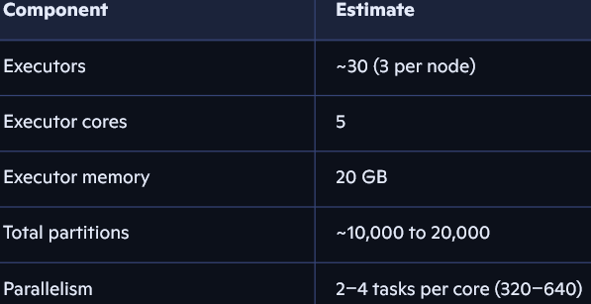

3. Data Handling (Duplicates, Nulls, Schema)

1. How to handle duplicate values and null values? At the time of loading and after loading? for rows and colums ? How do you handle missing data?
Handling Nulls at the time of loading files:
- Use schema to enforce types
- Use below options to control data.
spark.read.csv(“file", mode="DROPMALFORMED") to drop nulls.
spark.read.csv(“file", mode="PERMISSIVE“, columnNameOfCorruptRecord=”bad_data")
Handling nulls after loading files:
- df.na.drop() → drop rows with nulls
- df.na.drop(subset=["column1", ..]) → drop all rows where given columns hold nulls.
- df.drop("column_name") → drop a column (NOTE: No separate function to drop nulls at columns, using df.na)
- df.na.fill({"col1":0}) → fill null values
Handling duplicates after loading files:
- df.dropDuplicates(["col1","col2"])
- It drops duplicate rows based on specified columns. Keeps first occurrence of the each unique combination. Don’t remove rows with nulls unless they are duplicates.

2. What is schema evolution in Spark? How You Can Handle Later Columns with Older Columns in a Parquet File?
Schema evolution:
- Ability to add/remove/rename columns over time. (We will not have any issues, even if we add new columns to parquet files in future, older records filled with null values by default. We can use mergeSchema=true, while reading the parquet file to use this option)
- Spark will merge all available schemas across Parquet files.
- Missing columns will be filled with nulls
- Supported in Parquet & ORC
- Example:
df = spark.read.option("mergeSchema", "true").parquet("parquet_file")

3. What is schema inference? How to define a schema manually?
Schema inference:
- Spark identify column types automatically when reading CSV/JSON, but it is dangerous as it only considers first few of the records from the data frame and assumes its types.
- It is always better to define schema manually by using StructType() and StructField()
Example:
from pyspark.sql.types import StructType, StructField, StringType, IntegerType
schema = StructType([
StructField("id", IntegerType(), True),
StructField("name", StringType(), True)])
df = spark.read.csv("file.csv", schema = schema)

4. File Formats & Storage

1. File formats known? CSV, parquet? What is algorithm for parquet? Snappy
- CSV: row-based, large file size, slow reads
- Parquet: columnar, efficient compression & predicate pushdown
- Parquet uses dictionary & run-length encoding, Snappy compression for fast reads/writes

2. What is difference between partitioning and bucketing? Which one better and why? Is there any performance difference?
Partitioning:
- Creates directory structure based on column values
- Good for high-cardinality columns → too many small files possible
Bucketing:
- Fixed number of buckets based on hash of column
- Better for joins on bucketed column
Use bucketing when:
- You're joining large datasets on the same key.
- You want to reduce shuffle during joins or aggregations.
- You’re working with Hive tables or Spark SQL and can control table creation.
- Bucketing only works with Hive-compatible tables.
- You must use saveAsTable() or Hive metastore for Spark to recognize buckets.
- Bucketing does not help with filtering or pruning like partitioning does.
Performance:
- Partitioning improves pruning
- Bucketing improves shuffle performance

5. Data Transformations & Joins

1. Explain differences among narrow and wide transformation?
- Narrow: no shuffle needed, data within partition
Examples: map, filter, flatmap, union, coalesce, select, withColumn, drop, limit, etc.
- Wide: requires shuffle across partitions
Examples: groupBy, join, aggregateByKey, reduceByKey, distinct, repartition, sortBy, orderBy, etc.

2. What are transformations, actions?
- Transformations are lazy operations that define a logical plan(lineage) for modifying data. They don’t execute immediately — Spark builds a DAG (Directed Acyclic Graph) of transformations and waits until an action is called.
Examples, include narrow and wide transformations.
- Actions are operations that trigger the execution of transformations and pull results to the driver or write them to an external system.
Examples include collect(), count(), show(), write(), etc.
3. What are stages, tasks and how to calculate them? Give me an example.
Stages
- Spark builds a DAG (Directed Acyclic Graph) of transformations.
- It groups all narrow transformations (e.g., map, filter) into a single stage.
- It creates a new stage when it encounters a wide transformation (e.g., groupByKey, reduceByKey, join) because these require shuffling data across partitions.
Stages = 1N + W + W+ W … W
For all the narrow transformations 1 Stage
For every wide transformation New stage
Tasks
- Each stage is executed in parallel across partitions.
- Spark creates one task per partition in the stage.
- Example: If a stage operates on an RDD with 200 partitions, Spark will launch 200 tasks for that stage.

Example:
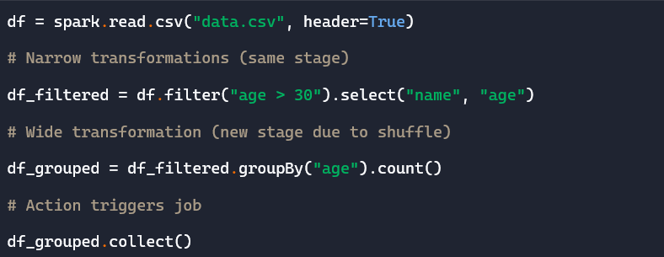
Stage | Details | Transformations | Task Count
Stage 1 | Pre-shuffle stage | read.csv, filter, select  (All Narrow Transformations) | Equal to number of input partitions (e.g., 200)
Stage 2 | Shuffle stage | groupBy(“age”).count()  (1 Wide Transformation) | Equal to spark.sql.shuffle.partitions  (default: 200)
Total No.of Stages = 2
Total No. of Tasks = 400

4. What are the transformations that you have worked upon?
Common ones:
- map, flatMap, filter
- groupBy, reduceByKey, join
- withColumn, select, dropDuplicates, repartition

5. Difference between coalesce() vs repartition()?
coalesce(n):
Reduces partitions without shuffle (faster, uneven)
Use When:
• You want to reduce the number of partitions
• Writing output and want to avoid too many small files
• You can tolerate uneven partition sizes
How It Works:
• Merges adjacent partitions
• No full shuffle, so it's faster
• Results in uneven data distribution
repartition(n):
- Full shuffle, equal distribution.
Use When:
- You want to increase or decrease partitions
- Need even distribution for joins, aggregations, or parallelism
- Preparing data for wide transformations
How It Works:
- Performs a full shuffle across the cluster
- Redistributes data into n partitions evenly
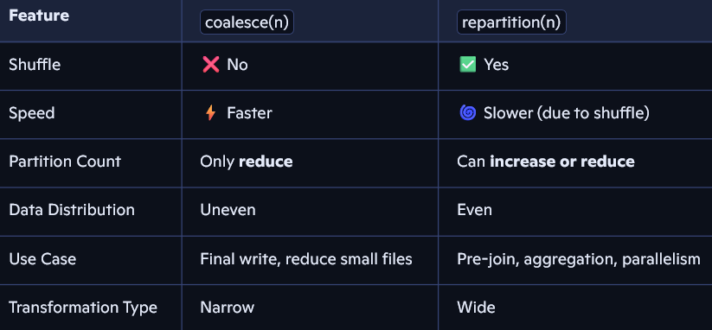
Example:
# Original DataFrame with 5 partitions
df = spark.range(0, 1000).repartition(5)

# Increase to 10 partitions with shuffle
df_repartitioned = df.repartition(10)

# Check partition count
print("Partitions after repartition:", df_repartitioned.rdd.getNumPartitions())
=> Use repartition() before joins to avoid skew.
df1 = df1.repartition("join_key")
df2 = df2.repartition("join_key")
df_joined = df1.join(df2, "join_key")

6. What are different joins that can be performed in PySpark?
JOINs:
inner, left, right, full_outer, left_semi, left_anti, cross join, broadcast_join, sort merge joins
Example:
Consider EMP & EMP Details Tables:
df_emp, df_details data frames for below tables respectively for the below tables.
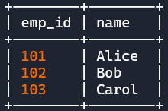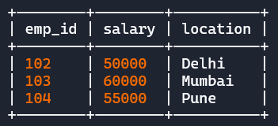
1. INNER JOIN: Returns rows with matching emp_id in both tables.
df = df_emp.join(df_details, on="emp_id", how="inner")
Result:
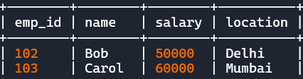
No of records matched records in return: 2
2. LEFT (OUTER) JOIN:
Keeps all rows from “df_emp” (left), and fills nulls if no match in “df_details” (right).
df = df_emp.join(df_details, on="emp_id", how="left")
Result:
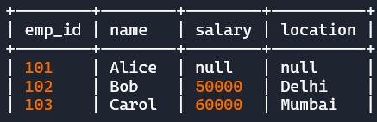
No of records matched records in return: 3
3. RIGHT (OUTER) JOIN:
Keeps all rows from “df_details” (right), and fills nulls if no match in “df_emp” (left).
df = df_emp.join(df_details, on="emp_id", how="right")
Result:
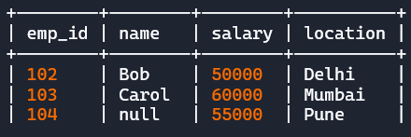
No of records matched records in return: 3
4. (FULL) OUTER JOIN:
Keeps all rows from both the tables and, and fills nulls where no match.
df = df_emp.join(df_details, on="emp_id", how="outer")
Result:
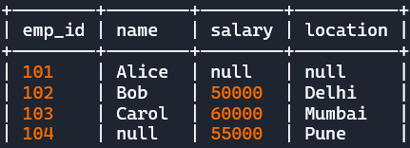
No of records matched records in return: 4
5. LEFT SEMI JOIN:
Returns rows from "df_emp" where a match exists in "df_details", but only columns from "df_emp".
df = df_emp.join(df_details, on="emp_id", how="left_semi")
Result:
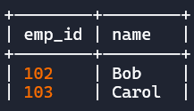
No of records matched records in return: 2

6. LEFT ANTI JOIN:
Returns rows from "df_emp" where no match exists in "df_details".
df = df_emp.join(df_details, on="emp_id", how="left_anti")
Result:
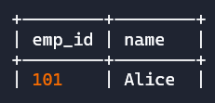
No of records matched records in return: 1

7. What is broadcast, and sort merge joins? When to use them? How it works?
Broadcast join:
- Smaller dataset is broadcasted to all executors to avoid shuffle
- Use when one dataset is small (<10MB default) & the other data set is bigger.
- Configurable: spark.sql.autoBroadcastJoinThreshold
When to Use
- One table is very small (fits in memory)
- Avoids shuffle by broadcasting the small table to all executors
How It Works
- Spark sends the small table to every node
- Each node joins its partition of the large table with the broadcasted copy
Performance
- Fastest join when applicable
- Avoids network shuffle
- Ideal for dimension + fact table joins

Example

from pyspark.sql.functions import broadcast
df_large.join(broadcast(df_small), on="emp_id", how="inner")
Spark auto-applies broadcast, if df_small is under spark.sql.autoBroadcastJoinThreshold (default: 10MB)

Sort Merge Join: Used when both tables are large.
When to Use
- Both tables are large
- Join keys are sortable and pre-partitioned
How It Works
- Spark shuffles both tables by join key
- Sorts each partition
- Merges sorted partitions to perform the join
Performance
- Highly scalable for big data
- Better than hash joins for large datasets
- Avoids memory pressure from broadcasting
Example
df1.join(df2, on="emp_id", how="inner")

Spark prefers Sort Merge Join when both sides are large and spark.sql.join.preferSortMergeJoin = true

8. What are window functions?
Window functions allow you to perform calculations across a group of rows that are related to the current row, without collapsing the rows (unlike groupBy).
- Equivalent to SQL OVER clause.
- They let you calculate things like ranking, running totals, moving averages, lead/lag values, etc.
- Examples: row_number(), rank(), lead(), lag(), moving_avg
from pyspark.sql.window import Window
from pyspark.sql.functions import row_number
win = Window.partitionBy("dept").orderBy("salary")
df.withColumn("r", row_number().over(win))

Deployment & Execution

1. How many ways we can deploy spark clusters?
- Standalone
- YARN
- Mesos
- Kubernetes

2. How can we do custom transformations in pyspark?
- By defining UDFs or using mapPartitions
- Avoid UDF: UDFs break Catalyst optimization and introduce serialization overhead.
- Always prefer built-in functions when possible, and use Pandas UDFs for better performance.
- Example UDF:
from pyspark.sql.functions import udf
from pyspark.sql.types import StringType
def capitalize_name(name):
return name.capitalize() if name else None
capitalize_udf = udf(capitalize_name, StringType())
df = df.withColumn("name_cap", capitalize_udf(df["name"]))

3. How can we handle errors, exceptions in pyspark?
- Use try/except in UDFs
- Use columnNameOfCorruptRecord path option while reading corrupt data using PERMISSIVE mode.
- Validate schema before loading

4. What are broadcast variables?
- Variables cached on executors, sent once, avoid shipping repeatedly
- Used for lookups/dictionaries

5. What are RDDs, DataFrames, and DataSets? Did you use any of them ? If so, what purposes?
- RDD: low-level, functional API, unstructured
- DataFrame: structured, optimized by Catalyst
- Dataset: typed (Scala/Java), combines benefits
Usage:
- RDDs for custom processing
- DataFrames for analytics

6. Explain how caching works by default in Spark? When to use catching techniques?
- cache() stores in-memory, if not enough then spills to disk
- Use when same DataFrame reused multiple times

7. Structured Streaming & Kafka

1. How do you read the streaming data from kafka and s3?
Kafka:
df = spark.readStream.format("kafka")\
.option(“kafka.bootstap.server”,”localhost:9092”)\
.option(“inputTopic”,”topicName”)\
.option(“startingOffsets”, “latest”)\
.load()
S3:
df = spark.readStream.format("parquet").load("s3://bucket/path")

2. What are the challenges encountered with large data sets? how can we overcome them?
- Memory overflow → use partitioning, caching wisely
- Skewed data → salting, broadcast joins
- Small files → compact them

3. What is structured streaming ? How it works internally?
- Incremental execution engine on top of Spark SQL
- Treats stream as unbounded table
- Executes mini-batches or continuous mode

4. What are different types of output modes and when to use them?
- Append: new rows only (e.g., logs)
- Complete: full table every trigger (e.g., aggregates)
- Update: only updated rows (e.g., counts)

5. How to handle late events in pyspark?
- Use watermarking with event-time
df.withWatermark("event_time", "10 minutes")

6. How Structure streaming is fault tolerant in pyspark?
- Uses checkpointing & WAL (Write Ahead Logs)

7. What are different types of windows in Structured Streaming? when to use them? give use cases?
- Tumbling: fixed interval (e.g., every 5 mins)
- Sliding: overlapping intervals (e.g., last 5 mins, every 1 min)
- Session: dynamic gap, e.g., user inactivity

8. What kind of joins are supported and not supported in structured streaming and why?
Supported: inner, left outer, right outer, full outer (static-stream or stream-stream depending on watermarking)
Not supported: cross join without bounds (unbounded state)

9. Explain the steps involved in a structured streaming? Consider an example like reading from Kafka topics and writing to kafka topics. How can we achieve it. Can you write the steps involved?
1. Read from Kafka using readStream
2. Parse/transform data
3. Apply business logic
4. Write to Kafka using writeStream
Example:
from pyspark.sql import SparkSession
from pyspark.sql.functions import col, window, from_json, to_json
from pyspark.sql.types import StructType, StringType, DoubleType, TimestampType
# 1. Create Spark session
spark = SparkSession.builder \
.appName("KafkaWindowWatermarkExample") \
.getOrCreate()

# 2. Schema for JSON messages
schema = StructType() \
.add("device_id", StringType()) \
.add("temperature", DoubleType()) \
.add("event_time", TimestampType()) # event timestamp

# 3. Read stream from Kafka
df_raw = spark.readStream \
.format("kafka") \
.option("kafka.bootstrap.servers", "localhost:9092") \
.option("subscribe", "input_topic") \
.option("startingOffsets", "latest") \
.load()

# 4. Parse JSON and extract columns
df_parsed = df_raw.select(
from_json(col("value").cast("string"), schema).alias("data")
).select("data.*")

# 5. Apply watermark and window
# Watermark: Wait up to 10 minutes for late data
# Window: Group events into 5-minute intervals
df_windowed = df_parsed \
.withWatermark("event_time", "10 minutes") \
.groupBy(
window(col("event_time"), "5 minutes"),
col("device_id")
) \
.avg("temperature") \
.withColumnRenamed("avg(temperature)", "avg_temp")

# 6. Prepare output for Kafka
df_to_kafka = df_windowed.selectExpr(
"CAST(device_id AS STRING) AS key",
"CAST(to_json(struct(*)) AS STRING) AS value"
)

# 7. Write back to Kafka
query = df_to_kafka.writeStream \
.format("kafka") \
.option("kafka.bootstrap.servers", "localhost:9092") \
.option("topic", "output_topic") \
.option("checkpointLocation", "/tmp/kafka_window_checkpoint") \
.outputMode("update") \ # update because aggregations are used
.start()
query.awaitTermination()

10. Why do you need stream processing? Do you know any other competitive applications? Which one is better among them you think and why?
- Stream processing: real-time insights (fraud detection, monitoring)
- Alternatives: Kafka Streams, Flink, Storm
- Spark Structured Streaming better when already in Spark ecosystem

