Sigmoid Case Study Round 2 – Bike-Sharing Demand: More Bikes or Better Allocation?

Final Report: Analysis, Demand Model and Natural-Language Prototype
Candidate: Chindhrad Gyaneswar Rao
NIT Warangal Role: Data Science Trainee (2026-27),
Sigmoid Data: UCI Bike Sharing Dataset – Capital Bikeshare, Washington D.C., 2011-2012 (hourly and daily)
Approach: Human-led, AI-assisted; code, notebook, prototype and decision log accompany this report
Live prototype: https://chgyaneswar2004-sigmoid-r2-bike-sharing-cs-app-vq96rc.streamlit.app/
Date: 4 November 2026

Executive Summary:
Recommendation: do not buy bikes yet. Run a 4-6 week pilot that moves bikes to busy areas before the commuter peaks, and start recording the failed searches we cannot see today. Decide on buying after the pilot.

Why
- Demand is very uneven through the day. On working days an average hour has about 524 rentals at 5pm but only about 5 at 3am. Riders can fail to find a bike at the peaks while bikes sit unused at other times. Both complaints can be true together.
- A fleet sized for busy hours is mostly idle on average. In July-December 2012 the busy hour (P90) had about 192 bikes in use, versus 85 in an average hour (2.3 times). A fleet sized for that busy hour would be only about 44% used in an average hour. Adding bikes would raise that idle share, and it only helps if the shortage is a total-fleet problem, which this data cannot show.
- The busy hours are commute hours. The peaks are around 8am and 5-6pm on working days, and about 90% of those rides are by registered riders. This is consistent with commuting.

What we do not know
The data has only completed rentals for the whole city. It has no stations, no bike inventory, and no record of riders who found no bike. So the numbers above show when pressure is highest, but they cannot prove that bike placement is the cause. The fleet figure is a lower bound, not a purchase number.

Proposed next steps
- Pilot (4-6 weeks): randomly choose some zones to receive bikes before the morning and evening peaks, and keep others as usual. Compare failed-rental rates.
- Measure what is missing: log app searches that find no bike, and station-level availability by hour.
- Check bike health: broken or offline bikes also look like "unused" bikes.
- Revisit buying if shortages persist everywhere at once even after rebalancing. That would mean the fleet itself is too small.

Bike Sharing Demand: Short Report
Data: UCI Bike Sharing (Capital Bikeshare, Washington DC), hourly rentals, 2011-2012. All figures come from the accompanying notebook.

1. Data quality checks
Check | Result
Shape, nulls, duplicates | 17,379 hourly rows; 0 nulls; 0 duplicate rows or (date, hour) pairs
Consistency | casual + registered = total in every row; weekday, month, year and working-day flags all agree with the date
Missing hours | 165 of 17,544 expected hours are absent, about 70% of them between midnight and 6am. Neighbouring hours have a median of 3 rentals (overall median 142), so they look like no-rental hours
Cross-check with day.csv | All 731 days match the hourly totals exactly (casual, registered, total), and daily weather equals the mean of hourly values. This confirms the missing hours carry zero rentals. day.csv is used only as a check, not as model input
Short days | 8 days have fewer than 20 hours recorded, including 29-30 October 2012 (Hurricane Sandy). Flagged and kept: they are real events
Suspicious values | 22 humidity values of 0, all on 2011-03-10. Kept as is (a single day)
Outliers | 130 high values (0.7%) by hour-and-day-type IQR. Kept: they are genuine busy hours, and those hours drive fleet need

2. Features and what the data shows
Features: hour, weekday, working day, holiday, month, year (2011/2012), weather type, temperature, humidity and wind speed. Extra features built for exploration: rush-hour flag (7-9am and 5-7pm on working days), hour-by-day-type, un-normalised weather in real units. Not used as inputs: registered and casual counts (they add up to the target).
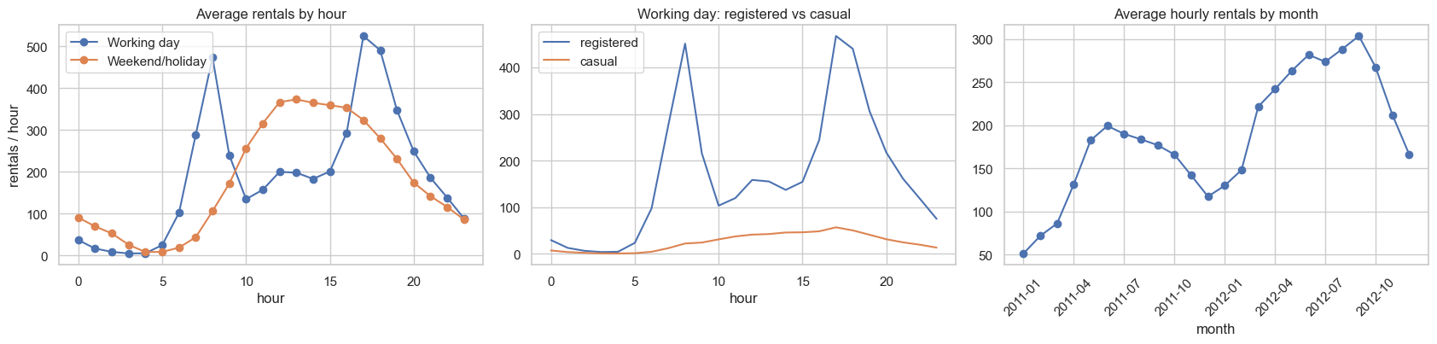
Figure 1. Left: working days have two commuter peaks, weekends one midday hump. Middle: the working-day peaks are almost entirely registered riders. Right: demand grows from 2011 to 2012 and follows the seasons.
- Working-day average rentals: 473 at 8am, 524 at 5pm, 4.6 at 3am. Registered riders are 95% of rentals at 8am and 89% at 5pm, versus 79% at midday.
- Average hourly rentals rose 64% from 2011 (142) to 2012 (233).
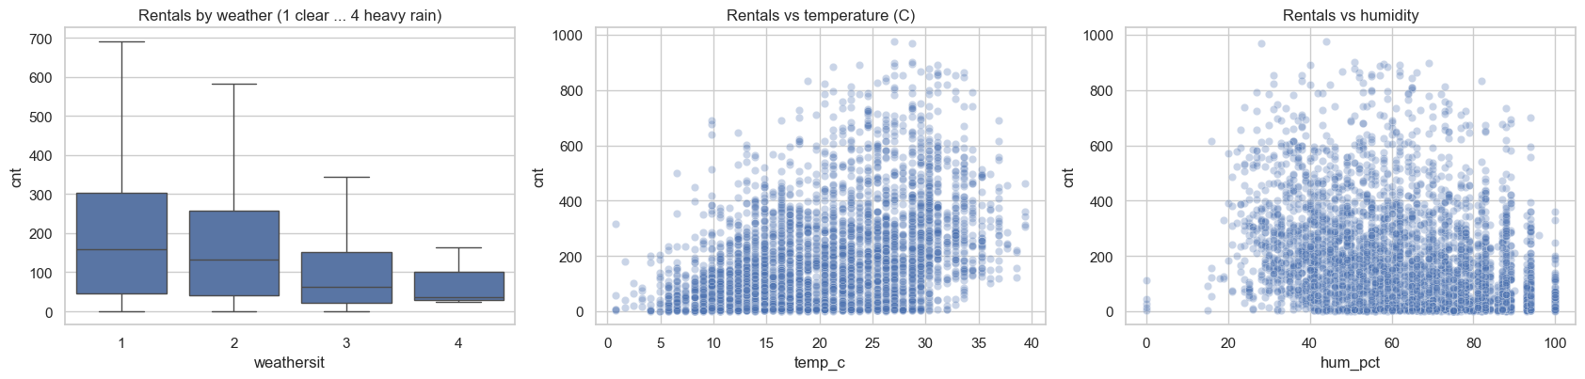
Figure 2. Rentals fall in poor weather and rise with temperature up to about 30 C; above roughly 33 C they look flat or lower (visual only, not tested). Heavy rain (type 4) occurs in only 3 hours, so the model knows little about it.

3. Hypothesis and how to test it
H1: on working days during 7-9am and 5-7pm, moving bikes to high-demand zones before the peak reduces the failed-rental rate compared with the current process. H0: no difference.
The current data cannot run this test: it has no intervention, no failed-rental measure, and no locations. It only supports the hypothesis (peaks, commuter-type riders, idle off-peak hours). The test is a field experiment:
Item | Design
Unit and randomisation | Zones (clusters of nearby stations), randomly assigned to proactive rebalancing or business as usual, stratified by size and demand
Duration | 4-6 weeks, covering several weather conditions (or a day-by-day switchback)
Primary metric | Failed-rental rate at peak = app opens that find no bike / all app opens
Guardrails | Rebalancing cost, truck-km, idle bikes off-peak, overflow at drop zones
Analysis | Compare treated and control zone-days, adjusting for weather and weekday; report effect size with a confidence interval
Sample size | From a business-chosen minimum effect (for example a 20% relative cut) and the measured baseline failed rate
What would change my mind | Shortages everywhere at once, even after rebalancing, which would mean the fleet is too small

4. Model to estimate bikes needed

4.1 Demand model
Hourly rentals are forecast with gradient boosting using a Poisson loss (suited to counts). The split is by time: trained on January 2011 to June 2012, tested on July to December 2012, so the model never sees the future. Two simple models are the benchmark.
Model (test: Jul-Dec 2012) | MAE | RMSE | R2
Same hour last week | 64.3 | 110.6 | 0.75
Poisson regression | 52.1 | 83.8 | 0.85
Gradient boosting (chosen) | 43.4 | 68.4 | 0.90
MAE and RMSE are in rentals per hour.
- Growth feature. A first version used a day counter for growth and under-predicted rush hours by about 117 rentals/hr. Trees cannot extrapolate beyond training values. Using a simple 2011/2012 flag cut the test MAE from 56.8 to 43.4.
- Validation. That choice was first made after seeing test scores, so it was re-checked on a slice inside the training period (fit before April 2012, validate April-June). The 2011/2012 flag still won: validation MAE 36.2, against 39.8 for the day counter and 81.1 with no growth feature.
- Daily check with day.csv. Summing hourly forecasts per day gives a daily MAE of 775 rentals on a mean of 6,043 (median error 11.7%), with predictions about 532 rentals per day too low.
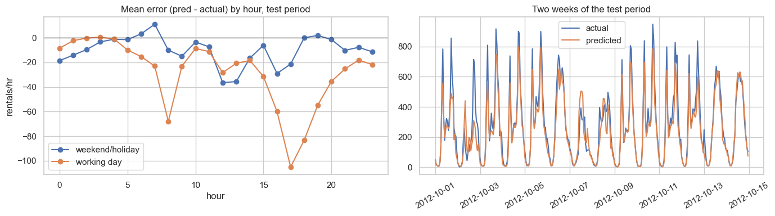
Figure 3. Left: forecasts are too low at working-day rush hours (about 60 rentals/hr on average; mean actual at rush hours is 540). Right: forecasts follow the daily pattern closely.
Hour of day is by far the most important input, followed by working day and temperature (permutation importance). The year flag shows almost no importance only because every test row is from 2012, so shuffling it changes nothing.
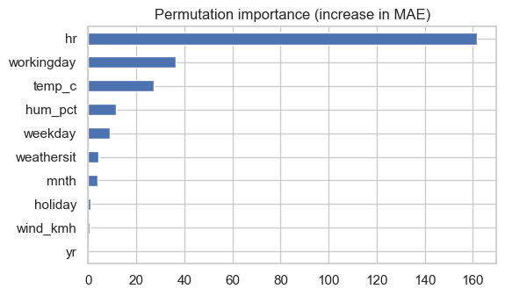

4.2 Fleet estimate
Method: bikes in use = rentals per hour x trip minutes / 60. We plan for a high percentile of hourly demand (P90: enough bikes in 90% of hours), not the average hour. Trip length is assumed at 20 minutes because the data has no trip duration.
July-December 2012, 20-minute trips | Bikes in use
Average hour (observed) | 85
P90 hour (observed) | 192
P90 hour (model forecast; model runs low at peaks) | 175
Busiest single hour (observed) | 326
Peak-to-average ratio (P90 / average) | 2.3 times
Average use of a fleet sized for the P90 hour | 44%

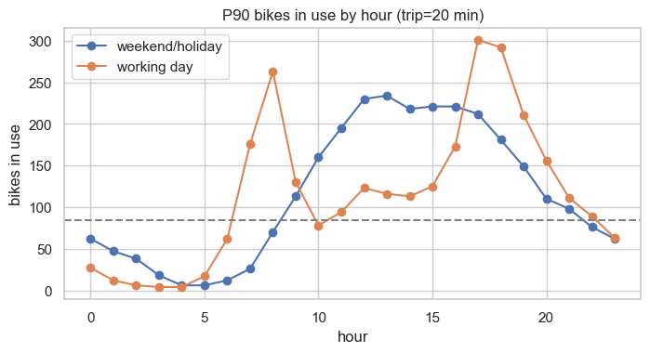
Figure 4. P90 bikes in use by hour. The working-day curve peaks at about 300 at 5pm and sits near or below the 85-bike average (dashed line) for much of the day.
Sensitivity: bikes in use | 15 min | 20 min | 30 min | 45 min
P50 | 54 | 71 | 107 | 160
P80 | 108 | 144 | 216 | 325
P90 | 144 | 192 | 289 | 433
P95 | 176 | 234 | 351 | 527
P99 | 216 | 289 | 433 | 649
Fleet need scales almost directly with trip length, the biggest assumption. Adding a 10% maintenance share and a 1.5x spatial buffer (both assumed, not measured) turns the P90 figure of 192 into about 321 bikes.
Why this is a lower bound: riders who found no bike are never recorded, so true demand is higher than observed rentals. The number is for comparing peak with off-peak pressure, not for placing a purchase order.

5. Prototype for the operations manager
A small web app lets an operations manager ask plain-English questions. The flow is: question, parse, validate, model, templated answer. Every number in an answer comes from the model, and every answer lists its assumptions (day type, month, weather, trip length, service level).
Example question | Behaviour
How many bikes do we need on Friday at 8am if it rains? | Forecast 491 rentals/hr, planning level 685, about 228 bikes available (September, rain, 20-minute trips, P90)
How many bikes do we need on Monday? | Busiest hour 17:00, about 326 bikes; planning level capped at the highest hour ever recorded (977)
Should we buy more bikes? | "Not yet", with the peak-to-average facts and the caveat that the data cannot prove the cause
Which station runs out first? | Refused: the data has no stations, so it will not guess
How many bikes at 30pm | Input error shown, not a guess

- Parser: keyword rules by default. An optional Gemini step only extracts fields (intent, hour, day, month, weather, temperature) as structured data; it never writes the answer. Its output is validated again and any failure falls back to the rules. Topics the data cannot answer are caught before Gemini is called.
- Safety multiplier: the P90 of actual divided by forecast on July-December 2012, separately for rush and other hours, with the planning level capped at the record hour (a first version exceeded the record, which is why the cap exists).
- Testing: 17 automated tests pass (parsing, input validation, refusals, ChatGPT integration with a mocked response, and fallback scenarios). The live ChatGPT API call has not yet been tested because the service was unreachable from the build environment; it requires verification using a valid API key.

6. Limitations
Limitation | Effect
Rentals are not demand | Fleet number is a lower bound
City-wide data, no stations | Cannot say where bikes are missing; the pilot and new logging address this
Trip length and buffers assumed | Fleet number moves with them (sensitivity table)
Weather used as recorded | Real forecast errors would add to model error
Two years, strong growth | Seasonal effects are partly mixed with growth
Under-prediction at rush hours | About 60 rentals/hr low; fleet sizing uses observed demand as the reference

7. Code and files
File | Contents
bike_sharing_analysis.ipynb | Quality checks, features, EDA, hypothesis, models, validation, fleet estimate
DECISION_LOG.md | Hypothesis, assumptions, decisions with alternatives and reasons, AI use, limitations
model_utils.py | Trains the demand model and converts forecasts into bikes needed
nl_assistant.py, llm_parser.py | Question parsing (rules and optional Gemini), validation, answers
app.py | Streamlit page with adjustable assumptions
test_nl.py | 17 automated tests

AI use: AI assistance was used for brainstorming, drafting and debugging code, and drafting this document. Decisions, assumptions and the recommendation were reviewed by the author; the figures above come from running the notebook.

