# Adaptive Applications - User Interface Documentation

The user interface is responsible for providing the user with a seamless, enjoyable experience when using our application. When using our application, users who already travelled using our application are required to sign in at which point we gather all the previous data learnt such as their basic information and the tags that the user previously enjoyed. If the user is new to our application, they must create an account specifying their basic information together with what type of attractions they wish to see throughout their stay (up to a maximum of 3 categories);

1. Outdoor
2. Museums
3. Historical places
4. Parks
5. Lakes
6. Food
7. Pubs
8. Play
9. Movie
10. Styling
11. Attire
12. Shoes

So basically, UI has two different entries for users, one for new users and the other for existing users. The main difference between two is that one has no history using our app which means the system need them to provide some basic information to initialise a user model. As for existing user, the system would adapt the user model based on the new input.

User profile includes username, gender, age and preferences which would be taking into consideration initialise the user model. Once the system has the user profile, when personalise the trip plan, user only needs to input the budget, duration and preference for this trip.

UI is connected to the backend service through flask, information would be sent to backend using http post and then visualises the trip with route between locations with received list of places.

## New User

When a new user comes in, at the page, s/he will be asked to fill in her/his basic information, such as age, gender, preferences and etc. See graph 1 below for details. Once new user sign up, he or she will be provided with a unique user id which will be needed for future request.

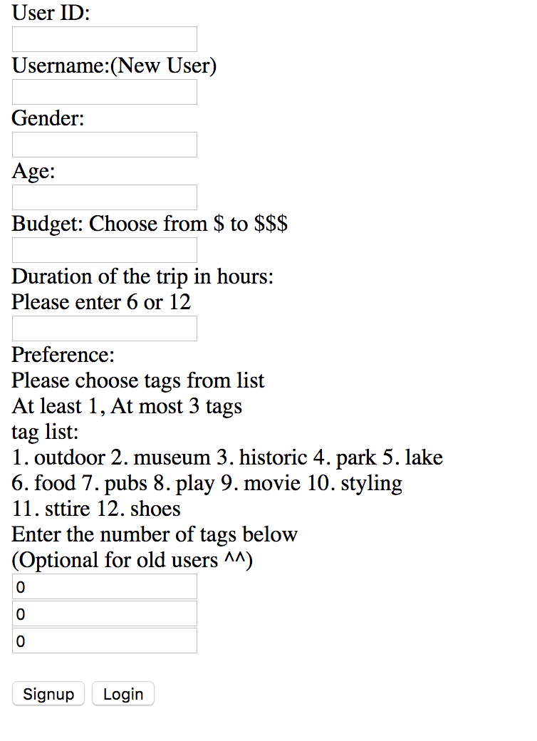

graph 1 UI

Existing User

When making a new plan request, the existing user only need to input their user id, budget, duration of the trip while the preference is optional. If preferences were entered, it will be sent back to backend and used to updating the weight for each category upon this user. As it’s said, the new input preference would be take into consideration while proposing new plan, however, the history of user is considered as well.

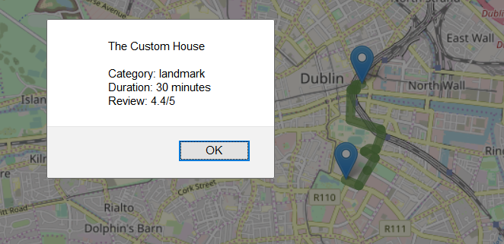As mentioned, when an existing user makes use of the application, they have the option to get a personalised travel plan based on any new preferences or simply use their profile based on previous usage to generate a travel plan. The UI contacts the backend services with the information the user provides, where a personalised travel plan is returned. Starting from a hardcoded location (current the Shelbourne hotel), the next step is to visualise this travel plan. Step by step the user has the option to see their first attraction on the map, or iteratively see the next attractions and their details on the map.