**Question 1:**

Taking 1 million random samples between 1 to 1 million, what is the probability that the numbers are prime to each other?

**Answer 1:**

Theoretical answer is 6/ = 0.60792710185

Code in R:

> start_time <- Sys.time()

> totalCount=1000000

> totalCountDecrementer=1000000

> primeCount=0

> x=sample(1000000,1000000)

> y=sample(1000000,1000000)

>

> gcd <- function(x, y) {

+ while(y) {

+ temp = y

+ y = x %% y

+ x = temp

+ }

+ return(x)

+ }

>

> for(i in 1:totalCount) {

+ #smaller=min(x,y)

+ #prime=TRUE

+ #for(i in 2:sqrt(smaller)){

+ # if(x%%i==0 & y%%i==0) {

+ # prime=FALSE

+ # break

+ # }

+ #}

+

+ if(gcd(x[i],y[i]) == 1)

+ {

+ primeCount=primeCount+1

+ }

+ }

> print(paste("Probability that 2 numbers are prime to each other is: ",primeCount/totalCount))

[1] "Probability that 2 numbers are prime to each other is: 0.607472"

> end_time <- Sys.time()

> print(start_time)

[1] "2018-09-22 00:07:30 BST"

> print(end_time)

[1] "2018-09-22 00:07:38 BST"

> print(end_time - start_time)

Time difference of 8.000176 secs

**Question 2:**

x – number of males arriving in the bank at rate

y – number of females arriving at the bank at rate

z – total number of people at the bank represented by x + y

E[X | Z=z]

Plot x/z against z

**Answer 2:**

> start_time <- Sys.time()

> avgRateMale=30

> avgRateFemale=40

> totalPersonRequired=1000000

> maleObservationsPerHour=c()

> femaleObservationsPerHour=c()

> totalObservationsPerHour=c()

> totalObservationsPerHourSum=c()

>

> while(totalPersonRequired > 0){

+ maleObservations=rpois(5,lambda = avgRateMale)

+ femaleObservations=rpois(5,lambda = avgRateFemale)

+ totalPeople=sum(maleObservations)+sum(femaleObservations)

+ maleObservationsPerHour=c(maleObservationsPerHour,maleObservations)

+ femaleObservationsPerHour=c(femaleObservationsPerHour,femaleObservations)

+ totalObservationsPerHour=maleObservationsPerHour+femaleObservationsPerHour

+ totalPersonRequired=totalPersonRequired-totalPeople

+ }

> totalWalkIn=sum(totalObservationsPerHour)

> for(i in 1:length(totalObservationsPerHour)){

+ totalObservationsPerHourSum[i]=sum(totalObservationsPerHour[1:i])

+ }

> print(paste("Expected Value = ",(avgRateMale/(avgRateMale+avgRateFemale))*totalWalkIn))

[1] "Expected Value = 428730.857142857"

> plot(totalObservationsPerHourSum,maleObservationsPerHour/totalObservationsPerHourSum, type="l")

> end_time <- Sys.time()

> print(start_time)

[1] "2018-09-22 00:24:43 BST"

> print(end_time)

[1] "2018-09-22 00:24:46 BST"

> print(end_time - start_time)

Time difference of 2.854399 secs

> plot(totalObservationsPerHourSum,maleObservationsPerHour/totalObservationsPerHourSum, xlab = "z",ylab = "x/z",type="l")

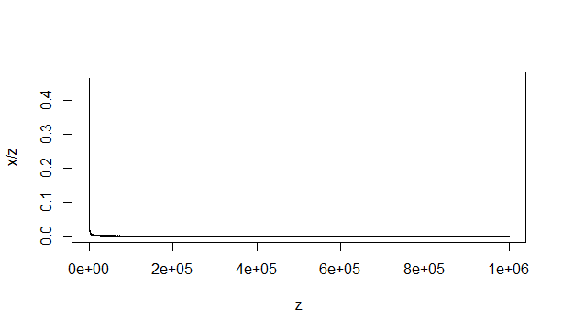

**Question 3:**

xi ~ U(0,1)

Yn = xi

Plot histogram for y1,y2,y5,y10,y30,y100

**Answer 3:**

Code in R:

> max=100

> randomSamples=10000

> x=c()

> x=replicate(max,runif(randomSamples),simplify = FALSE)

> y=c()

>

> #for(i in 1:max)

> #{

> # x[[i]]=runif(10000)

> #}

>

> for(i in 1:max)

+ {

+ sumVector=c()

+ totalVector=x[[1]]

+ if(i>1)

+ {

+ for(j in 2:i)

+ {

+ sumVector=x[[j]]

+ totalVector=totalVector+sumVector

+ }

+ }

+ y[[i]]=totalVector

+ }

>

> hist(y[[1]])

> hist(y[[2]])

> hist(y[[5]])

> hist(y[[10]])

> hist(y[[30]])

> hist(y[[100]])

