**A Project Report on**

**Fitness Club**

By

**Dhiraj Dipak Lavhale**

**Chhaganram Kumawat**

MCA – I, SEM – II

2023-24

To

Savitribai Phule Pune University,Pune

In Partial Fulfillment of the Degree of

Master in Computer Application (M. C. A.)

Under The Guidance Of

**Prof. Arati Kadam**

**Suryadatta Group of Institutes, Pune**

**Suryadatta Institute of Management and Mass Communication (SIMMC)**

Date:-

**CERTIFICATE**

This is to certify that Mr. / Ms. Chhaganram Ridamal Kumawat ,Dhiraj Dipak

Lavhale has successfully completed his/her project work entitled **“**Fitness Club **”** in partial fulfillment of MCA – I Semester-I program for the year A.Y. 2023-24 .

He / She have worked under our guidance and direction.

**Prof. Arati Kadam Dr. Manisha Kumbhar**

**(Project Guide) HO D-MCA,SGI**

**Examiner 1 Examiner 2**

**Date :**

**Place :**

**Acknowledgment**

We are the student of MCA first year. Here by we express our thanks to our project guide for allowing us to do the project on Fitness Club This project work has been the most exciting part of our learning experience which would be an asset for our future carrier. We would especially like to thank our guide and mentor Prof. Arati Kadam, who constantly guided us in developing, pushing us to search for more answers to her numerous questions. Also I would like to thank Dr. Rupali Dahake project coordinators for their support. As a building block of MCA Department, I thank Dr. Manisha Kumbhar, HOD, MCA Department for her continuous support and help. We are grateful to many classmates who contributed their suggestions. Their hard work and examples push us to limits of our capability and encourage us daily.

**Thank You**

**Student Name**

Chhaganram Ridamal Kumawat, Dhiraj Dipak Lavhale

**Index**

|  |  |
| --- | --- |
| **Chapter** | **Page number** |
| **CHAPTER 1 : INTRODUCTION** |  |
| 1.1 Existing System |  |
| 1.2 Need for System |  |
| 1.3 Operating Environment Hardware and Software |  |
| **CHAPTER 2 : PROPOSED SYSTEM** |  |
| 2.1 Proposed System (Introduction of system) |  |
| 2.2 Module specifications (Scope) |  |
| 2.3 Objectives of System |  |
| **CHAPTER 3 : ANALYSIS & DESIGN** |  |
| 3.1 Use Case Diagrams |  |
| 3.2 Activity Diagram |  |
| 3.3. Sequence Diagram |  |
| 3.4 Class Diagram |  |
| 3.5 Table specifications (Database design) |  |
| 3.6 Data dictionary |  |
| **CHAPTER 4 : USER MANUAL** |  |
| 4.1 User Interface Screens (Input) |  |
| 4.2 Output Screens with data |  |
| 4.3 Data Reports |  |
| 4.4 Test Procedures and cases |  |
| 4.5 Sample program code |  |
| 4.6 Limitations and Bibliography |  |

# CHAPTER 1 : INTRODUCTION

Our Gym E-commerce Software is a gym and health club membership E-commerce system. You can keep records on your members, their memberships and have quick and easy communication between you and your members. Gym E-commerce also includes a booking system, point of sale, banking, accounting concessions and has a range of reports that help in the E-commerce of your club.

Our Gym E-commerce Software is a complete gym and recreation facility system program which looks after all of your members, memberships and activities. It is designed for gyms, recreation centre and health clubs.

Our Gym E-commerce Software provides lots of functions such data entry of customer, keeping records of all the things about customer’s fees, plan, and physical fitness which help to provide good quality of services to customer from Gym managers.

We are more than just an E-commerce platform; we are your partner in achieving your fitness goals. At FitnessClub, we understand that living a healthy lifestyle goes beyond just working out; it's about making informed choices, finding the right products, and staying motivated every step of the way.

With our wide range of high-quality fitness equipment, apparel, supplements, and accessories, we aim to cater to every aspect of your fitness journey. Whether you're a seasoned athlete, a beginner looking to kickstart your fitness routine, or someone in between, we have something for everyone.

Our user-friendly website offers a seamless shopping experience, allowing you to browse through our extensive catalog with ease and convenience. From state-of-the-art gym equipment to stylish activewear, from nutritious supplements to handy workout accessories, we've got everything you need to elevate your fitness game.

But FitnessClub is more than just a store; it's a community of likeminded individuals who share a passion for health and wellness. Explore our blog for expert tips, workout routines, nutrition advice, and inspiring success stories from our community members.

## 1.1 Existing System

In the gym E-commerce system, if we take the current system and compare it with the proposed it is far behind. Every work in the existing is manual and done on paper. There might be a computer used somewhere for the work but it’s is not doing exactly what it’s is supposed which is reducing the manual work.

Entering everything manually to the computer by creating a file is not exactly what we are talking about in computerization. The existing system requires a lot of manual work which results in taking more time than it should. The operations like updating and synchronizing data also done manually in the existing system that is not automated and again time-consuming process .

The existing system for FitnessClub currently comprises a traditional brick-and-mortar setup, where customers visit physical stores to purchase fitness equipment, apparel, supplements, and accessories. These stores are typically located in select regions, limiting accessibility for customers who reside elsewhere. Additionally, the in-store experience may lack convenience and flexibility, as customers are constrained by operating hours and geographical proximity.

While the physical stores offer face-to-face interactions with staff for product inquiries and recommendations, the reach and scalability of this model are limited. Moreover, customers may face challenges such as limited product availability, long wait times, and the absence of personalized online services like tailored product recommendations and virtual consultations.

In terms of customer engagement and retention, the existing system relies heavily on traditional marketing channels such as print advertisements, word-of-mouth referrals, and occasional promotional events. While these methods may yield results, they often lack the targeted approach and realtime feedback mechanisms offered by digital platforms.

Overall, while the existing system has served FitnessClub well in establishing its brand presence and catering to local customers, there is significant room for improvement in terms of expanding reach, enhancing convenience, and leveraging technology to deliver a more personalized and engaging experience to customers across geographical boundaries.

## 1.2 Need for System

Gym E-commerce software is one of the most effective ways for modern gyms to achieve success and optimize their business potential and it has great future scope as well.

This technology has progressed well beyond checking members into the gym and processing dues. It is now a necessary tool for general managers to oversee all aspects of the firm.

**Accessibility:** An e-commerce website will provide accessibility to customers beyond the limitations of physical stores. People from different regions and even countries can access FitnessClub's products and services online, expanding its customer base.

**Convenience:** Offering an online platform allows customers to browse, shop, and make purchases at their convenience, 24/7. This flexibility caters to the busy schedules of modern consumers who may not have the time to visit physical stores during regular business hours.

**Scalability:** A well-designed e-commerce website enables FitnessClub to scale its operations more effectively compared to relying solely on brick-and-mortar stores. With an online presence, the company can reach a wider audience without the need for extensive physical infrastructure.

**Personalization:** Through data analytics and user profiling, FitnessClub can provide personalized recommendations and offers to customers based on their preferences, purchase history, and browsing behavior. This enhances the overall shopping experience and increases customer satisfaction and loyalty.

**Market Reach:** An e-commerce website allows FitnessClub to tap into new markets and demographics that may not be accessible through traditional retail channels. By leveraging digital marketing strategies such as SEO, social media advertising, and influencer partnerships, the company can increase brand visibility and attract a diverse customer base.

**Competitive Advantage:** In an increasingly digital landscape, having an e-commerce website is essential for remaining competitive in the fitness industry. Competitors who offer online shopping options may attract customers who prioritize convenience and accessibility, potentially leading to loss of market share for FitnessClub if it does not adapt to changing consumer preferences.

## 1.3 Operating Environment Hardware and Software

Hardware and software Specification

1.3.1] Software Requirements

* Technology: PHP/ MYSQL
* Client-Side Technologies: HTML, CSS, JavaScript
* Server-Side Technologies: PHP
* Data Base Server: WAMP / XAMP / Vertigo
* Operating System: Microsoft Windows / Linux

1.3.2] Hardware Requirements:

* Processor: Intel Pentium 4 (or) Later.
* Ram: 2GB Minimum, 4GB (recommended)
* Hard Disk: 100 GB (or) Higher

Programming Languages:

* Frontend - HTML, CSS, JavaScript.
* Backend – PHP, MYSQL.

# CHAPTER 2 : PROPOSED SYSTEM

## 2.1 Proposed System (Introduction of system)

The FITNESS CLUB is helping the customer to pre booking the Product and also customer can order the product online.

**User-Friendly Interface:** The website will feature a clean and intuitive design, making it easy for users to navigate, browse products, and complete purchases. Clear categorization, search functionality, and filters will help users find what they're looking for quickly and efficiently.

**Product Catalog:** A comprehensive product catalog will showcase FitnessClub's range of fitness equipment, apparel, supplements, and accessories. Each product will have detailed descriptions, high-quality images, and customer reviews to help users make informed purchasing decisions.

**Personalization:** The website will utilize data analytics and user profiling to deliver personalized recommendations and content to each visitor. Recommendations will be based on factors such as purchase history, browsing behavior, and demographic information, enhancing the shopping experience and increasing conversion rates.

**Virtual Try-On:** For apparel and accessories, a virtual try-on feature will allow users to visualize how products will look on them before making a purchase. Augmented reality technology will enable users to see themselves wearing different clothing items and accessories, improving confidence in their buying decisions.

**Interactive Workouts:** To inspire and motivate customers, the website will offer interactive workout videos, tutorials, and training plans created by fitness experts. Users can access these resources for free or as part of a premium subscription service, enhancing engagement and loyalty.

Community Engagement: A dedicated community section will foster engagement among FitnessClub's customers, allowing them to connect with like-minded individuals, share fitness tips, success stories, and participate in challenges and competitions. User-generated content will be prominently featured to showcase the diverse community of FitnessClub enthusiasts.

**Mobile Compatibility:** The website will be fully optimized for mobile devices, ensuring a seamless shopping experience across all screen sizes and devices. Mobile users will have access to all features and functionalities, allowing them to shop on the go.

**Secure Payment Gateway:** Multiple payment options will be available, including credit/debit cards, digital wallets, and payment gateways. The website will prioritize security, implementing encryption and other measures to safeguard users' financial information.

**Order Tracking and Customer Support:** Users will be able to track their orders in real-time and receive notifications at each stage of the delivery process. A dedicated customer support team will be available via live chat, email, and phone to assist users with any questions or issues they may encounter.

**2.2 Module specifications (Scope)**

# 1. Admin

1. The Administration has access to all the information of the customers.
2. They can log in through the home screen to see the reports about customers, payments orders, etc.
3. They can manage the product catalogue which are available on the website.
4. They can handle any issue of the customer by online help support.

# 2. User

1. User can login easily login into the website can search any fitness product.
2. User can register on the website for buying the product and making the payment.
3. User can give review of the product and can get 24/7 online help support.

## 2.3 Objectives of System

* The main objective of the project is to develop software that facilitates the data storage, data maintenance and its retrieval for the gym in an igneous way.

* To store the record of the customers, the staff that has the privileges to access, modify and delete any record and finally the service, gym provides to its customers.

* Also, only the staff has the privilege to access any database and make the required changes, if necessary.

* To develop easy-to-use software which handles the customer- staff relationship in an effective manner.

* To develop a user-friendly system that requires minimal user training. Most of features and function are similar to those on any windows platform.

* Increase Accessibility: Enable customers from diverse geographical locations to access FitnessClub's products and services, breaking down barriers to entry and expanding the customer base beyond physical store locations.

* Improve Convenience: Provide a convenient and flexible shopping experience that allows customers to browse, purchase, and receive products at their convenience, 24/7, catering to their busy lifestyles and preferences.

* Enhance Personalization: Utilize data analytics and user profiling to deliver personalized recommendations, content, and promotions to each customer, creating a tailored shopping experience that increases engagement, satisfaction, and loyalty.

* Drive Sales and Revenue: Increase sales and revenue by leveraging digital marketing strategies, cross-selling, upselling, and promotional campaigns to attract new customers, encourage repeat purchases, and maximize the lifetime value of each customer.

* Optimize Customer Engagement: Foster meaningful interactions and engagement with customers through interactive features, user-generated content, community forums, and social media integration, building a loyal and active customer community around the FitnessClub brand.

* Expand Market Reach: Tap into new markets and demographics by leveraging the global reach of the internet and digital channels, targeting specific audience segments with relevant content, messaging, and advertising to increase brand awareness and market penetration.

* Improve Operational Efficiency: Streamline business operations, inventory management, order fulfillment, and customer service processes through automation, integration, and optimization, reducing costs, errors, and inefficiencies while improving speed and accuracy.

* Ensure Security and Compliance: Implement robust security measures and compliance protocols to protect customers' personal and financial information, instilling trust and confidence in the brand and providing a safe and secure online shopping environment.

* Stay Competitive: Maintain a competitive edge in the fitness industry by continuously innovating, adapting to changing market trends and consumer preferences, monitoring competitor activities, and delivering superior products, services, and experiences that differentiate FitnessClub from competitors.

# CHAPTER 3 : ANALYSIS & DESIGN

## 3.1 Use Case Diagrams

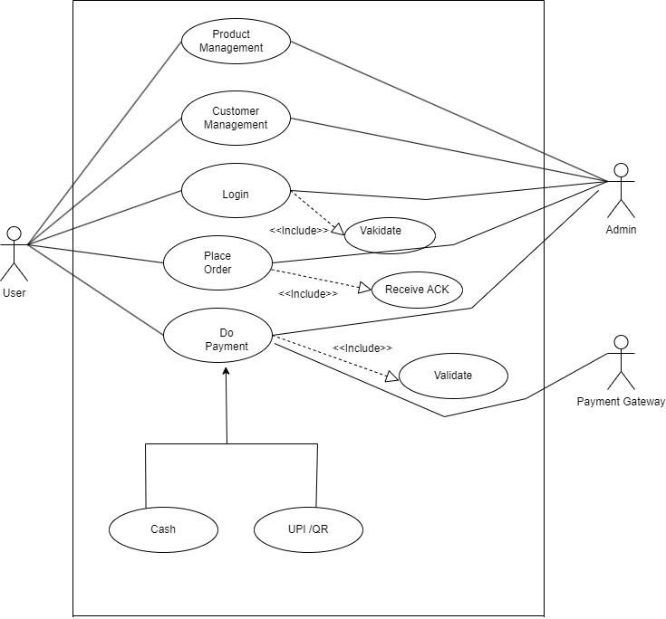

# Global Use case description for Login

**Actor:** 1) Customer

2) Admin

**Precondition:** User and admin have been registered previously otherwise Register**.**

**Description:** User and admin can get the access to use the system.

**Basic Flow:**

* Do Registration with required fields their validation by the system.

* Enter id and password.

* Validation of id and password.

* User receives acknowledgement.

**Post Conditions:** After Login Successfully user and admin can get access the account.

# Use Case Diagram for Admin and User Login

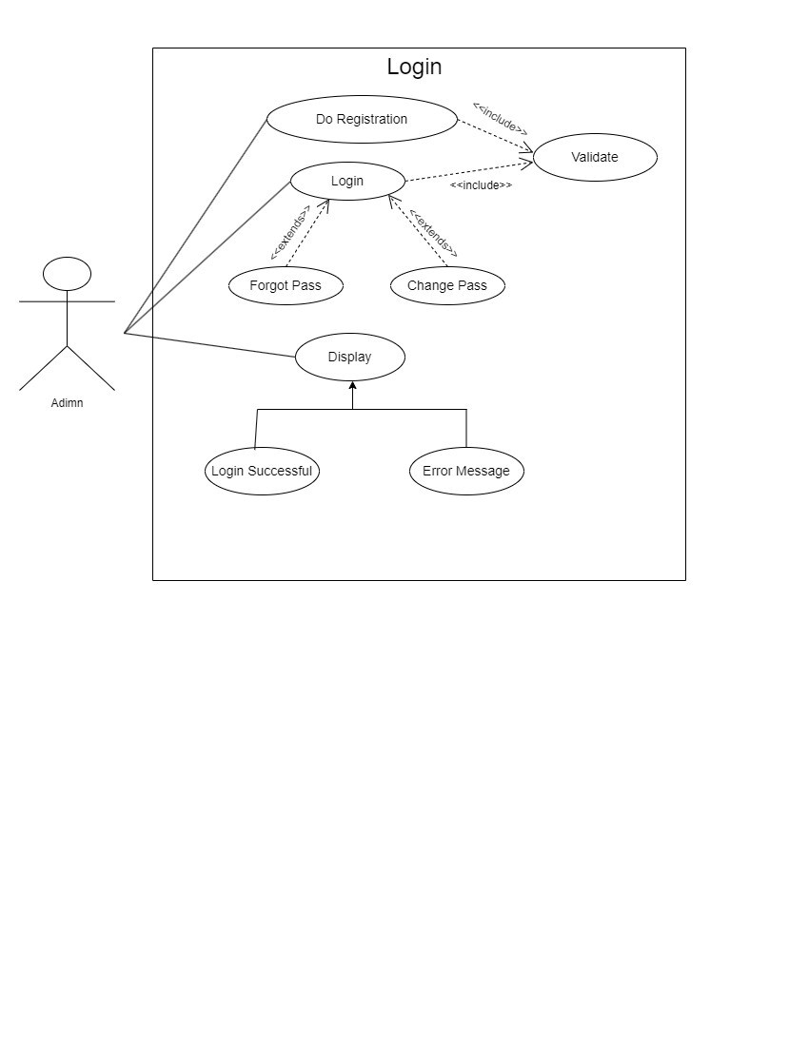

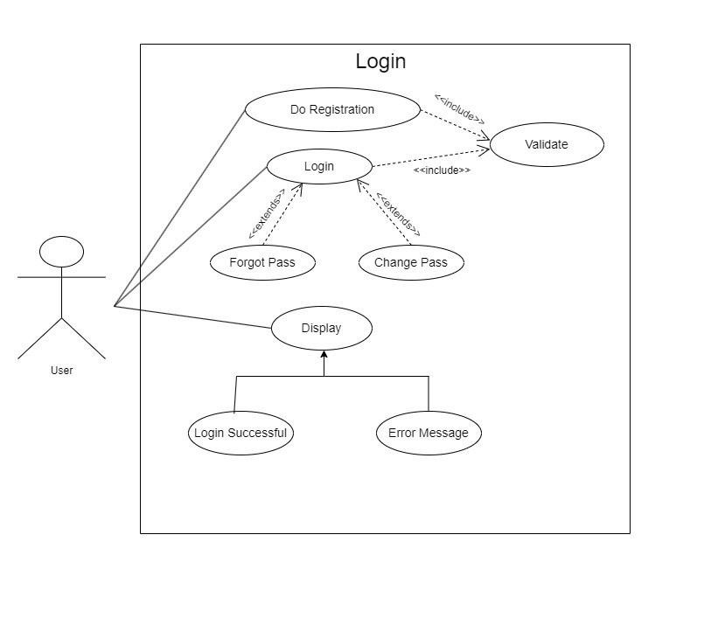

# Use case description for Login

**Actor:** 1) Users

2) Admin

**Precondition:** User and admin have been registered previously otherwise Register**.**

**Description:** User and admin can get the access to use the system.

**Basic Flow:**

* Do Registration with required fields their validation by the system.

* Enter id and password.

* Validation of id and password.

* User receives acknowledgement.

**Post Conditions:** After Login Successfully user and admin can get access the account.

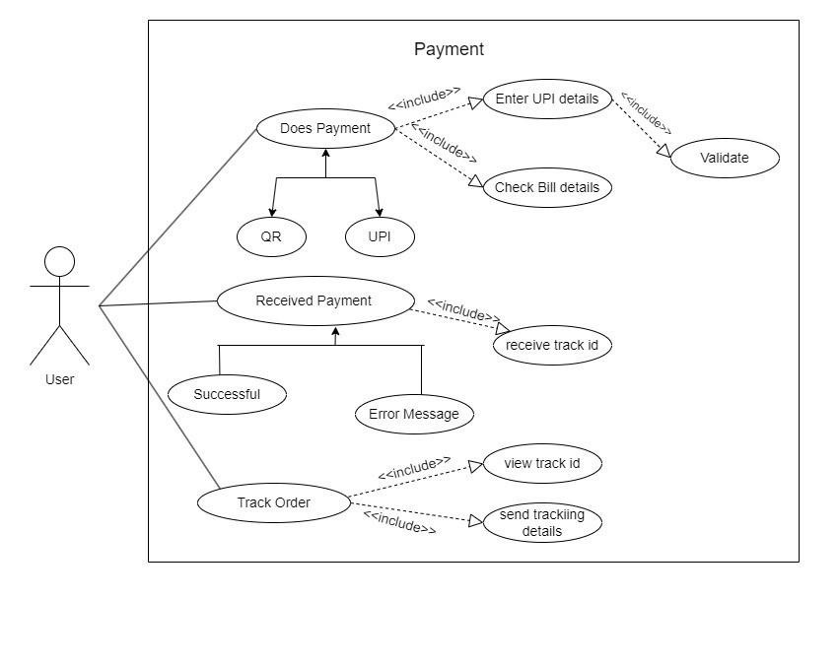

# Use case description for payment

**Actor:** 1) Users

**Precondition:** User have been registered previously otherwise Register**.**

**Description:** User can get the access to use the system.

**Basic Flow:**

* Do Registration with required fields their validation by the system.

* Enter id and password.

* Validation of id and password.

* User receives acknowledgement.

**Post Conditions:** After Login Successfully user can get access the account.

# Use case Diagram for Payment

## 3.2 Activity Diagram

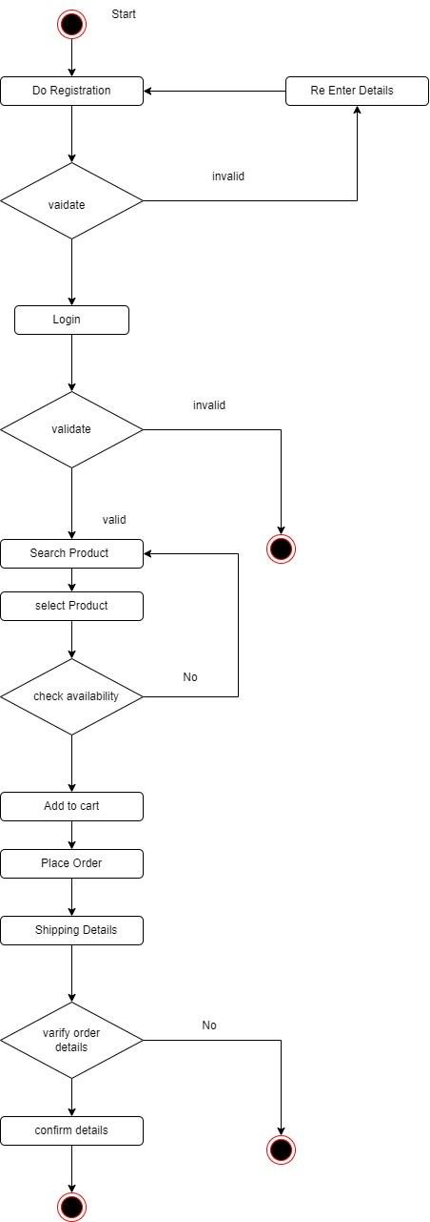

**User**

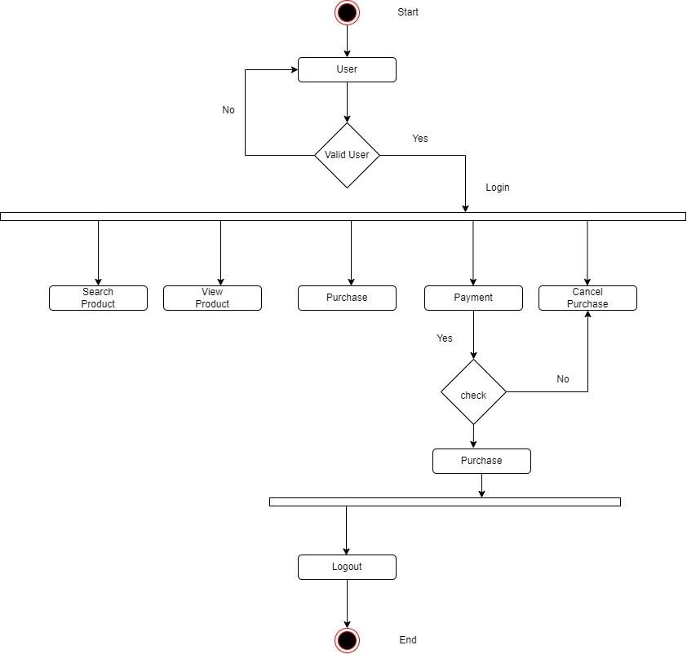

**Login**

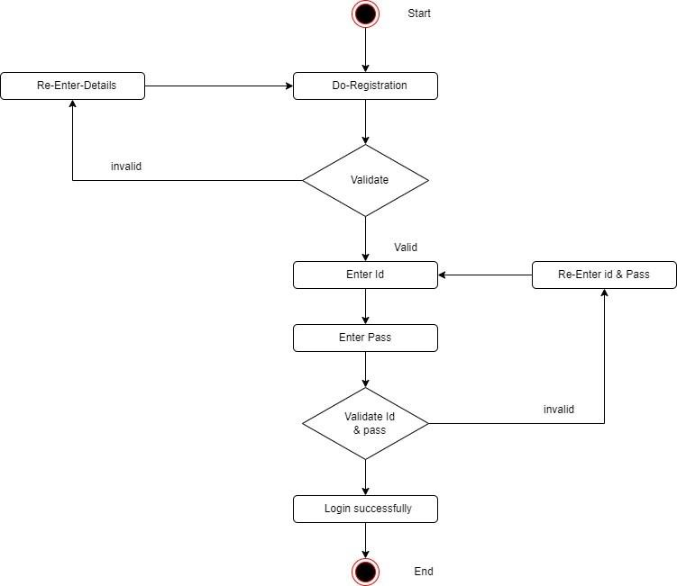

## Payment Activity Diagram

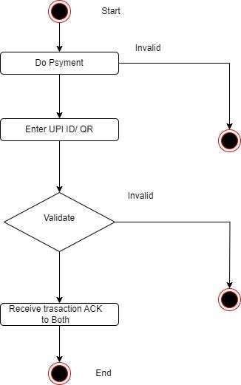

### 3.3 Sequence Diagram

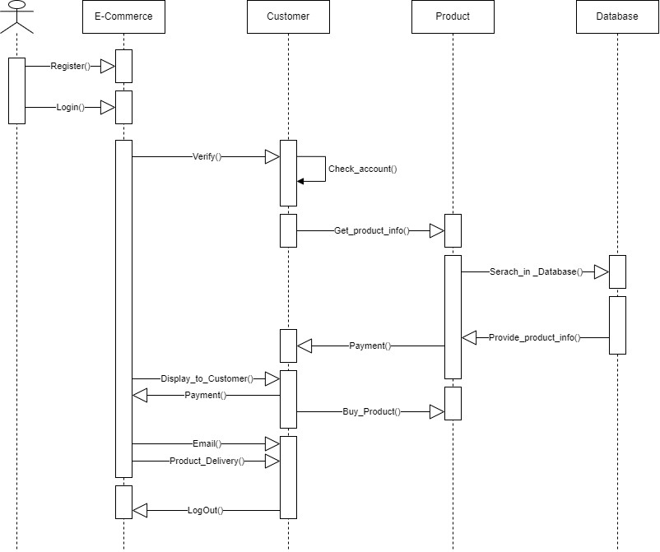

### 3.4 Class Diagram

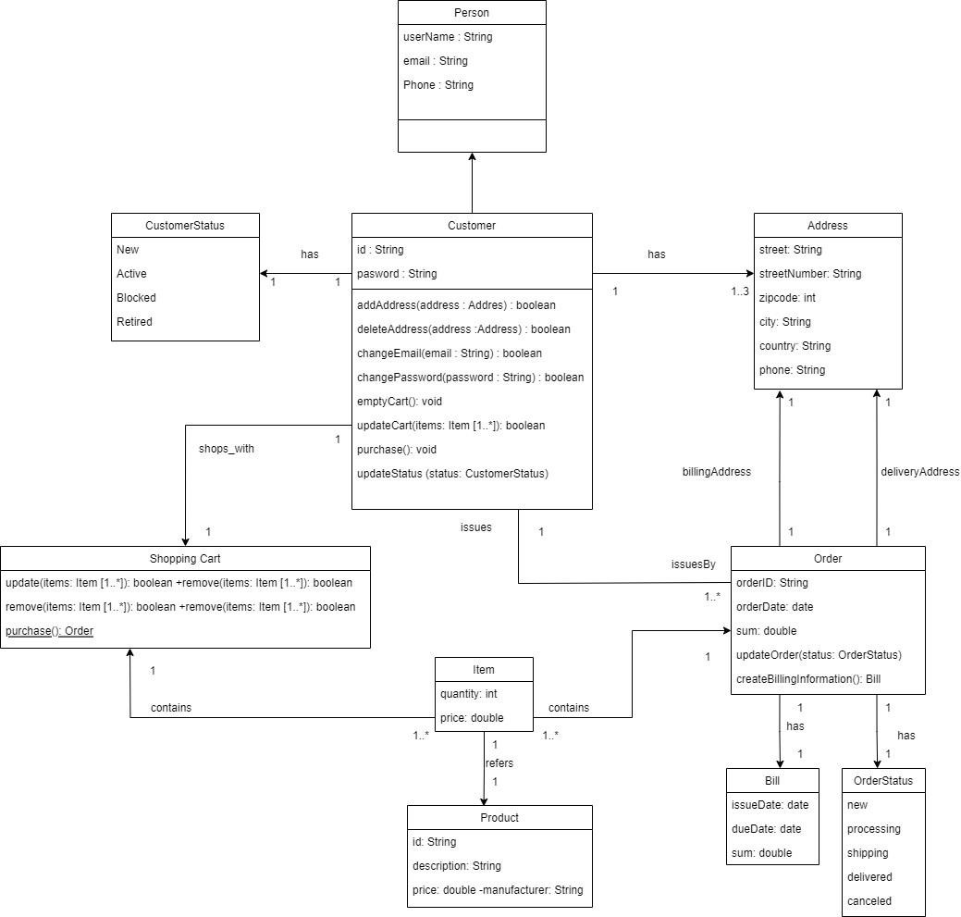

### 3.5 E-R Diagram

**What is an ER Diagram?**

An Entity Relationship Diagram (ER Diagram) pictorially explains the relationship between entities to be stored in a database. Fundamentally, the ER Diagram is a structural design of the database. It acts as a framework created with specialized symbols for the purpose of defining the relationship between the database entities. ER diagram is created based on three principal components: entities, attributes, and relationships.

**What is an ER Model?**

An Entity-Relationship Model represents the structure of the database with the help of a diagram. ER Modelling is a systematic process to design a database as it would require you to analyse all data requirements before implementing your database.

**History of ER models**

Peter Chen proposed ER Diagrams in 1971 to create a uniform convention that can be used as a conceptual modelling tool. Many models were presented and discussed, but none were suitable. The data structure diagrams offered by Charles Bachman also inspired his model.

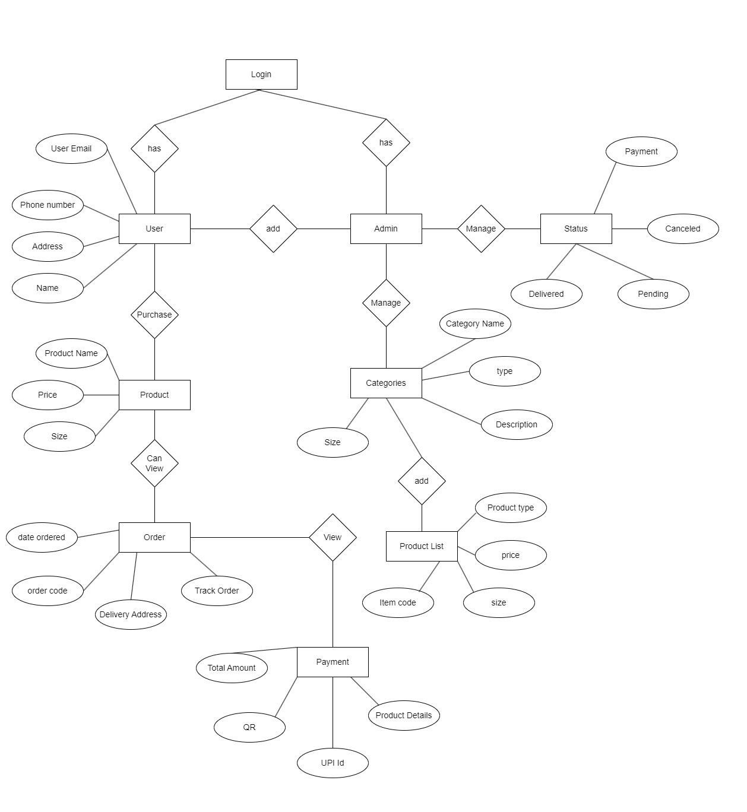

### 3.6 Table specifications And Data dictionary

**Table Name:** Register

**Primary Key:** user

|  |  |  |  |
| --- | --- | --- | --- |
| Sr. No. | Field | Datatype | Description |
| 1. | **id** | int(15) | It will store the id from which the user registers. |
| 2. | **password** | varchar(8) | It will store the password entered by the user. |
| 3. | **email** | varchar(25) | It will store the email of the user. |
| 4. | **user** | varchar(20) | (Primary Key)  It will store the name of the user. |

**Table Name:** Admin User

|  |  |  |  |
| --- | --- | --- | --- |
| Sr. No. | Field | Datatype | Description |
| 1. | **Admin_Password** | int(8) | It will store the password entered by the Admin. |
| 2. | **Admin_Name** | varchar(20) | It will store the Admin name from which the Admin  Register. |

**Table Name:** Order details

|  |  |  |  |
| --- | --- | --- | --- |
| Sr. No. | Field | Datatype | Description |
| 1. | **id** | int(15) | It will store the id from which the user. |
| 2. | **fname** | varchar(8) | It will store thefname store by the user. |
| 3. | **lname** | varchar(25) | It will store the lname of the user. |
| 4. | **email** | varchar(20) | It will store the email of the user. |
| 5. | **mobile** | number(12) | It will store the email of the user. |
| 6. | **address1** | varchar(40) | It will store the address1 of the user. |
| 7. | **address2** | varchar(40) | It will store the address2 of the user. |
| 8. | **city** | varchar(10) | It will store the city of the user. |
| 9. | **state** | varchar(15) | It will store the state of the user. |
| 10. | **zip** | Int(8) | It will store the zip of the user. |
| 11. | **pname** | varchar(20) | It will store the product name by the user selectred. |
| 12. | **pprice** | int(6) | It will store the product price |

## CHAPTER 4 : USER MANUAL

### 4.1 User Interface Screens (Input)

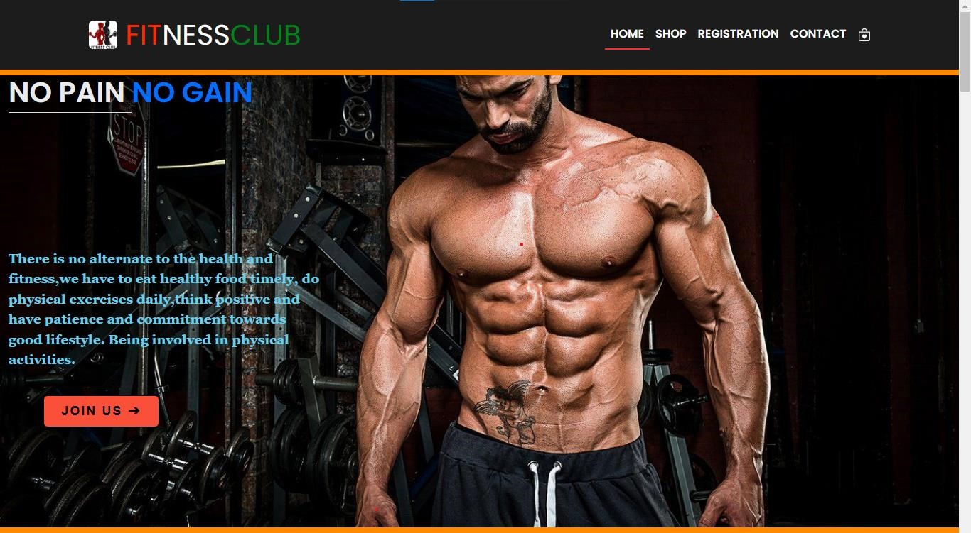

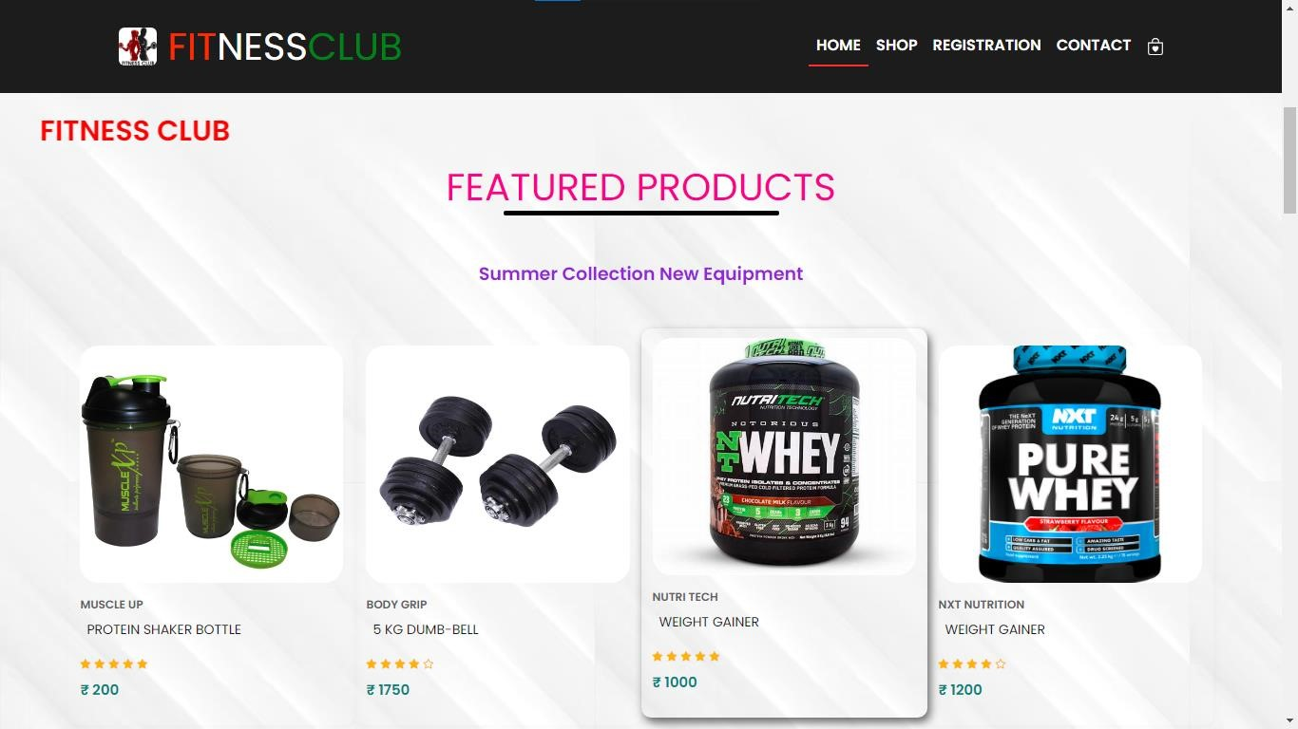

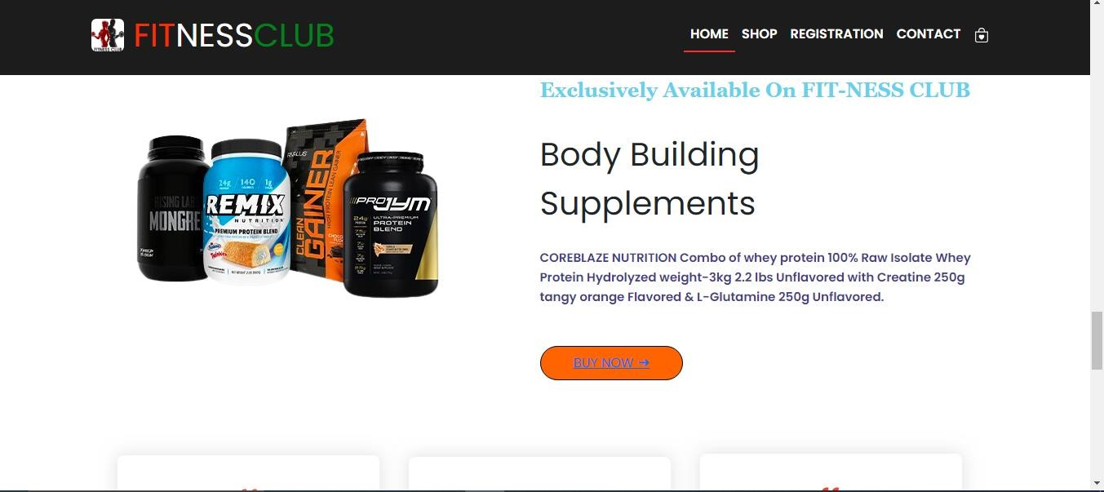

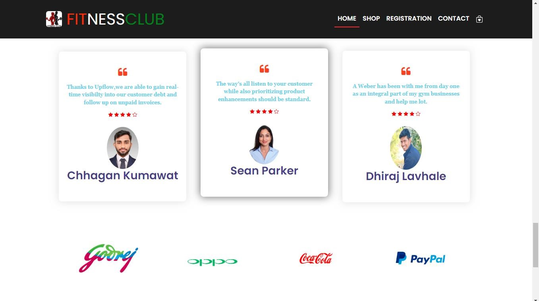

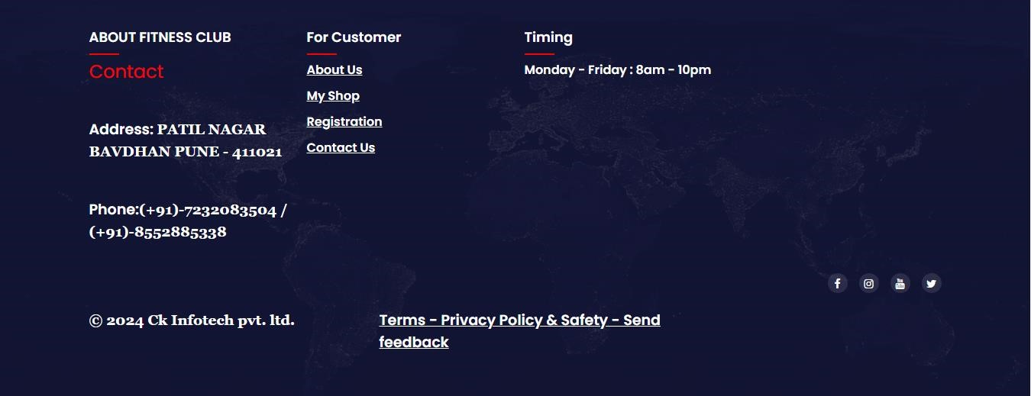

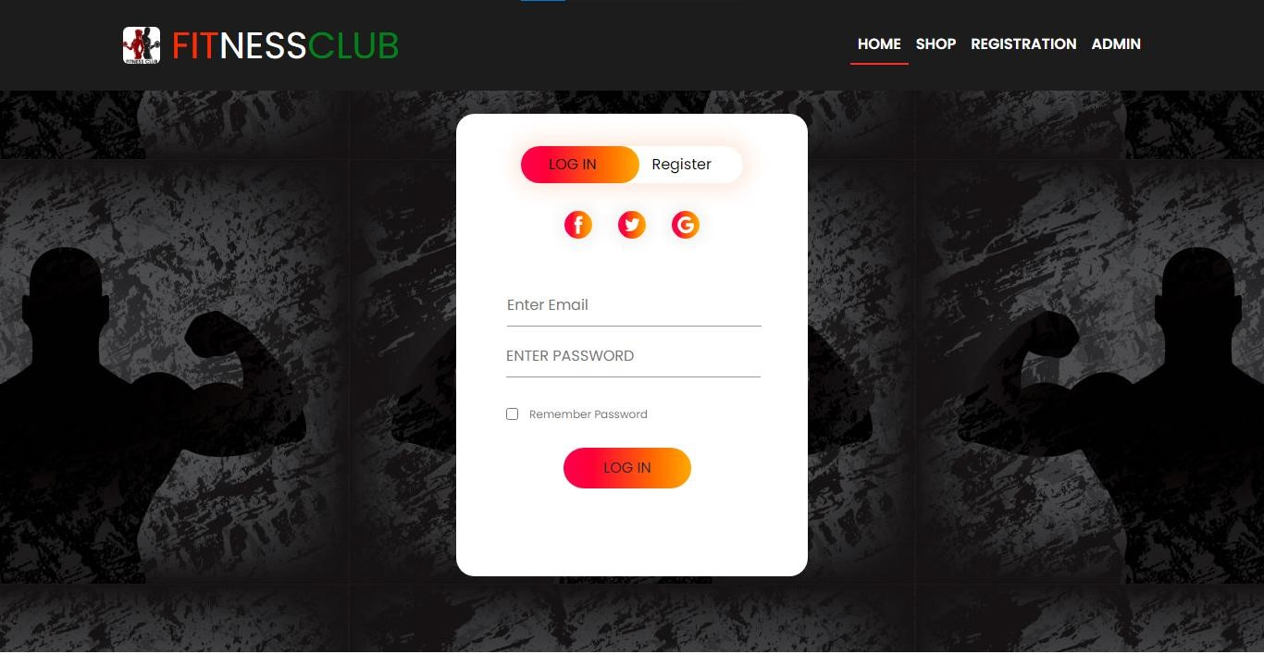

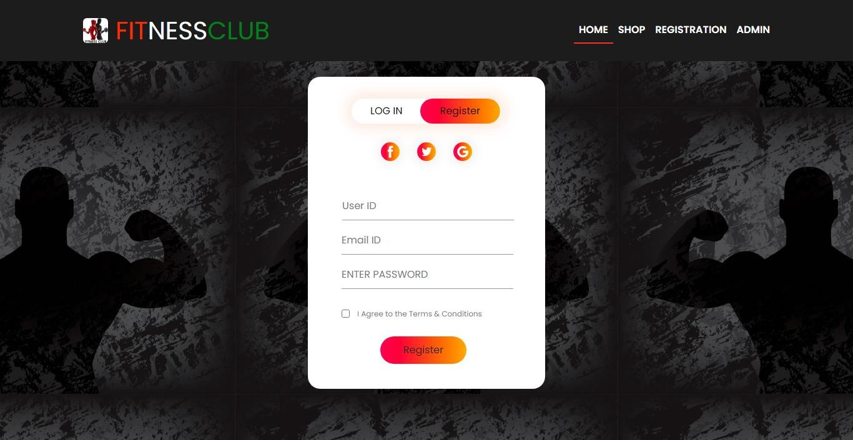

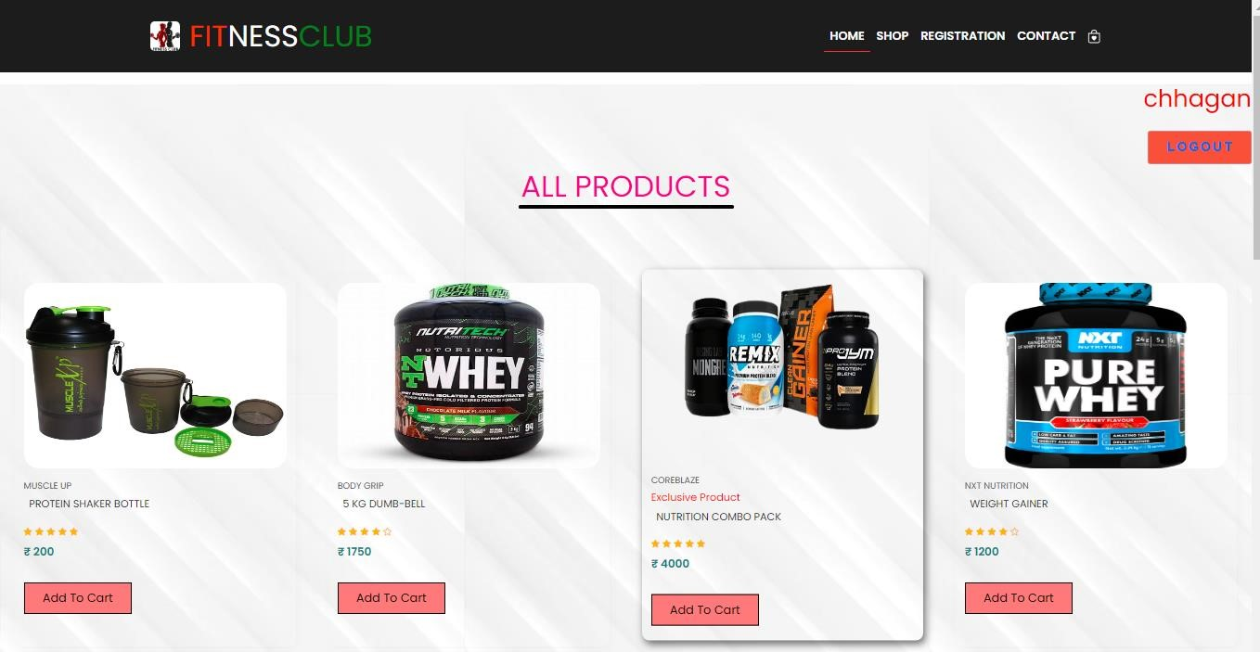

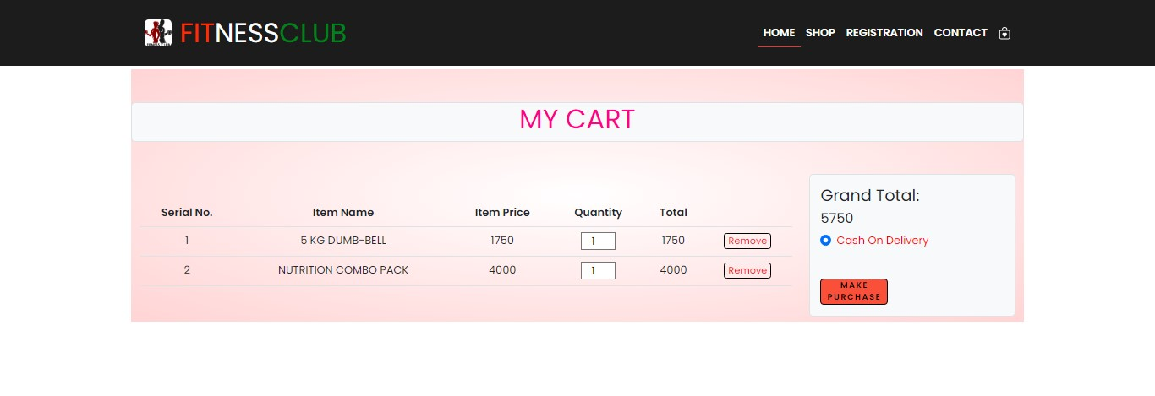

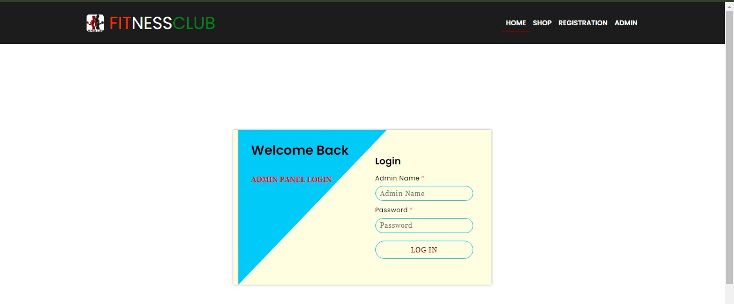

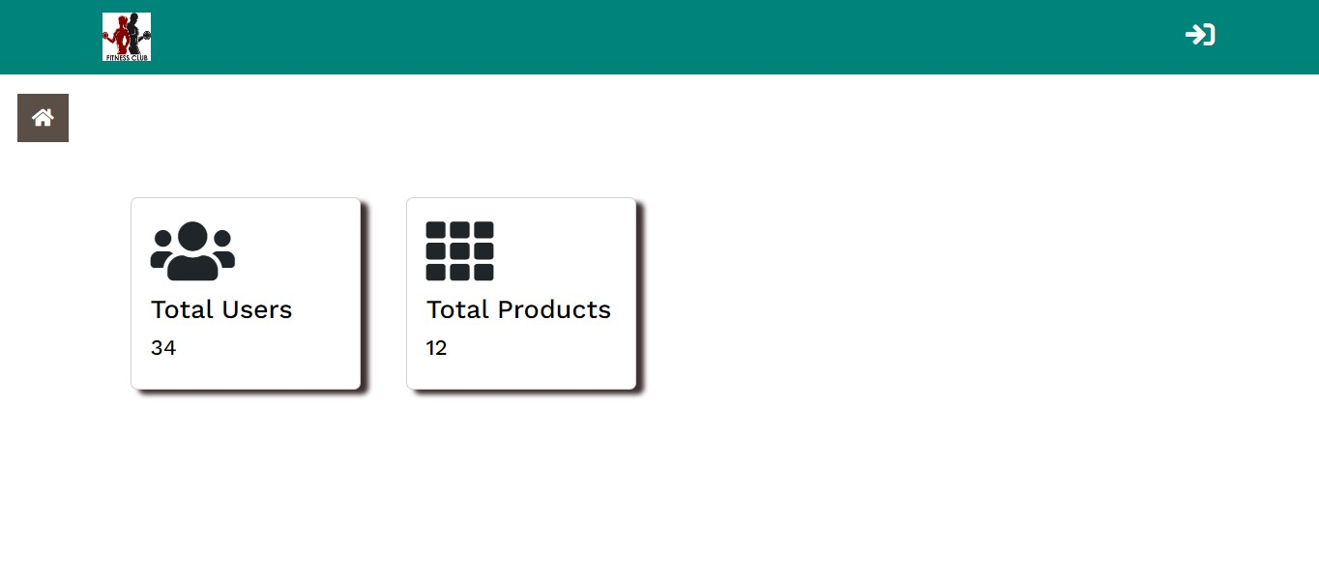

### 4.2 Output Screens with data

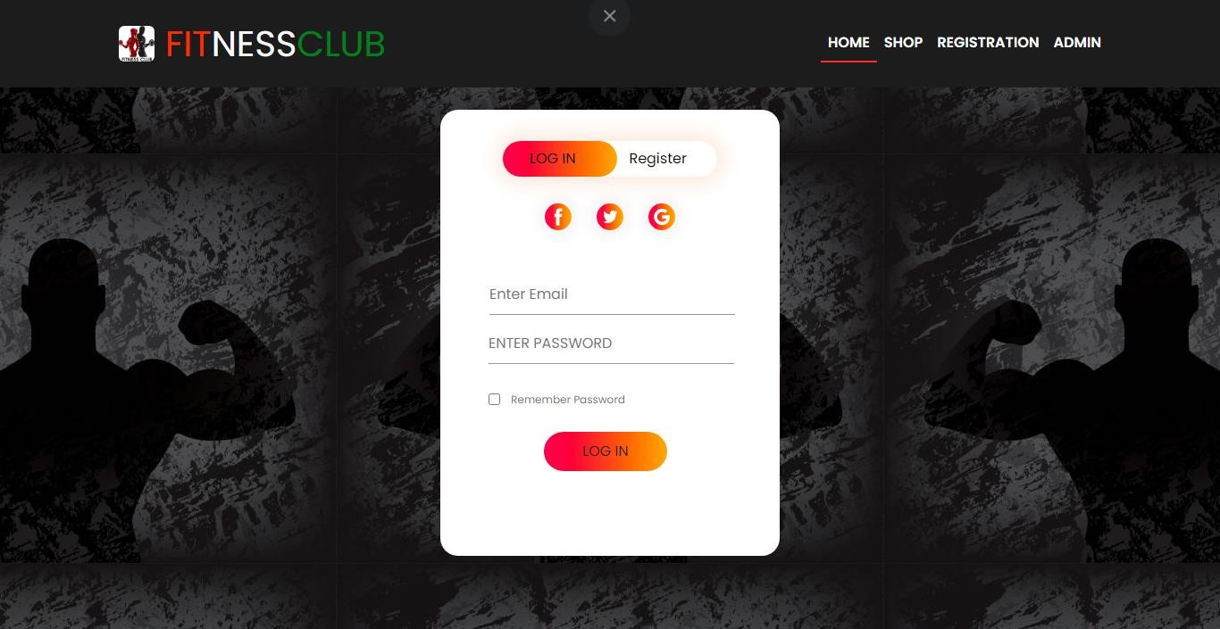

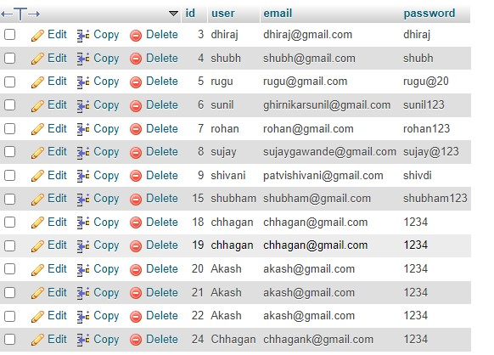

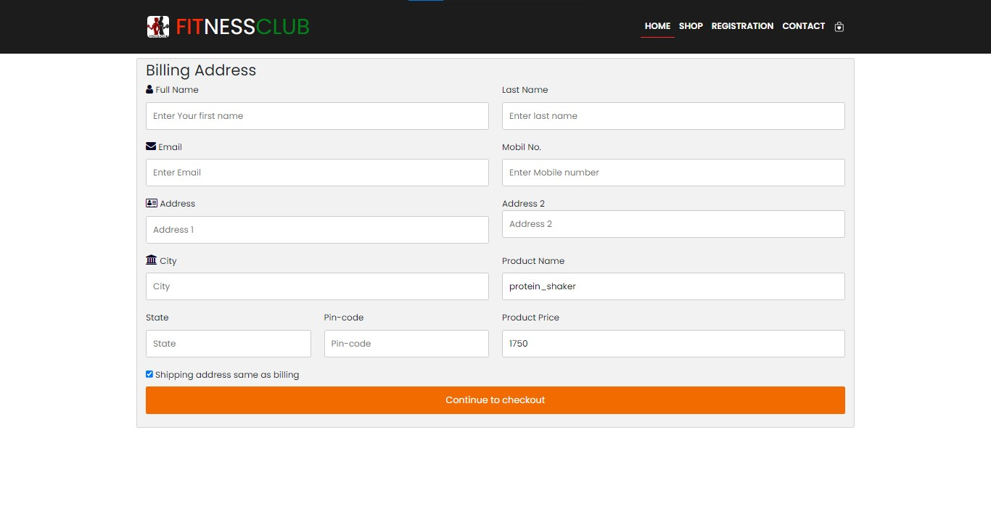

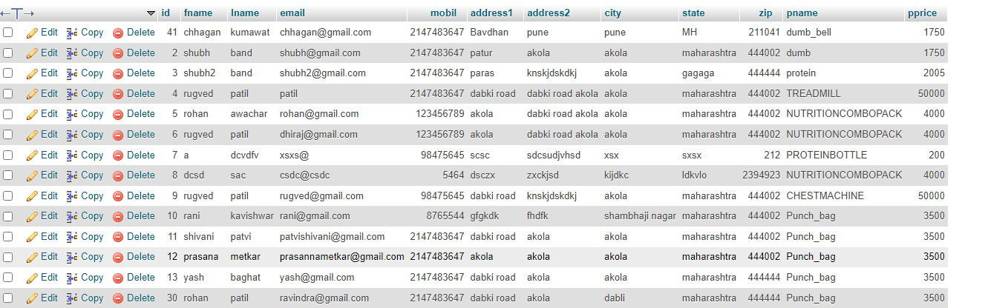

### 4.3 Data Reports





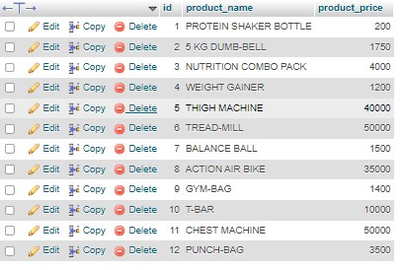



### 4.4 Test Procedures and cases

**4.4.1 User Registration and Login:**

Procedure:

Navigate to the registration page, fill in the required fields, submit the form. Then, attempt to log in with the newly created credentials.

Test Cases:

Verify that users can successfully register with valid information.

Ensure that users receive a confirmation email after registration.

Verify that registered users can log in using their credentials. Test for error handling: invalid email format, password strength requirements, etc.

**4.4.2 Browsing and Product Search:**

Procedure:

Browse different product categories, use the search function to find specific products.

Test Cases:

Confirm that all ssss

### 4.5 Sample program code

<?php

session_start(); include("navbar.php")

?>

<!-- Banner Start -->

<div class="container-fluid">

<div class="row header">

<div class="col col-xl-4 col-md-6 col-sm-12">

<h1><b><span class="border-bottom ">NO PAIN

</span><b><span class="text-primary"> NO GAIN</span></h1>

</div>

<div class="col col-xl-4 col-md-6 col-sm-12">

<p class="header-content">There is no alternate to the health and fitness,we have to eat healthy food

timely, do physical exercises daily,think positive and have

patience and commitment towards good

lifestyle. Being involved in physical activities. </p> </div>

<div class="col col-xl-4 col-md-6 col-sm-12">

<a href="registration.php">

<center><button class="btn btn-primary" id="b1"> JOIN US

&#10132;</button></center>

</a>

</div>

</div>

</div>

<!-- Banner End-->

<!-- FEATURED PRODUCTS Start-->

<section id="product1" class="section-p1" style="color: red;"> <br>

<b>

<marquee behavior="scroll" direction="right" style="font-size:

30px;">FITNESS CLUB</marquee><br>

</b> <b style="font-size:larger;">

<h1 class="title">FEATURED PRODUCTS</h1>

</b> <b>

<p style="color: blueviolet;" ; style="font-size: large;">Summer

Collection New Equipment </style>

</b></p>

<div class="pro-container justify-content-center">

<div class="col col-xl-4 col-lg-4 col-md-6 col-sm-12 pro" >

<img class="img-fluid" src="img/project1.jpeg" alt="">

<div class="des">

<span>MUSCLE UP</span>

<h5> PROTEIN SHAKER BOTTLE</h5>

<div class="star">

<i class="fa fa-star"></i>

<i class="fa fa-star"></i>

<i class="fa fa-star"></i>

<i class="fa fa-star"></i>

<i class="fa fa-star"></i>

</div>

<h4>&#8377; 200</h4>

</div>

</div>

<div class="col col-xl-4 col-lg-4 col-md-6 col-sm-12 pro" >

<img src="img/project2.webp" alt="">

<div class="des">

<span>BODY GRIP</span>

<h5>5 KG DUMB-BELL</h5>

<div class="star">

<i class="fa fa-star"></i>

<i class="fa fa-star"></i>

-star"></i>

-star"></i>

-star-o"></i>

</div>

<h4>&#8377; 1750</h4>

</div>

</div>

<div class="col col-xl-4 col-lg-4 col-md-6 col-sm-12 pro" >

<img src="img/project3.jpg" alt="">

<div class="des">

<span>NUTRI TECH</span>

<h5>WEIGHT GAINER</h5>

<div class="star">

<i class="fa fa-star"></i>

<i class="fa fa-star"></i>

<i class="fa fa-star"></i>

<i class="fa fa-star"></i>

<i class="fa fa-star"></i>

</div>

<h4>&#8377; 1000</h4>

</div>

</div>

<div class="col col-xl-4 col-lg-4 col-md-6 col-sm-12 pro" >

<img src="img/project4.jpg" alt="">

<div class="des">

<span>NXT NUTRITION</span>

<h5>WEIGHT GAINER</h5>

<div class="star">

<i class="fa fa-star"></i>

<i class="fa fa-star"></i>

<i class="fa fa-star"></i>

<i class="fa fa-star"></i>

<i class="fa fa-star-o"></i>

</div>

<h4>&#8377; 1200</h4>

</div>

</div>

<div class="col col-xl-4 col-lg-4 col-md-6 col-sm-12 pro" >

<img src="img/thigs.png" alt="">

<div class="des">

<span>NAUTILUS</span>

<h5>THIGH MACHINE</h5>

<div class="star">

<i class="fa fa-star"></i>

<i class="fa fa-star"></i>

<i class="fa fa-star"></i>

<i class="fa fa-star"></i>

<i class="fa fa-star"></i>

</div>

<h4>&#8377; 40,000</h4>

</div>

</div>

<div class="col col-xl-4 col-lg-4 col-md-6 col-sm-12 pro" >

<img src="img/project6.jpg" alt="">

<div class="des">

<span>SPARNOD</span>

<h5>TREAD-MILL</h5>

<div class="star">

<i class="fa fa-star"></i>

<i class="fa fa-star"></i>

<i class="fa fa-star"></i>

<i class="fa fa-star"></i>

<i class="fa fa-star"></i>

</div>

<h4>&#8377; 50,000</h4>

</div>

</div>

<div class="col col-xl-4 col-lg-4 col-md-6 col-sm-12 pro" >

<img src="img/project7.jpg" alt="">

<div class="des">

<span>BOLDFIT</span>

<h5>BALANCE BALL</h5>

<div class="star">

<i class="fa fa-star"></i>

-star"></i>

-star"></i>

-star"></i>

<i class="fa fa-star-o"></i>

</div>

<h4>&#8377; 1500</h4>

</div> </div>

<div class="col col-xl-4 col-lg-4 col-md-6 col-sm-12 pro" >

<img src="img/gym cycle.jpg" alt="">

<div class="des">

<span>POWER MAX</span>

<h5>ACTION AIR BIKE</h5>

<div class="star">

<i class="fa fa-star"></i>

<i class="fa fa-star"></i>

<i class="fa fa-star"></i>

<i class="fa fa-star"></i>

<i class="fa fa-star"></i>

</div>

<h4>&#8377; 35,000</h4>

</div>

</div>

</div>

</section>

<!-- FEATURED PRODUCTS End-->

<!-- LATEST PRODUCTS Start-->

<section id="product1" class="section-p1" style="color: red;">

<img src="img/dhiru.jpg" alt="" width="100%" height="65%">

<br> <br>

<b style="font-size:larger;">

<h1 style="color: red;" class="title">LATEST PRODUCTS</h1>

</b>

<div class="pro-container justify-content-center">

<div class="col col-xl-4 col-lg-4 col-md-6 col-sm-12 pro " >

<img src="img/gym bag.jpg" alt="">

<div class="des">

<span>PUMA</span>

<h5> GYM-BAG</h5>

<div class="star">

<i class="fa fa-star"></i>

<i class="fa fa-star"></i>

<i class="fa fa-star"></i>

<i class="fa fa-star"></i>

<i class="fa fa-star"></i>

</div>

<h4>&#8377; 1400</h4>

</div>

</div>

<div class="col col-xl-4 col-lg-4 col-md-6 col-sm-12 pro" >

<img src="img/T-bar.jpg" alt="">

<div class="des">

<span>SF TECH</span>

<h5>T-BAR</h5>

<div class="star">

<i class="fa fa-star"></i>

<i class="fa fa-star"></i>

<i class="fa fa-star"></i>

<i class="fa fa-star"></i>

<i class="fa fa-star"></i>

</div>

<h4>&#8377; 10,000</h4>

</div>

</div>

<div class="col col-xl-4 col-lg-4 col-md-6 col-sm-12 pro" >

<img src="img/Rd.jpg" alt="">

<div class="des">

<span>TONE UP</span>

<h5>CHEST MACHINE</h5>

<div class="star">

<i class="fa fa-star"></i>

<i class="fa fa-star"></i>

-star"></i>

-star"></i>

-star"></i>

</div>

<h4>&#8377; 50,000</h4>

</div>

</div>

<div class="col col-xl-4 col-lg-4 col-md-6 col-sm-12 pro" >

<img src="img/punch bag.jpg" alt="">

<div class="des">

<span>SPEED UP</span>

<h5>PUNCH-BAG</h5>

<div class="star">

<i class="fa fa-star"></i>

<i class="fa fa-star"></i>

<i class="fa fa-star"></i>

<i class="fa fa-star"></i>

<i class="fa fa-star"></i>

</div>

<h4>&#8377; 3500</h4>

</div>

</div>

</div>

</section>

<!-- LATEST PRODUCTS End-->

<!-- Welcome to Fitness Club Start-->

<main class="carousel">

<section class="banner_slider justify-content-center">

<div class="slide">

<div class="slide_content">

<p> WELCOME TO FITNESS CLUB </p>

<h2> MAKE YOUR BODY FIT </h2>

<a href="Product.php" class="btn btn_transparent"> VEIW

MORE</a>

</div>

</div>

<div class="slide slide_two">

<div class="slide_content">

<p> WELCOME TO FITNESS CLUB </p>

<h2> BEST RATED PRODUCTS </h2>

<a href="Product.php" class="btn btn_transparent"> VIEW

MORE</a>

</div>

</div>

<div class="slide slide_three">

<div class="slide_content">

<p> WELCOME TO FITNESS CLUB </p>

<h2>ONE OF THE BEST SHOP</h2>

<a href="Product.php" class="btn btn_transparent"> VIEW

MORE</a>

</div>

</div>

</section>

</main> <script

src="https://cdnjs.cloudflare.com/ajax/libs/jquery/3.6.4/jquery.min.js" integrity="sha512-

pumBsjNRGGqkPzKHndZMaAG+bir374sORyzM3uulLV14lN5LyykqN k8eEeUlUkB3U0M4FApyaHraT65ihJhDpQ=="

crossorigin="anonymous" referrerpolicy="no-referrer"></script>

<script src="https://cdnjs.cloudflare.com/ajax/libs/slickcarousel/1.8.1/slick.min.js" integrity="sha512-

XtmMtDEcNz2j7ekrtHvOVR4iwwaD6o/FUJe6+Zq+HgcCsk3kj4uSQQ

R8weQ2QVj1o0Pk6PwYLohm206ZzNfubg=="

crossorigin="anonymous" referrerpolicy="no-referrer"></script>

<script type="text/javascript"> $('.banner_slider').slick({

dots: true, arrows: true, infinite: true, speed: 1000, slidesToShow: 1, adaptiveHeight: true,

DragEvent: true,

});

</script>

<!-- Welcome to Fitness Club End -->

<!-- Exclusively Available On FIT-NESS CLUB Start -->

<section>

<div class="container Exclusively">

<div class="row row1 justify-content-center">

<div class="col-2 col-22 col-xl-4 col-lg-4 col-md-6 col-sm-12 justify-content-center">

<img src="img/exclusive.png" class="col2-img"> </div>

<div class="col-2 col-22 col-xl-4 col-lg-4 col-md-6 col-sm-12 justify-content-center">

<b>

<p> Exclusively Available On FIT-NESS CLUB </p>

</b>

<h1>Body Building Supplements</h1>

<b> <small>

COREBLAZE NUTRITION Combo of whey protein

100% Raw Isolate Whey Protein Hydrolyzed

weight-3kg 2.2 lbs Unflavored with Creatine 250g tangy orange Flavored & L-Glutamine

250g Unflavored.

</small>

</b> <br>

<button class="btn mt-5 btn_transparent ">

<a href="Product.php #buyp" >BUY NOW &#10132;</a> </button>

</div>

</div>

</div>

</section>

<!-- Exclusively Available On FIT-NESS CLUB End -->

<!-- Testinomial Start -->

<section>

<div class="testimonial">

<div class="small-cotainer">

<div class="row row2">

<div class="col-3 col-33">

<i class="fa fa-quote-left"></i><br>

<p>Thanks to Upflow,we are able to gain real-time

visibilty into our customer debt and follow up on unpaid invoices.</p>

<div class="star">

<i class="fa fa-star"></i>

<i class="fa fa-star"></i>

<i class="fa fa-star"></i>

<i class="fa fa-star"></i>

<i class="fa fa-star-o"></i>

</div>

<img src="img/memomic0.png">

<h3>Chhagan Kumawat</h3>

</div>

<div class="col-3 col-33">

<i class="fa fa-quote-left"></i><br>

<p>The way's all listen to your customer while also

prioritizing product enhancements should be

standard.</p> <div class="star">

<i class="fa fa-star"></i>

<i class="fa fa-star"></i>

<i class="fa fa-star"></i>

<i class="fa fa-star"></i>

<i class="fa fa-star-o"></i>

</div>

<img src="img/menomic2.png">

<h3>Sean Parker</h3>

</div>

<div class="col-3 col-33">

<i class="fa fa-quote-left"></i><br>

<p>A Weber has been with me from day one as an

integral part of my gym businesses and help me

lot.</p>

<div class="star">

<i class="fa fa-star"></i>

<i class="fa fa-star"></i>

<i class="fa fa-star"></i>

<i class="fa fa-star"></i>

<i class="fa fa-star-o"></i>

</div>

<img src="img/dhiraj.png" height="110px">

<h3>Dhiraj Lavhale</h3>

</div>

</div>

</div>

</div>

</section>

<!-- Testinomial End-->

<!-- Brands Start -->

<section>

<div class="container-fluid">

<div class="brands">

<div class="small-cotainer">

<div class="row3">

<div class="col-4">

<img src="img/godrej.png">

</div>

<div class="col-4">

<img src="img/oppo.png">

</div>

<div class="col-4">

<img src="img/coco cola.png">

</div>

<div class="col-4">

<img src="img/paypal.png">

</div>

</div>

</div>

</div>

</div>

</section>

<!-- Brands End -->

<!-- Footer -->

<?php

include("footer.php");

?>

<!-- Footer -->

<?php

$host = "localhost";

$username = "root";

$password = "";

$database = "gym";

$conn = mysqli_connect($host,$username,$password,$database); if(!$conn) {

die("Connection Failed:".mysqli_connect_error());

}

?>

<div >

<h2>All Customers</h2>

<table class="table ">

<thead>

<tr>

<th class="text-center bg-dark">S.N.</th>

<th class="text-center bg-dark">fname </th>

<th class="text-center bg-dark">lname </th>

<th class="text-center bg-dark">email</th>

<th class="text-center bg-dark">Product_name</th>

<th class="text-center bg-dark">product_price</th>

</tr>

</thead> <?php include_once "../config/dbconnect.php";

$sql="SELECT * from order_details";

$result=$conn-> query($sql);

$count=1;

if ($result-> num_rows > 0){ while ($row=$result-> fetch_assoc()) {

?>

<tr>

<td><?=$count?></td>

<td><?=$row["fname"]?></td>

<td><?=$row["lname"]?></td>

<td><?=$row["email"]?></td>

<td><?=$row["pname"]?></td>

<td><?=$row["pprice"]?></td>

</tr>

<?php

$count=$count+1;

}

}

?>

</table>

<?php session_start();

include('./dbconnect.php');

?>

<?php

if(isset($_POST['register_btn']))

{

$name= mysqli_real_escape_string($con,$_POST['name']);

$email= mysqli_real_escape_string($con,$_POST['email']);

$password= mysqli_real_escape_string($con,$_POST['password']);

//Check if email already registered

$check_email_query = "SELECT email FROM register WHERE email='$email'";

$check_email_query_run = mysqli_query($con,$check_email_query);

if(mysqli_num_rows($check_email_query_run)>0)

{

$_SESSION['message'] = "Email already registered"; header('Location:registration.php');

}

else { if($password == $cpassword)

{

// Insert user data

$insert_query = "INSERT INTO register (name,email,password)

VALUES ('$name','$email','$password')";

$insert_query_run =mysqli_query($con, $insert_query);

if( $insert_query_run )

{

$_SESSION['message']= "Registered Successfully"; header('location:registration.php');

}

else{

$_SESSION['message']= "Something went wrong"; header('location: registration.php');

}

}

else{

$_SESSION['message'] = "passwords do not match"; header('Location:registration.php');

}

}

}

else if(isset($_POST['login_btn']))

{

$email = mysqli_real_escape_string($con,$_POST['email']);

$password = mysqli_real_escape_string($con,$_POST['password']);

$login_query ="SELECT * FROM register WHERE email='$email' AND password='$password'";

$login_query_run = mysqli_query($con,$login_query);

if(mysqli_num_rows($login_query_run) > 0)

{

$_SESSION['auth'] = true;

$userdata = mysqli_fetch_array($login_query_run);

$username = $userdata['name'];

$useremail = $userdata['email'];

$role_as = $userdata['role_as'];

$_SESSION['auth_user'] = [

'name' => $username,

'email' => $useremail

];

$_SESSION['role_as'] = $role_as;

if($role_as ==1)

{

redirect("../admin_panel/index.php","Welcome To Dashboard");

} else

{

redirect("Product.php","Logged In Successfuly");

}

}

else{

redirect("index.php","Invalid Credentials");

}

}

?>

<!DOCTYPE html>

<html lang="en">

<head>

<meta charset="UTF-8">

<meta name="viewport" content="width=device-width, initialscale=1.0">

<title>GYM PROJECT</title>

<!-- bootstrap css cdn link -->

<link rel="stylesheet" href="https://cdnjs.cloudflare.com/ajax/libs/fontawesome/6.4.0/css/all.min.css" integrity="sha512-

iecdLmaskl7CVkqkXNQ/ZH/XLlvWZOJyj7Yy7tcenmpD1ypASozpmT/ E0iPtmFIB46ZmdtAc9eNBvH0H/ZpiBw=="

crossorigin="anonymous" referrerpolicy="no-referrer" />

<link href="https://cdn.jsdelivr.net/npm/bootstrap@5.3.0alpha3/dist/css/bootstrap.min.css" rel="stylesheet" integrity="sha384-

KK94CHFLLe+nY2dmCWGMq91rCGa5gtU4mk92HdvYe+M/SXH301 p5ILy+dN9+nJOZ" crossorigin="anonymous">

<link rel="stylesheet"

href="https://cdnjs.cloudflare.com/ajax/libs/slick-carousel/1.8.1/slicktheme.min.css" integrity="sha512-

17EgCFERpgZKcm0j0fEq1YCJuyAWdz9KUtv1EjVuaOz8pDnh/0nZxm

U6BBXwaaxqoi9PQXnRWqlcDB027hgv9A=="

crossorigin="anonymous" referrerpolicy="no-referrer" />

<link rel="stylesheet"

href="https://cdnjs.cloudflare.com/ajax/libs/slickcarousel/1.8.1/slick.min.css" integrity="sha512-

yHknP1/AwR+yx26cB1y0cjvQUMvEa2PFzt1c9LlS4pRQ5NOTZFWbh Big+X9G9eYW/8m0/4OXNx8pxJ6z57x0dw=="

crossorigin="anonymous" referrerpolicy="no-referrer" />

<link rel="stylesheet" href="https://cdnjs.cloudflare.com/ajax/libs/fontawesome/4.7.0/css/font-awesome.min.css">

<!-- Bootstrap js cdn link -->

<script src="https://cdn.jsdelivr.net/npm/bootstrap@5.3.0alpha3/dist/js/bootstrap.bundle.min.js" integrity="sha384-

ENjdO4Dr2bkBIFxQpeoTz1HIcje39Wm4jDKdf19U8gI4ddQ3GYNS7N

TKfAdVQSZe" crossorigin="anonymous"></script>

<!-- CSS Style File link-->

<link rel="stylesheet" href="style.css">

<link rel="stylesheet" href="style1.css">

<link rel="stylesheet" href="footerStyle.css">

<link rel="stylesheet" href="RegiStyle.css">

</head>

<body>

<nav class="navbar sticky-top navbar-expand-lg bg-color py-3 pt-lg3">

<div class="container">

<a class="navbar-brand text-white d-flex justify-content-around" href="index.php">

<img class="rounded m-2" src="img/logo.png" height="40px" width="40px">

<h1 class="m-1 fit"><spam style="color:orangered">FIT<spam style="color: white;">NESS<spam style="color: green;">CLUB</spam> </h1>

</a>

<button class="navbar-toggler" type="button" data-bstoggle="collapse" data-bs-target="#navbarSupportedContent" ariacontrols="navbarSupportedContent" aria-expanded="false"

aria-label="Toggle navigation">

<span class="navbar-toggler-icon"></span>

</button>

<div class="collapse navbar-collapse"

id="navbarSupportedContent">

<ul class="navbar-nav ms-auto mb-2 mb-lg-0">

<li class="nav-item">

<a href="index.php" class="nav-link active text-white" aria-current="page" href="#">HOME</a>

</li>

<li class="nav-item">

<a href="Product.php" class="nav-link text-capitalize" href="#">SHOP</a>

</li>

<li class="nav-item">

<a href="registration.php" class="nav-link text-capitalize"

href="#">REGISTRATION</a>

</li>

<li class="nav-item">

<a href="#footer" class="nav-link text-capitalize"

href="#footer">CONTACT</a>

</li>

<li class="nav-item lg-bag">

<a href="Cart.php" class="nav-link text-capitalize"><svg xmlns="http://www.w3.org/2000/svg" width="18" height="18" fill="currentColor" class="bi bi-bag-heart" viewBox="0 0 16 16">

<path fill-rule="evenodd" d="M10.5 3.5a2.5 2.5 0 0 0-5

0V4h5zm1 0V4H15v10a2 2 0 0 1-2 2H3a2 2 0 0 1-2-2V4h3.5v-.5a3.5

3.5 0 1 1 7 0M14 14V5H2v9a1 1 0 0 0 1 1h10a1 1 0 0 0 1-1M8

7.993c1.664-1.711 5.825 1.283 0 5.132-5.825-3.85-1.664-6.843 05.132"/>

</svg></a>

</li>

</ul>

</div>

</div>

</nav>

<link rel="stylesheet"

href="https://pro.fontawesome.com/releases/v5.10.0/css/all.css" />

<link href="https://cdn.jsdelivr.net/npm/bootstrap@5.3.0alpha3/dist/css/bootstrap.min.css" rel="stylesheet" integrity="sha384KK94CHFLLe+nY2dmCWGMq91rCGa5gtU4mk92HdvYe+M/SXH301p5ILy+ dN9+nJOZ" crossorigin="anonymous">

<?php

include_once "./config/dbconnect.php";

?>

<!-- nav -->

<nav class="navbar navbar-expand-lg navbar-light px-5"

style="background-color:#088178">

<a class="navbar-brand ml-5" href="./index.php"> <b><img src="../img/logo.png" width="50" height="50" alt="FITNESS CLUB" style="color:black"></b>

</a>

<ul class="navbar-nav mr-auto mt-2 mt-lg-0"></ul>

<a href="../index.php" style="text-decoration:none;">

<i class="fa fa-sign-in mr-5" style="font-size:30px; color:#fff;" aria-hidden="true"></i>

</a>

</nav>

<!-- Sidebar -->

<div class="sidebar" id="mySidebar" style="background-color:lightblue ">

<div class="side-header">

<b> <img src="../img/logo.png" width="50"

height="50"style="color:black" alt="FITNESS CLUB"> </B>

<h5 style="color:black">Admin</h5>

</div>

<hr style="border:1px solid; background-color:#8a7b6d; bordercolor:#3B3131;">

<a href="javascript:void(0)" class="closebtn"

onclick="closeNav()">×</a>

<a href="./index.php" style="color:black"><i class="fa fa-home" style="color:black"></i> Dashboard</a>

<a href="#customers" style="color:black" onclick="showCustomers()"

><i class="fa fa-users"></i> Users</a> <a href="#products" style="color:black" onclick="showProductItems()" ><i class="fa fa-th"></i> Products</a> <a href="#order_details" style="color:black" onclick="vieworder()" ><i class="fa fa-th"></i> order_details</a>

<!--<a href="#vieworders" style="color:black" onclick="order_details()" >

<a herf="#vieworders"><i class="fa fausers"></i>order_details</a></a>-->

<a href="../gym_project.php" style="color:black" onclick="showProductItems()"><i class="bi bi-box-arrowright"></i>Logout</a>

<!---->

</div>

<div id="main">

<button class="openbtn" onclick="openNav()"><i class="fa fahome"></i></button> </div>

<?php

session_start(); include("navbar.php");

?>

<div class="container">

<div class="row cartRow ">

<div class="col-12 text-center border rounded bg-light my-5">

<b>

<h1 style="color:deeppink;">MY CART</h1>

</b>

</div>

<div class="col-xl-9 col-lg-9 col-md-8 col-sm-12">

<table class="table text-center">

<thead>

<tr>

<b>

<th scope="col">Serial No.</th>

</b>

<b>

<th scope="col">Item Name</th>

</b>

<b>

<th scope="col">Item Price</th>

</b>

<b>

<th scope="col">Quantity</th>

</b>

<b>

<th scope="col">Total</th>

</b>

<th scope="col"></th>

</tr>

</thead>

<tbody class="text-center">

<?php

if(isset($_SESSION['cart']))

{

foreach($_SESSION['cart'] as $key => $value)

{

$sr=$key+1;

echo" <tr>

<td>$sr</td>

<td>$value[Item_Name]</td>

<td>$value[Price]<input type='hidden' class='iprice' value='$value[Price]'></td>

<td>

<form action='manage_cart.php' method='POST'>

<input class='text-center iquantity'

name='Mod_Quantity' onchange='this.form.submit();' type='number' value='$value[Quantity]' min='1' max='9'>

<input type='hidden' name='Item_Name' value=

'$value[Item_Name]'>

</form>

</td>

<td class='itotal'></td>

<td>

<form action='manage_cart.php' method='POST'> <button name='Remove_Item' class='btn btn-sm btnoutline-danger'>Remove</button>

<input type='hidden' name='Item_Name' value=

'$value[Item_Name]'>

</form>

</td>

</tr>

";

$string1=implode($value);

$_SESSION['order1']=$string1;

$_SESSION['order2']='150';

}

}

?>

</tbody>

</table>

</div>

<div class="col-xl-3 col-lg-3 col-md-4 col-sm-12 mb-2 ">

<div class="border bg-light rounded p-3 d-flex flex-column justifycontent-center ">

<h4>Grand Total:</h4>

<h5 class="text-left" id="gtotal"></h5>

<form action="Order.php" method="POST">

<div class="form-check">

<input class="form-check-input" type="radio" name="flexRadioDefault" id="flexRadioDefault2" checked>

<label class="form-check-label" for="flexRadioDefault2">

Cash On Delivery

</label>

</div>

<br>

<?php

if(isset($_SESSION['cart']) && count($_SESSION['cart'])>0)

{

?>

<button type="submit" class="btn-sm btn-primary btn-primary1

btn-block" style=color:black;>Make Purchase</button> <input type="hidden" name="Item_Name"

value="$value[Item_Name]">

<?php

}

?>

</div>

</div>

</div>

</div>

<script>

var gt = 0;

var iprice = document.getElementsByClassName('iprice'); var iquantity = document.getElementsByClassName('iquantity'); var itotal = document.getElementsByClassName('itotal'); var gtotal = document.getElementById('gtotal');

function subTotal() {

gt = 0;

for (i = 0; i < iprice.length; i++) {

itotal[i].innerText = (iprice[i].value) * (iquantity[i].value); gt = gt + (iprice[i].value) * (iquantity[i].value);

}

gtotal.innerText = gt;

}

subTotal();

</script>

### 4.6 Limitations and Bibliography

1. You need Internet access.

If you run tours and activities in remote areas where you aren’t able to get Internet, online booking might not for you. You’ll need reliable Internet access to check your booking and to add booking that is made online.

1. You need to be ready for an influx of new customer.

Online booking software is a great way to attract new customer, many of whom prefer booking online for their computers or mobile devices. However, if you are running a small operation without enough staff member or resource to expand your activities, growing too quickly may pose a challenge.

1. Human Resource Limitations.

Depending on the size of our coffee shop and the volume of online order and bookings it may be difficult to manage and fulfill all orders we handle customer inquiries and complaints.

1. Market Limitations.

As the coffee industry is highly competitive, your FITNESS CLUB may face challenges in attracting and retaining customers. It may be challenging to differentiate your brand from others, and you may need to invest in marketing and advertising efforts to raise awareness and generate interest.

1. Technical Limitations.

Depending on the level of technology expertise of your target audience, some users may encounter difficulties navigating your website, accessing online ordering and booking system, or using certain features.

69