INDEX

|  |  |  |
| --- | --- | --- |
| Sr. No. | Content | Page No. |
| 1 | Introduction | 1 |
| 1.1 | Introduction to the system | 2 |
| 1.2 | Existing to the System | 2 |
| 1.3 | Drawbacks of the System | 3 |
| 1.4 | Proposed System | 3 |
| 1.4.1 | Objective | 3 |
| 1.4.2 | Goal | 4 |
| 1.5 | Need of the System | 4 |
| 2 | Hardware and Software Requirement | 5 |
| 2.1 | Software Requirement | 5 |
| 2.2 | Hardware Requirement | 5 |
| 3 | System Analysis | 6 |
| 3.1 | Introduction to System Analysis | 6 |
| 3.2 | Feasibility Study | 6,7,8 |
| 3.3 | Project Modules | 9 |
| 4 | System Design | 10 |
| 4.1 | Introduction to System Design | 10 |
| 4.2 | Data Flow Diagram | 10,11 |
| 4.3 | Use Case | 12 |
| 4.4 | E-R Diagram | 13 |
| 4.5 | Form Layout | 14 |
| 4.6 | Database Design/Layout | 15 |
| 4.7 | Report Layout | 16 |
| 4.8 | Home Page | 17 |
| 4.9 | Product, Add to Cart | 18,19 |
| 5 | System Testing | 20 |
| 6 | Coding | 21,22,23 |
| 7 | Future Scope | 24 |
| 8 | Limitation of System | 25 |
| 9 | Conclusion | 26 |
| 10 | Bibliography & References | 27 |

1. **Introduction**

1.1] Introduction to the System.

Our Gym E-commerce Software is a gym and health club membership E-commerce system. You can keep records on your members, their memberships and have quick and easy communication between you and your members. Gym E-commerce also includes a booking system, point of sale, banking, accounting concessions and has a range of reports that help in the E-commerce of your club.

Our Gym E-commerce Software is a complete gym and recreation facility system program which looks after all of your members, memberships and activities. It is designed for gyms, recreation centre and health clubs.

Our Gym E-commerce Software provides lots of functions such data entry of customer, keeping records of all the things about customer’s fees, plan, and physical fitness which help to provide good quality of services to customer from Gym managers.

1.2] Existing System.

In the gym E-commerce system, if we take the current system and compare it with the proposed it is far behind. Every work in the existing is manual and done on paper. There might be a computer used somewhere for the work but it’s is not doing exactly what it’s is supposed which is reducing the manual work.

Entering everything manually to the computer by creating a file is not exactly what we are talking about in computerization. The existing system requires a lot of manual work which results in taking more time than it should. The operations like updating and synchronizing data also

done manually in the existing system that is not automated and again time-consuming process .

1.3] Drawbacks of System: -

* There is no Refund option for customer after buying product.
* Only cash on delivery available on the system.
* There is no return policy on the purchase of the products.

1.4] Proposed System

The FITNESS CLUB is helping the customer to pre booking the Product and also customer can order the product online.

1.4.1] Objective

* The main objective of the project is to develop software that facilitates the data storage, data maintenance and its retrieval for the gym in an igneous way.
* To store the record of the customers, the staff that has the privileges to access, modify and delete any record and finally the service, gym provides to its customers.
* Also, only the staff has the privilege to access any database and make the required changes, if necessary.
* To develop easy-to-use software which handles the customer- staff relationship in an effective manner.
* To develop a user-friendly system that requires minimal user training. Most of features and function are similar to those on any windows platform.

1.4.2] Goal

To automate the work and make it easier for the manager and owner to manage the Fitness club.

To allow an admin to manage the order records, Customer records, booking records and other E-commerce in Fitness club.

It maintains the relationship between customer and the admin in the technical way with the help of Fitness club E-commerce software.

* User friendly
* To provide correct, complete, on-going information.
* To develop well – organized information storage system.
* To make good documentation so as to facilitate possible further enhancement.

1.5] Need of the system

Gym E-commerce software is one of the most effective ways for modern gyms to achieve success and optimize their business potential and it has great future scope as well.

This technology has progressed well beyond checking members into the gym and processing dues. It is now a necessary tool for general managers to oversee all aspects of the firm.

1. Hardware and Software Requirements

Hardware and software Specification

2.1] Software Requirements

* + Technology: PHP/ MYSQL
  + Client-Side Technologies: HTML, CSS, JavaScript
  + Server-Side Technologies: PHP
  + Data Base Server: WAMP / XAMP / Vertigo
  + Operating System: Microsoft Windows / Linux

2.2] Hardware Requirements:

* + Processor: Intel Pentium 4 (or) Later.
  + Ram: 2GB Minimum, 4GB (recommended)
  + Hard Disk: 100 GB (or) Higher

Programming Languages:

* Frontend - HTML, CSS, JavaScript.
* Backend – PHP, MYSQL.

1. **System Analysis**

3.1] Introduction to System Analysis

To study any system the analyst needs to collect facts and all relevant information. The facts when expressed in quantitative form are termed as data.

The success of any project depends upon the accuracy of available data. Accurate information can be collected with help of certain methods/ techniques. These specific methods for finding information of the system are termed as fact finding techniques.

3.2] Feasibility Study

The feasibility study is major factor, which contributes to the analysis and development of the system. The decision of the system analyst whether to design a particular system or not depends on its feasibility study.

1. Operational Feasibility
2. Technical Feasibility
3. Economical Feasibility

**3.2.1] Operational Feasibility**

Operational flexibility is the measure of how well a proposed system solve the problem, and take advantage of the opportunities identified during scope definition and how it satisfies the requirement identified in a requirement analysis phase of system development. The operational flexibility focus on the degree to which deep proposed development project fits in with the existing business environment and objective with regard to develop schedule, delivery date, corporate culture and existing business processes. To ensure success, desired operational outcomes must be explored during design and development. These include such design-dependence parameters and reliability, maintainability, supportability, usability, disposability, sustainability, affordability and others. These parameters are required to consider at the early stage of design if design operational behaviour is to be released. A system design and develop required approximate and timely application from engineering and E-commerce efforts to meet the previous method of mentioned parameters. A system may serve intended purpose most effectively when its technical and operating characteristics are engineered into our design. Therefore, operational flexibility is a cultural aspect of system engineering the need to be an integral part of the early design phases.

3.2.2] Technical Feasibility

This involves questions such as whether the technology needed for system exists, how difficult it will be built, and whether the files have enough experience using that technology. The assessment is based on outline design of system requirement in terms of input, process, output, field, programs and procedures. This can be qualified in terms of volume of data, trends frequency of updating in order to give an introduction to a technical system. The application is the fact that it has been developed on windows XP platform and high configuration of 2GB RAM on Intel Pentium 4 core processor. This is technically flexible. The technical feasibility assessment of focus on gaining an understanding of the present technical resources of the organization and their applicability to expected need of the proposed system. It is an evaluation of hardware and software and how its meet the need of the purpose system.

3.2.3] Economical Feasibility

Establishing the cost effectiveness of the proposed system i.e., if benefits do not outweigh the cost, then it is not worth going ahead. In the fast-paced word today there is a great need of online social networking facilities. Thus, benefits of this project are the correct scenario makes it economically feasible. The purpose of economic feasibility assessment is to determine the positive economic benefits to the organization that the proposed system was provided. It includes quantification and identification of all benefits expected. This assessment typically involves a cost/benefit analysis.

**3.3] Project Modules:**

1. Admin
   1. The Administration has access to all the information of the customers.
   2. They can log in through the home screen to see the reports about customers, payments orders, etc.
   3. They can manage the product catalogue which are available on the website.
   4. They can handle any issue of the customer by online help support.
2. User
   1. User can login easily login into the website can search any fitness product.
   2. User can register on the website for buying the product and making the payment.
   3. User can give review of the product and can get 24/7 online help support.
   4. System Design

4.1] Introduction to System Design

It is process of planning a new business system or replacing an existing system by defining its components or modules to satisfy the specified requirement. Before planning, you need to understand the old system thoroughly and determine how computers can best be used in order to operate efficiently.

**4.2] Data Flow Diagram**

**Level 0**

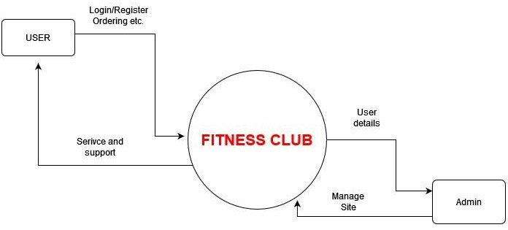

**Level 1**

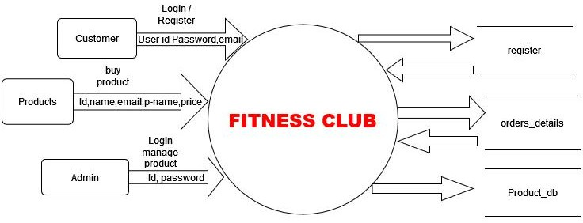

**4.3] Use Case Diagram**

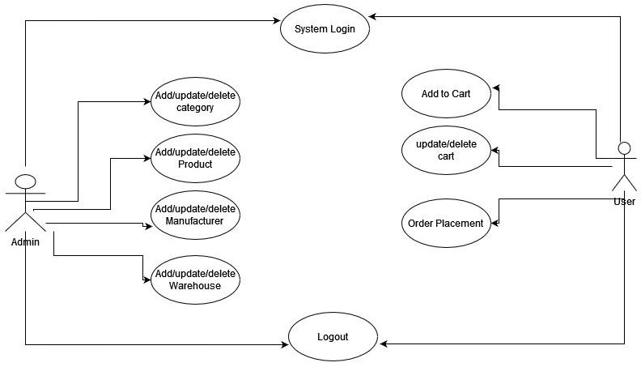

**4.4] ER Diagram**

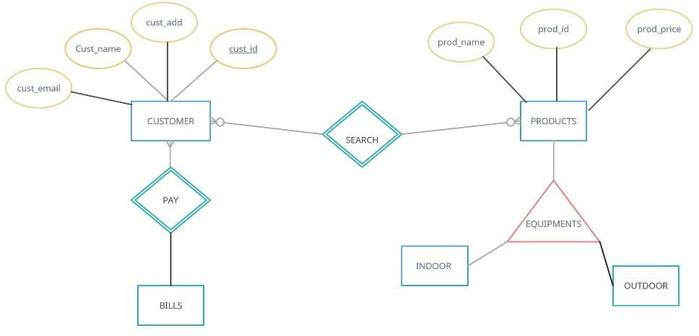

**4.5] Form Layout**

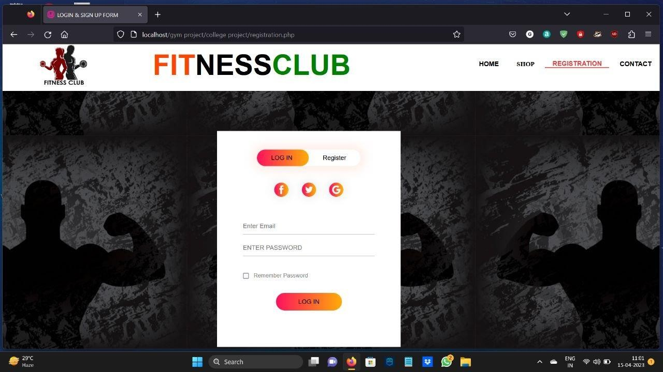

**4.6] Database Design/Layout**

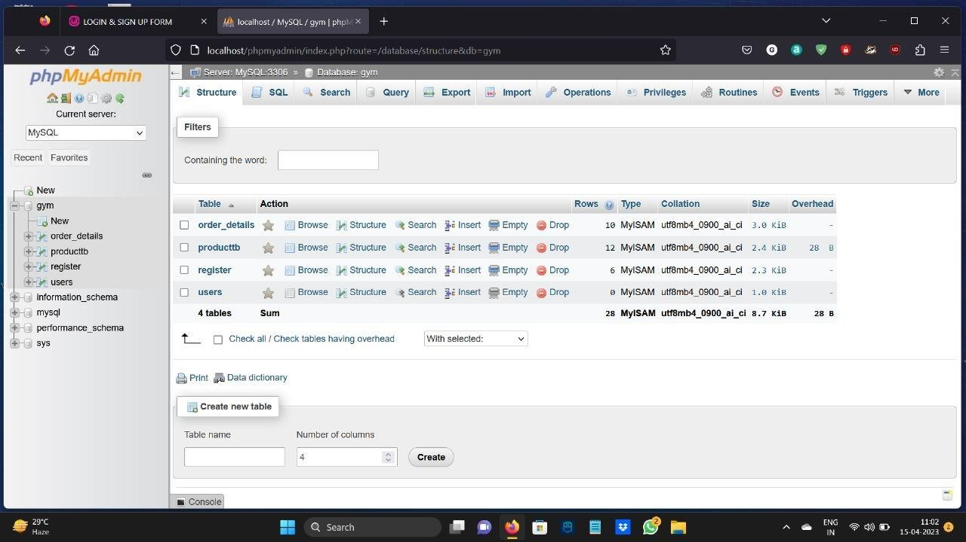

**4.7] Report Layout**

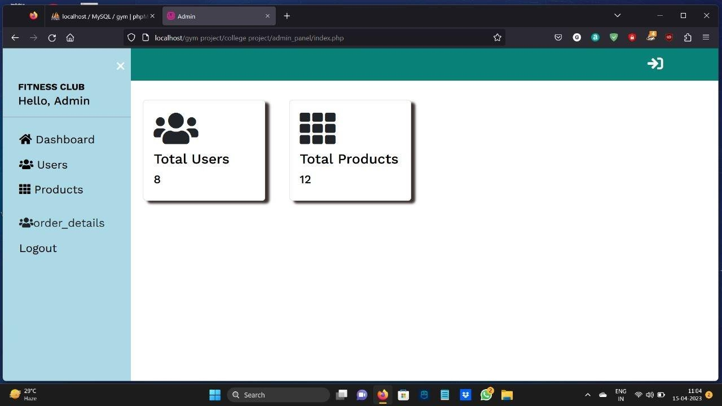

**4.8] Screenshots**

**4.8.1] Home Page**

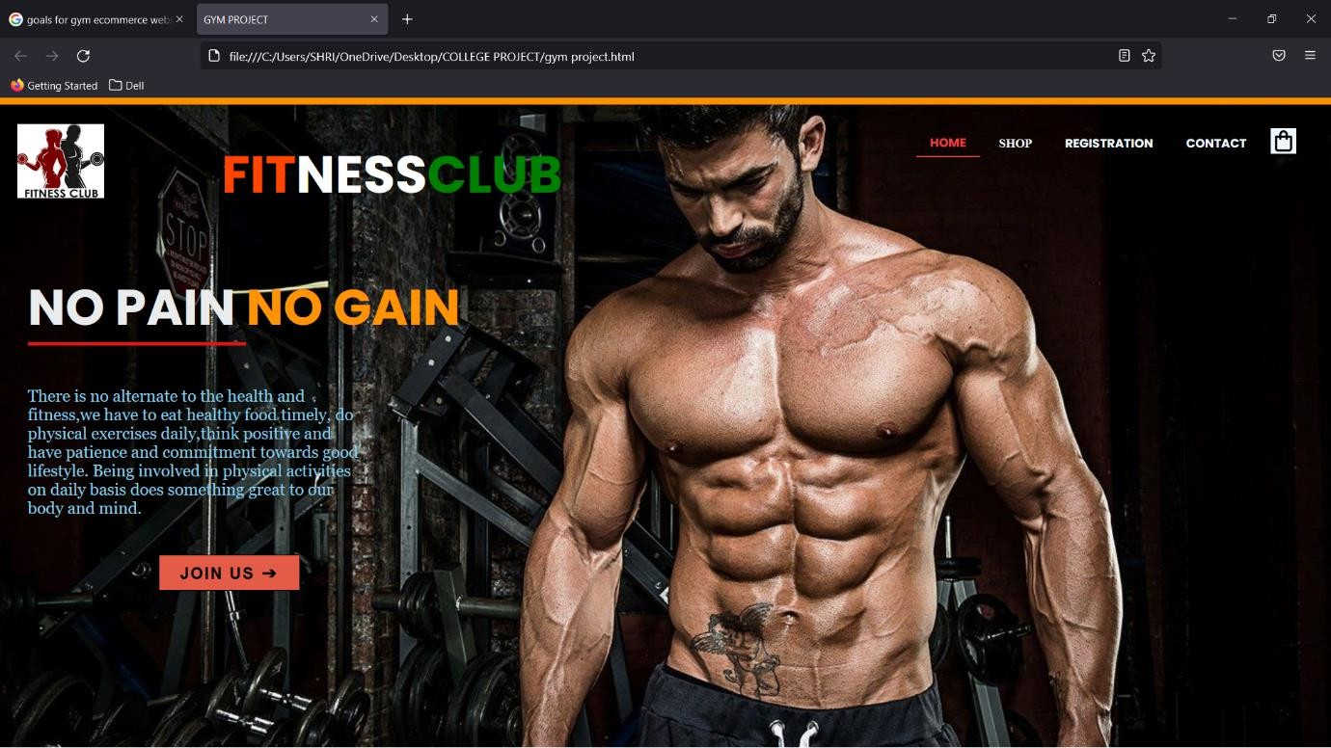

**4.8.3] Products**

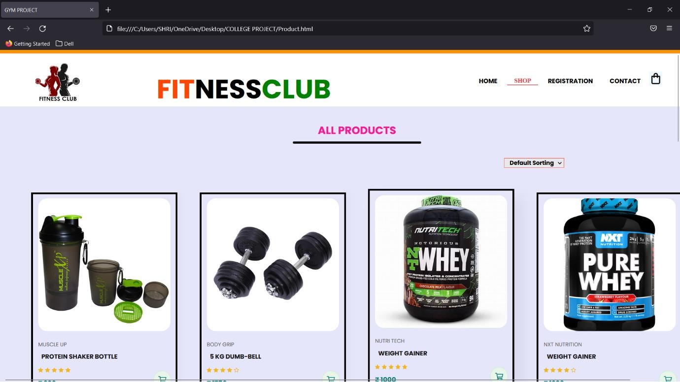

**4.8.4] Add to Cart Page**

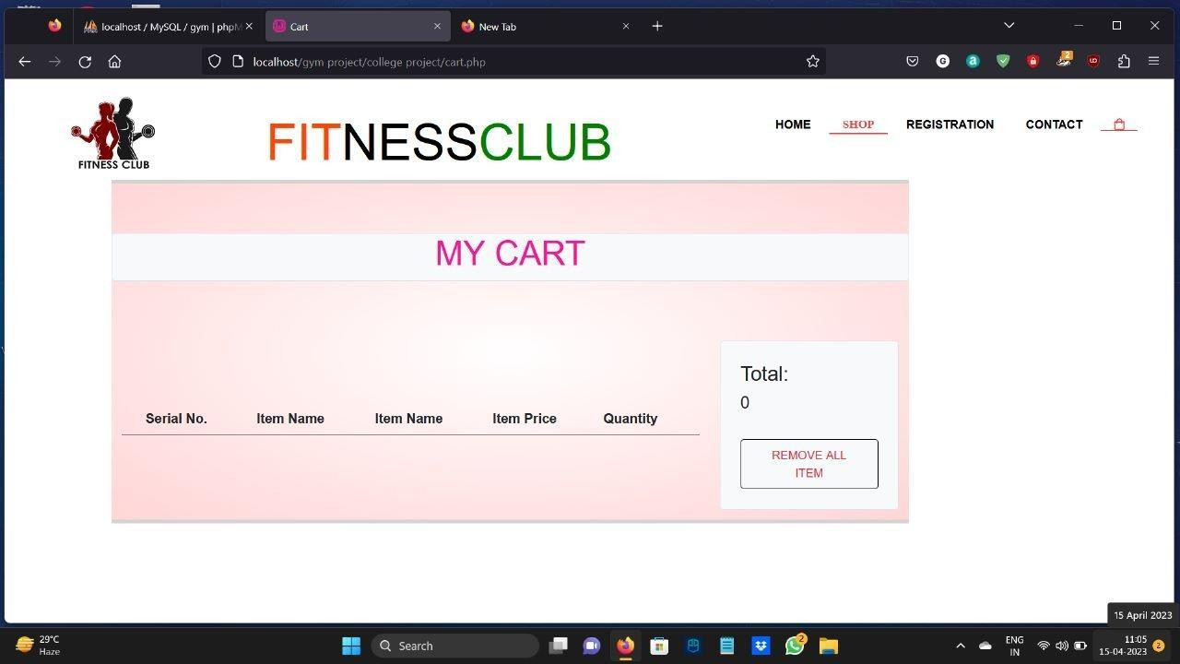

* 1. **System Testing**

System Testing is a type of software testing that is performed on a complete integrated system to evaluate the compliance of the system with the corresponding requirement. In system testing, integration testing passed components is taking as input. The goal of integration testing is to detect defect within both the integrated units and the whole system the result of the system testing is the observed behaviour of a component or a system when it is tested.

System testing is carried out on the whole system in a context of either system requirements specification or functional requirements specification r in the context of both. System testing tests the design and behaviour of the system and also expectation to the customer. it is performed to test the system beyond the bounds mentioned in the software requirement specification (SRS).

Objective: -

Program testing can be used to show the presence of bugs but never show their absence there is always a usage that can lead to incorrect behaviour.

Testing Step: -

We started testing each individual new equipotent and worked out as unit test, integration new component and worked off as unit, high order test customer acceptance testing and different testing techniques are used at different time in the process

1. **Future Scope**

The project has a wide scope as it is not intended to particular organization. This project is going to develop generic software, which can be applied by any business organization. Moreover, it provides facility to its users. Also, the software is going to provide a huge amount of summary data.

The current system is powerful and it consists of all types of information required for Booking. I have tried to make almost all the report computerized. I have generated the computerized report for the entire bill.

So, this system is more powerful than the existing system. The current system is user friendly. So, it’s easy to operate. Therefore, the current system is capable for handling all needs of billing facilities of the booking in which it will be run. It has more advantages over existing system.

1. Limitations
2. You need Internet access.

If you run tours and activities in remote areas where you aren’t able to get Internet, online booking might not for you. You’ll need reliable Internet access to check your booking and to add booking that is made online.

1. You need to be ready for an influx of new customer.

Online booking software is a great way to attract new customer, many of whom prefer booking online for their computers or mobile devices. However, if you are running a small operation without enough staff member or resource to expand your activities, growing too quickly may pose a challenge.

1. Human Resource Limitations.

Depending on the size of our coffee shop and the volume of online order and bookings it may be difficult to manage and fulfill all orders we handle customer inquiries and complaints.

1. Market Limitations.

As the coffee industry is highly competitive, your FITNESS CLUB may face challenges in attracting and retaining customers. It may be challenging to differentiate your brand from others, and you may need to invest in marketing and advertising efforts to raise awareness and generate interest.

1. Technical Limitations.

Depending on the level of technology expertise of your target audience, some users may encounter difficulties navigating your website, accessing online ordering and booking system, or using certain features.

1. Conclusion

FITNESS CLUB system is an application where the customer can book a table or order a coffee and 24/7 hours a day from any place in the world. Customers can also interact with the table booking website to know any other detail they want. FITNESS CLUB system has been developed successfully. System performance is also found to be satisfactory. This is user friendly application. Through this application, the cost can be reduced and efficiency is increased. There are server procedures that can be selected by customer. With the help of this application customer can order the coffee online and book the table online.

At the time of table booking or order a product customer can pay after the receiving the products. FITNESS CLUB system target internal and external audience online coffee system is very big to maintain but it always provides excellent facilities to accomplish the goal and help to reduce the complex paper work process to a mobile application. This can be benefit using FITNESS CLUB system application rather searching on several websites. Which the help of FITNESS CLUB system record is maintained and database is updated either time to time. Through FITNESS CLUB system, technologies and features have been introduced.