Suryadatta Education Foundation's
Suryadatta Group of Institutes, Pune
Suryadatta Institute of Business Management & Technology
MCA-SEM-II
Subject:- IT-23-Advanced Internet Technologies LAB
Note: Following practical questions are based on unit no: 1. Submit the handwritten assignment solutions (on practical pages) personally to college . Late submissions are not allowed. Submit the Journal copy of your practical assignment solutions in a proper format and upload the output in the shared google classroom.
Practical Assignment on unit no 1
Programs:-
- Home page Development static pages (using Only HTML 5) of an online Book store. The website should consist the following pages.
- Registration and user Login
- Books catalog
- Shopping Cart

Sample output:-
Source Code for Registration and user Login
Or 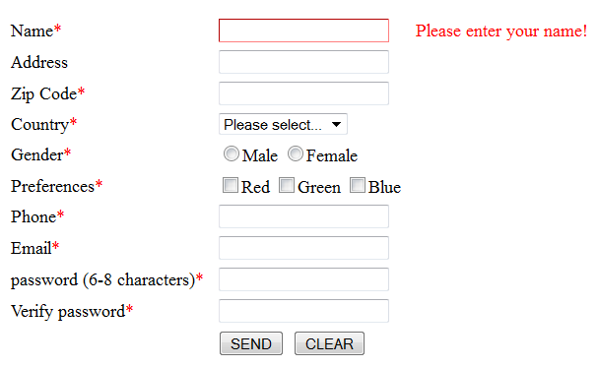

Login Page
➢ Books catalog

Shopping Cart

- Design a website for a College. There should be at least 5 web-pages present in the web-site. There should be: One Home page that leads to other pages. The Home page should contain the
  - name of the college as heading along with the college logo.
  - There should be a tab with the following links: Home;• Academics;• Admission;• Gallery.•
  - There should be an appropriate description of the college on the home page.
  - One Academics page which contains a list of all the departments present in the college “• Arts, Science and Commerce.
  - The list should be a nested list, with available courses mentioned under each department. There should be a minimum of two courses under each department, (for e.g. Computer Science and Mathematics under Science, English and Sociology under Arts and so on). Each Course entry in the list should be a HTML link that leads to a web-page totally dedicated to the course itself. Each Course should have its own dedicated web-page. This page should contain a description about the course, a list of all the teachers taking the course and the timetable for that particular subject.
  - The Admission page basically contains a form that a student needs to fill up in order to take admission in the college. The form should ask all the necessary questions using appropriate form elements. One gallery page that contains set of photos taken of the college and its students.
  - Please note that each web-page in this website should have the Different background Image/color. The looks of each page should be similar theme.

- Create a webpage names Audio.html to set an audio file in web page using html 5 elements. The audio file must play as soon as the webpage is loaded in browser and it will start over again when it is completed
- Write a program to create a webpage which provide multiple source file format for the same video file that plays automatically with controls, the dimension of the video area would be 400*300 pixels. The browser should display the message with an appropriate attribute when video file is not supported by browser.
- Implement transformation using translation ,rotation, scaling in your webpage
- Write a program to display following canvas.
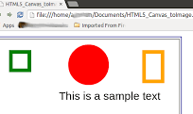





- Write a program to display following SVG.
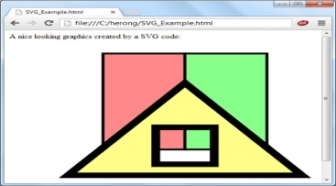
  - 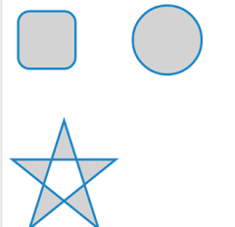

- Design this layout with given semantics
