**Homework Guideline (Topic 8)**

1. 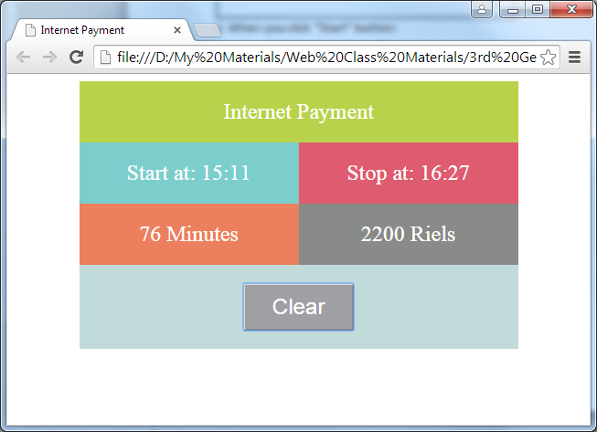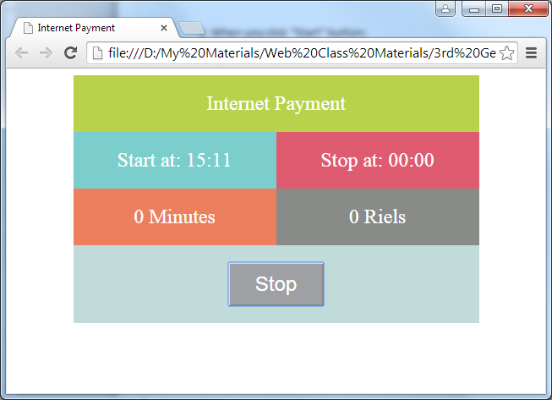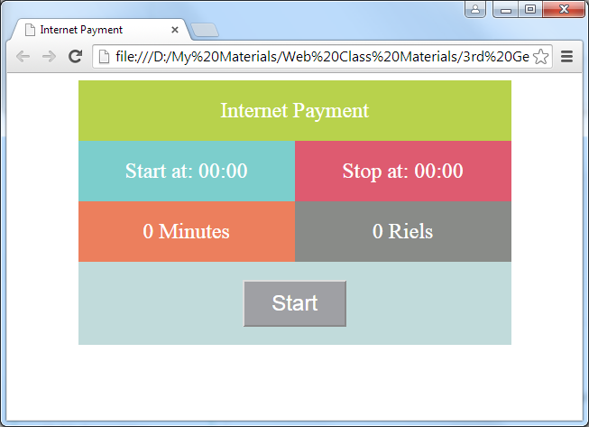**Screenshot**
2. **Objective**

* Understanding about how to use javascript
* How to use control flow statement
* How to use external javascript file for a better arrangement.

1. **Deadline**

* Start date: 06/May/2016
* Collecting Date: 11/May/2016 (Tuesday)

1. **Instruction**
2. Design your own form.
3. When you click “Start” button:

- Get start time from PC

- “Start” button changes to “Stop”

1. When you click on “Stop” button:

- Calculate the duration between start time and stop time.

- Calculate the cost of their payment by following the rule.

- “Stop” button changes to “Clear” button.

* Rules:

- 1 minutes -> 15 minutes: 500R

- 16 minutes -> 30 minutes: 700R

- 31 minutes -> 60 minutes: 1500R

* Example:

- 2h 10mn = 60mn + 60mn + 10mn = 1500R + 1500R + 500R = 3500R

- 2h 16mn = 60mn + 60mn + 16mn = 1500R + 1500R + 700R = 3700R

- 2h 46mn = 60mn + 60mn + 46mn = 1500R + 1500R + 1500R = 4500R

1. **Marking Criteria**

* Correctness: 80%
* Code Arrangement: 20%