**Homework Guideline (Topic 8)**

1. **Screenshot**

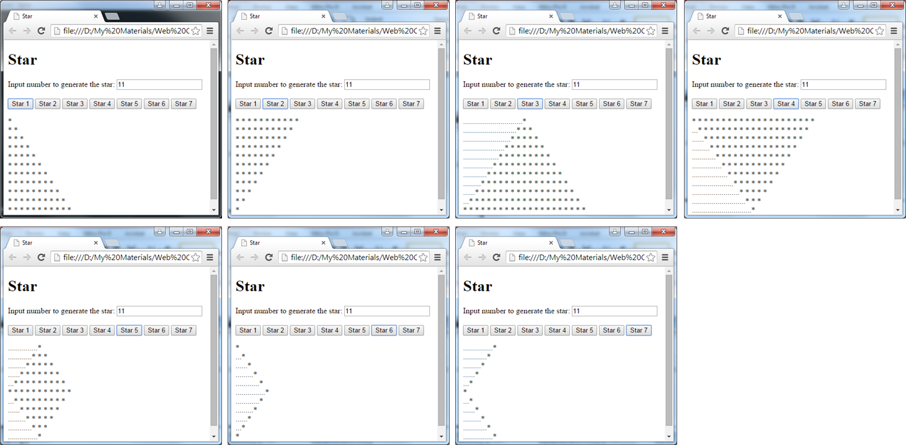

1. **Objective**

* Understanding about how to use javascript
* How to use control flow statement
* How to use external javascript file for a better arrangement.

1. **Deadline**

* Start date: 07/May/2016
* Collecting Date: 11/May/2016 (Tuesday)

1. **Instruction**

* Using “Control Flow statement” to make result like in the image.
* You can make any 4 of the image plus the “star 5” one. So you have to make 5 results.
* Clues:
  + “…” = “* ”
  + In case of 5th, 6th, 7th image, if input the even number, result must plus/minus 1 (e.g. input 10: result 9 lines or 11 lines)

1. **Marking Criteria**

* Correctness: 80%
* Code Arrangement: 20%