**Topic 15 Homework Description**

1. **Screenshot**

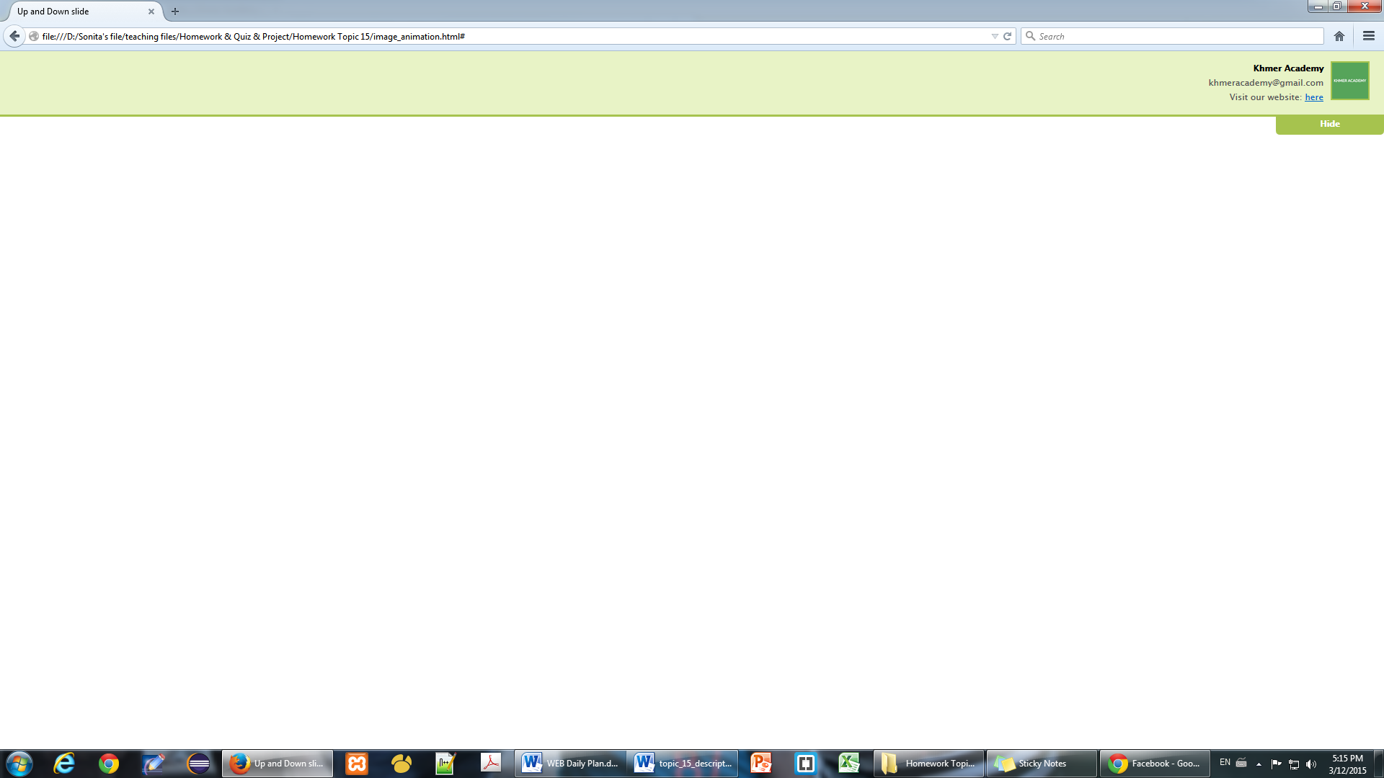

1. **Objective**

After doing this homework, student will be able to

* Can create slide menu on their website

1. **Deadline**

* Start Date: 10/June/2016
* Collecting Date: 16/June/2016

1. **Instruction**

In order to do this homework, they have to use jQuery slideToggle(), or they can use slideUp() or slideDown().

1. **Marking Criteria**

* Correctness: 80%
* Code Arrangement: 20%