**Improved Seam Carving for Video Retargeting - Sned Noodles**

**__________________________________________________________________________________________________________________ Date - 19th Nov, 2020**

**___________________________________________________________________________________________________________________**

Contents

1.Team Members and roll no.

2.Overview

2.a. About seam carving

2.b. About Graph cut

2.c. Graph cut for videos

3. Design Constructs

3.1 Narrative

3.2 Responsibility(ies) of each major file

4. Final Output

4.1 input

4.2 output

5. Installation

5.1 prerequisites

5.2 running

## 1.Team Members and Roll No.

|  |  |
| --- | --- |
| **Team Member Name** | **Team Member Roll No.** |
| Aakash Dantre | 2018101039 |
| Jay Sharma | 2018101033 |
| Dhurv Arya | 2018101003 |
| Varun Chhangani | 2019121011 |
| Vishal Verma | 2018101072 |

## 

## 2.Overview

### 2.a. About seam carving

Seam: monotonic and connected path of pixels going from the top of the image to the bottom, or from left to right. Satisfying the following constraints:

➢ Monotonicity: the seam must include one and only one pixel in each row (or

column for horizontal seams).

➢ Connectivity: the pixels of the seams must be connected

Seam carving is an effective technique for content aware image retargeting. Video, like images, should support content aware resizing. Instead of removing 1D seams from 2D images **we remove 2D seam manifolds from 3D space-time volumes**.

### 

### 2.b. About Graph cut

To achieve this we use **graph cuts** that are suitable for 3D volumes.

We formulate the seam carving operator as a minimum cost graph cut problem on images

and then extend this formulation to videos.

❖ Each pixel is considered a node and arc (edges in graph terminology) is drawn between

neighbouring nodes.

❖ Virtual terminal nodes, S (source) and T (sink) are created and connected with infinite

weight arcs to all pixels of the leftmost and rightmost columns of the image respectively.

❖ The optimal seam is defined by the minimum cut which is the cut that has the minimum

cost among all valid cuts.

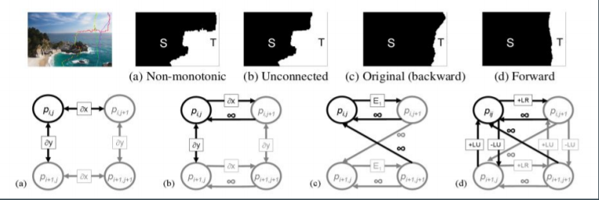

### 

### 2.c. Graph cut for videos

➔ Consider the X × T planes in the video cube and use the same graph construction as in

X × Y including backward diagonal infinity arcs for connectivity.

➔ A partitioning of the 3D video volume to source and sink using graph cut will define a

manifold inside the 3D domain

➔ The graph cut algorithm runs in polynomial time, but in practice was observed to have

linear running time on average [Boykov and Kolmogorov 2004].

➔ The graph cut approach to seam carving allows us to extend the benefits of

content-aware resizing to video.

## 3. Design Constructs

### 3.1 Narrative

Here, we examine the classes and files used.

**Narrative**

Remove_seam.py is first run, which opens the video file and array it such that it comes in 3d volume. It further store that in array.txt file and runs a bat file(flow.bat) or bash file(bash flow.sh) on the basis of your OS. These files drive the rest of code. Preproc.cpp is executed which calculates graph edge based energy functions and stores it. The output of it is used by graphcut.exe which is compiled using main.cpp, graph.h, block.h, graph.cpp, maxflow.cpp. All the major seam calculations happens in here, as it gives seamout.txt as the final output. Get_seamtry.py uses seamout.txt and remove all the seams from our 3d volume of video and stores it back in array.txt. Visual_compare.py coverts array.txt to video format.

### 3.Responsibility(ies) of each major file

**Responsibility(ies) of each major file**

|  |  |
| --- | --- |
| **Classes** | **Description** |
| **remove_seam.py** | * Driver, first file to be run * Coverts video, resize it according to **config.py** * Calls **flow.bat or bash_flow.sh** * Remove **NUM_SEAMS** number of seams from video. |
| **flow.bat or bash flow.sh** | * Drives the rest of code * Removes one seam from video * Compiles preproc.cpp to create **preproc.exe** * Compilesmain.cpp, graph.h, block.h, graph.cpp, maxflow.cpp and create executable **graphcut.exe**. |
| **preproc.cpp** | * Uses **energy function** * Creates edge based graph * Output of this file is passed on to graphcut.exe |
| **block.h** | * Template classes Block and DBlock * Implement adding and deleting items of the same type in blocks. * If there there are many items then using Block or DBlock is more efficient than using 'new' and 'delete' both in terms of memory and time |
| **graph.h** | * Helper function for graph.cpp to compute graph cuts |
| **graph.cpp** | * it is mentioned DP isn't enough and graph cuts are needed for video, * Even after that, the tradition graph cut algorithms take O(E*V^3) or O(E*V^2) time depending on use of adjacency list or matrix. * The implemented graph cut algorithm runs in o(V*V) time complexity |
| **main.cpp** |  |
| **maxflow.cpp** | * Functions for processing active list. * i->next points to the next node in the list * There are two queues. Active nodes are added to the end of the second queue and read fromthe front of the first queue. If the first queueis empty, it is replaced by the second queue   (and the second queue becomes empty) |
| **get_seamtry.py** | * seam removed array is created using **seamout.txt** and stored in array.txt |
| **visualcompare.py** | * Converts **array.txt** into a comparison video of before and after videos |
| **Config.py** | * Have constant values such as resolutions, path of videos, **NUM_SEAMS** |
| **exportToVideo.py** | * export the comparison video as mp4 video file |
| **rgbVidMaker.py** | * export the final processed RGB video as mp4 file |

## 4. Final Output

### 4.1 input

### 

### 4.2 output

### 

## 5. Installation

### 5.1 prerequisites

* g++ for c++ compilation
* python3
* numpy
* opencv-python

### 5.2 running

Install code from github

* git clone <https://github.com/Digital-Image-Processing-IIITH/project-sned-noodles.git>
* cd src
* bash compile.sh (or compile.bat for windows users) (necessary for setup)
* vim config.py (edit the configuration as per demand)
* python remove_seams.py (process video and remove seams)
* python visualcompare.py (view side by side comparison of processed and original video)
* python exportToVideo.py (export the comparison video as mp4 video file)
* python rgbVidMaker.py (export the final processed RGB video as mp4 file)