

SCHOOL OF ADVANCED TECHNOLOGY

ICT - Applications & Programming

Computer Engineering Technology – Computing Science

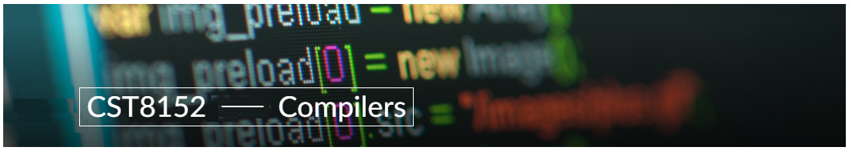

A21
Model Definitions (RE/Automaton)

Lab Professor / Lab Session:
[Prof. Paulo Sousa / 012]

Team:
[Chhatbar, Deep U.] - Id: [041085829] / [Saurav Bhasin] - Id: [041079920]

Language Name [REN]

This template is suggested (not mandatory) to answer A11 Specification.

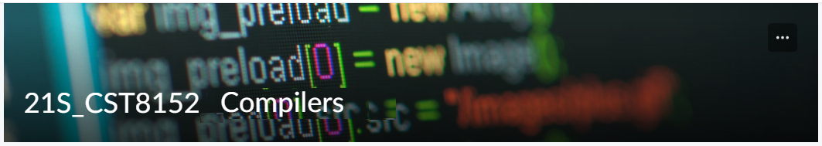

MODEL TASK FOR ASSIGNMENT 2.1 – REN

- Note: This task is part of the Assignment 2 from Compilers Course. Any problem, contact your lab professor.

Task 1: Language Symbols (2.0 marks)

List examples: Define main symbols to be used:
- Special symbols (ex: “{“, “(“, “<=”, etc.)
- Comments
- Variables
- Functions
- Literals (numbers, strings)
- Keywords
- Datatypes

Answer:
Keywords – [def, if, else, while, return, try, except, do, for, false, print]
Data Types – [int, float, str]
Special Symbols – [#, \n, :, (,), ‘, “, <, >, ==, !=, ….]
Variables – [EX: data, val, name, …]
Function – [EX: fact(data), input(….), int(….),…..]
LITERALS – [Numerical – 1, 1.1, 3.14591551, ……., ‘input data’, “hello”]

Task 2: RE – Regular Expression (3.0 mark)

Lexeme Classes: Define the classes to be used in your regular expression:

Answer:s
C – [#]- Comments in Python
N – [\n] – New Line
L – [A-Z | a-z] – Letters
D – [0-9] – Digits
P – [ . ] – Period
U – [ _ ] – Underscore
M – [ ( ] – Method Identifier
Q – [ ‘ ] – Quotes (Start and end)
O – [^ CNLDPQUM] – Other Class

RE(Keywords): L+
RE(Variables): L(L|D|U)*
RE(Integers): D(D)*
RE(Floats): D+PD* | D+PD+
RE(Strings): Q(^Q)*Q
RE(Comments): C(^N)*N
RE(Method Identifier): U|L(L|D|U)*M
Define the RE to be used for: variables, literals and keywords:

Task 3: TD – Transition Diagram (3.0 marks)

Activity: Starting from the previous lexeme classes and obeying the RE, it is possible to define the automata for your language:

Answer (draw / copy image of the automata):

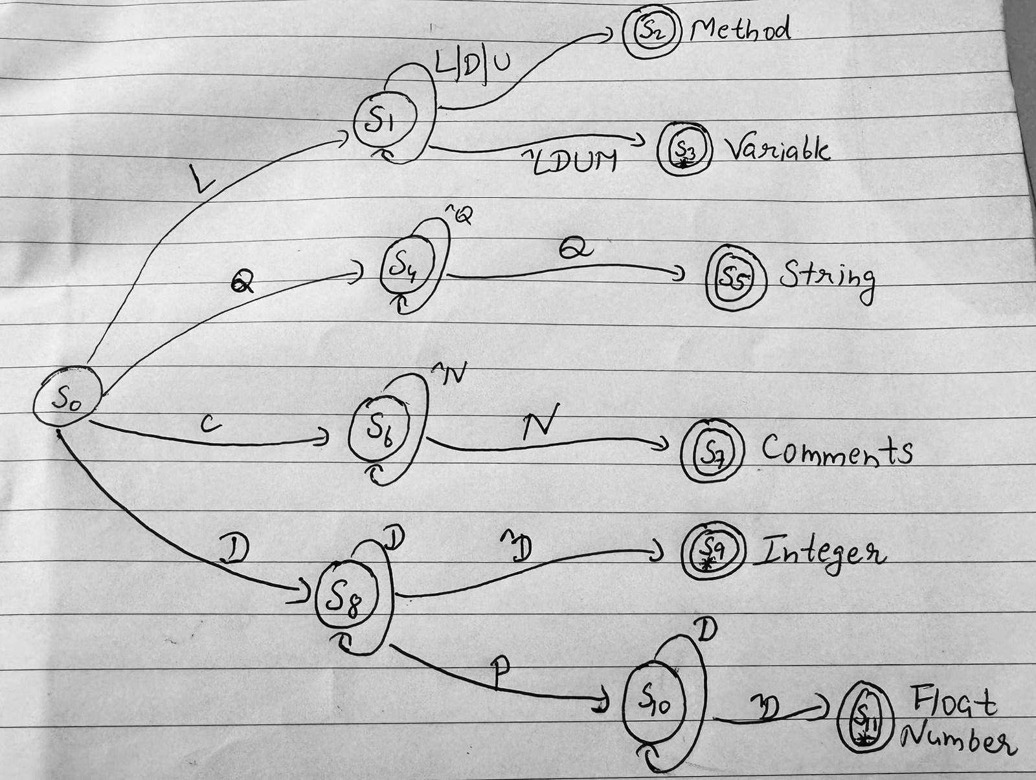

Task 4: TT – Transition Table (2.0 marks)

Activity: Now, it is possible to define the TT for these lexemes:

Answer (Transition Table):

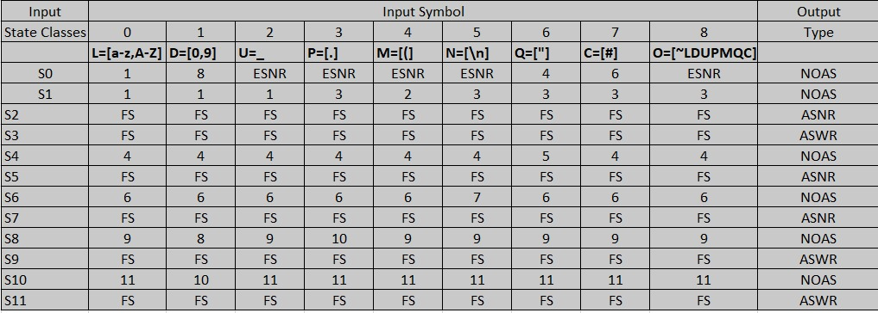

Update: Feb 4th 2024.

Adapted from resources developed by Prof. Svillen Ranev (Algonquin College, 2019)

