How to extract gene counts data from FASTQ raw sequencing files generated from 10x chromium single-cell RNA-seq experiment

Verification Step

This pipeline works if the FASTQ files were extracted from the 10x chromium single-cell RNA-seq experiment. Else we need to create FASTQ files from the raw BCL files from the sequencing facility and the csv file of the corresponding sample (s) sequencing by using the cellranger mkfastq.

Command: cellranger mkfastq –id=<output_folder> --run=<BCL_file_path> --csv=<sample_csv_file>

Step-1:
> First create a specific folder in your working directory for this specific work, and go inside that folder as shown in the following picture.

> For example,
Command: mkdir FASTQ_To_Count_Data

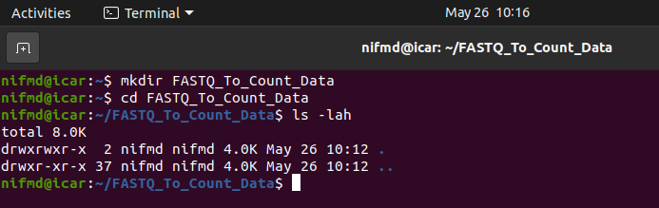

> Now our working directory was created successfully and we’re inside our working directory.

Step-2:
> Download and install the sratoolkit from its official git-hub page.

Command:
wget https://ftp-trace.ncbi.nlm.nih.gov/sra/sdk/3.2.1/sratoolkit.3.2.1-ubuntu64.tar.gz

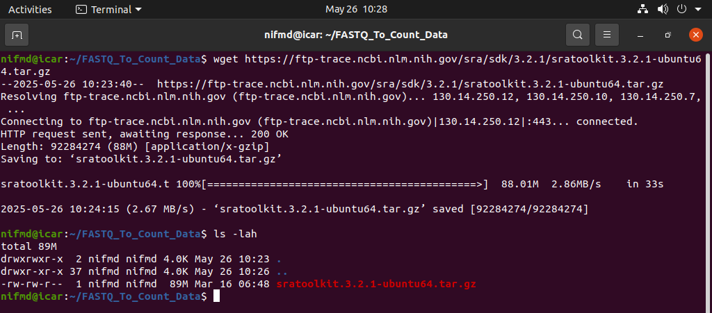
> Now extract the tar file.
Command: tar -xvzf sratoolkit.3.2.1-ubuntu64.tar.gz

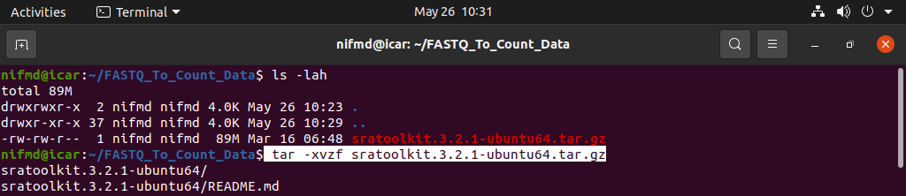
> After extracting this tar file you’ll get a sratookkit-<version>-ubuntu64 folder.

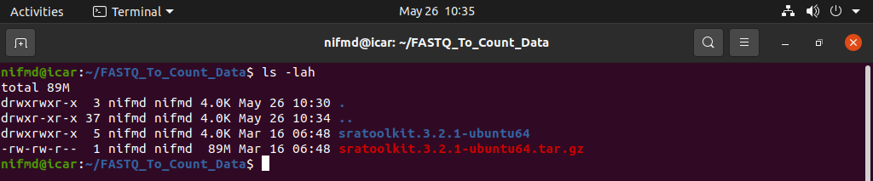
> Inside that sratoolkit folder a bin folder is present and we need to export that folder path to our global environment.

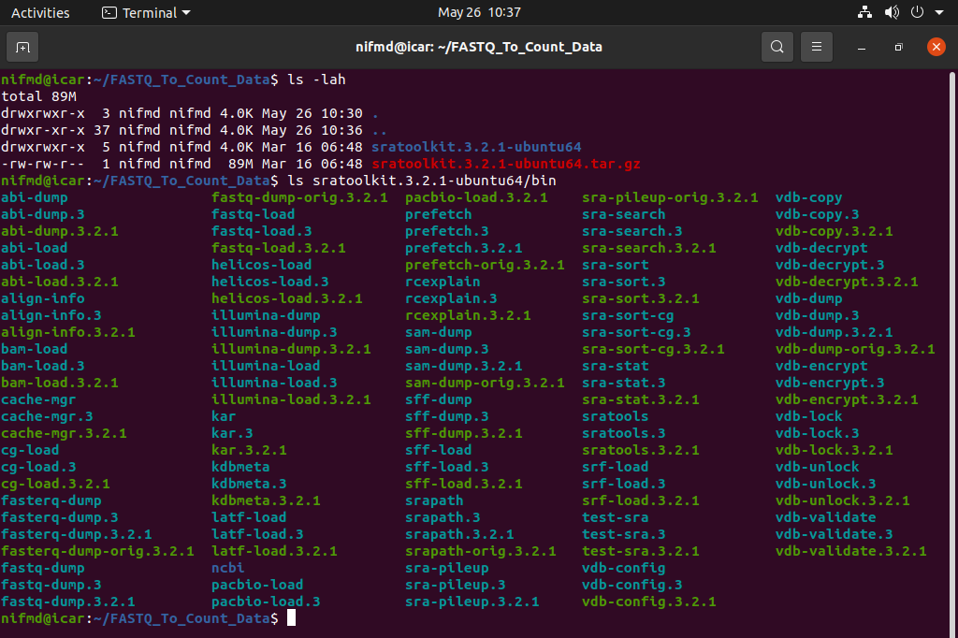

Command: export PATH=$PATH:$PWD/sratoolkit.3.2.1-ubuntu64/bin

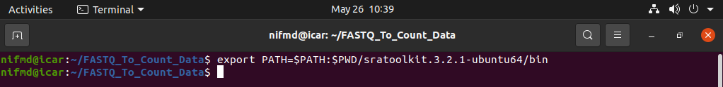
Step-3:
> Now its time for downloading our raw file data which is in *.sra format.
> For this you need to have a valid ERR, or SRR, or DRR ID for that particular data.
> Now configure the file output.

Command: vdb-config -i

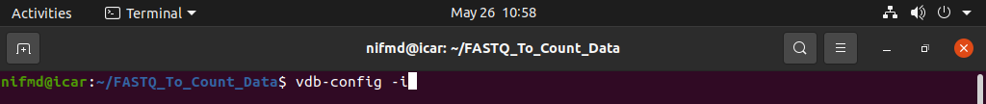
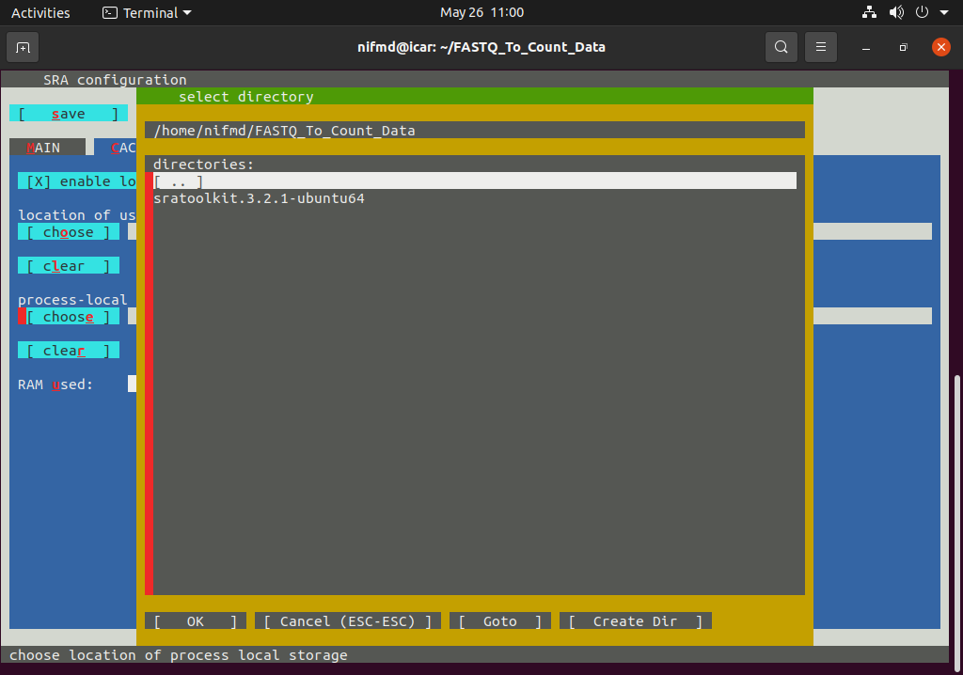
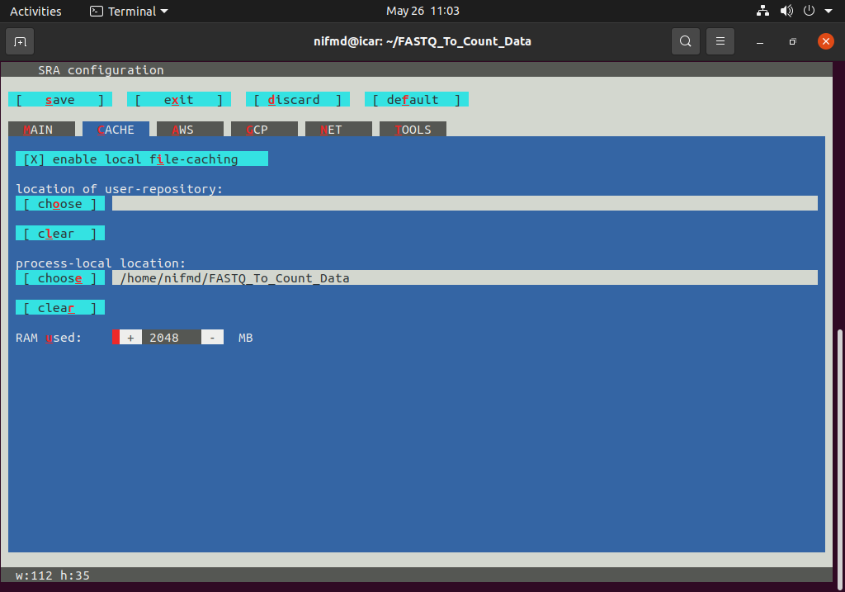
> Now save the configuration and exit this setting.

Step-4
Downloading the data as *.sra format.
> ID can be SRR_ID, or ERR_ID, or DRR_ID.

Command: prefetch <Valid_ID>

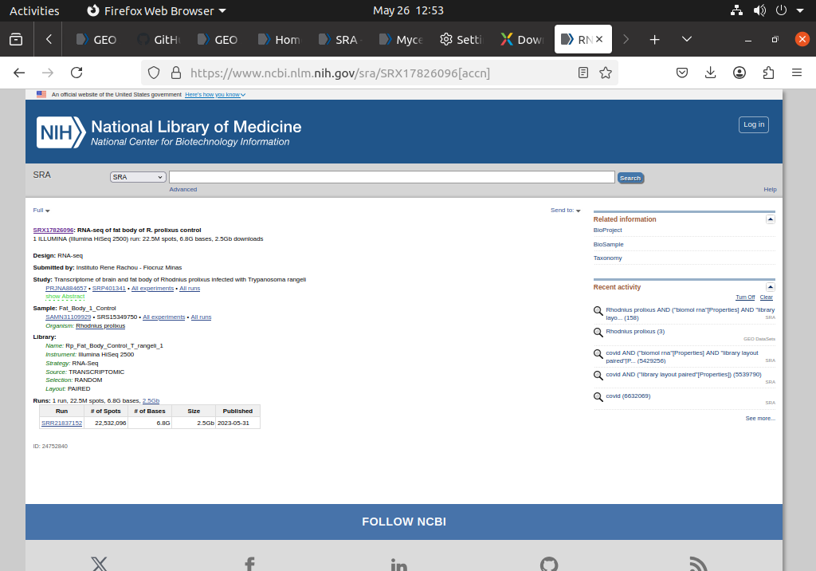
> Now retrieve the data using the prefetch command.

Command: prefetch <SRR_ID>

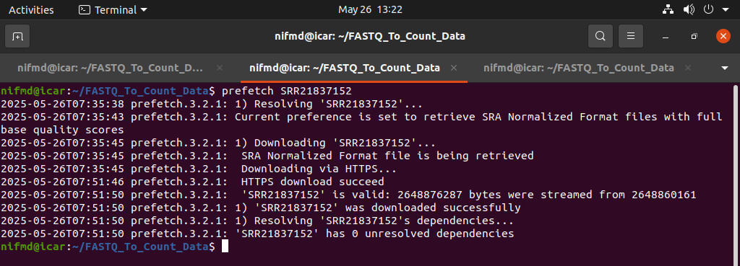

> Now create a specific folder to store the fastq files for both forward and backward read sequences.
> Use the following command to extract the files into the folder created.
> First go inside the folder created (here Fastq_Files).

Command: fastq-dump ../<SRR ID> --split-file --gzip

> Go to the previous working directory.

Step-5
> Now download the reference genome sequence for that particular organism from the NCBI Genome database and also download the annotated *.gtf file.

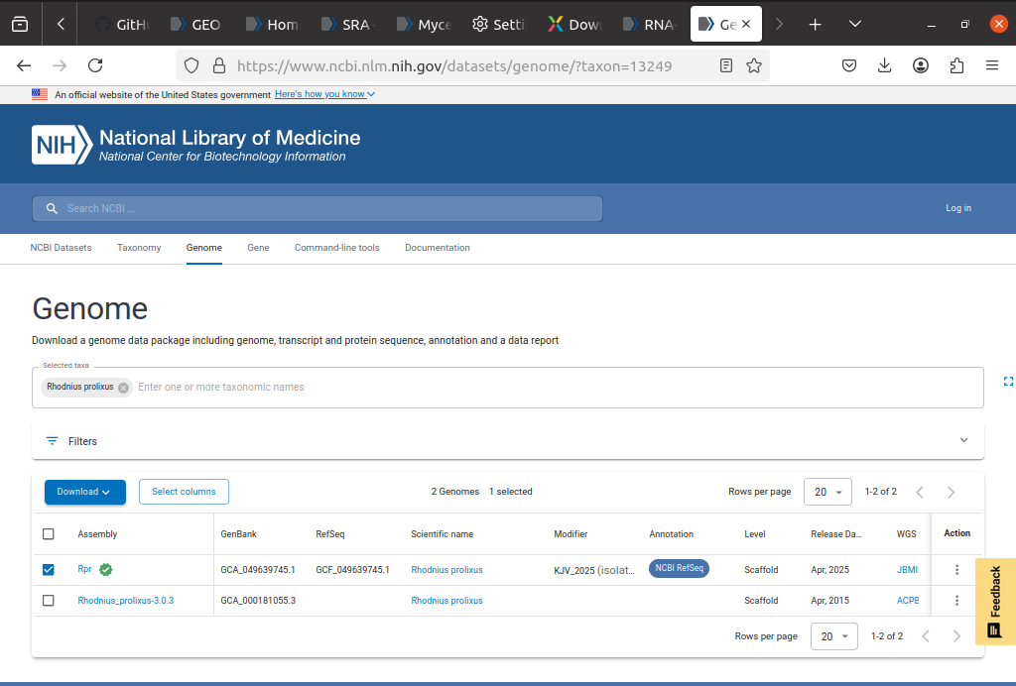
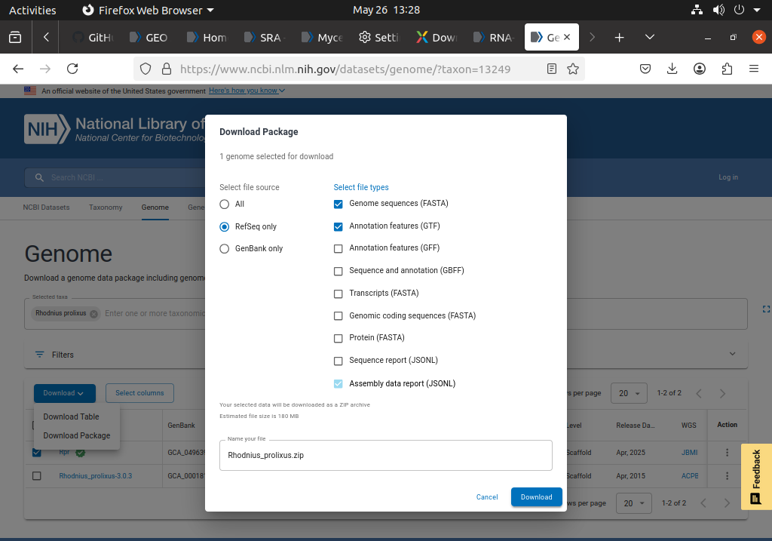

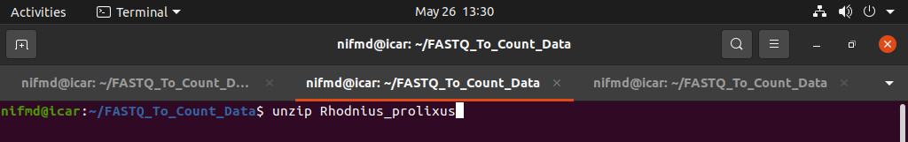

> Copy those two files in the following manner.

First copy the fasta file as

Command: cp <*.fna> ../../../<*.fa>

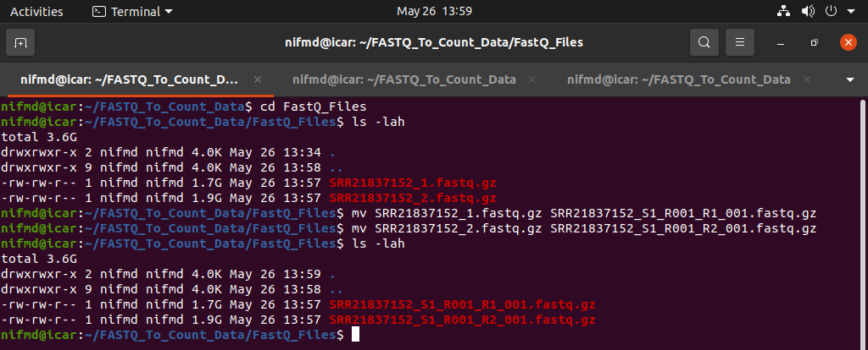

> Now copy the *.gtf file but only the functional parts, i.e., only the genes.

Step-6

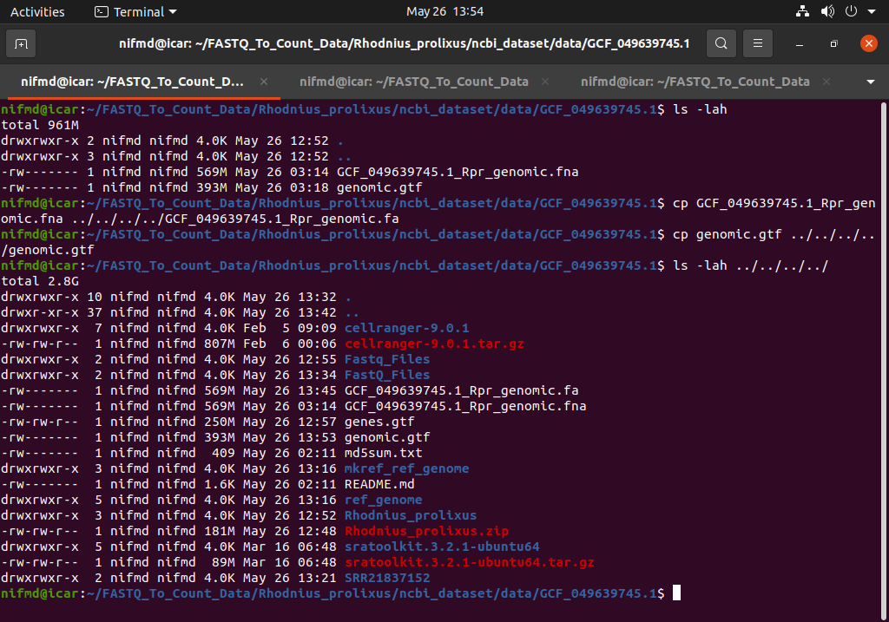

> Now it’s time for downloading the cellranger for generating the counts data.

Command: wget -O cellranger-9.0.1.tar.gz "https://cf.10xgenomics.com/releases/cell-exp/cellranger-9.0.1.tar.gz?Expires=1748283800&Key-Pair-Id=APKAI7S6A5RYOXBWRPDA&Signature=JJpsyHTR8ni0oBNbCUxJlN1-pgdnAhd9ZHA0~FJzQU5jO76kBXI6HwE5BkmLS9GV0Nek8QSY1nW1jJh6wUWdHS7CSMBrb8FJN0388icrazjgmRvn5F6jlCgwHAoBaxayQMJ2B-bRv0S0i4Ht-XdTAHcolHS7Jgu6aSTFtrh3GX85317eLLCfLvrWAR-z8gRluBul5on~SHFAh~Z4ICZ-hXTxjJCM4ZUj8lqjiV1SL9P58s6gODYXSs2PWdiXajg010J09IzGaRyVdShLFGekt4DBBlarqgvbXq8LUWh3m7WDAe7p41MWpca3uR0dwudrwvorZzsyBIL~zbDUwrthEQ__"
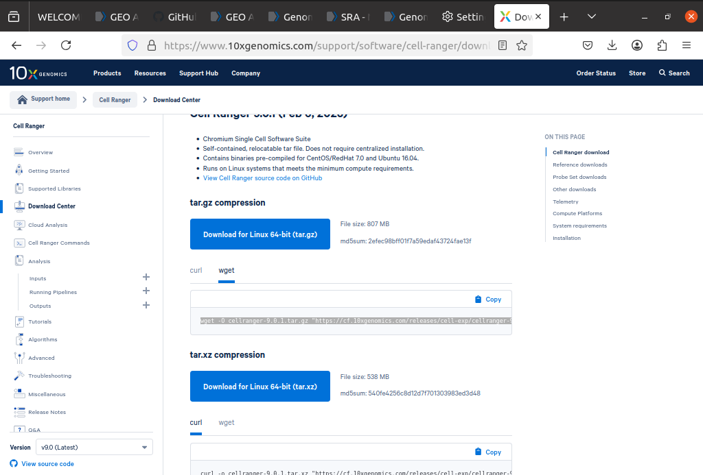
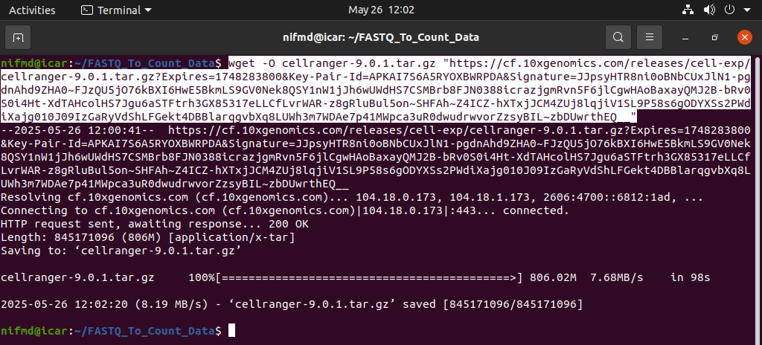
> Untar it.

Command: tar -xvzf cellranger-9.0.1.tar.gz

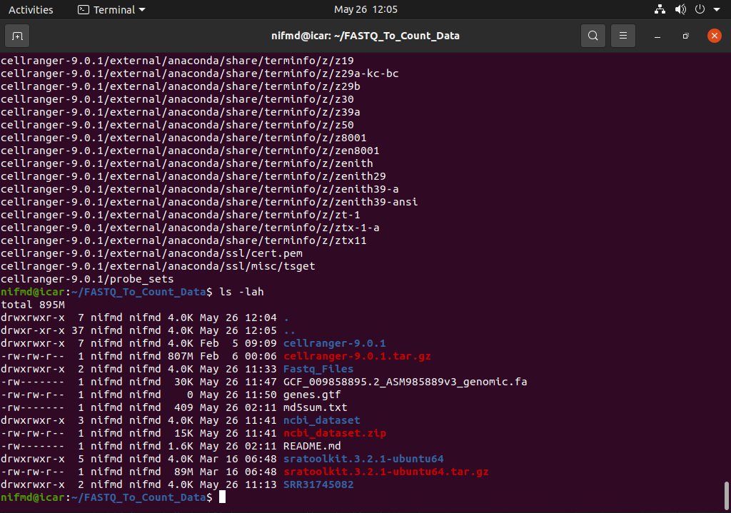
> Siumilarly here inside the cellranger-<version> folder a bin folder is present and we need to set this bin folder path to our global path.

Command: export PATH=$PATH:$PWD/cellranger-9.0.1/bin

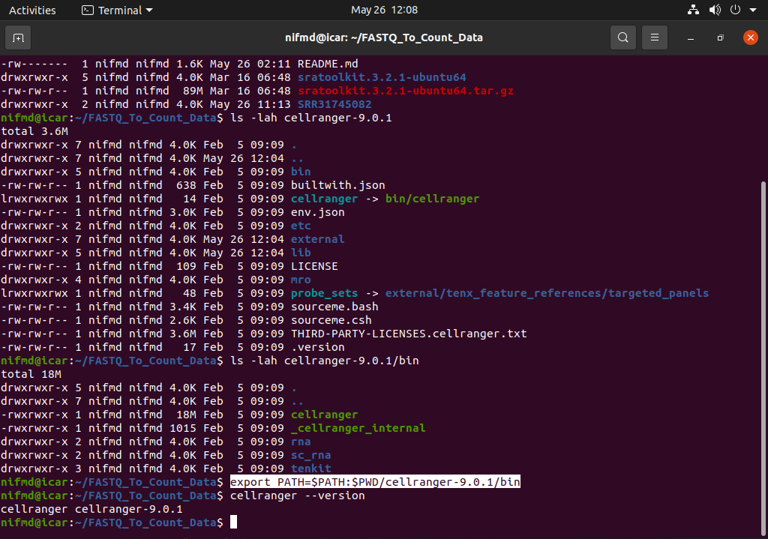
> Now we need to build a reference genomic sequence by using the genes.gtf and cellranger mkref command.

Command: cellranger mkref –genome=<ref_genome (output_folder_for_custom_genome_reference)> –fasta=<*.fa> --genes=<*.gtf>

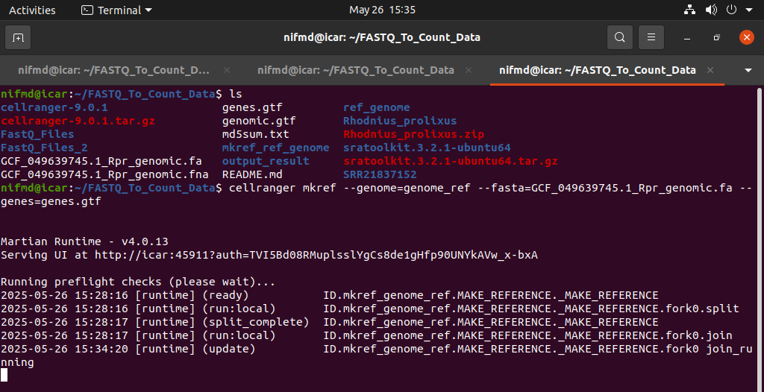

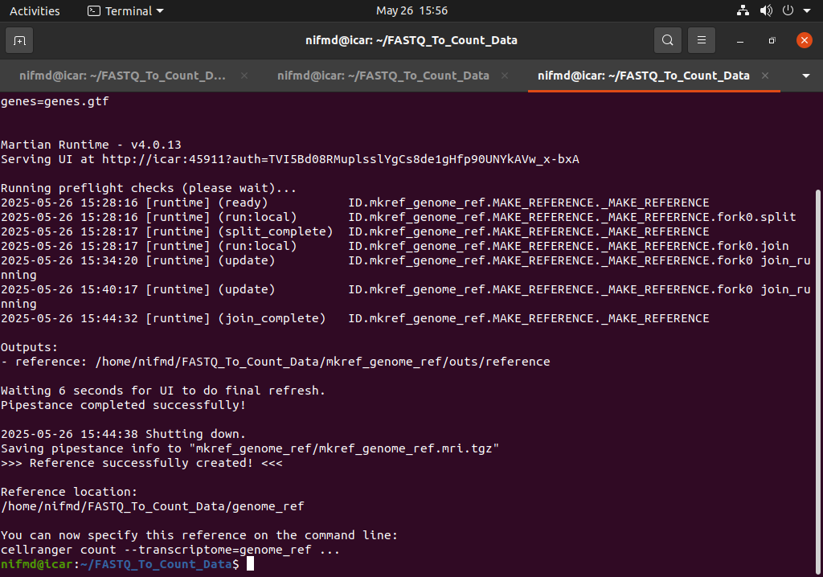

> Rename the FASTQ files as

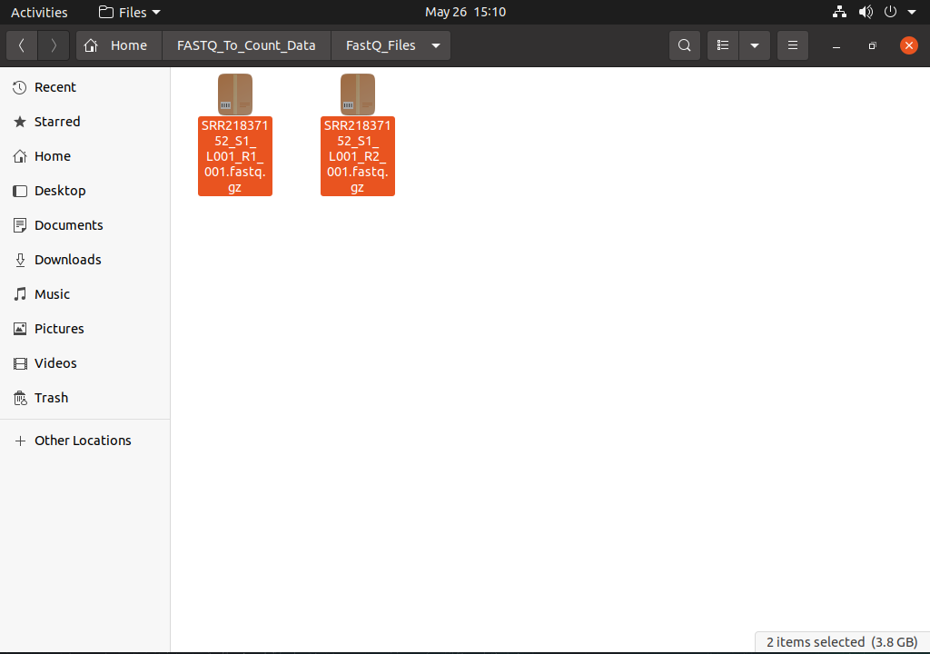
Step-6:
> Now finally run the cellranger count command to obtain the output result.

Command: cellranger count --id=<output_result_folder> --transcriptome=<ref_genome_generated_by_mkref> --fastqs=<FastQ_Files _folder_path> --sample=<Prefix (e.g, SRR21837152)> --create-bam=true

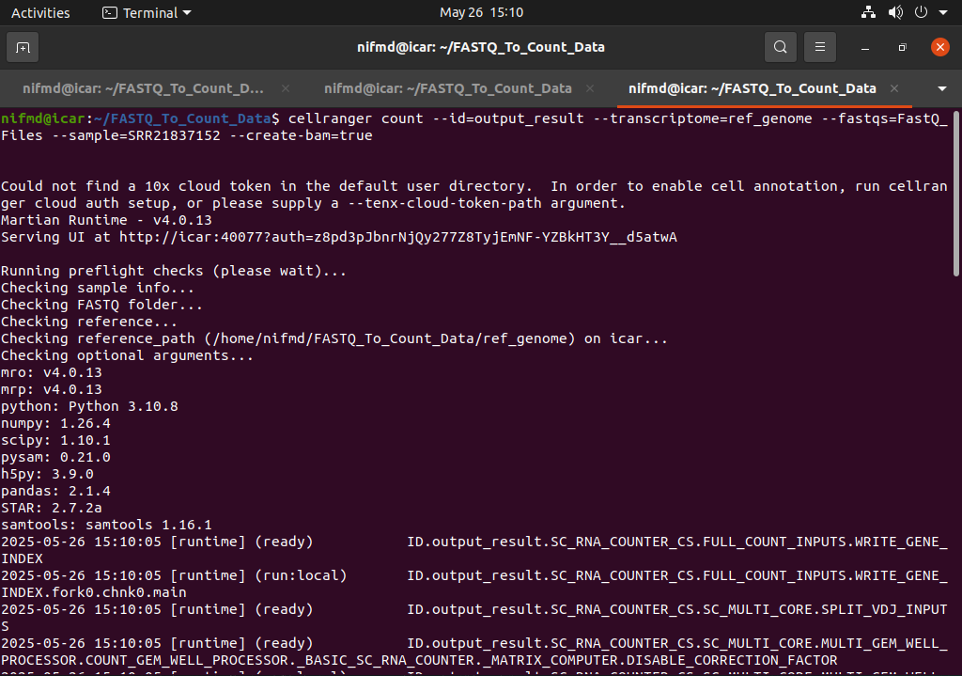
> Now the job is ready.

> Our result matrix will be present in /FASTQ_To_Count_Data/output_results/outs/filtered_feature_bc_matrix folder.

