A Project Report On

**Online Busbooking System**

The Report Submited To

**SAURASHTRA UNIVERSITY**



**Submitted In Partial Fullfillment Of The Requirement For The Award Of The Degree**

Academic Year 2025 - 26

**BACHELOR OF COMPUTER APPLICATION**

**[ SEMESTER – 5th ]**

**Prepared By :-**

[ Vikram Dabhi ]

[ Ravi Chhatrodiya ]

**Int.Project Guidance:- Profe.[ Sanjay Tilavat ]**

**FROM:-**

**23073 – N.P VEKARIA EDU.&DH.TRUST SANCH.GRACE COLL.OF**

**COMM.,RAJKOT**

**DECLARATION**

I, [Your Name], a student of [Your College/University Name], hereby declare that the project titled “Online Bus Booking System” is an original work done by me as a part of my [Course Name] curriculum under the guidance of [Guide/Professor Name].

I confirm that this project has not been submitted to any other institution or university for the award of any degree, diploma, or certification. The data and information presented in this project are true to the best of my knowledge and have been collected and implemented solely for academic purposes.

I have duly acknowledged all sources of information used in the project, and any resemblance to existing projects is purely coincidental.

I take full responsibility for the authenticity and originality of the work done in this project.

Name: [Your Full Name]  
Enrollment No.: [Your Enrollment Number]  
Course: [Your Course Name]  
Department: [Your Department Name]  
College/University Name: [Your College/University Name]  
Date: [Date of Submission]

Signature: _____________

**ACKNOWLEDGMENT**

I would like to express my sincere gratitude to everyone who contributed to the successful completion of this project, “Online Bus Booking System.

First and foremost, I extend my heartfelt thanks to [Guide/Professor’s Name], my project guide, for their invaluable guidance, continuous support, and constructive feedback throughout the development of this project. Their insights and encouragement have played a significant role in enhancing my learning experience.

I also wish to thank [College/University Name] and the [Department Name] for providing me with the necessary resources and a conducive learning environment.

A special note of appreciation goes to my family and friends for their unwavering support, motivation, and patience during this journey. Their encouragement kept me focused and determined.

Lastly, I am grateful to all the online resources, books, and tutorials that helped me gain the knowledge required to develop this project.

This project has been a great learning experience, and I am thankful for the opportunity to apply my skills in a practical scenario.

Name: [Your Full Name]  
Enrollment No.: [Your Enrollment Number]  
Course: [Your Course Name]  
Department: [Your Department Name]  
College/University Name: [Your College/University Name]  
Date: [Date of Submission]

**PREFACE**

The **"Online Bus Booking System"** project has been developed as a part of my academic curriculum, aiming to provide a user-friendly platform for booking bus tickets online. The increasing demand for digital solutions in transportation services inspired me to work on this project, which streamlines the process of booking bus tickets, checking seat availability, and managing reservations efficiently.

This project is designed to simplify the conventional bus ticket booking process, reducing manual efforts and enhancing user convenience. It incorporates key features such as user authentication, route management, real-time seat availability, and secure payment integration (if applicable).

Throughout the development of this project, I have explored various aspects of web development, including **HTML, CSS, JavaScript, and ASP.NET (if applicable)**. The project has helped me gain practical knowledge in backend development, database management, and UI/UX design.

I sincerely hope that this project will serve as a valuable reference for future enhancements in online ticketing systems. Any suggestions for improvement are most welcome.

**INDEX**

|  |  |  |
| --- | --- | --- |
| Sr  No | Title | Page  No. |
| 1 | Title Page | I |
| 2 | Certificate | II |
| 3 | Declaration | III |
| 4 | Acknowledgment | IV |
| 5 | Preface | V |
| 6 | Index | 1 |
| 7 | Introduction |  |
| 8 | Project Profile |  |
| 9 | Requirement |  |
| 10 | Flow Chart |  |
| 11 | Use Case Diagram |  |
| 12 | Data Flow Diagram |  |
| 13 | E-R Diagram |  |
| 14 | Data Dictionary |  |
| 15 | Screen Layout |  |
| 16 | Conclusion |  |
| 17 | Bibliography |  |

**INTRODUCTION**

In today’s fast-paced digital world, technology plays a vital role in making everyday tasks more efficient and convenient. One such area of transformation is the transportation industry, where online booking systems have replaced traditional methods of ticket reservation. The **“Online Bus Booking System”** is designed to streamline the process of booking bus tickets, reducing the hassle of manual reservations and long queues.

This project provides an easy-to-use web-based platform that allows users to search for available buses, select routes, book tickets, and make payments online. The system also includes an admin panel for managing bus schedules, routes, and ticket bookings. By implementing an automated solution, the project ensures better accessibility, security, and efficiency for both passengers and bus operators.

* **Objective of the Project**

The primary objective of this project is to develop an efficient, user-friendly, and secure bus ticket booking system that offers:

* **Easy Ticket Booking** – Users can book tickets from anywhere at any time.
* **Real-Time Seat Availability** – Provides up-to-date information on seat availability.
* **Secure User Authentication** – Ensures secure login and transactions.
* **Admin Management** – Allows administrators to manage bus routes, schedules, and bookings.
* **Payment Integration** – Supports online payments (if applicable).
* **Scope of the Project**

The system is designed to be used by:

1. **Passengers** – To book tickets, view bus schedules, and check seat availability.
2. **Bus Operators** – To manage their bus routes, schedules, and ticket sales.
3. **Administrators** – To oversee system operations, manage user data, and ensure smooth functioning.

**Project Profile**

**Requirement**

**Flow Chart**

s

**Use Case Diagram**

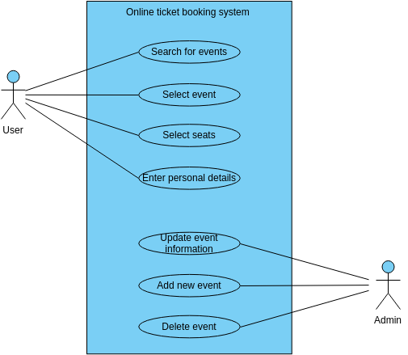

**Data Flow Diagram**

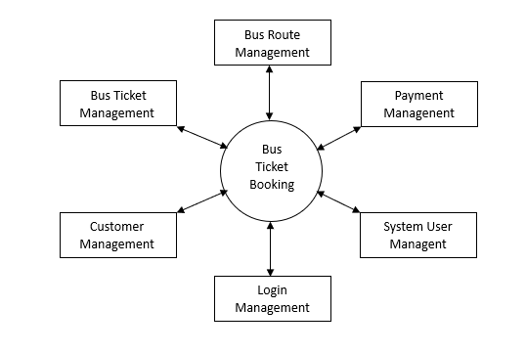

Bus Ticket Management

Generate Bus Ticket Report

Bus Shedule Management

Generate Bus Shedule Report

Booking Management

Generate Booking Report

Login Management

Generate System User Report

Check User Login detail

System User Management

Admin