EXPERIMENT 4
Multi-Node Kubernetes Cluster Orchestration, Workload Scheduling, Scaling, and Automated Self-Healing on Windows
Laboratory Study on KinD, Multi-Worker Pod Placement, and ReplicaSet Fault Recovery
Student Name | Chhavi Mishra
USN | 01fe24bci066
Roll Number / Division | Roll No: 136 | Division: A
Department / Program | Computer Science and Engineering (Artificial Intelligence)
Course & Institution | Cloud Computing Laboratory (CS401) | KLE Technological University, Hubballi

1. Aim & Objectives
Aim: To build and orchestrate a multi-node Kubernetes cluster on a Windows machine using KinD (Kubernetes IN Docker) over WSL 2, deploy a containerized NGINX web application, evaluate pod scheduling across worker nodes, scale the deployment horizontally, and validate automated self-healing fault tolerance upon pod failure.
Key Learning Outcomes:
- Configure and verify WSL 2 and Docker Desktop to host containerized Kubernetes nodes.
- Author a declarative YAML configuration (kind-config.yaml) to instantiate a 3-node cluster (1 control-plane, 2 workers).
- Verify Kubernetes control plane components, node readiness, and examine backing Docker container runtimes.
- Deploy an NGINX web server deployment and observe how kube-scheduler assigns pods across distinct worker nodes.
- Scale the workload from 3 to 6 replicas and observe dynamic load distribution across available compute nodes.
- Deliberately delete an active pod to test declarative state reconciliation and automated zero-touch self-healing by the ReplicaSet controller.

2. System & Experimental Configuration
Parameter | Configured / Observed Value
Host Operating System | Windows 11 (64-bit) Enterprise/Pro
Execution Shell | Windows PowerShell (Administrator)
Linux Subsystem | WSL 2 (Ubuntu distribution default, Version 2)
Container Engine | Docker Desktop (WSL 2 Backend Engine)
Kubernetes Orchestrator | KinD (Kubernetes IN Docker) v0.33.0
Kubernetes Client CLI | kubectl v1.37.0 (Client)
Kubernetes Node Image | kindest/node:v1.37.0
Application Workload | NGINX (Official Web Server Container)

3. Multi-Node Cluster Configuration Manifest (kind-config.yaml)
To instruct KinD to instantiate a multi-node cluster with dedicated roles rather than a single-node cluster, the following declarative YAML manifest was authored and saved in C:\WINDOWS\system32\k8s-lab\kind-config.yaml:
kind: Cluster
apiVersion: kind.x-k8s.io/v1alpha4
nodes:
- role: control-plane
- role: worker
- role: worker
Architectural Role Breakdown:
• kind-control-plane: Acts as the cluster brain, hosting kube-apiserver, etcd key-value store, kube-scheduler, and kube-controller-manager.
• kind-worker & kind-worker2: Serve as the compute execution pool where user pods and application containers are scheduled, managed by kubelet and kube-proxy.

4. Step-by-Step Procedure, Evidence & Terminal Outputs

4.1 Step 1: WSL 2 and Docker Engine Verification
Before initializing Kubernetes, the underlying WSL 2 virtualization layer was verified using wsl --status and wsl -l -v. As shown below, Ubuntu and docker-desktop are installed with Version 2, confirming that Docker Desktop is functioning with full hardware-assisted virtualization.
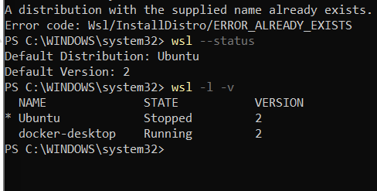
Figure 1: PowerShell output showing WSL 2 status and running docker-desktop backend.

4.2 Step 2: Cluster Creation, Node Verification & Docker Container Mapping
The cluster was created using kind create cluster --config kind-config.yaml. Running kubectl get nodes verified all three nodes in Ready status. In addition, docker ps revealed that each Kubernetes node operates inside an independent Docker container directly visible from Windows.
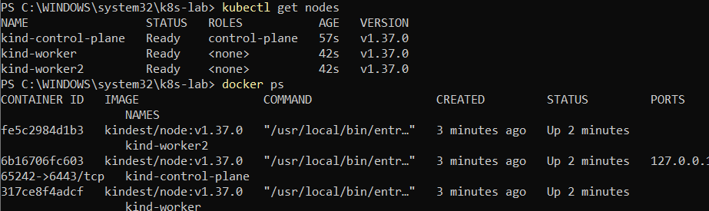
Figure 2: kubectl get nodes showing 3 Ready nodes and docker ps showing the backing containers.
Node Name | Kubernetes Role | Status | Version | Docker Container ID
kind-control-plane | control-plane | Ready | v1.37.0 | 6b16706fc603
kind-worker | <none> (worker) | Ready | v1.37.0 | 317ce8f4adcf
kind-worker2 | <none> (worker) | Ready | v1.37.0 | fe5c2984d1b3

4.3 Step 3: NGINX Web Application Deployment (3 Replicas)
An NGINX web application deployment was initiated with 3 replicas using kubectl create deployment web --image=nginx --replicas=3. Executing kubectl get pods -o wide demonstrated that the Kubernetes scheduler assigned the three pods across both worker nodes to ensure high availability.
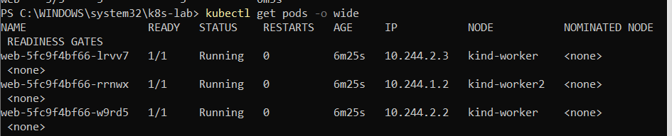
Figure 3: kubectl get pods -o wide displaying 3 NGINX replicas distributed across kind-worker and kind-worker2.
Pod Name | Status | Restarts | Assigned IP | Scheduled Worker Node
web-5fc9f4bf66-lrvv7 | Running | 0 | 10.244.2.3 | kind-worker
web-5fc9f4bf66-w9rd5 | Running | 0 | 10.244.2.2 | kind-worker
web-5fc9f4bf66-rrnwx | Running | 0 | 10.244.1.2 | kind-worker2

4.4 Step 4: Horizontal Scaling to 6 Replicas & Load Balancing
The application was scaled horizontally to 6 replicas using kubectl scale deployment web --replicas=6. The scheduler dynamically placed the 3 newly spawned pods such that each worker node hosted exactly 3 pods, achieving a perfect 50% / 50% compute balance.
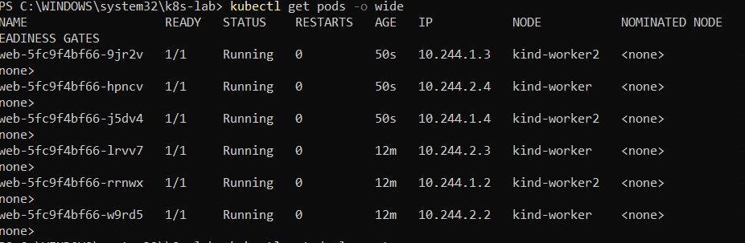
Figure 4: kubectl get pods -o wide showing 6 pods evenly balanced between kind-worker (3 pods) and kind-worker2 (3 pods).
Pod Name | Status | Age | Assigned IP | Scheduled Worker Node
web-5fc9f4bf66-hpncv | Running | 50s | 10.244.2.4 | kind-worker
web-5fc9f4bf66-lrvv7 | Running | 12m | 10.244.2.3 | kind-worker
web-5fc9f4bf66-w9rd5 | Running | 12m | 10.244.2.2 | kind-worker
web-5fc9f4bf66-9jr2v | Running | 50s | 10.244.1.3 | kind-worker2
web-5fc9f4bf66-j5dv4 | Running | 50s | 10.244.1.4 | kind-worker2
web-5fc9f4bf66-rrnwx | Running | 12m | 10.244.1.2 | kind-worker2

4.5 Step 5: Fault Injection & Automated Self-Healing Trigger
To validate self-healing capabilities, pod web-5fc9f4bf66-lrvv7 was deleted using kubectl delete pod web-5fc9f4bf66-lrvv7. The Kubernetes ReplicaSet controller detected that active replicas (5) differed from desired replicas (6) and automatically launched replacement pod web-5fc9f4bf66-49nq9 within 5 seconds.
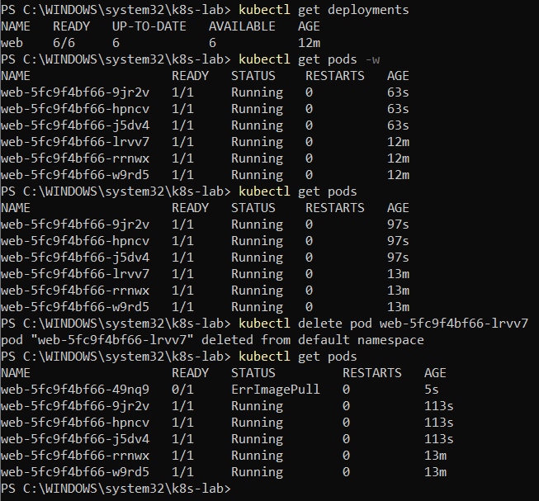
Figure 5: Deletion of pod lrvv7 and rapid automated recreation of replacement pod 49nq9 within 5 seconds.

4.6 Step 6: Steady-State Recovery & Healed Cluster State
Following the transient image pull and container startup, kubectl get pods verified that replacement pod web-5fc9f4bf66-49nq9 reached 1/1 Running status (observed at age 23m), restoring all 6 pods to healthy operation without any manual administrative action.
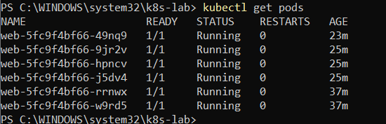
Figure 6: Final kubectl get pods output confirming steady-state 6/6 Running pods including the healed pod 49nq9.

5. In-Depth Technical Analysis
1. Declarative Control Loop (Reconciliation):
Unlike imperative VM systems where administrators must manually restart crashed services, Kubernetes operates on a declarative reconciliation loop. The Deployment manages a ReplicaSet that continuously calculates:
Discrepancy = Desired Replicas (6) - Active Healthy Replicas (5) = +1
The instant a discrepancy is identified, the controller issues API calls to schedule and launch an identical pod.
2. Workload Placement & Scheduling Algorithms:
The kube-scheduler uses a two-phase process: Filtering (ensuring nodes satisfy port, compute, and taint conditions) and Scoring (ranking candidates based on resource balance and spreading rules). In this experiment, the scoring algorithm distributed 6 pods equally (3 on kind-worker, 3 on kind-worker2), effectively guarding against single-node blast radius.
3. Software-Defined Networking (SDN) and IP Allocation:
The KinD CNI allocates non-overlapping /24 subnets to each worker container:
• kind-worker: 10.244.2.0/24 (Pods received 10.244.2.2, 10.244.2.3, 10.244.2.4)
• kind-worker2: 10.244.1.0/24 (Pods received 10.244.1.2, 10.244.1.3, 10.244.1.4)
This design guarantees unique IP addresses per pod, enabling transparent pod-to-pod east-west communication without port collisions.

6. Summary of Important Commands Used
Command | Functional Purpose
wsl --status / wsl -l -v | Verify WSL 2 virtualization status and registered distributions.
kind create cluster --config kind-config.yaml | Instantiate 3-node Kubernetes cluster from declarative manifest.
kubectl get nodes | Display cluster node inventory, roles, status, and version.
docker ps | Inspect underlying Docker containers executing each Kubernetes node.
kubectl create deployment web --image=nginx --replicas=3 | Deploy 3 initial NGINX web server pods.
kubectl get pods -o wide | Inspect pod IPs, readiness, restart counts, and node placement.
kubectl scale deployment web --replicas=6 | Horizontally scale deployment from 3 to 6 replicas.
kubectl delete pod <pod-name> | Deliberately delete pod to trigger automated self-healing.

7. Result & Conclusion
Result: A 3-node Kubernetes cluster (1 control-plane, 2 workers) was successfully built on Windows using KinD and Docker Desktop over WSL 2. The NGINX application was deployed with 3 replicas, successfully scaled horizontally to 6 replicas with balanced multi-worker distribution (3 pods per node), and verified for self-healing resilience when pod web-5fc9f4bf66-lrvv7 was deleted and automatically replaced by web-5fc9f4bf66-49nq9 within 5 seconds.
Conclusion: This experiment conclusively demonstrates the power of container orchestration over traditional manual virtualization. Kubernetes abstracts underlying hardware infrastructure into a unified compute pool, automates pod placement through intelligent scheduling, achieves high elasticity through dynamic horizontal scaling, and guarantees high service availability via continuous declarative self-healing.

