SMARTSUGGEST
An Intelligent Search Autocomplete and Suggestion Ranking System

A PROJECT REPORT

Submitted by

Chhavi - 25BCS10997
Shifali Bhasin – 25BCS10782

in partial fulfillment for the award of the degree of

BACHELOR OF ENGINEERING
IN
COMPUTER SCIENCE ENGINEERING

Under the guidance of
Mr. Kapil Katiyar



Chandigarh University
November 2026



CERTIFICATE
This is to certify that the project report entitled “SmartSuggest: An Intelligent Search Autocomplete and Suggestion Ranking System” is a bona fide work carried out by Chhavi and Shifali Bhasin as part of the Advanced Data Structures (ADSA) course under my guidance.

Project Guide: ____________________
Head of Department: ____________________
Date: ____________________ Place: ____________________

ABSTRACT
SmartSuggest is a browser-based intelligent search autocomplete system designed to provide relevant word suggestions while a user types. The system combines multiple data structures to perform prefix-based searching and rank the matching results. A Trie stores the dictionary words character by character and enables efficient prefix traversal. After matching words are retrieved, a custom Max Heap ranks them according to their search frequencies so that the most popular suggestions appear first. A HashMap maintains the frequency associated with each word, and a text file (dictionary.txt) is used to store words and their frequencies persistently. The backend is implemented in Java using the built-in HTTP server, while HTML, CSS and JavaScript provide the browser-based user interface. Users can type a prefix, select a suggestion to increase its frequency, and add new words to the dictionary. The project demonstrates the practical application of Trie, Heap, HashMap, file handling and client-server communication.

TABLE OF CONTENTS

Abstract ........................................................................................................ 4

1. INTRODUCTION ............................................................................................. 5

2. PROBLEM STATEMENT ...................................................................................... 5

3. OBJECTIVES .................................................................................................... 5

4. SCOPE AND APPLICATIONS ................................................................................. 6

5. SYSTEM REQUIREMENTS ..................................................................................... 6

6. SYSTEM ARCHITECTURE AND WORKING ............................................................. 7

7. DATA STRUCTURES USED ................................................................................... 8

8. ALGORITHMS AND COMPLEXITY ANALYSIS ....................................................... 9

9. IMPLEMENTATION DETAILS ............................................................................... 10

10. TESTING AND RESULTS ................................................................................... 11

10.1. Screenshots ............................................................................................. 11

11. LIMITATIONS AND FUTURE ENHANCEMENTS .................................................. 12

12. CONCLUSION .................................................................................................... 13

13. REFERENCES ..................................................................................................... 13

APPENDIX A – PROJECT STRUCTURE .................................................................. 14

1. INTRODUCTION
Searching is one of the most frequent interactions in modern software. Search engines, e-commerce sites, code editors and messaging apps all reduce typing effort by predicting what the user intends to type. Two properties make a good autocomplete system: it must respond within milliseconds, and it must show the most useful suggestions first.
A naive approach scans every dictionary word and compares it with the prefix, which costs O(N × P) per keystroke and grows slowly worse as the dictionary grows. SmartSuggest instead stores words in a Trie so that only words sharing the prefix are visited, and ranks them using a Max Heap keyed on search frequency. Production systems such as web search engines apply the same two ideas, prefix lookup and popularity ranking, at far larger scale. This project implements them from scratch in Java without external libraries, which makes the role of each data structure visible.

2. PROBLEM STATEMENT
To design and implement an autocomplete system that accepts a prefix from the user, retrieves all dictionary words beginning with that prefix, and displays a limited number of suggestions in descending order of search frequency. The system should also allow users to add new words and update word frequencies when suggestions are selected.

3. OBJECTIVES
- Implement a Trie for efficient storage and prefix-based retrieval of words.
- Implement a custom Max Heap to rank matching words by search frequency.
- Use a HashMap to maintain word-frequency pairs.
- Load the dictionary and frequencies from a text file.
- Save newly added words and updated frequencies to persistent storage.
- Develop a simple browser-based interface connected to a Java backend.
- Demonstrate the combined use of data structures in a real-world search feature.

4. SCOPE AND APPLICATIONS
The current implementation uses a local dictionary file and runs on the user’s computer through a local HTTP server. It is intended as an academic demonstration of data structures rather than a production search service. The same basic approach can be adapted for website search bars, product search, command suggestions, text editors and query recommendation systems.

5. SYSTEM REQUIREMENTS
Category | Requirement
Programming language | Java
Frontend | HTML, CSS and JavaScript
Backend | Java built-in com.sun.net.httpserver.HttpServer
Development environment | Visual Studio Code
Java version | A JDK supporting Path.of, Files.readString/writeString and HttpServer
Storage | Local text file: dictionary.txt
Browser | Any modern web browser
External frameworks | None required

6. SYSTEM ARCHITECTURE AND WORKING
The system follows a simple client-server architecture:
- The user enters a prefix in the browser search field.
- JavaScript sends a GET request to the Java backend endpoint /api/suggest with the entered prefix.
- The SuggestionEngine asks the Trie to retrieve words that begin with the prefix.
- The matching words and their frequencies are inserted into a custom Max Heap.
- The Max Heap returns the highest-frequency suggestions, up to the requested limit (five in the current interface).
- The backend returns the suggestions as JSON, and JavaScript displays them in the browser.
- When a user selects a suggestion, JavaScript sends a POST request to /api/select. The backend increments its frequency and saves the dictionary file.
- When a user adds a word, JavaScript sends a POST request to /api/add. The backend inserts the new word and saves the updated dictionary.

6.1 Architecture Flow
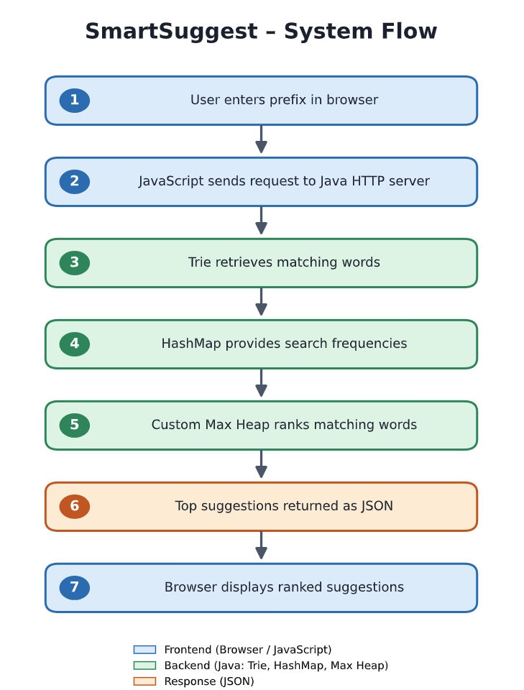
Figure 1: Logical flow of SmartSuggest. Replace this text diagram with a designed architecture diagram if required by the department.

7. DATA STRUCTURES USED

7.1 Trie
A Trie (prefix tree) is a tree-like data structure used to store strings. Each node represents a character path, and a boolean marker identifies the end of a complete word. Words with common prefixes share the same initial path. In SmartSuggest, the Trie supports insertion of words and retrieval of all words beginning with a given prefix.

7.2 Max Heap
A Max Heap is a complete binary tree in which each parent has priority over its children. In this project, priority is determined primarily by search frequency. The word with the highest frequency is removed first. If two words have the same frequency, the custom comparison uses alphabetical order as a tie-breaker.

7.3 HashMap
A HashMap stores each word as a key and its search frequency as the corresponding value. It provides average constant-time lookup and update operations, which makes it suitable for maintaining word frequencies.

7.4 File Handling
The dictionary.txt file stores one word-frequency pair per line in the format word,frequency. The application reads this file during initialization and rewrites it when a word is added or a search frequency changes. This allows changes to remain available after the server is restarted.

8. ALGORITHMS AND COMPLEXITY ANALYSIS

8.1 Prefix Search Algorithm
- Read the prefix entered by the user.
- Start from the root node of the Trie.
- Traverse the Trie using each character of the prefix.
- If a required child node does not exist, return an empty result.
- Otherwise, recursively collect complete words from the prefix node and its descendants.

8.2 Suggestion Ranking Algorithm
- Obtain all words matching the prefix from the Trie.
- Retrieve the frequency of each matching word from the HashMap.
- Insert each word-frequency pair into the Max Heap.
- Remove the root of the heap repeatedly until five suggestions are collected or the heap becomes empty.
- Return the ranked suggestions to the frontend.

8.3 Complexity Analysis
Let L be the length of a word, P be the length of the input prefix, M be the number of words matching that prefix, and K be the number of suggestions requested.
Operation | Time Complexity | Explanation
Trie insertion | O(L) | One traversal/insertion per character.
Trie prefix traversal | O(P) | Traverses the prefix characters.
Collect matching words | Output-dependent | Visits nodes in the matching subtree.
Max Heap insertion | O(log M) | Restores heap order after insertion.
Remove maximum | O(log M) | Restores heap order after removing the root.
Build heap by repeated insertion | O(M log M) | M matching words are inserted individually.
Extract top K | O(K log M) | At most K maximum elements are removed.
HashMap lookup/update | O(1) average | Average-case key access.
For the current implementation, ranking M matching words takes O(M log M) to insert them into the heap, followed by O(K log M) to extract the top K results. Trie collection also depends on the number of nodes visited in the matching subtree. These bounds describe the implemented approach, not an optimized heap-construction variant.

9. IMPLEMENTATION DETAILS
File | Responsibility
TrieNode.java | Defines a Trie node with a map of child characters and an end-of-word flag.
Trie.java | Implements word insertion, prefix traversal and recursive collection of matching words.
Suggestion.java | Represents a suggestion containing a word and its frequency.
MaxHeap.java | Implements a custom max heap using an array-backed list, insertion, removal and heap restoration.
SuggestionEngine.java | Coordinates the Trie, frequency HashMap, dictionary loading/saving, ranking and frequency updates.
SmartSuggestServer.java | Runs the Java HTTP server, exposes API endpoints and serves frontend files.
index.html | Defines the browser interface and page structure.
style.css | Defines layout, colors, spacing and responsive presentation.
script.js | Handles user input, fetch requests, suggestion display, selection and word addition.
dictionary.txt | Stores the initial word-frequency data.

9.1 API Endpoints
Endpoint | Method | Purpose
/api/suggest?prefix=app | GET | Returns up to five matching suggestions as JSON.
/api/select | POST | Increments the selected word frequency.
/api/add | POST | Adds a new alphabetic word to the dictionary.

10. TESTING AND RESULTS
The system should be tested using prefixes from different parts of the alphabet, selecting suggestions, adding new words and restarting the server to verify persistence. Record the actual test outcomes after running the final version.
Test case | Input / Action | Expected result | Status
Prefix matching | app | Matching app-words displayed | [Pass/Fail]
Alphabet coverage | u | university, user, update etc. | [Pass/Fail]
Less common prefix | x | xenon, xylophone etc. | [Pass/Fail]
No match | zzzz | No matching words message | [Pass/Fail]
Frequency update | Select apple | Frequency increases by one | [Pass/Fail]
Add word | Add a new alphabetic word | Word becomes searchable | [Pass/Fail]
Persistence | Restart server | Updated word/frequency retained | [Pass/Fail]

10.1 Screenshots
Insert screenshots captured from the final running application. Suggested screenshots:
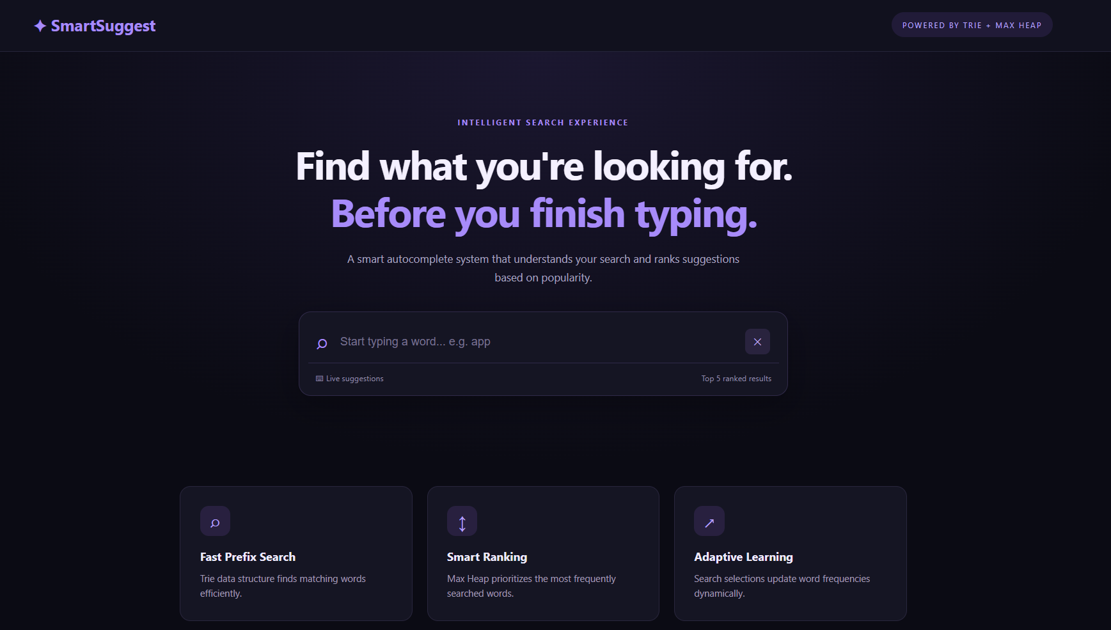
Figure 2: SmartSuggest home page
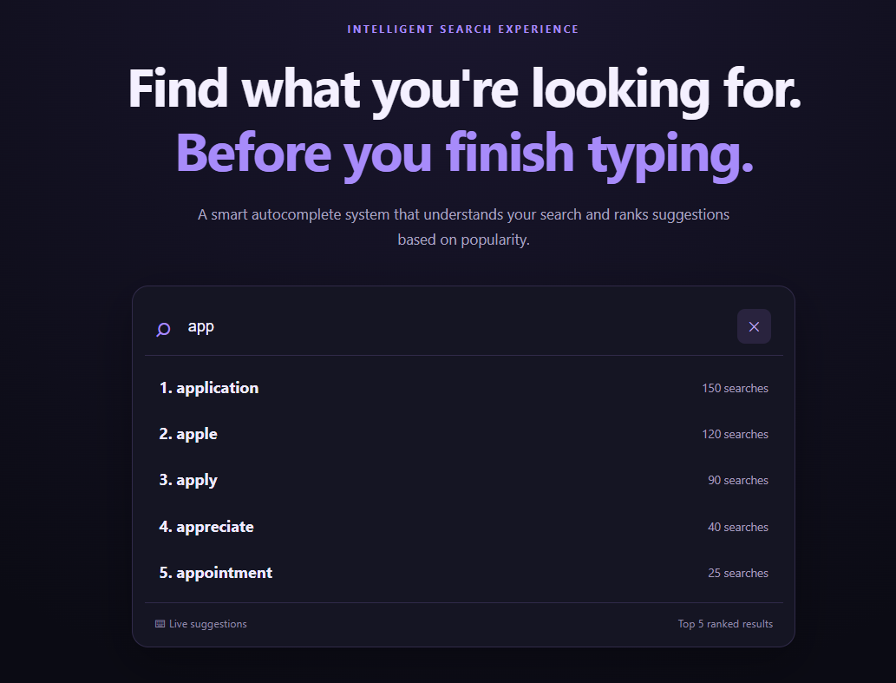Figure 3: Autocomplete results for a prefix such as “app”
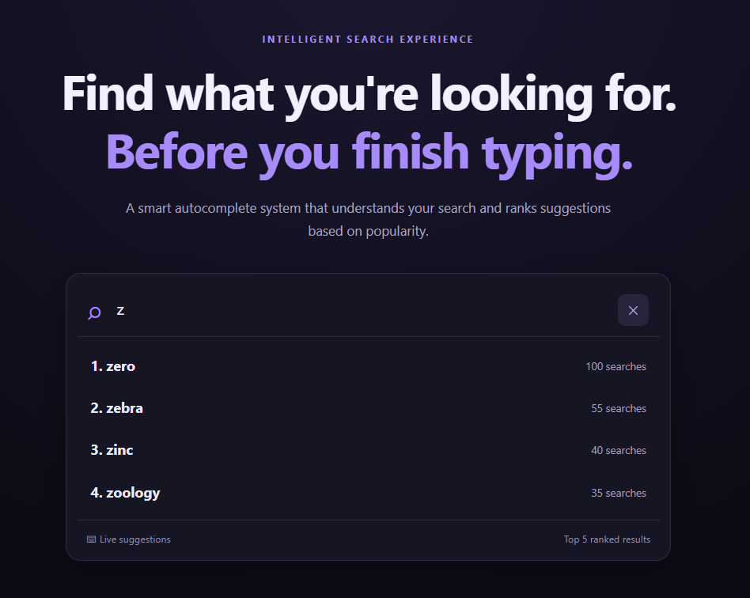Figure 4: Suggestions for a less common starting letter such as “x” or “z”
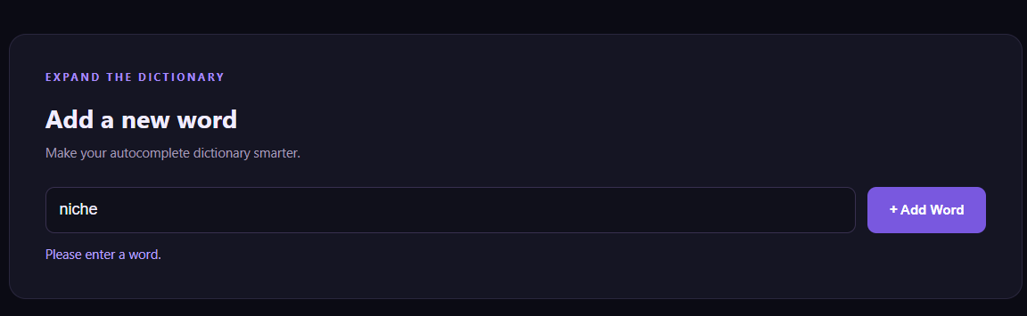
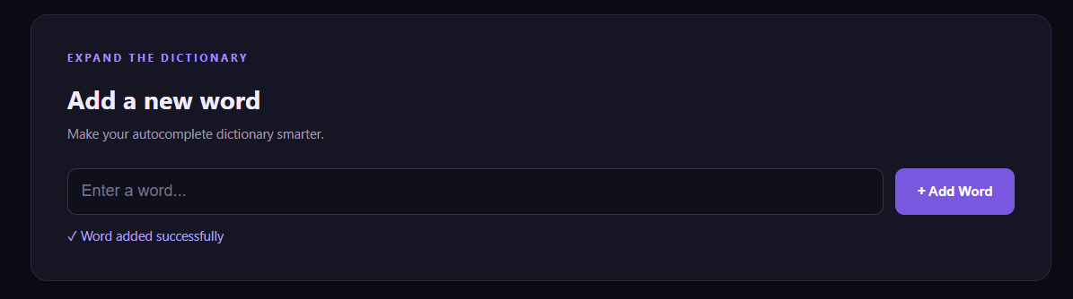Figure 5: Adding a new word and receiving confirmation

11. LIMITATIONS AND FUTURE ENHANCEMENTS
Current limitations:
- The dictionary is a manually prepared local word list rather than a comprehensive language dictionary.
- Search frequencies are based on local selections and are not collected from multiple users.
- The current application is designed for local demonstration and does not include authentication or multi-user access.
- The file is rewritten when updates occur; a database would be more suitable for a larger deployment.
Possible future enhancements:
- Use a larger dictionary or import words from a verified language dataset.
- Add a database for scalable and concurrent storage.
- Support multiple languages, phrases and search history.
- Add fuzzy matching to handle spelling mistakes.
- Improve ranking using recency, context and personalized preferences.
- Add analytics showing popular searches and usage trends.

12. CONCLUSION
SmartSuggest demonstrates how fundamental data structures can be combined to solve a practical search problem. The Trie efficiently locates words matching a prefix, while the custom Max Heap ranks the matching words according to frequency. The HashMap supports frequency management, and file handling preserves updates between application runs. A browser-based interface connected to a Java backend makes the implementation interactive and easy to demonstrate. The project provides practical experience in implementing and integrating data structures, analyzing their complexity, and connecting a frontend to a backend service.

13. REFERENCES
- Oracle. Java Platform, Standard Edition Documentation. https://docs.oracle.com/en/java/
- Oracle. Java Collections Framework Documentation. https://docs.oracle.com/en/java/javase/
- Sedgewick, R. and Wayne, K. Algorithms, 4th Edition. Addison-Wesley.
- Cormen, T. H., Leiserson, C. E., Rivest, R. L. and Stein, C. Introduction to Algorithms. MIT Press.
- MDN Web Docs. HTML, CSS and JavaScript Guides. https://developer.mozilla.org/

APPENDIX A – PROJECT STRUCTURE
SmartSuggest/
├── src/
│ ├── TrieNode.java
│ ├── Trie.java
│ ├── Suggestion.java
│ ├── MaxHeap.java
│ ├── SuggestionEngine.java
│ ├── SmartSuggestServer.java
│ └── Main.java
├── public/
│ ├── index.html
│ ├── style.css
│ └── script.js
├── dictionary.txt
└── out/
Run the application from the SmartSuggest project root after compiling the Java source files:
javac --add-modules jdk.httpserver -d out src\*.java
java --add-modules jdk.httpserver -cp out SmartSuggestServer
Open http://localhost:8081 in a web browser.

