SMARTSUGGEST
An Intelligent Search Autocomplete and Suggestion Ranking System

A PROJECT REPORT

Submitted by

Chhavi - 25BCS10997
Shifali Bhasin – 25BCS10782

in partial fulfillment for the award of the degree of

BACHELOR OF ENGINEERING
IN
COMPUTER SCIENCE ENGINEERING

Under the guidance of
Mr. Kapil Katiyar



Chandigarh University
November 2026



CERTIFICATE
This is to certify that the project report entitled “SmartSuggest: An Intelligent Search Autocomplete and Suggestion Ranking System” is a bona fide work carried out by Chhavi and Shifali Bhasin as part of the Advanced Data Structures (ADSA) course under my guidance.

Project Guide: ____________________
Head of Department: ____________________
Date: ____________________ Place: ____________________

ABSTRACT
SmartSuggest is a browser-based intelligent search autocomplete system designed to provide relevant word suggestions while a user types. The system combines multiple data structures to perform prefix-based searching and rank the matching results. A Trie stores the dictionary words character by character and enables efficient prefix traversal. After matching words are retrieved, a custom Max Heap ranks them according to their search frequencies so that the most popular suggestions appear first. A HashMap maintains the frequency associated with each word, and a text file (dictionary.txt) is used to store words and their frequencies persistently. The backend is implemented in Java using the built-in HTTP server, while HTML, CSS and JavaScript provide the browser-based user interface. Users can type a prefix, select a suggestion to increase its frequency, and add new words to the dictionary. The project demonstrates the practical application of Trie, Heap, HashMap, file handling and client-server communication.
The workflow is deliberately simple. As the user types, the browser asks the Java backend for suggestions, the backend narrows the dictionary to words sharing the typed prefix, and the ranked list is returned and displayed within the page. Selecting a suggestion acts as feedback: the frequency of that word rises, so it moves higher in future results. Because all data structures are written from scratch and no external frameworks are used, the project also serves as a clear, working demonstration of how Trie, Heap, HashMap and file handling cooperate inside a single application.

TABLE OF CONTENTS

Abstract ........................................................................................................ 3

1. INTRODUCTION ............................................................................................. 5

2. PROBLEM STATEMENT ...................................................................................... 6

3. OBJECTIVES .................................................................................................... 6

4. SCOPE AND APPLICATIONS ................................................................................. 7

5. SYSTEM REQUIREMENTS ..................................................................................... 7

6. SYSTEM ARCHITECTURE AND WORKING ............................................................. 8

7. DATA STRUCTURES USED ................................................................................... 10

8. ALGORITHMS AND COMPLEXITY ANALYSIS ....................................................... 11

9. IMPLEMENTATION DETAILS ............................................................................... 13

10. TESTING AND RESULTS ................................................................................... 14

10.1. Screenshots ............................................................................................. 14

11. LIMITATIONS AND FUTURE ENHANCEMENTS .................................................. 17

12. CONCLUSION .................................................................................................... 18

13. REFERENCES ..................................................................................................... 18

APPENDIX A – PROJECT STRUCTURE .................................................................. 19

1. INTRODUCTION
Searching is one of the most frequent interactions in modern software. Search engines, e-commerce sites, code editors and messaging apps all reduce typing effort by predicting what the user intends to type. Two properties make a good autocomplete system: it must respond within milliseconds, and it must show the most useful suggestions first.
A naive approach scans every dictionary word and compares it with the prefix, which costs O(N × P) per keystroke and grows slowly worse as the dictionary grows. SmartSuggest instead stores words in a Trie so that only words sharing the prefix are visited, and ranks them using a Max Heap keyed on search frequency. Production systems such as web search engines apply the same two ideas, prefix lookup and popularity ranking, at far larger scale. This project implements them from scratch in Java without external libraries, which makes the role of each data structure visible.
Background and motivation. Autocomplete has become a basic expectation. When a person types a few letters into a search box, they expect the system to complete the thought at once, correct their direction early and spare them the effort of typing the full term. Behind this small feature sit two distinct problems: finding every candidate that matches what has been typed so far, and deciding which of those candidates deserves to appear first. A system that solves only the first problem returns long, unordered lists; one that solves only the second cannot respond quickly as the dictionary grows.
Approach followed in this project. SmartSuggest treats these as two separate stages and assigns each to the data structure best suited to it. The Trie handles retrieval, because words with a common prefix share the same path and the search cost depends on the length of the prefix rather than on the size of the dictionary. The Max Heap handles ranking, because it always exposes the highest-frequency word at its root. A HashMap keeps the frequency of every word available in constant average time, and a plain text file preserves the dictionary and its frequencies between runs.
Application overview. The system runs as a small client-server application. A Java backend, built on the built-in HTTP server, owns the data structures and exposes three endpoints. A browser interface written in HTML, CSS and JavaScript sends the typed prefix to the backend and shows the returned suggestions. This separation keeps the algorithmic logic in Java and the presentation logic in the browser.
Organisation of the report. The remainder of this report defines the problem and objectives, describes the scope and system requirements, explains the architecture and the data structures, analyses the algorithms and their complexity, documents the implementation and testing, and closes with limitations, future enhancements and conclusions.

2. PROBLEM STATEMENT
To design and implement an autocomplete system that accepts a prefix from the user, retrieves all dictionary words beginning with that prefix, and displays a limited number of suggestions in descending order of search frequency. The system should also allow users to add new words and update word frequencies when suggestions are selected.
The problem can be broken down into the following functional requirements:
- Input and retrieval: The user types a prefix, and the system must return only words that begin with that prefix.
- Ranking: Matching words must be ordered from the highest to the lowest search frequency, with alphabetical order used when two words have equal frequency.
- Limiting results: Only a limited number of suggestions is displayed (five in the current interface) so that the list stays short and readable.
- Learning from selection: When the user selects a suggestion, its frequency must increase so that popular words rise in the ranking over time.
- Extending the dictionary: The user must be able to add new alphabetic words, which become searchable immediately.
- Persistence: Added words and updated frequencies must survive a server restart.
The main technical challenge is to keep the response fast for every keystroke while still producing a correctly ranked list. Scanning the whole dictionary for each prefix would work for a small word list but does not scale, and sorting every result by hand ignores the fact that only the top few entries are ever shown. The design therefore has to combine prefix-based retrieval, priority-based ranking and efficient frequency updates in one consistent system.

3. OBJECTIVES
- Implement a Trie for efficient storage and prefix-based retrieval of words.
- Implement a custom Max Heap to rank matching words by search frequency.
- Use a HashMap to maintain word-frequency pairs.
- Load the dictionary and frequencies from a text file.
- Save newly added words and updated frequencies to persistent storage.
- Develop a simple browser-based interface connected to a Java backend.
- Demonstrate the combined use of data structures in a real-world search feature.
Together, these objectives cover three areas. The first is data structure implementation: the Trie and the Max Heap are written by hand rather than taken from a library, so that their internal behaviour (node creation, heap restoration after insertion and removal, tie-breaking) is understood and visible in the code. The second is data management: the HashMap and the text file keep word frequencies consistent in memory and on disk. The third is system integration: the structures are connected to a Java HTTP backend and a browser interface so that they can be used and demonstrated as a working search feature. Meeting all seven objectives means the project is complete from storage and algorithms through to user interaction.

4. SCOPE AND APPLICATIONS
The current implementation uses a local dictionary file and runs on the user’s computer through a local HTTP server. It is intended as an academic demonstration of data structures rather than a production search service. The same basic approach can be adapted for website search bars, product search, command suggestions, text editors and query recommendation systems.
What is in scope. The current version of SmartSuggest is limited in the following ways:
- Prefix-based suggestions drawn from a local dictionary file.
- Frequency-based ranking of the matching words, updated whenever a suggestion is selected.
- Addition of new alphabetic words through the browser interface.
- Persistent storage of words and frequencies in dictionary.txt.
- A single-user setup running on the user’s own computer through a local HTTP server.
What is out of scope. The following are outside the current scope: authentication, multi-user or concurrent access, a database back end, spelling correction, and phrase-level or multilingual suggestions. These are listed in Section 11 as possible future enhancements.
Applications. The underlying idea of retrieving by prefix and ranking by popularity is not tied to a dictionary of words. In a website search bar, the same structure can suggest page titles or topics. In product search, it can suggest product names ordered by how often they are chosen. In command-line tools and text editors, it can complete commands or identifiers. In query recommendation systems, it can propose the most frequent previous queries. In each case only the data stored in the Trie and the source of the frequencies would change; the retrieval and ranking logic stays the same.

5. SYSTEM REQUIREMENTS
Category | Requirement
Programming language | Java
Frontend | HTML, CSS and JavaScript
Backend | Java built-in com.sun.net.httpserver.HttpServer
Development environment | Visual Studio Code
Java version | A JDK supporting Path.of, Files.readString/writeString and HttpServer
Storage | Local text file: dictionary.txt
Browser | Any modern web browser
External frameworks | None required
Software environment. The project is deliberately light on dependencies. The backend uses the HTTP server that is built into the JDK (com.sun.net.httpserver.HttpServer), so no web framework, build tool or third-party library has to be downloaded. The frontend uses only standard HTML, CSS and JavaScript and therefore runs in any modern web browser. Visual Studio Code is used as the development environment, although any editor that can compile Java would work equally well.
Java and runtime notes. The JDK used must support Path.of, Files.readString and Files.writeString, which the application uses to read and write dictionary.txt, together with the HttpServer class. Because the HTTP server lives in the jdk.httpserver module, the compile and run commands in Appendix A include the --add-modules jdk.httpserver option. Once started, the server listens on port 8081 and the interface is opened at http://localhost:8081.
Hardware. The dictionary is a small local text file, and every query touches only the matching part of the Trie, so the application needs no special hardware. A standard computer capable of running a JDK and a web browser is sufficient.

6. SYSTEM ARCHITECTURE AND WORKING
The system follows a simple client-server architecture:
- The user enters a prefix in the browser search field.
- JavaScript sends a GET request to the Java backend endpoint /api/suggest with the entered prefix.
- The SuggestionEngine asks the Trie to retrieve words that begin with the prefix.
- The matching words and their frequencies are inserted into a custom Max Heap.
- The Max Heap returns the highest-frequency suggestions, up to the requested limit (five in the current interface).
- The backend returns the suggestions as JSON, and JavaScript displays them in the browser.
- When a user selects a suggestion, JavaScript sends a POST request to /api/select. The backend increments its frequency and saves the dictionary file.
- When a user adds a word, JavaScript sends a POST request to /api/add. The backend inserts the new word and saves the updated dictionary.
The system can be viewed as three cooperating layers:
- Presentation layer. The browser interface (index.html, style.css and script.js) accepts input, sends fetch requests and renders the returned suggestions. It contains no ranking logic.
- Service layer. SmartSuggestServer.java receives the HTTP requests, calls the SuggestionEngine and returns JSON responses. It also serves the frontend files.
- Logic and data layer. SuggestionEngine coordinates the Trie, the frequency HashMap and the MaxHeap, and loads and saves dictionary.txt.
Read and write paths. Searching and updating follow different paths. A search is a read-only operation: the prefix travels from the browser to the Trie, the matching words are ranked through the heap, and the result travels back as JSON. A selection or an addition is a write operation: the in-memory structures are updated first and the dictionary file is then saved, so the stored data always reflects the latest changes.

6.1 Architecture Flow
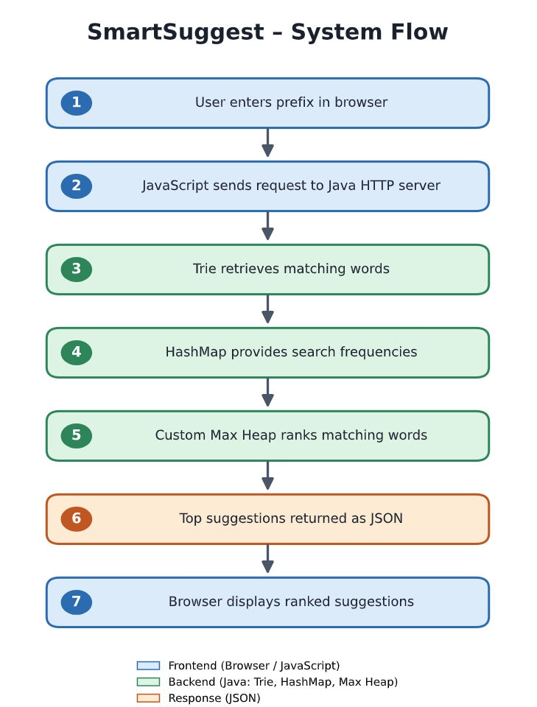
Figure 1: Logical flow of SmartSuggest. Replace this text diagram with a designed architecture diagram if required by the department.
Worked example. As an example, suppose the user types the prefix “app”. The browser sends a GET request to /api/suggest with that prefix. The Trie follows the three characters a, p and p and then collects every complete word below that node. Each word is paired with its frequency from the HashMap and inserted into the Max Heap. The five words with the highest frequencies are then removed from the heap in order and returned as JSON. When the user clicks one of them, for example apple, a POST request to /api/select raises its frequency by one and the file is saved, so apple will appear at least as high the next time “app” is typed.

7. DATA STRUCTURES USED

7.1 Trie
A Trie (prefix tree) is a tree-like data structure used to store strings. Each node represents a character path, and a boolean marker identifies the end of a complete word. Words with common prefixes share the same initial path. In SmartSuggest, the Trie supports insertion of words and retrieval of all words beginning with a given prefix.
Structure and behaviour. Each TrieNode holds a map from characters to child nodes and a boolean flag marking the end of a word, as listed in Section 9. Insertion walks down from the root one character at a time, creating a node when the required child is missing, and finally sets the end-of-word flag. A prefix search follows the same path without creating anything. If the path breaks, no word has that prefix and the result is empty. Because words such as “apple” and “apply” share the nodes for “appl”, shared prefixes are stored only once, which saves space and makes it possible to find every continuation of a prefix without looking at unrelated words.
Why a Trie is used. A plain list of words would need every word to be compared with the prefix on each keystroke. The Trie removes this cost: finding the prefix node takes O(P) time and only the words below that node are visited afterwards.

7.2 Max Heap
A Max Heap is a complete binary tree in which each parent has priority over its children. In this project, priority is determined primarily by search frequency. The word with the highest frequency is removed first. If two words have the same frequency, the custom comparison uses alphabetical order as a tie-breaker.
Structure and behaviour. The heap in SmartSuggest is array-backed: a list stores the elements in level order, so the parent and children of any position can be found by simple index arithmetic. Insertion places the new element at the end and moves it upward while it has higher priority than its parent. Removing the maximum takes the root, moves the last element to the root and moves it downward until the heap order is restored. Both operations take O(log M) time.
Comparison rule. Elements are compared by frequency first. When two words have the same frequency, alphabetical order decides, so the output is deterministic and does not change between runs. This matters for repeatable testing and for a stable display.
Why a Max Heap is used. Only the top few suggestions are shown, so there is no need to sort all M matches. A heap places the best candidate at the root at all times, and each of the K results is obtained with a single removal.

7.3 HashMap
A HashMap stores each word as a key and its search frequency as the corresponding value. It provides average constant-time lookup and update operations, which makes it suitable for maintaining word frequencies.
Role in the system. The Trie stores the words, but it does not store their frequencies. The HashMap supplies this missing information: when the engine collects a matching word from the Trie, it retrieves that word’s count from the map in O(1) average time. When a suggestion is selected, the same map is used to increase the count. The Trie and the HashMap are kept consistent: a new word is inserted into both, with an initial frequency, at the same time.

7.4 File Handling
The dictionary.txt file stores one word-frequency pair per line in the format word,frequency. The application reads this file during initialization and rewrites it when a word is added or a search frequency changes. This allows changes to remain available after the server is restarted.
Loading and saving. The loading step reads each line of dictionary.txt, splits it at the comma into a word and a number, inserts the word into the Trie and stores the pair in the HashMap. The saving step writes every pair back in the same word,frequency format. Rewriting the whole file is simple and reliable for a small dictionary, although it becomes less suitable as the data grows, as discussed in Section 11.

8. ALGORITHMS AND COMPLEXITY ANALYSIS

8.1 Prefix Search Algorithm
- Read the prefix entered by the user.
- Start from the root node of the Trie.
- Traverse the Trie using each character of the prefix.
- If a required child node does not exist, return an empty result.
- Otherwise, recursively collect complete words from the prefix node and its descendants.
This procedure is efficient because the Trie rules out every word that does not share the prefix before any collecting begins. If the prefix is not present in the Trie, the procedure stops after at most P steps and returns an empty result, which the interface reports as “no matching words”. If the prefix is present, the recursive collection visits only the nodes of the matching subtree, so its cost depends on the number of matches and not on the size of the whole dictionary.

8.2 Suggestion Ranking Algorithm
- Obtain all words matching the prefix from the Trie.
- Retrieve the frequency of each matching word from the HashMap.
- Insert each word-frequency pair into the Max Heap.
- Remove the root of the heap repeatedly until five suggestions are collected or the heap becomes empty.
- Return the ranked suggestions to the frontend.
Ranking uses a heap instead of a full sort because the interface needs only K results. Each word is inserted with its frequency, and the removal loop stops as soon as K suggestions have been collected or the heap is empty. Words with equal frequency are ordered alphabetically by the comparison rule, so the order of the suggestions is the same every time. The returned list is passed to the frontend unchanged.

8.3 Complexity Analysis
Let L be the length of a word, P be the length of the input prefix, M be the number of words matching that prefix, and K be the number of suggestions requested.
Operation | Time Complexity | Explanation
Trie insertion | O(L) | One traversal/insertion per character.
Trie prefix traversal | O(P) | Traverses the prefix characters.
Collect matching words | Output-dependent | Visits nodes in the matching subtree.
Max Heap insertion | O(log M) | Restores heap order after insertion.
Remove maximum | O(log M) | Restores heap order after removing the root.
Build heap by repeated insertion | O(M log M) | M matching words are inserted individually.
Extract top K | O(K log M) | At most K maximum elements are removed.
HashMap lookup/update | O(1) average | Average-case key access.
For the current implementation, ranking M matching words takes O(M log M) to insert them into the heap, followed by O(K log M) to extract the top K results. Trie collection also depends on the number of nodes visited in the matching subtree. These bounds describe the implemented approach, not an optimized heap-construction variant.
Comparison with the naive approach. The naive approach described in the Introduction costs O(N × P) per keystroke, where N is the number of dictionary words. The Trie-based approach costs O(P) to reach the prefix, plus the work to visit the M matching words and rank them, which is O(M log M) for insertion into the heap and O(K log M) to extract the top K. For short prefixes on a large dictionary M may be large, but for most realistic prefixes M is far smaller than N, so the work done per keystroke is much smaller than a full scan.
Space considerations. The Trie needs space proportional to the total number of characters stored, in the worst case when few prefixes are shared, and less when many words share prefixes. The HashMap needs space proportional to the number of words. The Max Heap exists only during a query and holds at most M entries. These requirements are small for the dictionary size used in this project.
Note. The bounds above describe the implemented approach, which inserts the M matches one by one. A heap built in a single pass could construct the structure in O(M) time, but this variant was not used here because the saving is minor for typical values of M.

9. IMPLEMENTATION DETAILS
File | Responsibility
TrieNode.java | Defines a Trie node with a map of child characters and an end-of-word flag.
Trie.java | Implements word insertion, prefix traversal and recursive collection of matching words.
Suggestion.java | Represents a suggestion containing a word and its frequency.
MaxHeap.java | Implements a custom max heap using an array-backed list, insertion, removal and heap restoration.
SuggestionEngine.java | Coordinates the Trie, frequency HashMap, dictionary loading/saving, ranking and frequency updates.
SmartSuggestServer.java | Runs the Java HTTP server, exposes API endpoints and serves frontend files.
index.html | Defines the browser interface and page structure.
style.css | Defines layout, colors, spacing and responsive presentation.
script.js | Handles user input, fetch requests, suggestion display, selection and word addition.
dictionary.txt | Stores the initial word-frequency data.
Organisation of the code. The ten files are grouped by responsibility. The classes TrieNode, Trie, Suggestion and MaxHeap contain the data structures and have no knowledge of HTTP or files. SuggestionEngine joins them with the HashMap and the dictionary file, and offers high-level operations such as suggesting, selecting and adding words. SmartSuggestServer is the only class that deals with HTTP, translating requests into calls to the engine, and Main.java (see Appendix A) starts the application. On the browser side, index.html defines the structure, style.css the appearance and script.js the behaviour. Keeping each concern in its own file makes the code easier to read, test and extend; for example, the ranking logic could be replaced without changing the server.

9.1 API Endpoints
Endpoint | Method | Purpose
/api/suggest?prefix=app | GET | Returns up to five matching suggestions as JSON.
/api/select | POST | Increments the selected word frequency.
/api/add | POST | Adds a new alphabetic word to the dictionary.
Request handling. When a request for /api/suggest arrives, the server reads the prefix, passes it to the SuggestionEngine and returns up to five results in JSON form. A request for /api/select carries the chosen word, and the engine increments its frequency and saves the file. A request for /api/add carries a new word, which the engine accepts only if it is alphabetic before inserting it into the Trie and the HashMap and saving the dictionary. Restricting added words to letters keeps the Trie consistent with the characters it expects and prevents malformed entries from being written to dictionary.txt.
Frontend behaviour. JavaScript calls the endpoints with fetch. As the user types, it sends the current prefix to the backend and displays the returned suggestions. Clicking a suggestion calls /api/select, and the add-word control calls /api/add and shows a confirmation message.

10. TESTING AND RESULTS
The system should be tested using prefixes from different parts of the alphabet, selecting suggestions, adding new words and restarting the server to verify persistence. Record the actual test outcomes after running the final version.
Test case | Input / Action | Expected result | Status
Prefix matching | app | Matching app-words displayed | [Pass/Fail]
Alphabet coverage | u | university, user, update etc. | [Pass/Fail]
Less common prefix | x | xenon, xylophone etc. | [Pass/Fail]
No match | zzzz | No matching words message | [Pass/Fail]
Frequency update | Select apple | Frequency increases by one | [Pass/Fail]
Add word | Add a new alphabetic word | Word becomes searchable | [Pass/Fail]
Persistence | Restart server | Updated word/frequency retained | [Pass/Fail]
Test approach. The test cases in the table below cover the main behaviours of the system. The prefix tests (app, u and x) confirm that retrieval works across common and uncommon starting letters. The “zzzz” test checks that a prefix with no entries produces an empty result and a friendly message. The frequency test checks that selecting a word raises its frequency by exactly one. The add-word test checks that a new alphabetic word can be found immediately after it is added, and the persistence test checks that both the new word and the updated frequencies are still present after the server is stopped and started again.
Recording results. Each test should be run on the final version of the application and the Status column should then be completed with Pass or Fail, together with any notes, so that the report records the actual outcomes rather than the expected ones.

10.1 Screenshots
Insert screenshots captured from the final running application. Suggested screenshots:
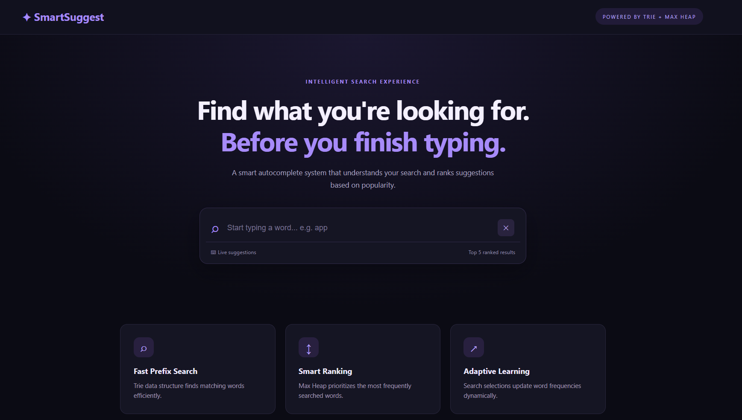
Figure 2: SmartSuggest home page
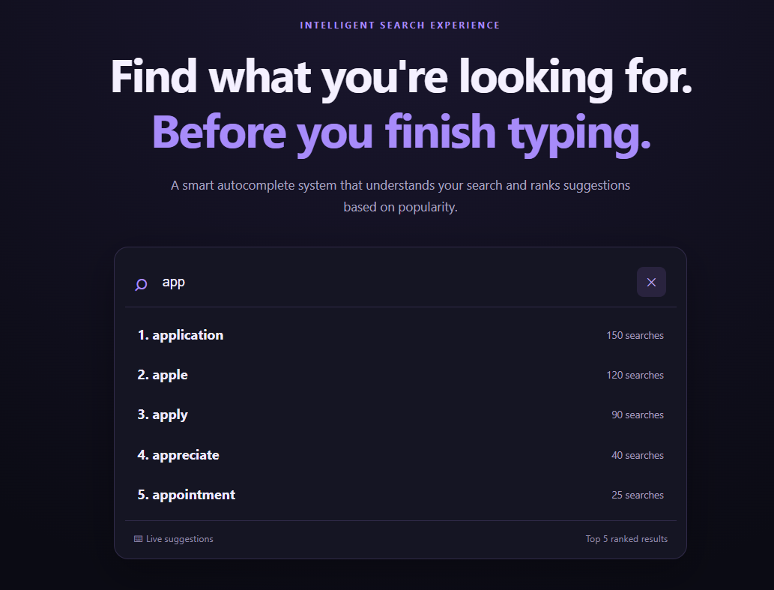
Figure 3: Autocomplete results for a prefix such as “app”
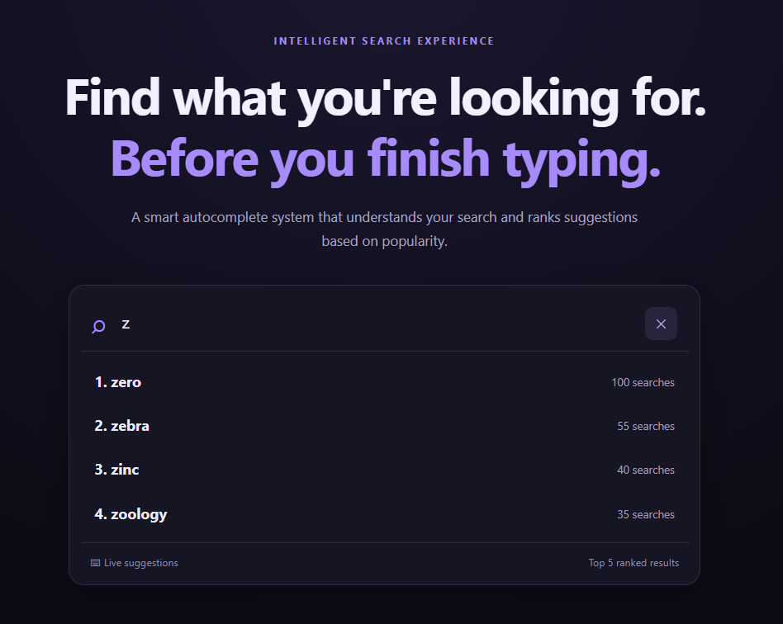
Figure 4: Suggestions for a less common starting letter such as “z”
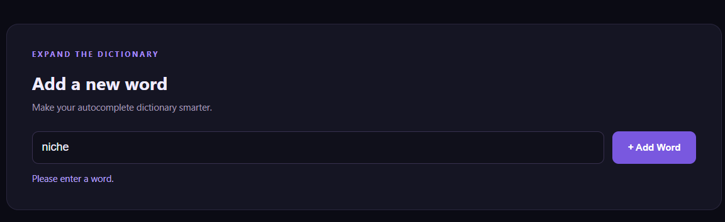
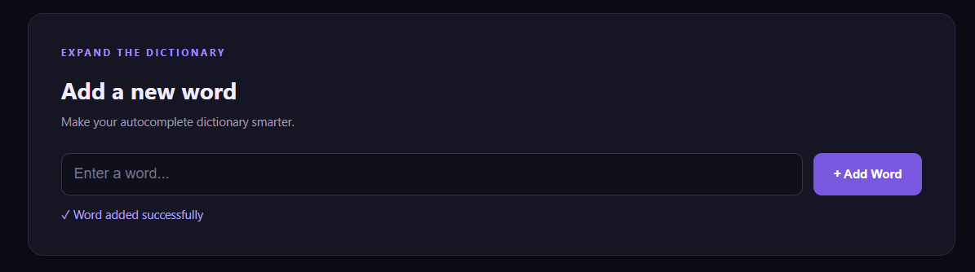
Figure 5: Adding a new word and receiving confirmation
Observations. The screenshots above are intended to show the application in use. The home page presents the search field. Typing a common prefix such as “app” should display a ranked list of up to five suggestions, with the highest-frequency words at the top. A less common prefix such as “x” should return the few words that exist, and a prefix with no match, such as “zzzz”, should show a message that nothing matched. After a new word is added, a confirmation should be displayed and the word should appear in later suggestions. Together, these views demonstrate retrieval, ranking, frequency update and word addition through the browser interface.

11. LIMITATIONS AND FUTURE ENHANCEMENTS
Current limitations:
- The dictionary is a manually prepared local word list rather than a comprehensive language dictionary.
- Search frequencies are based on local selections and are not collected from multiple users.
- The current application is designed for local demonstration and does not include authentication or multi-user access.
- The file is rewritten when updates occur; a database would be more suitable for a larger deployment.
Possible future enhancements:
- Use a larger dictionary or import words from a verified language dataset.
- Add a database for scalable and concurrent storage.
- Support multiple languages, phrases and search history.
- Add fuzzy matching to handle spelling mistakes.
- Improve ranking using recency, context and personalized preferences.
- Add analytics showing popular searches and usage trends.
Impact of the limitations. The limitations above mainly reflect the academic purpose of the project. A small hand-made dictionary and local-only frequencies mean the ranking reflects one user’s choices, not those of a population, and rewriting a whole text file on each update would become slow and unsafe if several users acted at the same time. None of these affects the correctness of the core algorithms; they affect scale and realism.
Suggested development path. The enhancements are best seen as a progression. The first step is a larger dictionary and a database, which solve the data volume and concurrency issues. The second is richer matching, through fuzzy matching and support for phrases and several languages, which makes the system more forgiving and more general. The third is smarter ranking, which uses recency, context and personal preferences instead of raw counts alone. Finally, analytics on popular searches and usage trends would give feedback on how well the suggestions serve users. Because retrieval and ranking are kept in separate components, each of these improvements can be added without redesigning the whole system.

12. CONCLUSION
SmartSuggest demonstrates how fundamental data structures can be combined to solve a practical search problem. The Trie efficiently locates words matching a prefix, while the custom Max Heap ranks the matching words according to frequency. The HashMap supports frequency management, and file handling preserves updates between application runs. A browser-based interface connected to a Java backend makes the implementation interactive and easy to demonstrate. The project provides practical experience in implementing and integrating data structures, analyzing their complexity, and connecting a frontend to a backend service.
From a learning point of view, the project achieves each of its objectives. It implements a Trie and a custom Max Heap from scratch, uses a HashMap for frequency management, stores data persistently in a text file and connects everything to a browser interface through a Java HTTP server. The complexity analysis shows why this combination is more efficient than scanning the whole dictionary: the Trie limits the search to words that share the prefix, and the heap delivers the top results without sorting all of them.
The project also illustrates a wider lesson in software design, which is that each data structure should be chosen for the specific problem it solves. The Trie, the heap and the hash map each do one job well, and the application is effective because they are combined. With a larger dictionary, a database and richer ranking, the same foundation could support a much more capable search suggestion service.

13. REFERENCES
- Oracle. Java Platform, Standard Edition Documentation. https://docs.oracle.com/en/java/
- Oracle. Java Collections Framework Documentation. https://docs.oracle.com/en/java/javase/
- Sedgewick, R. and Wayne, K. Algorithms, 4th Edition. Addison-Wesley.
- Cormen, T. H., Leiserson, C. E., Rivest, R. L. and Stein, C. Introduction to Algorithms. MIT Press.
- MDN Web Docs. HTML, CSS and JavaScript Guides. https://developer.mozilla.org/

APPENDIX A – PROJECT STRUCTURE
SmartSuggest/
├── src/
│ ├── TrieNode.java
│ ├── Trie.java
│ ├── Suggestion.java
│ ├── MaxHeap.java
│ ├── SuggestionEngine.java
│ ├── SmartSuggestServer.java
│ └── Main.java
├── public/
│ ├── index.html
│ ├── style.css
│ └── script.js
├── dictionary.txt
└── out/
Run the application from the SmartSuggest project root after compiling the Java source files:
javac --add-modules jdk.httpserver -d out src\*.java
java --add-modules jdk.httpserver -cp out SmartSuggestServer

