REPORT

TEAM – “CODIFIERS”

TEAM MEMBERS :

Arjav Kasliwal, Khushi Upadhyay,

Chhavi Ambor, Ishaan Narsihani

(PROBLEM 1)

EXPLANATION

To give users a better clothing buying experience, we created Virtual Try-On using the Python framework.

The foundation of our program is the green screen. The program combines the user's preferred print or pattern with the green hue of our built-in model image to produce an image of the model wearing that print.

Users can use this function to visualize how a particular piece of clothing looks on an individual.

This feature helps in decreasing the number of returns and refunds because customers are frequently dissatisfied with the way the clothing looks on them.

This feature can help users to trust the website more which leads to increase in number of purchases.

DETAILS OF THE ALGORITHMS :-

Libraries used :-

* Numpy : NumPy can be used to perform a wide variety of mathematical operations on arrays. It adds powerful data structures to Python that guarantee efficient calculations with arrays and matrices and it supplies an enormous library of high-level mathematical functions that operate on these arrays and matrices.
* CV2 : OpenCV (Open Source Computer Vision Library) is an open source computer vision and machine learning software library. OpenCV was built to provide a common infrastructure for computer vision applications and to accelerate the use of machine perception in the commercial products.

There are mainly four types of statements in Python, print statements, Assignment statements, Conditional statements, Looping statements. The print and assignment statements are commonly used. The result of a print statement is a value.

Choice statements are used in the program to take choice of the user as the input.

REFRENCE LINKS :-

<https://texelmoda.com/>

<https://mobidev.biz/blog/ar-ai-technologies-virtual-fitting-room-development>

<https://www.kiksarvr.com/#section2>

BUILT-IN MODEL :- PRINT CHOSEN BY USER :-

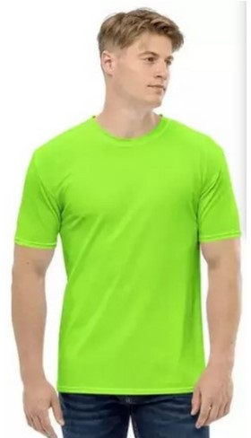 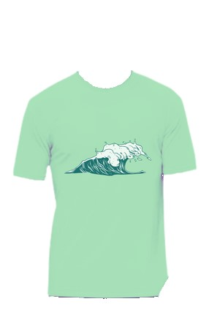

OUTPUT :-

