# **Task 4: Window Functions**

**Objective:** Utilize SQL window functions to rank students and perform cumulative analysis.

1. Dataset Setup

● Create and Populate Table:

Define a table Students with fields like:

○ StudentID (Primary Key)

○ Name

○ MathScore

○ TotalScore

● Populate with sample data for the analysis.

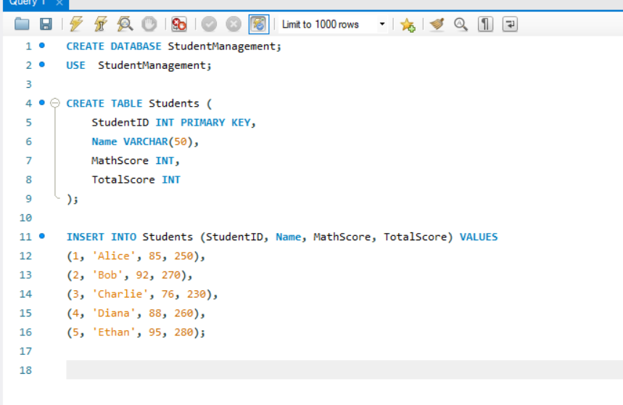

2. Tasks to Perform

Task 1: Rank Students Based on Total Scores

● Query Objective: Use the RANK() function to assign ranks to students based on their

TotalScore.

● Query Explanation:

○ Use RANK() OVER (ORDER BY TotalScore DESC) to rank students in

descending order of their total scores.

○ If two students have the same score, they receive the same rank, and the next

rank is skipped.

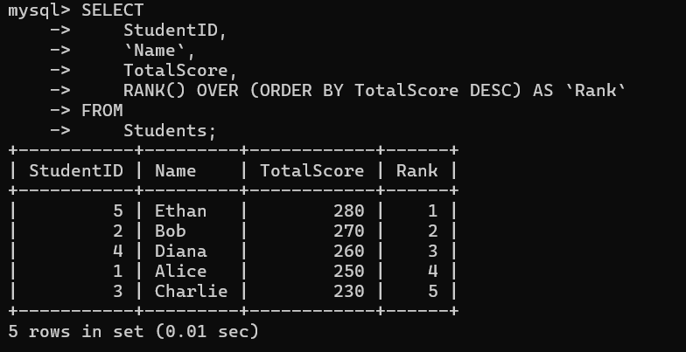

Task 2: Calculate Running Totals for Math Scores

● Query Objective: Use the SUM() function with OVER() to calculate running totals of

MathScore ordered by StudentID.

● Query Explanation:

○ Use SUM(MathScore) OVER (ORDER BY StudentID) to compute a

cumulative total.

○ This provides the total Math score up to each student in the order specified.

