# Task 5: CASE Statements for Conditional Transformation

**Objective**

Use SQL CASE statements to transform and categorize data based on specified conditions.

1. **Setup**

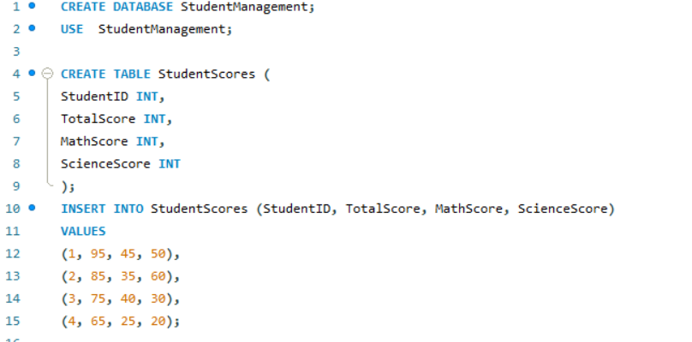

**2. Task**

1. Assign Grades Based on Total Scores

● Goal: Assign grades to students based on their total scores.

● Logic:

○ CASE statements can categorize students' total scores into grade brackets, e.g.:

■ >= 90: A

■ >= 80: B

■ >= 70: C

■ < 70: D (Fail)

● Expected Output:

○ Displays StudentID, TotalScore, and the assigned grad.

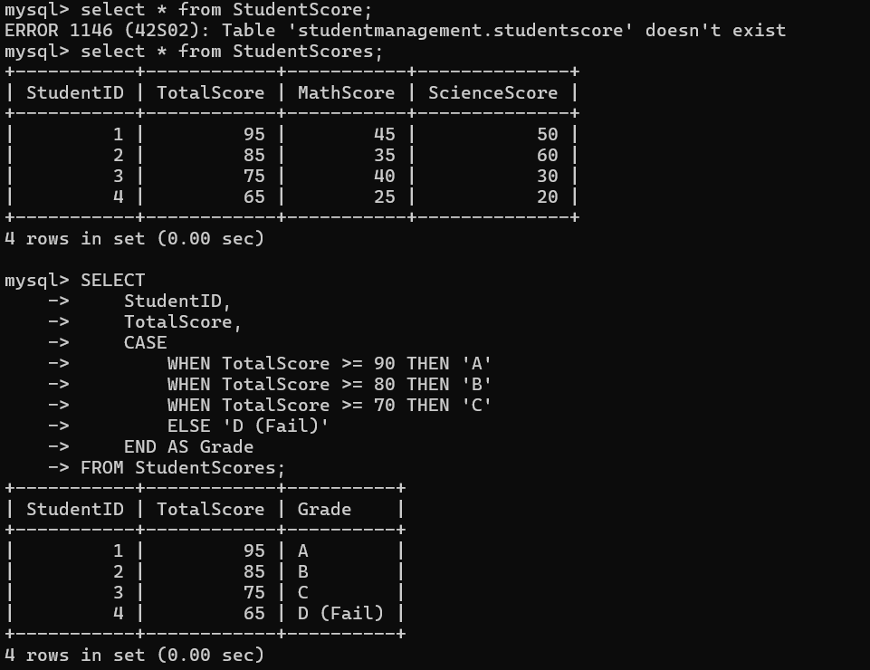

2. Identify Pass/Fail Status in Specific Subjects

● Goal: Check if a student passed or failed in each subject based on a passing threshold.

● Logic:

○ Use a CASE statement to evaluate individual subject scores:

■ Example: Pass if score ≥ 40, Fail otherwise.

● Expected Output:

○ Displays StudentID, individual subject scores, and their Pass/Fail status.

