**TELEPHONE DIRECTORY SYSTEM**

**Computer Science Project**

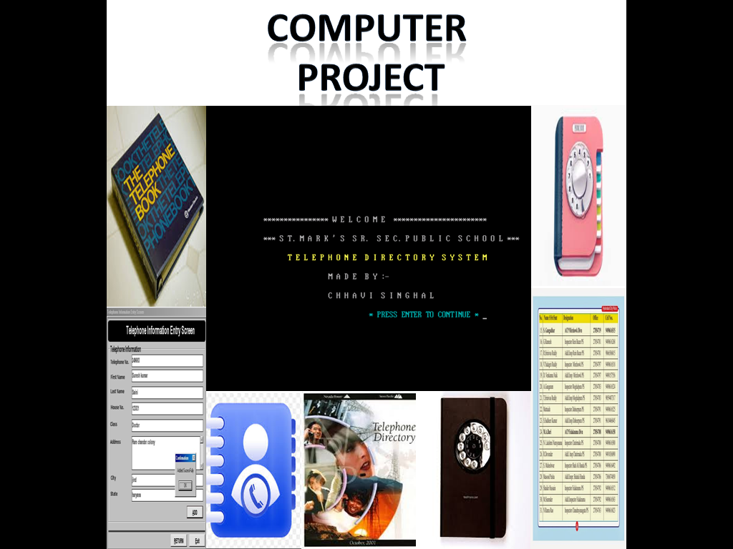

Developed By

CHHAVI SINGHAL

XII - F

St. Mark’s Sr. Sec. Public School

www.saintmarksschool.com

**INDEX**

|  |  |  |
| --- | --- | --- |
| Sno | Description | Page no. |
| 1 | Certificate | 3 |
| 2 | Acknowledgement | 4 |
| 3 | References | 5 |
| 4 | Introduction | 6 |
| 5 | Source Code | 7-21 |
| 6 | Output Screen | 22-54 |
| 7 | Header Files | 55 |
| 8 | Hardware & Software requirement | 56 |

**CERTIFICATE**

This is to certify that Telephone Directory System Computer Science project is developed by Chhavi Singhalunder my supervision in the computer lab of St. Mark’s Sr. Sec. Public School in the session 2015-2016. The work done by them is original.

Mr. Naveen Gupta

Computer Science Teacher

Date: ……………..........

Signature : ………………………

Acknowledgement

We would like to express my sincere gratitude to my computer teacher Mr. Naveen Gupta for his vital support, guidance and encouragement without which this project would not come forth from my side. Who helped me completing the project by giving ideas,thoughts and made this project easy and accurate.

We wish to thank my parents for their undivided support and interest who inspired me and encouraged me to go my own way, without which I would be unable to complete my project.

**References**

1.[www.google.com](http://www.google.com)/C++ project

2.www.wikepedia.com/c++ projects

3.Classnotes

**4.Computer Science C++ -Sumita Arora Textbook of**

**class XII**

**Introduction**

The system is designed such that it saves the name and number

of desired persons.

The system design will also meet the below objectives :-

* Displays the complete details of all the records of the directory.
* Easy search of telephone details based on person’s name.
* Easy search of telephone details based on the phone number.
* Deletion of the telephone records.
* Telephone details can be modified.

**Source Code**

**/\***

**Project Title: TELEPHONE DIRECTORY SYSTEM  
Version :  
Developed By :CHHAVI SINGHAL  
School :ST. MARK’S SR. SEC. PUBLIC SCHOOL**

**\*/**

**//Header Files**

#include<fstream.h>

#include<conio.h>

#include<process.h>

#include<stdio.h>

#include<string.h>

#include<dos.h>

#include<ctype.h>

**//Class**

class directory

{

private:

char name[30];//for name

char address[50];// for residence

char phno[10];//for phone number

int ch1,ch2;//for asking the choice

int valid;//for validation

char yn;//for asking yes or no

char a,b,c,d,e,f;//password variables

public:

**//Function Prototypes**

void intro();//for introduction of the project

void mainmenu();// for main menu

void user();//for user level

void admin();//for administrator level

void getdata(); //for getting the information

void showdata(); //for displaying the information

void add_record();//for adding the record

void report();//for displaying the record

void no_of_records();//for total no. of records

void delete_record();//for deleting the record

void update_record();//for updating the record

void search_phone();//for searching by phone no.

void search_name();//for searching by name

void password();//for password

void startagain();//for starting again

void std_isd();//for STD/ISD codes

}d1;

**//Function Definitions**

void directory::intro()

{

clrscr();

gotoxy(15,10);

cout<<"**************** W E L C O M E *********************** ";

gotoxy(15,12);

cout<<"*** S T. M A R K ' S S R. S E C. P U B L I C S C H O O L *** ";

gotoxy(20,14);

textcolor(YELLOW);

cputs(" T E L E P H O N E D I R E C T O R Y S Y S T E M ");

gotoxy(30,16);

cout<<" M A D E B Y :- ";

gotoxy(30,18);

cout<<" C H H A V I S I N G H A L ";

gotoxy(40,20);

textcolor(CYAN);

cputs(" * PRESS ENTER TO CONTINUE * ");

getch();

}

//###########################################################//

// M A I N M E N U //

//###########################################################//

void directory::mainmenu()

{

clrscr();

gotoxy(10,5);

cout<<"\t\t \n\t\t M A I N M E N U \n";

cout<<"\t\t \n\t\t (1) U S E R L E V E L ";

cout<<"\t\t \n\t\t (2) A D M I N I S T R A T O R L E V E L";

cout<<"\t\t \n\t\t (3) S T D / I S D C O D E S ";

cout<<"\t\t \n\t\t (4) E X I T \n\n " ;

cout<<" \t\t\n\t\t Enter your choice :";

cin>>ch1;

switch(ch1)

{

case 1 : clrscr();

d1.user();

break;

case 2 : clrscr();

d1.admin();

break;

case 3 : clrscr();

d1.std_isd();

break;

case 4 : exit(0);

break;

default : cout<<" \n Wrong choice ";

break;

}

}

//#########################################################//

// U S E R L E V E L //

//#########################################################//

void directory::user()

{

clrscr();

cout<<"\t\t\t \n\t\t\t U S E R L E V E L "<<endl;

cout<<"\t\t\t \n\t\t (1) Report ";

cout<<"\t\t\t \n\t\t (2) No of Records";

cout<<"\t\t\t \n\t\t (3) Search By Phone No ";

cout<<"\t\t\t \n\t\t (4) Search By Name ";

cout<<"\t\t\t \n\t\t (5) Main Menu";

cout<<"\t\t\t \n\t\t (6) Exit "<<endl;

cout<<"\t\t\t \n\t\t\t Enter your choice :";

cin>>ch2;

switch(ch2)

{

case 1: clrscr();

d1.report();

break;

case 2: clrscr();

d1.no_of_records();

break;

case 3: clrscr();

d1.search_phone();

break;

case 4: clrscr();

d1.search_name();

break;

case 5: clrscr();

d1.mainmenu();

break;

case 6: exit(0);

break;

default: cout<<" \n\t\t Wrong choice";

break;

}

}

//#######################################################//

// A D M I N I S T R A T O R L E V E L //

//#######################################################//

void directory::admin()

{

clrscr();

gotoxy(23,10);

//######### CALLING PASSWORD FUNCTION ##############//

d1.password();

clrscr();

cout<<"\n\n\n\t\t A D I M I N I S T R A T E R L E V E L ";

cout<<"\t\t\t\n\t (1) Add the record ";

cout<<"\t\t\t\n\t (2) Update the record ";

cout<<"\t\t\t\n\t (3) Delete the record ";

cout<<"\t\t\t\n\t (4) Main menu ";

cout<<"\t\t\t\n\t (5) Exit"<<endl;

cout<<"\n\t\t\t Enter your choice :";

cin>>ch2;

switch(ch2)

{

case 1: d1.add_record();

break;

case 2: clrscr();

d1.update_record();

break;

case 3: clrscr();

d1.delete_record();

break;

case 4: clrscr();

d1.mainmenu();

break;

case 5: exit(0);

break;

default: cout<<" \n Wrong choice";

break;

}

}

//#######################################################//

// To enter the details //

//#######################################################//

void directory::getdata()

{

clrscr();

gotoxy(23,10);

cout<<" \n Enter the name : ";

gets(d1.name);

cout<<" \n Enter the address :";

gets(d1.address);

do

{

valid=1;

cout<<" \n Enter phone number :";

gets(d1.phno);

if(strlen(d1.phno)!=10)

{

valid=0;

cout<<"\n\t Enter a valid 10-digit phone number \n";

getch();

}

else

{

for(int i=0;i<10;i++)

{

if(!isdigit(d1.phno[i]))

{

cout <<"\n\t Enter phone number containing digits only \n ";

valid=0;

break;

}

}

}

}while(!valid);

}

//#######################################################//

// To show data //

//#######################################################//

void directory::showdata()

{

cout<<"\n Name :"<<d1.name<<"\n";

cout<<"\n Address :"<<d1.address<<"\n";

cout<<"\n Phone No :"<<d1.phno<<"\n";

cout<<"----------------------------------------" ;

getch();

}

//#########################################################//

// REPORT OF ALL THE RECORDS //

//#########################################################//

void directory::report()

{

fstream f1;

cout<<" \n List of Telephone Directory : ";

cout<<" \n ------------------------------";

cout<<" \n Press enter to view next record ";

cout<<" \n ------------------------------";

f1.open("ghar.dat",ios::in|ios::binary);

while(!f1.eof()&&f1.read((char*)&d1,sizeof(d1)))

{

d1.showdata();

}

f1.close();

d1.startagain();

}

//#######################################################//

// NUMBER OF RECORDS //

//#######################################################//

void directory::no_of_records()

{

fstream f1;

f1.open("ghar.dat",ios::in|ios::binary);

f1.seekg(0,ios::end);

int n;

n=f1.tellg()/sizeof(d1);

gotoxy(10,5);

cout<<"\t\t\n Number of Records = "<<n;

getch();

d1.startagain();

}

//########################################################//

// SEARCH BY PHONE NUMBER // //########################################################//

void directory::search_phone()

{

fstream f1;

cout<<" \n Search By Phone No : ";

cout<<" \n ---------------------";

char phno1[10],flag1='n';

cout<<"\n Enter Phone No : ";

gets(phno1);

f1.open("ghar.dat",ios::in|ios::binary);

while(!f1.eof()&&f1.read((char*)&d1,sizeof(d1)))

{

if(strcmpi(phno1,d1.phno)==0)

{

flag1='y';

cout<<"\n\t Record found !!! \t\n";

d1.showdata();

break;

}

}

f1.close();

if (flag1=='n')

{

cout<<"\n\t\t\n------Record not found-----\n";

}

d1.startagain();

}

//############################################//

// Searching by name //

//############################################//

void directory::search_name()

{

fstream f1;

cout<<" \n Search By Name : ";

cout<<" \n -----------------";

char name1[30],flag2='n';

cout<<"\n Enter Name : ";

gets(name1);

f1.open("ghar.dat",ios::in|ios::binary);

while(!f1.eof() && f1.read((char*)&d1,sizeof(d1)))

{

if(strcmpi(name1,d1.name)==0)

{

cout<<"\n\t Record found !!! \n ";

d1.showdata();

flag2='y';

break;

}

}

f1.close();

if(flag2=='n')

{

cout<<"\n\t\t\n------Record not found-----\n";

}

d1.startagain();

}

//###################################################//

// ADD THE RECORD //

//###################################################//

void directory::add_record()

{

fstream f2;

cout<<" \n Add the record ";

clrscr();

cout<<"\n\n\n\t\t Add the record ";

cout<<"\n\n\t\t Accessing........ ";

delay(2000);

f2.open("ghar.dat",ios::app|ios::binary);

d1.getdata();

f2.write((char*)&d1,sizeof(d1));

cout<<"\n\t Record added successfully !!!";

f2.close();

d1.startagain();

}

//#################################################//

// UPDATE THE RECORD //

//#################################################//

void directory::update_record()

{

fstream f2;

cout<<" \n Update the record ";

cout<<" \n ---------------------";

char phno2[10],flag3='n';

int record=0;

f2.open("ghar.dat",ios::in|ios::out|ios::binary);

cout<<"\n Enter Phone No : ";

gets(phno2);

while(!f2.eof() && f2.read((char*)&d1,sizeof(d1)))

{

record++;

if(strcmpi(phno2,d1.phno)==0)

{

cout<<"\n Record found !!! ";

f2.seekg((record-1)*sizeof(d1));

d1.showdata();

cout<<" \n Are you sure you want to update(y/n) :";

cin>>yn;

if(yn!='y')

{

cout<<"\n Don't want to update ";

cout<<"\n (1) Press 1 to exit \n (2) Press 2 to return to main menu \n (3) Press 3 to return to administrator level ";

cin>>ch1;

if(ch1==1)

exit(0);

else if(ch1==2)

d1.mainmenu();

else if(ch1==3)

d1.admin();

}

else if(yn=='y')

{

cout<<"\n Enter the new record ------";

delay(1500);

d1.getdata();

f2.write((char*)&d1,sizeof(d1));

flag3='y';

cout<<"\n Record updated succesfully----";

break;

}

}

}

f2.close();

if(flag3=='n')

cout<<"\n------ Record not found --------\n";

getch();

d1.startagain();

}

//####################################################//

// DELETE THE RECORD //

//####################################################//

void directory::delete_record()

{

fstream f2,f3;

cout<<" \n Delete the record by Phone No : ";

cout<<" \n ---------------------";

char phno3[10],flag4='n';

f2.open("ghar.dat",ios::in|ios::binary);

f3.open("ghartemp.dat",ios::app|ios::binary);

cout<<"\n Enter Phone No : ";

gets(phno3);

while(!f2.eof() && f2.read((char*)&d1,sizeof(d1)))

{

if(strcmpi(phno3,d1.phno)==0)

{

flag4='y';

d1.showdata();

cout<<" \n Are you sure you want to delete(y/n) :";

cin>>yn;

if(yn!='y')

{

f3.write((char*)&d1,sizeof(d1));

}

else

{

cout<<"\n The record is deleted successfully \n";

}

}

else

{

f3.write((char*)&d1,sizeof(d1));

}

}

f2.close();

f3.close();

remove("ghar.dat");

rename("ghartemp.dat","ghar.dat");

if(flag4=='n')

cout<<"\n------- Record Not Found --------\n";

getch();

d1.startagain();

}

//#####################################################//

// PASSWORD PROGRAM //

//#####################################################//

void directory::password()

{

cout<<" Enter the password :";

a=getch();

cout<<" * ";

b=getch();

cout<<" * ";

c=getch();

cout<<" * ";

d=getch();

cout<<" * ";

e=getch();

cout<<" * ";

f=getch();

cout<<" * ";

if(a=='c'&&b=='h'&&c=='h'&&d=='a'&&e=='v'&&f=='i')

{

cout<<"\n\n\t\t The password is correct \n\t\t Accessing.......";

delay(2000);

}

else

{

cout<<" \n\n\t\t Password is incorrect \n";

cout<<" \n\n\t\t Do you wish to continue ? (y/n) :";

cin>>yn;

if(yn=='y')

{

cout<<" \n\t\t Press enter to re-enter the password ";

getch();

d1.admin();

}

else

{

exit(0);

}

}

}

void directory::startagain()

{

cout<<" \n Do you want to exit (y/n) ";

cin>>yn;

if(yn=='y')

{

exit(0);

}

else

{

d1.mainmenu();

}

}

//#####################################################//

// S T D / I S D C O D E S //

//#####################################################//

void directory::std_isd()

{

cout<<"\t\t\t City STD Code \n\n ";

cout<<"\t Ahmedabad - 079 "<<"\t\t Bangalore - 080 \n "<<"\t Bhopal - 0755 ";

cout<<"\t\t\t Kolkata - 033 \n "<<"\t Chennai - 044 "<<"\t\t\t Delhi - 011 \n ";

cout <<"\t Hyderabad - 040 "<<"\t\t Indore - 0731 \n "<<"\t Mumbai - 022 ";

cout<<"\t\t\t Vadodara - 0265\n"<<"\t Calcutta - 33 "<<"\t\t Chandigarh - 172\n ";

cout<<"\t Chennai - 44"<<"\t\t\t Gandhinagar - 2712\n "<<"\t Gurgaon - 124 ";

cout<<"\t\t Guwahati - 361\n"<<"\t Hyderabad - 40 "<<"\t\t Jaipur - 141\n "<<"\t Jammu -191" ;

cout<<"\t\t\t Lucknow -522\n "<<"\t Ludhiana -161 "<<"\t\t\t Mumbai 22\n"<<"\t Patna -612 "<<"\t\t\t Pune - 20 \n";

cout<<"\t\t\t ISD code\n";

cout<<"\t Australia - 61"<<"\t\t\t Canada - 1\n"<<"\t Germany -49 ";

cout<<"\t\t\t India - 91\n "<<"\t Italy - 39"<<"\t\t\t Japan -81\n";

cout<<"\t New zealand - 64 "<<"\t\t Pakistan - 92\n"<<"\t Russia - 7";

cout<<"\t\t\t South Africa - 27\n"<<"\t Sri Lanka - 94"<<"\t\t\t UAE - 971\n ";

cout<<"\t United Kingdom - 44"<<"\t\t USA - 1\n "<<"\t Zimbabwe - 263\n";

d1.startagain();

getch();

}

**//Main Function**

void main()

{

clrscr();

d1.intro();

d1.mainmenu();

getch();

}

**Output Screen Captures**

**(with all main screens)**

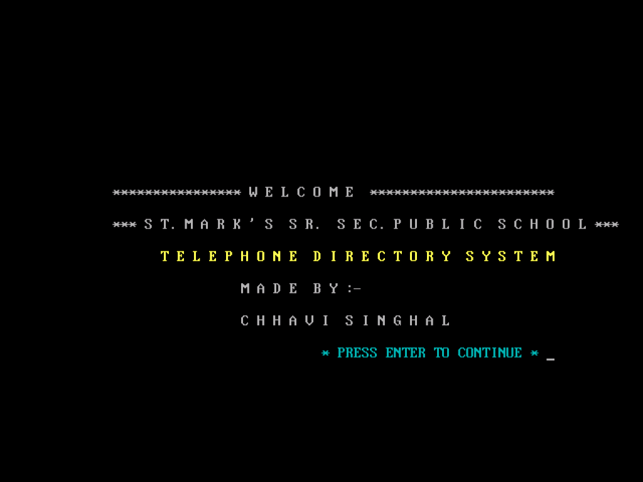

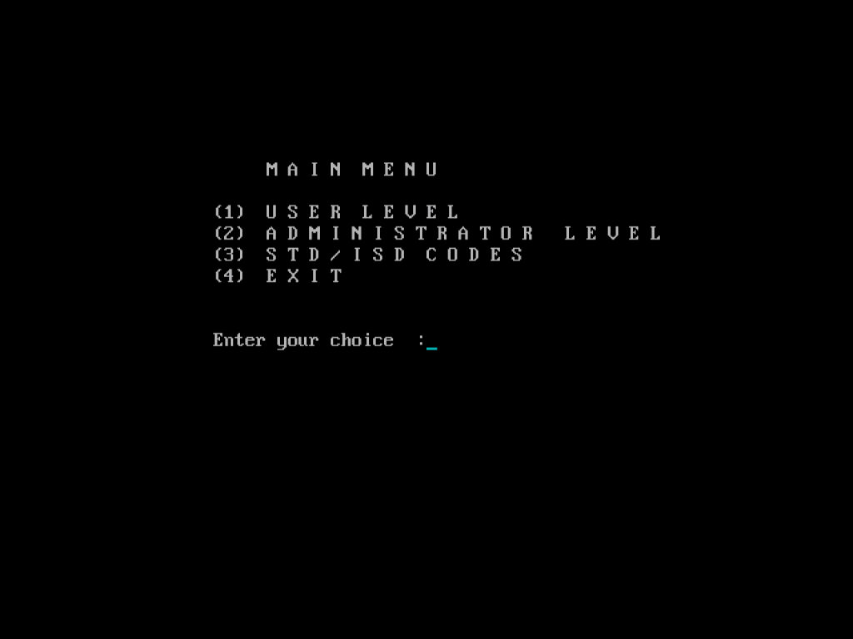

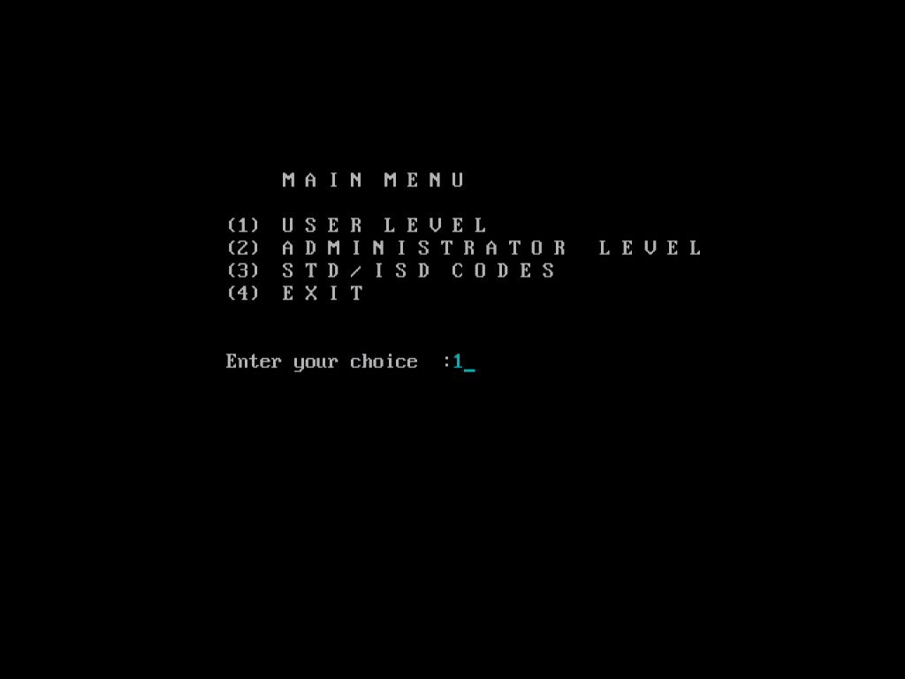

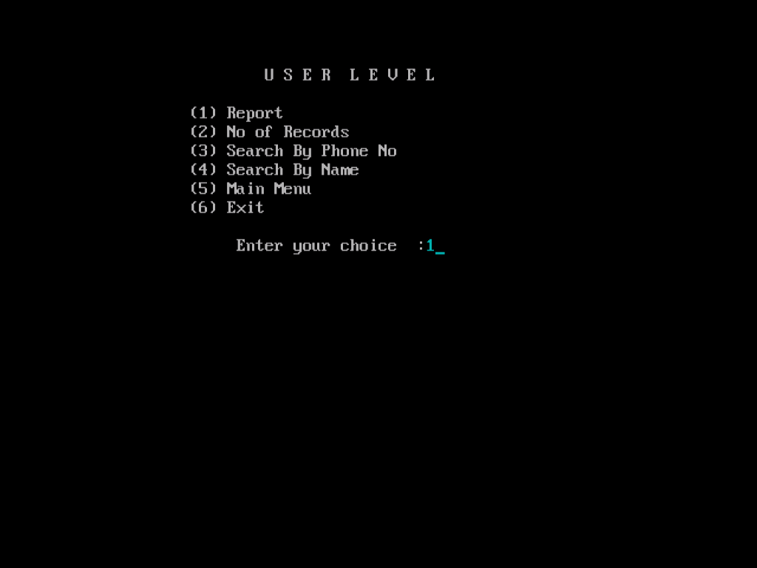

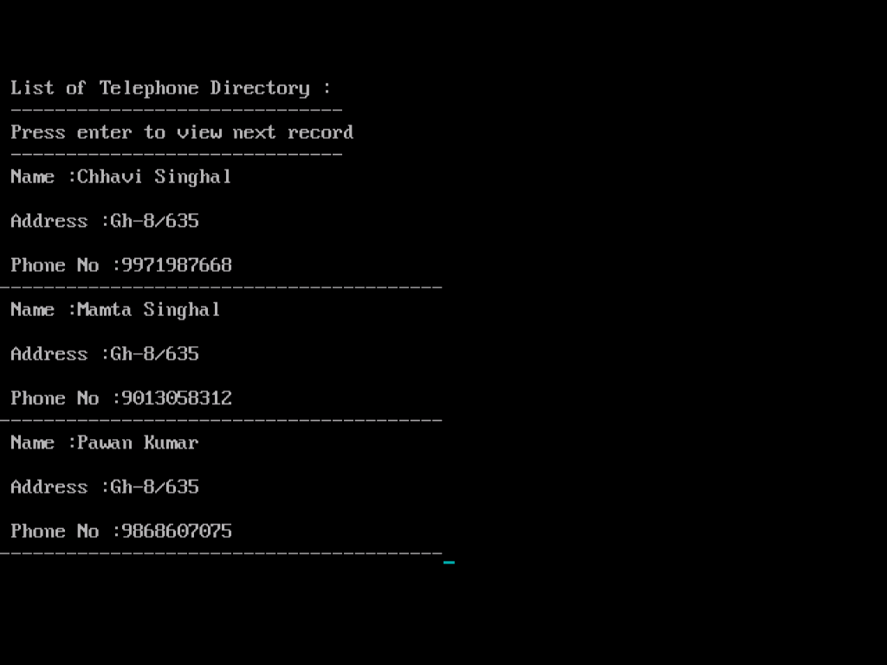

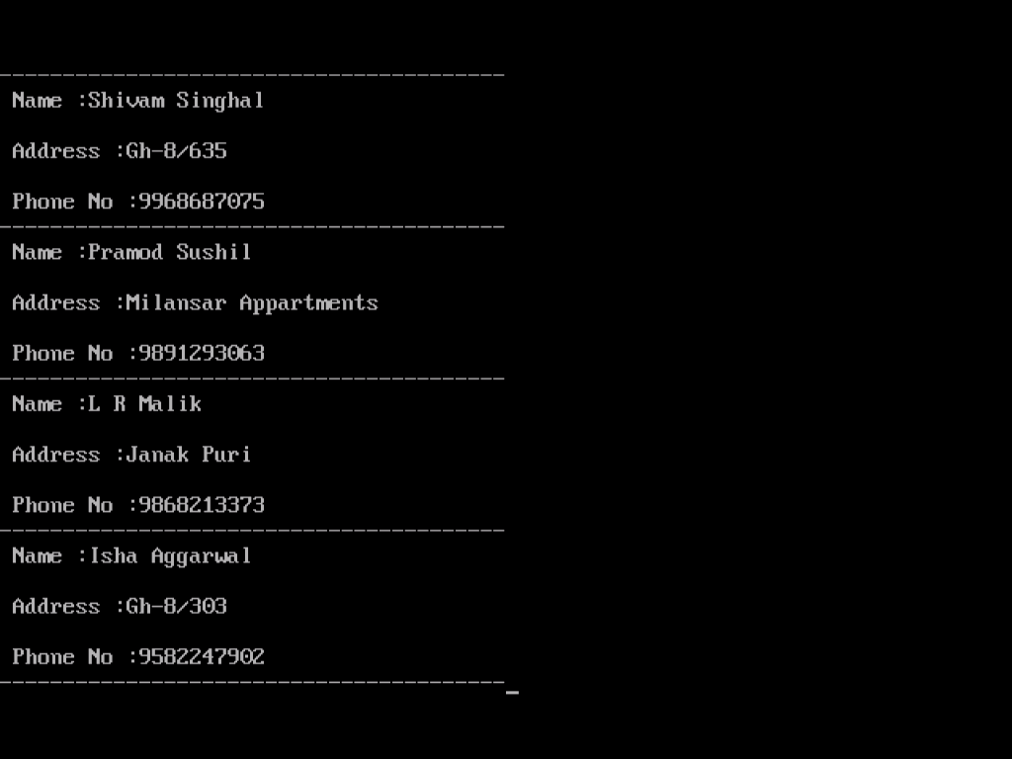

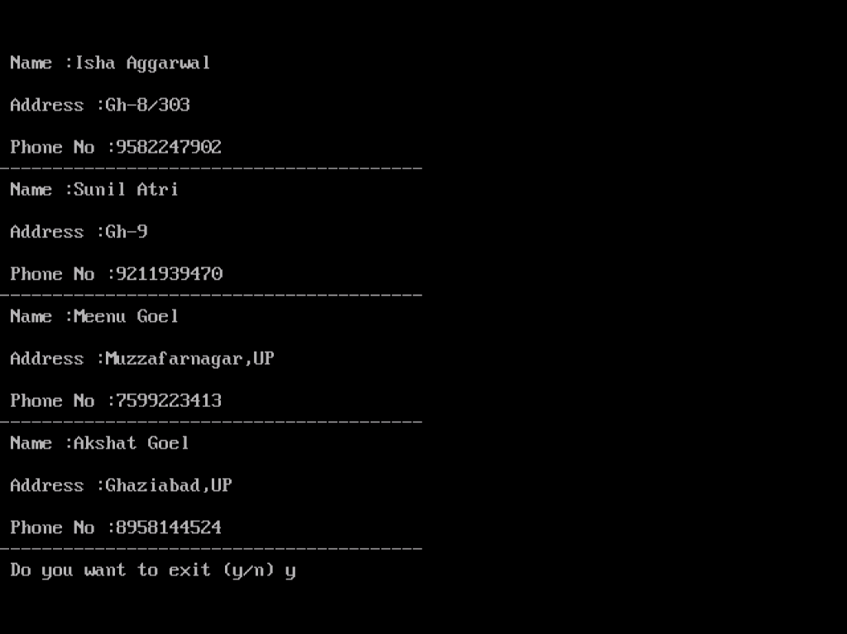

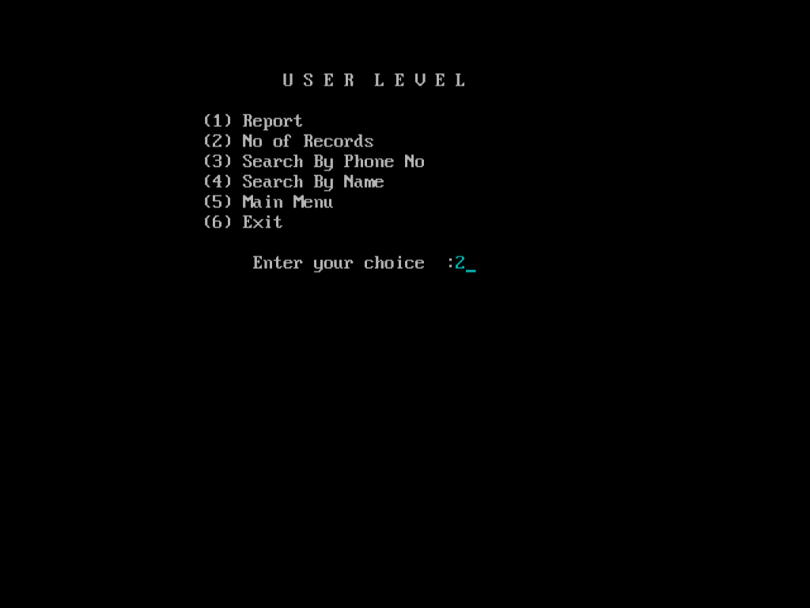

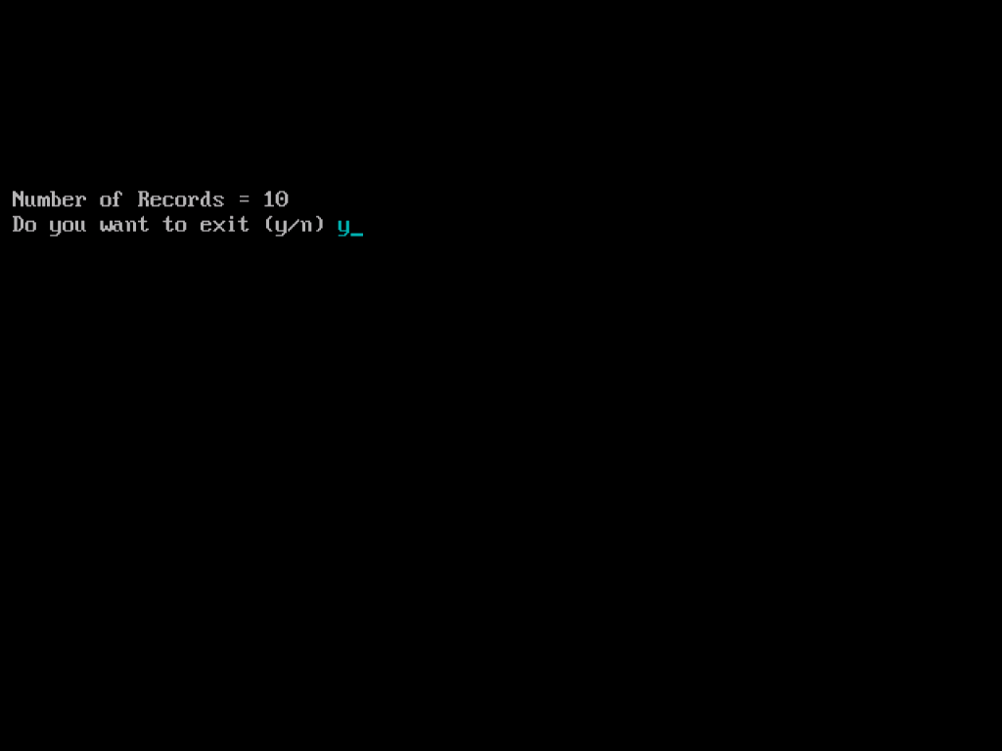

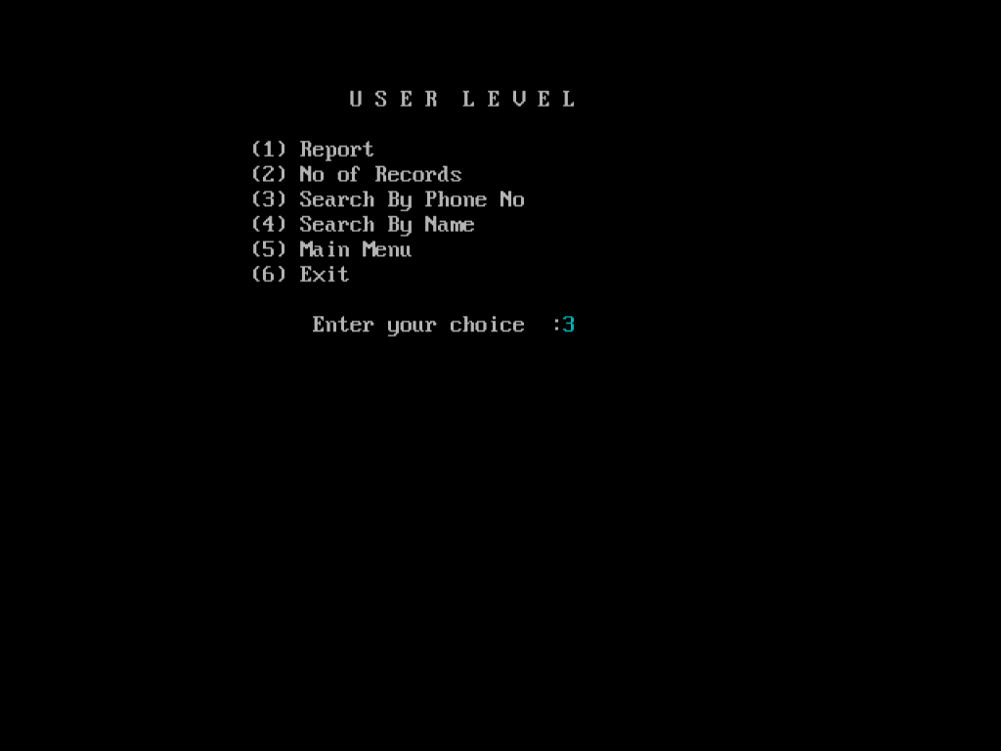

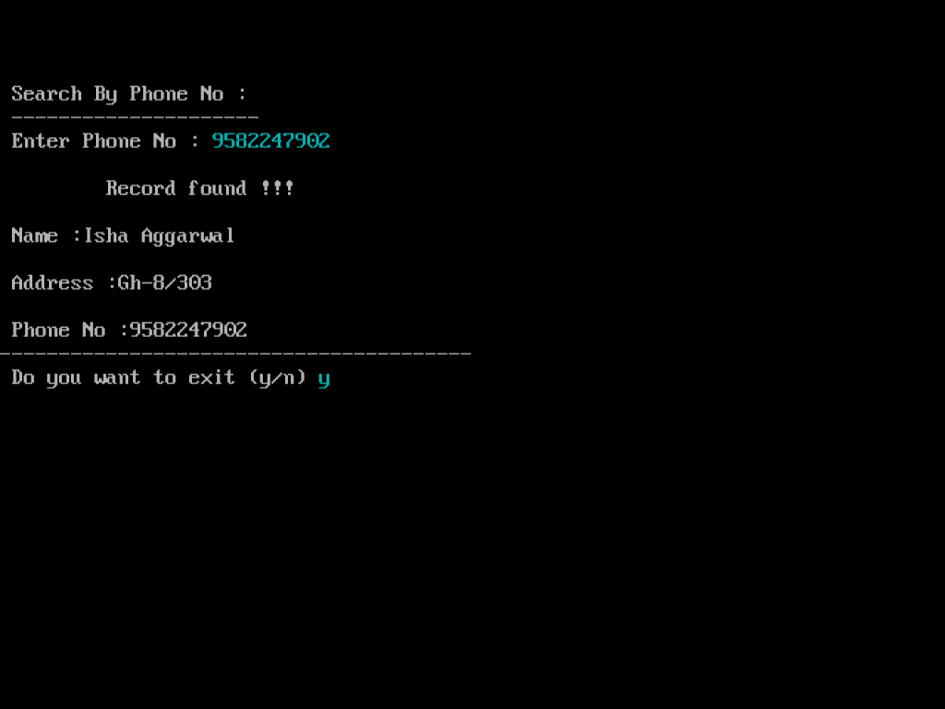

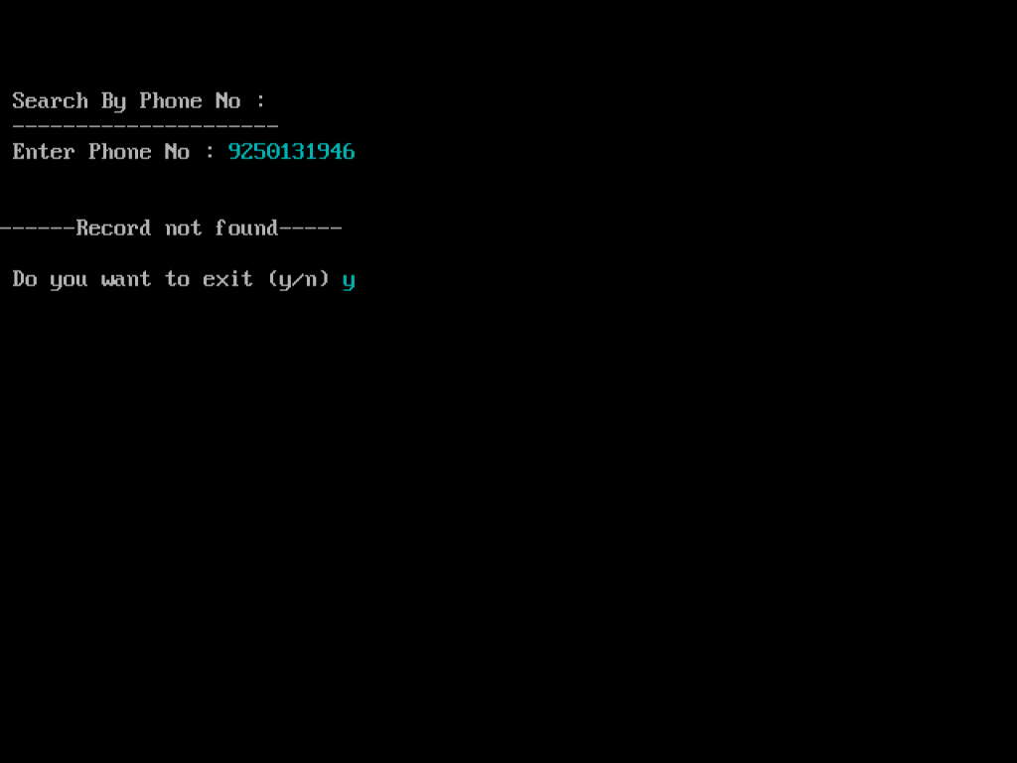

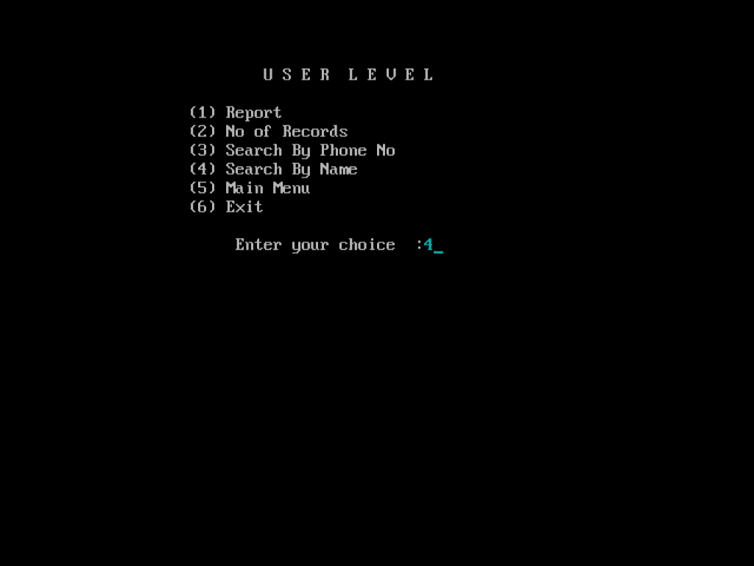

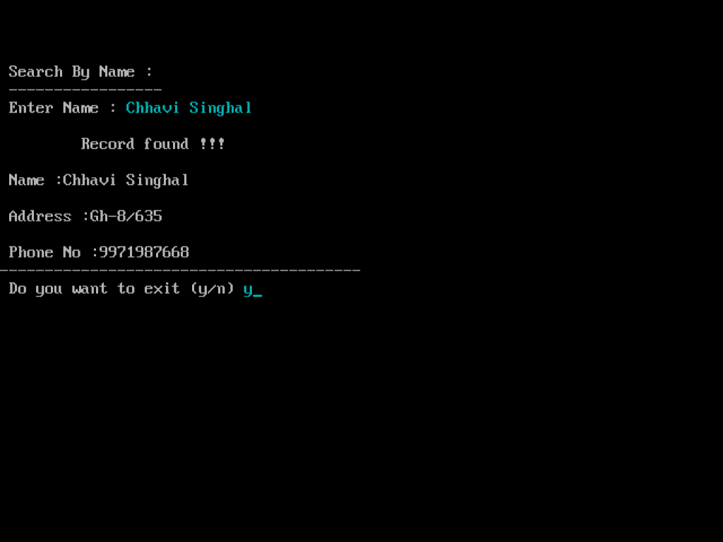

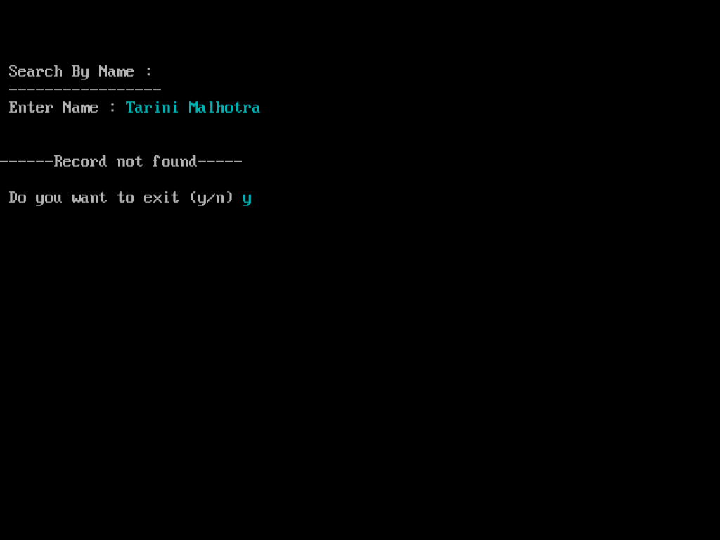

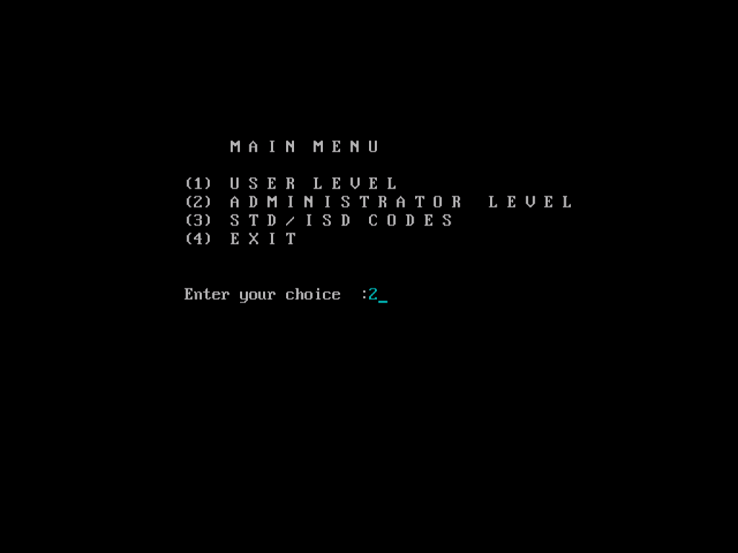

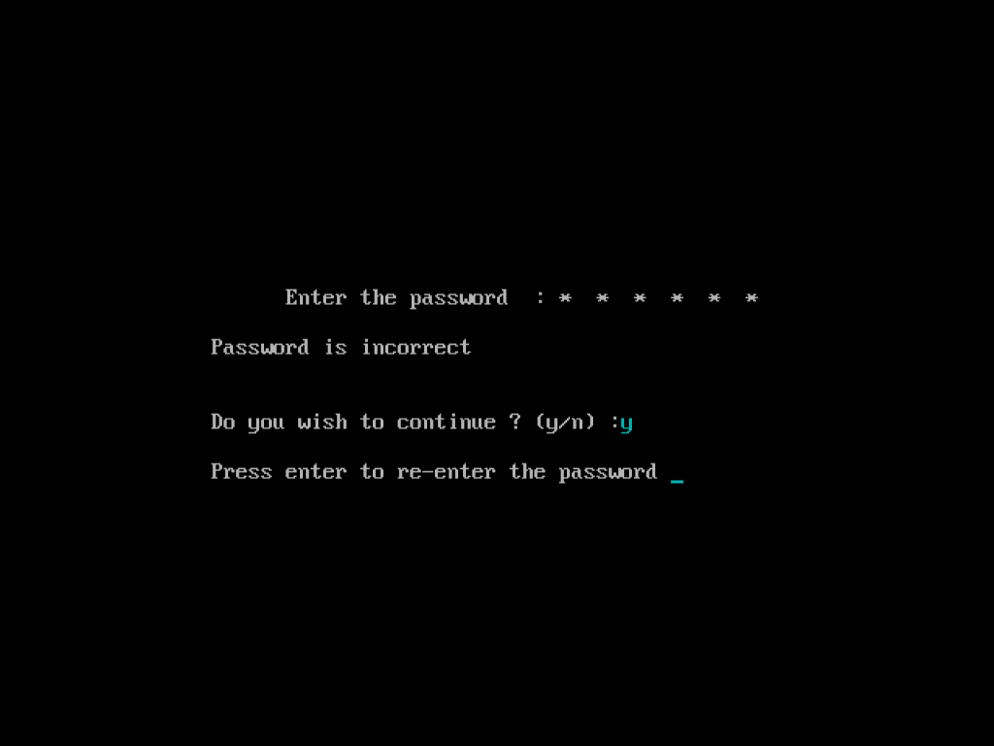

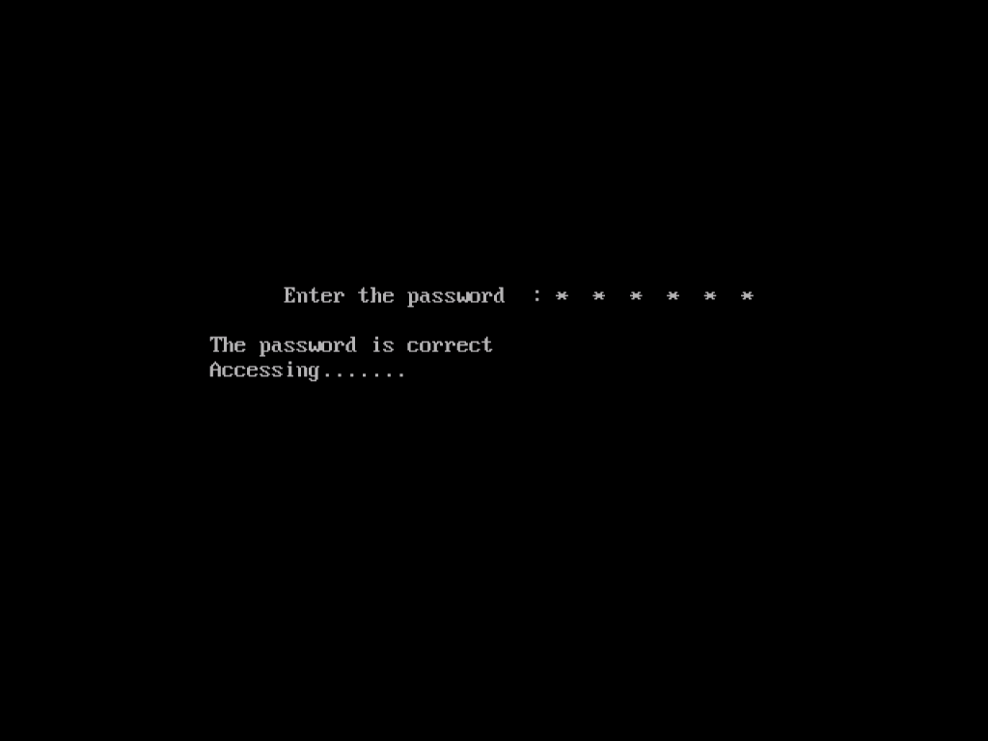

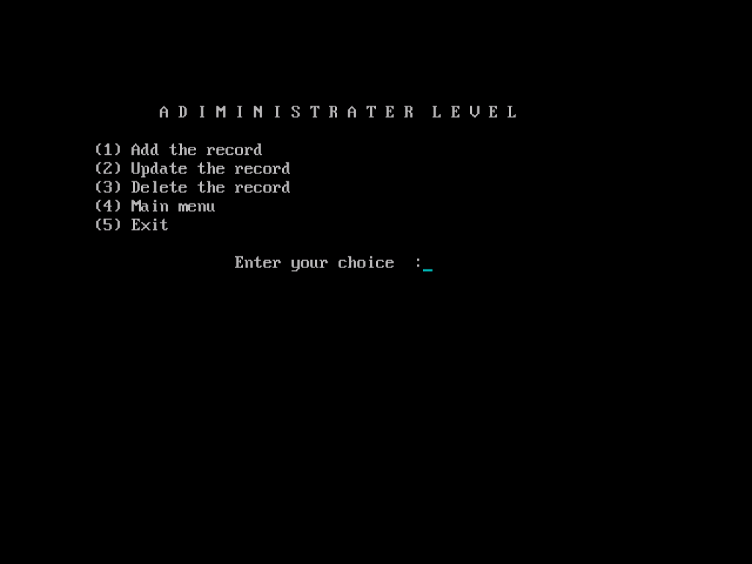

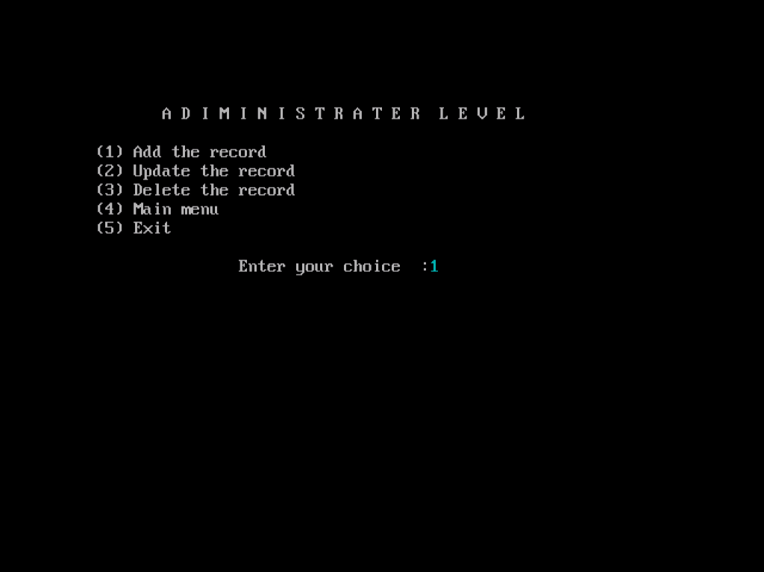

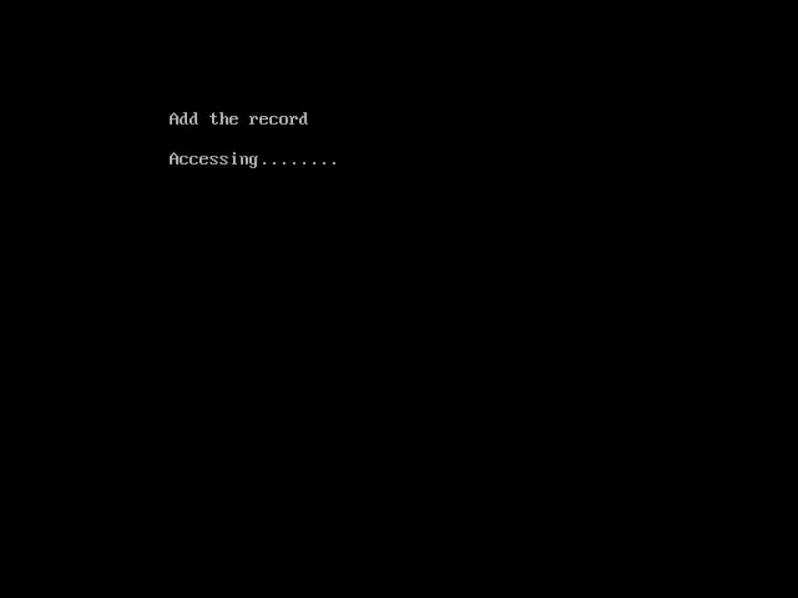

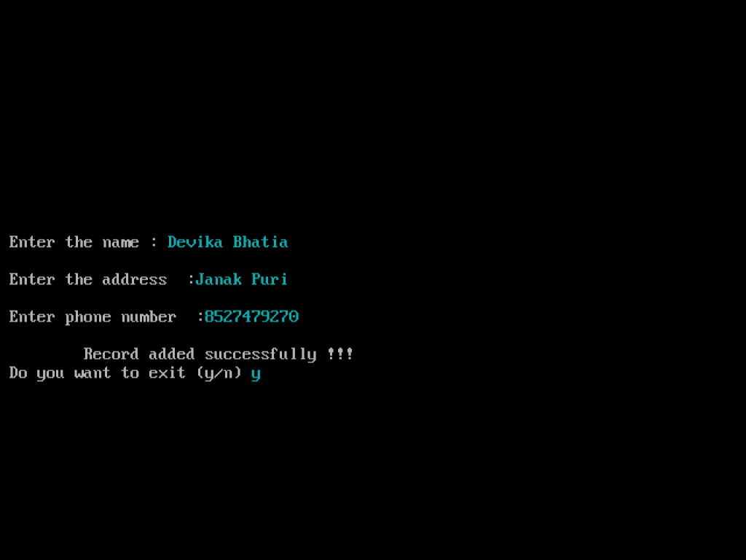



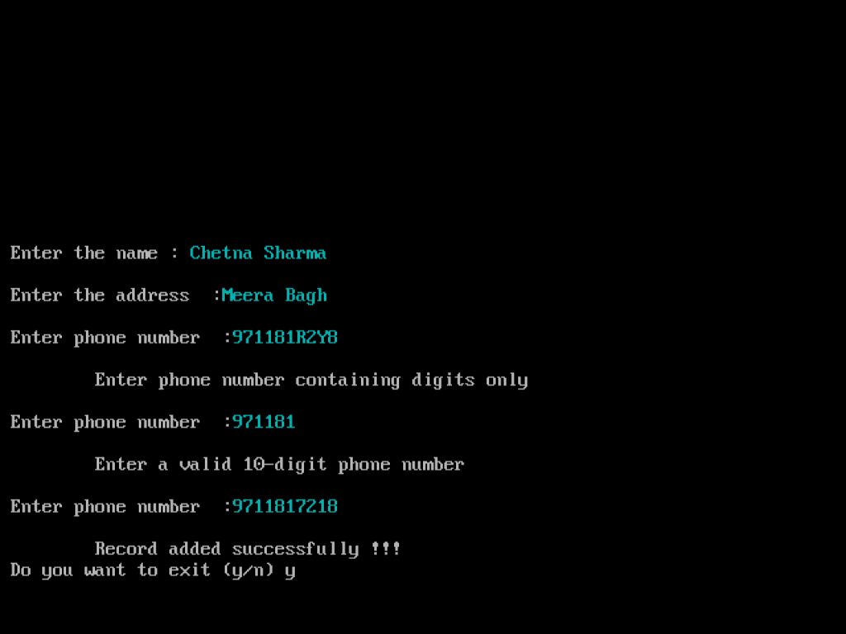

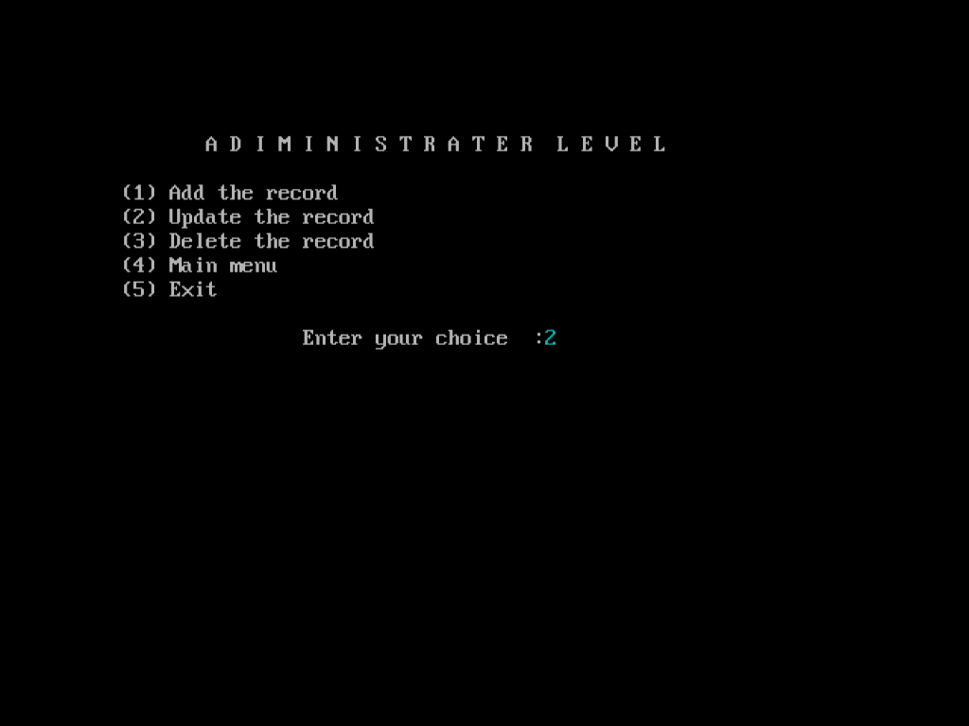

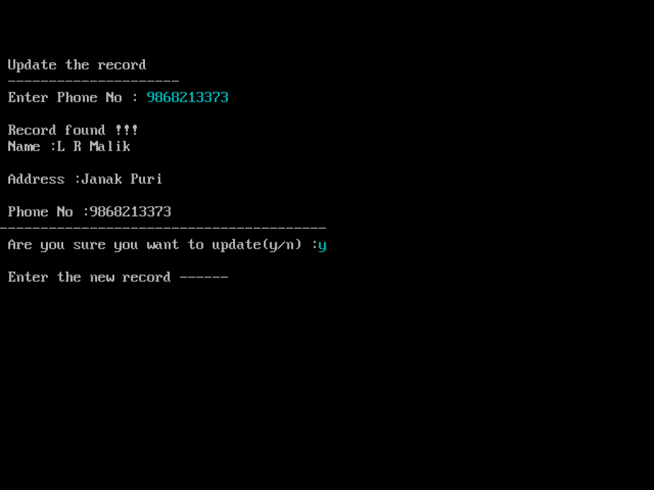

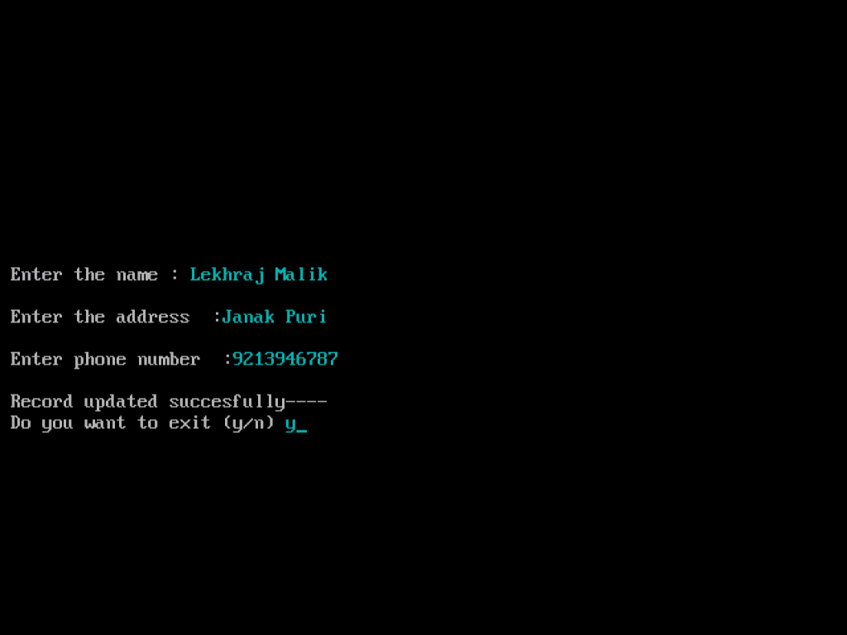

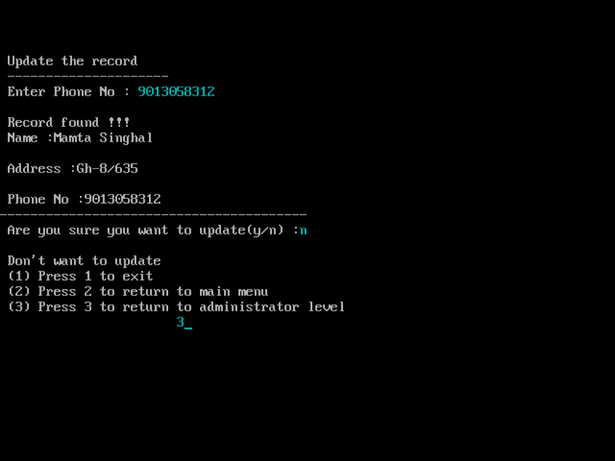

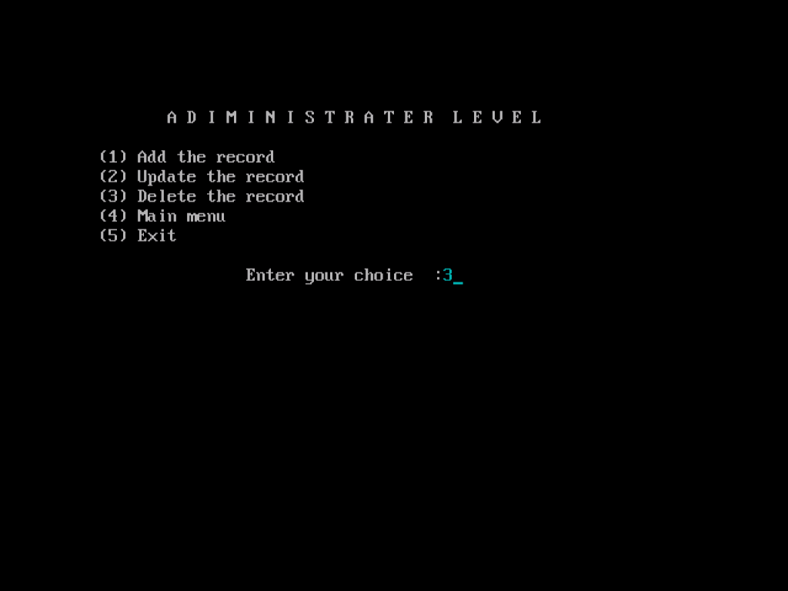

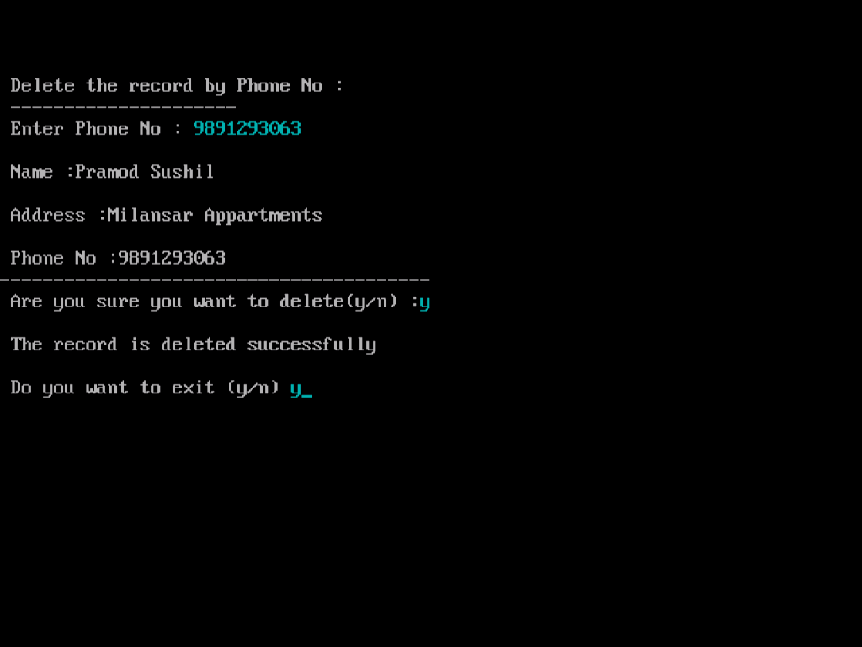

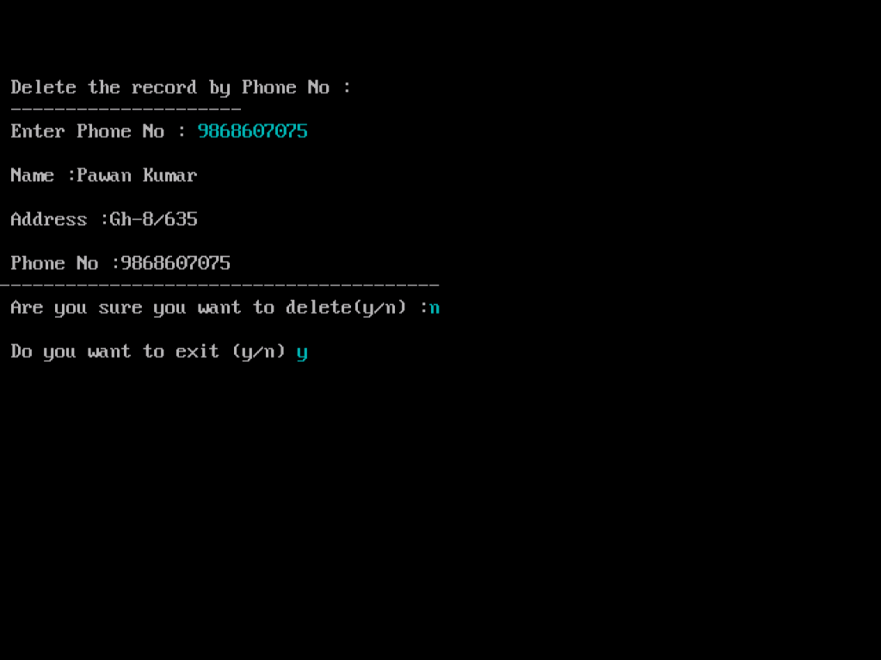

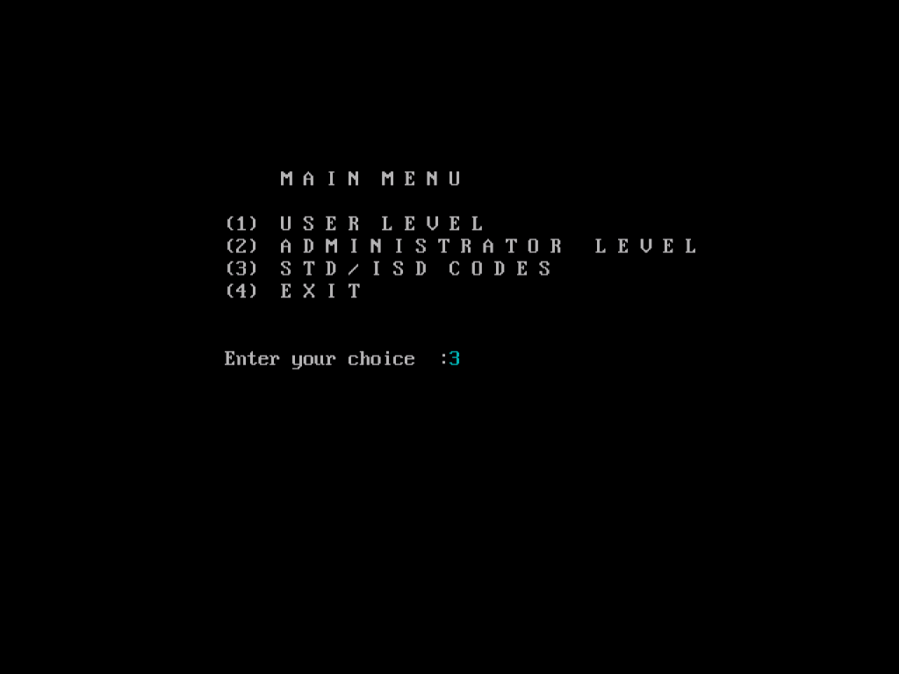

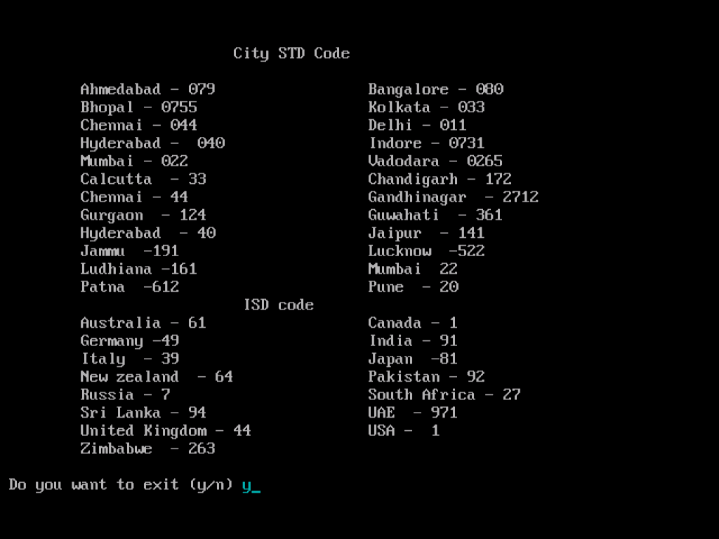

**HEADER FILES**

**The required header files which are used in the project are the following with the function which is accessed by using it :-**

1. fstream.h

This header file includes the definitions for the stream

classes ifstream, ofstream and fstream.

It contain predefines set of operation for handling file related input and output, fstream.

1. conio.h

Functions used are getch() , clrscr() , gotoxy() ,textcolor() ,

cputs()

1. process.h

Function exit(0) is used.

1. stdio.h

Function used are gets() , remove() , rename()

1. string.h

Function used strcmpi() , strlen()

1. dos.h

delay()

1. ctype.h

isdigit()

**Hardware & Software Requirement**

Hardware Requirement

Intel core/i3/i5/i7 or any equivalent

With at least 256 MB RAM

2 MB free space on Hard Disk

Color Monitor/LCD

Operating System & Compiler

MS Windows

Turbo C++ 3.0 Compiler/Dev C++ or any equivalent