Retail Sales & Profit Analysis Dashboard

- Project Objective
The objective of this project is to analyze retail sales and profit data and create an interactive Power BI dashboard that provides meaningful business insights. The dashboard helps analyze sales, profit, quantity, product categories, regions, customer segments, and sub-categories to support data-driven decision-making.

- Dataset Description
Dataset: Superstore Retail Sales Dataset
The dataset contains retail transaction information such as sales, profit, quantity, category, sub-category, region, customer segment, state, city, shipping mode, and other business-related fields.
The dataset was used to understand sales performance, profitability, regional performance, customer segments, and sub-category-level performance.

- Tools & Technologies

- Power BI: Used to create interactive dashboard and data visualizations.
- Power Query: Used for data cleaning and transformation.
- Python: Used for data analysis and preprocessing.
- Pandas & Numpy: Used for data manipulation and analysis.
- Microsoft Excel: Used for reviewing and preparing the dataset.

- Data Preparation
The dataset was reviewed and prepared before creating the dashboard. The data was checked for missing values, incorrect data types, duplicate records, and inconsistent values. Relevant columns such as Sales, Profit, Quantity, Category, Sub-Category, Region, and Segment were selected for analysis. Power Query was used to transform and prepare the data for visualization in Power BI.

- Analysis Performed
The Retail Sales data was analyzed using Power BI to identify important business trends and performance patterns. The analysis is focused on:
- Sales performance by category.
- Profit performance by category.
- Sales performance by region.
- Profit performance by region.
- Sales contribution by customer segment.
- Profit, sales, and quantity by sub-category.
- Overall Sales, Profit, and Quantity using KPI Cards.
Interactive slicers were also added for Region, Category, and Segment to allow users to filter and explore the data.

- Dashboard Features
The Power BI dashboard was designed to provides a clear and interactive view of retail business performance. The main feature of the dashboard include:
- KPI Cards: Display Total Sales, Total Profit, and Total Quantity.
- Sales by Category: Compares sales performance across different products categories.
- Profit by Category: Shows profitability across product categories.
- Sales by Region: Compares sales performance across different region.
- Profit by Region: Analyzes regional profitability.
- Sales by Segment: Shows the contribution of Consumer, Corporate, and Home Office segments to total sales.
- Sub-Category Performance Table: Provides detailed Sales, Profit, and Quantity information by sub-category.
- Interactive Slicers: Region, Category, and Segment slicers allow users to filter the entire dashboard.

- Key Business Insights
The Dashboard analysis provided the following key business insights:
- Technology is the strongest-performing category in terms of sales and profit.
- The West region shows strong sales and profit performance compared with other regions.
- The Consumer segment contributes the largest share of overall sales.
- Sub-Category performance varies, with some sub-categories generating high sales and profit while others have low or negative profit.
- The analysis shows that high sales do not always result in high profit, so both sales and profitability should be monitored.
- The interactive slicers make it possible to analyze performance for specific regions, categories, and customer segments.

- Business Recommendations
Based on the analysis, the following recommendations can be made:
- Focus on high-performing Technology products and continue effective marketing strategies for this category.
- Analyze the successful strategies used in the West region and consider applying similar strategies to lower-performing regions.
- Develop targeted offers and marketing campaigns for the Consumer segment, as it contributes the largest shares of sales.
- Review pricing, discounts, product costs, and shipping expenses for low-profit or negative-profit sub-categories.
- Monitor profit along with sales when evaluating business performance, because high sales do not always mean high profitability.
- Use the interactive Power BI dashboard regularly to monitor performance and support data-driven decisions.

- Conclusion:
The Retail Sales & Profit Analysis project successfully demonstrates how Power BI can be used to transform raw retail data into meaningful business insights. An interactive dashboard was developed to monitor sales, profit, quantity, category performance, regional performance, customer segments, and sub-category performance.
The Project helped in understanding the complete data analytics process, including data preparation, analysis, visualizations, dashboard development, and interpretation of business insights. The dashboard can help businesses monitor performance and make data-driven decisions.

- Power BI Dashboard
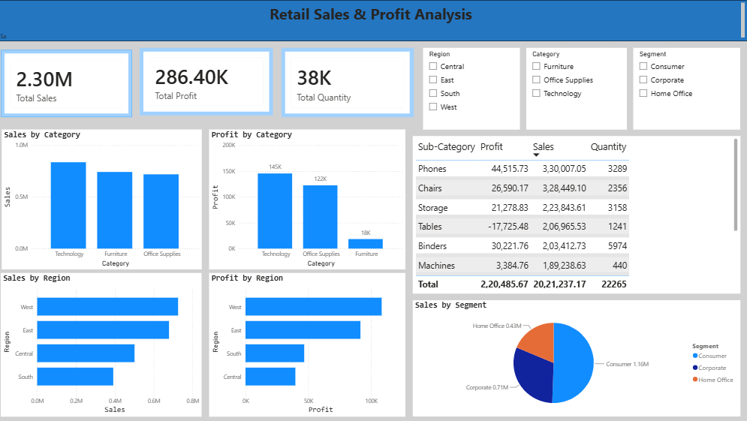
Figure 1: Retail Sales & Profit Analysis Dashboard

