Airvistara_BME_UserDocuments

Admin Module

1. Web Address : <http://bme.airvistara.com/bmeadmin>

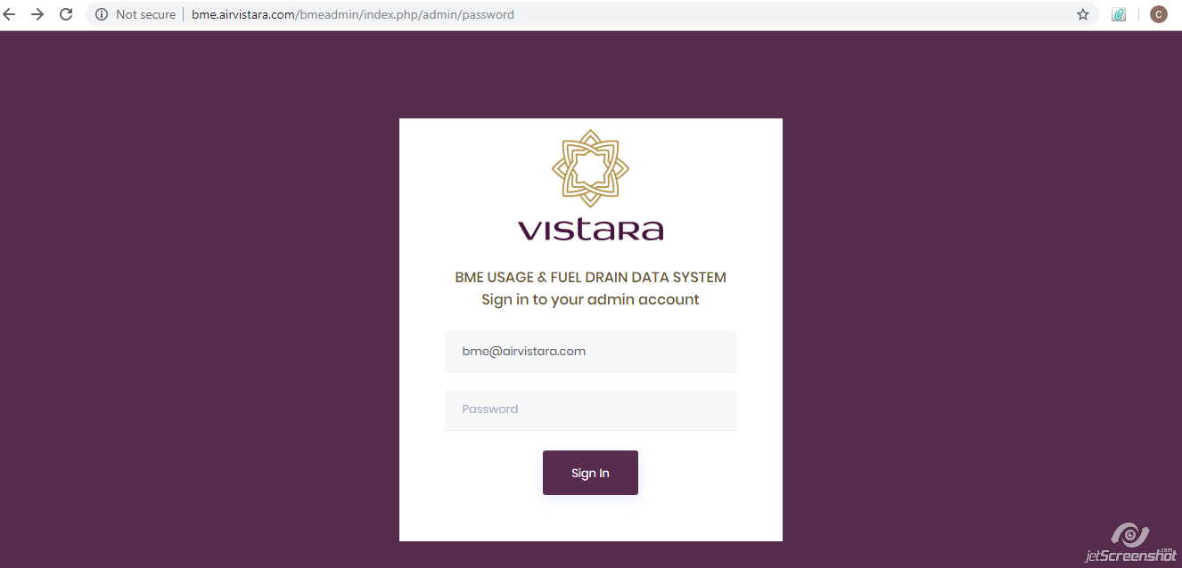

1. Login : After Opening Home Page It will ask for login credentials.
2. Login Name : [bme@airvistara.com](mailto:bme@airvistara.com)
3. Password : bme@123

After Entering login credentials it will direct to home page

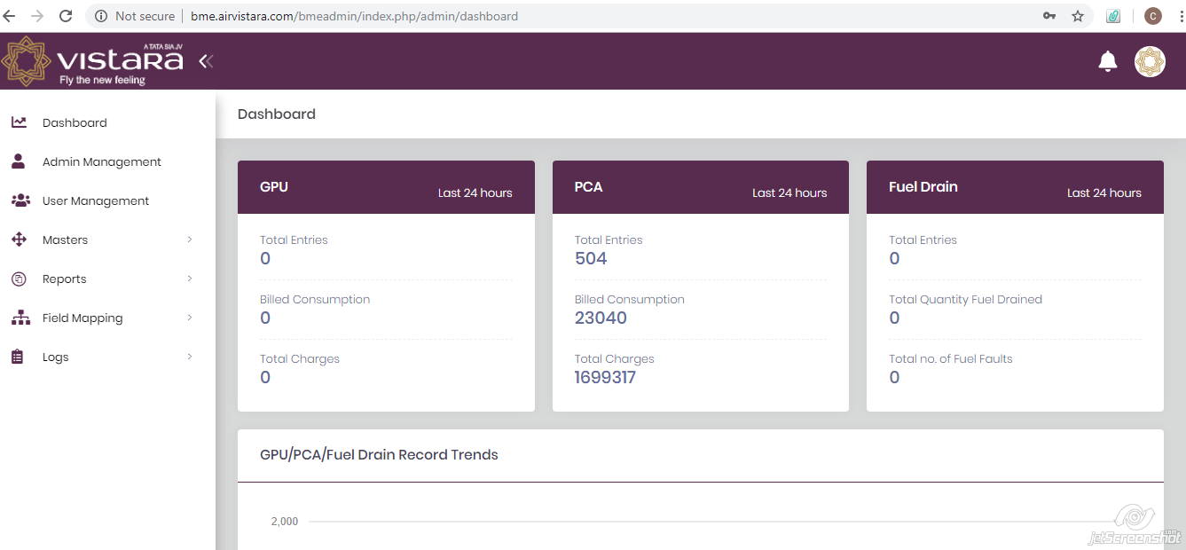

3) By default Home Page showing Dashboard or After clicking on dashboard it will direct on same page, having information about GPU, PCA & Fuel Drain in last 24 hours.

4) Home Page 🡪 Admin Management

i) When user click on Admin Management 🡪Admin Management Page open showing active admin management & Archived Admin Management

ii) For Active Admin Management it provide facility for Add New Admin, Search any name from particular department with particular sub department or user can Reset the search i.e. can clear the searching criteria as well as user can store the list of active admin management in .xlsx format.

iii) For Archived Admin Management it provide facility to Restore the archived admins in active admin, Search any name from particular department with particular sub department or user can Reset the search i.e. can clear the searching criteria as well as user can store the list of archived admin management in .xlsx format.

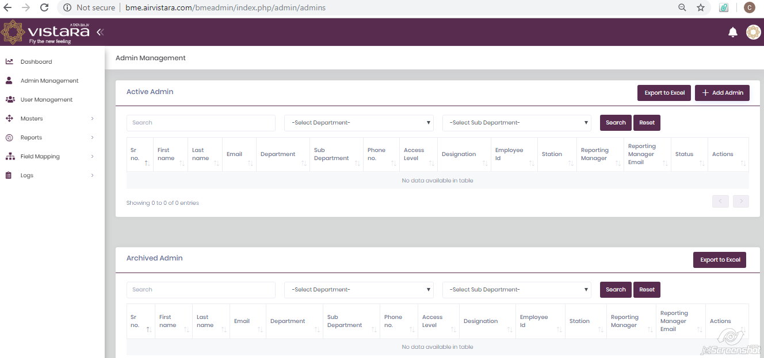

5) Home Page 🡪 Admin Management🡪Active Admin🡪Add Admin

In Active Admin, Add Admin button will open for admin’s credentials, in which First name, email id of admin with “@airvistara.com” extension, station assign for admin & for those stations which are the access levels assign for that admin is mandatory information.

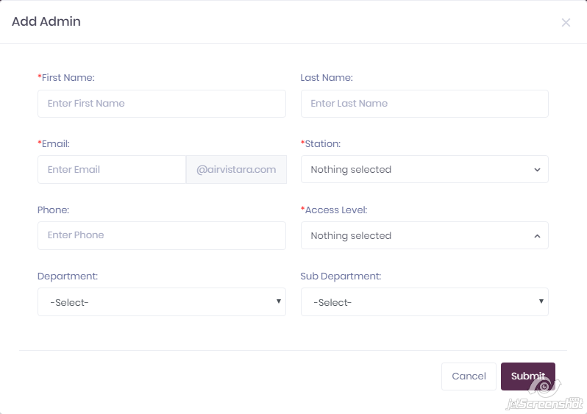

6) Home Page 🡪 Admin Management🡪Active Admin🡪Edit Admin

In Active Admin, Edit Admin Icon will open form for admin’s credentials in editable form, in which First name, email id of admin with “@airvistara.com” extension, station assign for admin & for those stations which are the access levels assign for that admin is mandatory information.

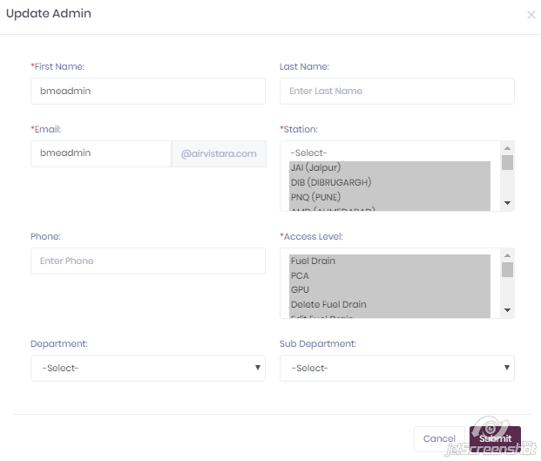

7) Home Page 🡪 User Management

i) When user click on User Management 🡪User Management Page open showing active user management & Archived user management

ii) For Active User Management it provide facility for Add New User, Search any name from particular department with particular sub department or user can Reset the search i.e. can clear the searching criteria as well as user can store the list of active user management in .xlsx format with Edit & Delete user options.

iii) For Archived User Management, it provide facility to Restore the archived users in active user, Search any name from particular department with particular sub department or user can Reset the search i.e. can clear the searching criteria as well as user can store the list of archived user management in .xlsx format.

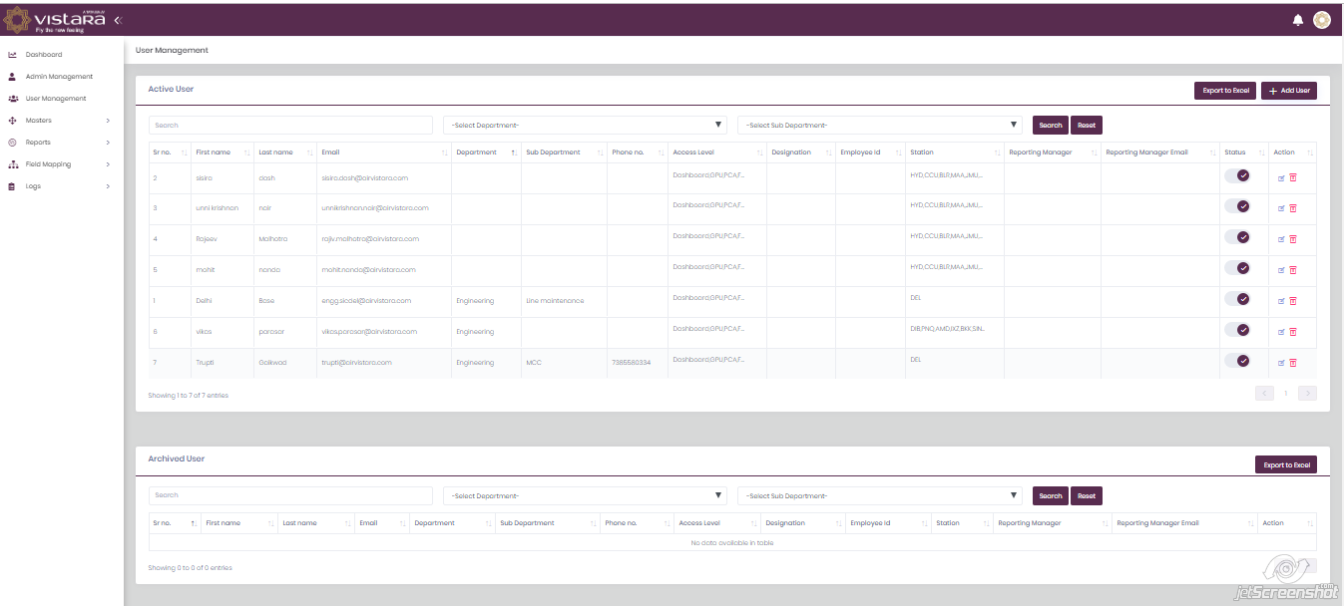

8) Home Page🡪User Management🡪Active User🡪Add User

In Active User, Add User button will open form for user’s credentials, in which First name, email id of user with “@airvistara.com” extension, station assign for user & for those stations which are the access levels assign for that user is mandatory information.

(User can modify only those station’s which assign for him & can do only those operation which right hi/she assign as access level)

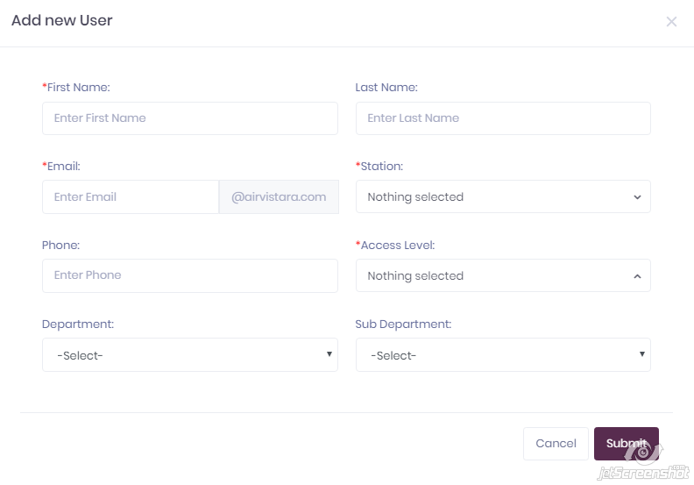

9) Home Page🡪User Management🡪Active User🡪Edit User

In Active User, Edit User Icon will open form having user’s credentials in editable mode In which admin can edit user’s station’s & access right’s for that stations with user personal profile like name, email, department etc.

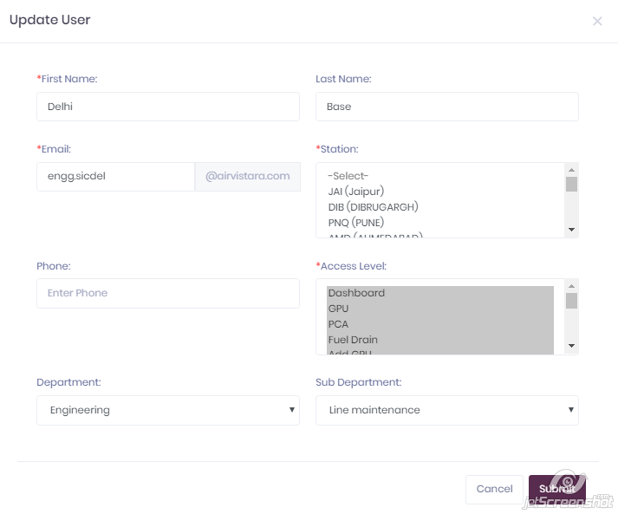

10) Home Page🡪Masters

When User click on Masters button on side bar of admin page, It will direct user on list for which Masters maintain records like Station, A/C Regn No., Flight Number, SC/DC/Tonnage, Body Type, GST

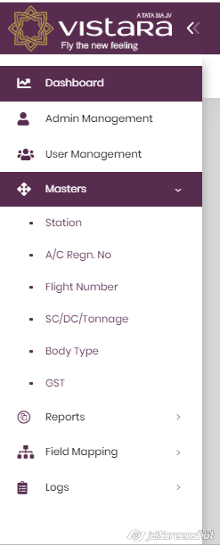

11) Home Page🡪Masters🡪Station

Admin maintain record of stations, having tables for active stations & archive stations with Add Station, Edit Station, restore station with download all station list in .xlsx format facility.

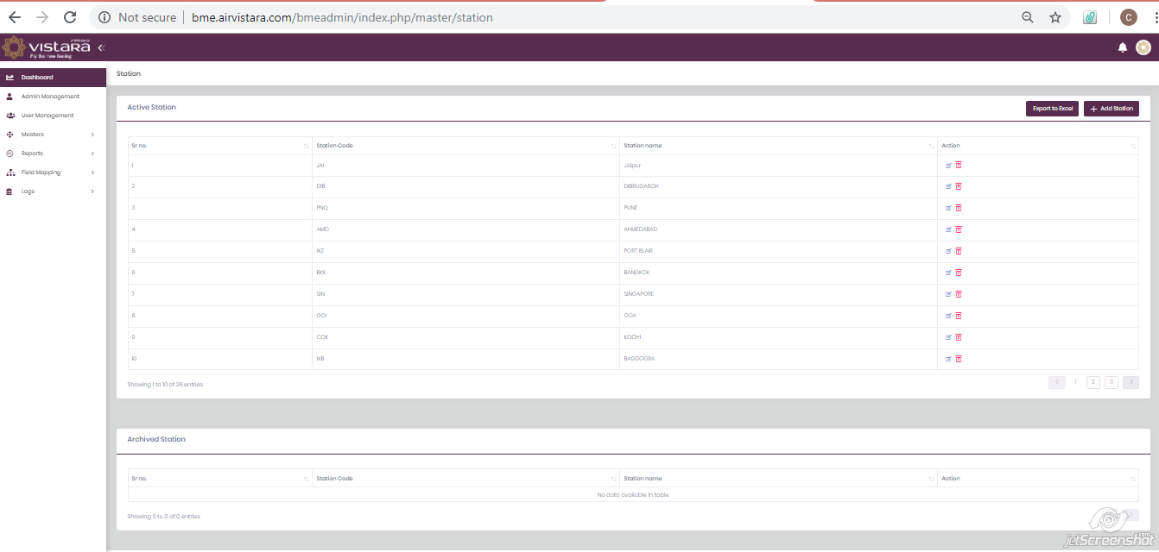

12) Home Page🡪Masters🡪Station🡪Add Station

Admin can have facility to add station in list of station with Add Station button on active station frame.

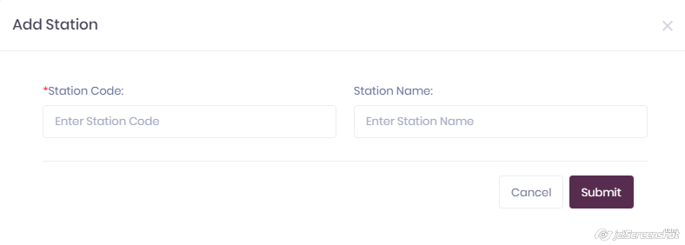

13) Home Page🡪Masters🡪Station🡪Edit Station

In Active Station table having column Actions with Edit Icon & Archive Icon. In which Edit Icon open form having station information in editable mode with station code & station name & Archive icon can archive station from active frame to archive frame.

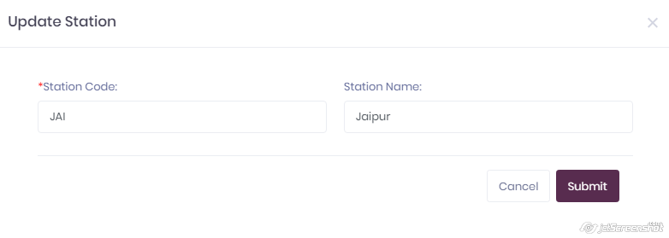

14) Home Page🡪Masters🡪A/C Regn No.

Admin can maintain A/C Regn No., In his Masters with fix prefix number “VT-”. Home pages have Master Tab with A/C Regn No. button, which direct user on page having Active A/c Regn. No. & Archive Regn No. with Add Regn No., Edit Regn No., archives Regn No., Restore Regn No., & downloads all data in .xlsx format.

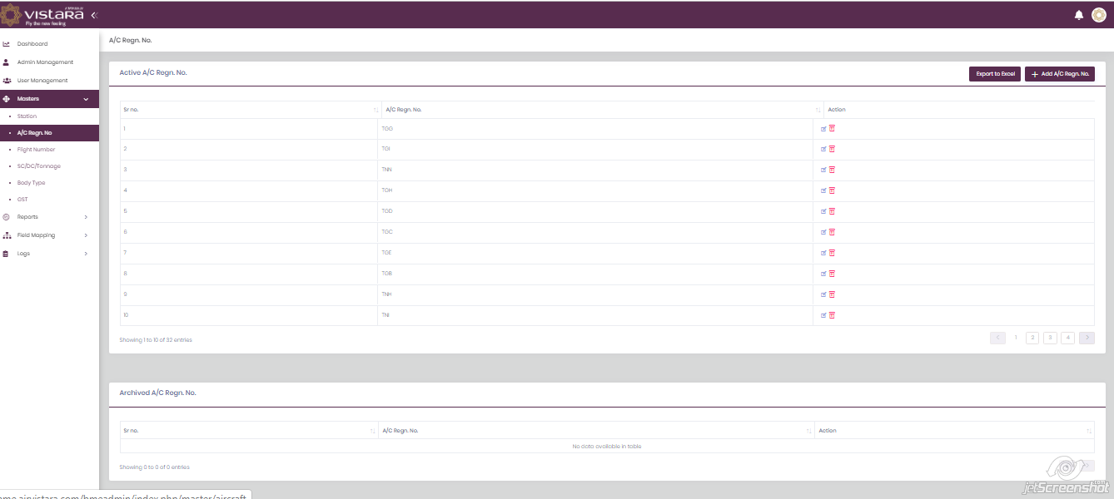

15) Home Page🡪Masters🡪A/C Regn. No.🡪+Add A/C Regn. No.

In Active A/C Regn. No. admin can Add new Regn. No. with Fix Prefix of “VT-”.

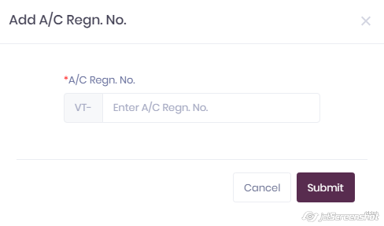

16) Home Page🡪Masters🡪A/C Regn. No.🡪Edit A/C Regn. No.

In Active A/C Regn. No. admin can Edit Existing Regn. No. but with Fix Prefix of “VT-”.

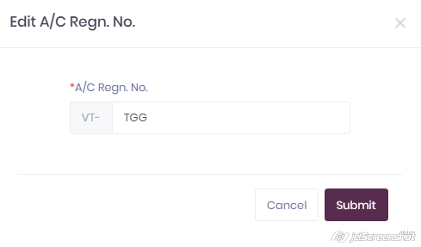

17) Home Page🡪Masters🡪Flight Number

On Home Page Side bar Masters having Flight Number tab, having information about all active & archive flight numbers with Add Flight Number, Edit Flight Number, Restore Flight number, Archive flight number facility with user can download all fight numbers in .xlsx format facility.

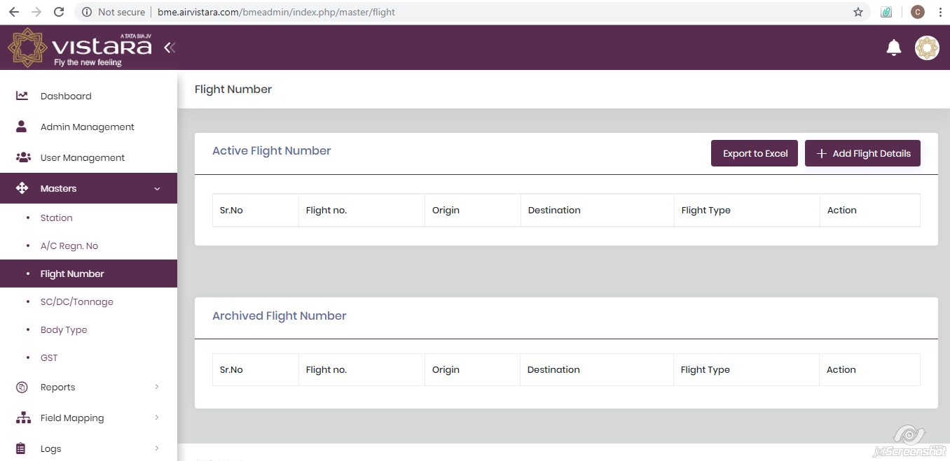

18) Home Page🡪Masters🡪Flight Number🡪+Add Flight Details

In Active Flight Number admin can Add new flight number with Fix Prefix of “UK”.

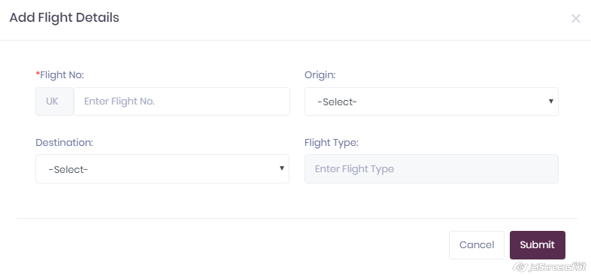

19) Home Page🡪Masters🡪Flight Number🡪Edit Flight Details

In Active Flight Number admin can Edit existing flight number with Fix Prefix of “UK”.

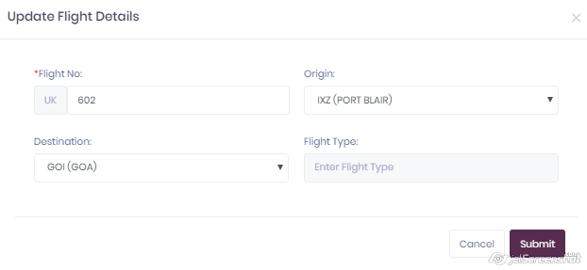

20) Home Page🡪Masters🡪SC/DC/Tonnage

On Home Page Side listing, Masters tab contain SC/DC/Tonnage tab which having records about Active SC/DC/Tonnage & Archive SC/DC/Tonnage with Add, Edit, Archive & Restore facility.

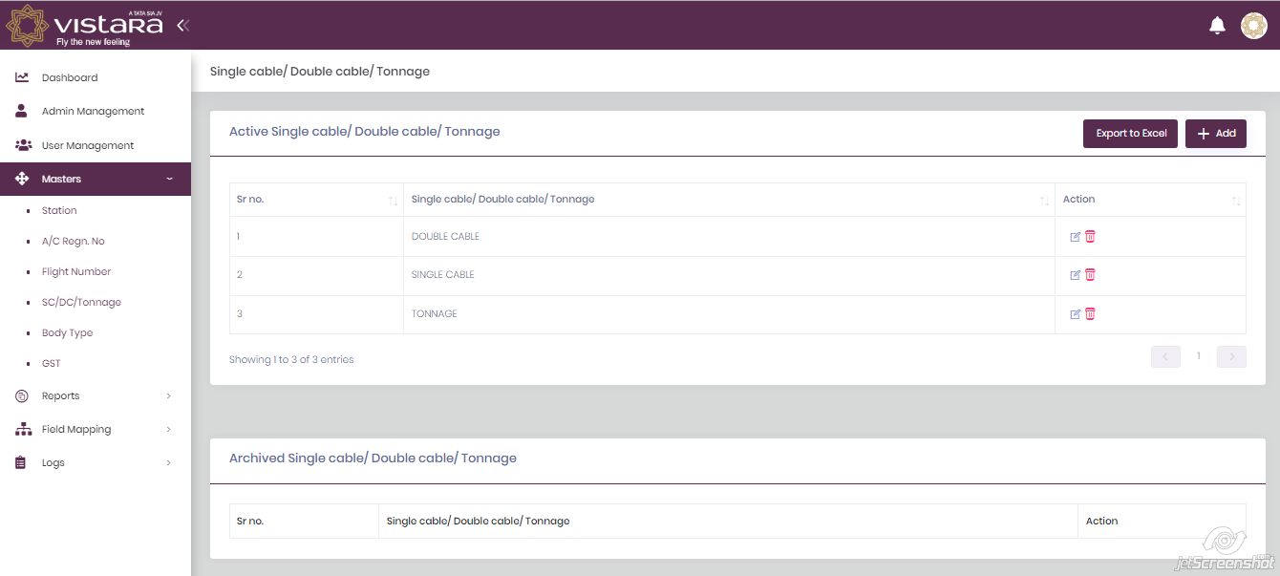

21) Home Page🡪Master🡪Active SC/DC/Tonnage🡪Add

Add button on Active SC/DC/Tonnage will open form asking SC/DC/Tonnage name information

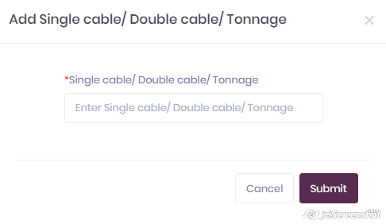

22) Home Page🡪Masters🡪Active SC/DC/Tonnage🡪Edit

In Active SC/DC/Tonnage table Edit Icon will open SC/DC/Tonnage name in editable mode.

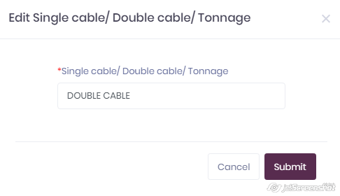

23) Home Page🡪Masters🡪Body Type

On Home Page Side listing, Masters tab contain Body Type tab which having records about Active Body Type & Archive Body Type with Add, Edit, Archive & Restore facility.

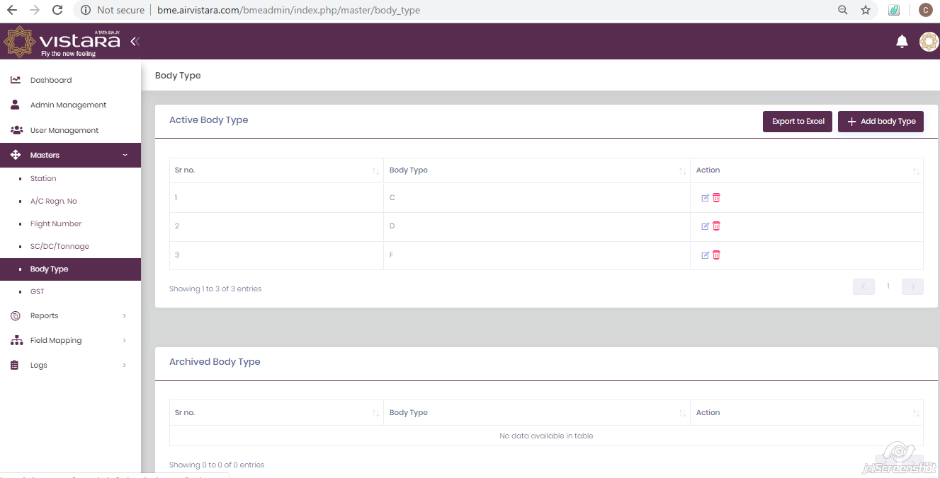

24) Home Page🡪Masters🡪Body Type🡪Active Body Type🡪+Add Body Type

In Active Body Type frame Add button is there for Adding new body type in list.

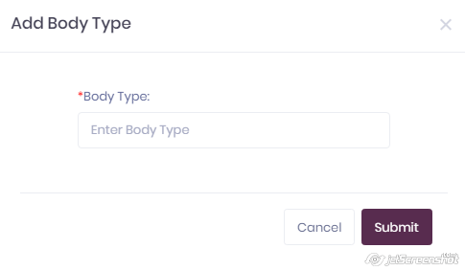

25) Home Page🡪Masters🡪Body Type🡪Active Body Type🡪Edit Body Type

In Active Body Type frame Edit icon is there for editing existing body type in list.

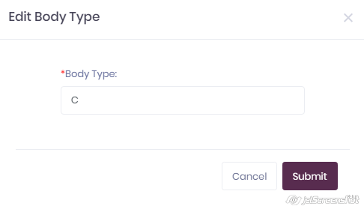

26) Home Page🡪Masters🡪GST

On Home Page of admin side listing bar contain tab for GST, clicking on this GST tab, page open showing calculations for Total GST (SGST+CGST+IGST) with user can add only one value as total GST. If anyone value for GST available in table the +Add Total GST button is hidden only in absence GST value it is in visible form.

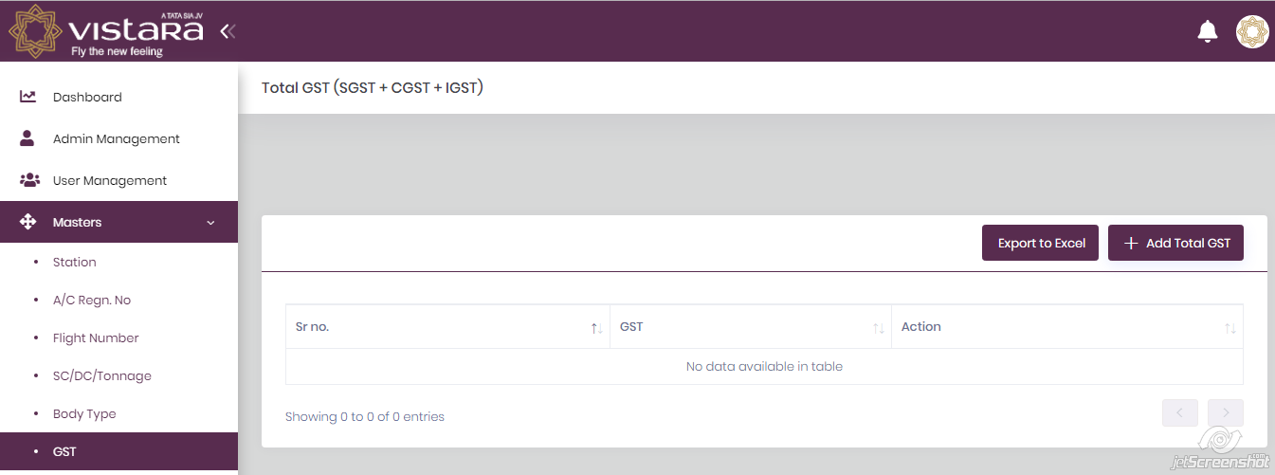

27) Home Page🡪Masters🡪GST🡪+Add Total GST

User can add only one value as Total GST value. After Adding value for GST +Add Total GST button will be invisible.

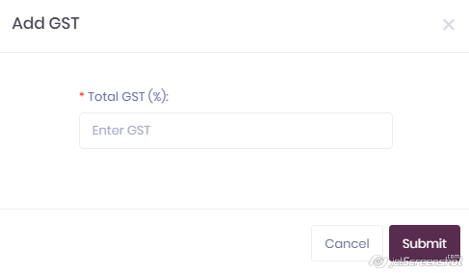

28) Home Page🡪Masters🡪GST🡪Edit Icon

When User Add GST value in record, Edit icon is visible for that value & open form having GST value in editable mode.

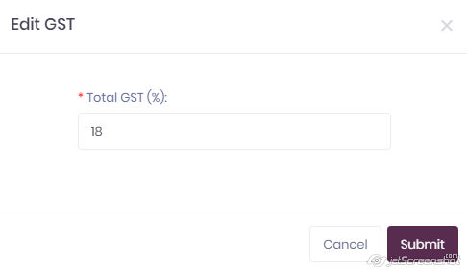

29) Home Page🡪Masters🡪GST🡪Delete

In BME Project, user can delete only GST value from record permanently, In other field user can archive value’s but can’t delete values from records.

30) Home Page🡪Reports

In Admin home page, side listing bar contain tab Reports, In which we can view different sub tabs like GPU, PCA, Fuel Drain. That means user can generate 3 types of reports, for GPU, for PCA & for Fuel Drain records.

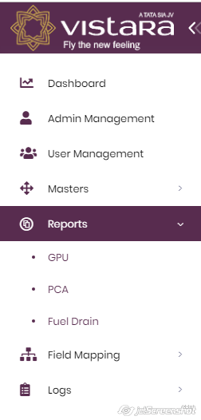

31) Home Page🡪Reports🡪GPU

When user click on GPU tab, it will direct user on page having GPU records in tabular form with +Create, Audit Trail, Delete all button with Export to Excel button facility for download all GPU records in .xlsx format.

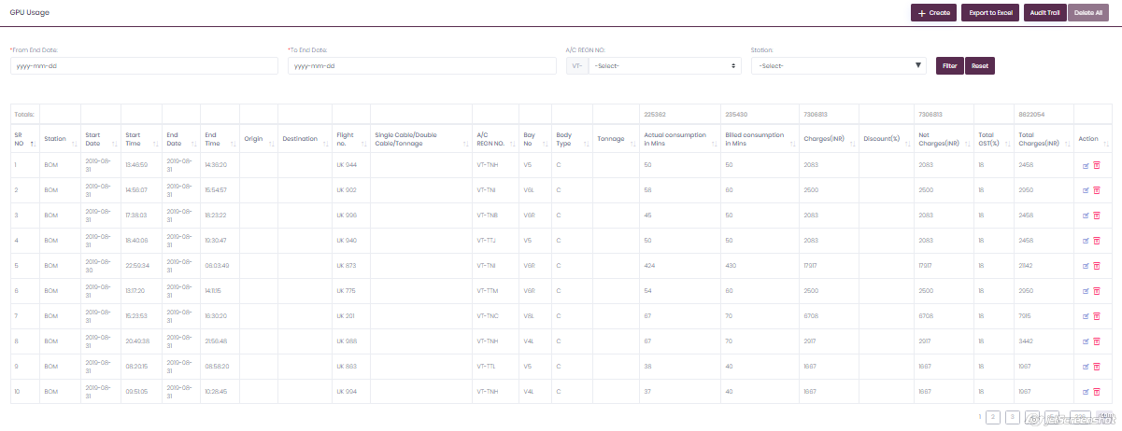

32) Home Page🡪Reports🡪GPU🡪+Create GPU Records

By clicking on button of “+Create”, It will open form to create GPU records by 2 way   
i) By Uploading Bulk Records (i.e. Uploading .xlsx file for station mention in list)  
ii) By Inserting GPU values manually in form

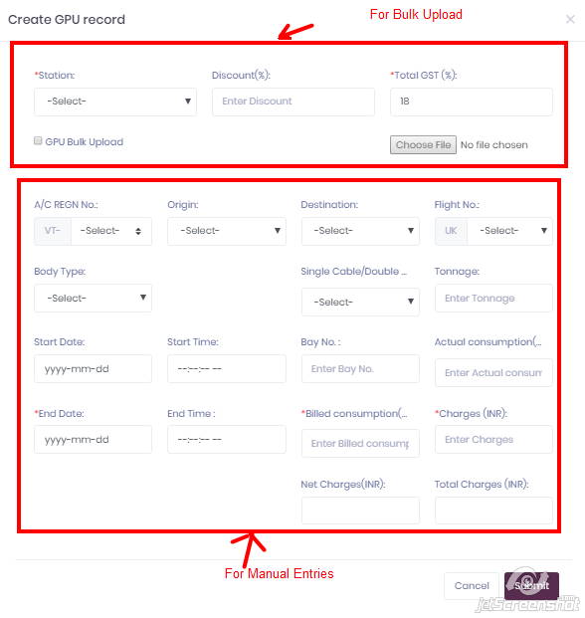

33) Home Page 🡪Records🡪GPU🡪Delete All

“Delete All” button in GPU records table is visible only when user select data using filter otherwise it will have single “delete icon” for each record.

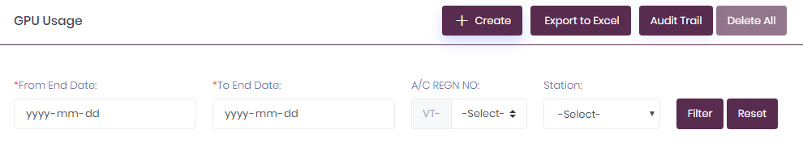

34) Home Page🡪Records🡪GPU🡪Audit Trail

“Audit Trail” button in GPU records table direct user on same table only having added 2 columns. One is for name of “Record Created by” & 2nd is for name of records “last modified by”.

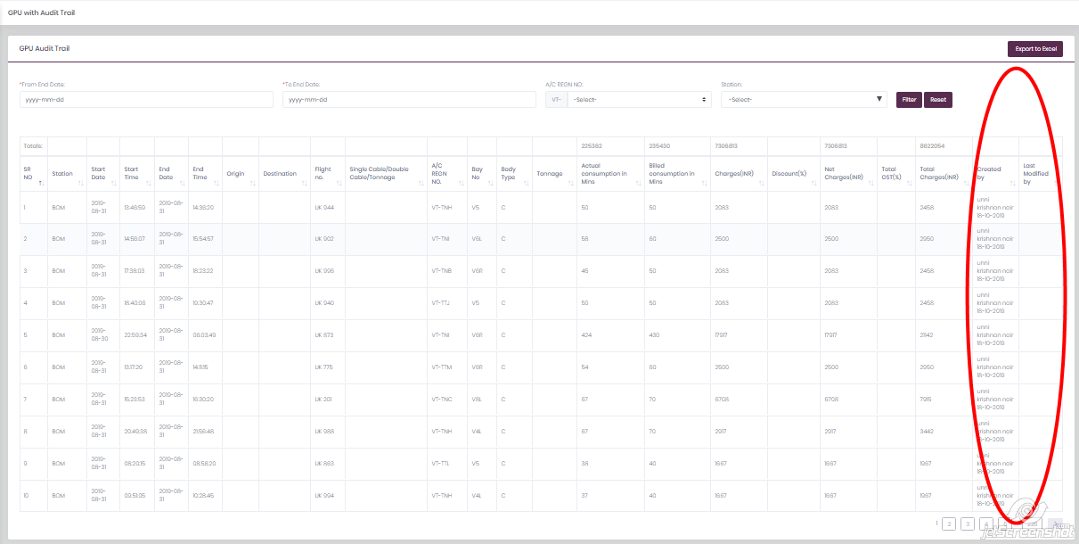

35) Home Page🡪Records🡪GPU🡪Edit

In GPU record table user has facility to edit record by clicking on Edit Icon in actions column.

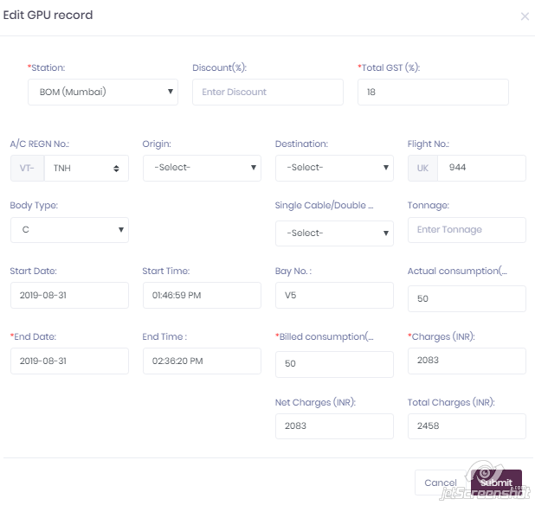

36) Home Page🡪Reports🡪PCA

When user click on PCA tab, it will direct user on page having PCA records in tabular form with +Create, Audit Trail, Delete all button with Export to Excel button facility for download all PCA records in .xlsx format.

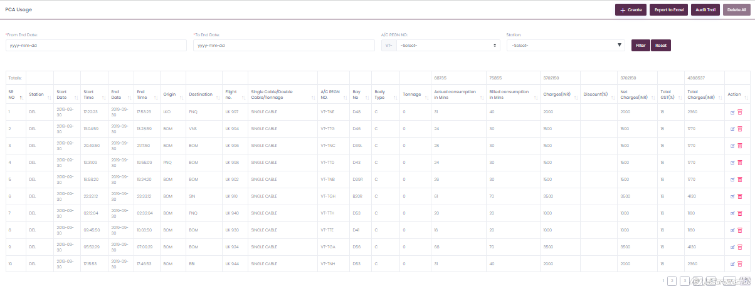

37) Home Page🡪Reports🡪PCA🡪+Create PCA Records

By clicking on button of “+Create”, It will open form to create PCA records by 2 way   
i) By Uploading Bulk Records (i.e. Uploading .xlsx file for station mention in list)  
ii) By Inserting PCA values manually in form

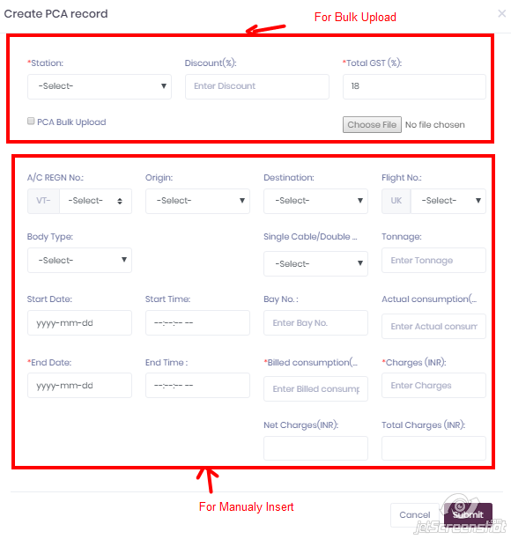

38) Home Page 🡪Records🡪PCA🡪Delete All

“Delete All” button in PCA records table is visible only when user select data using filter otherwise it will have single “delete icon” for each record.

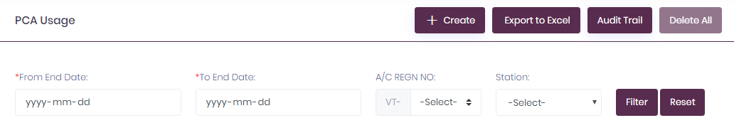

39) Home Page🡪Records🡪PCA🡪Audit Trail

“Audit Trail” button in PCA records table direct user on same table only having added 2 columns. One is for name of “Record Created by” & 2nd is for name of records “last modified by”.

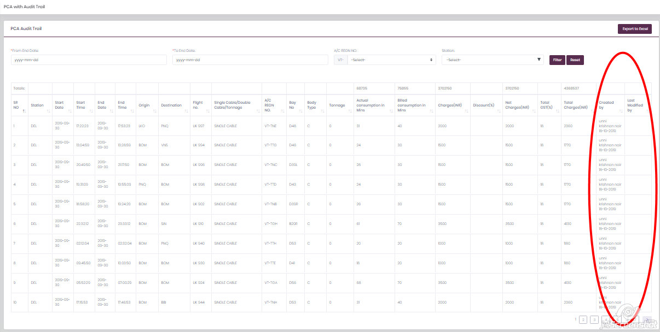

40) Home Page🡪Records🡪PCA🡪Edit

In PCA record table user have facility to edit record by clicking on Edit Icon in actions column.

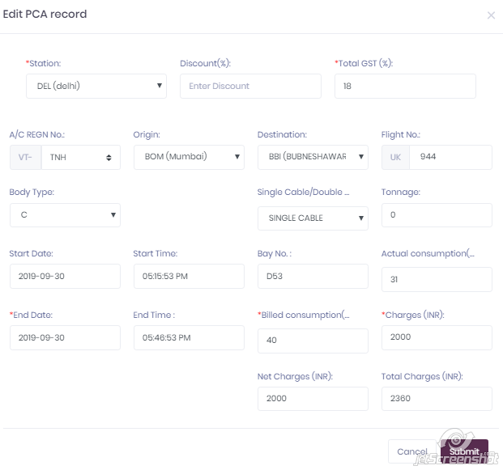

41) Home Page🡪Reports🡪Fuel Drain

When user click on Fuel Drain tab, it will direct user on page having fuel Drain records in tabular form with +Create, Audit Trail, Print button with Export to Excel button facility for download all Fuel Drain records in .xlsx format.

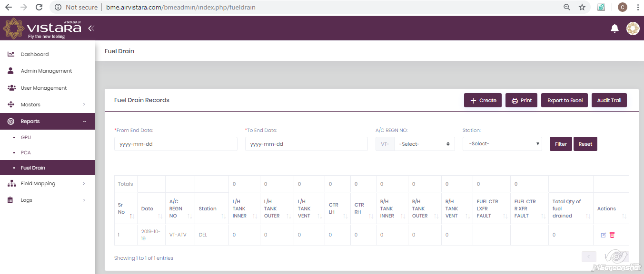

42) Home Page🡪Reports🡪Fuel Drain🡪+Create

By clicking on button of “+Create”, It will open form to create Fuel Drain records manually. In Fuel Drain User can’t Upload as well as Delete data.

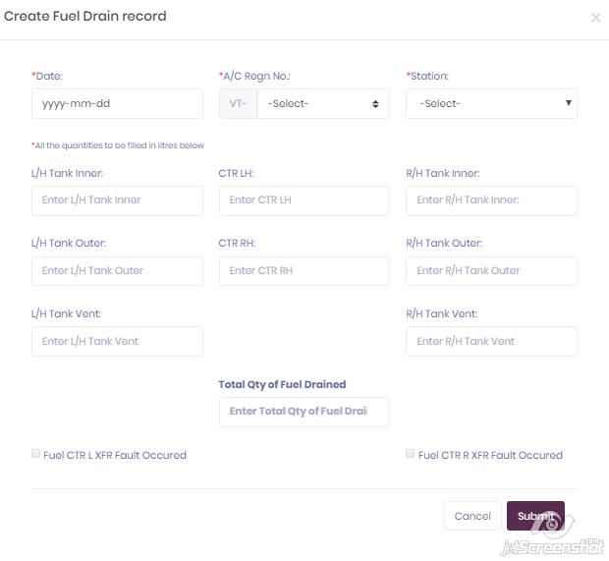

43) Home Page🡪Records🡪Fuel Drain🡪Audit Trail

“Audit Trail” button in Fuel Drain records table direct user on same table only having added 2 columns. One is for name of “Record Created by” & 2nd is for name of records “last modified by”.

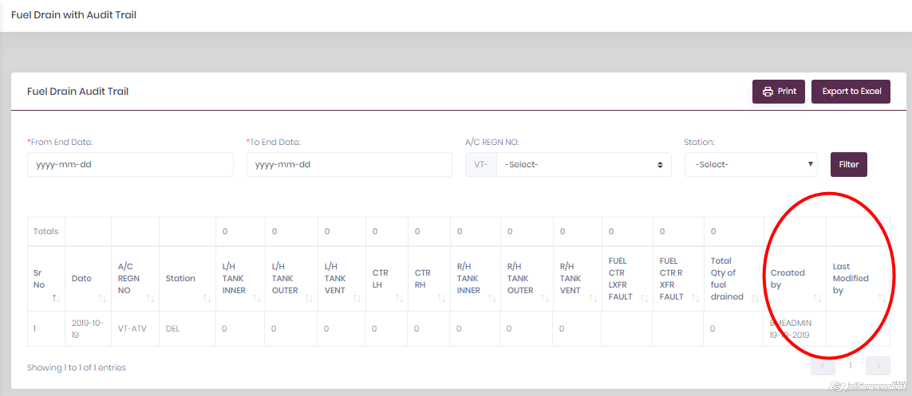

44) Home Page🡪Records🡪PCA🡪Edit

In PCA record table user have facility to edit record by clicking on Edit Icon in actions column.

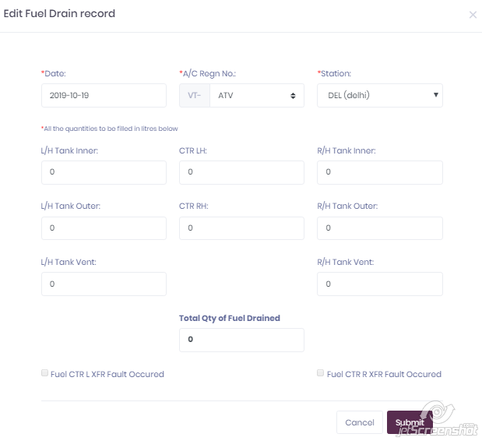

45) Home Page🡪Field Mapping

On Home page side listing bar having tab for Field Mapping with 2 sub tabs for GPU & PCA. Field Mapping tab is contain fields (column heading) in .xlsx for bulk upload & respective column heading for that fields in database.

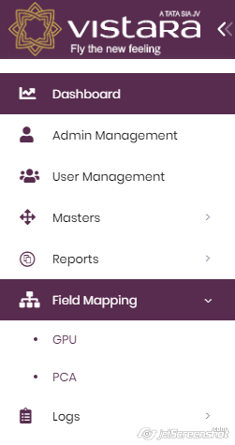

46) Home Page🡪Field Mapping🡪GPU

In Field Mapping, GPU tab direct user on page having information about “GPU Excel file fields” & “Fields of Database table”. (Different Stations have different field for GPU record)

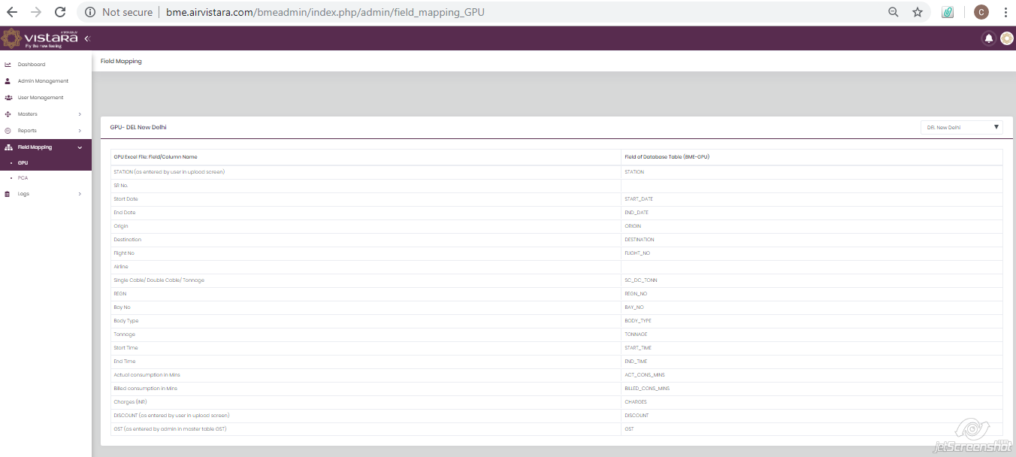

47) Home Page🡪Field Mapping🡪PCA

In Field Mapping, PCA tab direct user on page having information about “PCA Excel file fields” & “Fields of Database table”. (Different Stations have different field for PCA record)

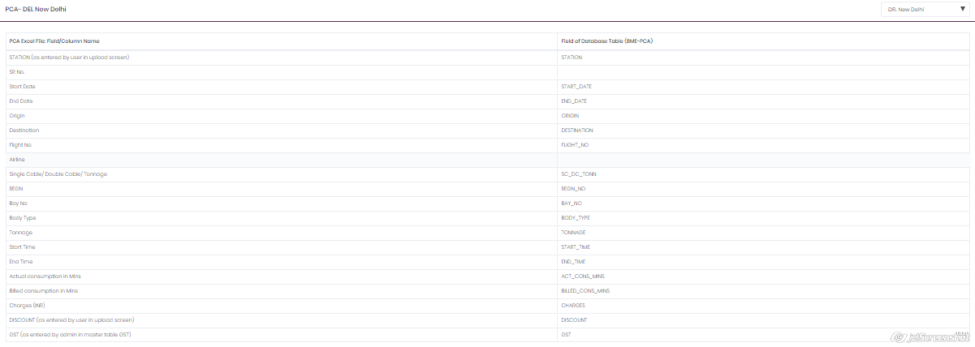

48) Home Page🡪Log

On Home Page of BME Admin, side listing bar contain tab for Logs. This Log tab again have 2 tabs to maintain 2 types of logs, One is for activity log & another is for Error log.

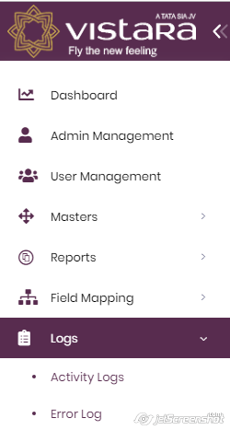

49) Home Page🡪Logs🡪Activity Logs

In Activity log all positive activities by all users did on BME Website are store as Activity log with Filter, Reset Filter & download all activities in .xlsx format facility.

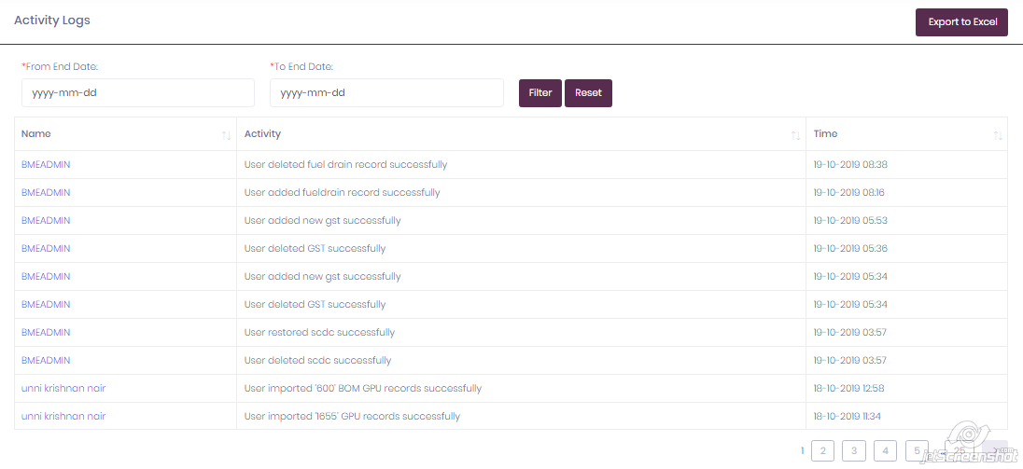

50) Home Page🡪Logs🡪Error Logs

In Error log all errors by all users did on BME Website are store as error log with Filter, Reset filter & download all errors in .xlsx format facility.

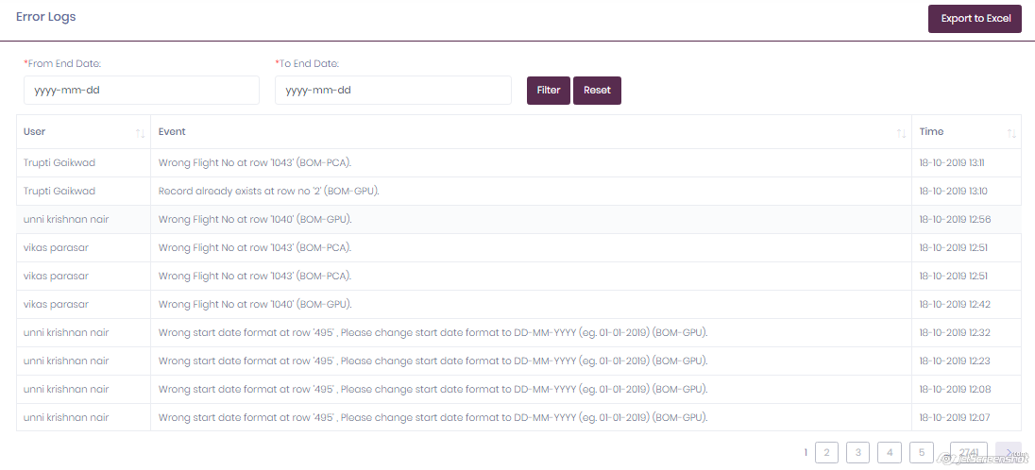

51) For BME Date Guidance

1. Right click on the date

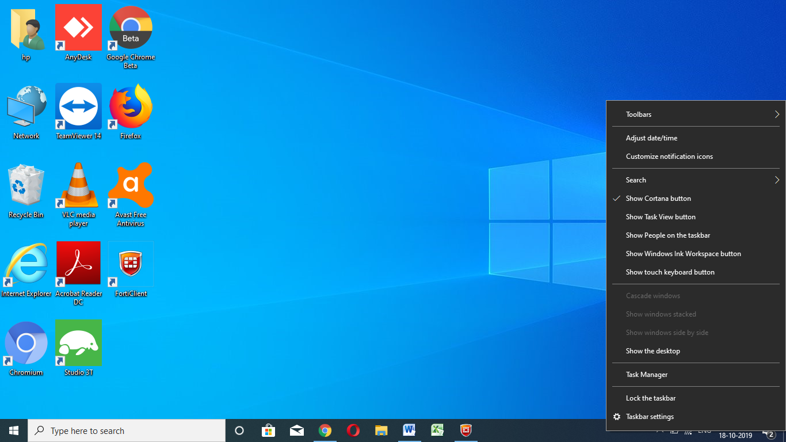

2) Go to adjust date and time

3) Click on date and time & region formatting in **Related settings**

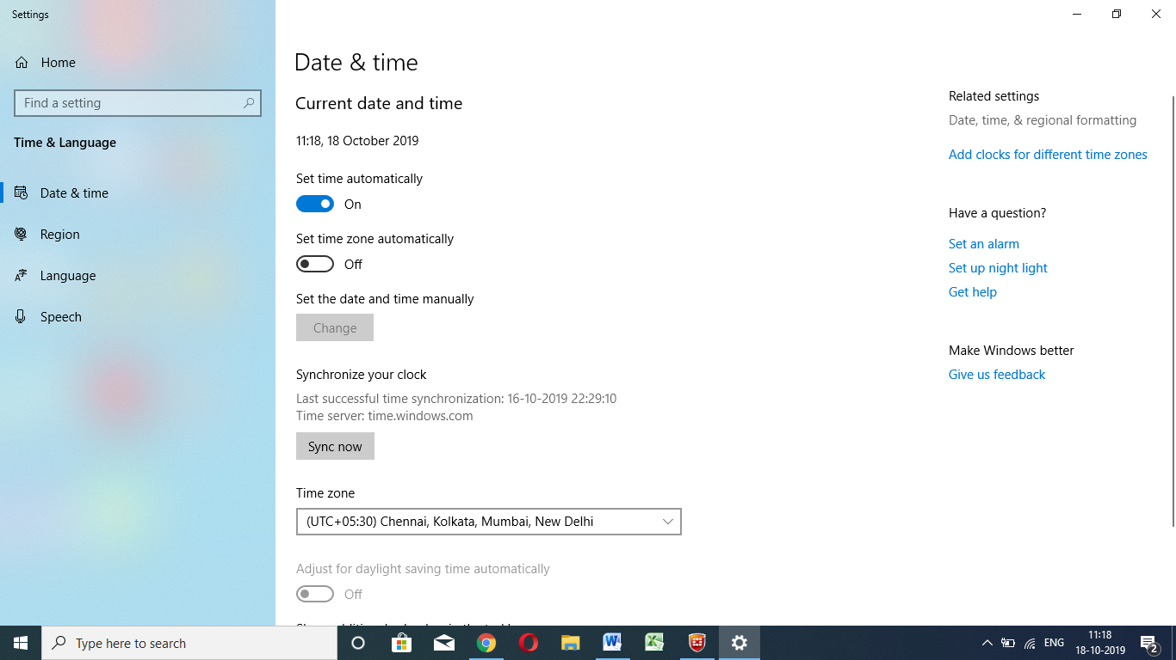

4) Check the region is **India** and region format is **English India** , if this details is different then change the details.

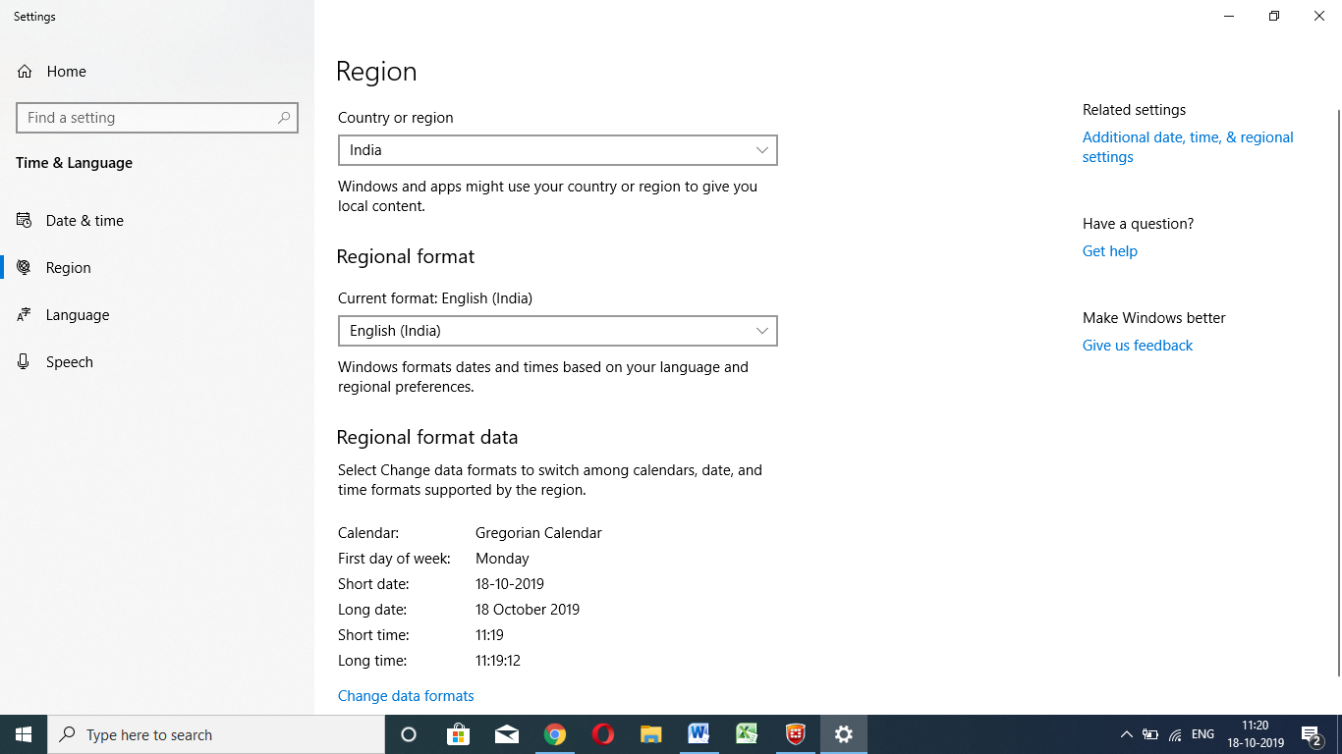

5) Confirm it system date format is **dd-mm-yyyy.**

6) Restart your system