Mylexx

Admin Module

Website : <http://134.209.23.223/admin/>

User name : 1111111111

Pass : admin

1. Footer Strip:

In Mylexx project showing wrong footer Strip.

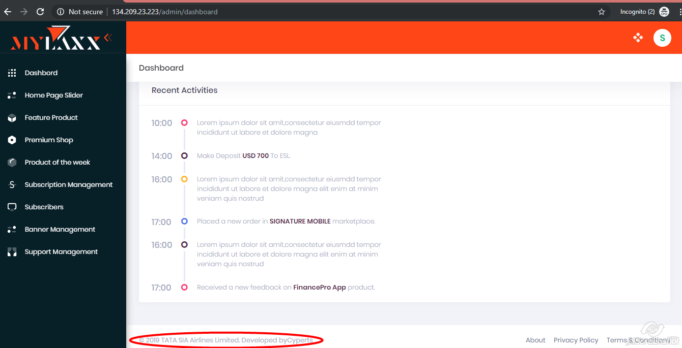

1. Home Page Slider 🡪 Add 🡪 Choose File

While adding new .png image it shows error.

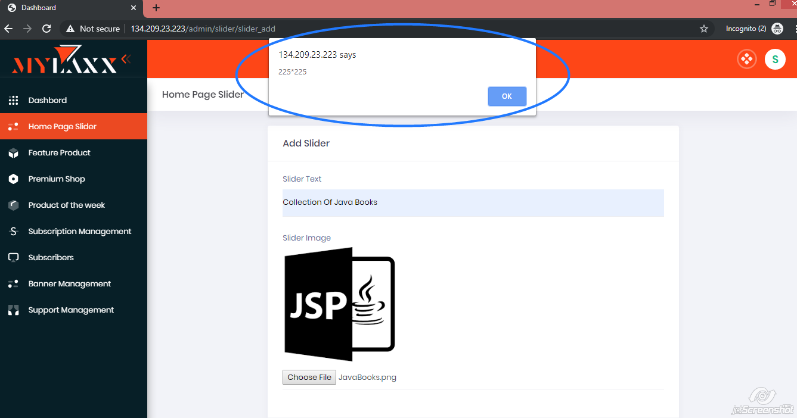

1. Home Page Slider

In Home Page Slider table image is not open in Slider image column.

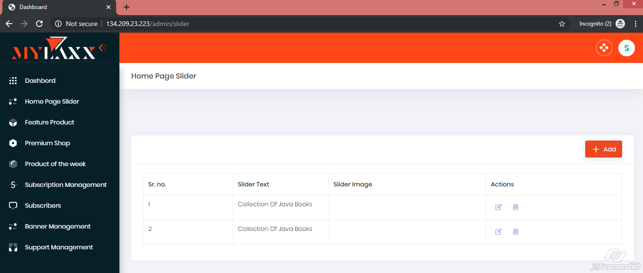

1. Home Page Slider

In Home Page Slider table, it is accepting duplicate data.

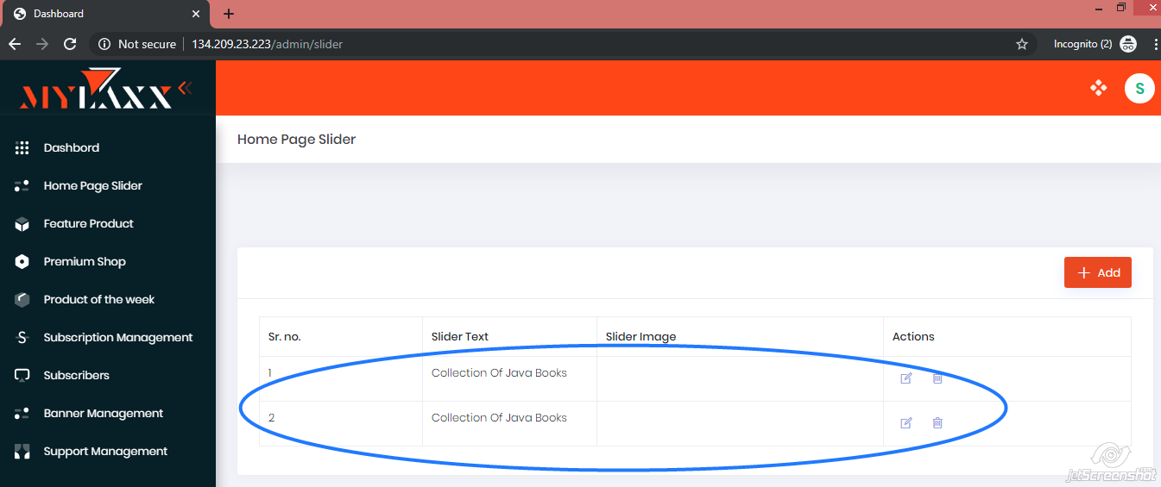

1. Home Page Slider:

While deleting home slider, not asking or showing confirmation message.

1. Home Page Slider:

Add Search Button for “Home Page Slider” page.

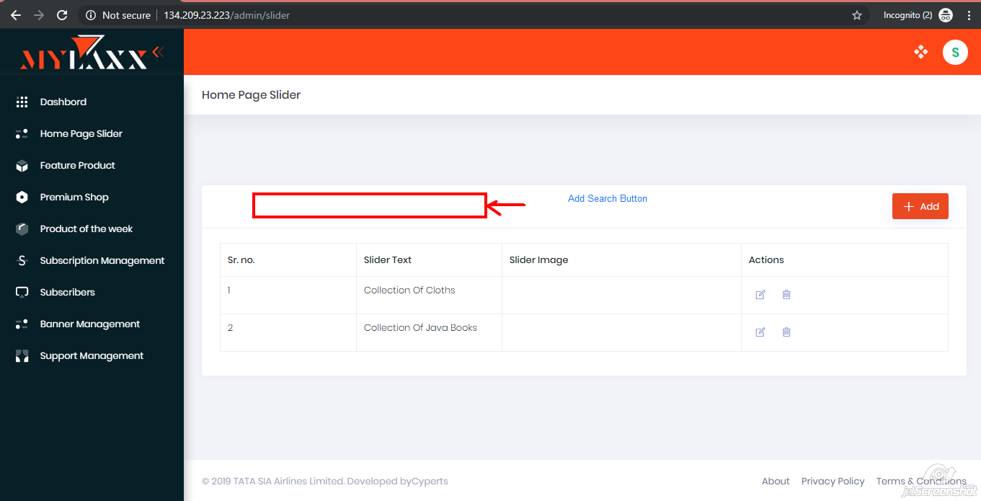

1. Feature Product:

Add Search button for “Feature Product” page.

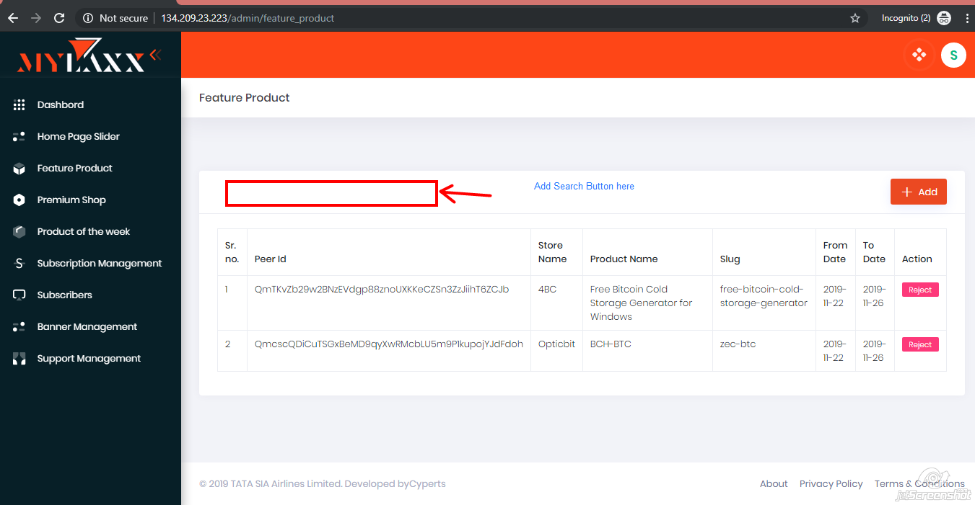

1. Feature Product 🡪Add Button

“Submit” & “Cancel” button should not be there before arriving list of product.

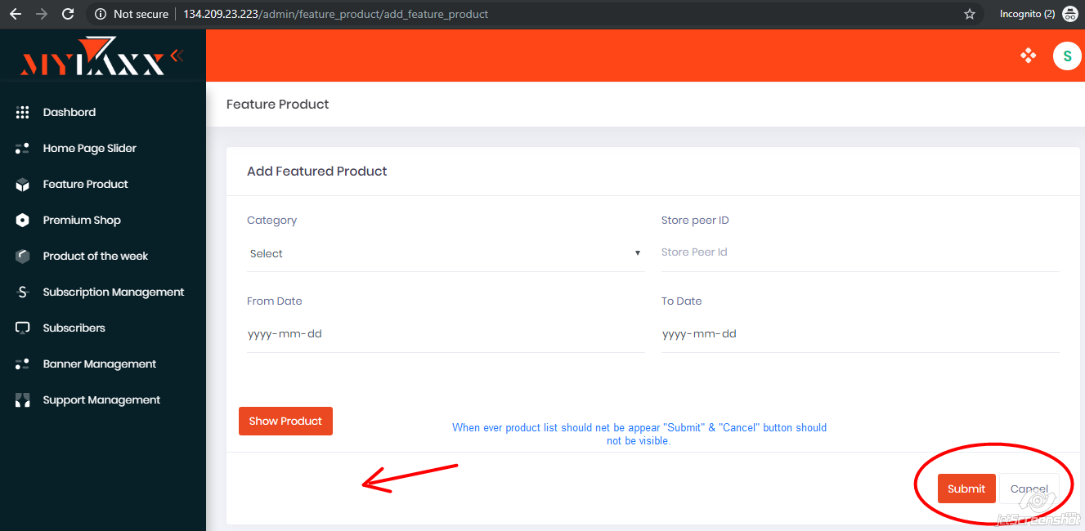

1. Premium Shop:

Add “Search” button for “Show Premium Shop” page.

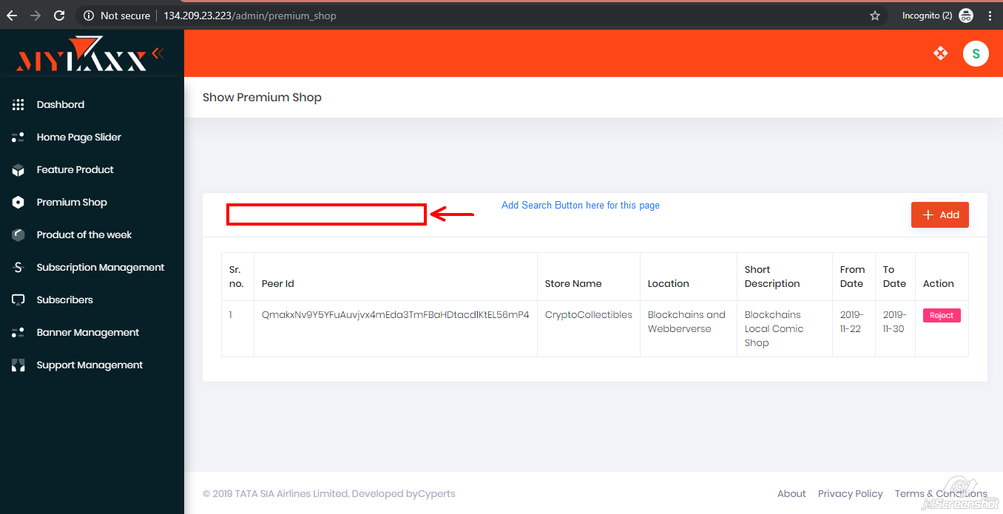

1. Premium Shop 🡪Add Button

“Submit” & “Cancel” button should not be there before arriving list of shops.

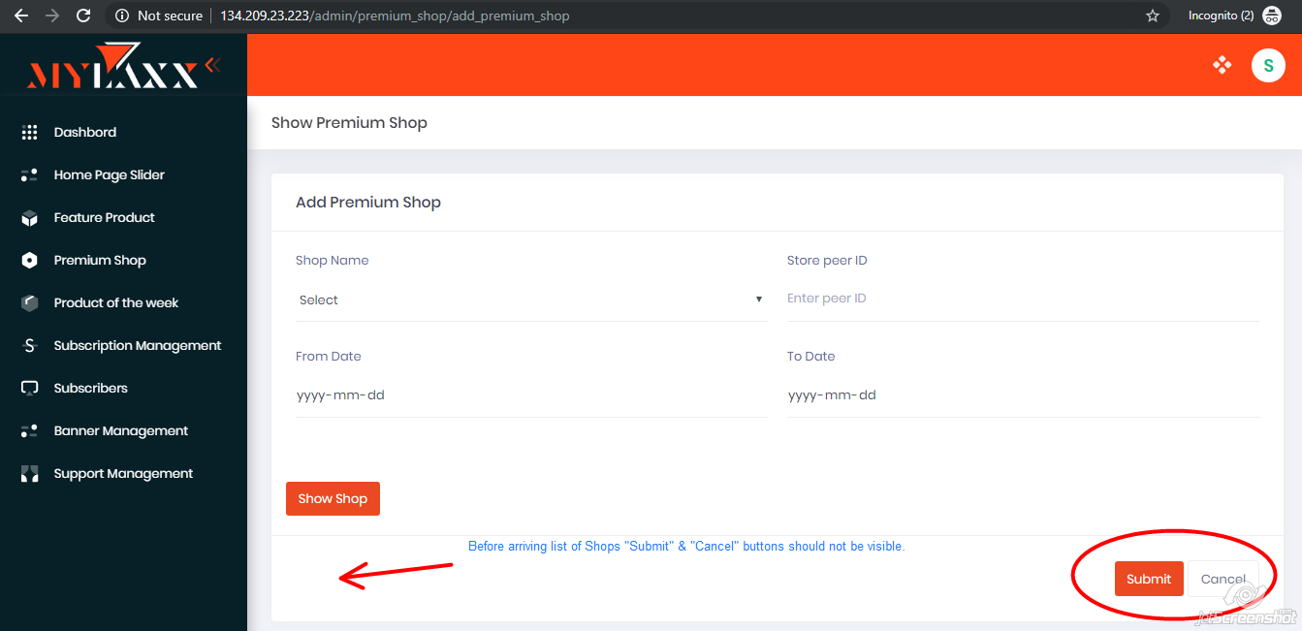

1. Product Of the Week:

Add “Search” button for “Product of the week” page.

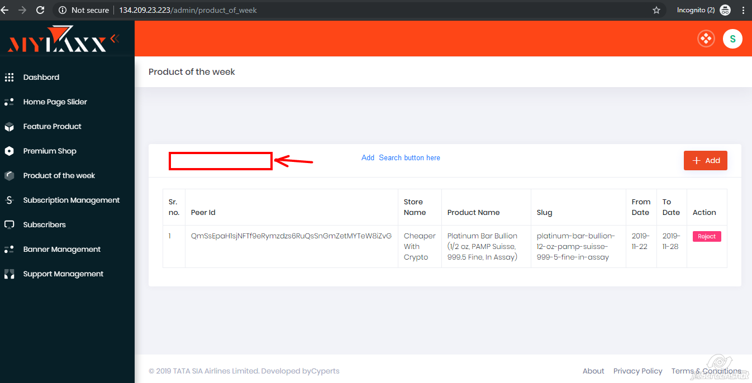

1. Product Of the Week 🡪 Add Button

“Submit” & “Cancel” button should not be there before arriving list of product.

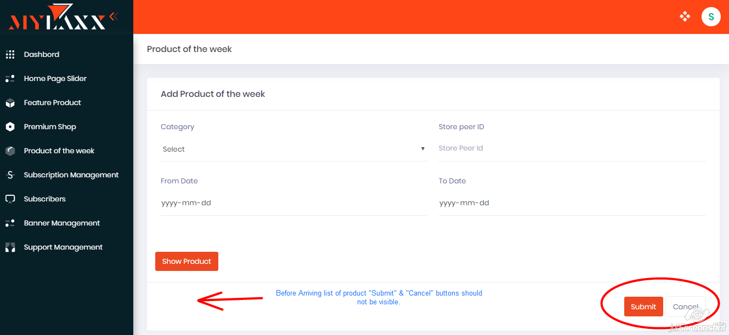

1. Subscription Management:

Add this type of Active/Deactive button in Status column.

 

1. Subscription Management:

Add “Search” button for “Subscription Management” page.

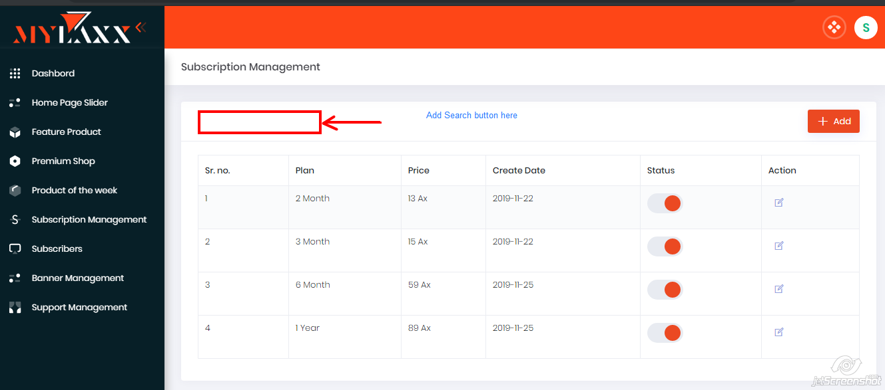

1. Subscriber:

Add “Search” button for “Subscriber Management” page.

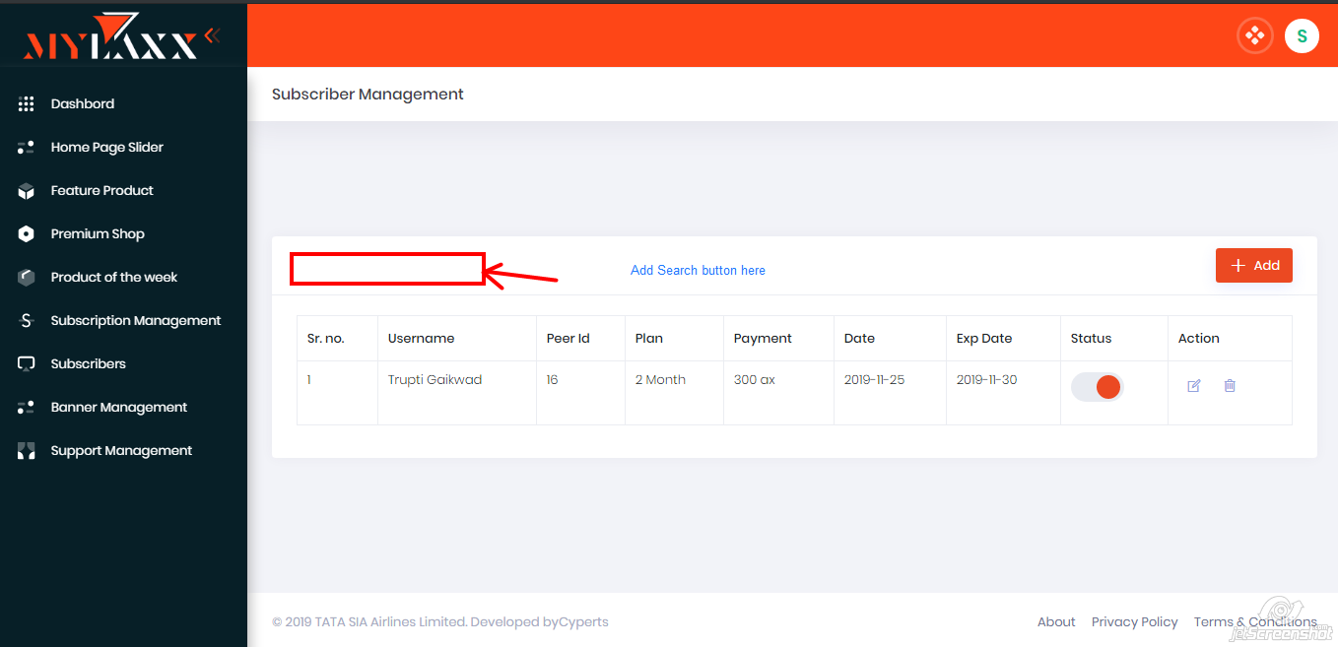

1. Subscriber 🡪 Add Button

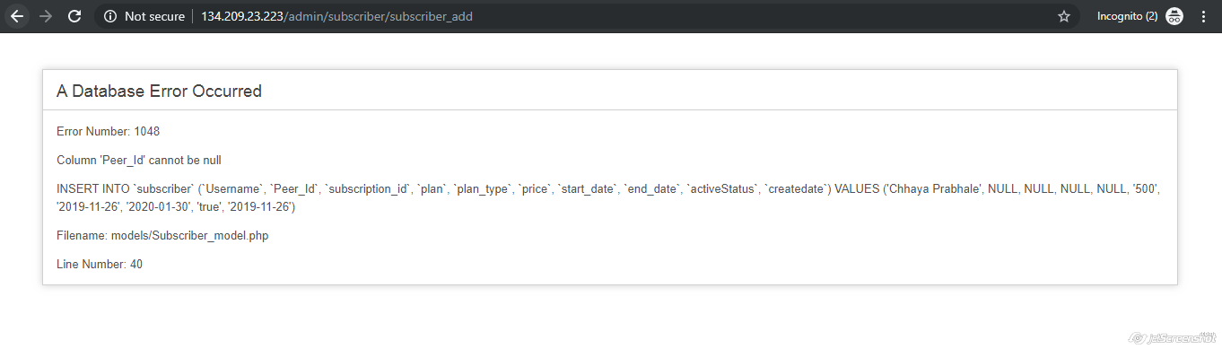

Showing above error message, if user don’t mention the “Peer Id” from mention dropdown list instead of showing message “Please fill this Field”.

1. Subscriber 🡪Add Button

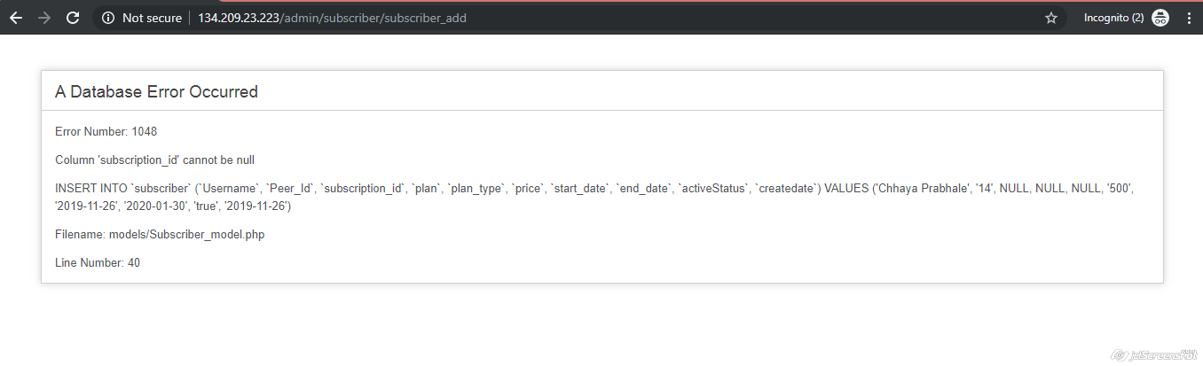

Showing above error message, if user don’t mention the “Plan” from mention dropdown list instead of showing message “Please fill this Field”.

1. Subscriber Management:

Delete Subscriber should have to ask confirmation message while deleting subscriber from list.

1. Banner Management:

Add “Search” button for “Banner Management” page.

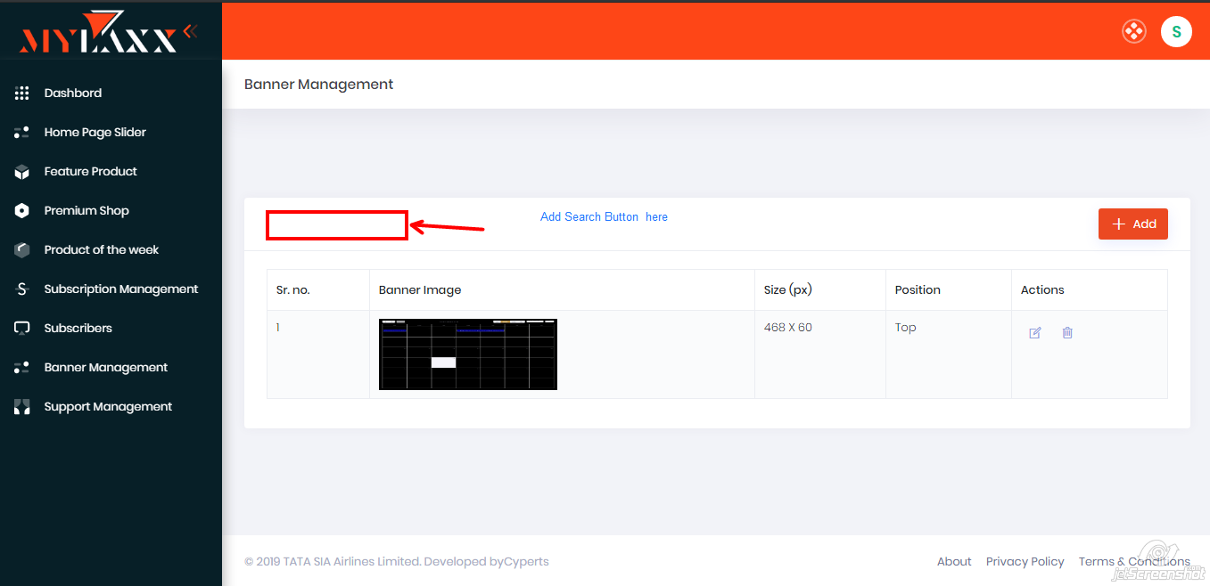

1. Banner Management 🡪Add Button

When user attach .png file for banner it shows following error message.

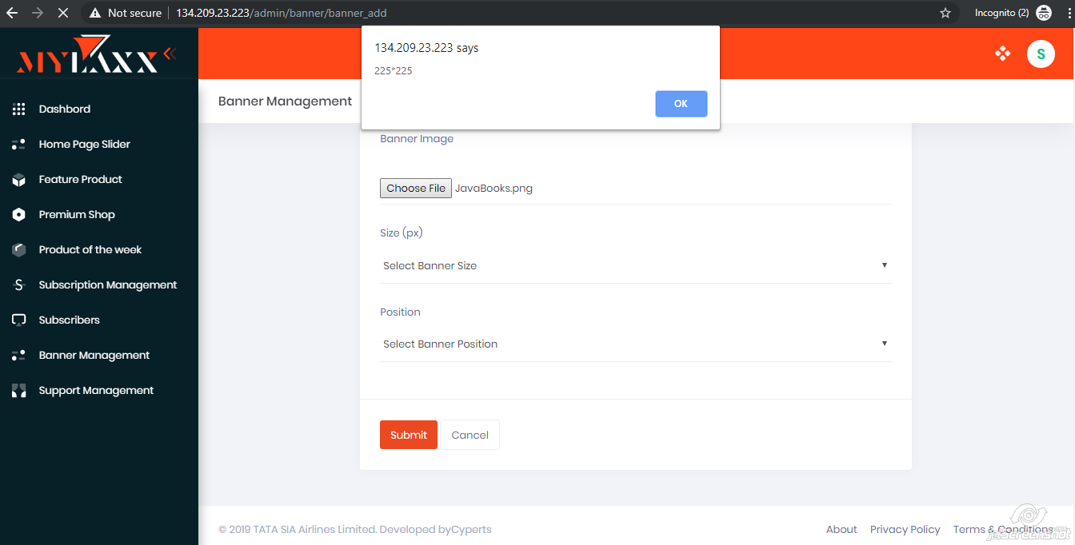

1. Banner Management 🡪 Add Button

If user didn’t mention Banner Size & click on “Submit” button then it has to show “Please Fill this Field” message. But currently it shows following error message.

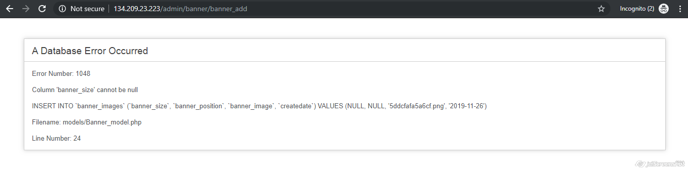

1. Banner Management 🡪 Add Button

If user didn’t mention Banner Position & click on “Submit” button then it has to show “Please Fill this Field” message. But currently it shows following error message.

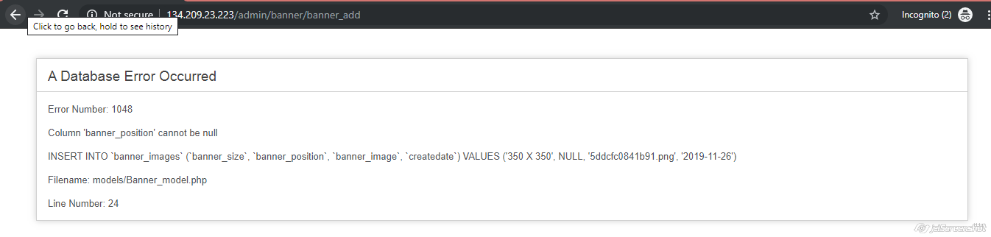

1. Support Management :

Add “Search” button in Support Management Page.

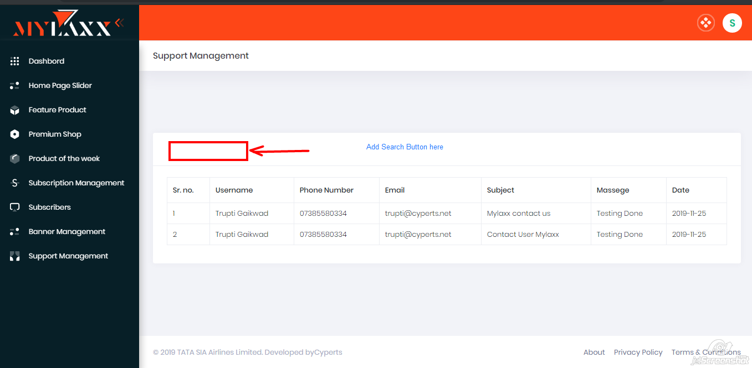

1. Title :

In title of project currently it is showing metadata.

