Table of Contents

1. Browser search for a website 3

2. Viewing Courses and events 4

3. Contact 5

4. Create Account 5

5. Profiles 7

6. Home Page 8

7. Course Creation by Legal Entity or Teacher/Administrator 8

8. Buying Courses 16

9. Registration 19

10. White labelling membership 19

11. Timetable 19

12. Mailbox 20

13. Live Classes 20

14. Course Schedule 22

15. Viewing Courses 23

16. Course completion 23

17. Course Evaluation 24

18. Events 24

19. Help / Faq 24

20. Dashboard / Reporting 25

21. Database 26

22. Sponsorship 26

23. Privacy & Miscellaneous 27

24. Quiz and Info 27

25. Teacher and Student Comments 27

28. School / Teacher league table 27

29. Account Management 28

30. License Admin 28

31. Forums 28

32. Announcements 28

33. Archiving 28

34. Advertising 29

**Actors:**

|  |  |
| --- | --- |
| **Entity** | **Type** |
| Education entity - School | Infant, Junior, High School, College, Universities, Private education, Private tuition |

**Technical**

The platform is a ‘closed system’ meaning that only the platform membership can access the use and contents.

Not able to send material or social sites out of the platform. Although the platform can use and import from external applications and social sites, no material is allowed to ‘go out’ to external sites.

Screen Colour:

School/Corporate – As Per Client Requirement

**Patents (not complete)**

|  |
| --- |
| Something in the development has to be new and unique. This can be that when the registration is performed the section that needs to be completed is shown by an animation leading the person to complete and not think about what needs to be completed. i.e. Dog leads the person to fill their First Name. Then the dog leads the person to fill in their Last name etc.  Something in the code needs to be unique also in order to patent |

Deleting

|  |
| --- |
| Nothing is to be actually deleted from the system. From a user point of view data is hidden but not deleted! |

Audit

|  |
| --- |
| An audit trail of all events, activities, key strokes, email etc. is to have an audit trail that cannot be deleted. |

GDPR

|  |
| --- |
| Data security message to be present on the website and the platform. Also produced for registering members. |

# Browser search for a website

As a School/ University I want to Search for a website for an Education platform that can teach in a Virtual ‘Live’ Classroom that is global.

|  |  |
| --- | --- |
| **EPIC** | **Acceptance Criteria** |
| As a School/ University I want to Search for a website for an Education platform that can teach in a Virtual ‘Live’ Classroom that is global. | * SEO finds the website * Google add words finds website * All main browsers find website |
| As a School/ University I want to see website and see what the platform does | * User can navigate the site through a fixed global navigation bar that stays with the user as they scroll through the site. * When the user searches for a specific poet, using the search bar, the user is taken the correct listing without error. * Any poets that have the same name will be listed in the search results so that the user can select which result is correct. * The search function will account for spelling errors and will offer alternate suggestions for the user when a word is misspelled instead of showing a “Not Found” error. |
| As a School/ University I want easy navigation | * The logo for the site will function as a direct link to the home page and will be present on every page so that the user will always be able to navigate home. * There will also be a home page icon present in the navigation bar for any user who sees this icon as more recognizable. |
| As a School/ University I want the website to be ‘idiot’ proof to navigate | * The global menu will contain simple submenus that are organized to fit within the main category. * The global navigation menu will include easily understandable terms that will not include jargon or technical terms. * The information in the submenu will be laid out in an organized and easy to read manner. |
| As a School/ University I want to be able to access and use the website with any device | * Access to the website using Iphone, Andoid Phone, Ipad, Notebook, MAC Laptop, Android laptop, etc. |

# Viewing Courses and events

|  |  |
| --- | --- |
| **EPIC** | **Acceptance Criteria** |
| As a School/ University I want to choose a subject and course to learn or teach | A list of course appear with the certification name and level |
|  | A list of events appear with a registration page and any payment details and Bolt-on to make a payment |
|  | A list of course appear with the certification name and level. Dropdown that when chosen a ‘popup’ screen appears for the registration |
|  | Fee payment is shown or non-fee listing |
|  | Details appear with an Edit function |
|  | Details appear with a deletion button of single and multiple nature |
|  | Details appear and an Edit mode to change the details. Then an ability to clone a module/lesson etc. |
|  | A deletion ability appears and when deleted all details are ‘hidden |
|  | An edit function appears and details can be changed and saved |
|  | Basic search and advanced search to be provided to user |
|  | Function provided |

**List of topics**

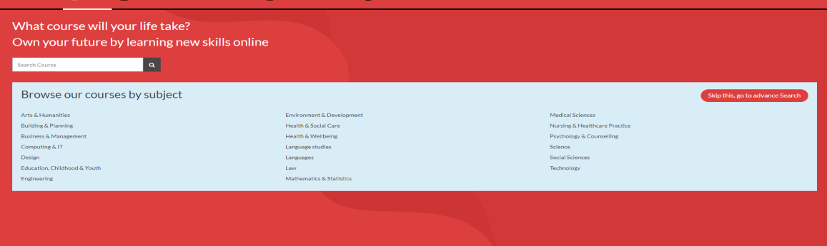

**List of Schools offering the topic**

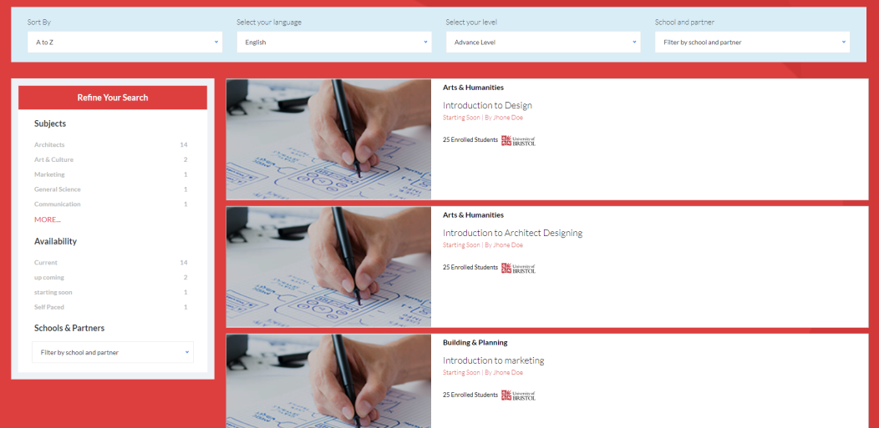

# Contact

|  |  |
| --- | --- |
| **EPIC** | **Acceptance Criteria** |
| As a School/ University I want to choose a subject and course to learn or teach | A contact section for users to see an email template and a submit Request button. Email can be edited |
|  | Telephone contact details are listed |
|  | Company address is listed |
|  | Links to company sites such as Facebook, Twitter etc. |

# Create Account

|  |  |
| --- | --- |
| **EPIC** | **Acceptance Criteria** |
| Create and Login | User should see login screen with input data fields for 1) Username 2) Password 3)Password reminder |
|  | Details appear and its able to use the chat line with a support person |
|  | Details fields appear to register. (See Patent section for animation) |
|  | Able to Login correctly |
|  | Edit function is available and details can be changed and saved |
|  | ‘Deletion’ occurs |
| Details to enter for registration | Fields to be completed for registration are:   * Tutor Title * School/entity name * First Name of contact * Last name of contact * Address 1,2 * Town * City * Region * Postcode * Zipcode * Country * Telephone country code * Telephone Area code * Telephone Number * Mobile Country code * Mobile Number |
|  | Message appears and I have to use another userID or password |
|  | Security questions appear and they are answered in order top gain access to the platform. |

**Registration and sign in page**

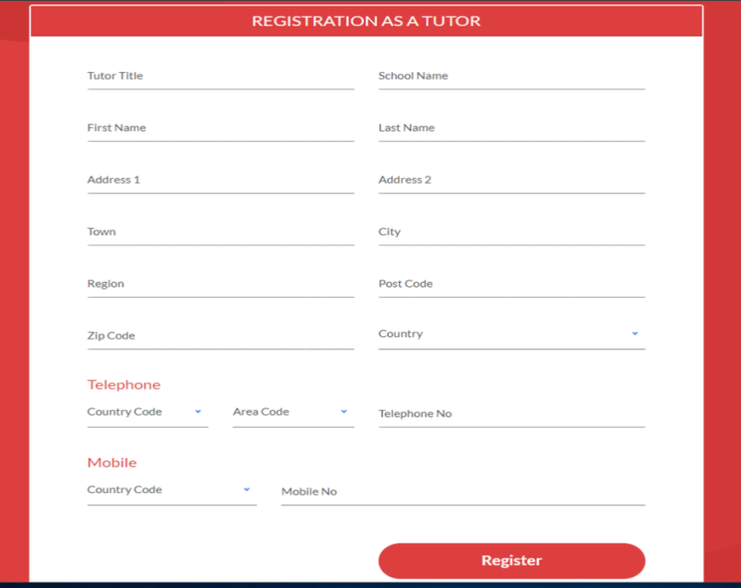

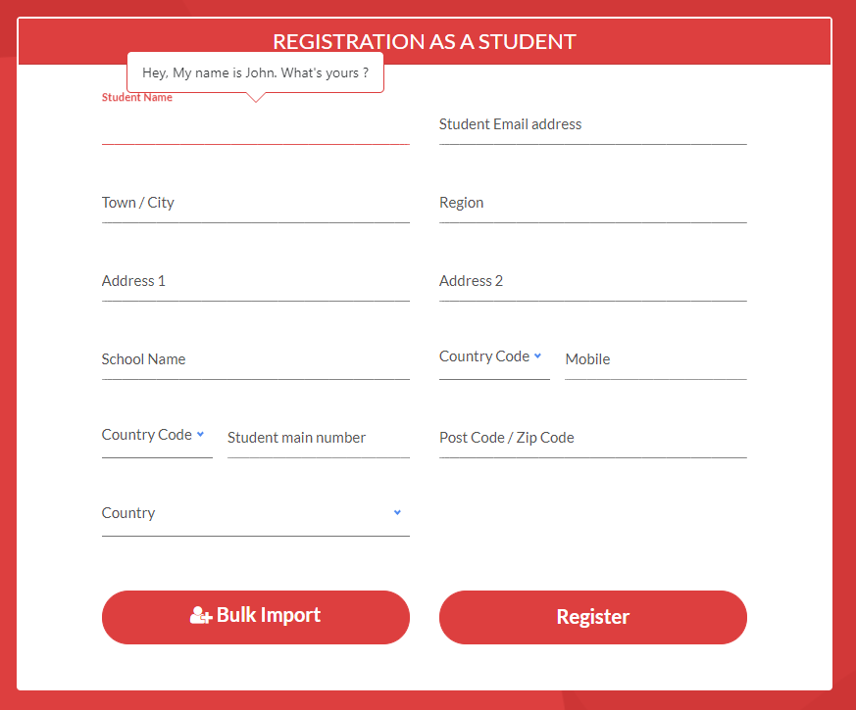

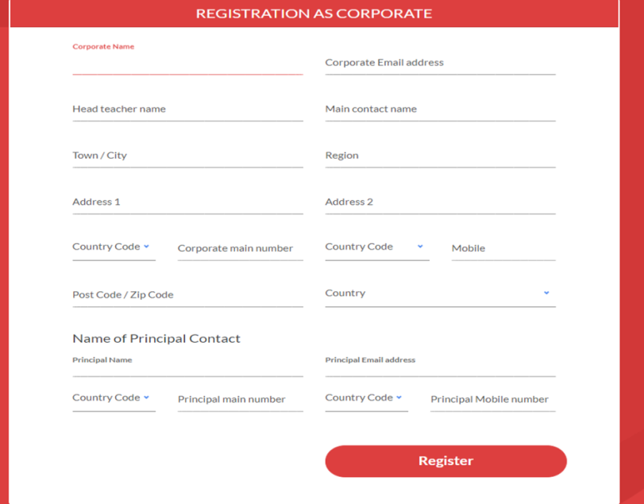

# Profiles

|  |  |
| --- | --- |
| **EPIC** | **Acceptance Criteria** |
| Create a member personal profile | Questions and details appear to be answered led by an animation leading to each mandatory reply. |
|  | Edit function appears and I am able to edit and save |
|  | Extra details are included such as:  University visited  Work experience  Hobbies  Certifications  Etc. |
|  | Articles appear and an Icon in my profile set up |
|  | Profiles listed by members of a Module/Class etc.  **N.B. This is only accessible by members of the platform as this is a ‘CLOSED’ platform** |
|  | Also search can include country.  **N.B. This is only accessible by members of the platform as this is a ‘CLOSED’ platform** |
|  | On the profile there should be a ‘Tick’ box to mark as ‘Private’ or ‘Public’.  **N.B. This is only accessible by members of the platform as this is a ‘CLOSED’ platform** |

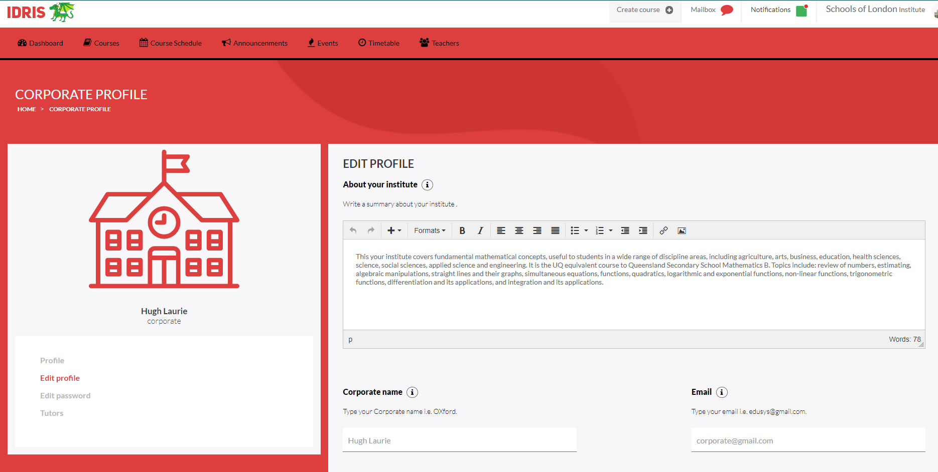

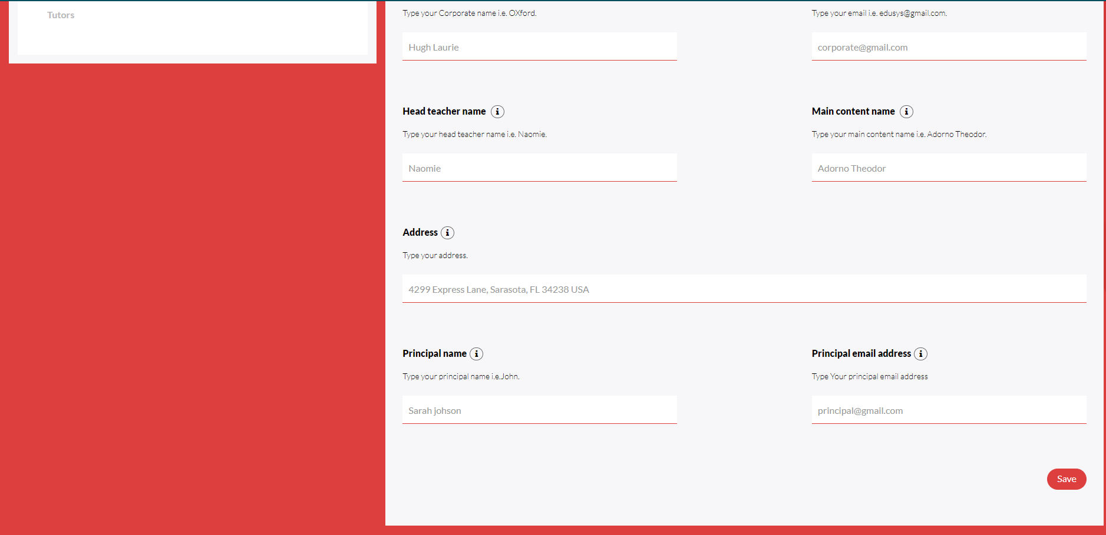

# Home Page

|  |  |
| --- | --- |
| **EPIC** | **Acceptance Criteria** |
| Create a Home Page | Client has a prominent area on the home page where he can put special announcements, not necessarily news or articles, so that he can give additional exposure. |
|  | As a site editor, we provide flexibility as to where things appear so as to accommodate different types of content. |
|  | As a School/University, the upcoming courses are what I want visitors to notice so that they register and there’s a benefit to my membership. |
|  | New details or page is updated |
|  | As a site visitor, I want to have articles that interest me and others and are easy to get to, so I come to the site for my agile news and learning. |
|  | For the administrator the Home page should have a link icon at the top of the screen |
|  | As a site visitor, I want to see a list of the most popular items on the site so I am most likely to read the most important or best content. |

# Course Creation by Legal Entity or Teacher/Administrator

|  |  |
| --- | --- |
| **EPIC** | **Acceptance Criteria** |
| As a School/University I want to create courses | Each client is able to upload its own profile, course details and subject contents, teacher/trainer details etc. |
|  | Quiz is produced and the user can answer the questions with a score showing from an algorithm. This should also appear in the reporting section as part of an algorithm for teachers league |
|  | Course details and content will appear per module. |
|  | Forum is created and discussions appear with userID, Time and Date |
|  | As School/University, I can indicate the schedule for a course so that prospective participants and participants can see what course elements will be presented each week and what they’ll be. |
|  | As School/University, I can set the publication date for course elements (for a scheduled course) so that items become available when I want and not sooner. This will appear in the course details and on the platform there will be a ‘Publish’ button as in the prototyope |
|  | As School/University, I can add subtitles to any video so that it is more accessible. |
|  | As School/University, I can set the thumbnail image for each video so that the image is one I like rather than randomly selected. This means that course details can be more interesting. Instructor should be able to import videos from external apps. And social media. |
|  | School logo if created by the school/university. Customised logo is watermarked |
|  | Course Description appears on the internet web page and found by browsers |
|  | Detailed page about each course appears on the internet web page and found by browsers |
|  | Browse a catalogue of all courses available |
|  | List of other related courses when viewing a course |

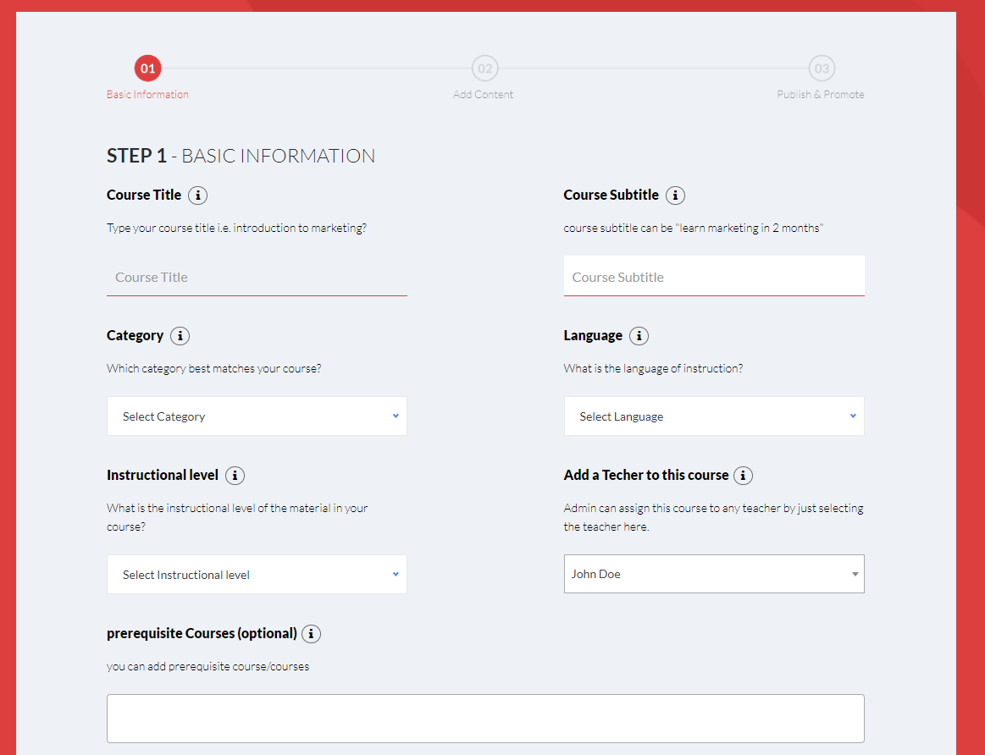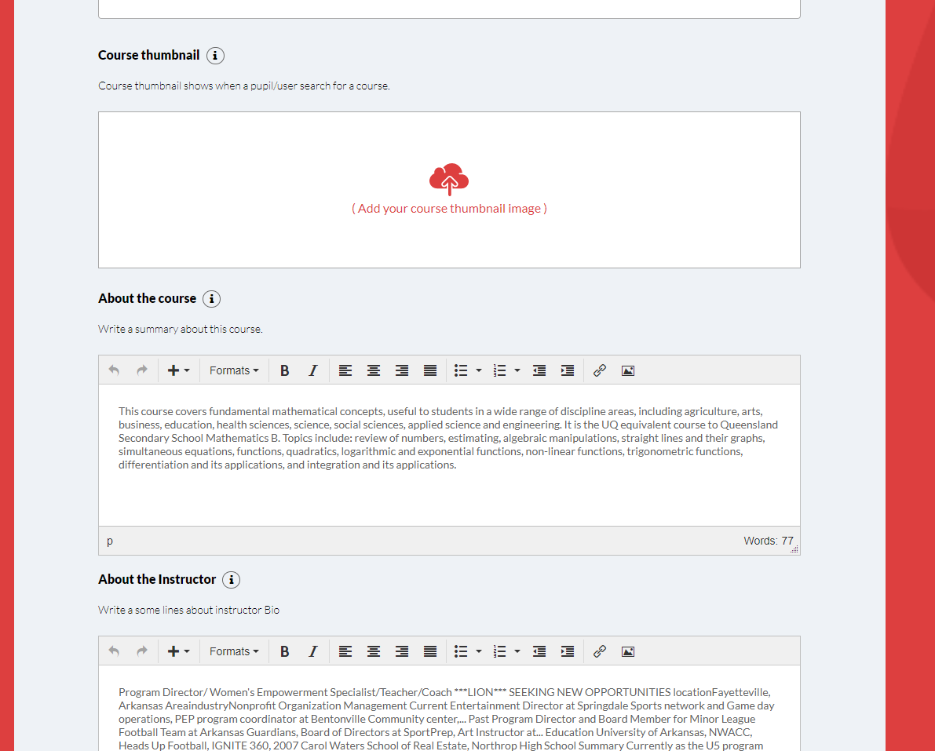

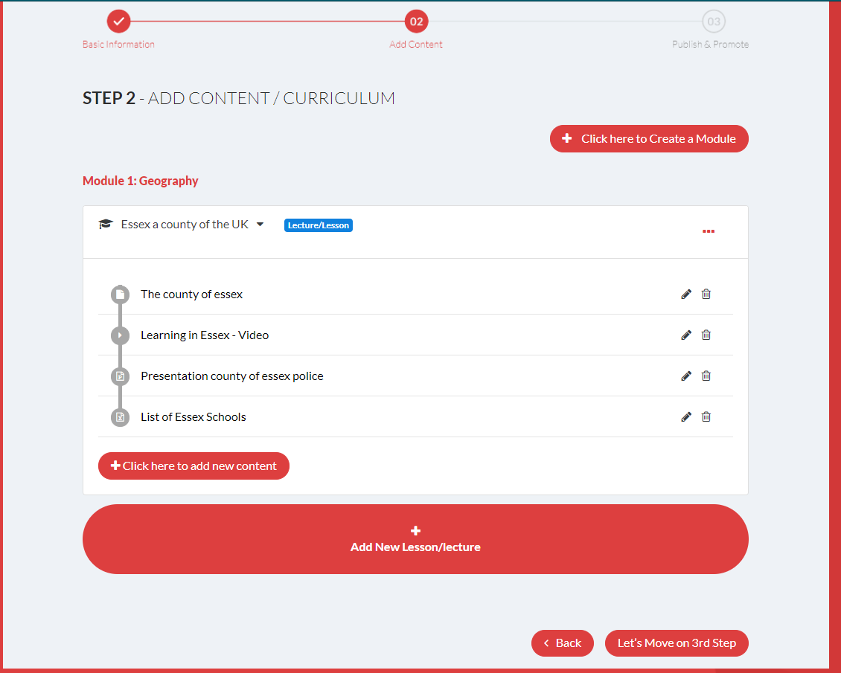

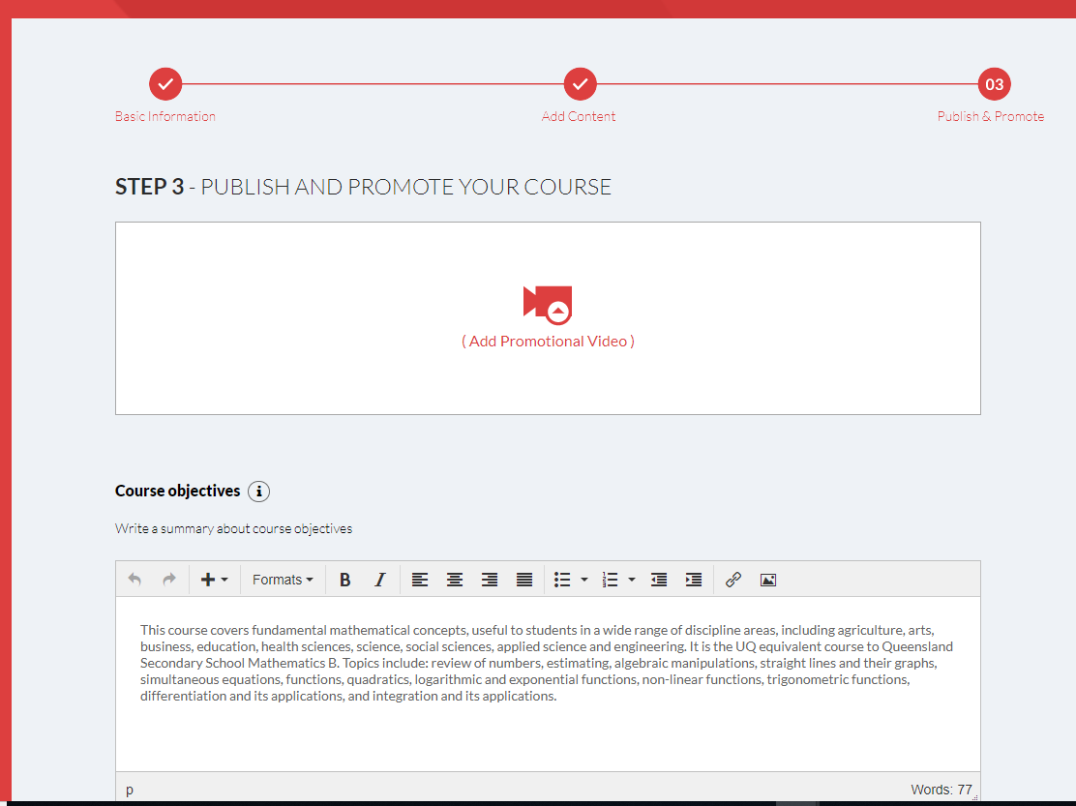

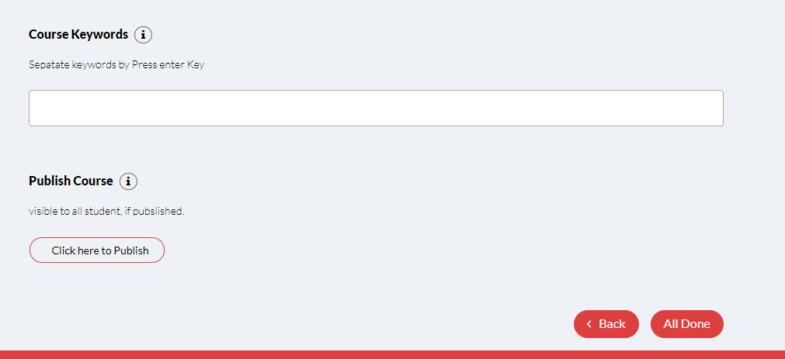

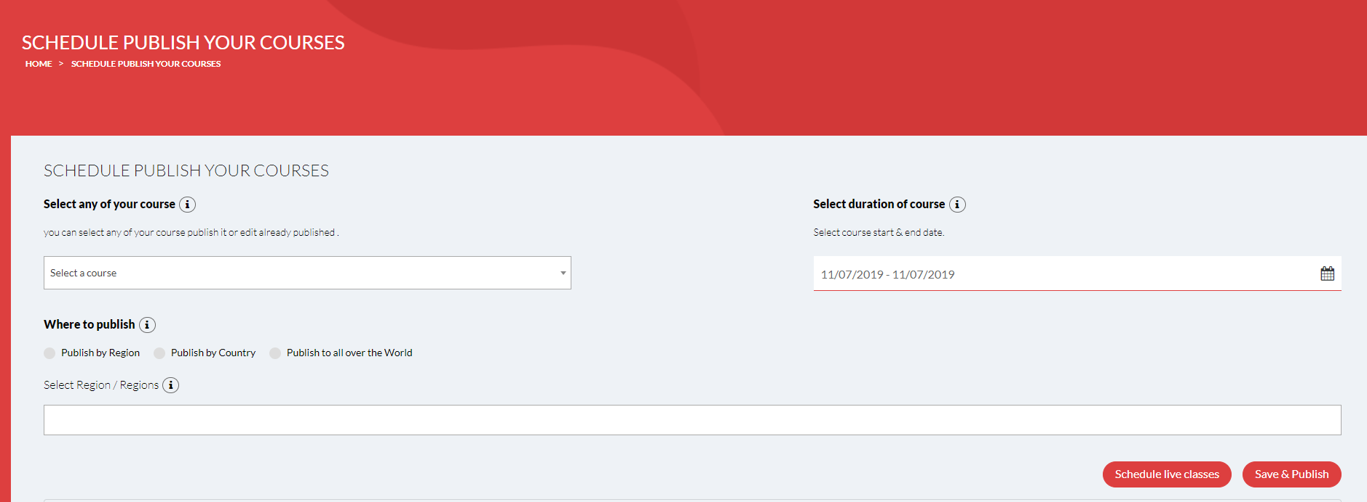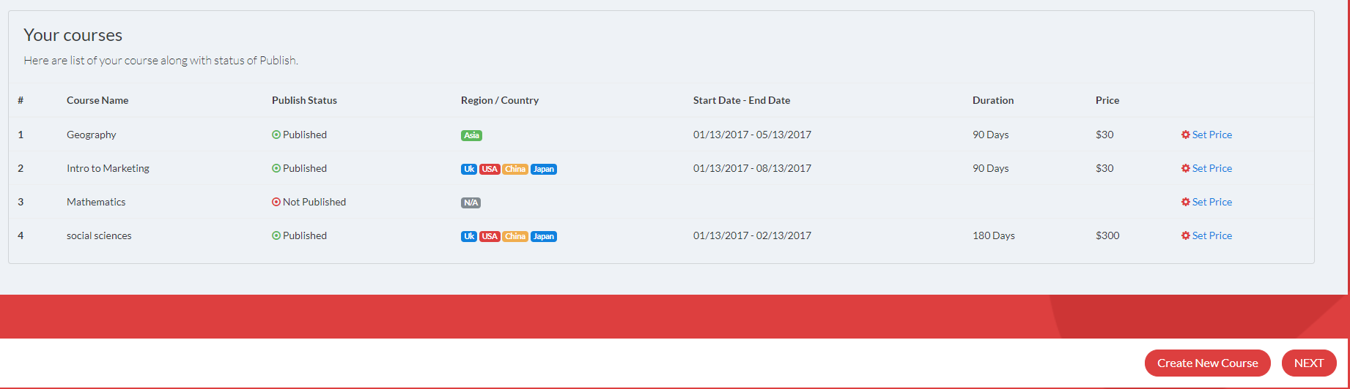

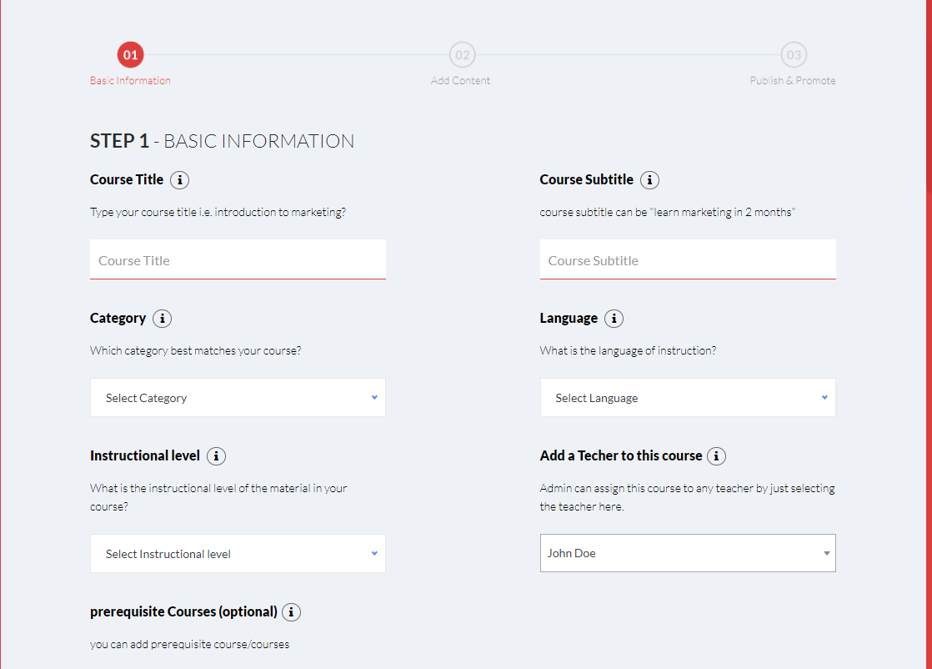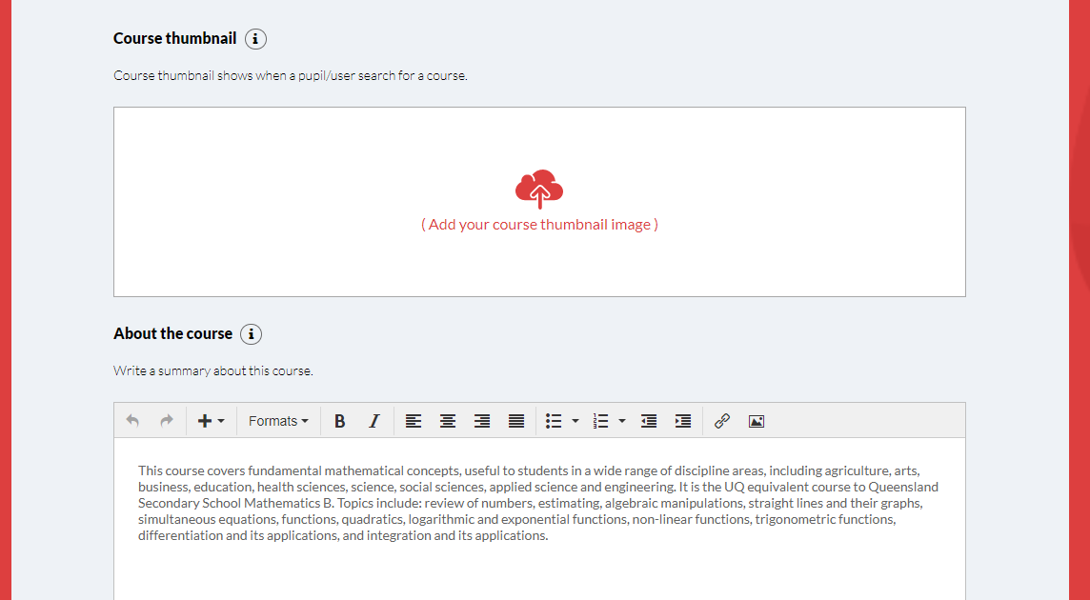

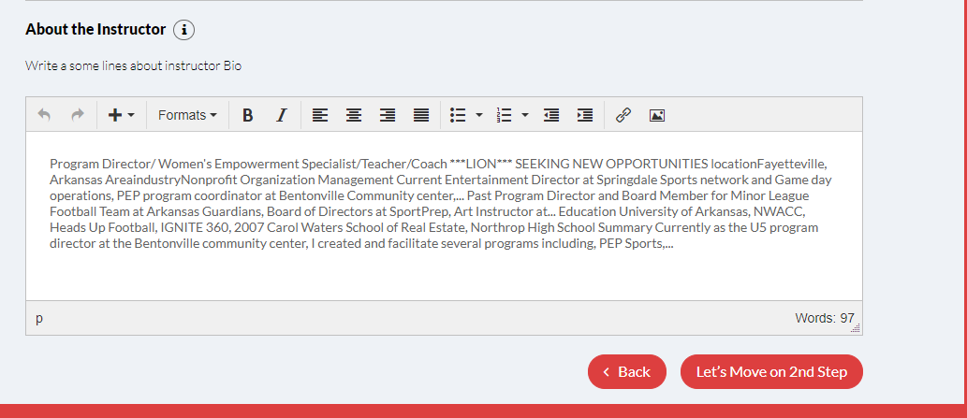

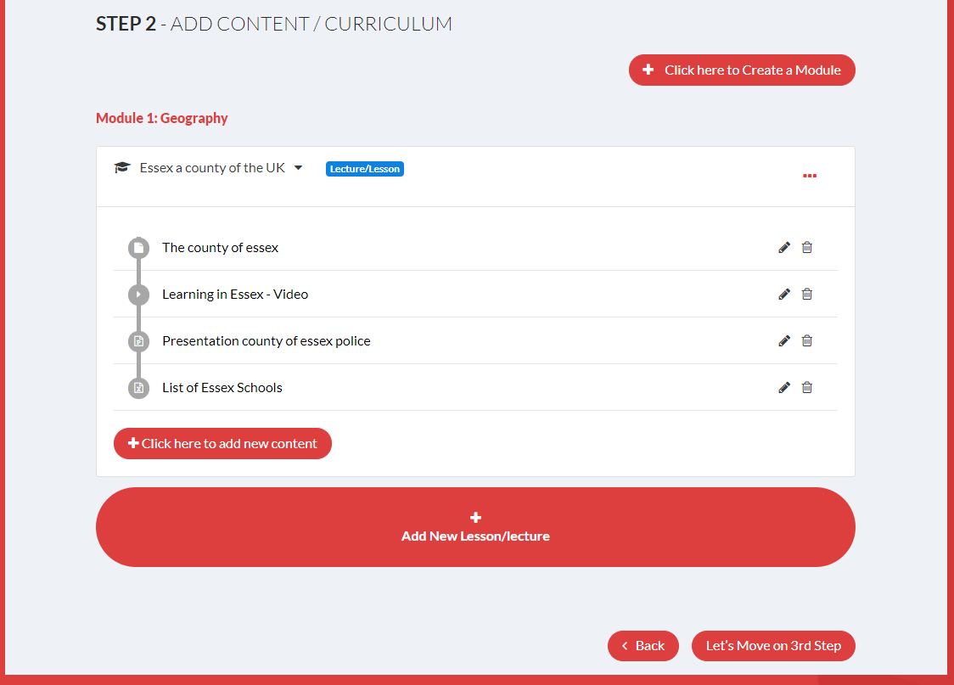

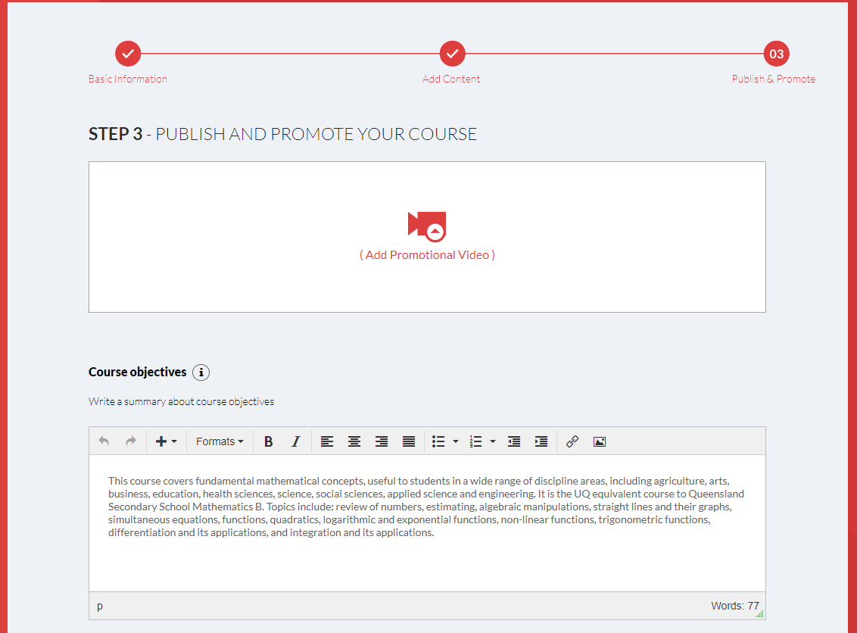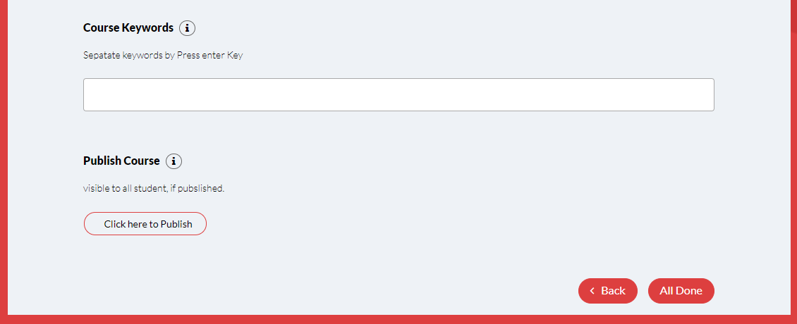

# Buying Courses

|  |  |
| --- | --- |
| **EPIC** | **Acceptance Criteria** |
| Course purchasing | In the set up of courses the price should be entered by the School administrator |
|  | As a School/University, I can set quantity thresholds and discounts so that I can offer lower prices for larger orders such as “buy three, get 10% off”. This will be in the pricing structure offered and in the calculation of the fee due. |
|  | As a School/University / administrator, I can create discount codes I can give to people so that I can customize pricing. |
|  | As a site visitor, I can put courses in my shopping cart so that I can purchase them and participate in (watch) them. In the cart the price will be calculated |
|  | As a site visitor, I can put one chapter of a course in my shopping cart so that I can purchase just a part of a course. In the cart the price will be calculated |
|  | As a site visitor, I can pay for the courses in my cart with a credit card so that I can purchase them and participate in (watch) them. Purchase will complete process with the ‘plugin’ 3rd party application |
|  | As a site visitor, I can pay for the courses in my cart with PayPal so that I can purchase them and participate in (watch) them. Purchase will complete process with the ‘plugin’ 3rd party application |
|  | Receipt is produced in the payment function and an email sent to the client email address |
|  | Notification to other group members is notified |
|  | As a user, I can view the license terms before purchasing or subscribing so that I know what I’m getting. |
|  | As a participant, I can sign up for a monthly or annual subscription so that I can take all (video?) courses. All details are entered into the Database as Annual payment or monthly payment |
|  | As a company, I can purchase multiple licenses so that I can manage course registrations for a group of people. License will specify the subject and education year. Multiple license will be decided. The license details will be sent to the client and a reminder when there is 1 month left to license expiry |
|  | As a company, I manage a set of course registrations so that I can control which employees in my company have access to which courses. |
|  | As a company, I can purchase a site license so that everyone in my company can take the course. License will specify the subject and education year. Multiple license will be decided. The license details will be sent to the client and a reminder when there is 1 month left to license expiry |
|  | Payments will be made via a 3rd party function such as Paypal/Worldpay, Credit card/ Debit card etc |

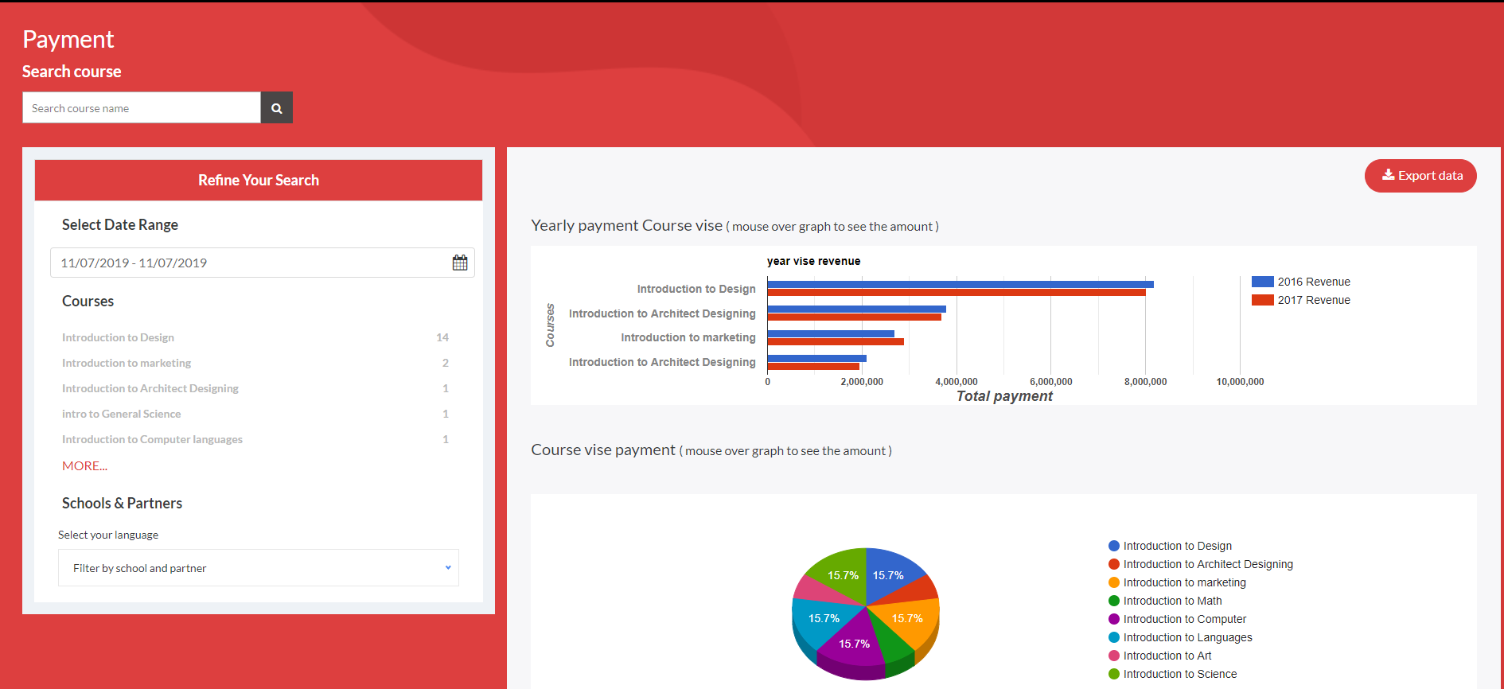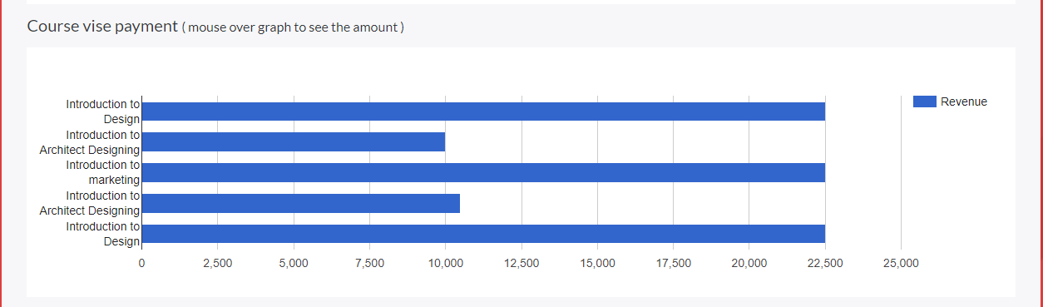

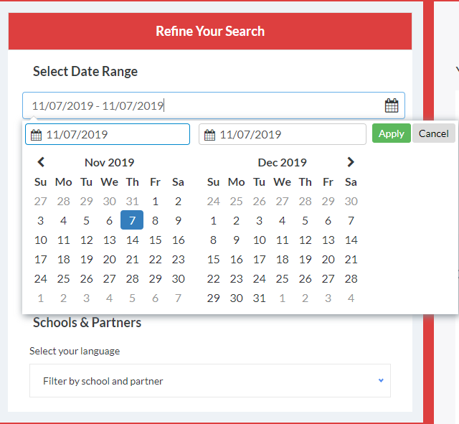

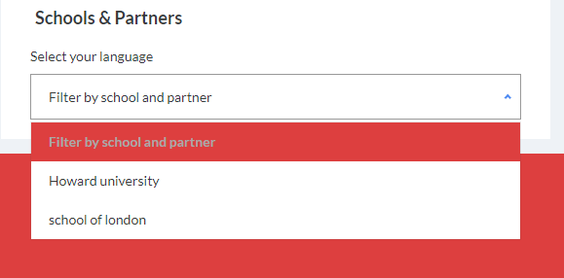

# Registration

|  |  |
| --- | --- |
| **EPIC** | **Acceptance Criteria** |
| Platform Registration | View lists on the site of all School, Teachers, Practitioners, Trainers. |
|  | Name will appear in the list for teachers by subject, Country, Region, Town |
|  | As a teacher / trainer who has finished teaching a Certification class, I can load an Excel file (first name, last name, email) into the site so that those course participants are added to the class records. Import data from an excel sheet into the platform database |
|  | Courses are marked as “pending” until the teacher/school pays the platform fees. |
|  | As a site admin, I can view all classes in a pending state so that I can approve any that need to be approved. |
|  | As a site admin who has received proof of payment from a teacher/school, I can move people in his or her class from a pending state to the registry. Able to edit class participants |
|  | As a new Teacher, once my name has been loaded to the registry I am sent an email welcoming me to the Class and containing instructions on how to register / activate my membership. Message is sent to teacher / trainer |
|  | As a site editor, I can edit the content of the email automatically sent to new Teacher and Product owners so that I don’t need to involve a programmer on simple email edits. Able to edit the message as an editor |

# White labelling membership

|  |  |
| --- | --- |
| **EPIC** | **Acceptance Criteria** |
| Client labelling of platform | Open the platform for the client and ensure that the name and logo etc is in the client name and requirements |
|  | Platform client has an advertisement appear in a banner for the school/University, Corporate name, Private tutor etc |

# Timetable

|  |  |
| --- | --- |
| **EPIC** | **Acceptance Criteria** |
| Tuition timetable | A diary appears with each class details, date, time and a link to open the platform |

# Mailbox

|  |  |
| --- | --- |
| **EPIC** | **Acceptance Criteria** |
| Email box | New email opens with the ability to attach files or documents.  Reply or forward emails and being able to attach files or documents. |
|  | Able to attach excel, Word, Powerpoint, Visio, Videos, etc |
|  | Attachment of large files such upto 20mb |
|  | When saving emails the user may want to use their own subject matter or add a prefix for filters. |
|  | Emails to be sent within the system but not externally. |
|  | As a Teacher / Trainer/Student I want to be able to categorize the emails (shown on the mail page as shown below) and to have a selection of filters |

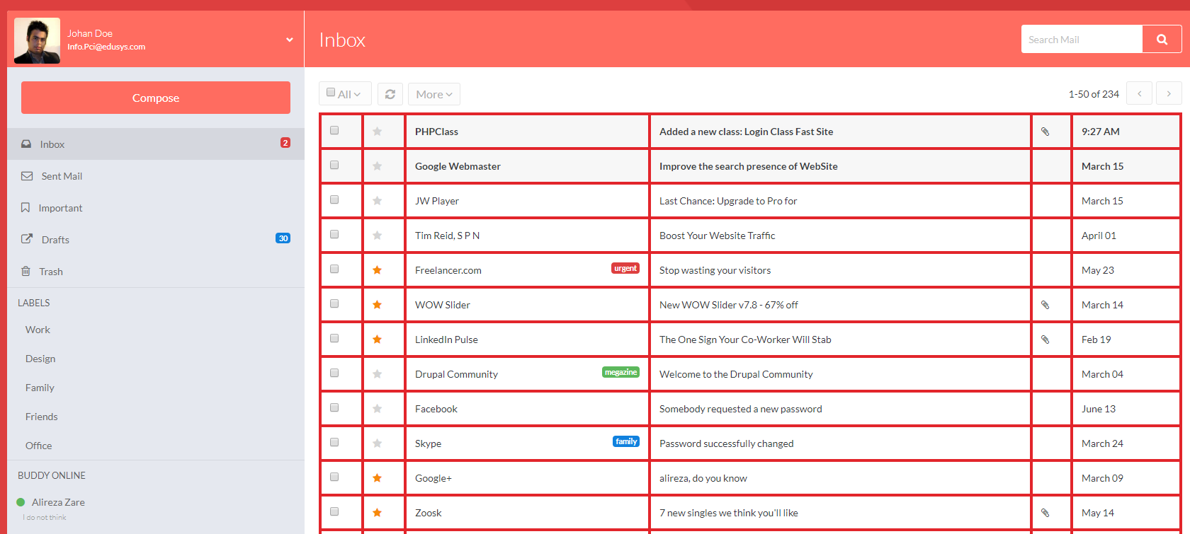

# Live Classes

|  |  |
| --- | --- |
| **EPIC** | **Acceptance Criteria** |
| Live class screen | List of lessons that are clickable in order to enter into the class. Must have date and time and teacher name and subject matter (See Below) |
|  | The class list must have buttons to open URL for; Completed, Start Now, Up-Coming |
|  | See all lesson content of documents and videos |
|  | Student should be able to see the teacher/Trainer giving the lesson |
|  | Student should be able to see all practical demonstrations |
|  | Student should be able to download all documents and videos of the lesson either individually or as a complete content. |
|  | Teacher / Trainer and student should be able to Logout of a lesson but remain on the platform. |
|  | Teacher / Trainer and student should be able to see a clock to show time, Countdown of current lesson in time |
|  | Teacher / Trainer and student should be able for all advertising turned off during the lessons |
|  | School/University should be able to see Total students registered, Live students online. |

Scrolling question pane fro questions from students and the teacher can answer after the class. A list is produced for the teacher after the lesson to show the questions.

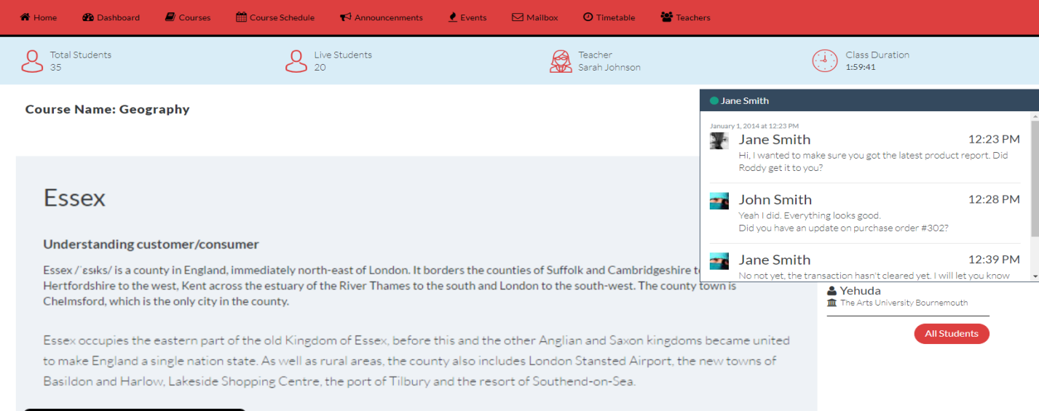

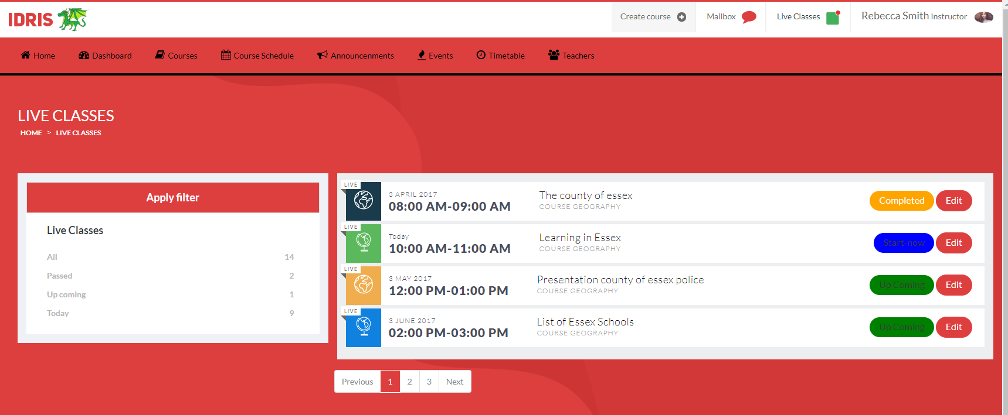

Click on ‘Start now’

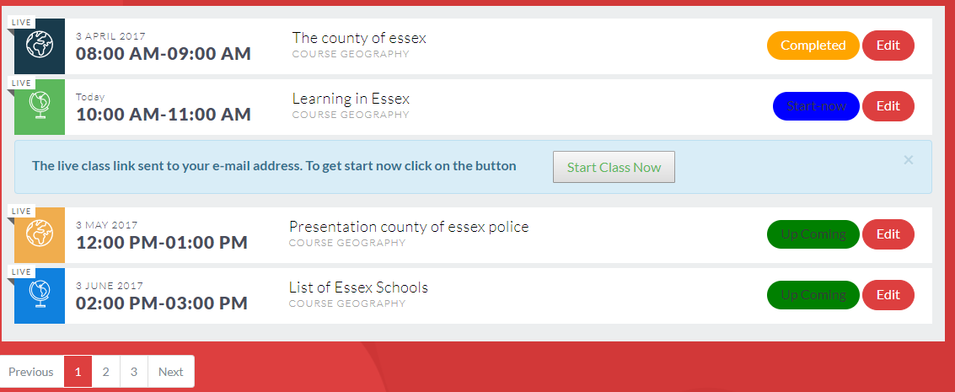

Click on ‘Start Class Now’ to see class screen below with the ‘Live’ Teacher in the video

Click on ‘Next Lesson’ (not correct heading) to show the lesson and its contents of documents and videos and URL links

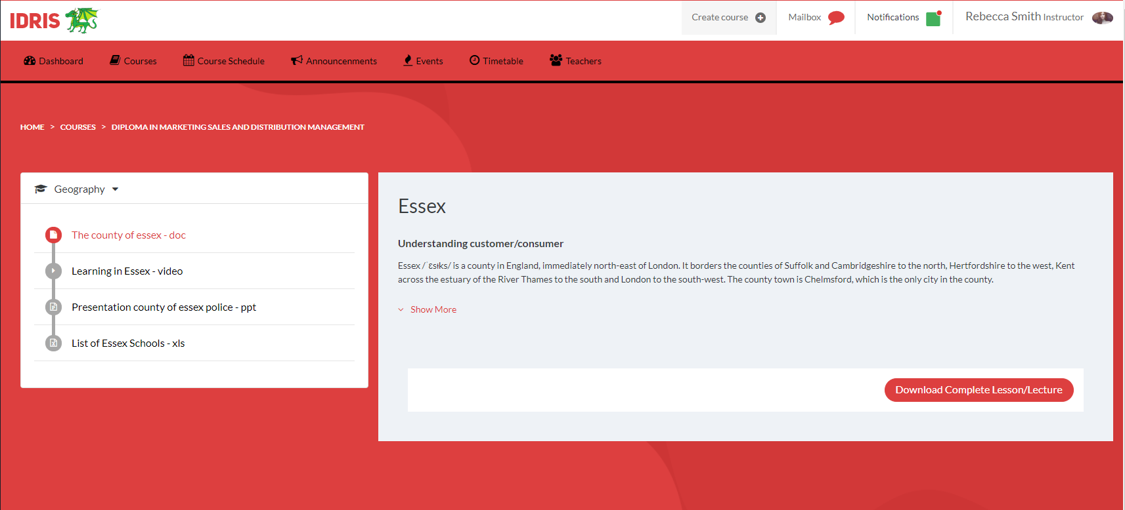

# Course Schedule

|  |  |
| --- | --- |
| **EPIC** | **Acceptance Criteria** |
| Publish a course | Course appears advertised on the client and Dragonista webpages, with the details and costs (see example below) |

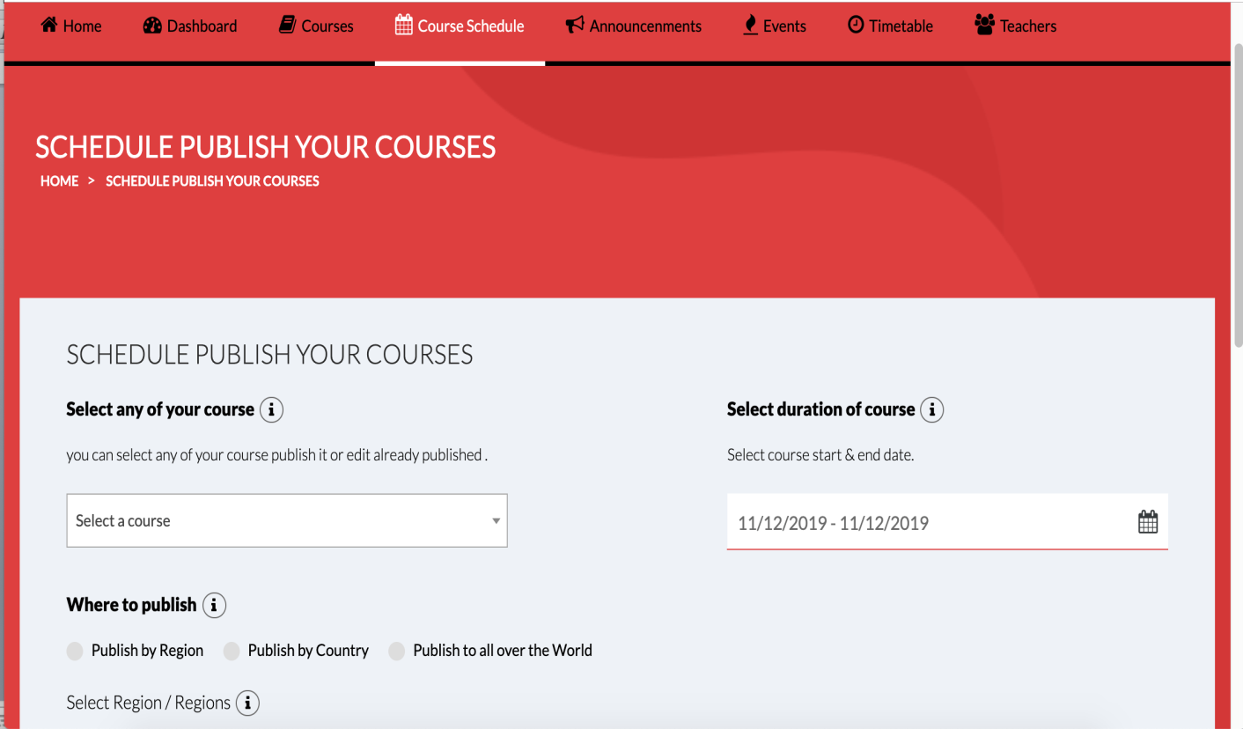

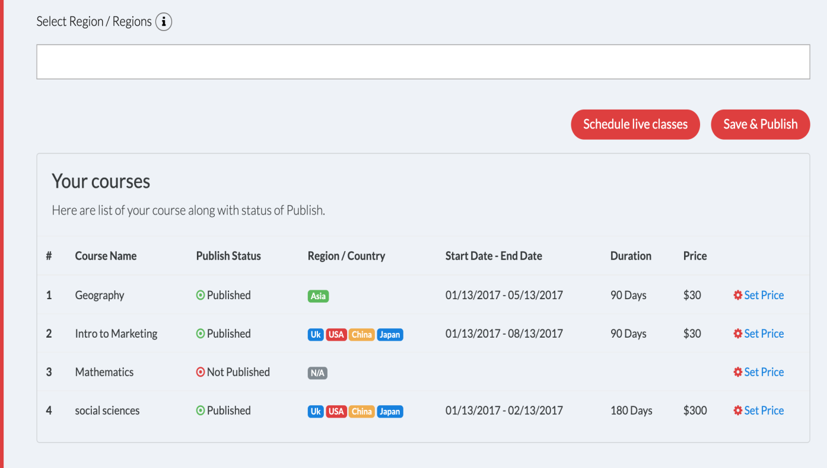

# Viewing Courses

|  |  |
| --- | --- |
| **EPIC** | **Acceptance Criteria** |
| Viewing courses | Course is listed on the client white labelled web site. Once the student logs in they can see if they have completed the course |
|  | I go to a library of courses and lessons and I can open any lesson required for revision or to cover any missed lessons, plus the content of the lesson |
|  | As a site visitor, user can view some excerpts videos for free, so that I can decide if I want to buy the full course. |
|  | A video is watched to the end and then the next in the series is started after 1 minute as an example. |

# Course completion

|  |  |
| --- | --- |
| **EPIC** | **Acceptance Criteria** |
| Course status | Course completion timeline  I.e. 30% COMPLETED  70% required over this time period. |
|  | User can earn a certificate of completion by finishing a course so that user have proof that he completed a course. This is an platform certificate sent by email to user. |
|  | User can earn a badge showing that he completed a course so that he can display that badge on his own website. Badge icon appears next to name and course in student profile |
|  | User had a page he can link to and share with others that shows all the training courses he had completed so that people can see all the great stuff he had learned. This will appear on the user profile |

# Course Evaluation

|  |  |
| --- | --- |
| **EPIC** | **Acceptance Criteria** |
| Course evaluation | Questionnaire appears and an algorithm that provides a score. |
|  | Email message is sent to the Teacher / Trainer |
|  | School/University can view all feedback for a course when logged in so that they can see historical or aggregate data on courses. |
|  | School/University can export all feedback for a course to a CSV file so that they can perform more in-depth analysis. |

# Events

|  |  |
| --- | --- |
| **EPIC** | **Acceptance Criteria** |
| Create events Function | A diary to show Pending events and its description. Also appears in a calendar with the ability to drill down on the event in the date to see any further information. |

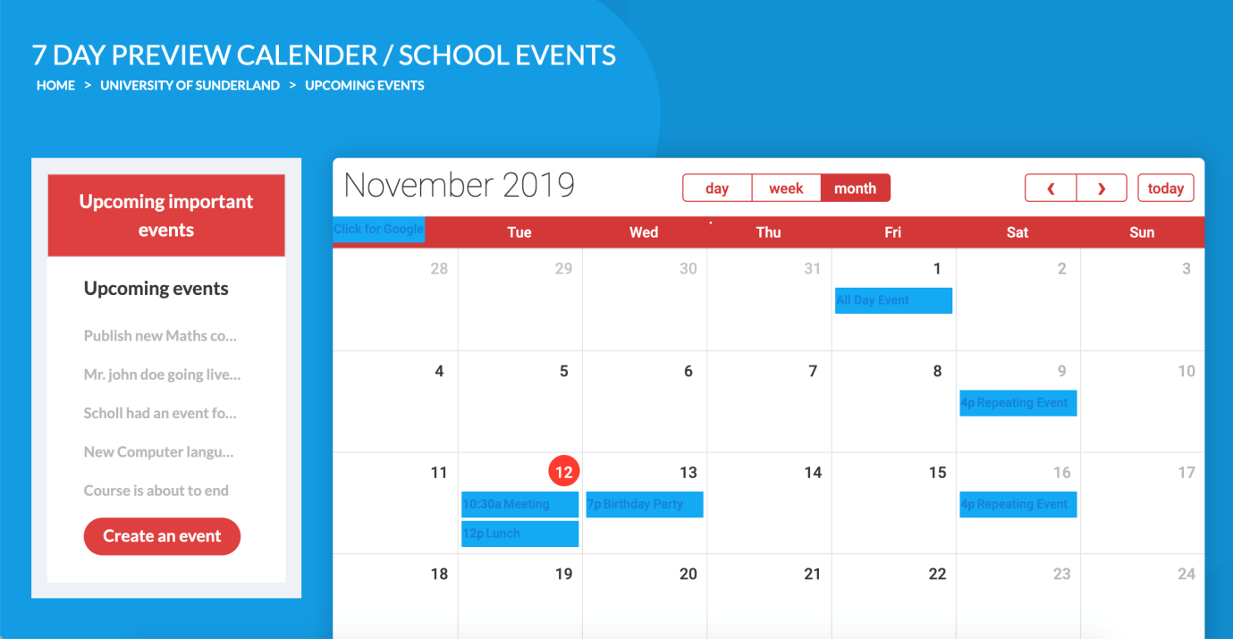

# Help / Faq

|  |  |
| --- | --- |
| **EPIC** | **Acceptance Criteria** |
| Help function | List and categorize FAQ questions and answers |
|  | Role based access rights to update the Help and FAQ function |
|  | In the search box enter full or partial text to get FAQ |
|  | Email the help team and receive a message that the email was received and an answer will be forthcoming |
|  | Open chat line and talk to a support staff |

# Dashboard / Reporting

|  |  |
| --- | --- |
| **EPIC** | **Acceptance Criteria** |
| Dashboard and management reports | Site owner should receive a periodic email summarizing registrations for the day, week and month to date, so that he know how they’re doing. Email is received on a daily basis |
|  | Report produced and will also include items such as remuneration as a portion of the number of lessons given or bums on seats |
|  | School/University can run a few helpful reports to be determined later so that they can monitor various aspects of my courses. |
|  | System admin, I can run any report a trainer can run so that he can see overall information for any trainer on the site |
|  | An algorithm to be included based on a questionnaire and scoring |
|  | School/University can see how much they are earning. Earnings will come from ‘bums on seats’ or from the school |
|  | School/ University can see how much they are paying and the net of the cost v income |

Example of reports

1. All reports are to be customisable as per client requirements

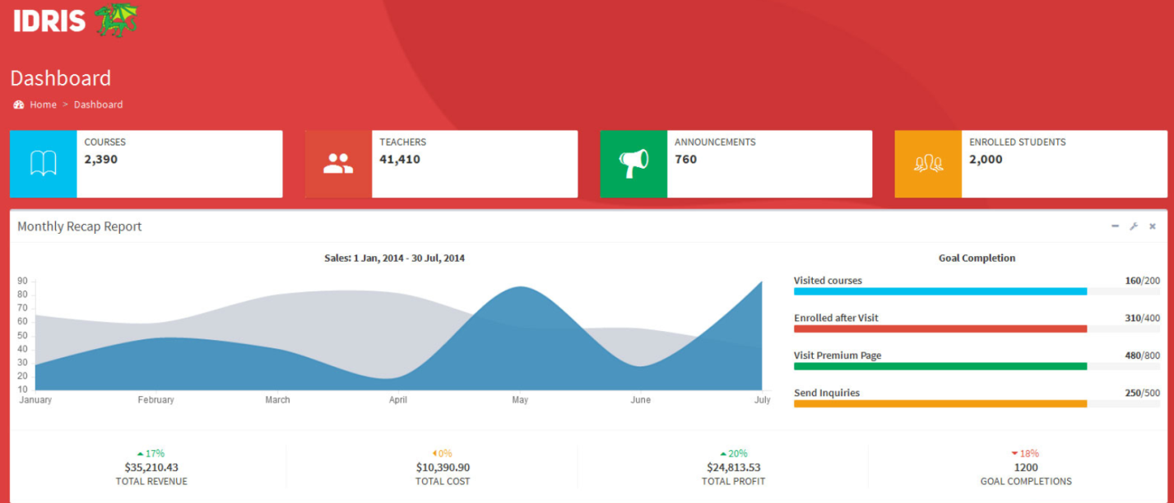

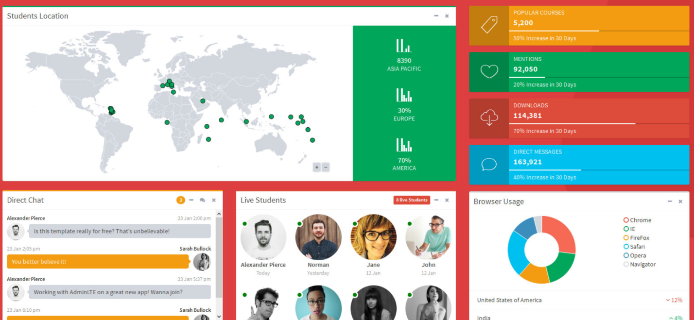

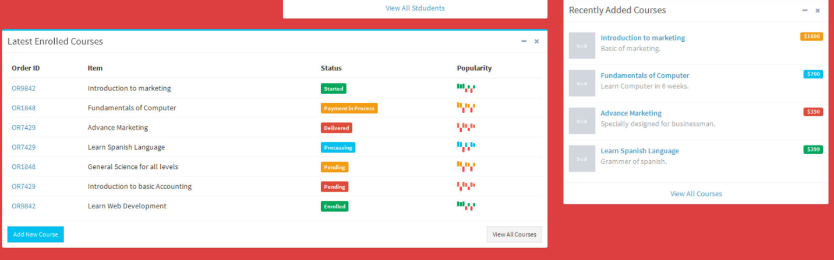

# Database

|  |  |
| --- | --- |
| **EPIC** | **Acceptance Criteria** |
| Creating a Database structure | Data will need to be easily accessible for the client to create their own reports |

# Sponsorship

|  |  |
| --- | --- |
| **EPIC** | **Acceptance Criteria** |
| **Sponsorship** | Banner and advert to be shown depending on sponsor requirement. The advert will need to disappear during class session |
|  | A renewal message is sent to the sponsor 6 weeks before expiration. So the email is produced by the system with a copy sent to accounting dept as a copy |

# 23. Privacy & Miscellaneous

|  |  |
| --- | --- |
| **EPIC** | **Acceptance Criteria** |
| Privacy & Miscellaneous | • Site visitor, can read an FAQ so that all his questions are answered. |
|  | • As a search engine, I can view a site map so that all pages are indexed. |
|  | • Site visitor, can read a privacy policy so that he know what’s private. |
|  | • Site visitor, can sign up for a newsletter so that he get announcements about new courses and other information. |
|  | • Site visitor, see “Featured Products” on the home page so that he can see the products the site most wants all visitors to see. |
|  | • Participant, do not want the site shut down while he is in the midst of a quiz or video so that his progress isn’t interrupted. |

# 24. Quiz and Info

|  |  |
| --- | --- |
| **EPIC** | **Acceptance Criteria** |
| Quiz | School/University can create quizzes so that participants can assess their learning. |
|  | School/University can take a quiz as part of a course so that they can get feedback on how well they learned material in the previous video(s). |
|  | Participant, can see which quizzes they’ve passed, not passed, or not yet taken when viewing the course outline so that they know which quizzes they need to take or possibly re-take. |
|  | Quiz responses stored in the database so that School/University can see how people are doing at various questions, perhaps so they can fix one that is worded poorly. |

# 25. Teacher and Student Comments

|  |  |
| --- | --- |
| **EPIC** | **Acceptance Criteria** |
| Comments | Published comments to be seen by all |

# 28. School / Teacher league table

|  |  |
| --- | --- |
| **EPIC** | **Acceptance Criteria** |
| League table | Via an algorithm from questionnaire and scoring a league table will appear to show the league table by Country, Region, Subject |
|  | Via an algorithm from questionnaire and scoring a league table will appear to show the league table by Country, Region, Subject |

# 29. Account Management

|  |  |
| --- | --- |
| EPIC | Acceptance Criteria |
| Opening an account on the platform | Site visitor, can create an account so that he can track his progress. This should be automatically created when registering |
|  | Editable functionality will appear account details. |
|  | A report by student to show basic data including the courses and their progress in the course and list their badges and course status |

# 30. License Admin

|  |  |
| --- | --- |
| EPIC | Acceptance Criteria |
| License administration | This will be applied by a school, corporation or Private tutor. Then the license holder will include the student details to register |
|  | Buyer, can distribute out licenses to others in his company so that they can view a course he pay for. |
|  | Buyer, can share a company-wide license with everyone in his company so that everyone in the company can view the course. |

# 31. Forums

|  |  |
| --- | --- |
| EPIC | Acceptance Criteria |
| Forum | User participate in a forum for a course so that he can discuss questions and topics with the instructor and other participants. This should be within the members in a closed system and based on a Social Media type of discussion board |

# 32. Announcements

|  |  |
| --- | --- |
| EPIC | Acceptance Criteria |
| Announcements | Announcements can be made for events, closures, lesson cancellation etc. An email should be sent to the participants. Therefore an email should be produced and sent |
|  | Announcements can be made for events, closures, lesson cancellation etc. An email should be sent to the participants. Therefore an email should be produced and sent |

# 33. Archiving

|  |  |
| --- | --- |
| EPIC | Acceptance Criteria |
| Archiving | A search function for a library of modules and lessons based on:  Subject, Country, region, Teacher, Date, School, Corporation. |
|  | Moderator can view a transcript of a lesson. |
|  | Moderator can export a transcript of a lesson as a HTML file so that he can save the stories and estimates locally. |

# 34. Advertising

|  |  |
| --- | --- |
| EPIC | Acceptance Criteria |
| Platform Advertising | 1 minute before the lesson is scheduled, remove all advertising notifications and banners etc.  Then turn them all back on 1 min after the scheduled lesson finishes checking that students and teachers / Trainers have logged off the lesson |
|  | Advertising can be by Banner, Special messages from advertisers |