iOS Application Bug Report

1. When course store in completed tab then also showing one lesson completed & another lesson pending.

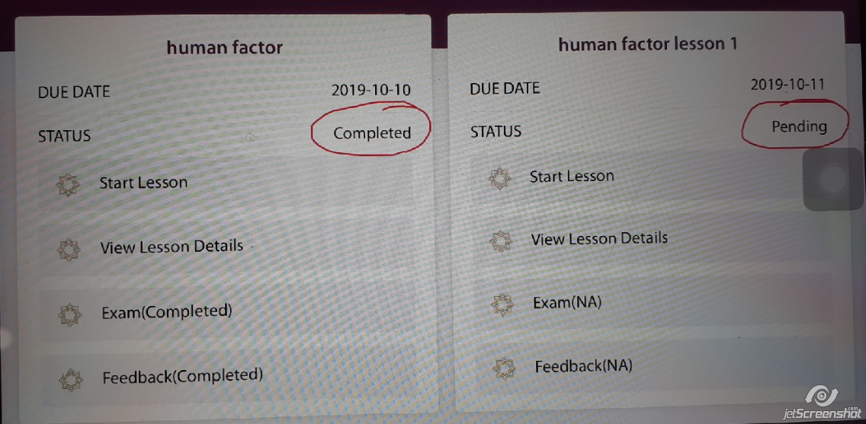

1. Calendar settings not well... showing year for previous month & some text for next month.

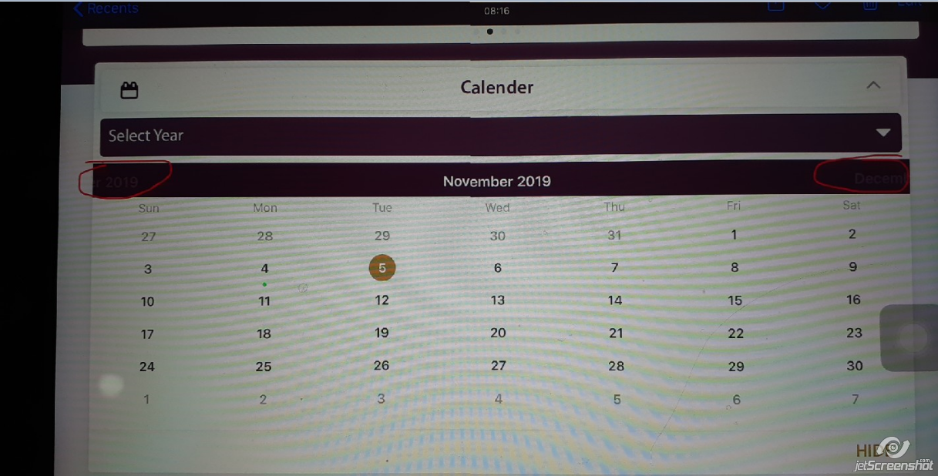

1. On pinch zoom in or zoom out timer getting stop while completing lesson.
2. Application not working Off line (some action done off line & for some action it says to check internet connections) (Once I completed 1/2 course online & come back from course then turn off internet connection & again try to open lesson it show message " Please check internet connection")
3. Pending Issues : 1) Quiz

2) Download Certificate

3) Feedback in side listing bar

4) Terms & Conditions

5) About