

TAKSHSHILA INSTITUTE OF

ENGINEERING AND TECHNOLOGY

Jabalpur , (M.P.)

# 

# [DEPARTMENT OF CSE]

A MINOR PROJECT ON

WEB PORTAL

SUBMITTED BY

PALLAVI SHUKLA [0207CS201049]

ANMOL KUSHWAHA [0207CS201009]

RANU MASRAM [0207CS201064]

UNDER THE GUIDANCE OF

PROF. SWATI SONI

# CANDIDATE’S DECLARATION

I hereby declare that the minor project work being presented in this report entitled "WEB PORTAL” submitted in the department of COMPUTER

SCIENCE, under the guidance of Prof.

Swati Soni, Department of Computer

Science, Takshshila Institute of

Engineering and Technology, Jabalpur.

## Date_ _/_ _/_ _

PALLAVI SHUKLA ANMOL KUSHWAHA RANU MASRAM

CSE 5TH SEM

# CERTIFICATE

This is to certify that this report represents the original work done by

PALLAVI SHULKA, ANMOL KUSHWAHA & RANU MASRAM during this project submission as a partial fulfilment of the requirement for the Web Portal Project of Computer Science and

Engineering, 5th Sem, Takshshila Institute Of Engineering And Technology, Jabalpur.

## Date_ _/_ _/_ _ PALLAVI SHUKLA

ANMOL KUSHWAHA RANU MASRAM

CSE 5TH SEM

# 

# ACKNOWLEDGEMENT

I would like to express my special thanks of gratitude to my teacher Prof. Swati Soni who gave me the golden opportunity to do this wonderful project on the topic Web Portal, which also helped me in doing a lot of Research and I came to know about so many new things I am really thankful to them.

## Date_ _/_ _/_ _ PALLAVI SHUKLA

ANMOL KUSHWAHA

RANU MASRAM

CSE 5TH SEM

# INDEX

# 

1. TITLE OF THE PEOJECT:

Web Portal

1. OBJECTIVE OF THE PROJECT:

It enables the users to sign up customers for subscriptions, services, or other programs or plans.

1. Language and Software Tools Used:
2. . HTML
3. . CSS
4. . JAVA SCRIPT

4. Structure of The Project:

1. Enter Your First Name (Textbox)

1. Enter Your Last Name (Textbox)

1. Enter Your Email (Textbox)

1. Create A New Password (Password)

1. Select Your Account (Radio Button)

* + 1. Personal Account

* + 1. Business Account

(f). Upload a Profile Picture

(Browse your image)

(Opens a browsing window)

(g). Enter your DOB: (Opens a Calendar)

(DD/MM/YY)

(h). How did you hear about us

(Select one) (Drop-down Menu)

* 1. LinkedIn
  2. You tube
  3. Instagram
  4. Other

(i). Accept The Terms and Conditions

(Checkbox)

(j). A SUBMIT button

(k). Internal Linking

*Image takes you to the new page which contains courses and GfG website.*

(l). A Video Player : *plays video on tap & directs to YouTube on double tap.*

(5). Future Scope of The Project:

The purpose of web portal is to give a notice to the world of a certain property document having been executed. Record keeping is another important function of registration offices and these records are permanent for all practical purposes.

(6). Hardware Requirements:

OPERATING SYSTEM:

Windows 11

HARD DISK-80 GB

RAM-1 GB

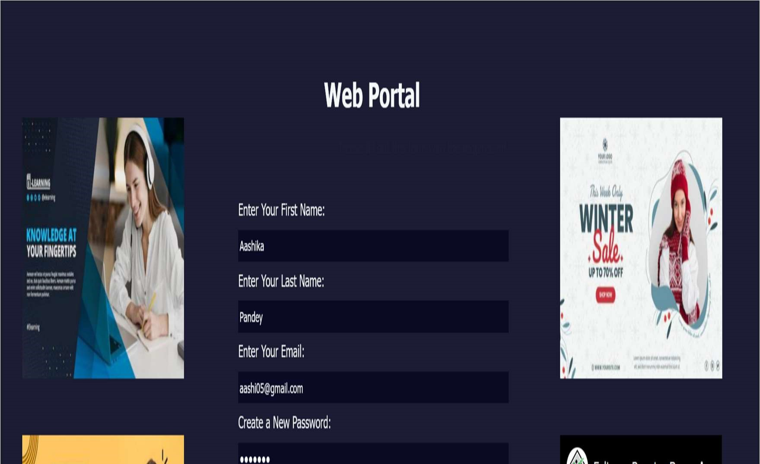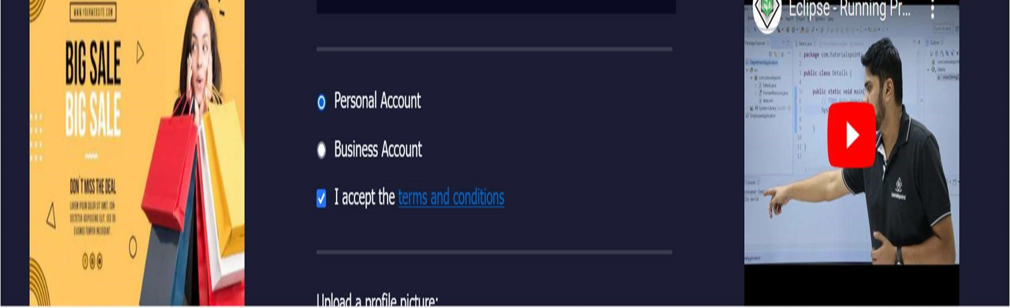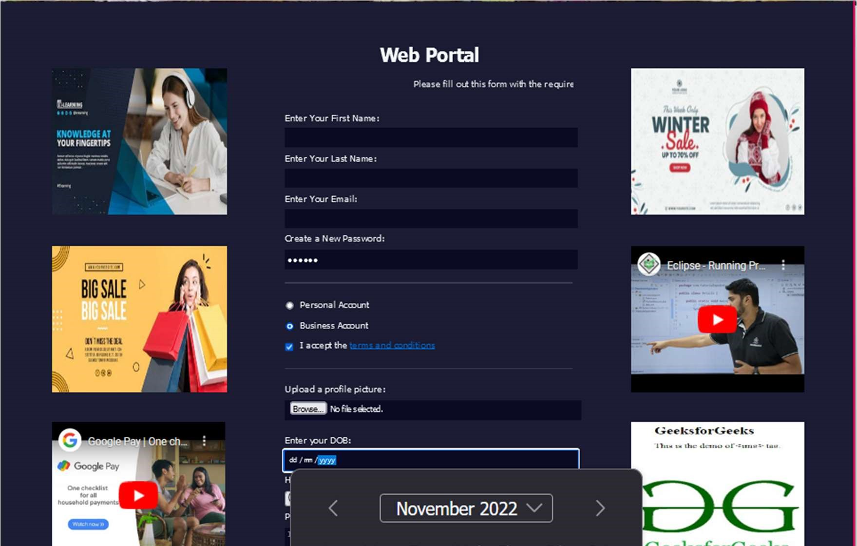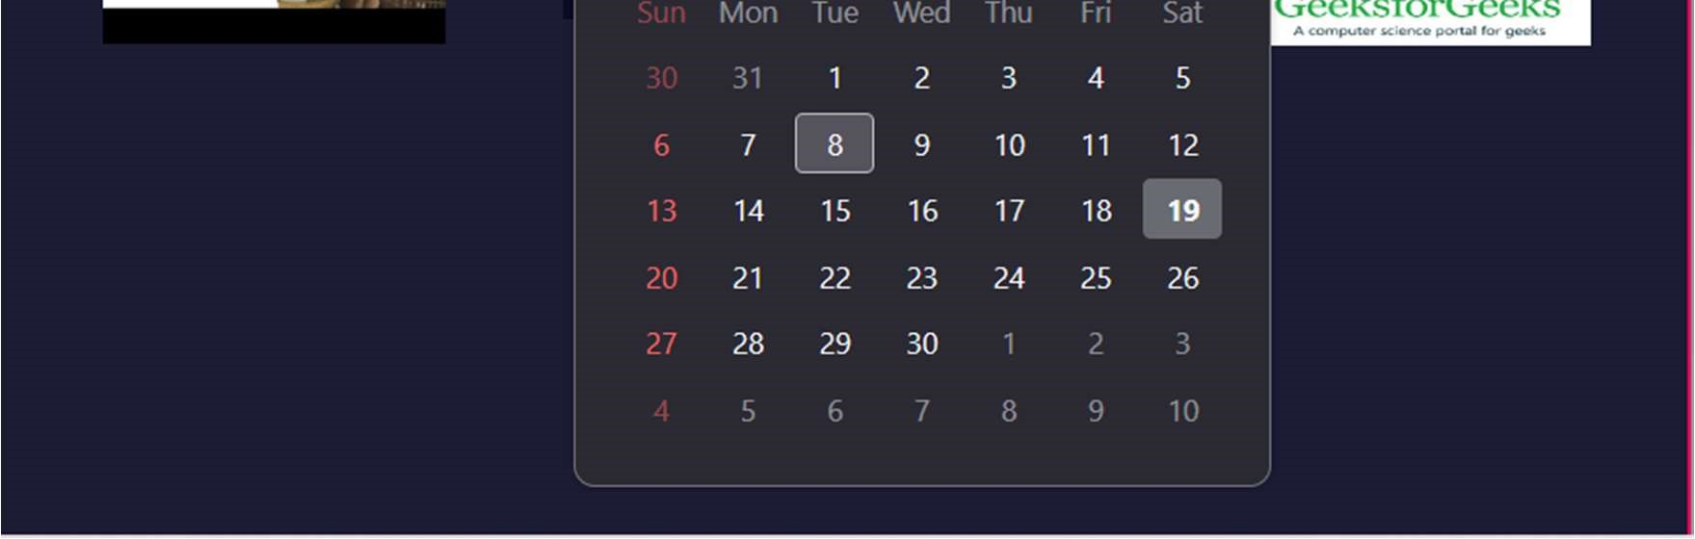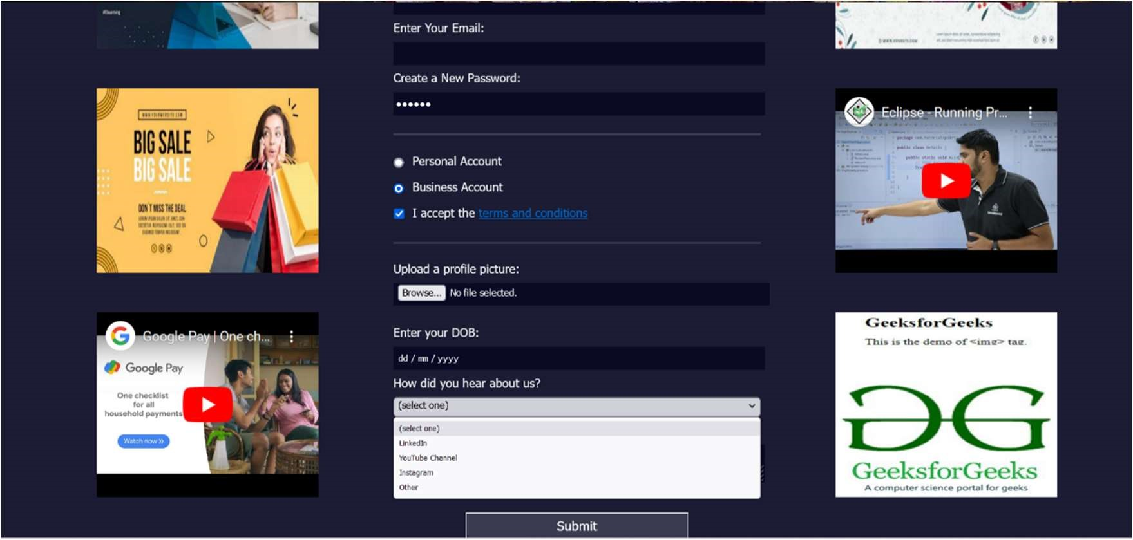

(7). Source Code:

1. HTML

|  |
| --- |
| <!DOCTYPE html>  <html lang="en">  <head>  <meta charset="UTF-8">  <title>Web Portal</title>  <link rel="stylesheet" href="css/custom.css" />  </head>  <body>  <div class="main">    <!-Added images and videos-->  <div class="col">  <div>  <a href="https://ets.utdallas.edu/elearning" target="_blank">  <img src="pics/eLearning.jpg" width="300" height="250"></img> </a>  </div>  <div>  <!-- <img src="https://picsum.photos/id/30/200/200"></img> -->    <img src="pics/bigSale.jpg" width="300" height="250"></img> </div>  <div>  <iframe width="300" height="250" src="https://www.youtube.com/embed/E4SSTEYEnpE" title="YouTube video player" frameborder="0" allow="accelerometer; autoplay; clipboard-write; encrypted-media; gyroscope; picture-in-picture" allowfullscreen></iframe> </div> |

|  |
| --- |
| <img id="output_image">  </label>  //Adding calendar in DOB in place of age:  <label for="age">Enter your DOB: <input id="age" type="date" name="age"/></label>  <label for="referrer">How did you hear about us?  <select id="referrer" name="referrer">  <option value="">(select one)</option>  <option value="1">LinkedIn</option>  <option value="2">YouTube Channel</option>  <option value="3">Instagram</option>  <option value="4">Other</option>  </select>  </label>  <label for="bio">Provide a bio:  <textarea id="bio" name="bio" rows="3" cols="30" placeholder="I like coding on the beach..."></textarea>  </label>  </fieldset>  </div>  <input type="submit" value="Submit" />        </form>    <!--Added videos and images-->  <div class="col"> <div>  <!-- <img src="https://picsum.photos/id/65/200/200"></img> --> <img src="pics/winter.jpg" width="300" height="250"></img>  </div>  <div id="im">  <iframe width="300" height="250"  src="https://www.youtube.com/embed/y881t8ilMyc" frameborder="0" allowfullscreen></iframe>  </div>  <div> |

<a href="https://practice.geeksforgeeks.org/"

|  |
| --- |
| target="_blank">  <img src="pics/gfg.png" width="300" height="250"></img> </a> </div>  </div>    </div>    <!-- linking js file to html -->  <script src = "js/app.js"></script>  </body>  </html> |

|  |
| --- |
| body { width: 100%; height: 100vh; margin: 0; background-color: #1b1b32; color: #f5f6f7; font-family: Tahoma; font-size: 16px;  } h1, p { margin: 1em auto; |

1. CSS

|  |
| --- |
| text-align: center;  }  .main { display: flex; flex-direction: row; justify-content: center;  } div { padding: 25px; padding-left: 10px;  } form { width: 60vw; max-width: 500px; min-width: 300px; margin: 0 auto; padding-bottom: 2em;  }  .col { display: block; flex-direction: col; padding: 4em; /* width="300"; height="250"; */  }    /*HOVER Feature */  .blink {  animation: blinker 1.5s linear infinite;  }    @keyframes blinker {  50% {  opacity: 0;  }  } fieldset { border: none; padding: 2rem 0; |
| border-bottom: 3px solid #3b3b4f;  } fieldset:last-of-type { border-bottom: none;  } label { display: block; margin: 0.5rem 0;  } input, textarea, select { margin: 10px 0 0 0; width: 100%; min-height: 2em;  } input, textarea { background-color: #0a0a23; border: 1px solid #0a0a23; color: #ffffff;  }    .inline { width: unset; margin: 0 0.5em 0 0; vertical-align: middle;  }  input[type="submit"] { display: block; width: 60%; margin: 1em auto; height: 2em; font-size: 1.1rem; background-color: #3b3b4f; border-color: white; min-width: 300px;  } |
| |  | | --- | | input[type="file"] { padding: 1px 2px;  }    #output_image { max-width: 45px;  } |       [C] JAVA SCRIPT     |  | | --- | | function preview_image(event) { var reader = new FileReader(); reader.onload = function () { var output = document.getElementById('output_image'); output.src = reader.result;  } reader.readAsDataURL(event.target.files[0]); } |     (7). Testing :   * Unit Testing * Integration Testing * WhiteBox Testing * BlackBox Testing * System Testing |