E-Thunder-Mobile-AppRequirement

**This innovation platform uses orders from overseas to help people buy their needs and easy to buy and order products with reliable service.**

**HISTORY**

|  |  |  |
| --- | --- | --- |
| Version | Update Date | Description |
| v1.0 | 01.01.2021 | initial |
|  |  |  |
|  |  |  |

1. **AUTHENTICATION**

Please find the example screen and the information below:

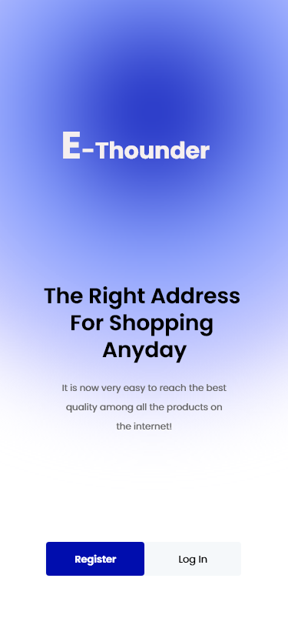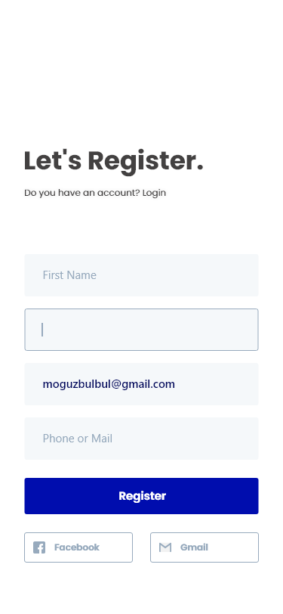

● Splash Screen

* + We use spinners animation for 3 seconds.
  + After click open the application for the first time we have two button for user (Register or Login).

● Register (first name, last name, email and phone number)

* Step 1: Then SMS verification (only number and 6-digits)
* Step 2: Enter with new number 6 digits, enter own new password and confirm password
* Step 3: Then go to home screen directly without login

● Forgot password

○ Step 1: Enter the phone number

○ Step 2: Then SMS verification

○ Step 3: Then enter new password and confirm password

○ Step 4: Then go to home screen directly without login again

1. **HOME SCREEN**

Please find the example screen and the information below:

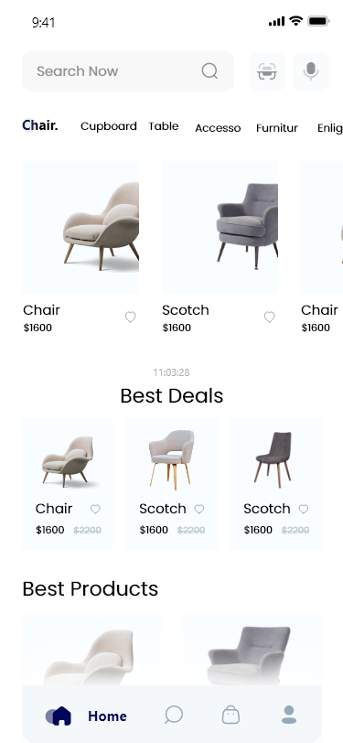

* Search Box: search for all product from all tabs are the same. We all so can voice to search the products.
* Icon search at the bottom is the same action, when we scroll down we will lose that search input. Click the search icon at the bottom to show the search input.
* Category: we can select the type of product category. Example black chare or white chare …
* We also can react to each product
* We switch product any time by Best product or best seller …

** Note: all action need to be login first.

III. **LIST PRODUCTS AND DETAILS**

Please find the example screen and the information below:

* Search Box: search for all product from all tabs are the same.
* Icon search at the bottom is the same action, when we scroll down we will lose that search input. Click the search icon at the bottom to show the search input.
* Add to Cart button: the custom could be able to select product by click Add to cart button, then we will be going to detail product screen.

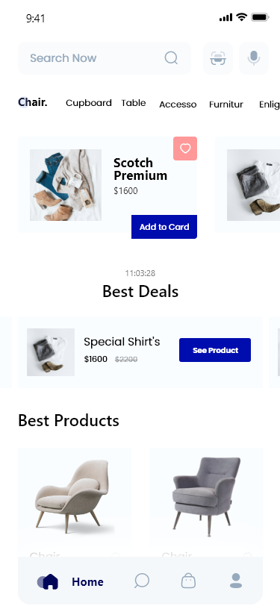

V. **ADD PRODUCTS TO CARD**

Please find the example screen and the information below:

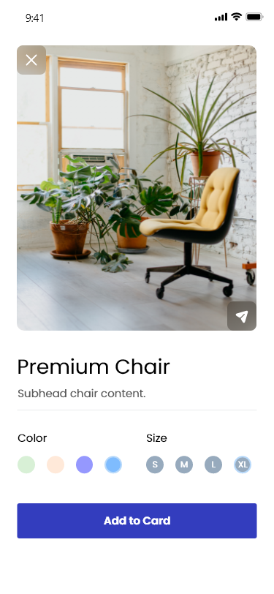

From there we can customize which product we wanted. The customer could be able to choose size color or read some detail text about the product, then choose add to cart. The screen will be changed to checkout out screen.

VI. **CHECKOUT SCREEN**

Please find the example screen and the information below:

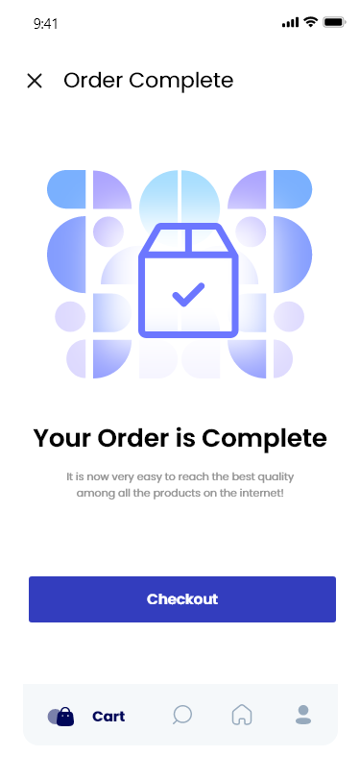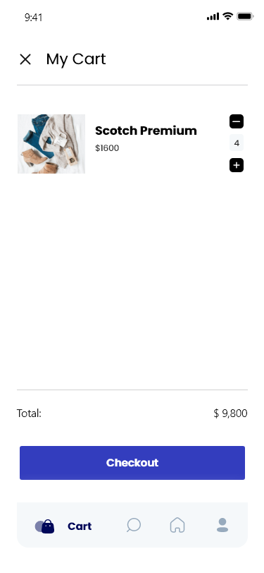

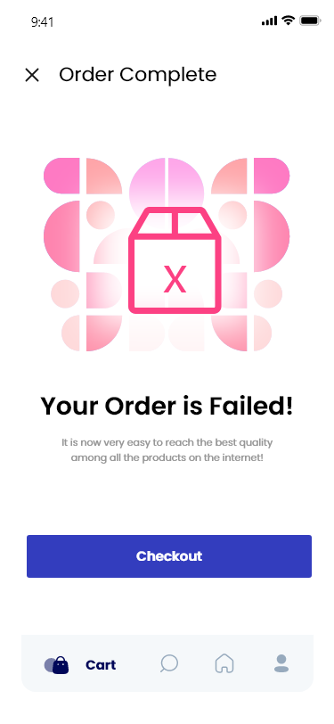

From there we the customer can add or remove the product by click on plus (+) or minus (-). They can see the total price of the products which were selected. Then customer can click on Checkout button, If the process done the success checkout screen will appear. If not screen checkout fail will appear (The connection problem…).

VII. **MAPS**

Please find the example screen and the information below:

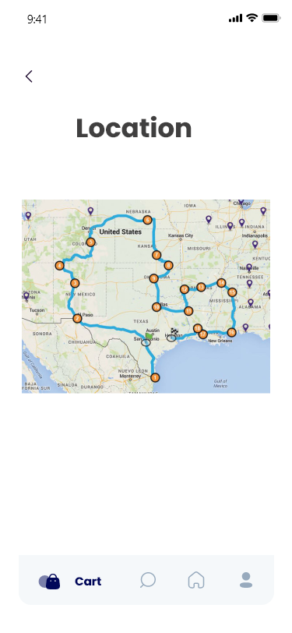

After the customer’s order products, they are able to see the delivery location by checking the map.

VIII. **USER NOTIFICATION**

Please find the example screen and the information below:

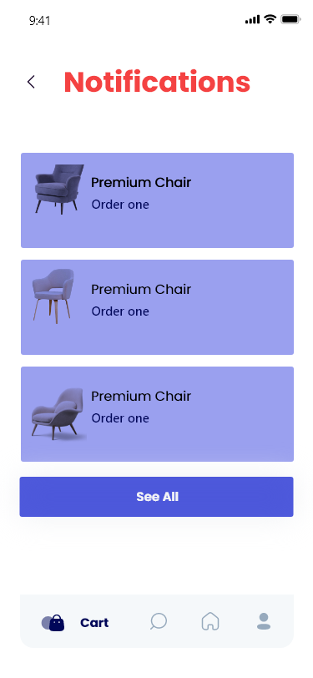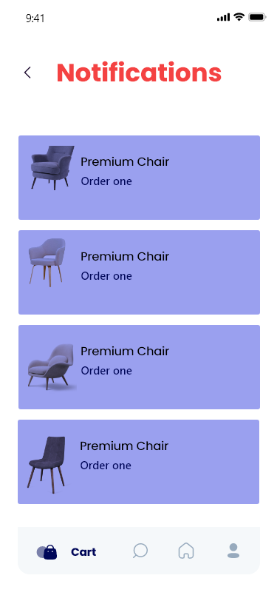

The notification screen allow the user can check their orders or new notification update from the system. We don’t show for all notification list, but if the user would like to see they can click See all button at the bottom of the screen.

VIII. **USER NOTIFICATION**

Please find the example screen and the information below:

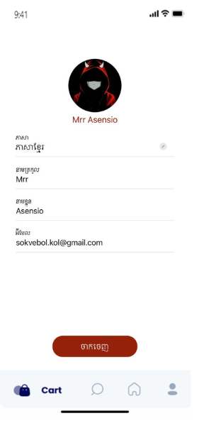

From this screen the user can see the own information such as: Username, or email …

The user also can change the language or edit own information form this screen by click in each input.