

Institute of Technology of Cambodia

International Program

Lab 3 Assignment
“Programming Design and Implementation”

16th November 2025
Lecturer: BOU Channa
Student: CHHENG Sokuntheary (p20240044)

Link:
- Git:
- Flowchart:

Exercises

Library Management System

Problem
Design a program to manage books in a library.
- Input: For N books, store Book ID, Title, Author, and Price.
- Process: Display details of all books, and calculate the average price of all books.
- Output: Display all book details and the average price.

Pseudocode
Start
Input N
sum = 0
For i = 1 to N:
Input BookID, Title, Author, Price
Store book in an array
sum = sum + Price
avg = sum / N
Display each book information
Display average price
End

Flowchart
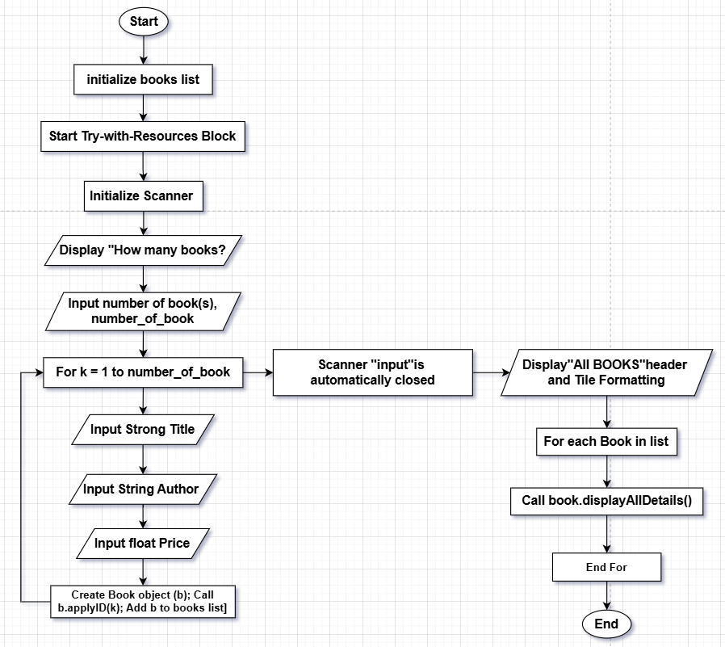

Java Code
decompiler (from Intellij IDEA).
import java.util.Date;

public class Book {
private int ID;
private final String title;
private final String author;
private final float price;
private final Date registered_date;

public Book(String var1, String var2, float var3) {
this.title = var1;
this.author = var2;
this.price = var3;
this.registered_date = new Date();
}

public void applyID(int var1) {
this.ID = var1;
}

public void displayAllDetails() {
System.out.printf("%2d | %-25s | %-20s | $%-8.2f | %s\n", this.ID, this.title, this.author, this.price, this.registered_date.toString());
}

public boolean isID(int var1) {
return this.ID == var1;
}
}

import java.util.ArrayList;
import java.util.List;
import java.util.Scanner;

public class LibraryMain {

public static void main(String[] args) {

final List<Book> books = new ArrayList<>();
try (Scanner input = new Scanner(System.in)) {
System.out.println("<< Welcome to the Library Program! >>\n");

// 1. Get number of books
System.out.print("How many books?: ");
int number_of_book = input.nextInt();
input.nextLine(); // consume newline

// 2. Loop to get each book's details
for (int k = 1; k <= number_of_book; k++) {

System.out.println("\n\t*Getting data for book #" + k);

System.out.print("Enter Book Title: ");
String title = input.nextLine();

System.out.print("Enter Book Author: ");
String author = input.nextLine();

System.out.print("Enter the book price: ");
float price = input.nextFloat();
input.nextLine(); // consume newline

// Create the book object
Book b = new Book(title, author, price);
b.applyID(k); // ID starts from 1

books.add(b);
}
}

// 3. Show all book details
System.out.println("\n----- ALL BOOKS -----");
System.out.printf("%2s | %-25s | %-20s | %-9s | %s\n",
"ID", "Title", "Author", "Price", "Registered Date");
System.out.println("-----------------------------------------------------------------------");

for (Book book : books) {
book.displayAllDetails();
}
}
}

Temperature Conversion

Problem

Write a program that reads temperatures of N cities in Celsius and converts them to Fahrenheit.

Input: Temperature of N cities in Celsius.

Process: Use the formula F = (C × 9/5) + 32.

Output: Display the temperatures in both Celsius and Fahrenheit for each city.

Pseudocode
Start
Input N
For i = 1 to N:
Input Celsius
F = (Celsius * 9/5) + 32
Display Celsius and Fahrenheit
End

Flowchart
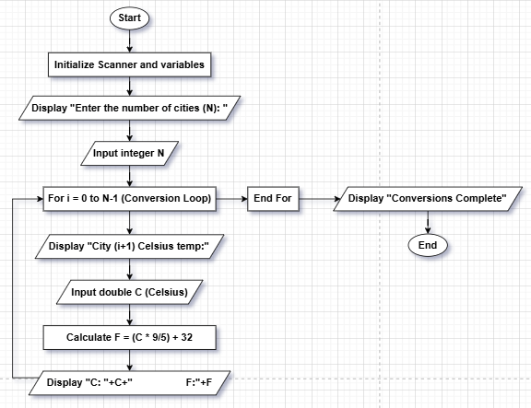

Java Code
public class Temp {
public static void main(String[] args) {
java.util.Scanner sc = new java.util.Scanner(System.in);

System.out.print("Enter N: ");
int n = sc.nextInt();

for (int i = 0; i < n; i++) {
System.out.print("Celsius: ");
double c = sc.nextDouble();
double f = (c * 9 / 5) + 32;
System.out.println("C: " + c + " → F: " + f);
}
}
}

Employee Salary Management

Problem

Problem: Store and display salary details of N employees.

Input: For each employee, store Employee ID, Name, and Basic Salary.

Process: Calculate the Gross Salary using the formula: o Gross Salary = Basic Salary + HRA (20% of Basic) + TCA (10% of Basic)

Output: Display all details, including the calculated gross salary.

Pseudocode
START
// Initialization
CREATE List employees (of type Employee)
CREATE Scanner input
DISPLAY "--- Employee Salary Calculator ---"
// Input N
DISPLAY "Enter the number of employees (N): "
READ integer N

// Input and Process Loop
FOR i FROM 1 TO N DO
DISPLAY "-- Entering details for Employee #i --"
// Input details
DISPLAY "Enter Employee ID: "
READ integer ID
DISPLAY "Enter Name: "
READ string NAME

DISPLAY "Enter Basic Salary: $"
READ double BASIC_SALARY

// Calculation within Employee Constructor
HRA = BASIC_SALARY * 0.20
TCA = BASIC_SALARY * 0.10
GROSS_SALARY = BASIC_SALARY + HRA + TCA

// Create and store
CREATE Employee EMP(ID, NAME, BASIC_SALARY, GROSS_SALARY)
ADD EMP to employees list
END FOR

// Output
CLOSE Scanner input
DISPLAY Salary Report Header

// Output Loop
FOR each EMPLOYEE in employees list DO
CALL EMPLOYEE.displayDetails() (which prints ID, Name, Basic, Gross)
END FOR
END

Flowchart
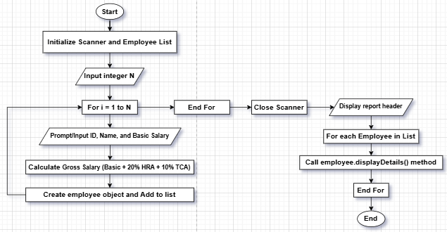

Java Code
class Employee {
String id, name;
double basic;

Employee(String id, String name, double basic) {
this.id = id;
this.name = name;
this.basic = basic;
}
}

public class SalarySystem {
public static void main(String[] args) {
java.util.Scanner sc = new java.util.Scanner(System.in);

System.out.print("Enter N: ");
int n = sc.nextInt();

for (int i = 0; i < n; i++) {
System.out.print("ID: "); String id = sc.next();
System.out.print("Name: "); String name = sc.next();
System.out.print("Basic Salary: "); double b = sc.nextDouble();

double hra = b * 0.20;
double tca = b * 0.10;
double gross = b + hra + tca;

System.out.println(id + " " + name + " " + b + " Gross: " + gross);
}
}
}

Employee Salary Management

Problem

Calculate and display student grades based on marks.

Input: For N students, read Student ID, Name, and marks of 5 subjects.

Process: Calculate the total marks, average, and assign a grade:

A: Average >= 90

B: Average >= 75

C: Average >= 50

F: Average < 50

Output: Display all details, including total marks, average, and grade.

Pseudocode

START
// Initialization
DECLARE List STUDENTS (of type Student)
CREATE Scanner INPUT
DISPLAY "--- Student Grade Calculation Program ---"
// Input N
DISPLAY "Enter the number of students (N): "
READ integer N
// Main Input and Process Loop
FOR i FROM 1 TO N DO
DISPLAY "-- Entering details for Student #i --"
// Input core details
DISPLAY "Enter Student ID: "
READ integer ID
DISPLAY "Enter Student Name: "
READ string NAME
// Input Marks Loop
DECLARE integer array MARKS[5]
FOR j FROM 0 TO 4 DO
DISPLAY "Mark for Subject (j+1): "
READ integer MARKS[j]
END FOR
// Calculation and Assignment (within Student Constructor)
TOTAL_MARKS = SUM(MARKS)
AVERAGE = TOTAL_MARKS / 5
IF AVERAGE >= 90 THEN
GRADE = 'A'
ELSE IF AVERAGE >= 75 THEN
GRADE = 'B'
ELSE IF AVERAGE >= 50 THEN
GRADE = 'C'
ELSE
GRADE = 'F'
END IF
// Create and store
CREATE Student S(ID, NAME, MARKS, TOTAL_MARKS, AVERAGE, GRADE)
ADD S to STUDENTS list
END FOR
// Output
CLOSE Scanner input
DISPLAY Grade Report Header
// Output Loop
FOR each STUDENT in STUDENTS list DO
CALL STUDENT.displayDetails()
END FOR
END

Flowchart
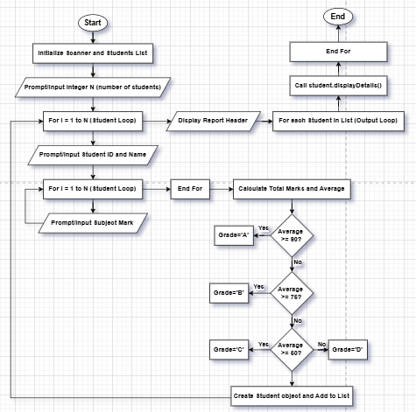

Java Code
class Employee {
String id, name;
double basic;

Employee(String id, String name, double basic) {
this.id = id;
this.name = name;
this.basic = basic;
}
}

public class SalarySystem {
public static void main(String[] args) {
java.util.Scanner sc = new java.util.Scanner(System.in);

System.out.print("Enter N: ");
int n = sc.nextInt();

for (int i = 0; i < n; i++) {
System.out.print("ID: "); String id = sc.next();
System.out.print("Name: "); String name = sc.next();
System.out.print("Basic Salary: "); double b = sc.nextDouble();

double hra = b * 0.20;
double tca = b * 0.10;
double gross = b + hra + tca;

System.out.println(id + " " + name + " " + b + " Gross: " + gross);
}
}
}

Inventory Management System

Problem

Manage inventory details for a store.

Input: For N items, read Item ID, Name, Quantity, and Price per item.

Process: Calculate the total cost for each item (Price × Quantity).

Output: Display all item details and total cost for each item.

Pseudocode
START
// Initialization
CREATE List INVENTORY (of type InventoryItem)
CREATE Scanner INPUT
DISPLAY "--- Store Inventory Management System ---"

// Input N
DISPLAY "Enter the number of unique items (N): "
READ integer N

// Input and Process Loop
FOR i FROM 1 TO N DO
DISPLAY "-- Entering details for Item #i --"

// Input details
DISPLAY "Enter Item ID: "
READ integer ITEM_ID

DISPLAY "Enter Item Name: "
READ string NAME

DISPLAY "Enter Quantity in Stock: "
READ integer QUANTITY

DISPLAY "Enter Price per Item: $"
READ double PRICE

// Calculation (within InventoryItem Constructor)
TOTAL_COST = PRICE * QUANTITY

// Create and store
CREATE InventoryItem ITEM(ITEM_ID, NAME, QUANTITY, PRICE, TOTAL_COST)
ADD ITEM to INVENTORY list
END FOR

// Output
CLOSE Scanner input
DISPLAY Inventory Report Header

// Output Loop
FOR each ITEM in INVENTORY list DO
CALL ITEM.displayDetails() (which prints ID, Name, Quantity, Price, Total Cost)
END FOR
END

Flowchart
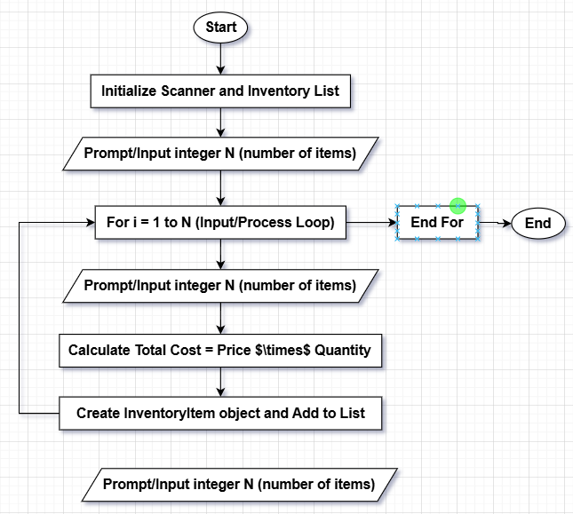

Java Code
public class Inventory {
public static void main(String[] args) {
java.util.Scanner sc = new java.util.Scanner(System.in);

System.out.print("Enter N items: ");
int n = sc.nextInt();

for (int i = 0; i < n; i++) {
System.out.print("ID: "); String id = sc.next();
System.out.print("Name: "); String name = sc.next();
System.out.print("Quantity: "); int q = sc.nextInt();
System.out.print("Price: "); double p = sc.nextDouble();

double total = q * p;

System.out.println(id + " " + name + " Total cost: " + total);
}
}
}

Simple Banking System

Problem

Simulate a basic banking system.

Input: For N customers, store Account Number, Name, and Balance.

Process: Allow the user to: 1. Deposit money into an account. 2. Withdraw money from an account (ensure sufficient balance).

Output: Display updated account details.

Pseudocode
START
// Initialization
CREATE List employees (of type Employee)
CREATE Scanner input
DISPLAY "--- Employee Salary Calculator ---"
// Input N
DISPLAY "Enter the number of employees (N): "
READ integer N
// Input and Process Loop
FOR i FROM 1 TO N DO
DISPLAY "-- Entering details for Employee #i --"
// Input details
DISPLAY "Enter Employee ID: "
READ integer ID
DISPLAY "Enter Name: "
READ string NAME
DISPLAY "Enter Basic Salary: $"
READ double BASIC_SALARY
// Calculation within Employee Constructor
HRA = BASIC_SALARY * 0.20
TCA = BASIC_SALARY * 0.10
GROSS_SALARY = BASIC_SALARY + HRA + TCA
// Create and store
CREATE Employee EMP(ID, NAME, BASIC_SALARY, GROSS_SALARY)
ADD EMP to employees list
END FOR
// Output
CLOSE Scanner input
DISPLAY Salary Report Header

// Output Loop
FOR each EMPLOYEE in employees list DO
CALL EMPLOYEE.displayDetails() (which prints ID, Name, Basic, Gross)
END FOR
END

Flowchart
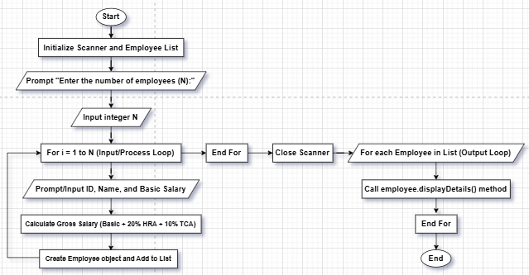

Java Code
class Customer {
String accNo, name;
double balance;
Customer(String accNo, String name, double balance) {
this.accNo = accNo;
this.name = name;
this.balance = balance;
}
}
import java.util.*;
public class Bank {
public static void main(String[] args) {
Scanner sc = new Scanner(System.in);
System.out.print("Enter number of customers: ");
int n = sc.nextInt();
Customer[] cus = new Customer[n];
for (int i = 0; i < n; i++) {
System.out.print("Acc No: "); String acc = sc.next();
System.out.print("Name: "); String name = sc.next();
System.out.print("Balance: "); double bal = sc.nextDouble();
cus[i] = new Customer(acc, name, bal);
}
System.out.println("1. Deposit\n2. Withdraw");
int ch = sc.nextInt();
System.out.print("Enter Account Number: ");
String accSearch = sc.next();
for (Customer c : cus) {
if (c.accNo.equals(accSearch)) {
if (ch == 1) {
System.out.print("Amount to deposit: ");
double amt = sc.nextDouble();
c.balance += amt;
} else {
System.out.print("Amount to withdraw: ");
double amt = sc.nextDouble();
if (c.balance >= amt) c.balance -= amt;
else System.out.println("Insufficient balance");
}
System.out.println("Updated Balance: " + c.balance);
}
}
}
}

Git link:

