**PERSONAL-RESUME**

**Current Address: Budhanilkantha-4, Kathmandu** 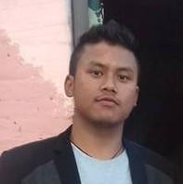

**Mobile No: 9849476964**

**E-mail:** [chhewanglama171@gmail.com](mailto:chhewanglama711@gmail.com)

**PERSONAL DETAILS:**

* Name: Chhewang Lama
* Father’s Name: Bijendra kumar lama
* Date of Birth: 2053-07-25
* Place of Birth: Kathmandu, Nepal
* Marital status: Single
* Religion: Buddhist
* Gender: Male
* Nationality: Nepali

**EDUCATIONAL ATTAINMENTS:**

* School Leaving Certificate (S.L.C) with distinction(83.25%) Bal Bikas Boarding High school, Budhanilkantha, Kathmandu
* +2 with 1st division (70.99%) Southwestern state college, Basundhara ,KTM
* Bachelor’s in computer science and information technology (last semester) St.lawrence college, Chabahil, Ktm

**LANGUAGE PROFICIENCY:**

* English- perfect
* Nepali- Mother Language
* Hindi- perfect

**COMPUTER KNOWLEDGE:**

* Diploma in office package from National Computer Center
* Php (laravel) learned and has worked in laravel
* Back-end for nepbigyapan.com (laravel)
* Bus-ticketing system for collage project using laravel