1:NUMBERS AND CHARCTER VARIABLES:

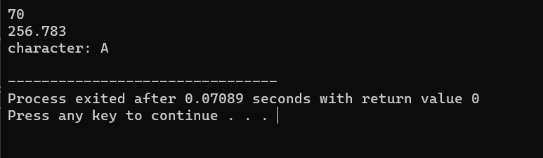

2:NUMBER BY TAKING INPUT:

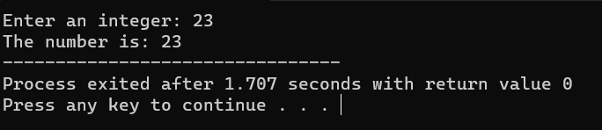

3:MULTIPLE INPUT:

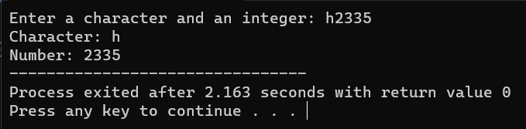

4:NUMBER IS ODD OR EVEN:

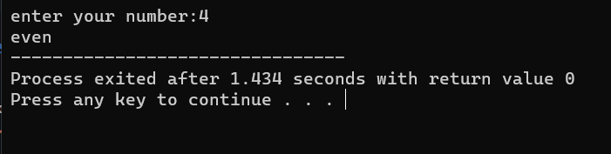

5:ERROR IN PROGRAM:

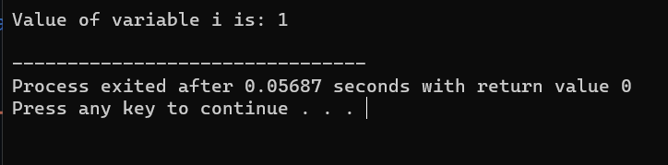

6:ERROR IN PROGRAM:

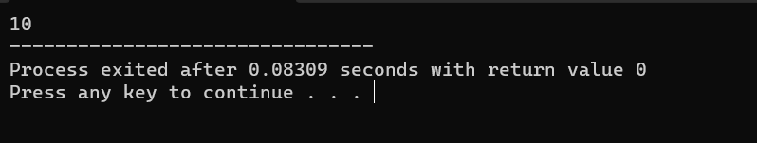

7:SWAPPING OF TWO NUMBER:

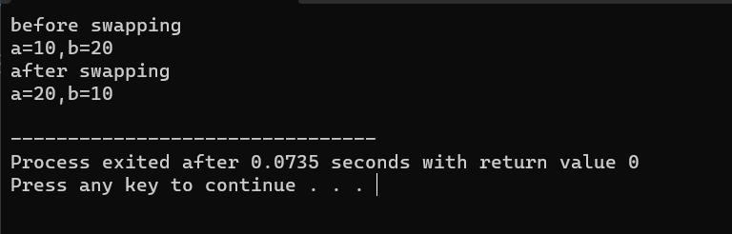

10:AREA OF CIRCLE AND AREA OF RECTANGLE:

