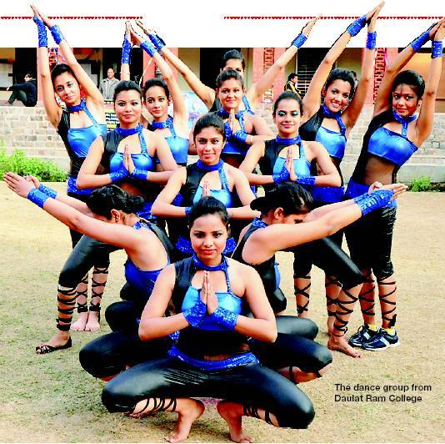

The College has active and vibrant societies for cultural activities

in drama, debate, fine arts, music and environment related activities.

A student may join one of the following Societies:

1) Debating Society

2) Dramatics Society

3) Environment/Eco Club

4) Fine Arts Society

5) Film Society

6) Music & Dance Society

7) Gandhi Study Circle

8) Quiz Society

9) Poetry Society

It is mandatory for the students to join one of the following:

(i) National Sports Organization (N.S.O.)/(Physical Education) or

(ii) National Service Scheme (N.S.S.) or

(iii) National Cadet Corps (N.C.C.)

(iv) Cultural Activities