**Lesson 02 Demo 01**

**Creating a Pipeline from the GitHub Repository**

**Objective:** To create an AWS CodePipeline for continuous integration and delivery (CI/CD) using a GitHub repository

**Tools required:** GitHub and CodePipeline

**Prerequisites:** A GitHub Git repository with the master branch should be set up and integrated with AWS CodePipeline for continuous integration and delivery (CI/CD)

Steps to be followed:

1. Create a new pipeline using the GitHub repository

**Step 1: Create a new pipeline using the GitHub repository**

1. Sign in to the AWS Console

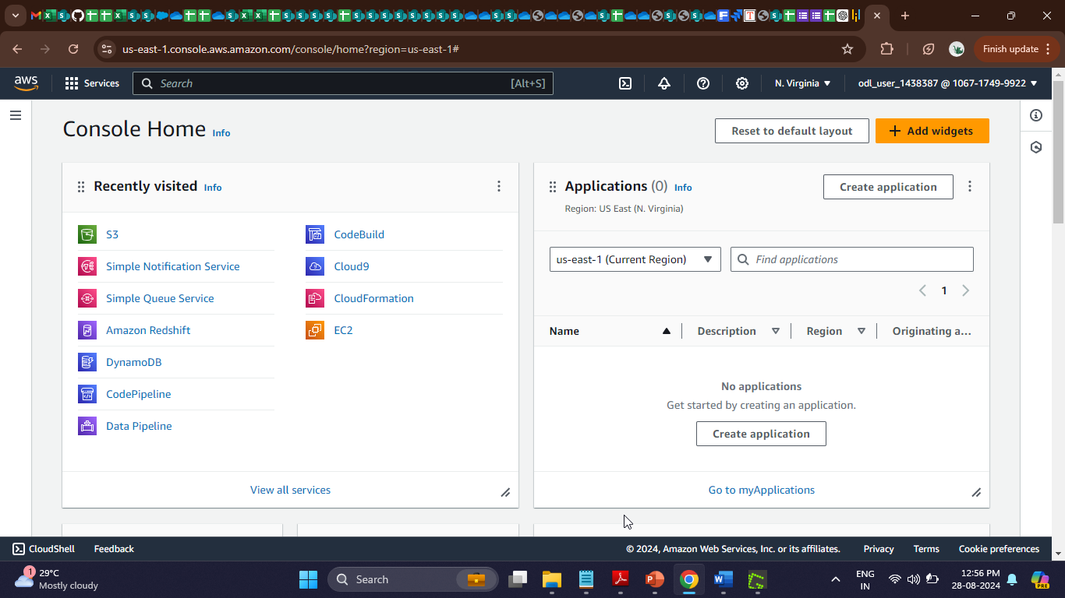

1. Search for and click on **CodePipeline**

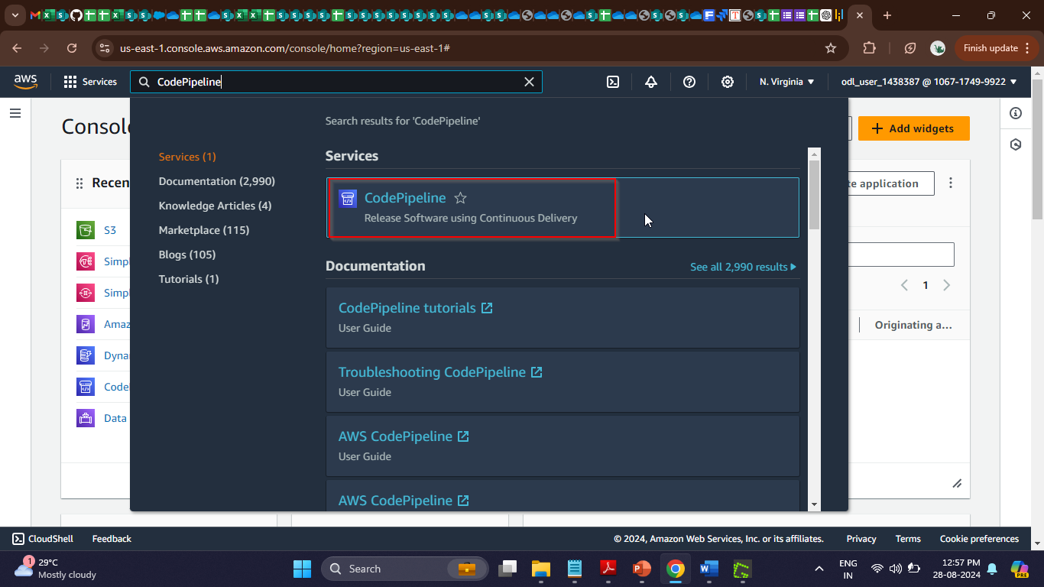

After clicking on the **CodePipeline** service, you will see the following interface:

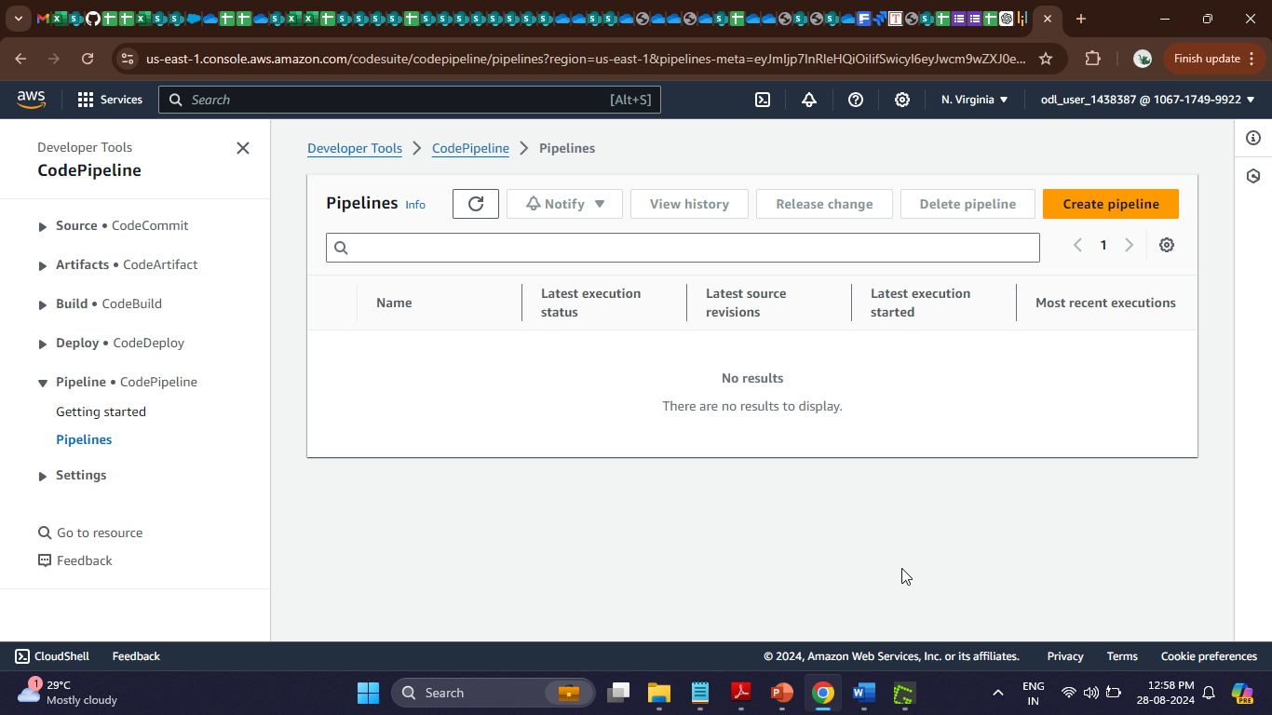

1. Click on the **Create pipeline** button

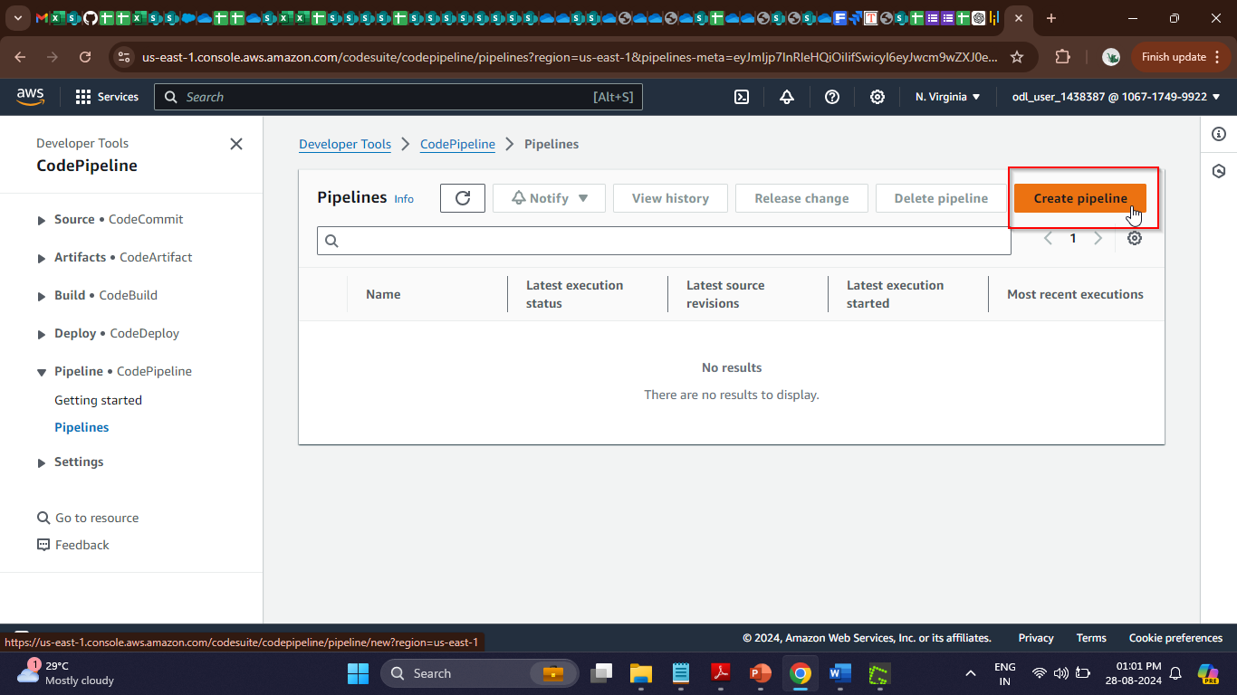

1. Enter a name for the pipeline and click the **Next** button

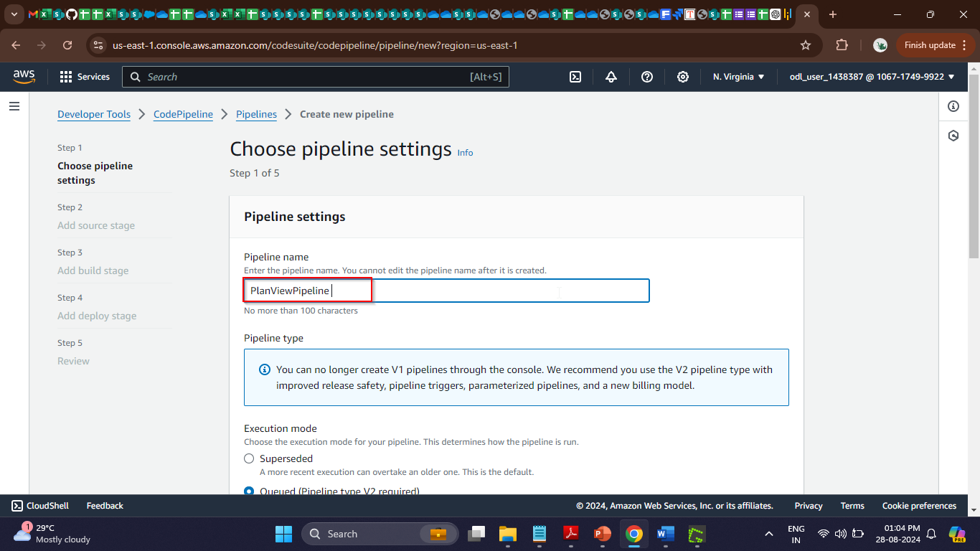

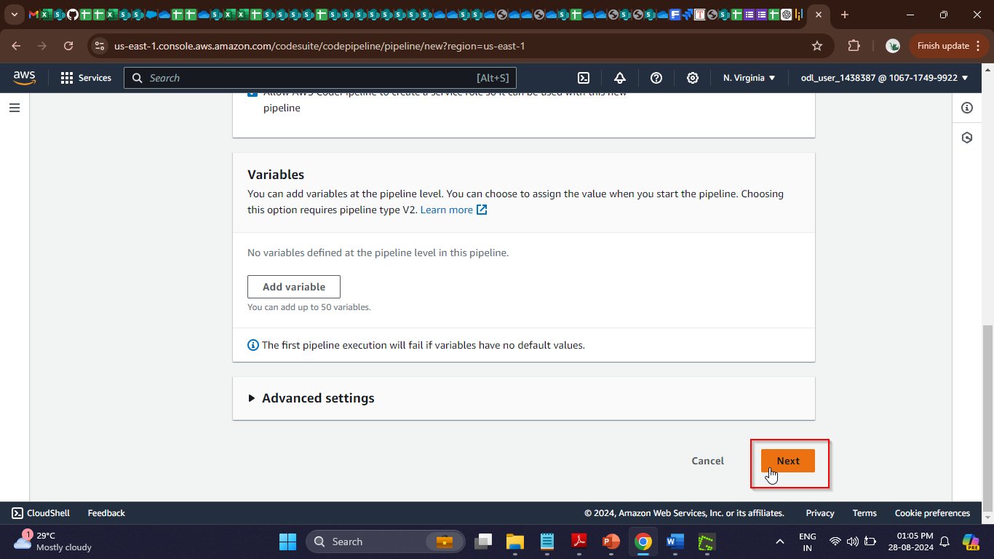

1. Select the desired **Source provider** as **GitHub (Version 1)**

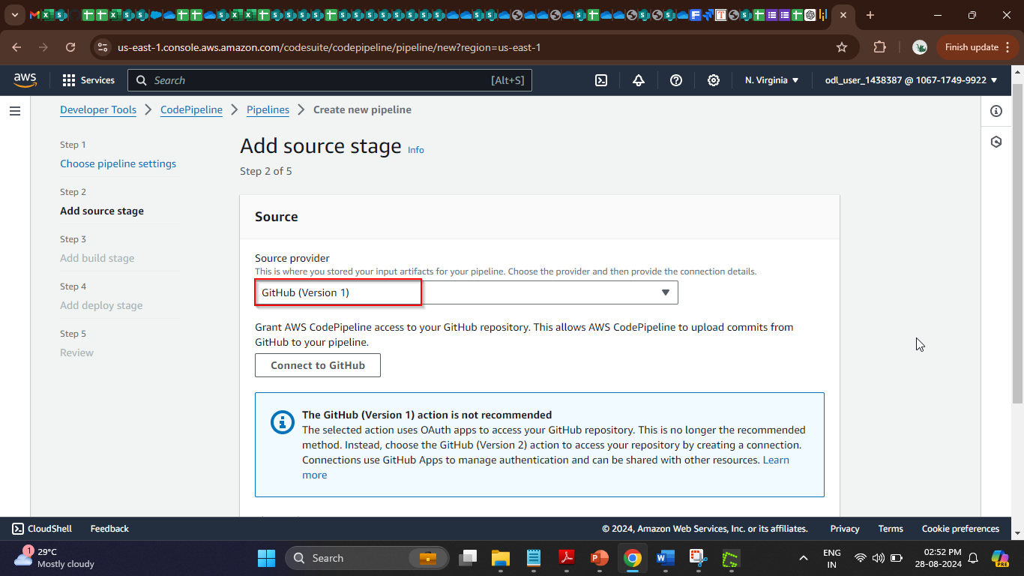

1. Click on **Connect to GitHub**

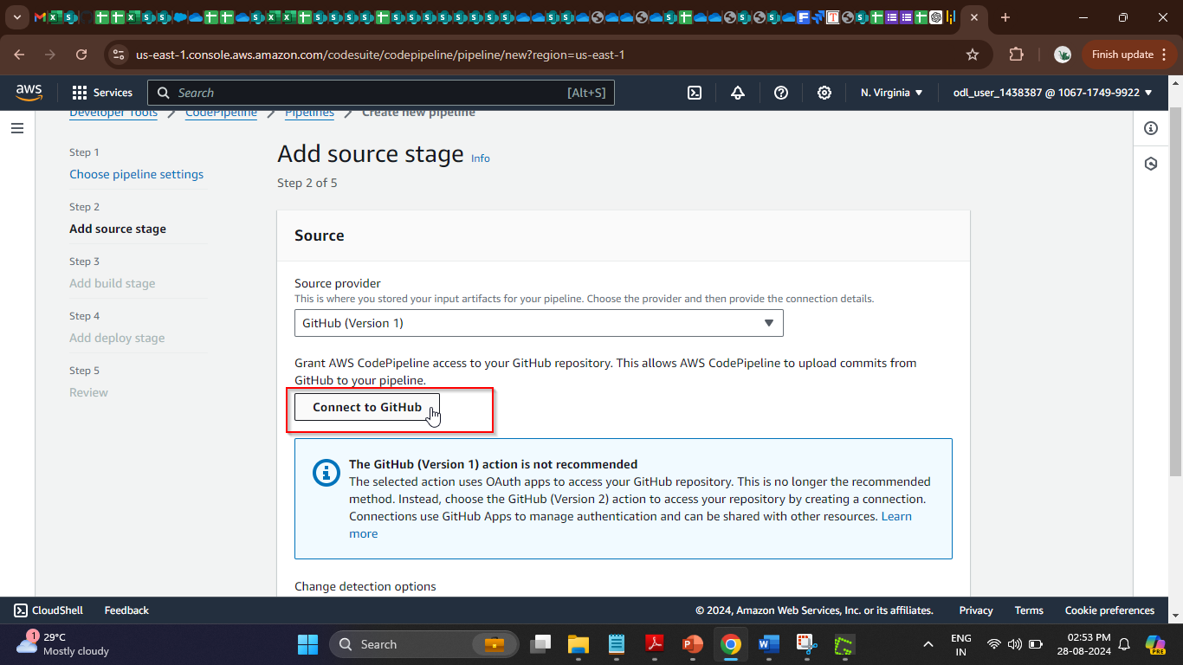

1. Click on **Confirm**

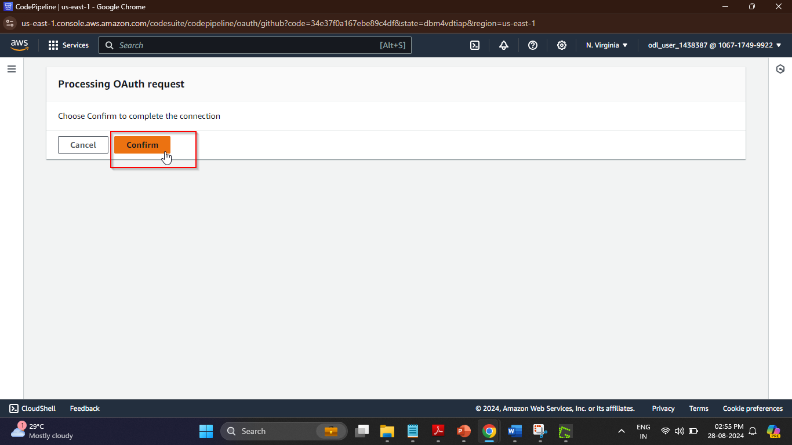

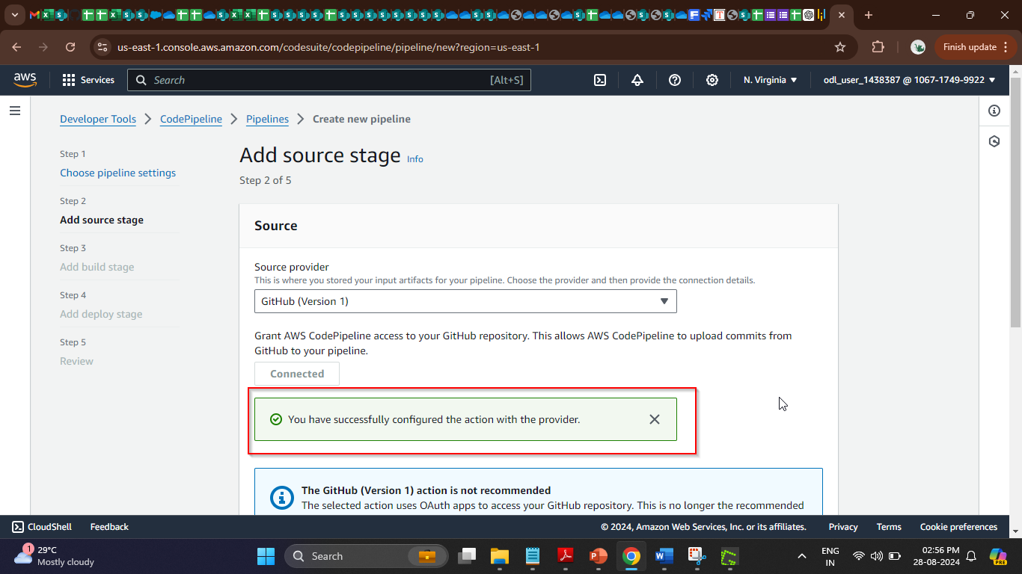

The GitHub connection is now ready for use.

1. Select the **GithubWorkstation/PlanView** option under **Repository**

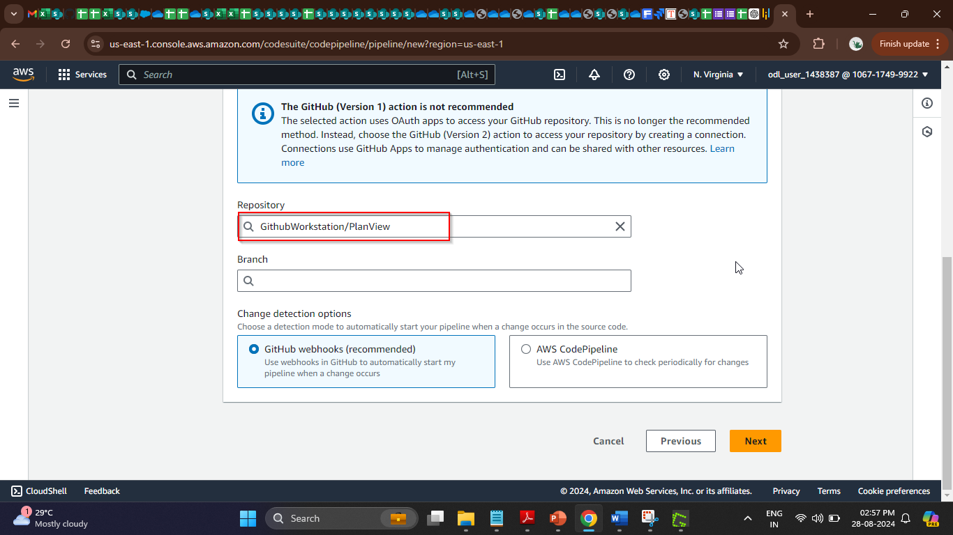

|  |
| --- |
| **Note:** Name the previously created repository as **PlanView** or specify any desired name of the repository you created |

1. Select the **master** option under **Branch**

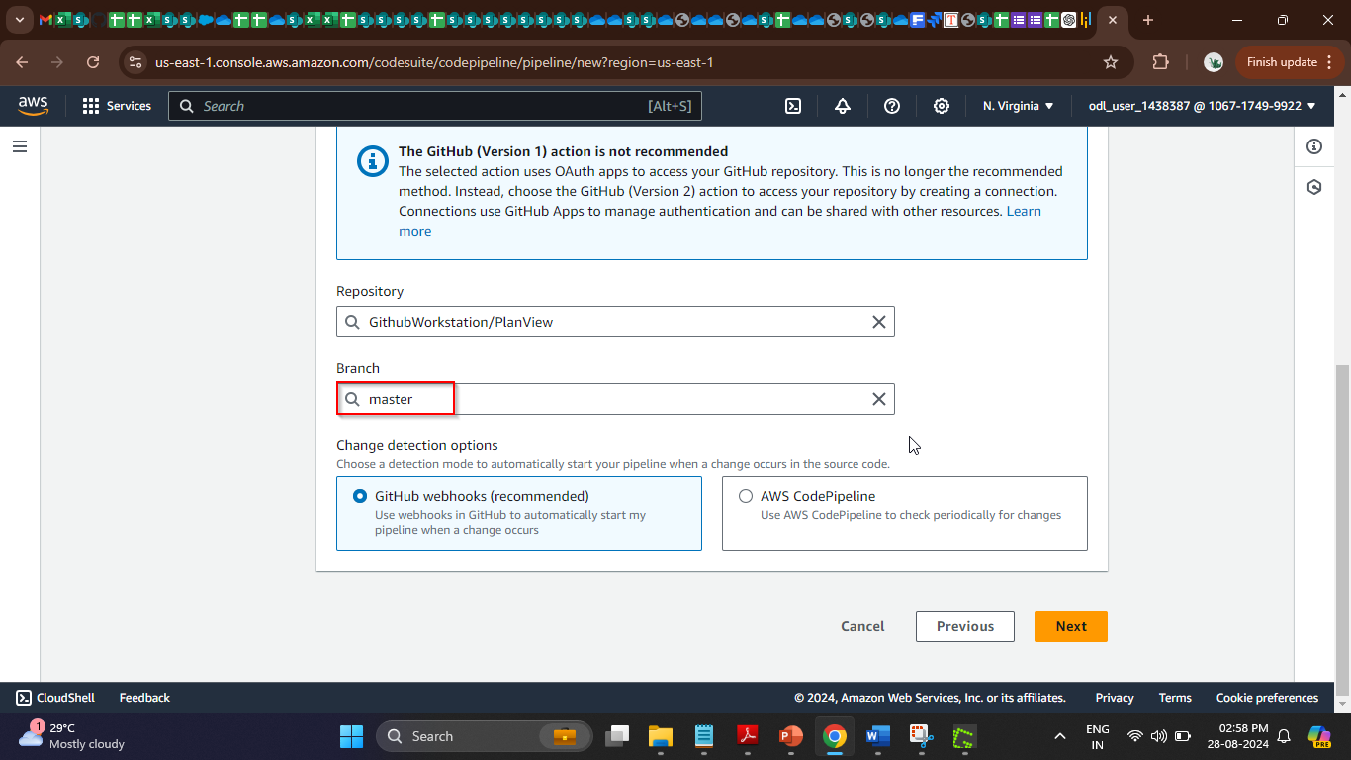

1. Click the **Next** button  
     
   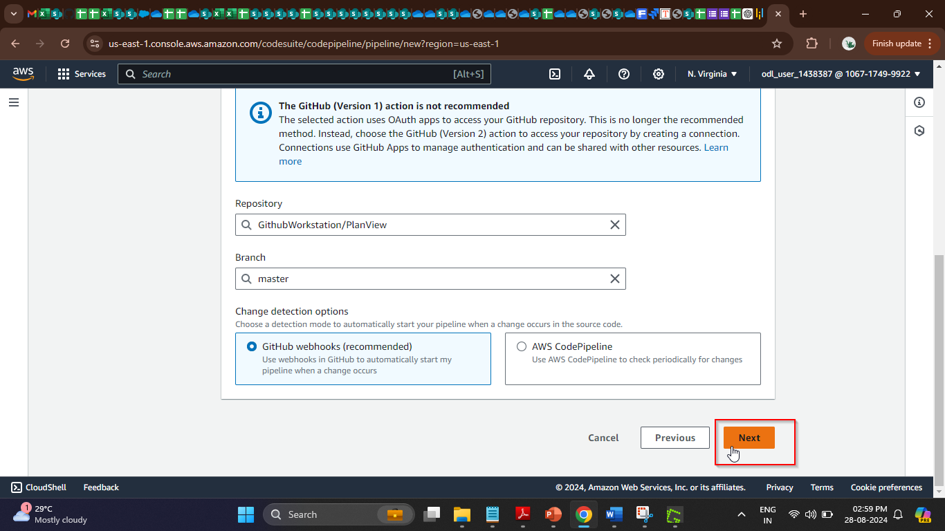
2. Select **AWS CodeBuild** under **Build provider** for building and automating tests  
     
   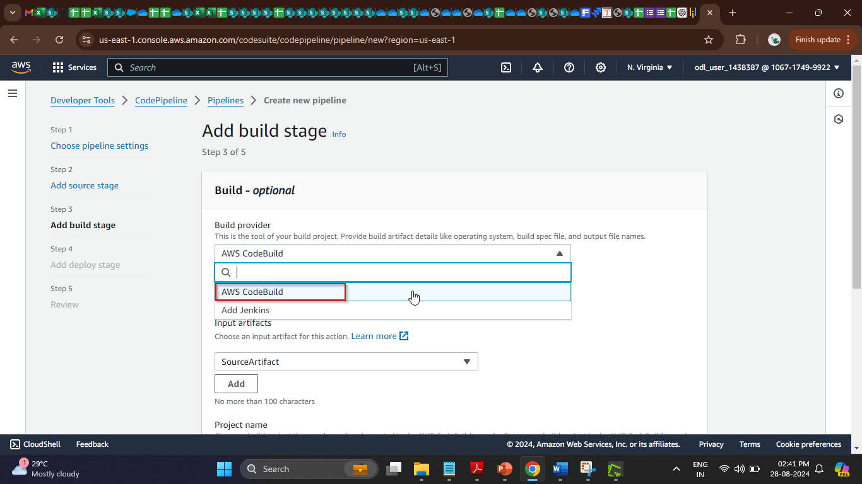
3. Click on the **Create project** button; a pop-up window will appear  
     
   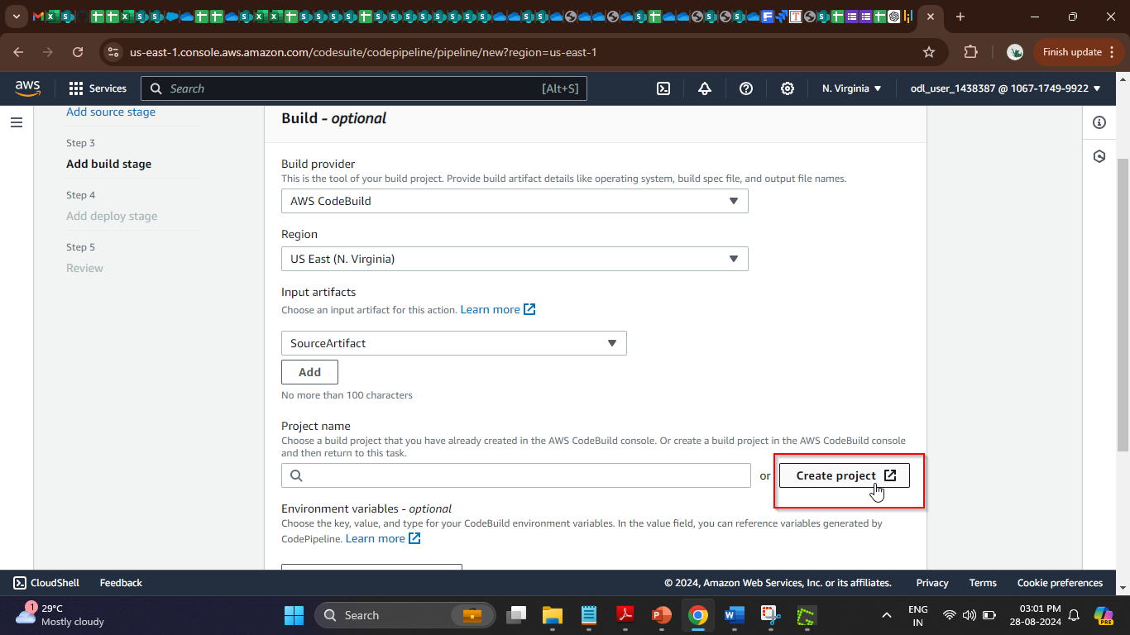
4. In the new window, add the name of the project  
     
   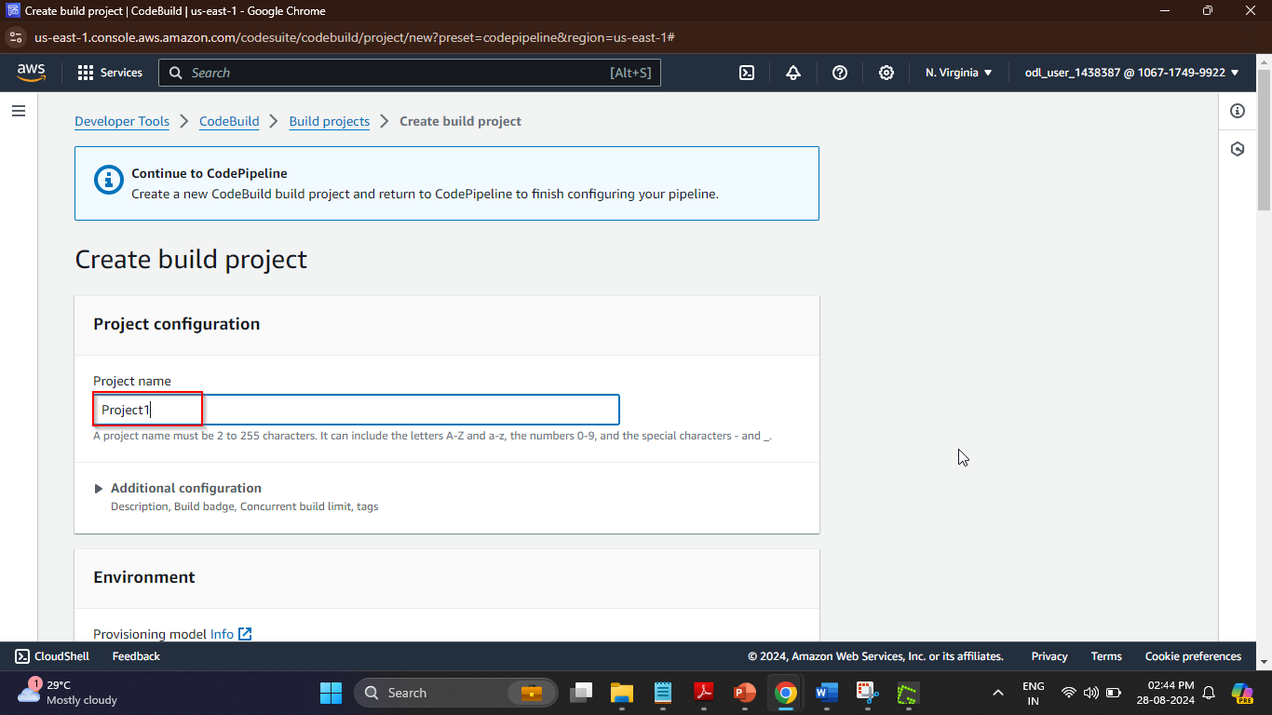
5. In the **Environment** section, add the details as shown in the screenshot below:

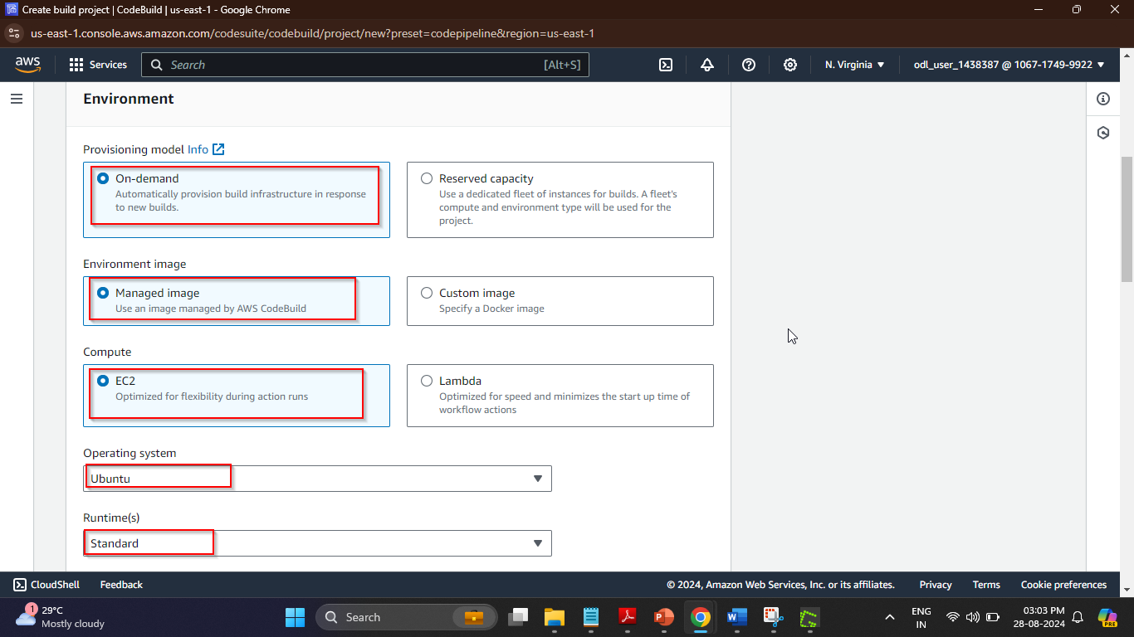

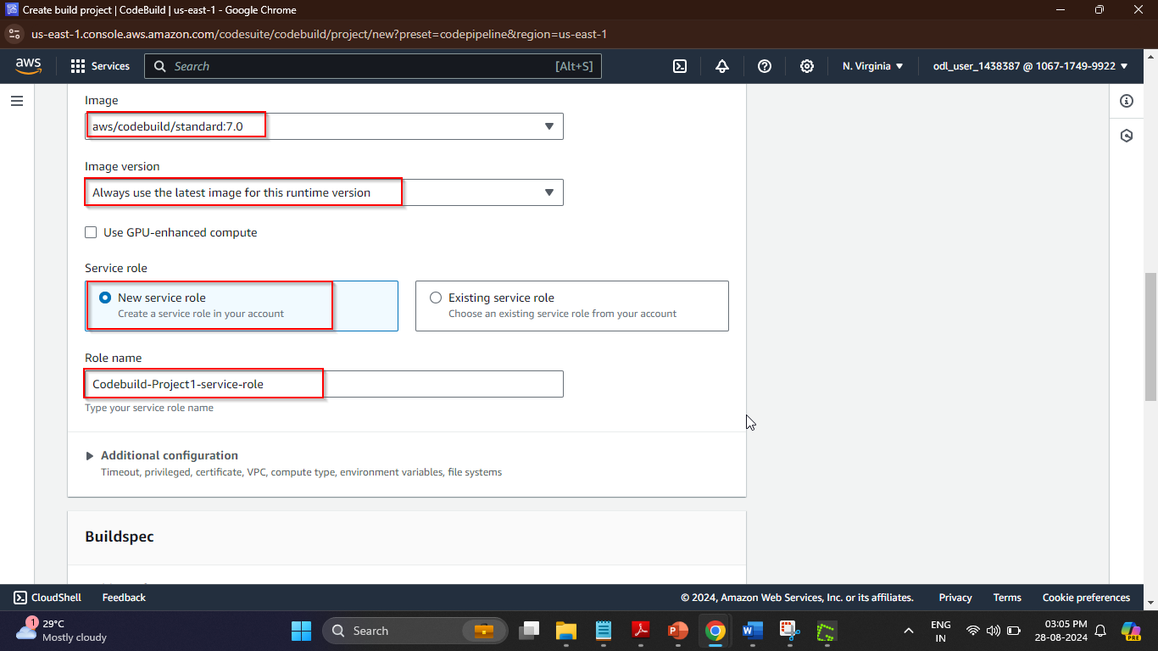

1. Under **Buildspec**, select the **Insert build commands** option and click on the **Switch to editor** button  
     
   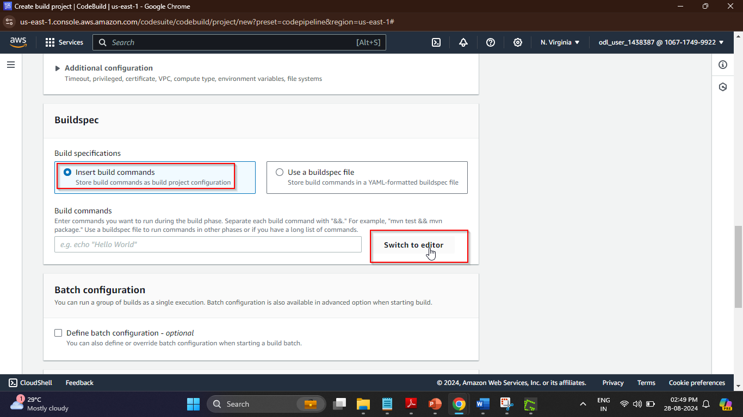
2. Remove the existing build commands from the editor and enter the following YAML code:

**version: 0.2**

**phases:**

**build:**

**commands:**

**- "ls -alrt"   
  
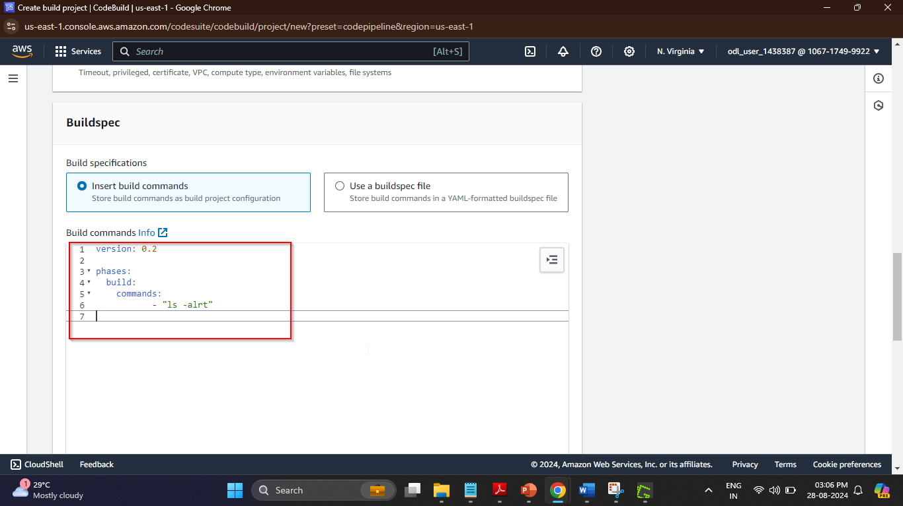**

1. Scroll to the bottom of the page and click on the **Continue to CodePipeline** button 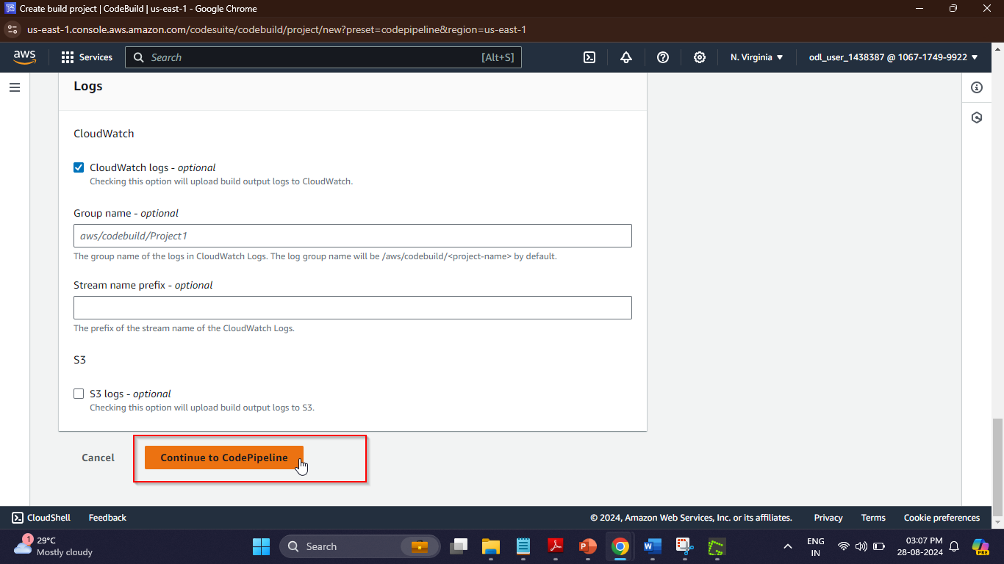

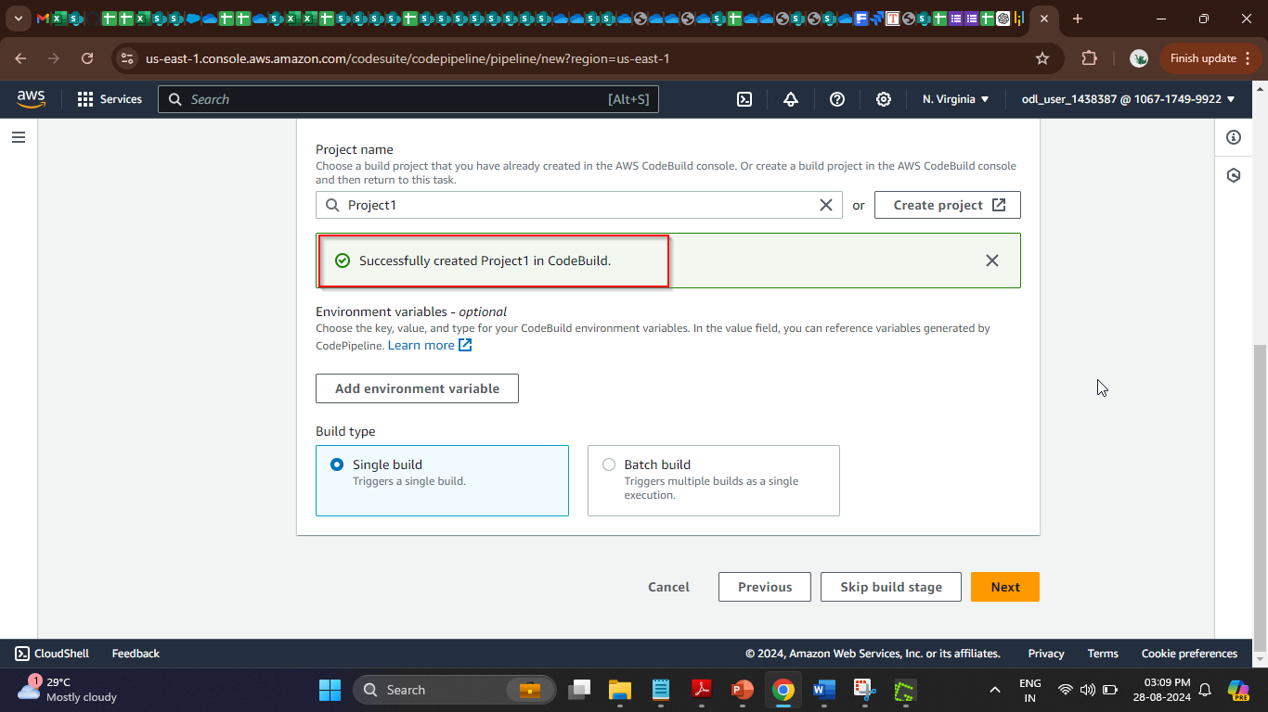

The project has been successfully created.

1. Now, click on the **Next** button  
     
   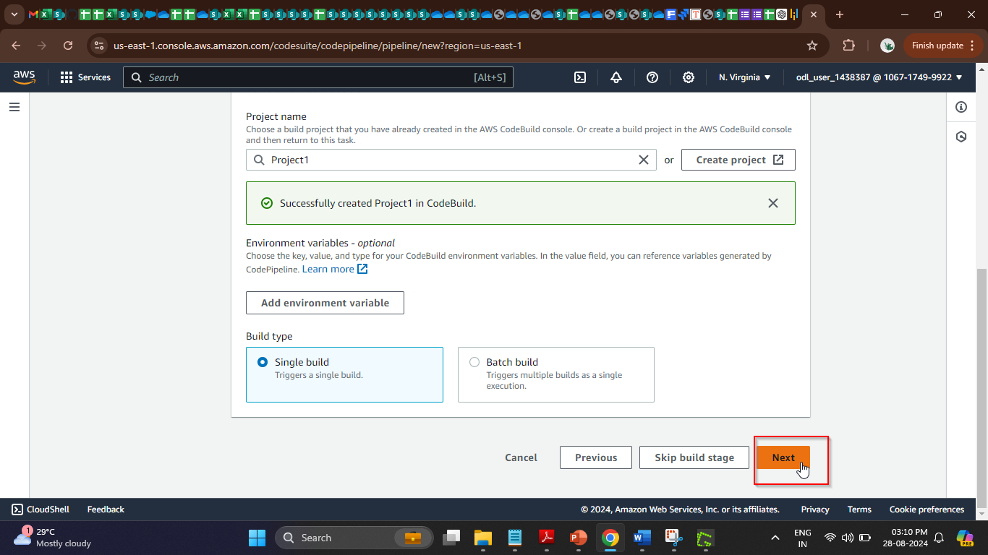
2. Click on the **Skip deploy stage** button and then on the **Skip** button to finalize the   
    pipeline  
     
   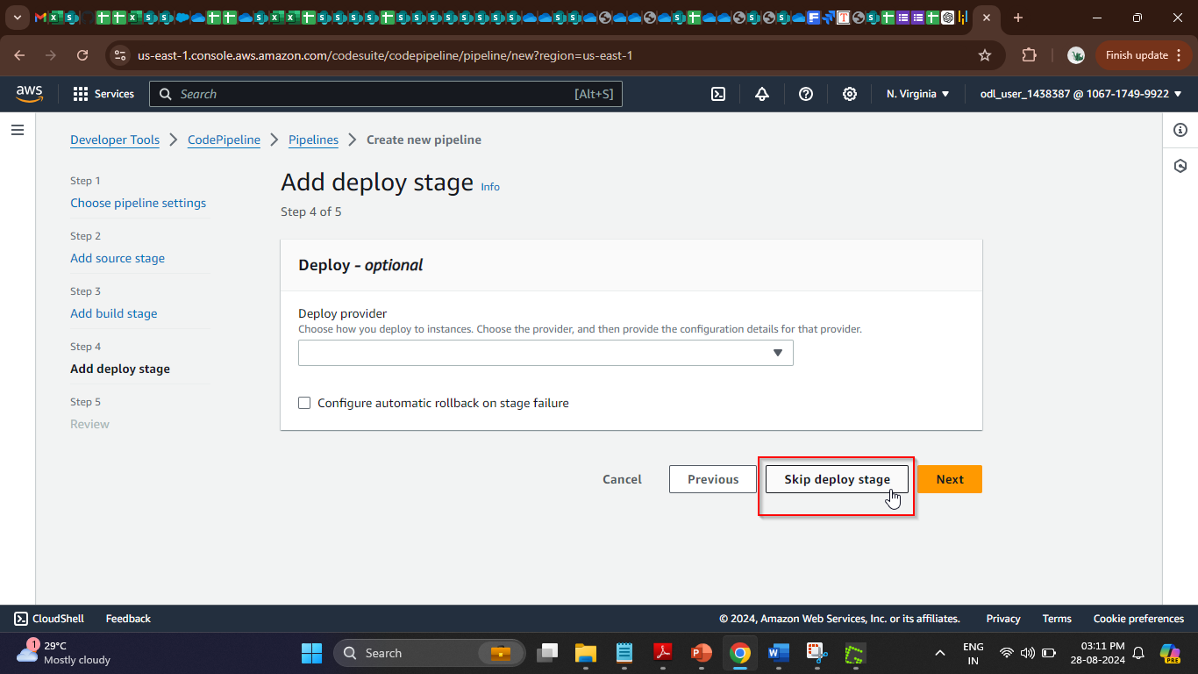  
    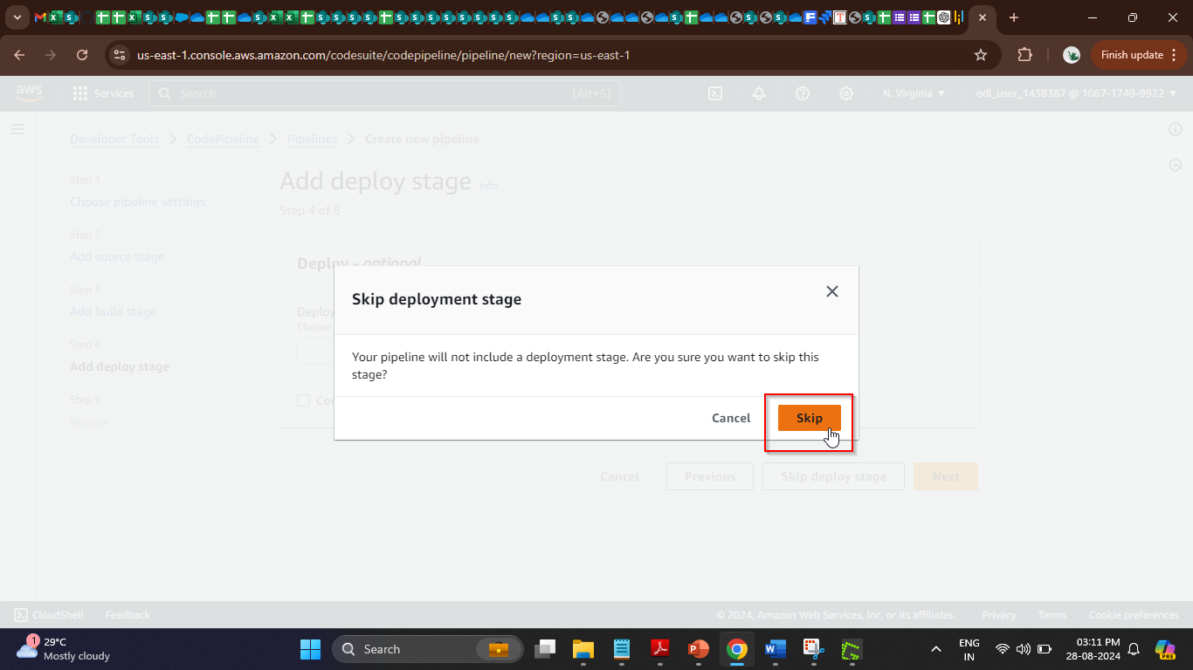
3. Scroll to the bottom of the page and click on the **Create pipeline** button 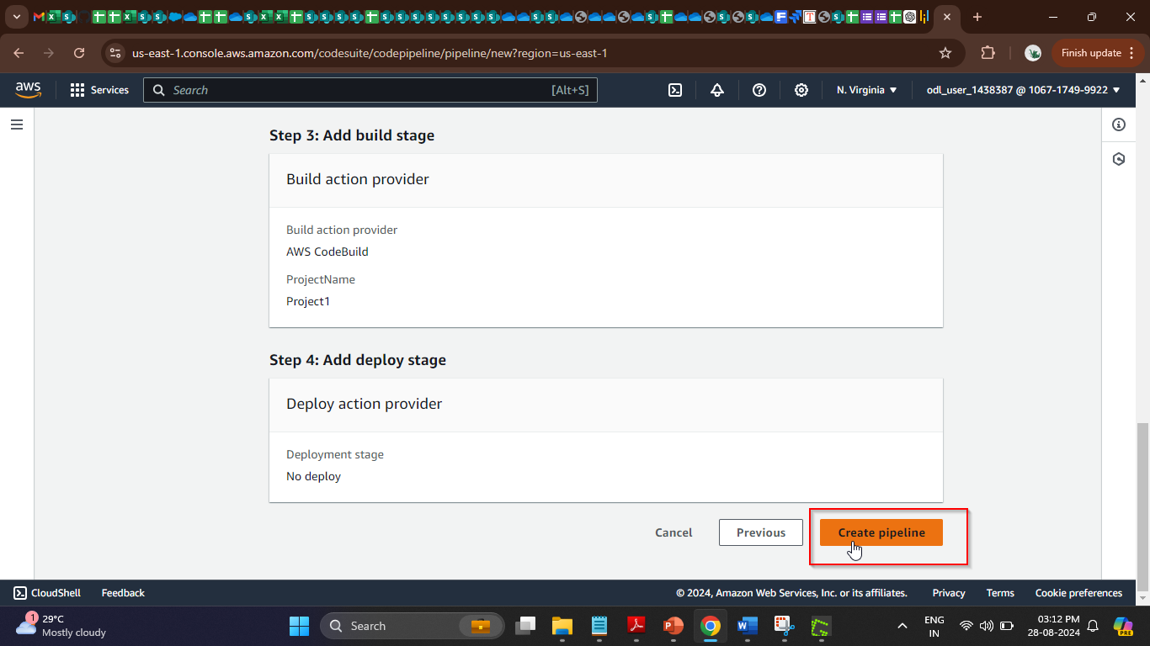

After creating the pipeline, the execution starts.  
  
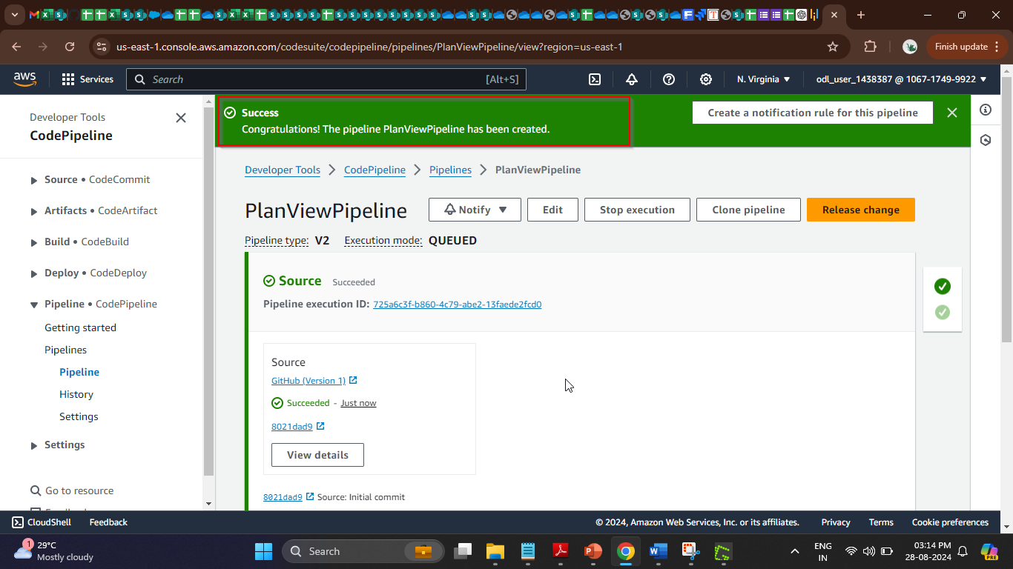

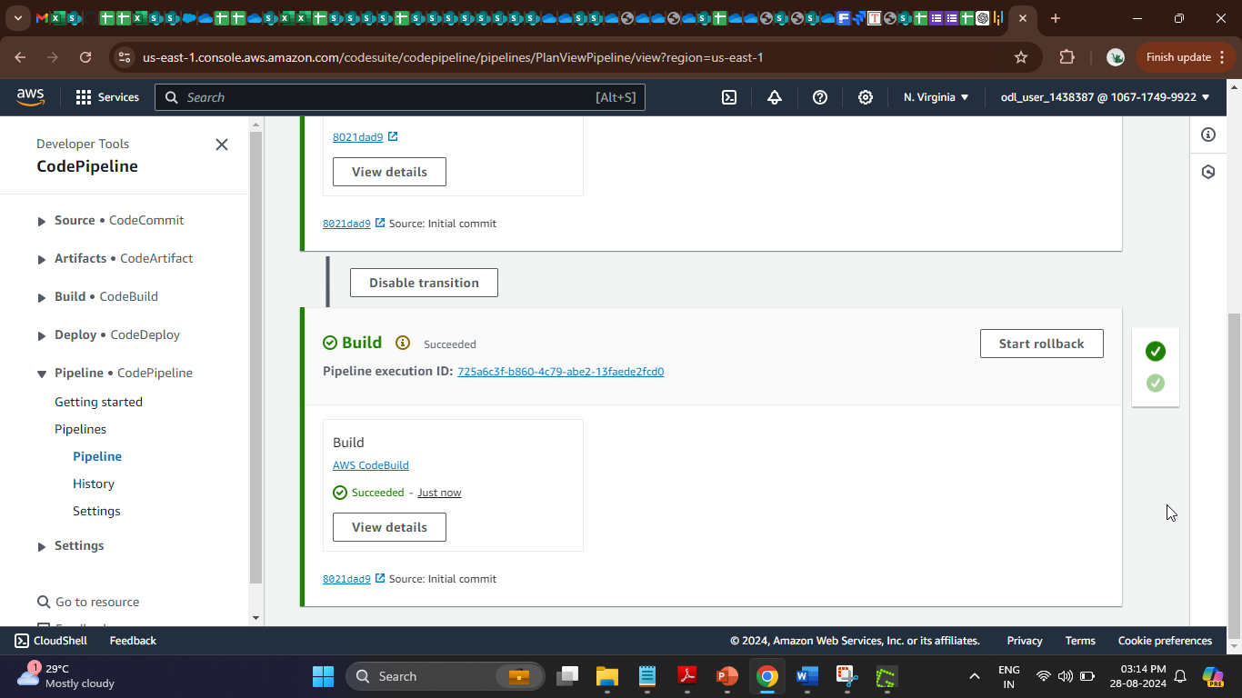

1. Once the build stage is completed, click on the **View details** button in the **Build** section for validation 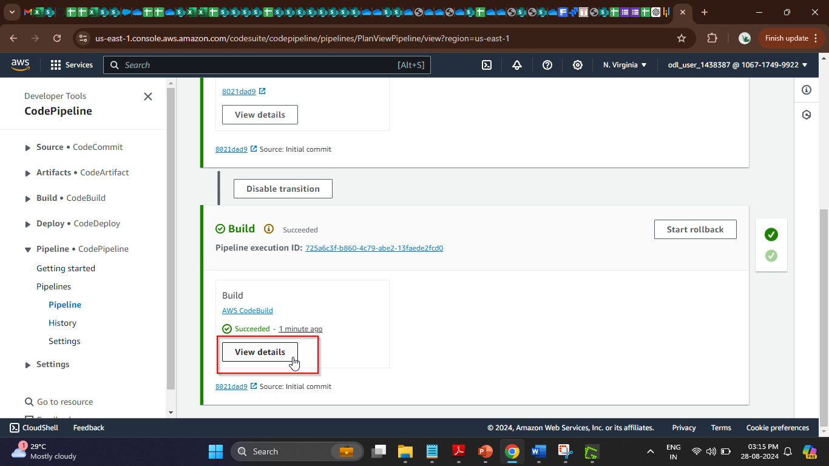

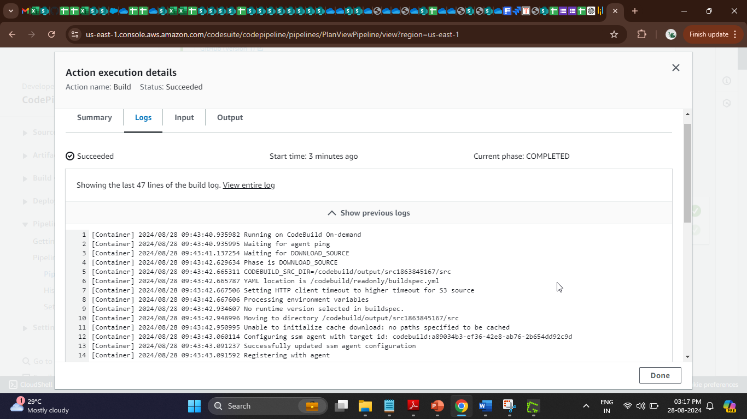

By following these steps, you have successfully created an AWS CodePipeline for continuous integration and delivery (CI/CD) using a GitHub repository.