LINUX SHELL ASSIGNMENT

This repository contains my Linux Shell Scripting assignment, completed as part of the CSFCP course.
The project includes three functional shell scripts along with screenshots, documentation, and instructions for execution.

📌 Project Overview

This assignment demonstrates my understanding of basic Linux commands, file management, permissions, process monitoring, and automation using shell scripting.
The project includes:

Backup automation

CPU & memory monitoring

Automatic file downloading

Proper documentation and screenshot evidence

📂 Scripts Included

1. backup.sh

A script that:

Creates a backup of a specified directory

Stores it inside a backup folder

Adds a timestamp to each backup

Ensures previous backups are not overwritten

2. monitor.sh

A script that:

Logs CPU and memory usage

Stores the log in a .txt file

Runs at regular intervals until stopped

Helps understand system performance

3. download.sh

A script that:

Downloads a file from the internet using wget or curl

Saves it into a predefined directory

Automatically creates the folder if it doesn't exist

🛠 How to Run the Scripts

Before running any script, make it executable:

chmod +x scriptname.sh

✔ Run the Backup Script

./backup.sh
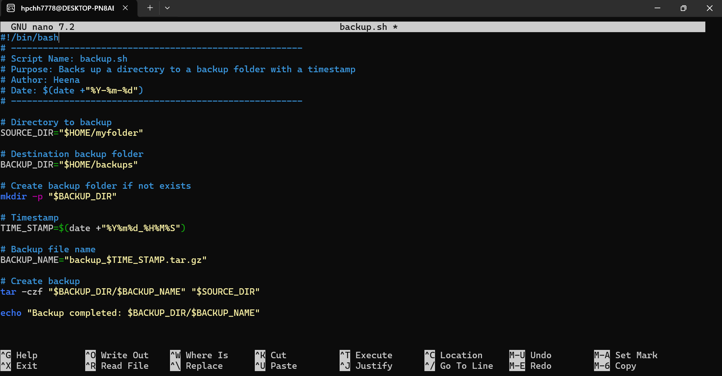

✔ Run the Monitoring Script

./monitor.sh
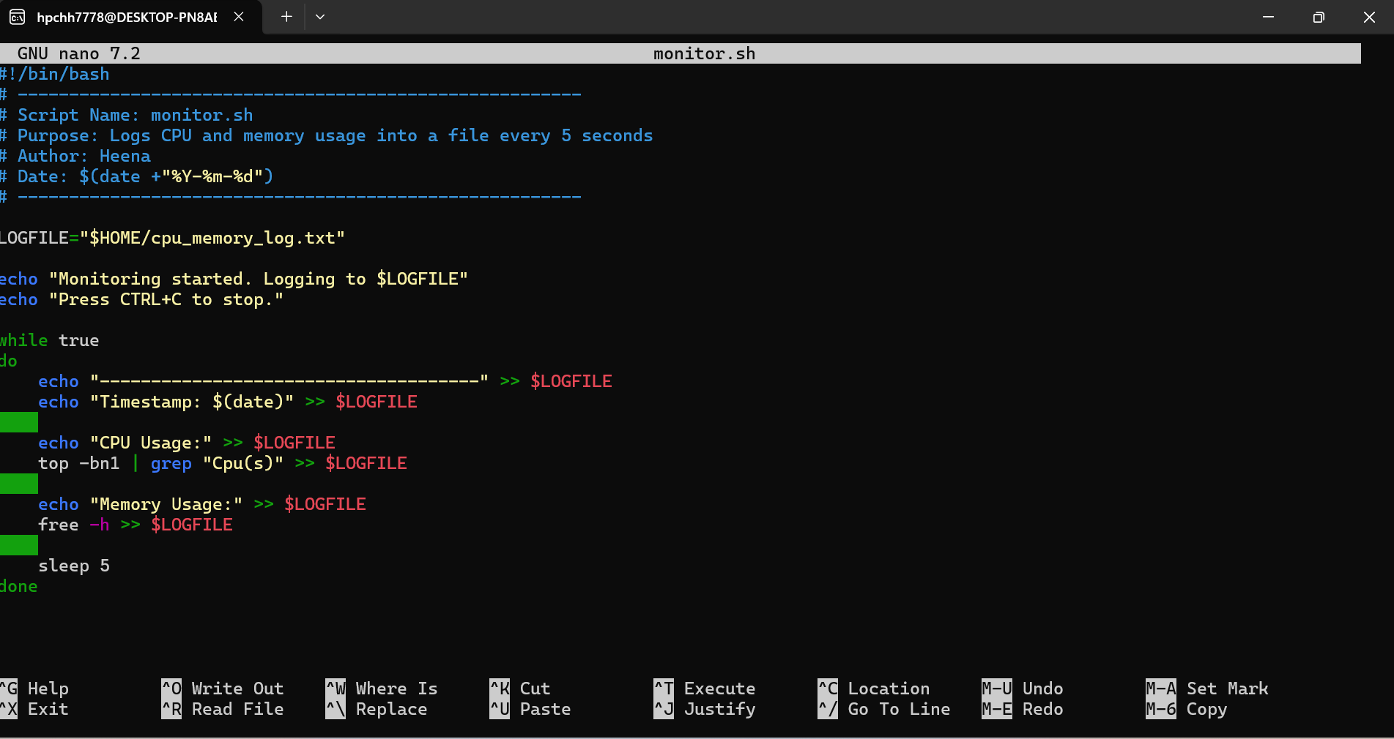

✔ Run the Download Script

./download.sh
