Internet Programming

**Javascript (NodeJS, Typescript)**

**Name: Sophart Chhordaphea**

**ID: e20191055**

**Group: I4 GIC C**

Link: <https://github.com/chhordaphea-27/I4-TP_Internet_Programming/tree/TP7>

Table of Contents

Exercise 1 - Activity Suggestion 1

Source Code 1

Index.html 1

Styles.css 4

Index.js 5

Package.json 6

Result 7

Exercise 2 - List/Viewer 7

Source Code 7

Index.html 7

Styles.css 8

Script.js 10

Index.js 13

Package.json 13

Result 15

Exercise 3 - Bookstore 15

Source Code 15

Index.html 15

Detail.html 16

Styles.css 17

Script.js 20

Index.js 22

Package.json 23

Result 24

Exercise 4 - Past Time Library with Typescript 24

Source Code 24

Index.html 24

KhmerDate.ts 26

Index.js 27

Package.json 28

Result 29

# 

# Exercise 1 - Activity Suggestion

## Source Code

### Index.html

<!DOCTYPE html>

<html lang="en">

<head>

<meta charset="UTF-8">

<meta http-equiv="X-UA-Compatible" content="IE=edge">

<meta name="viewport" content="width=device-width, initial-scale=1.0">

<title>Activity Suggestion</title>

<link rel="stylesheet" href="./styles.css">

<link rel="preconnect" href="https://fonts.googleapis.com">

<link rel="preconnect" href="https://fonts.gstatic.com" crossorigin>

<link href="https://fonts.googleapis.com/css2?family=Roboto:ital,wght@0,100;0,300;0,400;0,500;0,700;0,900;1,100;1,300;1,400;1,500;1,700;1,900&display=swap" rel="stylesheet">

</head>

<body>

<div class="wrapper">

<svg width="201" height="201" viewBox="0 0 201 201" fill="none" xmlns="http://www.w3.org/2000/svg">

<path d="M100.415 0.0691528C73.8016 0.0691528 48.2782 10.6413 29.4597 29.4598C10.6412 48.2783 0.0690918 73.8016 0.0690918 100.415C0.0690918 127.028 10.6412 152.552 29.4597 171.37C48.2782 190.189 73.8016 200.761 100.415 200.761C127.028 200.761 152.552 190.189 171.37 171.37C190.189 152.552 200.761 127.028 200.761 100.415C200.761 73.8016 190.189 48.2783 171.37 29.4598C152.552 10.6413 127.028 0.0691528 100.415 0.0691528Z" fill="#FFCA28"/>

<path d="M120.484 153.097C120.484 156.072 120.294 158.555 119.872 160.623H80.953C80.5366 158.555 80.3459 156.072 80.3459 153.097C80.3459 137.854 89.3319 125.501 100.415 125.501C111.498 125.501 120.484 137.854 120.484 153.097Z" fill="#5D4037"/>

<path d="M100.415 155.605C92.2518 155.605 85.3831 157.943 80.9729 160.623C83.4815 170.657 91.3938 170.657 100.415 170.657C109.436 170.657 117.348 170.657 119.857 160.623C115.447 157.943 108.578 155.605 100.415 155.605Z" fill="#E53935"/>

<path d="M85.3632 95.3977L45.2249 100.415C45.2249 87.7162 51.6219 78.5898 60.2767 76.046L65.294 80.3458L75.3437 78.0228C81.3343 81.4948 85.3632 87.8718 85.3632 95.3977Z" fill="#6D4C41"/>

<path d="M67.8025 85.3631C71.8716 85.3631 75.1629 82.132 75.3034 78.0981C72.3482 76.3822 68.9565 75.3286 65.2939 75.3286C63.6382 75.3286 62.0527 75.6196 60.5124 76.051C60.3719 76.628 60.2766 77.2201 60.2766 77.8372C60.2766 81.9915 63.6482 85.3631 67.8025 85.3631Z" fill="white"/>

<path d="M115.467 95.3977L155.605 100.415C155.605 87.7162 149.208 78.5898 140.553 76.046L135.536 80.3458L125.486 78.0228C119.496 81.4948 115.467 87.8718 115.467 95.3977Z" fill="#6D4C41"/>

<path d="M133.027 85.3631C128.958 85.3631 125.667 82.132 125.527 78.0981C128.482 76.3822 131.873 75.3286 135.536 75.3286C137.192 75.3286 138.777 75.6196 140.318 76.051C140.458 76.628 140.553 77.2201 140.553 77.8372C140.553 81.9965 137.182 85.3631 133.027 85.3631Z" fill="white"/>

</svg>

<h1>Are You Boring?</h1>

<button onclick="getActivity()">Tell me what to do</button>

<div class="data-container">

<p id="acivityName"><b>Activity</b></p>

<div class="data-row">

<svg class="data" width="14" height="14" viewBox="0 0 23 23" fill="none" xmlns="http://www.w3.org/2000/svg">

<g clip-path="url(#clip0_191_74)">

<path d="M10.8605 21.9373L0.823593 12.3127C0.0515472 11.5739 5.29893e-07 11.1503 5.29893e-07 10.1159V6.37247C5.29893e-07 5.32825 0.257418 5.00316 1.03979 4.25447L3.40748 1.9887C4.17953 1.24987 4.51917 0.993736 5.61041 0.993736H9.53252C10.6134 0.993736 11.0458 1.04299 11.8179 1.78183L21.8856 11.3965C23.3577 12.8053 23.3886 14.2632 21.8753 15.7015L15.3591 21.9275C13.8458 23.3657 12.3326 23.346 10.8605 21.9373ZM7.33982 8.87466C8.15308 8.87466 8.75014 8.27375 8.75014 7.52505C8.75014 6.76652 8.15308 6.17545 7.33982 6.17545C6.53688 6.17545 5.92949 6.76652 5.92949 7.52505C5.92949 8.27375 6.53688 8.87466 7.33982 8.87466Z" fill="#3083FF"/>

</g>

<defs>

<clipPath id="clip0_191_74">

<rect width="23" height="23" fill="white" transform="matrix(-1 0 0 1 23 0)"/>

</clipPath>

</defs>

</svg>

<p class="data">Type: </p>

<p class="data" id="type">Unknown</p>

</div>

<div class="data-row">

<svg class="data" width="14" height="14" viewBox="0 0 37 18" fill="none" xmlns="http://www.w3.org/2000/svg">

<g clip-path="url(#clip0_191_78)">

<path d="M12.2852 17.8809H24.5508C26.084 17.8809 26.6309 17.4414 26.6309 16.582C26.6309 14.0625 23.4766 10.5859 18.418 10.5859C13.3496 10.5859 10.1953 14.0625 10.1953 16.582C10.1953 17.4414 10.7422 17.8809 12.2852 17.8809ZM18.418 8.83789C20.5176 8.83789 22.3242 6.96289 22.3242 4.52148C22.3242 2.10938 20.5078 0.322266 18.418 0.322266C16.3379 0.322266 14.5117 2.14844 14.5215 4.54102C14.5215 6.96289 16.3281 8.83789 18.418 8.83789ZM1.71875 17.8809H9.13086C8.11523 16.4062 9.35547 13.4375 11.4648 11.8164C10.3711 11.0938 8.97461 10.5566 7.1582 10.5566C2.75391 10.5566 0 13.8086 0 16.5137C0 17.3926 0.478516 17.8809 1.71875 17.8809ZM7.1582 9.0625C8.98438 9.0625 10.5566 7.42188 10.5566 5.30273C10.5566 3.20312 8.97461 1.65039 7.1582 1.65039C5.35156 1.65039 3.75 3.24219 3.75977 5.32227C3.75977 7.42188 5.3418 9.0625 7.1582 9.0625ZM35.0977 17.8809C36.3379 17.8809 36.8164 17.3926 36.8164 16.5137C36.8164 13.8086 34.0625 10.5566 29.6582 10.5566C27.832 10.5566 26.4355 11.0938 25.3516 11.8164C27.4512 13.4375 28.6914 16.4062 27.6758 17.8809H35.0977ZM29.6484 9.0625C31.4746 9.0625 33.0566 7.42188 33.0566 5.32227C33.0566 3.24219 31.4648 1.65039 29.6484 1.65039C27.8418 1.65039 26.25 3.20312 26.25 5.30273C26.25 7.42188 27.832 9.0625 29.6484 9.0625Z" fill="#3083FF"/>

</g>

<defs>

<clipPath id="clip0_191_78">

<rect width="36.8164" height="17.8809" fill="white"/>

</clipPath>

</defs>

</svg>

<p class="data">Participaint: </p>

<p class="data" id="participaint">Unknown</p>

</div>

<div class="data-row">

<svg class="data" width="14" height="14" viewBox="0 0 36 36" fill="none" xmlns="http://www.w3.org/2000/svg">

<path d="M18 0C8.07422 0 0 8.07422 0 18C0 27.9258 8.07422 36 18 36C27.9258 36 36 27.9258 36 18C36 8.07422 27.9258 0 18 0ZM19 27.1016V29H17V27.1016C15.3008 26.8008 12.3008 25.8008 12 21.5H14C14 22.8008 14.8984 25.1992 18 25.1992C21.1016 25.1992 21.8008 23.6992 21.8008 22.0977C21.8008 17.3008 12.5 20.5977 12.5 14.1992C12.5 10.8008 15.3984 9.39844 17 9.19922V7H19V9.30078C21.8984 9.80078 22.8984 11.8008 23.5 14H21.5C21.1992 12.3984 20.1992 11.1016 18.1016 11.1016C15.1016 11.1016 14.6992 13.1016 14.6992 14C14.6992 16.1016 16.6016 16.6016 18.6992 17.1016C21.3008 17.6992 24 18.6016 24 21.8984C24 25.8984 20.5 27 19 27.1016Z" fill="#3083FF"/>

</svg>

<p class="data">Price: </p>

<p class="data"id="price">0$</p>

</div>

<div class="data-row">

<svg class="data" width="14" height="14" viewBox="0 0 21 21" fill="none" xmlns="http://www.w3.org/2000/svg">

<path d="M10.4773 6.35376L9.17847 7.67212C10.4675 7.77954 11.3074 8.1604 11.9421 8.79517C13.6511 10.5042 13.6414 12.926 11.9519 14.6155L8.75855 17.7991C7.05933 19.4983 4.65698 19.5081 2.948 17.8088C1.23902 16.0901 1.24878 13.6877 2.948 11.9885L4.86206 10.0745C4.58862 9.45923 4.52027 8.72681 4.62769 8.09204L1.75659 10.9534C-0.577391 13.2971 -0.596921 16.6174 1.76636 18.9807C4.13941 21.3538 7.45972 21.3342 9.7937 19.0002L13.1335 15.6506C15.4773 13.3069 15.4968 9.98657 13.1238 7.62329C12.5085 7.00806 11.7273 6.56861 10.4773 6.35376ZM10.2332 14.4006L11.532 13.0823C10.2429 12.9846 9.40308 12.594 8.76831 11.9592C7.05933 10.2502 7.06909 7.82837 8.75855 6.13892L11.9421 2.95532C13.6511 1.25611 16.0535 1.24634 17.7625 2.95532C19.4714 4.66431 19.4519 7.07642 17.7625 8.76587L15.8484 10.6799C16.1218 11.3049 16.1804 12.0276 16.0828 12.6624L18.9539 9.80103C21.2878 7.45728 21.3074 4.14673 18.9441 1.77368C16.571 -0.599363 13.2507 -0.579832 10.907 1.76392L7.57691 5.10376C5.23316 7.44751 5.21362 10.7678 7.58667 13.1311C8.20191 13.7463 8.98316 14.1858 10.2332 14.4006Z" fill="#3083FF"/>

</svg>

<p class="data">Link: </p>

<p class="data" id="link">Unknown</p>

</div>

</div>

</div>

<script>

function getActivity() {

const activity = document.getElementById("acivityName")

const type = document.getElementById("type")

const participaint = document.getElementById("participaint")

const price = document.getElementById("price")

const link = document.getElementById("link")

fetch("https://www.boredapi.com/api/activity").then( async (response) => {

let data = await response.json()

console.log(data)

activity.innerHTML = `<b>${data.activity}</b>`

type.innerHTML = data.type

participaint.innerHTML = data.participaint

price.innerHTML = data.price

link.innerHTML = data.link

})

}

</script>

</body>

</html>

### Styles.css

body {

text-align: center;

font-family: 'Roboto', sans-serif;

}

.wrapper {

margin-top: 100px;

}

.smileIcon {

width: 64px;

}

.wrapper button {

width: 180px;

height: 40px;

background-color: #3083FF;

border-style: none;

border-radius: 6px;

color: white;

}

.data-container {

width: 400px;

background-color: #F4F4F4;

text-align: left;

margin-top: 30px;

margin-left: auto;

margin-right: auto;

padding-left: 25px;

padding-right: 25px;

padding-bottom: 25px;

border-radius: 10px;

border-style: solid;

border-color: #CFCFCF;

}

.data-container #acivityName {

text-align: center;

}

.data {

display: inline-block;

margin-top: 1px;

margin-left: 10px;

}

### Index.js

const express = require('express')

const path = require('path');

const fs = require("fs")

const app = express()

app.get('/', function (req, res) {

fs.readFile('./src/Index.html', 'utf8', (err, data) => {

if (err) {

console.error(err)

return;

}

fs.readFile('./src/styles.css', 'utf8', (err, cssData) => {

const updatedData = data.replace('<link rel="stylesheet" href="./styles.css">', `<style>${cssData}</style>`);

res.send(updatedData)

});

})

})

// start the server

app.listen(3000, () => {

console.log('Server started on port 3000');

});

### Package.json

{

"name": "activity-suggestion",

"version": "1.0.0",

"description": "",

"scripts": {

"start:dev": "node index.js",

"start:watch": "nodemon npm run start:dev"

},

"author": "hongsin",

"license": "ISC",

"dependencies": {

"express": "^4.18.2"

},

"devDependencies": {

"nodemon": "^2.0.21"

}

}

## Result

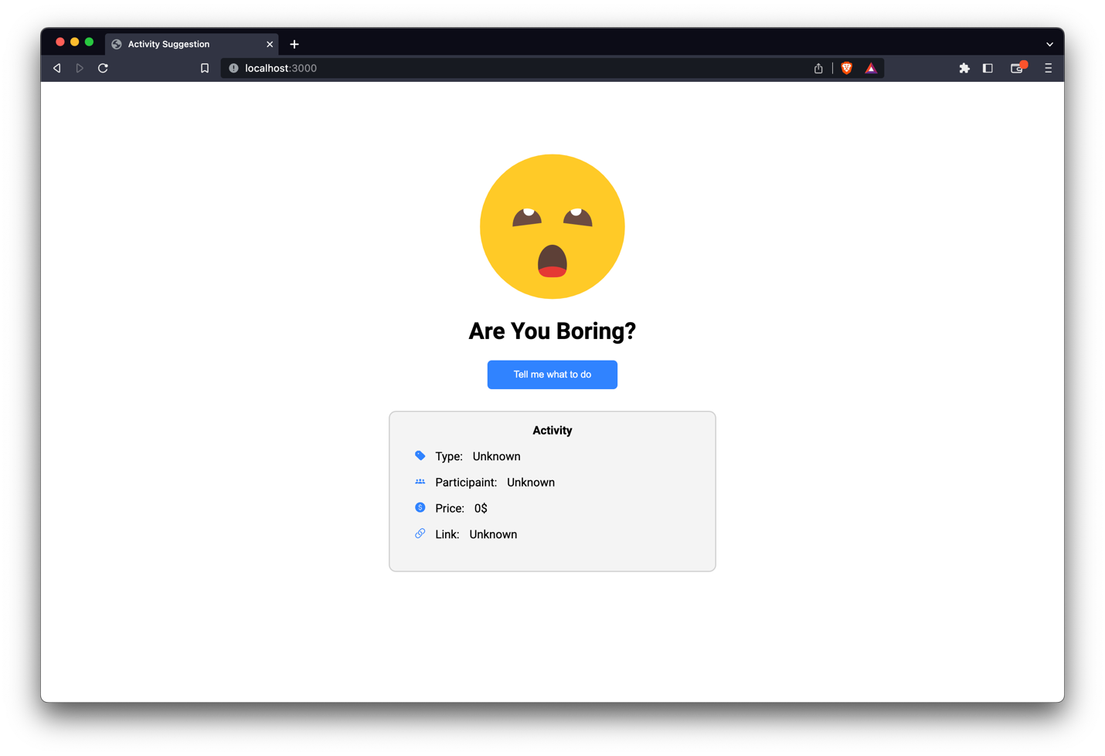

# Exercise 2 - List/Viewer

## Source Code

### Index.html

<!DOCTYPE html>

<html lang="en">

<head>

<meta charset="UTF-8">

<meta http-equiv="X-UA-Compatible" content="IE=edge">

<meta name="viewport" content="width=device-width, initial-scale=1.0">

<title>Document</title>

<link rel="stylesheet" href="./styles.css">

<link rel="preconnect" href="https://fonts.googleapis.com">

<link rel="preconnect" href="https://fonts.gstatic.com" crossorigin>

<link href="https://fonts.googleapis.com/css2?family=Roboto:ital,wght@0,100;0,300;0,400;0,500;0,700;0,900;1,100;1,300;1,400;1,500;1,700;1,900&display=swap" rel="stylesheet">

</head>

<body>

<h1>Find your favorite 🥂</h1>

<br>

<div class="wrapper">

<div id="dataList">

</div>

<div class="dataDetail">

<img src="" alt="" srcset="" id="beerImage">

<h2 id="selectedName">Arcade Nation</h2>

<p id="date">04/2013</p>

<p id="detailInfo">Lorem ipsum dolor sit amet, consectetur adipisicing elit. Corrupti natus suscipit sequi tempora vero incidunt fuga quibusdam repellat cupiditate molestiae!</p>

<br>

<p>contributor</p>

<p><b>(Sam Mason)</b></p>

</div>

</div>

<script src="script.js"></script>

</body>

</html>

### Styles.css

body {

text-align: center;

font-family: 'Roboto', sans-serif;

/* width: 50%; */

margin: auto;

display: table;

}

h1 {

margin-bottom: 10px;

}

.wrapper {

display: grid;

grid-template-columns: auto auto;

}

/* Left-Side */

#dataList {

background-color: #cfcfcf;

overflow-x: auto;

width: 450px;

height: 89vh;

padding: 4px;

padding-top: 2px;

border-radius: 10px;

border-color: #CACACA;

border-style: solid;

}

#dataCell {

background-color: white;

border-radius: 10px;

padding-top: 10px;

padding-left: 10px;

padding-right: 10px;

text-align: left;

margin-top: 3px;

}

#dataCell :hover {

cursor: pointer;

}

#dataCell img {

display: inline-block;

width: 60px;

height: 60px;

margin-bottom: 7px;

}

#dataCell #info {

display: inline-block;

margin-left: 10px;

}

#dataCell #info p {

color: #CACACA;

font-size: small;

overflow: hidden;

white-space: nowrap;

text-overflow: ellipsis;

max-width: 300px;

}

#dataCell h2 {

margin-top: 0px;

margin-bottom: -10px;

font-size: x-large;

overflow: hidden;

white-space: nowrap;

text-overflow: ellipsis;

max-width: 300px;

}

/* Right-Side */

.dataDetail {

/* display: inline-block; */

width: 450px;

height: 89vh;

border-radius: 10px;

border-style: solid;

border-color: #E6E6E6;

margin-left: 5px;

}

.dataDetail #date {

color: #CACACA;

}

.dataDetail #detailInfo {

margin-left: 80px;

margin-right: 80px;

}

#beerImage {

height: 300px;

background-repeat: no-repeat;

background-size: contain;

}

### Script.js

//MARK: Element

// Left-side

const dataListEle = document.getElementById("dataList")

// Right-side

const nameDetailProduct = document.getElementById("selectedName")

const dateDetailProduct = document.getElementById("date")

const descriptionDetailProduct = document.getElementById("detailInfo")

const beerImageProdect = document.getElementById("beerImage")

let allPage = 1;

const pageSize = 20;

let dataLoading = false;

const localDataArray = [];

function init() {

if (isHaveLocalData()) {

readLocalStorage()

renderAllData()

} else {

fetchData()

}

}

function fetchData() {

console.log("Fetch Data")

fetch(`https://api.punkapi.com/v2/beers?page=${allPage}&per_page=${pageSize}`).then(async (res) => {

let data = await res.json()

console.log(data);

data.forEach(element => {

localDataArray.push(element)

});

renderAllData()

writeLocalStorage()

})

}

function renderAllData() {

localDataArray.forEach(element => {

dataListEle.innerHTML += `

<div id="dataCell" onclick="clickHandling(${element.id})">

<img src="http://cleanswifter.com/wp-content/uploads/2016/07/beer.png" alt="" srcset="">

<div id="info">

<h2>${element.name}</h2>

<p>${element.description}</p>

</div>

</div>

`

});

dataLoading = true

}

function writeLocalStorage() {

let localData = JSON.stringify(localDataArray)

localStorage.setItem("beerLocalData", localData)

}

function readLocalStorage() {

console.log("Read Local Data")

let local = localStorage.getItem("beerLocalData")

let data = JSON.parse(local)

console.log(data)

data.forEach(element => {

localDataArray.push(element)

})

}

function isHaveLocalData() {

let local = localStorage.getItem("beerLocalData")

let data = JSON.parse(local)

if (data === null) return false

else return true

}

function clickHandling(selecrtedID) {

localDataArray.forEach(element => {

if (element.id === selecrtedID) {

renderDetailData(element)

}

});

}

function renderDetailData(data) {

console.log("Clicked Data: ", data)

beerImageProdect.src = data.image_url

nameDetailProduct.innerHTML = data.name

dateDetailProduct.innerHTML = data.first_brewed

descriptionDetailProduct.innerHTML = data.description

}

dataListEle.addEventListener("scroll", (event) => {

const pageNumberEle = document.getElementById("pageNumber")

const { scrollTop, clientHeight, scrollHeight } = dataListEle;

// console.log(scrollWrapper.scrollTop)

if (clientHeight + scrollTop >= scrollHeight * 0.95) {

allPage += 1;

if (dataLoading) {

fetchData();

console.log("Loading new page")

}

dataLoading = false

}

})

init();

### Index.js

const express = require('express')

const path = require('path');

const fs = require("fs")

const app = express()

app.get('/', function (req, res) {

fs.readFile('./src/index.html', 'utf8', (err, data) => {

if (err) {

console.error(err)

return;

}

fs.readFile('./src/styles.css', 'utf8', (err, cssData) => {

const updateSylesFile = data.replace('<link rel="stylesheet" href="./styles.css">', `<style>${cssData}</style>`);

fs.readFile('./src/script.js', 'utf8', (err, jsData) => {

const updateScriptFile = updateSylesFile.replace('<script src="script.js"></script>', `<script>${jsData}</script>`);

res.send(updateScriptFile)

});

});

})

})

// start the server

app.listen(3000, () => {

console.log('Server started on port 3000');

});

### Package.json

{

"name": "ex2",

"version": "1.0.0",

"description": "",

"main": "index.js",

"scripts": {

"start:dev": "node run index.js",

"start:watch": "nodemon npm run start:dev"

},

"author": "Hongsin",

"license": "ISC",

"dependencies": {

"express": "^4.18.2"

},

"devDependencies": {

"nodemon": "^2.0.21"

}

}

## Result

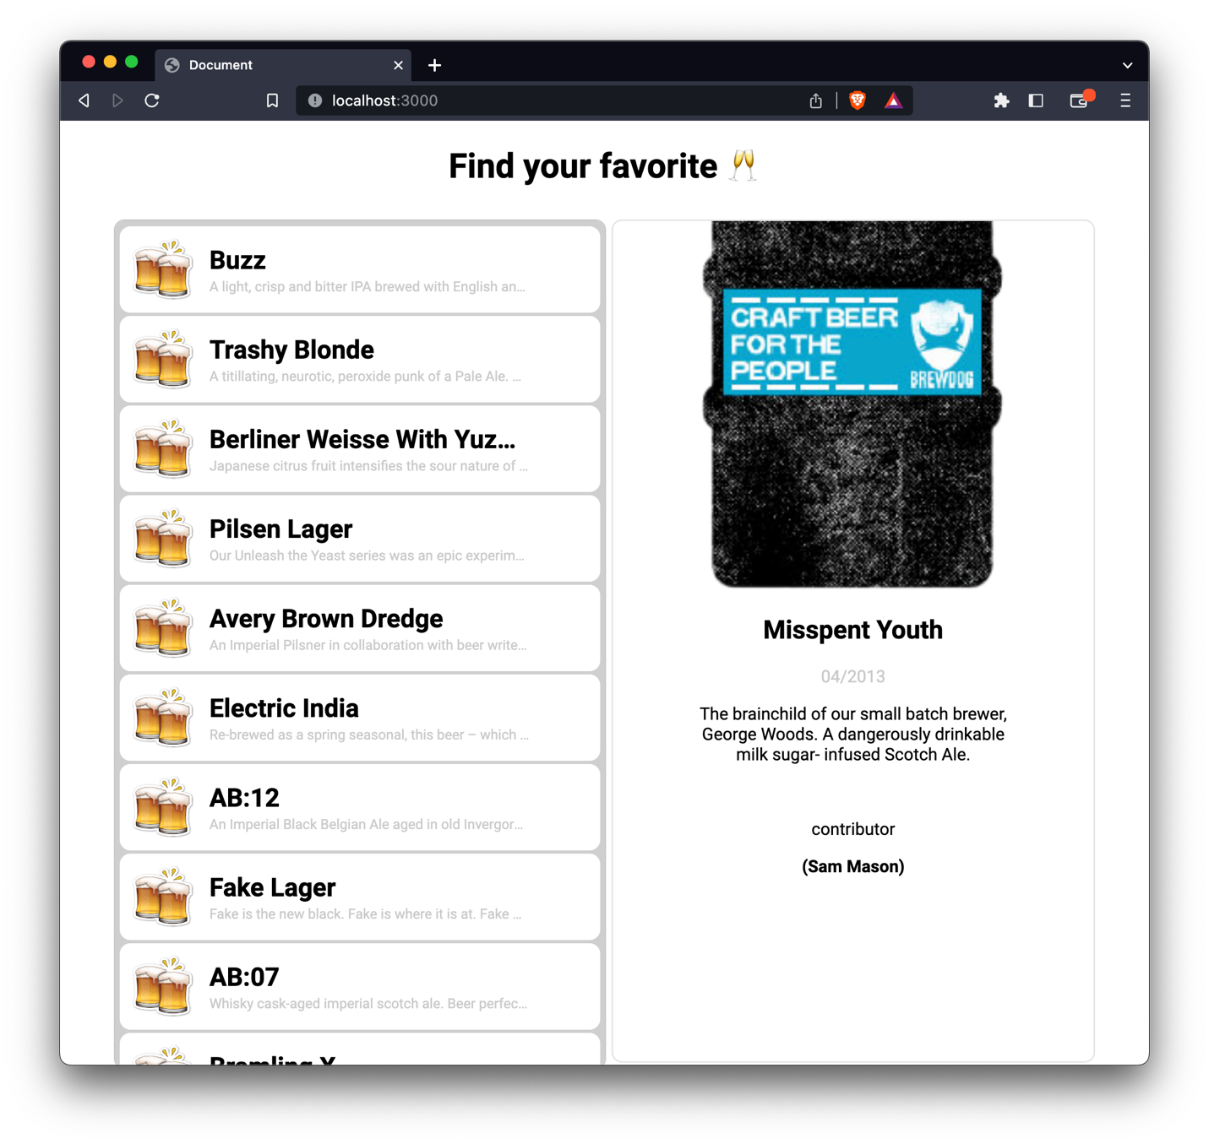

# Exercise 3 - Bookstore

## Source Code

### Index.html

<!DOCTYPE html>

<html lang="en">

<head>

<meta charset="UTF-8">

<meta http-equiv="X-UA-Compatible" content="IE=edge">

<meta name="viewport" content="width=device-width, initial-scale=1.0">

<title>Book Store</title>

<link rel="stylesheet" href="./styles.css">

<link rel="preconnect" href="https://fonts.googleapis.com">

<link rel="preconnect" href="https://fonts.gstatic.com" crossorigin>

<link href="https://fonts.googleapis.com/css2?family=Roboto:ital,wght@0,100;0,300;0,400;0,500;0,700;0,900;1,100;1,300;1,400;1,500;1,700;1,900&display=swap" rel="stylesheet">

</head>

<body onload="loadBook()">

<div class="parent">

<div class="sideBar">

<div class="form-Container">

<form action="" method="get" class="form">

<label for="name">Name: </label><br>

<input type="text" name="name" id="name-input" placeholder="C Programming"><br>

<label for="category">Category: </label><br>

<input type="text" name="category" id="category-input" placeholder="Coding"><br>

<label for="pice">Price: </label><br>

<input type="text" name="price" id="price-input" placeholder="1,000 riel"><br>

<button class="add-btn" type='button'>Add</button>

</form>

</div>

</div>

<div class="main" id="book-container">

<div id="loadingView" hidden>

<div class="lds-ring"><div></div><div></div><div></div><div></div></div>

</div>

</div>

</div>

<script src="script.js"></script>

</body>

</html>

### Detail.html

<!DOCTYPE html>

<html lang="en">

<head>

<meta charset="UTF-8">

<meta http-equiv="X-UA-Compatible" content="IE=edge">

<meta name="viewport" content="width=device-width, initial-scale=1.0">

<title>Detail Book</title>

<link rel="stylesheet" href="./styles.css">

</head>

<body onload="loadDetailBook()">

<div class="header-Detail">

<h2 id="titleBook">Title</h1>

<p id="category">1</p>

<p>Resize the browser window to see that this page responsive by the way.</p>

</div>

<h3>1</h3>

<img class="bookIcon" src="" alt="Book Cover">

<script src="script.js"></script>

</body>

</html>

### Styles.css

body {

text-align: center;

font-family: 'Roboto', sans-serif;

}

.parent {

display: flex;

height: auto;

justify-content: space-between;

}

.sideBar {

min-height: 100vh;

width: 200px;

background: rgb(224, 223, 223);

border-radius: 7px;

text-align: left;

}

.add-btn {

margin-top: 10px;

width: 100px;

height: 30px;

}

.form {

margin: 10px;

width: 100%;

margin-bottom: 10px;

}

.main {

background: rgb(224, 223, 223);

width: calc(100% - 210px);

height: 100%;

border-radius: 7px;

}

.book {

background-color: rgb(255, 255, 255);

width: 175px;

height: 350px;

border-radius: 5px;

border-width: 5px;

display: inline-block;

margin: 5px;

}

.book-top {

display: block;

text-align: right;

margin-top: 5px;

margin-right: 10px;

height: 10%;

}

.bookIconContainer {

text-align: center;

margin-top: 35px;

}

.bookIcon {

margin: auto;

/* width: 90px; */

/* height: 76px; */

}

.bookInfo {

font-size: small;

line-height: 0.3;

margin: 10px;

/* margin-top: 20px; */

width: 88.5%;

height: 25%;

display: flex;

flex-direction: column;

text-align: left;

}

.bookTitle {

text-align: left;

line-height: 20px;

margin-bottom: 0px;

}

.book-row-container {

height: 20px;

}

.value {

display: inline-block;

}

.bookInfo a {

margin-top: 10px;

}

/* Loading View */

.lds-ring {

display: inline-block;

position: relative;

width: 80px;

height: 80px;

}

.lds-ring div {

box-sizing: border-box;

display: block;

position: absolute;

width: 64px;

height: 64px;

margin: 8px;

border: 8px solid #3083FF;

border-radius: 50%;

animation: lds-ring 1.2s cubic-bezier(0.5, 0, 0.5, 1) infinite;

border-color: #3083FF transparent transparent transparent;

}

.lds-ring div:nth-child(1) {

animation-delay: -0.45s;

}

.lds-ring div:nth-child(2) {

animation-delay: -0.3s;

}

.lds-ring div:nth-child(3) {

animation-delay: -0.15s;

}

@keyframes lds-ring {

0% {

transform: rotate(0deg);

}

100% {

transform: rotate(360deg);

}

}

/* ============================== Detail Screen ============================== */

.header-Detail {

color: white;

height: 40vh;

padding-top: 20px;

background-color: #474E5D;

}

.header-Detail h2 {

display: block;

margin-top: 30px;

font-size: xx-large;

}

.header-Detail p {

margin-top: auto;

margin-bottom: 20px;

}

### Script.js

var selectedBookID;

function loadBook() {

const bookContainerElement = document.getElementById("book-container")

const loadingElement = document.getElementById("loadingView")

loadingElement.hidden = false

fetch("https://jsonplaceholder.typicode.com/photos")

.then((response) => {

return response.json()

})

.then((myjson) => {

console.log(myjson)

loadingElement.hidden = false

for (let index = 0; index < 100; index++) {

const book = myjson[index];

loadingElement.hidden = true

bookContainerElement.innerHTML += `

<div class="book">

<div class="bookIconContainer">

<img src="${book.thumbnailUrl}" alt="Book Cover" class="bookIcon">

</div>

<div class="bookInfo">

<p class="bookTitle">${book.title}</p>

<div class="book-row-container">

<label for="price-book-labell">AlbumID: </label>

<p class="value">0 Reil</p>

</div>

<div class="book-row-container">

<label for="category-book-label">Category: </label>

<p class="value"> ${book.albumId} </p>

</div>

<a href="/detail?id=${book.id}" class="book-row-container"">See</a>

</div>

</div>

`

}

})

}

function loadDetailBook() {

// Get the user ID from the URL parameter

const urlParams = new URLSearchParams(window.location.search);

const bookID = urlParams.get('id');

const titleElement = document.getElementById("titleBook")

const categoryElement = document.getElementById("category")

const thumbnailElement = document.getElementsByClassName("bookIcon")[0]

fetch("https://jsonplaceholder.typicode.com/photos/" + bookID)

.then((response) => {

return response.json()

})

.then((myjson) => {

console.log(myjson)

titleElement.innerHTML = myjson.title

categoryElement.innerHTML = myjson.albumId

thumbnailElement.src = myjson.thumbnailUrl

})

}

### Index.js

const express = require('express')

const path = require('path');

const fs = require("fs")

const app = express()

app.get('/', function (req, res) {

fs.readFile('./src/index.html', 'utf8', (err, data) => {

if (err) {

console.error(err)

return;

}

fs.readFile('./src/styles.css', 'utf8', (err, cssData) => {

const updateSylesFile = data.replace('<link rel="stylesheet" href="./styles.css">', `<style>${cssData}</style>`);

fs.readFile('./src/script.js', 'utf8', (err, jsData) => {

const updateScriptFile = updateSylesFile.replace('<script src="script.js"></script>', `<script>${jsData}</script>`);

res.send(updateScriptFile)

});

});

})

})

app.get('/detail', function (req, res) {

fs.readFile('./src/detail.html', 'utf8', (err, data) => {

if (err) {

console.error(err)

return;

}

fs.readFile('./src/styles.css', 'utf8', (err, cssData) => {

const updateSylesFile = data.replace('<link rel="stylesheet" href="./styles.css">', `<style>${cssData}</style>`);

fs.readFile('./src/script.js', 'utf8', (err, jsData) => {

const updateScriptFile = updateSylesFile.replace('<script src="script.js"></script>', `<script>${jsData}</script>`);

res.send(updateScriptFile)

});

});

})

})

// start the server

app.listen(3000, () => {

console.log('Server started on port 3000');

});

### Package.json

{

"name": "ex3",

"version": "1.0.0",

"description": "",

"main": "index.js",

"scripts": {

"start:dev": "node run index.js",

"start:watch": "nodemon npm run start:dev"

},

"author": "Hongsin",

"license": "ISC",

"dependencies": {

"express": "^4.18.2"

},

"devDependencies": {

"nodemon": "^2.0.21"

}

}

## Result

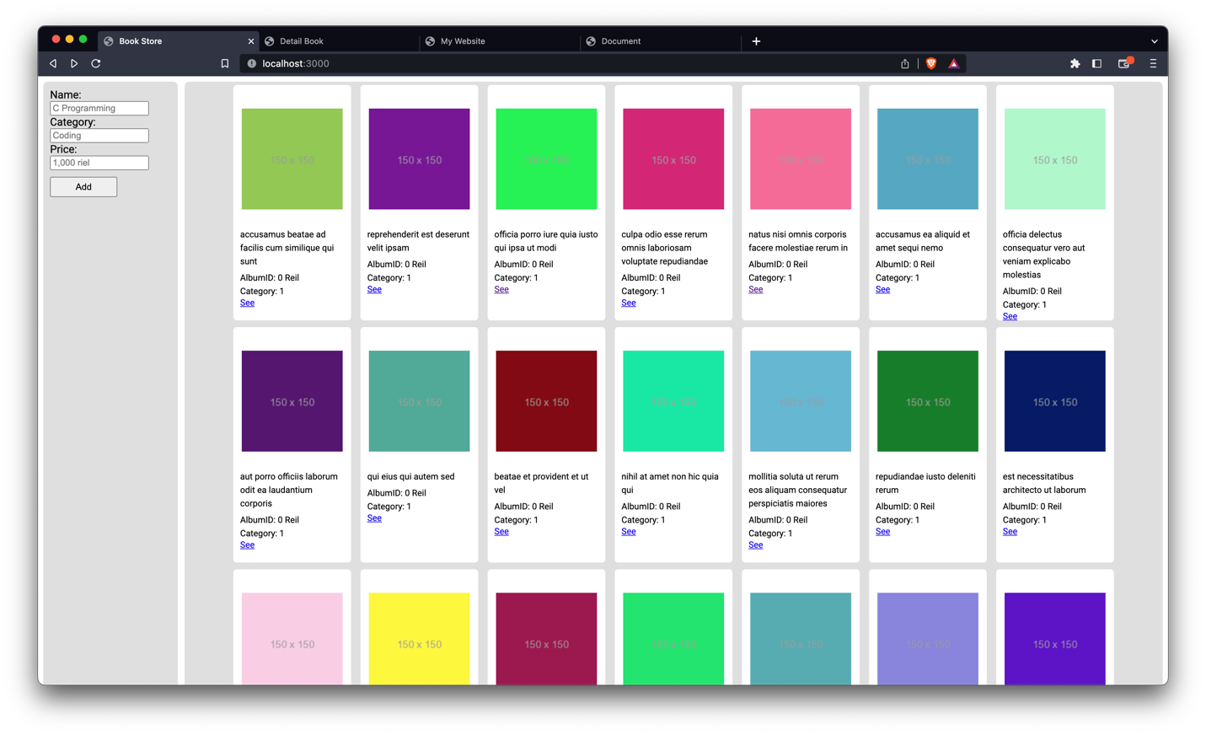

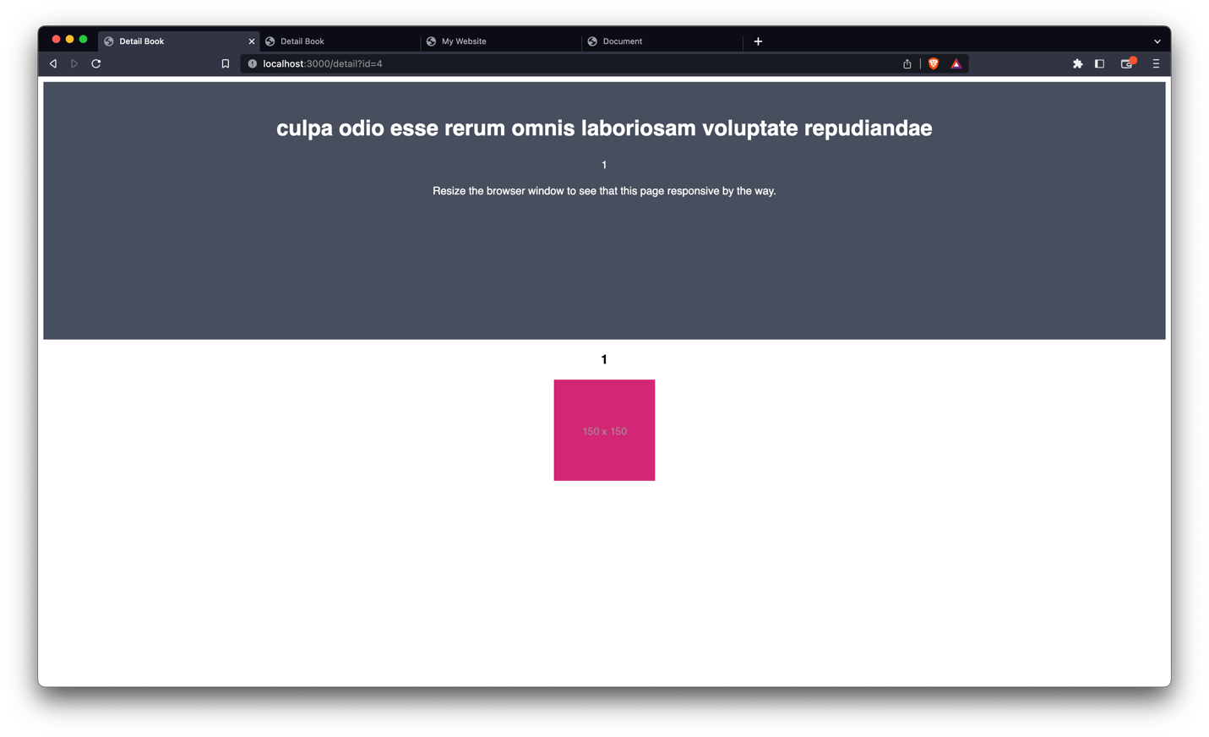

# Exercise 4 - Past Time Library with Typescript

## Source Code

### Index.html

<!DOCTYPE html>

<html lang="en">

<head>

<meta charset="UTF-8">

<meta http-equiv="X-UA-Compatible" content="IE=edge">

<meta name="viewport" content="width=device-width, initial-scale=1.0">

<link class="style" rel="stylesheet" href="">

<title>Khmer Past Time</title>

<link rel="preconnect" href="https://fonts.googleapis.com">

<link rel="preconnect" href="https://fonts.gstatic.com" crossorigin>

<link href="https://fonts.googleapis.com/css2?family=Roboto:ital,wght@0,100;0,300;0,400;0,500;0,700;0,900;1,100;1,300;1,400;1,500;1,700;1,900&display=swap" rel="stylesheet">

</head>

<body>

<style>

body {

font-family: 'Roboto', sans-serif;

}

.lds-dual-ring {

display: inline-block;

width: 80px;

height: 80px;

}

.lds-dual-ring:after {

content: " ";

display: block;

width: 64px;

height: 64px;

margin: 8px;

border-radius: 50%;

border: 6px solid #000000;

border-color: #000000 transparent #000000 transparent;

animation: lds-dual-ring 1.2s linear infinite;

}

@keyframes lds-dual-ring {

0% {

transform: rotate(0deg);

}

100% {

transform: rotate(360deg);

}

}

</style>

<main>

<img class="img" alt="Clock Logo">

<h1>Khmer Past Time</h1>

<form>

<input class="data_input" type="datetime-local">

</form>

<span class="Output">

<div class="lds-dual-ring"></div>

</span>

</main>

<script>

var script = document.createElement('script');

script.setAttribute('src', `${window.location.origin}/asset/?assetPath=js/app.js`);

document.head.appendChild(script);

// document.querySelector('.loader').href=`${window.location.origin}/asset/?assetPath=Activity Suggestion/loader.css`

document.querySelector('.style').href = `${window.location.origin}/asset/?assetPath=css/style.css`

</script>

</body>

</html>

### KhmerDate.ts

export class KhmerDate {

private readonly _date: Date;

constructor(date: Date) {

this._date = date;

}

getDate() {

return this._date;

}

getLabel() {

const now = new Date()

let dateSecond: any = Math.floor((now.getTime() - this._date.getTime()) / 1000);

let label: String = "ពេលក្រោយ"

if (dateSecond >= 0) {

label = "មុននេះបន្តិច"

if (dateSecond / 60 > 1) {

label = `${Math.floor(dateSecond / 60)} នាទីមុន`

}

if (dateSecond / 3600 > 1) {

label = `${Math.floor(dateSecond / 3600)} ម៉ោងមុន`

}

if (dateSecond / 86400 > 1) {

label = `${Math.floor(dateSecond / 86400)} ថ្ងៃមុន`

}

if (dateSecond / 604800 > 1) {

label = `${Math.floor(dateSecond / 604800)}សប្តាហ៍មុន`

}

if (dateSecond / 2629440 > 1) {

label = `${Math.floor(dateSecond / 2629440)}ខែមុន`

}

} else {

dateSecond = Math.floor((this._date.getTime() - now.getTime()) / 1000);

label = "ក្រោយនេះបន្តិច"

if (dateSecond / 60 > 1) {

label = `${Math.floor(dateSecond / 60)} នាទីក្រោយ`

}

if (dateSecond / 3600 > 1) {

label = `${Math.floor(dateSecond / 3600)} ម៉ោងក្រោយ`

}

if (dateSecond / 86400 > 1) {

label = `${Math.floor(dateSecond / 86400)} ថ្ងៃក្រោយ`

}

if (dateSecond / 604800 > 1) {

label = `${Math.floor(dateSecond / 604800)}សប្តាហ៍ក្រោយ`

}

if (dateSecond / 2629440 > 1) {

label = `${Math.floor(dateSecond / 2629440)}ខែក្រោយ`

}

}

return label

}

}

### Index.js

require("dotenv").config();

const express = require('express')

const fs = require('fs')

const app = express()

const { KhmerDate } = require('./src/asset/js/KhmerDate')

app.use(express.json())

app.get('/asset', (req, res) => {

// console.log(req.query['assetPath']);

if (fs.existsSync(`./src/asset/${req.query['assetPath']}`)) {

res.sendFile(req.query['assetPath'], { root: './src/asset/' })

} else {

res.send("<h1>File Not found</h1>")

}

})

app.post('/getPastTime', (req, res) => {

const { date } = req.body

const pastDate = new KhmerDate(new Date(date))

res.json({

msg: pastDate.getLabel()

})

})

app.get('/', (req, res) => {

res.sendFile('src/Template/index.html', { root: './' })

})

app.listen(process.env.PORT ?? 3000, () => {

console.log(`Server run on http://localhost:${process.env.PORT ?? 3000}`);

})

### Package.json

{

"name": "project-base",

"version": "1.0.0",

"description": "",

"main": "index.js",

"scripts": {

"test": "echo \"Error: no test specified\" && exit 1",

"start": "node index.js",

"start:dev": "nodemon index.js",

"start:compile:ts":"npx tsc src/Ts/KhmerDate.ts --outDir src/asset/js --watch "

},

"keywords": [],

"author": "ChhornKakada",

"license": "ISC",

"dependencies": {

"dotenv": "^16.0.3",

"express": "^4.18.2"

},

"devDependencies": {

"nodemon": "^2.0.21"

}

}

## Result

