Internet Programming

TP8: VueJS, NodeJS

(Authentication frontend and APIs)

**Name: Sophart Chhordaphea**

**Id: e20191055**

**Group: I4 GIC C**

**Github:** [**Github.com**](https://github.com/chhordaphea-27/I4-TP_Internet_Programming/tree/TP8/TP8)

Contents

Exercise 1 : Auth screens in VueJS 1

Login 1

Register 1

Exercise 2: NodeJS with ExpressJS 1

Login 2

Register 2

Exercise 3: UI and APIs Integration 3

# Exercise 1 : Auth screens in VueJS

## Login

## Register

Exercise 2: NodeJS with ExpressJS

## Login

## Register

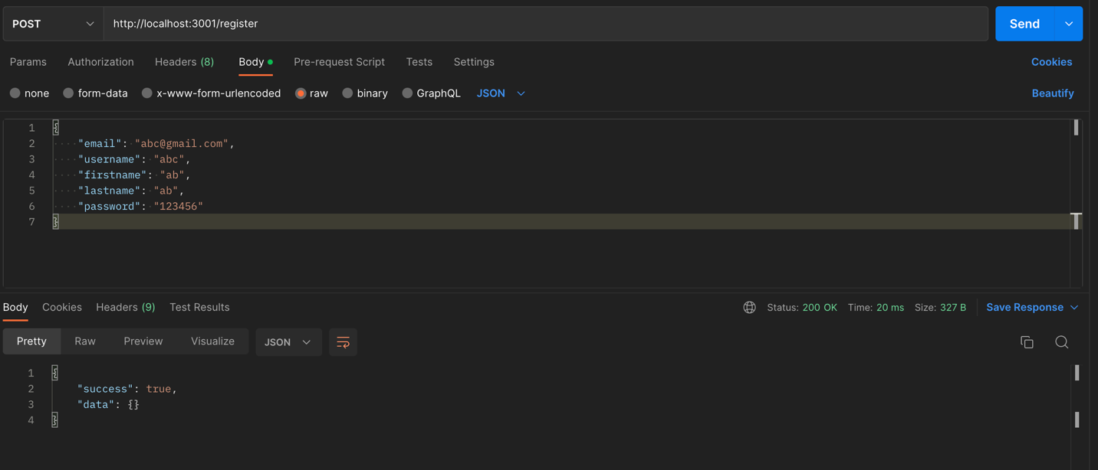

# Exercise 3: UI and APIs Integration

